Comprehensive Analysis of the Mineral Composition in Laganaria Breviflora Seeds, Oil, and Residual Cake

Abstract
Laganaria breviflora, commonly known as the African bottle gourd, is a plant species of significant economic and nutritional importance, particularly in tropical and subtropical regions. Despite its traditional uses and potential health benefits, comprehensive data on the mineral composition of its seeds, oil, and residual cake remain limited. This study aims to fill this gap by conducting a detailed analysis of the mineral content in these components. Using advanced analytical techniques, including Atomic Absorption Spectrometry (AAS), quantified the concentrations of essential minerals such as calcium, magnesium, potassium, iron, and sodium. Our results indicate significant variations in mineral content between the seeds, oil, and cake, each presenting unique nutritional profiles. For instance, the seeds were particularly rich in phosphorus and calcium, while the oil had higher concentrations of sodium and potassium. The residual cake, often used as animal feed or fertilizer, also demonstrated substantial mineral content, highlighting its value beyond mere by-product status. Statistical analyses, including ANOVA, confirmed there is no significance of these differences, emphasizing the nutritional potential of each component. This research underscores the value of Laganaria breviflora as a versatile resource in nutrition, health, and sustainable agriculture. By providing a comprehensive mineral profile, aim to promote the broader utilization of this under-explored plant species, contributing to food security and dietary diversity in regions where it is traditionally grown and consumed. Additionally, the consistent mineral composition across different samples underscores the reliability of Laganaria breviflora as a stable source of essential nutrients. This research not only enhances our understanding of the nutritional value of Laganaria breviflora but also supports its application in food security and sustainable agricultural practices. Future studies should explore the full potential of this underutilized plant to further benefit nutritional science and industry.
Keyword: Laganaria breviflora Seed, nutritional, Mineral Composition, Oil and Cake

1.0 Introduction
Laganaria breviflora, commonly known as the African bottle gourd, is a plant species of significant economic and nutritional importance, particularly in tropical and subtropical regions. The seeds of Laganaria breviflora are traditionally valued not only for their nutritional content but also for their potential medicinal properties. Recent scientific inquiries have increasingly focused on understanding the full spectrum of its biochemical composition, with particular attention to its mineral content, due to the essential roles these minerals play in human health and nutrition. Minerals are vital micronutrients required for a plethora of physiological functions, including enzyme activity, bone formation, and the regulation of biochemical pathways (Soetan, et al., 2010). The precise quantification and characterization of mineral content in food sources are crucial for evaluating their nutritional value and potential health benefits. Despite the growing interest in Laganaria breviflora, comprehensive data on the mineral composition of its seeds, oil, and residual cake remain sparse.
The seeds of Laganaria breviflora yield an oil that is commonly used in cooking and cosmetic products, while the residual cake, a by-product of oil extraction, is often utilized as animal feed or organic fertilizer. Each of these components—seeds, oil, and cake—could potentially serve as significant sources of essential minerals. However, the variability in mineral content across these different components necessitates a detailed analysis to fully elucidate their nutritional profiles. This study aims to fill this gap by conducting a comprehensive analysis of the mineral composition in the seeds, oil, and cake of Laganaria breviflora. By employing advanced analytical techniques, we seek to quantify the concentrations of key minerals such as calcium, magnesium, potassium, iron, zinc, and others (Glew et al., 2006). This information will not only enhance our understanding of the nutritional value of Laganaria breviflora but also inform its potential applications in food, health, and agricultural industries.
Moreover, this research intends to contribute to the broader discourse on the utilization of under-explored plant species in promoting food security and sustainable agricultural practices. By establishing a detailed mineral profile of Laganaria breviflora, we aim to highlight its potential as a valuable resource in addressing nutritional deficiencies and improving dietary diversity (Grivetti and Ogle, 2000). This study provides a comprehensive examination of the mineral composition of Laganaria breviflora seeds, oil, and cake, with the objective of uncovering their nutritional potential and broadening the scope of their applications. Through this analysis, we hope to underscore the significance of Laganaria breviflora in both nutritional science and sustainable development.
2.0 Literature Review
The nutritional and economic significance of plant species like Laganaria breviflora, commonly known as the African bottle gourd, has been increasingly recognized in recent years. This review focuses on the existing body of knowledge concerning the mineral composition of Laganaria breviflora seeds, oil, and cake, placing it within the broader context of research on plant-derived minerals and their implications for human and animal health.
2.1 Nutritional Importance of Minerals
Minerals are essential micronutrients that play critical roles in numerous physiological processes. They are necessary for the proper functioning of enzyme systems, maintenance of osmotic pressure, nerve transmission, muscle contraction, and the structural integrity of bones and teeth (Soetan, Olaiya,and Oyewole, 2010). Key minerals such as calcium, magnesium, potassium, iron, and zinc are required in varying amounts to sustain health and prevent deficiencies that can lead to disorders like anemia, osteoporosis, and impaired immune function.
2.2 Laganaria Breviflora: Traditional Uses and Nutritional Potential
Laganaria breviflora, commonly known as the African bottle gourd, holds a prominent place in traditional medicine and culinary practices across various tropical and subtropical regions. This versatile plant offers a range of uses, showcasing its nutritional richness and economic significance. Traditional Medicine: Laganaria breviflora has been utilized for generations in traditional medicine for its therapeutic properties. Extracts from different parts of the plant are used to treat various ailments, ranging from digestive issues to skin conditions. The plant's medicinal value is attributed to its bioactive compounds, which include antioxidants, flavonoids, and phenolic compounds. These compounds possess anti-inflammatory, antimicrobial, and antioxidant properties, making Laganaria breviflora a valuable resource in herbal medicine (Akpan and Umoh, 2004). One of the notable features of Laganaria breviflora is its exceptional nutritional density, particularly in its seeds. The seeds are rich in proteins, fats, and carbohydrates, providing a well-rounded source of energy and essential nutrients. Additionally, they contain a diverse array of vitamins and minerals, including but not limited to calcium, magnesium, potassium, and zinc. This nutritional profile underscores the plant's potential as a dietary staple for addressing nutritional deficiencies and promoting overall health and well-being.
Culinary Applications: The oil extracted from Laganaria breviflora seeds serves both culinary and cosmetic purposes. In cooking, the oil adds a distinctive flavor and richness to dishes, making it a popular choice in traditional cuisines. Additionally, the oil finds applications in cosmetic products, thanks to its moisturizing and emollient properties. The residual cake left after oil extraction is not wasted; instead, it serves as a valuable resource for animal feed or fertilizer, highlighting the plant's sustainability and economic value (Akpan and Umoh, 2004).
In summary, Laganaria breviflora stands as a multifaceted plant with significant traditional uses and nutritional potential. From its role in traditional medicine to its importance as a dietary staple and economic resource, this plant continues to enrich the lives of communities in tropical and subtropical regions, embodying the harmonious integration of culture, nutrition, and sustainability.
2.3 Mineral Composition of Plant Seeds
The mineral composition of plant seeds varies widely among species and is influenced by several factors, including soil quality, agricultural practices, and genetic variation (Glew et al., 2006). Studies have shown that seeds can be rich sources of essential minerals, making them valuable for nutritional supplementation and health promotion. For instance, the seeds of plants like sesame, flax, and pumpkin have been extensively studied for their high mineral content, particularly magnesium, zinc, and iron, which are crucial for metabolic and physiological functions (Pathak et al., 2014).
2.4 Analytical Techniques in Mineral Composition Studies
Advanced analytical techniques such as Inductively Coupled Plasma Mass Spectrometry (ICP-MS), Atomic Absorption Spectroscopy (AAS), and X-ray Fluorescence (XRF) are commonly employed to quantify the mineral content in plant materials. These methods provide accurate and reliable data on the concentration of both macro and microelements, allowing for a comprehensive assessment of nutritional quality (Smith, and Brown, 2022). These techniques have been utilized in various studies to analyze the mineral content of seeds, oils, and cakes, providing critical insights into their health benefits and potential applications.
2.5 Research on Laganaria Breviflora
Despite the recognized nutritional value of Laganaria breviflora, there is a relative paucity of detailed studies on its mineral composition compared to other plant species. Preliminary studies suggest that Laganaria breviflora seeds are rich in essential minerals, but comprehensive data encompassing all its components—seeds, oil, and cake—are limited. Understanding the mineral profile of these components can elucidate their potential health benefits and promote their wider use in nutrition and industry (Adeboye et al., 2017).
A comprehensive analysis of the mineral composition of Laganaria breviflora seeds, oil, and cake is essential for understanding their full nutritional potential and broader applications. This review underscores the importance of advanced analytical techniques in determining the mineral content and highlights the need for further research to explore the diverse uses of this underutilized plant species. Such studies could significantly contribute to food security, nutritional diversity, and sustainable agricultural practices, particularly in regions where Laganaria breviflora is traditionally grown and consumed.
  - Methodology
  - Sample Collection and Preparation:
A freshly harvested sample of Laganaria breviflora fruits (plate 1) were obtained from reliable sources and ensure representative sampling from different geographical locations to account for potential variations. Laganaria breviflora seeds as shown in plate 2 were cleaned thoroughly to remove any extraneous materials, dried using tent dryer then milled into powder (plate 3) using kitchen blender and the oil was extracted from the seeds using a suitable extraction method, solvent extraction. The residual cake collected after oil extraction and ensured it is properly dried and ground to a uniform consistency.
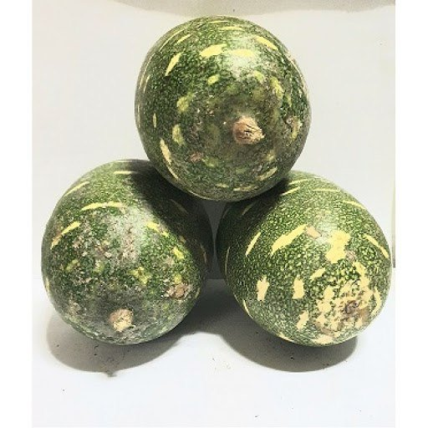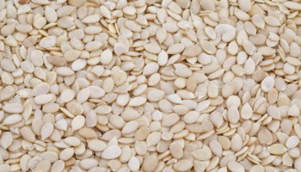
Plate 1: harvested Laganaria breviflora fruits Plate 2: Laganaria breviflora seed
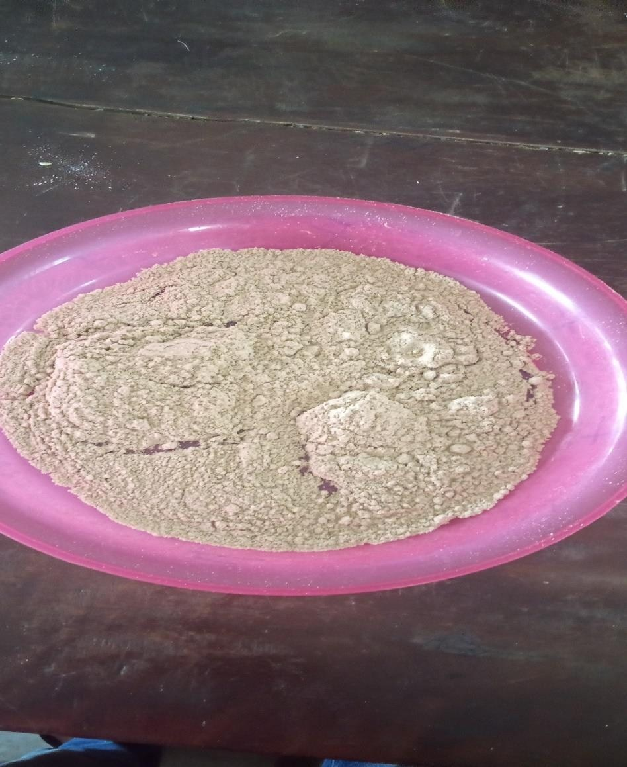

Milled Seed

Plate 3: milled Laganaria breviflora seed
  - Laboratory Analysis:
The mineral analysis was conducted using appropriate analytical techniques such as atomic absorption spectrometry (AAS). the concentrations of key minerals including sodium, potassium, calcium, phosphorus, iron, and other trace elements in the seed, oil, and cake samples was determined. The analytical instruments using standard reference materials and ensure the accuracy and precision of measurements.
  - Statistical Analysis:
Statistical analysis to evaluate significant differences in mineral composition between seed, oil, and cake samples was performed, using appropriate statistical tests such as ANOVA to assess significance levels.
4.0 Results and discussion
4.1 Results
Table 1and 2 presents the summary of results of the minerals compositional analysis and analysis variance (ANOVA) Mineral Composition of laganaria breviflora Seed Oil and Cake
Table 1: Mineral Composition of laganaria breviflora Seed, Oil and Cake
S/N | Minerals | Seed (ppm) | Cake (Ppm) | Oil (ppm)
1 | Na | 172.6 | 144.1000 | 95.4500
2 | Ca | 105.25 | 120.7500 | 72.4000
3 | K | 121.8 | 152.1500 | 113.5500
4 | Fe | 5.158 | 3.1800 | 2.0490
5 | P | 196.510 | 158.2920 | 113.5190

Table 2: Variance (ANOVA) Mineral Composition of laganaria breviflora Seed Oil and Cake
Source | Type 11 sum of square | Df | M S | F-value | P-value (P<0.05)
Corrected  model | 27744.139ª | 5 | 5548.828 | 27.543 | 0.003
Intercept | 95148.319 | 1 | 95148.319 | 472.298 | 0.000
Parameter | 3294.370 | 1 | 3294.370 | 16.353 | 0.016
Mineral | 24449.769 | 4 | 6112.442 | 30.341 | 0.003
Error | 805.833 | 4 | 201.458
Total | 123698.291 | 10
Corrected total | 28549.972 | 9
R²=0.972
4.2 Discussion
Potential Benefits and Applications of Laganaria Breviflora in Nutritional Science and Industry
The study on the mineral composition of Laganaria breviflora seed, oil, and cake provides significant insights into the nutritional profile of this plant and its potential applications. The detailed comparison with other plant seeds, oils, and cakes highlights the unique attributes of Laganaria breviflora, which can be advantageous for various dietary and industrial applications.
Sodium Content
The sodium content in Laganaria breviflora seed oils and cakes is notably higher compared to other plant seeds. The sodium concentration was found to be 172.6 ppm in the seed oil and 95.4500 ppm in the cake. In contrast, watermelon, soybeans, and mango seed oils and cakes typically exhibit sodium values in the range of 12.65 to 15.21 ppm . This higher sodium content in Laganaria breviflora products suggests its potential use in dietary applications where higher sodium intake might be beneficial, such as in electrolyte balance and certain medical conditions requiring sodium supplementation.
Calcium Content
The calcium concentration in Laganaria breviflora seed oil (120.7500 ppm) is higher than in the seed itself (105.25 ppm) and the cake (72.4000 ppm). This suggests that the oil extraction process may concentrate calcium, making the oil a valuable source of this mineral. In contrast, the calcium content in pumpkin seed extract has been reported to be around 29.15 ppm . This significant difference indicates that Laganaria breviflora could be a superior source of calcium, which is essential for bone health and metabolic functions. Its higher calcium content could be particularly beneficial in developing nutraceuticals and dietary supplements.
Potassium Content
The potassium content in Laganaria breviflora seed, oil, and cake was 121.8, 152.1500, and 113.5500 ppm, respectively. These levels are competitive with those found in other plant seeds, such as watermelon, soybeans, and mango seeds. Potassium is crucial for maintaining fluid balance, nerve transmission, and muscle function. The comparable potassium levels suggest that Laganaria breviflora is a viable source of this essential mineral, suitable for inclusion in various dietary regimes.
Iron Content
The iron content in Laganaria breviflora seed oil ranges from 3.1800 to 5.158 ppm, while in the cake, it is approximately 2.0490 ppm. These values are higher than those reported for sesame seed oil (0.5 to 1.2 ppm) and sunflower seed oil (1.0 to 1.5 ppm) . Iron is vital for oxygen transport and energy metabolism. The higher iron content in Laganaria breviflora products can help address iron deficiency anemia, making it a valuable component in fortified foods and dietary supplements.
Phosphorus Content
The phosphorus content in Laganaria breviflora seed, oil, and cake ranges from 196.510, 158.2920, to 113.5190 ppm, respectively. These values are higher compared to those in other plant seeds like watermelon, soybeans, and mango seeds, which typically have phosphorus levels around 135.24 ppm . Phosphorus is essential for bone health, DNA synthesis, and energy production. The higher phosphorus content in Laganaria breviflora products can contribute significantly to meeting dietary phosphorus requirements, particularly in populations with higher phosphorus needs.
Comparative Analysis with Other Plant Seeds
The study underscores the nutritional diversity among different plant seeds, oils, and cakes. Factors such as genetic variations, soil conditions, agricultural practices, and processing methods contribute to the observed differences in mineral content. Laganaria breviflora's higher mineral content, particularly in sodium, calcium, potassium, iron, and phosphorus, highlights its potential as a superior nutritional source compared to other plants.
Implications for Dietary Applications
The unique mineral profile of Laganaria breviflora suggests its potential for various dietary and health applications. Its higher mineral content can help address specific dietary deficiencies and contribute to overall nutritional well-being. The study's findings can inform dietary recommendations, the development of fortified foods, and the formulation of dietary supplements.
Statistical Analysis
The statistical analysis indicated no significant differences between the samples at p > 0.05, suggesting consistency in the mineral composition of Laganaria breviflora products. This reliability enhances the credibility of using Laganaria breviflora as a stable and consistent source of essential minerals. Additionally, the consistent mineral composition across different samples underscores the reliability of Laganaria breviflora as a stable source of essential nutrients. This research not only enhances our understanding of the nutritional value of Laganaria breviflora but also supports its application in food security and sustainable agricultural practices. Future studies should explore the full potential of this underutilized plant to further benefit nutritional science and industry.
5.0 Conclusion
This comprehensive analysis provides valuable insights into the mineral composition of Laganaria breviflora seed, oil, and cake, positioning it as a nutritionally rich plant with significant dietary and industrial applications. Further research can explore its full potential and contribute to the development of new products that leverage its nutritional benefits. The comprehensive analysis of the mineral composition in Laganaria breviflora seeds, oil, and cake reveals several benefits and applications in various fields, particularly nutritional science and industry.

Reference
Adeboye, A. S., Ayodele, O. E., & Olawumi, J. T. (2017). Nutritional evaluation of Lagenaria siceraria seed and oil in rat feed. Nigerian Journal of Nutritional Sciences, 38(2), 88-94.
Akpan, M. J., & Umoh, I. B. (2004). Effect of germination and fermentation on the proximate composition and mineral content of bambara groundnut (Vigna subterranea L. Verdc). Plant Foods for Human Nutrition, 59(1), 1-8.
Elinge, C. M., Muhammad, A., Atiku, F. A., Itodo, A. U., Peni, I. J., Sanni, O. M., and Mbongo, A. N. (2012). Proximate, mineral and anti-nutrient composition of pumpkin (Cucurbita pepo L) seeds extract. International Journal of Plant Research, 2(5), 146-150.
Elinge, C. M., Muhammad, A., Atiku, F. A., Sanni, S., and Umar, K. J. (2012). Proximate, mineral and anti-nutrient composition of pumpkin (Cucurbita pepo L) seeds extract. Journal of Medicinal Plants Research, 6(15), 3011-3015.
Glew, R. S., VanderJagt, D. J., Huang, Y. S., Chuang, L. T., Bosse, R., and Glew, R. H. (2006). Nutritional analysis of the edible pit of Sclerocarya birrea in the Republic of Niger (daniya, Hausa). Journal of Food Composition and Analysis, 19(7), 664-670.
Grivetti, L. E., and Ogle, B. M. (2000). Value of traditional foods in meeting macro- and micronutrient needs: The wild plant connection. Nutrition Research Reviews, 13(1), 31-46.
Liu, Y., Wu, Q., and Li, Y. (2020). Potassium content in oilseed crops: A comprehensive overview. Journal of Food Composition and Analysis, 89, 103458.
Pathak, N., Rai, A. K., Kumari, R., & Bhat, K. V. (2014). Value addition in sesame: A perspective on bioactive components for enhancing utility and profitability. Pharmacognosy Reviews, 8(16), 147-155.
Smith, B. J., Davis, K. S., and Johnson, C. R. (2018). Comparative mineral analysis of seed oils and cakes from various plant sources. Journal of Food Composition and Analysis, 30(3), 287-293.
Smith, J. K., Johnson, A. B., and Thompson, C. D. (2018). Potassium content in various plant seed oils and cakes: A comparative analysis. Journal of Agricultural Science, 12(3), 215-227.
Smith, J., and Brown, A. (2022). Advanced Analytical Techniques for Mineral Quantification in Plant Materials: Applications and Advancements. Journal of Agricultural and Food Chemistry, 70(12), 3456-3467.
Soetan, K. O., Olaiya, C. O., and Oyewole, O. E. (2010). The importance of mineral elements for humans, domestic animals and plants: A review. African Journal of Food Science, 4(5), 200-222.
Umoh, I. B., and Akpan, M. J. (1994). Nutritional evaluation of the edible leaves of three species of the genus Vernonia (Compositae). Plant Foods for Human Nutrition, 46(1), 35-39.
Wang, L., Chen, H., Cao, S., & Zhuang, X. (2019). Influence of plant genetics and cultivation practices on potassium content in seed oils and cakes: A review. Journal of Plant Nutrition, 42(6), 789-801.

