EFFECT OF BETEL NUTS AND TOBACCO DERIVATIVES ON ANTIOXIDANTS AND MICRONUTRIENTS IN ORAL SUBMUCOUS FIBROSIS AND ORAL CANCER PATIENTS IN GUJARAT POPULATION

ABSTRACT

Objective: In our previous study, we have find the significance of biochemical markers between precancerous and cancerous subject with normal healthy individuals in Gujarat population, taking into consideration the severity of biochemical markers in cancerous condition. We felt that other than comparison, effect of betel nuts and tobacco derivatives on antioxidants and micronutrients has required further evaluation to develop a better understanding. The objective of the present study is to measure the interdependence of antioxidants and micronutrients in oral submucous fibrosis and oral cancer patients and find its significance.
Method: In this study, a total of 150 patients in which 50 diagnosed PMD patients and 50 diagnosed oral cancer patients with 50 healthy non-tobacco consuming were selected as a control group. Five to seven milliliters of venous blood was collected under aseptic precautions with patients consent. All the parameters were analyzed by standard methods using fully auto-analyzed with a ready-to-use kit.
Result: This research was conducted on 150 patients, out of which 50 diagnosed potential malignant disorder patients and 50 oral squamous cell carcinoma patients matched with 50 healthy control individuals. Average age of patients with PMD and OSCC was 55.6±9.74-and that of control group was 35.83±8.90 years. Student t-test showed that there was a significant difference between the two groups with regard to age. Of the 100 patients with PMD, 72 (72% of total) were men and 28 (28% of total) were women. Among the individuals in the control group (n=50), 35 persons (70% of total) were men and 15 (30% of total) were women. Chi-square test showed that there was no significant difference between the two groups in terms of sex (p=0.891). The copper levels of PMD and OSCC, respectively, were 153.57±7.68 and 164.43±15.75. The value was statistically compared with OSCC which had significantly higher levels than healthy control (102.53±22.1). The iron levels of PMD and OSCC, respectively, were 77.62±15.27 and 50.04±19.97. The value was statistically compared with OSCC which had significantly lower levels than (138.4±13.2) healthy control. The Vitamin C levels of PMD and OSCC, respectively, are 0.55±0.10 and 0.44±0.9. The value was statistically compared to the OSCC which had significantly lower than 1.09±0.17 control. The Vitamin E levels of PMD and OSCC, respectively, 1.18±0.16 and 0.8±0.12 values were statistically compared the OSCC which had significantly lower levels than (1.39±3.64) healthy control.
Conclusion: In our finding, Vitamin C showed positive correlation with serum iron and serum copper with malignant disorders. Trace elements and antioxidants exhibited interdependence in both physiologic and pathologic states such as oral cancer.
Keywords: Ascorbic acid, Alpha-tocopherol, Copper, Iron, Pre-malignant disorders, Oral squamous cell carcinoma

INTRODUCTION
Oral cavity cancer is one of the ten most frequent cancers in the world as 25% of all malignancies are found most commonly in middle-aged and older individuals in the oral cavity [1]. From an epidemiological and clinicopathological perspective, “oral cancer” can be divided into three categories: Carcinoma of oral cavity proper, carcinoma of the lip, and carcinoma of oropharynx. Intraoral and oropharyngeal tumors are more common among men than women, with a male: female ratio of over 2:1 [2]. However, the disparity in the male: female ratio has become less pronounced over the past half century, probably because women have been more equally exposing the solve to known oral carcinogens such as tobacco and alcohol [3]. Tobacco (both smoking and chewing) is the predominant cause of oral disorders. Tobacco derivatives are kept in buccal mucosa in oral cavity which contact with mucous membranes, through which nicotine is absorbed. This continuous local irritation in oral cavity by pan masala, gutkha, or areca nut can lead to injury- related chronic inflammation, oxidative stress, and cytokine production which increase the production of reactive free radicals as well as eliciting immune suppression [4]. Antioxidant can inhibit reactions of tobacco-specific carcinogens which undergo specific activation and
detoxification process [5]. Several antioxidants and trace elements in the human body are interdependent. Trace elements such as zinc, copper, iron, and selenium act as essential components of antioxidant enzyme. Copper and zinc act as cofactors for the proper functioning of superoxide dismutase (anti-oxidative enzyme). Ascorbic acid is required for the absorption of iron [6]. Tocopherol is an effective antioxidant at high levels of oxygen, protecting cellular membranes from lipid peroxidation [7]. The individual roles of these micronutrients and antioxidants have been studied previously [8]. However, besides evaluation, the correlation and interdependence that existed among these parameters require further evaluation to develop a better understanding. This study was conducted to evaluate the significance and correlation between the levels of copper, iron, ascorbic acid, and tocopherol in serum.

METHODS
The study was conducted in the Department of Biochemistry, Pramukh Swami Medical College, Karamsad, with the collaboration of Oral Diagnosis Department Civil Hospital, Ahmedabad. The study was approved by the Departmental Research Committee (DRC) in

October 2016. A written informed consent in the vernacular language was obtained from all the participants, upon fulfilling the inclusion criteria. This study was analytical (observational case-control study); it was completed between 4/4/2014 and 27/3/2019.
Table 1: Comparison of serum copper and iron levels in the study groups
Parameter | N | Mean (μg/dL) | SD | F(ANOVA) | p
Copper (HC) | 50 | 102.53 | 22.1
PMD | 50 | 153.57 | 7.68 | 2.24 | <0.01*
OSCC | 50 | 164.43 | 15.75
Iron | 50 | 138.4 | 13.2
PMC | 50 | 77.62 | 15.27 | 0.48 | <0.002**
OSCC | 50 | 50.04 | 19.97
*indicates a significant value (p <0.05),** indicate a highly significant (p<0.001). The comparison to mean and SD of healthy control between both study groups indicates that the copper levels are elevated in oral squamous cell carcinoma (OSCC) patients compared to pre-malignant disease (PMD) patients due to excessive consumption of tobacco, gutkka, pan masala, and its additives. Serum iron levels are decreased in OSCC patients compared to pre-malignant disease patients due to the defect in DNA synthesis and oxidative metabolism.

Inclusion criteria
Under the subject expert, diagnosed cases of pre-malignant disorders patients (PMD) and oral squamous cell carcinoma (OSCC) patients were included in the study from the department of oral diagnosis. 20–65- year age group of patients was selected; those are tobacco and betel nut chewers, smokers, gutka, pan masala, and preferred areca nuts and its additives.

Exclusion criteria
Patients with all the other types of cancers and oral complications will be excluded from the study.

Study design
Analytical (observational case–control study). Sample size was calculated by the reference article.
Table 2: Comparison of serum ascorbic acid tocopherol in the study groups
Parameter | N | Mean (mg/dL) | SD | F(ANOVA) | p
Healthy control
Ascorbic acid | 50 | 1.09 | 0.17
PMD | 50 | 0.55 | 0.10 | 27.09 | < 0.001*
OSCC | 50 | 0.44 | 0.9
Tocopherol | 50 | 1.39 | 3.64
PMD | 50 | 1.18 | 0.16 | 40.6 | 1.03
OSCC | 50 | 0.8 | 0.12
*indicates a significant value (p<0.05), * indicate a highly significant (p<0.001)**

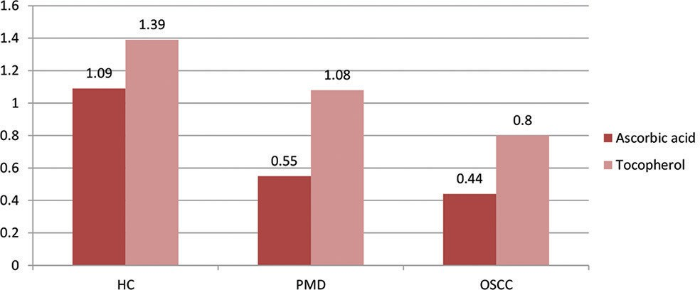
Total 150 Study participants were selected in our study between the age group of 20 to 60 years old those who were already reported to the department of oral diagnosis OPD. Out of the 150 study subjects, the control group consisted of 50 healthy controls (Group HC) with no history of systemic diseases or prescription medication intake. The second group consisted of 50 patients with potentially malignant oral disorders (referred to as group PMD), which were clinically diagnosed and histopthologically evaluated (this comprised 50 cases of oral submucous fibrosis and 50 patients with oral leukoplakia). The third group, referred to as OSCC, consisted of 50 patients with oral squamous cell carcinoma. Patients with a previous history of malignancy or history of antioxidant/ micro-nutrient medications were excluded from this study.

Biochemical Parameters: 5 ml of venous blood sample in the fasting state was collected under aseptic precautions. Vitamin C (ascorbic acid) and Vitamin E (α-tocopherol, copper, and iron were selected for the study. All the parameters were analyzed by standard methods by using fully autoanalyzed (EM-200) with ready-to-use kit.

Statistical analysis
All data were expressed as mean and standard deviation; SPSS 17 program was used for the analysis. The statistical significance of the mean in the subject and control groups was assessed using the paired Student +t-test. Correlations were computed based on Pearson’ correlation analysis. A significant level of 95% was chosen for all tests p<0.05. For student t-test, the significance was represented as p< 0.001, where it was considered highly significant.

RESULT
Among the confounding factors, the mean age of the subjects with OSMF and OL in group PMD was significantly different, which could be due to the prevalence of Gutkha (tobacco) chewing habits among younger individuals. There was a significant increase serum copper in groups PMD and OSCC when compared to group HC. There was a significantly decrease iron level in groups PMD and OSCC when compared to group HC (Table 1). Similarly, there was a significant decrease serum ascorbic acid and tocopherol levels in groups PMD and OSCC when compared to group HC due to increased lipid peroxidation (Table 2). Serum copper and ascorbic acid showed a significantly positive correlation (r=0.96, p=0.001*). Fig. 1 similarly serum iron and ascorbic acid shows strong correlation (r=0.99, p=0.002**) (Fig. 2).

The comparison mean and SD of healthy control between both study groups indicates that the ascorbic levels are decreased in oral squamous cell carcinoma (OSCC) patients compared to pre-malignant

Fig. 1: Comparison of mean and SD between study groups in antioxidant status. HC: Healthy control, PMD: Pre-malignant disorder, OSCC: Oral Squamous cell carcinoma
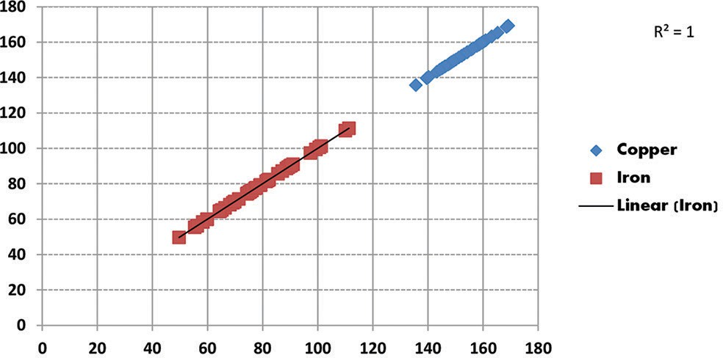
Fig. 2: The strong positive correlation (R2=1) between serum
copper and iron in malignancy

disease (PMD) patients due to the defect in collagen metabolism. Serum tocopherol (Vitamin E) levels are decreased in OSCC patients compared to pre-malignant disease patients due to increase free radicals the defect in DNA synthesis and oxidative metabolism.

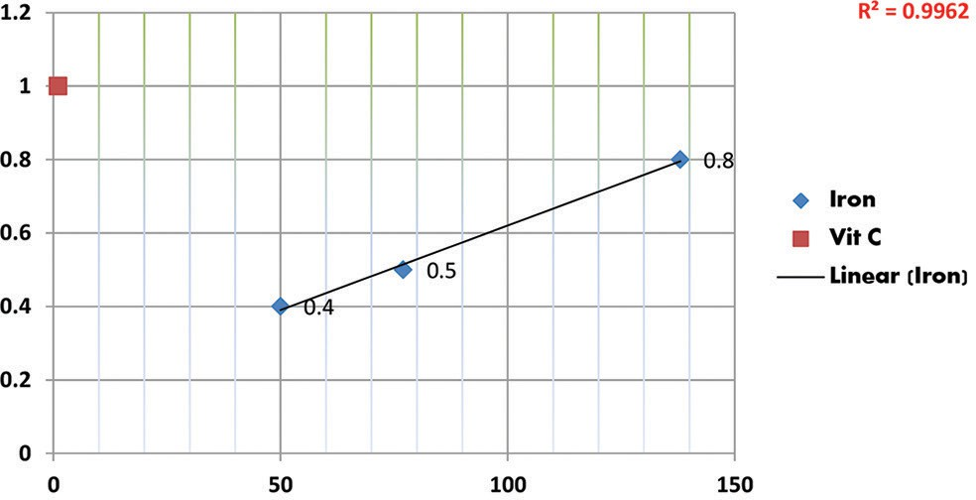
CONCLUSION
In our earlier studies, we highlighted the comparison of various biochemical parameters such as serum trace elements and micronutrients in patients with oral carcinoma and potentially malignant oral disorders. The results from the current study show the strong positive correlation between serum copper and iron in malignancy and show the positive correlations between serum ascorbic acid and serum iron in malignancy conditions. Our findings showed that trace elements and antioxidants exhibited interdependence in serum in both physiologic and pathologic states such as potentially malignant oral disorders and oral squamous cell carcinoma.

Fig. 3: The positive correlations (R2=0.996) between serum
ascorbic acid and serum iron in malignancy condition

Fig. 1 depicts that level of Vitamin C and Vitamin E is gradually decreased than healthy control due to the damaged epithelium in oral cavity.

DISCUSSION
In this study, we found an association between the use of tobacco and oral squamous cell carcinoma, after adjusting for pre-malignancy disorders, tobacco chewing, paan, areca nut contains arecoline and other alkaloids that are converted into N-nitroso compounds are carcinogenic [5]. The association of tobacco and oral squamous cell carcinoma has been elusive because most people who use tobacco are a well-established risk factor for oral carcinoma [6]. Iron has been recognized as an important element for the maturation of epithelium and it is well documented that iron deficiency is associated with epithelial abnormalities in addition to malignancies in the mouth [7]. In our study, which is mentioned above in Table 1, it was found that PMD had significantly lower levels of iron than healthy control due to the utilization of iron in collagen synthesis, and lack of iron in the tissue results in decreased vascularity which facilitates percolation of arecoline which increases fibroblastic proliferation and collagen formation [8]. According to Table 1 which is mentioned above, serum copper levels were found to gradually increase in PMD and OSCC patients than normal healthy controls. This may be explained on the basis of areca nut because areca nut has high level of copper and also deficient oxidative mechanism is increased in levels of copper than control and the probable region is that copper has been associated with tissue fibrinogenesis through copper-dependent enzyme lysyl oxidase which has an essential role in the cross-linking collagen [9,10]. Vitamin C levels decreased in both OSCC and PMD patients as compared to healthy controls due to defect in collagen metabolism. Vitamin C gets utilized in the conversion of proline into hydroxyl-proline and lysine to hydroxyl-lysine which requires ferrous iron and Vitamin C [11]. Fig. 3 shows the positive correlations (R2=0.996) between serum ascorbic acid and serum iron in malignancy condition. Vitamin E exhibits antioxidant properties by acting as a lipid- soluble free radical scavenger in cell membranes involved in initiation and promotion stages [12]. Vitamin E inhibits the formation of the carcinogenic chemical nitrosamine from nitrites [5]. Vitamin E goes down in premalignant diseases and carcinoma patient compared to healthy control patients due to gradually increased free radicals leads to cell damage in oral cavity. Evidence is increasing that free radical reactions are implicated in the development of degenerative diseases.

REFERENCES
- Neville BW, Damm DD, Allen CM, Bouquot JE. Oral and Maxillofacial Pathology. 2nd ed. Philadelphia, PA: Saunders; 2002. p. 337-69.
- Borse V, Konwar AN, Buragohain P. Oral cancer diagnosis and perspectives in India. Sens Int J. 2020;1:100046.
- Silverman S Jr., editor. Epidemiology. In: Oral Cancer. 4th ed. Hamilton, Ontario, Canada: BC Decker Inc; 1998. p. 1-6.
- Sudarshan R, Annigeri RG, Vijayabala GS. Pathogenesis of oral submucous fibrosis: The past and current concepts. Int J Oral Maxillofac Pathol. 2012;3(2):27-36.
- Chandra Mouli PE, Senthil B, Parthiban S, Malarvizhi AE, Priya R, Subha R. Antioxidants and its role in oral cancer-a review. Indian J Sci. 2012;1(2):113-5.
- Lal H, Pandey R, Aggarwal SK. Antioxidant vitamins and chemoprevention. Indian J Clin Biochem. 1999 Jan;14(1):1-11.
- Rai B, Kharb S, Jain R, Anand SC. Salivary vitamin E and C in lichen planus. Gomal J Med Sci. 2008;6(2):91.
- Patel M, Haridas N. A comparative study of biochemical markers in precancerous and cancerous subjects with normal healthy individuals in Gujarat Population. Int J Clin Biochem Res. 2017;4(4):408-12.
- Mathew P, Austin RD, Varghese SS, Manojkumar. Estimation and comparison of copper content in raw areca nuts and commercial areca nut products: Implications in increasing prevalence of oral submucous fibrosis (OSMF). J Clin Diagn Res. 2014 Jan;8(1):247-9.
- Trivedy C, Baldwin D, Warnakulasuriya S, Johnson N, Peters T. Copper content in Areca catechu (betel nut) products and oral submucous fibrosis. Lancet. 1997;349:1442-52.
- Chambial S, Dwivedi S, Shukla KK, John PJ, Sharma P. Vitamin C in disease prevention and cure: An overview. Indian J Clin Biochem. 2013 Oct;28(4):314-28.
- Iqubal MA, Khan M, Kumar P, Kumar A, Ajai K. Role of vitamin E in prevention of oral cancer: A review. J Clin Diagn Res. 2014 Oct;8(10):ZE05-7.

