A Peptide Mimetic of Sialic Acid(α2,3)Galactose with Anti-Inflammatory Activity

Short title: Peptide mimetic of sialic acid-galactose

ABSTRACT

A tetravalent peptide with the functional sequence NPSHPLSG, designated svH1C, binds with high avidity to lectin-type receptors specific for structures that contain sialic acid (5-acetylneuraminic acid, Neu5Ac). The peptide binds preferentially to siglecs that bind Neu5Ac(α2,3)Gal and Neu5Ac(α2,8)Neu5Ac(α2,3)Gal sequences, including the sialyl Lewis^{x} (sLe^{x}) structure. Physical properties of the peptide indicated that svH1C is a flexible structure that binds with high avidity in the glycan binding site in an ‘induced-fit’ conformation. Peritoneal populations of immune cells in C57BL/6 mice were increased 2- to 6-fold after three alternate-day subcutaneous injections. Incubation of neuraminidase-treated, human peripheral blood mononuclear cells with biotin-tagged svH1C resulted in substantial binding of the peptide to a subset of the CD14⁺ monocyte population. Phagocytic activity of adherent cells (monocytes and macrophages) from PBMC cultures was activated by incubation svH1C. Predictions by molecular modeling suggest that the peptide binds to Siglec-1 and P- and E-selectins with avidities that are expected to mitigate neutrophil-driven inflammation. Severe lipopolysaccharide-induced inflammation in the skin of mice was resolved in two weeks by daily subcutaneous injections of 1 nmol/g body weight. These results support the conclusion that svH1C mimics Neu5Ac(α2,3)Gal sequences and interacts with glycan binding sites of specific receptors with avidities sufficient to induce anti-inflammatory responses at low concentrations.

Keywords: Sialic acid mimetics, Siglecs, Selectins, NKG2D, STAT6, Phagocytosis, Inflammation, Neutrophils

- INTRODUCTION
An inflammatory response to injury, environmental irritants, or infections can often be traced back to the prime cause and usually treated effectively. Severe neutrophil- and T cell-driven dermatoses cause lesions that are difficult to treat and heal slowly [1-3]. However, the causes of progressive inflammatory, neurodegenerative diseases such as multiple sclerosis (MS) and amyotrophic lateral sclerosis (ALS) are less clear, although they often involve mutations or an autoimmune response [4-6]. A common feature of these diseases is an infiltration of inflammatory neutrophils and subsequent tissue deterioration. Treatment is usually confined to containing the disease and preventing progression. Drugs are being sought that provide relief without the side-effects of long-term use of steroids to reduce inflammation [5-7].
An extensive number of lectin-type cell surface receptors regulate activity of immune cells and offer potential therapeutic targets [8-13]. Receptors that bind sialic acid-containing glycans are members of a large family of glycan-specific, I-type lectins of which the best characterized members are siglecs (sialic acid-binding immunoglobulin-like lectins) that bind sialic acid and modulate cellular signaling events and maturation of immune cells [11,12]. The surface of most cells is abundantly decorated with sialylated glycans and thus these receptors can bind glycan ligands on the same cell (cis) or on neighboring cells (trans). The siglec family in humans comprises 14 different proteins, 13 of which are expressed on various cells of the immune system. Most siglecs, in particular Siglec-1 (CD169, Sialoadhesin) [14], Siglec-2 (CD22) [15], Siglec-3 (CD33) [16], and Siglec-5 (CD170) [17] undergo endocytosis upon binding of sialylated ligands [12]. Most siglecs contain an inhibitory ITIM (immunoreceptor tyrosine-based inhibitory motif) sequence in their cytoplasmic domain, except for Siglec-1, -14, -15 and -16, which lack a cytoplasmic inhibitory domain and function in conjunction with an activating adaptor protein, DAP10 or DAP12, that contains an ITAM (immunoreceptor tyrosine-based activation motif) [11,17-19]. Upon ligand binding, the ITIM is phosphorylated and recruits the phosphatase SHP-1, which inactivates signal transduction pathways by dephosphorylation [10-12].
Some receptors have non-glycan ligands in vivo yet contain a lectin-like domain. The receptor NKG2D is expressed on natural killer (NK) cells, γδ T cells and CD8⁺ cytotoxic T cells and is regulated by endogenous polypeptide ligands such as MICA/B, ULBP, Rae-1 or H60 [20-22], but NKG2D also contains a lectin domain that binds Neu5Ac(α2,3)Gal sequences [23]. Receptors of major therapeutic interest are the P-, E- and L-selectins, which bind specifically to the sialyl Lewis^{x} (sLe^{x}) structure (Neu5Ac(α2,3)Gal(β1,4)[Fucα1,3]GlcNAcβ). Siglec-5 binds α(2,3)- or α(2,6)-linked sialosides with K_{D} values of 8.7 and 8.0 mM, respectively, and a K_{D} for α(2,8)-linked disialic acid of 25 mM [24]. However, multivalent, polyacrylamide-conjugated sialosides with α(2,3)- or α(2,6)-linkages were bound with a K_{D} of 2 to 4 μM, whereas the K_{D} for α(2,8)-linked multivalent disialic acid structures was 0.4 μM. Searches for higher affinity ligands for these receptors led to synthesis of a series of sialic acid-containing glycopeptides that bind with affinities in the micromolar range [25-29]. The glycan itself has low affinity but was retained to provide targeting specificity of binding. Complex multivalent structures were designed that included a peptide component derived from the binding site of Siglec-1 and P-selectin, which increased avidity and achieved K_{D} values in the nanomolar range [30-34].
Because siglecs are important regulators of the immune system, ligands with high affinity should provide valuable tools to address therapeutic opportunities [13,35,36]. A question of interest is how to design druggable ligands that bind to these regulatory receptors with sufficient avidity and specificity to achieve manipulation of the immune system under the extensive canopy of cell surface glycoproteins. We asked whether short peptides can mimic the ligands of lectin receptors, including siglecs, for this purpose. Peptide mimetics of sugars have potential advantages over glycans and glycopeptides because of the ease of chemical synthesis, their flexibility, and favorable physical properties. Many peptides that mimic sugars have been identified [35-43]. Some peptides can functionally mimic a sugar, such as those with the consensus core sequence YPY that inhibit the mitogenic activity of the Man-specific lectin concanavalin A, yet bind at a site different from the saccharide-binding site [44,45]. Peptide mimetics of carbohydrate antigens have been studied as vaccines to elicit antibodies against sugar antigens, including those on the surface of HIV, and complex oligosaccharides [38,42].
We initially identified several sequences of amino acids that bound to specific lectins by screening phage display libraries [35,46,47]. Sequences were further refined by in silico modeling of docking of a peptide into the sugar binding site of the crystal structure of lectins. These studies predicted that several short peptide sequences, 5 to 8 amino acids in length, would have significant affinity to lectins chosen as analogs of cell-surface receptors. The sequences identified by this approach were incorporated into tetravalent structures, a design based on the concept of avidity as a function of ligand density and entropic factors [48-50], and to accommodate the possibility that cross-linking of receptors may be required for modulation of signal transduction pathways [51,52]. In binding assays, the peptide with the sequence HPSLK had characteristics of a general sugar mimetic and bound to several lectins that bind monosaccharides such as sialic acid, Gal, GalNAc or fucose with avidities several orders of magnitude higher than their natural ligands [35,53]. When the HPSL core was retained but the peptide lengthened to NPSHPSLG, and in particular the inversion of SL→LS to generate NPSHPLSG (designated svH1C), the peptides did not bind significantly to lectins that bound monosaccharides but bound strongly to those specific for di- or tri-saccharides that terminate with Neu5Ac(α2,3)Gal or Neu5Ac(α2,8)Neu5Ac(α2,3)Gal. Addition of svH1C to cultures of human peripheral blood mononuclear cells (PBMCs) activated endocytosis of opsonized microspheres by adherent cells (monocytes and macrophages) [35,53]. Additionally, svH1C stimulated phosphorylation of STAT6, an indication that the peptide triggered a receptor-mediated signal transduction pathway [53]. These observations suggested that the peptide has biological activity and may bind productively to specific receptors. As a step to further understand the mechanism of action of svH1C, we hypothesized that, as a mimetic of Neu5Ac-Gal, the peptide will bind to other receptors that have sites specific for these sugars such as selectins and NKG2D.
The amino acid residues in the binding sites of many lectin-type receptors have been identified. Although the protein structures obtained from data bases are rigid, the validity of the in silico approach to predictions of binding energies for peptides is supported by the concept that flexible ligands adapt to specific conformations of a binding site according to the ‘induced-fit’ hypothesis [54]. To confirm that the peptide interacted with a glycan binding site from a flexible, non-structured conformation, CD and NMR spectra of svH1C were examined. Although an unusual CD signal was observed at elevated concentrations, a specific structure for the peptide was not observed by NMR spectroscopy [47]. We designed solid-phase assays in which binding of biotin-tagged svH1C to recombinant receptors occurred under conditions in which the peptide sequences retained full flexibility. We explored with CABS-dock software [55,56] whether in silico modeling would predict the binding revealed by crystallography. Whereas ligands that contain the glycan required a peptide adduct to reach high avidity, svH1C achieved this goal itself. Furthermore, svH1C induced activation and proliferation of immune cells in the peritoneal cavity of mice and resolved inflammation in the skin that was induced by topical lipopolysaccharide (LPS).

- MATERIALS AND METHODS
  - Ethics Statement
The animal studies were conducted at Biomodels LLC (Waltham, MA), an Association for Assessment and Accreditation of Laboratory Animal Care accredited facility in Watertown, MA. Approval for this work was obtained from Biomodels LLC Institutional Animal Care and Use Committee (protocol number 17-0613-4). Female C57BL/6J mice aged 10 weeks were obtained from The Jackson Laboratory (Bar Harbor, ME) and housed at Biomodels LLC. The studies were performed in animal rooms provided with HEPA filtered air at a temperature of 21+/-3°C and 50+/-20% relative humidity. Animal rooms were set to maintain a minimum of 12 to 15 air changes per hour. The room was on an automatic timer for a light/dark cycle of 12 hours on and 12 hours off with no twilight. A cage card or label with the appropriate information necessary to identify the study, dose, animal number, and treatment group marked all cages. Animals were identified by an ear punch corresponding to an individual number. Animals were fed with a sterile Purina Labdiet 5053 rodent diet and water was provided ad libitum. Human PBMCs were prepared from purchased discarded cellular residues of a plasma preparation procedure (TRIMA) performed on blood of anonymous donors at the Blood Centers of the Pacific, San Francisco, CA, and sold commercially for research use.

2.2 LPS-Induced Dermatitis
On day minus-1, all mice were anesthetized with inhaled isoflurane, and the hair was removed from the dorsal skin using electric clippers followed by depilation with thioglycolate and sodium hydroxide (Nair). The skin was then washed with 70% ethanol followed by PBS to ensure no depilation reagent remained. On day 0, mice were again anesthetized with inhaled isoflurane, and a 1-cm² square was drawn on the center of the back skin to direct the placement of gauze. A 1% SDS solution was applied to a 1-cm² sterile piece of gauze secured to the hair-free back skin with a bioocclusive dressing (Tegaderm). Two hours after SDS treatment, mice were again anesthetized with inhaled isoflurane, and the Tegaderm and gauze were removed. The skin was blotted dry with sterile gauze. For treatment groups, 0.1 mL of a 10 mg/mL solution of LPS (E. coli 0111:B4, catalog number L2630, MilliporeSigma, Burlington, MA) and 0.1 mL of PBS or 2 mM peptide in PBS were applied to a 1-cm² sterile piece of gauze secured to the hair-free back skin with a bio-occlusive dressing (Tegaderm). Every 3 days, the SDS application was repeated 2 hours before topical gauze application of the treatment solution, which was replaced every 24 hours with fresh LPS and peptide. On day 14, all mice were killed by carbon dioxide inhalation, and skin was collected for histological analysis.

2.3 Synthesis of svH1C
The amino acid sequence identified previously [47] as a Neu5Ac-Gal mimetic was incorporated into a tetravalent peptide that has the structure [(NPSHPLSGGGGS)₂K]₂K-NH₂. The tetravalent peptide was synthesized by CBL Biopharma (Patras, Greece) on a tri-lysine core [57] by standard procedures utilizing Fmoc (9-fluorenylmethoxycarbonyl)-protected amino acids. The sequence –GGGS- is a linker that extends the mimetic from the tri-lysine core. Modifications at the C-terminus made during synthesis consisted of an amide group (no tag) or an extension of the peptide by addition of ε-biotinyl-lysine-amide for the binding assays. The ‘arms’ were synthesized separately by solid-phase synthesis by standard chemistry and subsequently condensed in solution with the four amino groups generated by the tri-lysine core [58]. Quality of the synthetic product was assessed by HPLC and mass spectroscopy. Purity of the peptide was 97.7%, with net peptide content 73% without counter-ion and 87% when the counter-ion was included. The remaining material was largely water of hydration of the polar peptide. Solutions of the peptide in water were neutralized and passed through a 1 x 10 cm column of CM-Sephadex C-25, Na⁺ form, at pH 5 to 6 to remove trifluoroacetic acid and LPS. The peptide was eluted with 500 mM NaCl and diluted to the desired concentration with endotoxin-negative phosphate-buffered saline, pH 7.2 (PBS). Concentration was determined by the bicinchoninic acid assay (Pierce, Rockland, IL) using a dansylated peptide (extinction coefficient, ε_{mM} = 5.7 cm⁻¹ at 336 nm) as standard or with a calculated [47] svH1C extinction coefficient of 25 OD_{210 nm}/mg/mL.

2.4 Binding Assays
Isothermal microcalorimetry was performed by TA Instruments Professional Services (New Castle, DE) by titrating 10 μM NKG2D (monomer concentration) (R&D Systems, Inc., Minneapolis, MN) with 100 μM svH1C in 50 mM Tris-HCl, pH 7.5, 150 mM NaCl, 0.1 mM EDTA. Recombinant receptors were obtained from R&D Systems as chimeric proteins with the extracellular domain of the receptor containing the binding site fused at the C-terminus to the Fc domain of IgG or a His tag. The lyophilized proteins were reconstituted in PBS to 100 μg/mL. The Fc-chimeric proteins were bound to protein A/G-coated wells of microtiter plates (Pierce Biotechnology, Rockford, IL). His-tagged proteins were bound in Nickel-coated plates (Pierce). Sufficient proteins were added to wells to saturate the binding capacity of the wells. After a wash to remove unbound receptor, wells were blocked with 1% gelatin in wash buffer. Wash buffers were either 10 mM phosphate, pH 7.2; 10 mM HEPES, pH 7.4; or 50 mM Tris-HCl, pH.7.5, each in 150 mM NaCl containing 0.05% Tween-20. Biotinylated peptides were prepared as 2 μM solutions in the wash buffer and 50 μL (100 pmoles) were added to each well and incubated at room temperature for one hour. After four washes with 350 μL buffer containing 0.05% Tween-20, each assay was incubated with 50 μL of 1 μg/mL streptavidin-peroxidase (Sigma-Aldrich, St. Louis, MO). The wells were again washed four times with buffer-Tween-20 and then 50 μL peroxidase substrate (1-Step ULTRA TMB, Pierce) were added. The reaction was allowed to proceed at room temperature for 5 min, and the reaction was stopped with 50 μL of 2 N H₂SO₄ or 1 M H₃PO₄. Absorbance was measured at 450 nm and converted to the amount of streptavidin-peroxidase bound with the specific activity of the conjugate determined under the conditions of the assay. Absorbance of assays with svH1C was corrected for background levels of binding of streptavidin to the receptors in wells without a peptide or with an inactive peptide, which were less than 10% of the value with bound peptide, except for Siglec-5 and Siglec-14. Binding of streptavidin to these siglecs caused a background level of nearly 50% of binding in the presence of svH1C. For inhibition studies, fetal bovine fetuin (purity, 88%; cat. no. 341506, Calbiochem, EMD Chemicals, Philadelphia, PA) was added to the assay along with svH1C.

2.5 Binding of svH1C to Cells
PBMCs in RPMI medium containing 10% fetal bovine serum (FBS) were washed two times with RPMI medium without FBS. Cells (1 x 10⁶ in 100 uL RPMI) were digested with 10 mU α(2→3,6,8,9)neuraminidase from Arthrobacter ureafaciens (Sigma-Aldrich) for 60 min at 37°C, washed two times with cold PBS and then incubated 30 min on ice with 1 μM biotin-tagged svH1C in PBS. The cells were washed two times with PBS and stained 20 min on ice with CD3-APC, CD4-PE-Cy7, CD14-APC-Cy7, CD16-FITC, CD56-PE, plus streptavidin-PerCP-Cy5.5, washed two times with PBS and fixed with 1% formaldehyde for flow cytometry.

2.6 Phospho-Immunoreceptor Assay
Human PBMCs were incubated at a density of 2 x 10⁶ cells/mL overnight in RPMI-1640
medium supplemented with 0.1% ovalbumin, 1:100 dilution of penicillin-streptomycin solution (Mediatech, Inc., Herndon, VA), and 1 mM glutamine at 37°C and 5% CO₂. svH1C was added to a final concentration of 100 nM, and after 5 min the cells were collected by centrifugation at 500g for 2 min. The cells were lysed and spread on an array of capture antibodies against cell-surface receptors on immune cells (Human Phospho-Immunoreceptor Array, R&D Systems). The protocol for detection of phosphorylated receptors with an anti-phospho-tyrosine antibody conjugated to horseradish peroxidase and detection by chemiluminescence with x-ray film was followed as described by the manufacturer. Spots on the film were analyzed by ImageJ software.

2.7 Proliferation of Peritoneal Cells
C57BL/6 mice, 22–24 g body weight, were injected subcutaneously with 1 nmol svH1C per g on days 0, 2 and 4. On days 1, 3 and 5, primary peritoneal cells from three animals were isolated and pooled, and the populations of macrophages, dendritic cells (DCs), CD3+, CD4+ and CD8+ T cells, natural killer (NK) cells and B cells were evaluated by flow cytometry with specific biomarkers. FACS was performed using a MACSQuant Analyzer (Miltenyi Biotec, Teterow, Germany). Data were analyzed with FlowJo software, version 10.0.6.

2.8 Molecular Modeling
Molecular modeling was performed of docking of a single (monovalent) sequence into the glycan-binding site of well-characterized lectin-type, cell-surface receptors. CABS-dock software [55,56] searches without prior assignment for a binding site of a peptide on the crystal structure of a protein, accessed from the National Center for Biotechnology Information (NCBI) web site, and defines the most probable secondary structure of the peptide. The docking program ranks the 10 most likely models based on cluster density and average root mean square deviation (RMSD), a measure of the fit, after 50 simulation cycles. The models were downloaded into the docking mode of ArgusLab 4.0.1 software (Mark A Thompson, Planaria Software LLC, Seattle, WA, http://www.arguslab.com) for additional molecular dynamics calculations with which binding energies can be predicted. CABS-dock identifies the binding site as the amino acid residues within 4.5 Å from the bound ligand.

3. RESULTS
3.1 Binding of svH1C to Siglecs
Tetravalent svH1C, with the mimetic sequence NPSHPLSG, bound selectively to plant lectins from Sambucus nigra (SNA1) and Maackia amurensis (MAA) [53]. MAA is a mixture of M. amurensis leukoagglutinin (MAL) and M. amurensis hemagglutinin (MAH), both of which bind preferentially to terminal Neu5Ac(α2,3)Gal sequences on complex glycans [59]. We then assayed binding of svH1C to a selection of siglecs, which comprise a family of cell-surface receptors that are specific for Neu5Ac-Gal/GalNAc- sequences. Within this family of receptors are proteins that bind to Neu5Ac(α2,3 or α2,6)Gal, Neu5Ac(α2,6)GalNAc or Neu5Ac(α2,8)Neu5Ac(α2,3)Gal structures [9-12]. For binding assays, sufficient recombinant chimeric proteins containing a siglec domain and a Fc domain were added to protein A/G-coated microtiter wells. Recombinant Siglec-1 contained a His tag rather than a Fc domain and was bound in Nickel-coated wells. Non-specific sites in the wells were blocked with 1% gelatin-0.05% Tween-20 in the wash buffer.
Extent of binding of biotinylated svH1C to siglecs was assayed with three different buffers, either 10 mM phosphate, pH 7.2; 10 mM HEPES, pH 7.4; or 50 mM Tris-HCl, pH 7.5, each in 150 mM NaCl-0.05% Tween-20. Binding data in PBS are presented in Fig. 1. Strong binding was found with the siglecs except Siglec-2 and Siglec-3, which are specific for Neu5Ac(α2,6)Gal. Greatest binding occurred consistently with Siglec-1 and Siglec-14 regardless of the buffer composition. Siglec-1 is specific for Neu5Ac(α2,3)Gal, a specificity shared with Siglec-8 and Siglec-9. Siglec-5, -7, -11, -14 and -16 preferentially bind a disialyl ligand, Neu5Ac(α2,8)Neu5Ac(α2,3)Gal [12]. Siglec-5 and Siglec-14 apparently function as paired receptors on several types of immune cells [60].
The composition of the buffer had a significant effect on binding of peptide to individual siglecs. Interestingly, Siglec-2 and Siglec-3 bound svH1C as strongly as the other siglecs in assays with Tris buffer (data not shown). In contrast, the most discrimination of binding between the various siglecs was observed when HEPES buffer was used, with little or no binding detected to Siglec-2 or Siglec-3, which was similar to results in PBS (Fig. 1). Binding of svH1C to Siglec-7, -9, and -11 was significantly less with HEPES buffer as compared with PBS. These results suggest that the peptide binds to the siglecs with differing avidities, with only the strongest interactions surviving the extensive washes.
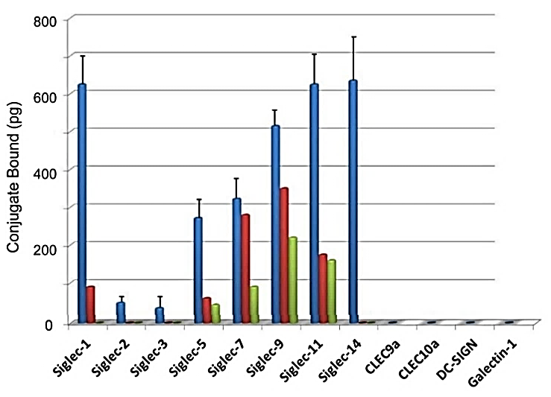
Fig. 1. Binding of biotinylated svH1C (blue) to recombinant siglecs (2.5 μg/well). The buffer in these assays was PBS containing 0.05% Tween-20. The figure shows the amount of streptavidin-peroxidase bound to svH1C that was bound to the receptors. Siglec-1 and CLEC10A contained a C-terminal His tag and were assayed in separate experiments. Galectin-1 was bound to antibody-coated assay wells. The other receptors were Fc-chimeras and were included in the same assays. SEM was determined from four independent experiments run in duplicate. Inhibition by fetuin is shown when added at 5 μM (red) or 15 μM (green). Values were corrected for binding of streptavidin-peroxidase to each siglec without peptide.

Consistent with results from binding of peptides to lectins [35,53], biotinylated tetravalent peptides with the sequence HPSLK (sv6B) and NPSHPSLG (svH1D) also bound to siglecs, although with avidity patterns different from that of svH1C (data not shown). In contrast, no binding occurred with a peptide with the structure [(VGGGSGGGS)₂K]₂K-ε-biotinyl-K-NH₂, which was used as a negative control. No binding was detected with the lectin-type receptors CLEC9A (ligand F-actin [61]), CLEC10A (specific for GalNAc [62]) or DC-SIGN (specific for Man [63]). Binding of svH1C to these receptors was not detected regardless of the buffer used. Addition of CaCl₂ and MgCl₂ (1 mM each) did not increase binding of svH1C, which suggested that binding of the peptide mimetic was Ca²⁺-independent.
Binding of the peptide was inhibited by the sialic acid-rich, multivalent glycoprotein, fetuin. Fetuin contains three N-linked and three O-linked glycans per molecule [64-68], with trisialylated or tetrasialylated termini that are linked nearly equally as Neu5Ac(α2,3)Gal or Neu5Ac(α2,6)Gal. The inhibition of binding of svH1C to siglecs confirmed that the peptide was binding in the glycan binding site. Moreover, the extent of inhibition reflected the avidity of the peptide in competition with the glycoprotein. The minimal inhibition observed with Siglec-7, -9 and -11 suggest that the peptide binds strongly to these receptors. We previously found that digestion of fetuin with neuraminidase nearly eliminated its ability to inhibit binding of svH1C to lectins [53].

3.2 Effect of svH1C on Receptor Phosphorylation
We then asked whether svH1C would alter the phosphorylation status of cell-surface
receptors. Human PBMCs were cultured overnight in RPMI-1640 medium supplemented with 0.1% ovalbumin, which was added in place of serum to minimize effects of possible regulatory factors in serum. svH1C was added to 100 nM and cells were collected after 5 min of further incubation. Cells were lysed and spread on an array of cell-surface receptor antibodies. After washes, an anti-phosphotyrosine antibody conjugated to horseradish peroxidase was added and bound antibody was detected by chemiluminescence. Sections of films corresponding to a selection of receptors are shown in Fig 2. Phosphorylation of the siglecs included on the array was decreased by more than half, with the greatest reduction on Siglecs-3, -5 and -7. As compared with samples of untreated cells, phosphorylation of other receptors with inhibitory cytoplasmic ITIMs, CD229/SLAMF3, LAIR-1 and FcγRIIA, was dramatically reduced. LAIR-1 is expressed by NK, B and T cells and contains two ITIMs. Phosphorylation of FcRH4/IRTA1 and NKp46 was not changed, while that of BLAME/SLAMF8 increased. Interestingly, phosphorylation of the phosphatase recruited by the inhibitory siglecs, SHP-1, was not decreased. The major phosphorylated protein, the ε subunit of the CD3 T cell receptor complex, was slightly reduced. These effects indicated that the peptide interacted with cells and, by inducing dephosphorylation, attenuated the activity of inhibitory receptors. Whether dephosphorylation resulted from direct binding of the peptide to each of the receptors, or because of activation of a general phosphatase such as CD45, was not determined. However, as support for the latter suggestion, we found that svH1C bound to CD45 in the type of assay described for siglecs (data not shown). Association of CD45 with Siglec-2 has been described [69] and the dephosphorylation or lack thereof may result from segregation of CD45 with some of the receptors [70].
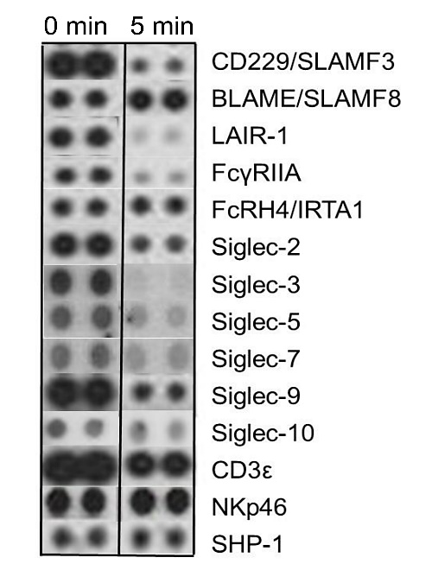
Fig. 2. Dephosphorylation of cell-surface receptors after treatment of human PBMCs with 100 nM svH1C for 5 min. The cells were collected by centrifugation, lysed, and analyzed by the Human Phospho-Immunoreceptor Array (R&D Systems). A selection of receptors from the array are compared after 0 and 5 min of incubation. This experiment was performed in duplicate two times with similar results.
3.3 Effect of svH1C on Immune Cells in vivo
To determine whether a decrease in activity of inhibitory receptors is reflected by proliferation of immune cells in vivo, svH1C was injected subcutaneously on day 0, 2 and 4 into C57BL/6 mice at a dose of 1 nmol per g body weight. Peritoneal lavage was performed to obtain primary cells 24 h after each injection from different groups of mice. We found that a large population of undifferentiated cells occurred in the peritoneal cavity of the Balb/c mouse, which seemed to be the progenitor of mature immune cells that appeared after a single injection [62]. This undifferentiated population was small In C57BL/6 mice and significant changes in mature cells did not occur in the 24 h after the first injection of svH1C. However, this injection induced the undifferentiated population, which upon the second injection on day 2 decreased concomitantly with an increase in populations of mature immune cells. As illustrated in Fig. 3, dramatic increases after the second and third alternate day injections occurred in populations of most cell types over the period of treatment. In particular, populations of DCs (CD11c⁺), NK cells (NK1.1⁺), T cells (CD3⁺), T_{H} cells (CD4⁺), cytotoxic T cells (CD8⁺), and B cells (CD19⁺) increased several-fold, including those that expressed the activation marker CD69. Memory B cells that expressed CD73, CD80 and CD273 increased significantly. Smaller increases were found with macrophages and NK cells. These results indicated that svH1C induced a significant expansion of the innate immune system in these mice.
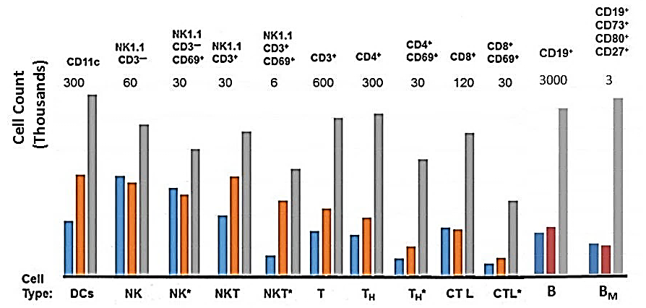
Fig. 3. Increases in populations of immune cells in the peritoneal cavity of mice. svH1C was injected subcutaneously every other day with a dose of 1 nmol/g into C57BL/6 mice. Peritoneal cells were obtained from 3 animals, pooled, and analyzed by flow cytometry. The bars show populations of specific cell types at day 1 (blue), 3 (orange) or 5 (grey) of treatment, i.e., 24 hours after each injection at day 0, 2 and 4. The markers used to identify cell types are listed across the top of the figure. The total number of each cell type was plotted, with the scale indicated at the top of each cell type in thousands. Cells are identified by the usual designations across the bottom of the figure. B_{M} indicates memory B cells. An asterisk indicates activated populations that expressed CD69 or CD86.

3.4 Binding of svH1C to Cells
To determine whether binding of svH1C to receptors could be observed with whole cells, PBMCs were incubated on ice with biotinylated svH1C in PBS for 30 min, washed with PBS, stained with labeled antibodies against cell-surface markers plus streptavidin-PerCP-Cy5.5, washed and fixed. By flow cytometry, streptavidin was detected on subsets of NK, CD4⁺ and CD8⁺ T cells (Fig. 4A). These cell types express the activating receptor, NKG2G (see below, section 3.7). However, no binding was detected with monocytes. Collins et al. [71] and Zhang and Varki [69] found that binding of multivalent sialic acid-containing glycans to B cells was detected only after digestion of the cells with neuraminidase to remove cell-surface sialic acid residues. We repeated the experiment to include a treatment of PBMCs with neuraminidase at 37°C before cooling the cells and incubating with biotin-tagged svH1C on ice. The binding step was performed on ice to prevent endocytosis of the peptide that could be mediated by siglecs [11,12]. As shown in Fig. 4C, significant binding was found among CD14⁺ monocytes after cells were treated with neuraminidase. Treatment with neuraminidase did not have a significant effect on binding of svH1C to NK, CD4⁺ and CD8⁺ T cells, which suggested that binding sites of receptors made available by the enzyme digestion were predominantly on monocytes. Histograms of samples treated with neuraminidase that was inactivated by heating in boiling water (Fig. 4B) was similar to the control without peptide.
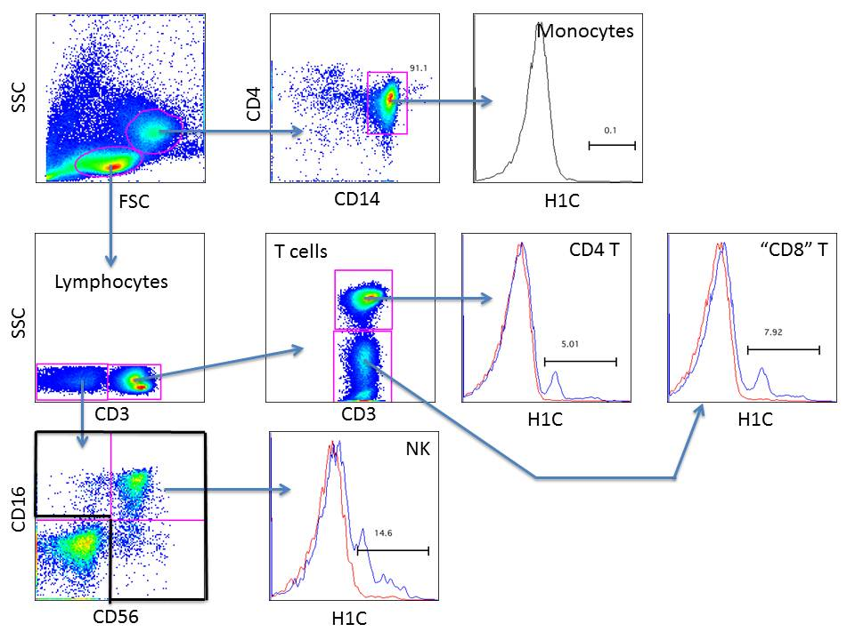
A

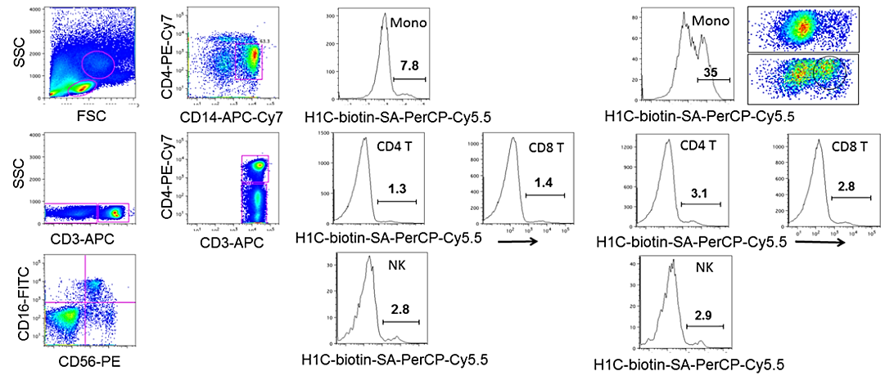
C
B
Fig. 4. Binding of biotin-tagged svH1C to various cell types in PBMCs. (A) Cells were incubated on ice with the 1 μM peptide, washed and then incubated with streptavidin tagged with the fluorescent dye PerCP-Cy5.5. Histograms show samples (red) without or (blue) with peptide. (B) Dot plots and histograms of cells in PBMC samples treated 30 min at 37°C with neuraminidase inactivated by heating 20 min in boiling water. (C) Histograms of PBMCs from the same donor as (B) after treatment with active neuraminidase. After enzyme digestion, cells were incubated 30 min on ice with 1 μM biotin-tagged svH1C, washed and incubated 30 min on ice with marker antibodies and streptavidin labeled with PerCP-Cy5.5. Histograms of the major cell populations illustrating binding to monocytes (mono) after neuraminidase digestion. The dot plot in (C) illustrates streptavidin-PerCP-Cy5.5 staining of the CD4⁺/CD14⁺ monocyte gate without (upper) or after (lower) neuraminidase digestion, with the svH1C-binding population circled, which accounted for 35% of the total monocyte population. This experiment was performed four times with similar results.

3.4 Activation of Endocytosis/Phagocytosis

Siglec-1, -14, -15 and -16 lack a cytoplasmic ITIM and function in association with cytoplasmic adaptor proteins DAP10 or DAP12, which contain ITAMs [11]. These siglecs are expressed by monocytes and macrophages [12]. The ability of the peptide to stimulate endocytic/phagocytic activity through these receptors was assayed by incubating adherent cells (monocytes and macrophages) from human PBMCs with 50 nM svH1C for 16 h and then challenging the cells with 1-μm diameter streptavidin-conjugated, Dragon green-dyed beads that were opsonized with anti-streptavidin antibodies. In Fig. 5, rows 1 and 2, are shown micrographs of cells incubated with (A) no treatment, (B) an inactive peptide svD2, (C) sv6B or (D) svH1C. Cells in each culture were also treated with wortmannin, an inhibitor of PI3K, which is an activity required for phagocytosis and macropinocytosis [53] (Fig. 5, row 3). To ensure that the dense material within the cells was engulfed beads, the cells were examined in a fluorescence microscope. As shown in Fig. 6, the dense material in cells was highly fluorescent, an indication that cells were active in phagocytosis. (Individual beads were visible at higher magnifications [35]). Phagocytosis and endocytosis are differentiated by phosphorylation by Syk kinase, Src-related tyrosine kinase (SRTK) and PI3K [53].
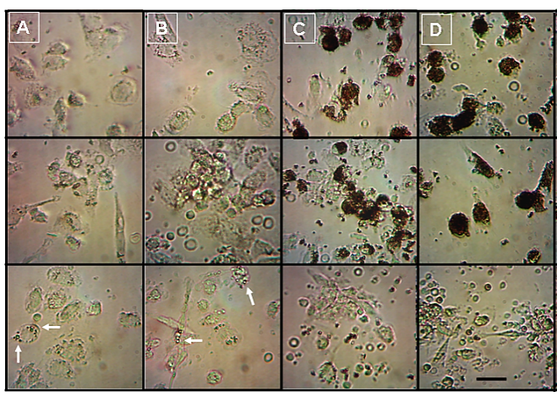
1

2

3
Fig. 5. Phagocytosis of opsonized microspheres by peptide-treated adherent cells. Cells were incubated with 50 nM peptide for 16 h, with microspheres for 60 min, and then fixed with 2% formalin. Free microspheres were removed by washing with PBS and the samples were examined by phase contrast microscopy. (A) Controls without peptide; (B) 50 nM inactive peptide svD2 (VSHQH); (C) 50 nM sv6B (HPSLK); (D) 50 nM svH1C (NPSHPLSG). Panels 1 and 2 were images from the same treatment. Samples in Panel 3 in each column also contained 100 nM wortmannin, an inhibitor of phagocytosis. Bar = 20 μm. (Reprinted from ref. 53).

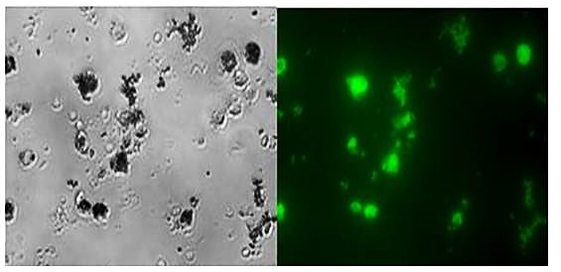
Fig. 6. Fluorescence microscopy of cells treated with peptides. Cultures were incubated with 50 nM peptide for 24 h and then challenged with microspheres for 30 min. Cells were fixed with 2% formalin, washed 3 times with PBS, and examined by phase contrast microscopy (left panel) and fluorescence microscopy with blue excitation light (right panel).

To verify that activation of phagocytosis by the peptide is independent of the antibody used for opsonization, the HIV envelope protein gp41, tagged with biotin, was bound to streptavidin-coated, polystyrene beads that were then opsonized with IgG raised against HIV envelope protein gp41. Results similar to those shown in Fig. 5 were obtained (not shown). Therefore, stimulation of macrophages with svH1C should remove any particle such as a virus to which an antibody is generated.

3.6 Phosphorylation of STAT6
A major factor in resolution of inflammation is phagocytosis (efferocytosis) of neutrophils by activated M2 macrophages [72]. Efferocytosis requires the expression by macrophages of growth arrest specific-6 (Gas6), which bridges the macrophage TAM receptors with phosphatidyl serine of apoptotic neutrophils to initiate phagocytosis. Gas6 expression is induced by activation of the anti-inflammatory transcription factor, STAT6, which is phosphorylated by JAK1 in associated with IL-4Receptor-α [73,74]. STAT6 is required to drive M2 macrophage activation during T_{H}2 cell-mediated immune responses [74]. Therefore, phosphorylation of STAT6 is a key indicator of the activity of the efferocytic pathway in macrophages. As shown in Fig. 7, the increase in phosphorylation of STAT6 suggested that svH1C stimulates a branch of the alternative activation pathway of macrophages that leads to the M2 phenotype and an anti-inflammatory response, but does not promote phosphorylation of the inflammatory factor, STAT2. sv6B stimulated phagocytosis as well as svH1C (Fig. 5) and stimulated phosphorylation of STAT2 and STAT6 (Fig. 7). However, svH1C stimulated phosphorylation of only the anti-inflammatory STAT6.
Fig. 7. Phosphorylation of STAT2 and STAT6 in response to incubation with peptide. PBMCs were cultured in filter plates without serum overnight. Cells were then treated with 50 nM peptide for 10 min and fixed. (A) STAT2; (B) STAT6. Blue bars represent (1) total or (2) phospho-STAT2 or -STAT6 in untreated cultures. Phosphorylated STAT2 or STAT6 in cultures treated with sv6B is shown in yellow and with svH1C in red. Each was assayed in duplicate using peroxidase-conjugated secondary antibodies against antibodies against total or phosphorylated STAT proteins (Active Motif ELISA kits). Absorbance was measured at 450 nm.

3.7 Binding of svH1C to NKG2D
Binding of native ligands to NKG2D results in a pro-inflammatory and cytotoxic response [75]. NKG2D is a homodimeric receptor whose recognized ligands are cell-surface proteins MICA and MICB, which are major histocompatibility complex class I homologs. Other polypeptide ligands include ULBP, Rae-1 and H60 [20-22]. Extensive studies of binding of MICA and MICB have shown that each homodimer binds a single ligand at the interface of the subunits. Thompson et al. [75] proposed that a compound that inhibits ligand binding would prevent the cytolytic activity of NK cells. They identified a small molecule that bound to human NKG2D with a K_{D} of 3.9 μM. Each subunit of NKG2D also contains a lectin-type domain that binds Neu5Ac(α2,3)Gal, including the sialyl Lewis^{x} structure [23]. With the assay as used for siglecs (Fig. 1), we found that svH1C bound strongly to NKG2D. Binding was inhibited by fetuin (Fig. 8A), with an IC₅₀ of approximately 3 μM protein. Fetuin was as effective an inhibitor of binding of svH1C to NKG2D as it was of the binding of the peptide to siglecs. From the number of multivalent glycans on each fetuin molecule, we concluded that svH1C effectively competed with natural multivalent glycan ligands for the same binding site on these receptors.
We then assayed binding of svH1C to NKG2D directly by isothermal microcalorimetry. svH1C (100 μM) was titrated into a solution of NKG2D (10 μM, subunit concentration) and changes in heat content of the system were measured. The concentration of NKG2D was introduced into the data analysis as the total number of lectin-like binding sites. The data yielded a K_{A} = 1.7 x 10⁶ M⁻¹ (K_{D} = 0.58 μM). The dissociation constant corresponds to a binding energy value of ΔG = -36 kJ/mol. The ΔH of the binding reaction determined by microcalorimetry was positive, 16.4 kJ/mol, which indicated that entropy was a major factor in the energy of binding.
Analysis of the microcalorimetry data yielded a stoichiometry value, n, of 0.71, which suggested that both binding sites on approximately half of the dimeric protein were each filled with one peptide molecule while the binding sites on the remaining dimers were either cross-linked by one peptide or that only one of the subunits was bound with a peptide. If each arm of the tetravalent peptide was in an extended conformation, the distance from each mimetic domain to another is approximately 70 Å. This distance is sufficient to span the approximately 34 Å between the lectin domains in the structure of the dimeric NKG2D [20,21]. Thus, it is feasible that the two binding sites on the dimeric protein are accessible to a single peptide molecule. The stoichiometry also suggests that a fraction of the receptor may have dissociated as the result of binding of the peptide, which would contribute to an increase in entropy of the reaction.
The binding site for svH1C on NKG2D was explored further by molecular modeling with CABS-dock. Docking of the peptide occurred in two stages: in each trial the peptide was bound by CABS-dock in the glycan binding site. The model was then downloaded into ArgusLab for additional molecular dynamics calculations, which achieved a tight ‘induced fit’ conformation of the peptide within the binding site [54]. In Fig. 8B, the binding site residues in contact with bound svH1C are shown in yellow, while the sequence NPSHPLSG, the functional arm of svH1C, is shown in color. Imaizumi et al. [23] determined that replacement of tyrosine-152 (Y¹⁵²) with alanine in NKG2D strongly reduced binding to sLe^{x} structures on glycoproteins, which indicated that Y¹⁵² is within the glycan binding site. The model predicted a binding energy for svH1C of -38 kJ/mol and a calculated K_{D} of 0.22 μM. These values are similar to those determined by microcalorimetry. The binding site is adjacent to, or partially overlapping, the site to which the small molecule inhibitor of NKG2D binds, with the residues that interact with the inhibitor as identified by Thompson et al. [75] indicated as space filled, colored atoms (Fig. 8B).
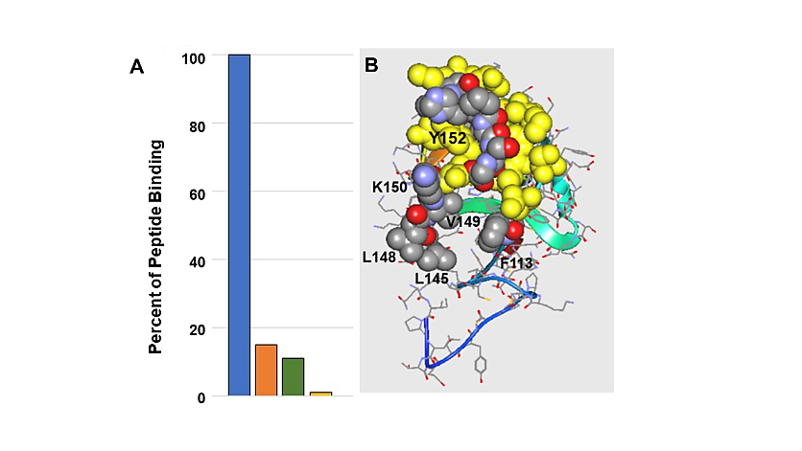
Fig. 8. Binding of svH1C to NKG2D. (A) Inhibition by fetuin. A recombinant NKG2D-Fc chimera was bound in protein A/G-coated wells, 2 μM biotinylated svH1C was added, and after extensive washes with10 mM phosphate, pH 7.4, in 150 mM NaCl containing 0.05% Tween-20, bound peptide was measured with strepavidin-peroxidase. Fetuin (4.3 μM, red; 8.6 μM, green; or 28 μM, yellow) was included as inhibitors. (B) Model of the binding of the sequence NPSHPLSG to NKG2D (accession no 1MPU). The binding site is in yellow, with the peptide within the binding site as colored, space-filled atoms (C, grey; N, blue; O, red). Site-directed mutation Y152A decreased binding of NKG2D to a sialic acid-rich glycoprotein greater than 50%, evidence for its location in the sugar binding site [23]. The numbered residues, F113, L146, L148, V149 and K150, were identified as the rim of the binding site of a small molecule inhibitor [75].

3.8 Efficacy of svH1C as an Anti-Inflammatory Drug
To determine whether svH1C has anti-inflammatory activitity in vivo, we studied its effectiveness in the model system of LPS-induced inflammation in the skin of C57BL/6 mice [3]. Subcutaneous injections of svH1C eliminated disruptions in the epidermis caused by LPS. Shown in Fig. 9A is a typical section of mouse skin after 14 days of topical application of LPS, with SDS included every third day as a penetration enhancer. The epidermis was thickened, often highly disrupted, and the dermis was infiltrated with abundant Ly6G⁺ neutrophils (Fig. 9B). svH1C in PBS was injected subcutaneously into mice daily at a dose of 1 nmol/g body weight. After the 14-day treatment, the epidermis was thin (Fig. 9C) and the dermis was free of neutrophils (Fig. 9D). Thus, this study demonstrated that normal morphology of the skin was completely restored by treatment with svH1C.
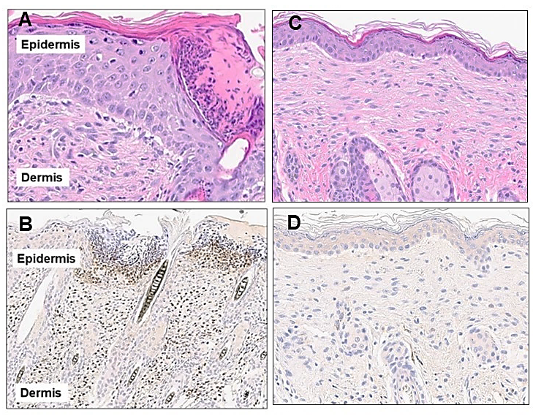
Fig. 9. Immunohistochemical analysis of the skin of mice after subcutaneous administration of svH1C. LPS (1 μg per cm²) was applied daily to dorsal skin, with 1% SDS for 2 h every third day. (A,B) Sections of untreated skin. (C,D) As in (A,B) but with daily injection of 1 nmol/g svH1C for 14 days. (A,C) Sections were stained with hematoxylin and eosin; (B,D) sections were stained with anti-Ly6G antibody and peroxidase-conjugated secondary antibody. Bar = 100 μm.

3.8 In Silico Binding of svH1C to Selectins
We considered seveal possible mechanisms for the remarkable effectiveness of svH1C in achieving resolution of inflammation as shown in Fig. 9. P- and E-selectins are expressed by endothelial cells and have a critical role in facilitating migration of neutrophils and T cells from the blood through these cells into peripheral tissues to cause an inflammatory response [76]. The selectins are C-type lectin receptors that are specific for binding sLe^{x} structures, which occur on the glycoprotein PSGL1, the natural ligand expressed by neutrophils and T cells [31,77-79]. Thus, inhibition of the binding of PSGL-1 to selectins may offer a means to prevent the inflammatory response. To obtain predictive data whether svH1C could inhibit migration of neutrophils from the blood into the skin by binding to P- and E-selectins, the accession number of the structure of each receptor, obtained from the NCBI website, was submitted to the CABS-dock program along with the peptide sequence. Our modeling studies were performed with the sequence NPSHPLSG-GGG. In the tetravalent structure of svH1C, the NPSHPLSG sequence is attached through the a GGGS linker to the tri-lysine core [3,47]. Accuracy of docking was first evaluated by docking to Siglec-1, a receptor specific for sLe^{x} and to which svH1C binds strongly (Fig. 1). As shown in Fig. 10A, the docking program placed the peptide in the glycan binding site of Siglec-1 as identified in the crystal structure of the receptor (accession no. 1URL) [12,80-82]. Several amino acids in the binding site are labeled.
Fig. 10. Models of peptide NPSHPLSGGGG bound to receptors. CABS-dock identifies the binding site as the amino acids (yellow) in the receptor that are within 4.5 Å of the bound peptide ligand. Amino acids known to be in the binding site of each receptor are labeled. The peptide ligand is indicated by colored atoms (carbon, grey; oxygen, red; nitrogen, blue). (A) Siglec-1 (accession no. 1URL): RMSD = 2.52 Å; predicted ΔG = -38 kJ/mol. (B) P-selectin (accession no. 1G1S): RMSD = 1.58 Å; predicted ΔG = -40 kJ/mol.

Because svH1C bound effectively to Siglec-1 as a mimetic of sLe^{x}, consistent with the data in Fig. 1, we modeled the binding of the peptide to P-, E- and L-selectins, receptors that are also specific for the sLe^{x} glycan. In models of P-selectin (Fig. 10B), the peptide bound in the site identified by the position of sLe^{x} in the crystal structure of the receptor. K_{D} values were calculated from the predicted binding energies obtained by molecular dynamics (Table 1). Each selectin was run three times with the docking program, and interestingly, similar values were found, which indicated that svH1C had similar avidity to each of the receptors. The data obtained from modeling experiments supported the hypothesis that the peptides bind to sialic acid-specific receptors and would likely provide therapeutic efficacy. The peptide mimetic bound with much greater affinity than glycans. Moreover, high avidity was achieved without the need for additional peptide adducts. Thus, these results are consistent with the activity of svH1C as inhibitors of the selectins and that efferocytosis of apoptotic neutrophils could occur in the dermis by svH1C-activatied macrophages.

Table 1. Predicted K_{D} (μM) values (mean ± SE, n=3) for NPSHPLSG-GGG binding to sLe^{x}-specific receptors obtained by molecular modeling. The accession number for each receptor is indicated.
Receptor NPSHPLS-GGGG
Siglec-1 (1URL) 0.23 ± 0.09
P-Selectin (1G1S) 0.59 ± 0.37
E-Selectin (4CSY) 0.24 ± 0.12
L-Selectin (3CFW) 0.34 ± 0.25

3.11 Toxicity of svH1C
No loss of viability was detected when human PBMCs were incubated 3 days with concentrations of svH1C from 1 nM to 1 mM [35]. Toxicity of svH1C was evaluated after two bolus intravenous injections of 12.5 nmol/g (57 mg/kg) into rats, one week apart. The peptide was well tolerated and no test article-related findings were noted during hematological, clinical, anatomical pathology or necrosis examinations. Therefore, this study achieved a margin of safety of at least 100-fold over a therapeutic subcutaneous dose with no evidence of toxicity. In a study of treatment of mice with implanted ovarian cancer cells [62], mean survival was extended from 122 days to 135 days (P = 0.0021 vs PBS) by every other day subcutaneous injections of 1 nmol/g body weight for 3 months without evidence of toxicity.

- DISCUSSION
The abundance of sialylated glycans on the cell surface, estimated to provide a local sialic acid concentration of 110 mM on B cells [15,71], and the many receptors that bind sialic acid-containing glycans, call into question whether a drug can bind with sufficient avidity and specificity to achieve a biological response. The prominent family of siglecs, bind sialylated proteins on the same cell (cis) or on neighboring cells (trans) and serve as adhesion proteins [12,71]. Siglecs tend to be specific for the linkage between terminal sialic acid and the penultimate sugar, usually Gal. Siglec-1 has a preference for terminal Neu5Ac(α2,3)Gal, which is also a ligand for NKG2D [23]. Glycan ligands bind with relatively low affinity, with K_{D} values from 100 μM into the mM range [12,82]. These features offer the opportunity to design a high avidity ligand that can engage receptors under the glycocalyx canopy with K_{D} values in the nanomolar range. The peptide svH1C was developed as a mimetic of sialic acid and binds with orders of magnitude greater avidity than the natural ligands. svH1C bound to sialic acid-specific plant lectins SNA1 and MAA with K_{D} values of 0.2 and 0.5 μM, respectively [53], which are similar to those obtained with the selectins (Table 1). Peptides achieve high avidity because of their flexibility, which allows them to adopt the optimal conformation for partner recognition and interaction with a receptor, consistent with the Monod-Wyman-Changeux hypothesis [54]. In addition, multivalent peptides are easily synthesized and achieve greater avidity than monovalent sequences [48-50].
Most siglecs are inhibitory, checkpoint-type receptors that provide an immunoregulatory function in concert with cell-surface, sialic acid-containing glycoproteins. The ITIM within the cytoplasmic domain of siglecs is phosphorylated by Src kinases when sialic acid is bound to the receptor, which recruits phosphatases SHP-1 and SHP-2 that dephosphorylate down-stream signal transduction intermediates. Consequently, pro-inflammatory cellular activities mediated by NF-κB are suppressed. In contrast, Siglec-1, -14, -15 and -16 lack a cytoplasmic ITIM and function in association with cytoplasmic adaptor proteins, DAP10 or DAP12, that contain an ITAM [10,11]. Oligomerization is thought to be a common feature of agonist ligands or antibodies [32,83], whereas single chain variable fragments of antibodies or high avidity ligands that do not aggregate siglecs tend to lose effectiveness as agonists [27,28,83]. The multiple native ligand structures on a glycoprotein promote crosslinking or formation of oligomers regardless of affinity or concentration of the individual ligand. Tetravalent peptides such as svH1C likely crosslink receptors at low concentrations but lose agonist activity at higher concentrations as each binding site becomes filled with a separate peptide, which results in a bell-shaped pharmacodynamics curve [13,83].
May et al. [80] obtained the crystal structure of the carbohydrate recognition domain of Siglec-1 and showed that sialic acid formed an ionic bond with Arg⁹⁷ of the receptor. However, the glycan exhibited low affinity and bound with a K_{D} in the low millimolar range. Similar studies have been done with P-selectin, which binds the sLe^{x} structure with low affinity (K_{D} = 7.8 mM) [82]. The endogenous ligand for the selectins is P-selectin glycoprotein ligand-1 (PSGL-1), a glycoprotein expressed by neutrophils and T cells [31,32,76]. PSGL-1 contains multiple terminal α(2,3)sialyl-Le^{X} adducts that bind to P-selectin with a K_{D} of 1.2 μM [79]. To achieve ligands with higher affinities, derivatives of PSGL-1 were synthesized that contain sialic acid glycans attached to peptides of up to 17 amino acids in length. The peptides included sulfated tyrosine residues, which extended affinity into the nanomolar range [31,32]. These complex synthetic ligands retained the sugar, which was considered essential to achieve identification of the specific target. Halkes et al. [29] described glycopeptides as ligands for Siglec-1 and stated that the glycan is essential to provide specificity of binding. However, the mimicry of svH1C for sialic acid is sufficiently high to identify the binding site of receptors, with avidities sufficiently high to achieve binding without the need for additional peptide adducts. These studies were predicated on the hypothesis that these sialic acid-binding receptors can be engaged by a single, flexible peptide, svH1C, to provide an anti-inflammatory therapy, as observed by molecular modeling of the binding reaction.
Siglec-1, -14, -15 and -16 are expressed on macrophages [12]. We observed that svH1C stimulated endocytosis of opsonized microspheres in PBMC cultures at a concentration of 50 nM [35,53]. Wu et al. [84] showed that expression of Siglec-1, expressed primarily by macrophages and dendritic cells [85], is induced in macrophages that are exposed—but become tolerant—to LPS. Moreover, expression of sialidases is reduced in tolerant cells, which provides an increase in sialyl glycans on the cell surface. The more abundant sialic acid-containing glycoproteins on the cell caused oligomerization of Siglec-1, which activated Syk kinases to signal the production of anti-inflammatory TGF-β1. Subsequently, the activity of NF-κB and production of pro-inflammatory cytokines such as TNF-α and IFN-γ were blocked [84]. IL-4 promotes alternative activation of M2 macrophages, and binding of IL-4 to the IL-4 receptor-α activates phosphorylation of STAT6 via JAK1. We found that a brief incubation of PBMCs with 50 nM svH1C activated phosphorylation of the anti-inflammatory transcription factor, STAT6, but not the inflammatory STAT2 (Fig. 7). Activation of STAT6-mediated Gas6 expression during macrophage phenotype transition results in efferocytosis of neutrophils, which plays a major role in resolution of inflammatory injury [72]. These activities would drive an anti-inflammatory response in tissues where M2 macrophages are abundant [3].
LPS-induced eczema and neutrophil-driven dermatoses are highly inflammatory skin diseases that involve migration of neutrophils from the blood into the dermis. We observed recovery from inflamed and damaged skin by subcutaneous injection of svH1C, even with continued presence of LPS. Our data suggest that the restoration of normal epidermal morphology was achieved by binding of svH1C to selectins, thereby inhibiting migration of neutrophils and T cells through endothelial tissues, and activating phagocytosis by macrophages that leads to elimination of neutrophils in the dermis. Our hypothesis states that extravasation of these cells in neuroinflammatory diseases have elements in common with inflammation of the epidermis. We propose that inflammation of the skin is an appropriate model system to evaluate therapeutic approaches that may benefit inflammatory diseases of the central nervous system (as in MS) and motor neurons (as in ALS) [86-90]. MS involves migration of neutrophils and T cells from the blood, breaching of the blood brain barrier and demyelation of the CNS. This approach may have particular benefit in treatment of inflammatory dermatoses such as pyoderma gangrenosum [1,2]. These results lead to the conclusion that svH1C is an effective glycan mimetic and binds with avidities greater than natural multivalent glycan structures. svH1C or similar glycan mimetics are readily synthesized, non-toxic in vivo and may find practical application as immunomodulatory therapeutic agents.

References
1. Maverakis E, Marzano AV, Le ST, Calleri JP, Brüggen M-C, Guenova E, et al. Pyoderma gangrenosum. Nat. Rev. Dis. Primers. 2020;6:81.
2. Wang EA, Steel A, Luxardi G, Mitra A, Patel F, Cheng MY, et al. Classic ulcerative pyroderma gangrenosum is a T cell-mediated disease targeting follicular adnexa structures: a hypothesis based on molecular and clinicopathologic studies. Front. Immunol. 2018;8:1980.
3. Eggink LL, Hoober JK. Resolution of eczema with multivalent peptides. J. Invest. Dermatol. Innov. 2022;2:100142.
4. Schröder L-J, Thiesler H, Gretenkort L, Möllenkamp TM, Stangel M, Gudi V, Hildebrandt H. Polysialic acid promotes remyelination in cerebellar slice cultures by Siglec-E-dependent modulation of microglia polarization. Front. Cell Neurosci. 2023;17:1207540.
5. Eshima J, O’Connor SA, Marschall E, NYGC ALS Consortium, Bowser R, Plaisier CL, Smith BS. Molecular subtypes of ALS are associated with differences in patient prognosis. Nat. Commun. 2023;14:95.
6. Jiang Z, Wang Z, Wei X, Yu X-F. Inflammatory checkpoints in amyotrophic lateral sclerosis: from biomarkers to therapeutic targets. Front. Immunol. 2022;13:1059994.
7. Buchman AL. Side effects of corticosteroid therapy. J. Clin. Gastroenterol. 2001;33:289-294.
8. Geijtenbeek TBH, Gringhuis SI. Signalling through C-type lectin receptors: shaping immune responses. Nat. Rev. Immunol. 2009;9:465-479.
9. Varki A, Angata T Siglecs—the major subfamily of I-type lectins. Glycobiology. 2006;16:1R-27R.
10. Macauley MS, Crocker PR, Paulson JC. Siglec-mediated regulation of immune cell function in disease. Nat. Rev. Immunol. 2014;14:653–666.
11. Pillai S, Netravali IA, Cariappa A, Mattoo H. Siglecs and immune regulation. Annu. Rev. Immunol. 2012;30:357-392.
12. Gonzalez-Gil A, Schnaar RL. Siglec ligands. Cells. 2021;10;1260.
13. HooberJK, Eggink LL. Glycomimetic peptides as therapeutic tools. Pharmaceutics. 2023;15:688.
14. Zou Z, Chastain A, Moir S, Ford J, Trandem K, Martinelli E, et al. Siglecs facilitate HIV-1 infection of macrophages through adhesion with viral sialic acids. PLoS ONE. 2011;6:e24559.
15. Collins BE, Blixt O, Han S, Duong G, Li H, Nathan JK, Bovin N, Paulson JC. High-affinity ligand probes of CD22 overcome the threshold set by cis ligands to allow for binding, endocytosis, and killing of B cells. J. Immunol. 2006;177:2994-3003.
16. Walter RB, Raden BW, Zeng R, Häusermann P, Bernstein ID, Cooper JA. ITIM-dependent endocytoosis of CD33-related siglecs: role of intracellular domain, tyrosine phosphorylation, and the tyrosine phosphatases Shp1 and Shp2. J. Leukoc. Biol. 2008;83:200-211.
17. Avril T, Freeman SD, Attrill H, Clarke RG, Crocker PR. Siglec-5 (CD170) can mediate inhibitory signaling in the absence of immunoreceptor tyrosine-based inhibitory motif phosphorylation. J. Biol. Chem. 2005;280:19843-19851.
18. Ikehara Y, Ikehara SK, Paulson JC. Negative regulation of T cell receptor signaling by Siglec-7 (p70/AIRM) and Siglec-9. J. Biol. Chem. 2004;279:43117-43125.
19. Angata T, Tabuchi Y, Nakamura K, Nakamura M. Siglec-15: an immune system Siglec conserved throughout vertebrate evolution. Glycobiology. 2007;17:838-846.
20. Li P, Morris DL, Willcox BE, Steinle A, Spies T, Strong RK. Complex structure of the activating immunoreceptor NKG2D and its MHC class 1-like ligand MICA. Nat. Immunol. 2001;2:443-451.
21. McFarland BJ, Kortemme T, Yu SF, Baker D, Strong RK. Symmetry recognizing asymmetry: analysis of the interactions between the C-type lectin-like immunoreceptor NKG2D and MHC class 1-like ligands. Structure. 2003;11:411-422.
22. Champsaur M, Lanier LL. Effect of NKG2D ligand expression on host immune responses. Immunol. Rev. 2010;235:267-285.
23. Imaizumi Y, Higai K, Suzuki C, Azuma Y, Matsumoto K. NKG2D and CD94 bind to multimeric α2,3-linked N-acetylneuraminic acid. Biochem. Biophys. Res. Commun. 2009;382:604-608.
24. Zhuravleva MA, Trandem K, Sun PD. Structural implications of Siglec-5-mediated sialoglycan recognition. J. Mol. Biol. 2008;375:437-447.
25. Blixt O, Allin K, Pereira L, Datta A, Paulson JC. Efficient chemoenzymatic synthesis of O-linked sialyl oligosaccharides. J. Am. Chem. Soc. 2002;124:5739-5746.
26. Blixt O, Han S, Liao L, Zeng Y, Hoffmann J, Futakawa S, Paulson JC. Sialoside analogue arrays for rapid identification of high affinity siglec ligands. J. Am. Chem. Soc. 2008;130:6680-6681.
27. Blixt O, Collins BE, van den Nieuwenhof IM, Crocker PR, Paulson JC. Sialoside specificity of the siglec family assessed using novel multivalent probes. J. Biol. Chem. 2003;278:31007-31019.
28. O’Reilly MK, Paulson JC. Multivalent ligands for siglecs. Meth. Enzymol. 2010;478:343-363.
29. Halkes KM, St Hilaire PM, Crocker PR, Meldal M. Glycopeptides of oligosaccharide mimics: high affinity sialopeptide ligands to sialoadhesion from combinatorial libraries. J. Comb. Chem. 2003;5:18-27.
30. Magesh S, Ando H, Tsubata T, Ishida H, Kiso M. High-affinity ligands of siglec receptors and their therapeutic potentials. Curr. Med. Chem. 2011;18:3537-3550.
31. Krishnamurthy VR, Sardar MYR, Ying Y, Song X, Haller C, et al. Glycopeptide analogues of PSGL-1 inhibit P-selectin in vitro and in vivo. Nat. Commun. 2015;6:6387.
32. Smith BAH, Bertozzi CR. The clinical impact of glycobiology: targeting selectins, Siglecs and mammalian glycans. Nat. Rev. Drug Discov. 2021;20:217-243.
33. Bukrinsky JT, St Hilaire PM, Meldal M, Crocker PR, Henriksen A. Complex of sialoadhesion with a glycopeptide ligand. Biochem. Biophys. Acta. 2004;1702:173-179.
34. Leppänent A,Yago T, Otto VI, McEvert RP, Cummings RD. Model glycosulfopeptides from P-selectin glycoprotein ligand-1 require tyrosine sulfation and a core 2-branched O-glycan to bind to L-selectin. J. Biol. Chem. 2003;278:26391-26400.
35. Eggink LL, Salas M, Hanson CV, Hoober JK. Peptide sugar mimetics prevent HIV-1 replication in peripheral blood mononuclear cells in the presence of HIV-positive antiserum. AIDS Res. Human Retrovir. 2010;26:149-160.
36. Matsubara T. Peptide mimotopes to emulate carbohydrates. Chem. Soc. Rev. 2022;DOI: 602 10.1039/d2cs00470d.
37. Yu L, Yu PS, Mui EYY, McKelvie JC, Pham TPT, Yap YW, et al. Phage.display screening against a set of targets to establish peptide-based sugar mimetics and molecular docking to predict binding site. Bioorg. Med. Chem. 2009;17:4825-4832.
38. Pashov A, Canziani G, Monzavi-Karbassi B, Kaveri SV, MacLeod S, Saha R, et al. Antigenic properties of peptide mimotopes of HIV-1-associated carbohydrate antigens. J. Biol. Chem. 2005;280:28959-28965.
39. Oldenburg KR, Loganathan D, Goldstein IJ, Schultz PG, Gallop MA. Peptide ligands for a sugar-binding protein isolated from a random peptide library. Proc. Natl. Acad. Sci. USA. 1992;89:5393-5397.
40. Harris SL, Craig L, Mehroke JS, Rashed M, Zwick MB, Kenar K, et al. Exploring the basis of peptide-carbohydrate cross-reactivity: evidence for discrimination by peptides between closely related anti-carbohydrate antibodies. Proc. Natl. Acad. Sci. USA. 1997;94:2454-2459.
41. Lang J, Zhan J, Xu L, Yan Z. Identification of peptide mimetics of xenoreactive α-Gal antigenic epitope by phage display. Biochem. Biophys. Res. Commun. 2006;344:214-220.
42. Pashov AD, Plaxco J, Kaveri SV, Monzavi-Karbassi B, Harn D, Kieber-Emmons T. Multiple antigenic mimotopes of HIV carbohydrate antigens. Relating structure and antigenicity. J. Biol. Chem. 2006;281:29675-29683.
43. Agostino M, Sandrin MS, Thompson PE, Farrugia W, Ramsland PA, Yuriev E. Carbohydrate-mimetic peptides: structural aspects of mimicry and therapeutic implications. Expert Opin. Ther. 2011;11:211-224.
44. Jain D, Kaur K, Sundaravadivel B, Salunke DM. Structural and functional consequences of peptide-carbohydrate mimicry. J. Biol. Chem. 2000;275:16098-16102.
45. Zhang Z, Qian M, Huang Q, Jia Y, Tang Y, Wang K, Cui D, Li M. Crystal structure of the complex of concanavalin A and hexapeptide. J. Prot. Chem. 2001;20:423-429.
46. Eggink LL, Hoober JK. A biologically active peptide mimetic of N-acetylgalactosamine/galactose. BMC Res. Notes. 2009;2:23.
47. Eggink LL, Spyroulias GA, Jones NG, Hanson CV, Hoober JK. A peptide mimetic of 5-acetylneuraminic acid-galactose binds with high avidity to siglecs and NKG2D. PLoS ONE. 2015;10:e0130532.
48. Mammen M, Choi S-K, Whitesides G. M. Polyvalent interactions in biological systems: implications for design and use of multivalent ligands and inhibitors. Angew. Chem. Int. Ed. 1998;37:2754-2794.
49. Cairo CW, Gestwicki JE, Kanai M, Kiessling LL. Control of multivalent interactions by binding epitope density. J. Am. Chem. Soc. 2002;124:1615-1619.
50. Dam TK, Gerken TA, Brewer CF. Thermodynamics of multivalent carbohydrate-lectin cross-linking interactions: importance of entropy in the bind and jump mechanism. Biochemistry. 2009;48:3822-3827.
51. Marsh CB, Lowe MP, Rovin BH, Parker JM, Liao Z, Knoell DL, Wewers MD. Lymphocytes produce IL-1beta in response to Fc-gamma receptor cross-linking: effects on parenchymal cell IL-8 release. J. Immunol. 1998;160:3942-3948.
52. Bone H, Williams NA. Antigen-receptor cross-linking and lipopolysaccharide trigger distinct phosphoinositide 3-kinase-dependent pathways to NK-κB activation in primary B cells. Int. Immunol. 2001;13:807-816.
53. Eggink LL, Hoober JK. Peptide mimetics of terminal sugars of complex glycans. Glycobiol. Insights. 2010;2:1–12.
54. Changeux J-P. Allostery and the Monod-Wyman-Changeux model after 50 years. Annu. Rev. Biophys. 2012;41:103-133.
55. Blaszczyk M, Kurcinski M, Kouza M, Wieteska L, Debinski A, Kolinski A, Kmiecik S. Modeling of protein-peptide interactions using the CABS-dock web server for binding site search and flexible docking. Methods. 2016;93:72-83.
56. Kurcinski M, Badaczewska-Dawid A, Kolinski M, Kolinski A, Kmiecik S. Flexible docking of peptides to proteins using CABS-dock. Prot. Sci. 2020;29:211-222.
57. Tam JP. Recent advances in multiple antigen peptides. J. Immunol. Meth. 1996;196:17-32.
58. Vasileiou Z, Barlos K, Gatos D. Convergent solid-phase and solution approaches in the synthesis of the cysteine-rich Mdm2 RING finger domain. J. Pept. Sci. 2009;15:824-831.
59. Geisler C, Jarvis DL. Effective glycoanalysis with Maackia amurensis lectins requires a clear understanding of their binding specificities. Glycobiology. 2011;21:988-993.
60. Angata T, Hayakawa T, Yamanaka M, Varki A, Nakamura M. Discovery of Siglec-14, a novel sialic acid receptor undergoing concerted evolution with Siglec-5 in primates. FASEB J. 2006;20:1964-1973.
61. Hanč P, Fujii T, Iborra S, Yamada Y, Huotari J, Schulz O, et al. Structure of the complex of F-actin and DNGR-1, a C-type lectin receptor involved in dendritic cell cross-presentation of dead cell-associated antigens. Immunity. 2015;42:839–849.
62. Eggink LL, Roby K, Cote R, Hoober JK. An innovative immunotherapeutic strategy for ovarian cancer: CLEC10A and glycomimetic peptides. J. ImmunoTher. Cancer. 2018;6:28.
63. Cote R, Eggink LL, Hoober JK. CLEC receptors, endocytosis and calcium signaling. AIMS Allerg. Immunol. 2017;1:207-231.
64. Spiro RG, Bhoyroo VD. Structure of the O-glycosidically linked carbohydrate units of fetuin. J. Biol. Chem. 1974;249:5704–5717.
65. Baenziger JU, Fiete D. Structure of the complex oligosaccharides of fetuin. J. Biol. Chem. 1979;254:789–795.
66. Takasaki S, Kobata A. Asparagine-linked sugar chains of fetuin: occurrence of tetrasialyl triantennary sugar chains containing the Galβ1→3GlcNAc sequence. Biochemistry. 1986;25:5709-5715.
67. Hayase T, Rice KG, Dzieglielewska KM, Kuhlenschmidt M, Reilly T, Lee YC. Comparison of N-glycosides of fetuins from different species and human α₂-HS-glycoprotein. Biochemistry. 1992;31:4915-4921.
68. Cointe D, Leroy Y, Chirat F. Determination of the sialylation level and of the ratio α-(2→3)/α-(2→6) sialyl linkages of N-glycans by methylation and GC/MS analysis. Carbohydr. Res. 1998;311:51–59.
69. Zhang M, Varki A. Cell surface sialic acids do not affect primary CD22 interactions with CD45 and surface IgM nor the rate of constitutive CD22 endocytosis. Glycobiology. 2004;14:939-949.
70. Chang VT, Fernandes RA, Ganzinger KA, Lee S, Siebold C, McColl J, et al. Initiation of T cell signaling by CD45 segregation at ‘close contacts.’ Nat. Immunol. 2016;17:574-582.
71. Collins BE, Blixt O, DeSieno AR, Bovin N, Marth JD, Paulson JC. Masking of CD22 by cis ligands does not prevent redistribution of CD22 to sites of cell contact. Proc. Natl. Acad. Sci. USA. 2004;101:6104-6109.
72. Greenlee-Wacker MC. Clearance of apoptotic neutrophils and resolution of inflammation. Immunol. Rev. 2016;273:357-370.
73. Lawrence T, Natoli G. Transcriptional regulation of macrophage polarization: enabling diversity with identity. Nat. Rev. Immunol. 2011;11:750-761.
74. Nepal S, Tiruppathi C, Tsuskasaki Y, Farahany J, Mittal M, Rehman J, et al. STAT6 induces expression of Gas6 in macrophages to clear apoptotic neutrophils and resolve inflammation. Proc. Natl. Acad. Sci. USA. 2019;116:16513-16518.
75. Thompson AA, Harbut MB, KarpowichNK, Branson JD, Gramt JC, Hagan D, et al. Identification of small-molecule protein-protein interaction inhibitors for NKG2D. Proc. Natl. Acad. Sci. USA. 2023;120:e2216342120.
76. Zhang N, Tang W, Torres L, Wang X, Ajaj Y, Zhu L, et al. Cell surface RNAs control neutrophil recruitment. Cell. 2024;187:1-15.
77. Soares CO, Grosso AS, Ereño-Orbea J, Coelho H, Marcedo F. Molecular recognition insights of sialic acid glycans by distinct receptors unveiled by NMR and molecular modeling. Front. Mol. Biosci. 2021;8:727847.
78. Somers WS, Tang J, Shaw GD, Camphausen RT. Insights into the molecular basis of leukocyte tethering and rolling revealed by structures of P- and E-selectin bound to SLe(X) and PSGL-1. Cell. 2000;103:467-79.
79. Mehta-D’souza P, Klopocki AG, Oganesyan V, Terzyan S, Mather T, Li Z, et al. Glycan bound to the selectin low affinity state engages Glu-88 to stabilize the high affinity state under force. J. Biol. Chem. 2017;292:2510-2518.
80. May AP, Robinson RC, Vinson M, Crocker PR, Jones EY. Crystal structure of the N-terminal domain of sialoadhesion in complex with 3’ sialyllactose at 1.85 Å resolution. Mol. Cell. 1998;1:710-728.
81. Preston RC, Jakob RP, Binder FP, Sager CP, Ernst B, Maier T. E-selectin ligand complexes adopt an extended high-affinity conformation. J. Mol. Cell. Biol. 2016;8:62-72..
82. Poppe L, Brown GS, Philo JS, Nikrad PV, Shah BH. Conformation of sLe^{x} tetrasaccharide, free in soltion and bound to E-, P-, and L-selectin. J. Am. Chem. Soc. 1997;119:1727-1736.
83. Wang JHS, Jiang N, Jain A, Lim J. Development of effective Siglec-9 antibodies against cancer. Curr. Oncol. Reports. 2023;25:41-49.
84. Wu Y, Lan C, Ren D, Chen GY. Induction of Siglec-1 by endotoxin tolerance suppresses the innate immune response by promoting TGF-β1 production. J. Biol. Chem. 2016;291:12370-12382.
85. Prenzler S, Rudrawar S, Waespy M, Kelm S, Anoopkumar-Dukie S, Haselhorst T. The role of sialic acid-binding immunoglobulin-like-lectin-1 (siglec-1) in immunology and infectious disease. Int. Rev. Immunol. 2023;42:113-138.
86. Tinoco R, Otero DC, Takahashi A, Bradley LM. PSGL-1: a new player in the immune checkpoint landscape. Trends Imunol. 2017;38:323-335.
87. Kendirli A, de la Rosa C, Lämmle KF, Eglseer K, Bauer IJ, Kavala V, et al. A genome-wide in vivo CRISPER screen identifies essential regulators of T cell migration into the CNS in a multiple sclerosis model. Nat. Neurosci. 2023;26:1713-1725.
88. Jiang Z, Wang Z, Wei X, Yu X-F. Inflammatory checkpoints in amyotrophic lateral sclerosis: from biomarkers to therapeutic targets. Front. Immunol. 2022;13:1059994.
89. Nόgrádi B, Nόgrádi-Halmi D, Erdélyl-Furka B, Kádár Z, Csont T, Gáspár R. Mechanism of motorneuronal and pyramidal cell death in amyotrophic lateral sclerosis and its potential therapeutic modulation. Cell Death Discov. 2024;10:291.
90. Mimic S, Aru B, Pehlivanoğlu C, Sleiman H, Andjus PR, Yanikkaya Demirel G. Immunology of amyotrophic lateral sclerosis—role of the innate and adaptive immunity. Front. Neurosci. 2023;17:1277399

