Characterization of Psychrotrophic Molds in Indigenous Fermented Dairy Products

ABSTRACT
The research work was conducted in the Department of Dairy Microbiology, Dairy Science College, KVAFSU, Hebbal, Bengaluru, 560 024, Karnataka, India between June 2014 to June 2015 as part of post graduate research work. The indigenous fermented dairy product samples unbranded (n=6) and branded (n=15) used in the study were Mishtidoi, Shrikhand, Lassi and Buttermilk which are collected from Bengaluru markets. The market samples of indigenous fermented dairy product samples were subjected for isolation on poured sterile Malt Extract Agar of pH 3.5. The isolates were obtained by pour-plate technique on Malt Extract Agar. The mold isolates were identified by colony morphology, microscopic examination for cell morphology and specific biochemical tests. Out of total of 21 psychrotrophic mold isolates, 6 and 15 isolates were obtained from unbranded and branded samples, respectively. Based on the preliminary identification, the isolates were characterized as Penicillium spp. (n=3), Mucor spp. (n=2) and Cladosporium spp. (n=1) from unbranded samples while branded indigenous fermented dairy product samples showed Penicillium spp. (n=9 and Alternaria spp. (n=6) were isolated from branded samples. According to pheno and genotypic characterization, the isolates were identified as P. chrysogenum (57.12%) followed by A. alternata (28.56%),C. cladosporioides (4.76%) and M. mehei (9.52%) at the species level. Except unbranded mishitdoi, all types of indigenous fermented dairy product samples were found to contain psychrotrophic molds. P. chrysogenum was the most abundant species especially in branded butter milk indicating longer refrigeration may lead to selection of psychrotrophic molds due to low temperature storage and favourable pH of the indigenous fermented dairy product samples.

Keywords: Psychrotrophic mold, Morphology, Unbranded, Mishtidoi, Refrigeration

INTRODUCTION

India ranks first in the world milk production with 230.58 million tonnes during 2022-23 [1]. Milk produced is utilized to manufacture a variety of milk products such as heat desiccated, acid coagulated products and fermented dairy products to increase the shelf life. Simple processes are used to preserve milk’s nutrition quality to protect and promote health. Indigenous dairy products (IDPs) may be defined as those milk products that are native to India, evolved over ages prepared utilizing locally available cooking wares and fuels. Out of the total milk production, 50-55% is utilized to manufacture IDPs in which 7% is utilized to manufacture fermented dairy products such as Mishtidoi, Shrikhand, Lassi and Butter milk [2]. Market for Indigenous Fermented Dairy Products (IFDPs) in Bangalore is covered by varieties of brands like AMUL, Danone, Milky Mist, Mother Dairy, Britannia, Nilgiris, K. C. Das and its regional brands such as Nandini. The IFDPs need to be stored at low temperature to avoid spoilage by molds. The presence of Aspergillus, Fusarium, Mucor and Penicillium spp., were noticed in yogurt stored at low temperature. Low temperature storage extends the shelf life of IFDPs, but significance of psychrotrophic molds and their metabolites need to be considered. Psychrotrophic molds (Penicillium, Rhizpous and Aspergilllus) produce proteolytic and lipolytic enzymes even at low temperature that alter the product composition leading to defects [3]. In the fall of 2013, a large spoilage incident resulted in a national recall of Greek yogurt contaminated with the mold Mucor circinelloides. Approximately one month's production was recalled for potential contamination, and the event received national media attention. The company initially implemented a product withdrawal, but after several hundred consumers reported symptoms of gastroenteritis, the withdrawal was changed to a voluntary recall [4, 5]. Psychrotrophic mold count of 1.8 log₁₀cfu/g was noticed during storage of shrikhand, an IFDP at refrigeration temperature for 10 days[6].In some cases, contamination of yogurt products with dimorphic mold (e.g., Mucor), or those that can grow as yeast or mold depending on environmental conditions, have also been shown to cause yogurt spoilage[5]. A total of 21 psychrotrophic mold isolates were obtained from the Indigenous Fermented Dairy Products such as Mishti Doi, Shrikhand, Lassi and Buttermilk collected from Bengaluru market, Karnataka, India, that revealed predominance of Penicillium chrysogenum (12 nos.) followed by Alternaria alternata (6 nos.), Mucor mehei (2 nos.) and Cladosporium cladosporioides (1 no.) [7]
In a mycological study, a total of 125 random samples from raw milk, locally manufactured kareish cheese, hard cheese (Rass cheese), plain yoghurt and flavored yoghurt (25 of each) collected from dairy shops and super markets in Beni Suef city, Egypt revealed average log viable counts of molds as 2.34, 0.70, 3.63 and 0.40 in the examined milk, Rass, locally manufactured kareish cheese and flavoured yoghurt samples respectively, while molds couldn’t be detected in the examined plain yogurt samples. The most predominant species of Mucor, Absidia, Penicillium, Geotrachum candidum, Cladosporium, Phoma, Fusarium, Asperigellus flavus, Asperigellus niger and Asperigellus fumigatus but samples were free of aflatoxin M1 [8]. The primary mold found in yogurt spoilage incidents was Penicillium, due to its acidic pH. However, a number of other genera have been reported in yogurt including species of Mucor, Alternaria, Aspergillus, Monilia and Rhizopus [9]. M. circinelloides 01180023 required around 14 days to reach a specific colony size of 1.5 × 10⁵ (in pixels) at 5°C with sporulation was observed after incubation ranging from 9 to 11 days. Growth of P. roqueforti ISI4 started out slowly with the highest growth recorded after day 20 at 5°C[10]. Fermented milk products such as yoghurt and sour milk from Western Kenya were contaminated with fungal species that cause spoilage, as the low pH (2.9–3.6) of these products favour their growth. The common molds observed were species of Penicillium and Aspergillus [11]. Fungal count on an average of 4.99 (77 samples), 5.29 (111 samples) and 4.23(111 samples) were found in raw milk cheese, pasteurized milk cheese and Kajmak samples (a thick, tangy clotted cream from the Balkans usually made with sheep's or cow's milk) collected from small scale producers of Serbia, respectively. The present study showed mostly satisfactory levels of yeasts and molds in the cheese and Kajmak samples, exceeding 8 log CFU/g, indicated potential spoilage in Serbia [12].
In addition to organoleptic properties’ deterioration, certain molds like Penicillium spp., release the mycotoxins such as citrinin, patulin, penicillic acid, ochratoxin A and sterigmocystin in cheese and other fermented dairy products which are difficult to destroy during milk processing to produce FDPs [3]. The mycotoxins (low weight metabolites which cause harm known as mycotoxicoses) are the secondary metabolites produced by certain molds which have been found to be present in most food substances like in livestock and their by products therefore of public health significance[13]. The Penicillium species are highly adaptive to low temperatures and several of them are considered xerophilic species, therefore, their occurrence in spoiled dairy products like yoghurt, soft, semisoft cheeses is not surprising. Citrinin production mainly by P. citrinicum and also by P. chrysogenum found to be involved in nephrotoxicosis issues by disfunctioning of renal veins of kidney and also caused Balkan nephropathy and yellow rice fever when the food contaminated with the mold was consumed. Various cytotoxic and genotoxic effects were offered by patulin like damage to the immune system; pancreas; liver and gastrointestinal tract [14,15]. Mucor spp. are common spoilage agents of yogurt and cheese. Apart from the negative impacts on food quality, such as visible growth and off-flavors, some fungal genera possess the ability to produce mycotoxins, which constitute a threat to human health. For instance, Mucor circinelloides (M. circinelloides) is recognized as an opportunistic pathogen, which can produce the mycotoxin 3-nitropropionic acid [10]. The spoilage mold Aspergillus spp. can also produce aflatoxin. The occurrence of AFM1 in milk results from the conversion by dairy animals, fed on aflatoxin B1 (AFB1)-contaminated feedstuffs, of AFB1 to AFM1, which then pass to their urine and milk. Large doses of aflatoxins can lead to acute poisoning (aflatoxicosis) and can be life threatening, usually through damage to the liver. Aflatoxins have also been shown to be genotoxic, meaning they can damage DNA and cause cancer in animal species. There is also evidence that they can cause liver cancer in humans [13, 16].
The present study help to know the number and types of psychrotrophic molds occur in IFDPs and gives an idea regarding their metabolites (enzymes and toxins) that cause spoilage and health hazards when such products are ingested.

MATERIALS AND METHODS

Collection of IFDPs: Different varieties of mishtidoi, shrikhand, lassi and buttermilk samples were collected in an ice box from many sweetmeat sellers as well as from retail branded sellers of Banashankari, Hebbal, R.T. Nagar, Majestic areas of Bengaluru city which were considered as unbranded samples and branded samples respectively. The samples were brought to the laboratory for the isolation of psychrotrophic molds using Malt Extract Agar (MEA) adjusted to pH 3.5 [17] followed by incubation at 7°C for 20-25 days.

Isolation of Psychrotrophic Molds from IFDPs: Plates, showing cottony colonies were selected and streaked thrice onto MEA plates in order to purify the isolates [18]. The purified isolates were grown on MEA slants, subcultured every month and maintained at 2°C till required.

Phenotypic Characterization of Psychrotrophic Mold Isolates
    - Macroscopic and Microscopic characteristics of the isolates: The psychrotrophic mold isolates obtained were characterized macroscopically through the colony morphology, such as colour of colony, front view, reverse view, surface of the colony and any exudate production over the colony. The isolates were microscopically identified by Wet Mount Staining technique [19].
    - Specific tests for selective mold isolates:
      - Ehrlich test: All the mold isolates were examined for production of cyclopiazonic acid and other alkaloids reacting with Ehrlich using a filter paper method. The appearance of a violet ring for 2- 6 min indicates the presence of cyclopiazonic acid or related alkaloids [20].

      - Screening of Penicillium isolate for penicillin production: Penicillium isolate was tested for penicillin production. After extraction they are tested by β-Lactamase test against Staphylococcus aureus. The production of yellow color confirms the presence of penicillin [21]. After the preliminary test, the penicillin extracted was tested for its antibacterial activity against Staphylococcus aureus [22]. Zone of inhibition was noted and the activity of the antibiotic was confirmed.

      - Screening of the Penicillium isolate for citrinin production: Citrinin production form penicillium isolates were tested against S. aureus and Escherichia. Citrinin was found to inhibit Staphylococcus aureus but not the Escherichia coli. The inhibition zones around wells of citrinin inoculated with the S. aureus culture confirms the presence of citrinin toxin [23].

      - Genotypic identification of mold isolates: The gene sequencing of mold isolates was outsourced for Serene Biosciences, Molecular Diagnostics Research, Custom services & Training. No. 30, II cross, Marappa Garden, Benson Town Post, Bangalore - 560 046 to determine the genotypic identity [23].

RESULTS AND DISCUSSION

Psychrotrophic Mold Isolated from IFDPs
Out of 21 isolates, 6 and 15 numbers of isolates were obtained from unbranded and branded samples, respectively (Table 1). Four different colony morphologies were obtained among the mold isolates. These isolates were further subjected to preliminary, specific tests and characterized by genotyping methods.

Table 1. Psychrotrophic molds isolated from Indigenous fermented dairy products
Sl. no. | Samples | Number of isolates  Unbranded Branded
1 | Mishtidoi | - 4
2 | Shrikhand | 3 4
3 | Lassi | 2 2
4 | Butter milk | 1 5
Total isolates obtained |  | 6 15

Phenotypic Identification of Psychrotrophic Molds from Selected IFDPs

The preliminary identification of psychrotrophic molds isolates (n=4) were based on the colony characteristics, cell morphology while specific tests included Ehrlich reaction for screening of toxigenic mold species and antibiotic production by the species (Table 2). Mold isolate -1 formed colony with greenish on the surface, yellow exudate while citrine yellow colour at the bottom. Microscopic examination of the same revealed septate hyphae bearing conidiospores resembling the characteristics of Penicillium spp., with production of penicillin and citrinin with absence of alkaloid (Fig.1).

Table 2. Colony morphology of the isolated psychrotrophic mold isolates from indigenous fermented dairy products
Characteristics | Isolate - 1 | Isolate – 2 | Isolates – 3 | Isolate - 4
Colony morphology
Diameter on MEA | 18 mm X 17 mm | 22 mm X 25 mm | 9 mm X 10 mm | 25 mm X 26 mm
Colour on MEA | Greenish with | Brownish red | Blackish with | Dark green
 | whitish edges |  | aerial spores
Reverse side | Citrine yellow | Brownish black | Dark muddy | Black
 |  |  | White
Aspect on MEA | Radially | Flat with raised | Highly raised | Flat spread
 | grooved | at the center
Texture of the colony | Grainy, non | Cottony spread | Grainy of aerial | Velvety hard ,
 | dissociable |  | Spores | leathery
Cell morphology | spores
Spore shape | Oval round | Beak shaped | Round | Round
 | conidiospores | conidiospores | Sporangiospores | conidiospores
Type of hyphae | Septate | Septate | Non septate | Septate
Type of mycelia | Septate | Septate | Non septate | Septate
Species wise special characteristics
Exudate production | Typical yellow | - | - | -
Ehrlich reaction | - | + (reddish pink) | - | -
 |  | indicates
Antibiotic production: |  | alkaloids
Penicillin (β- | + | - | - | -
Lactamase test)
Citrinin (MH Agar) | + | - | - | -
Identity of the isolate | Penicillium sp. | Alternaria sp. | Mucor sp. | Cladosporium
 |  |  |  | sp.

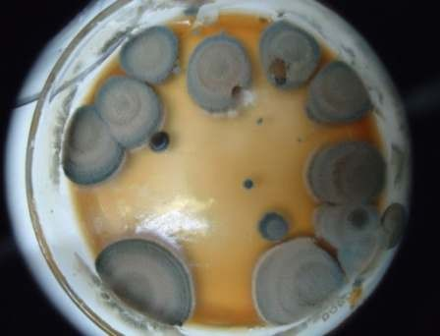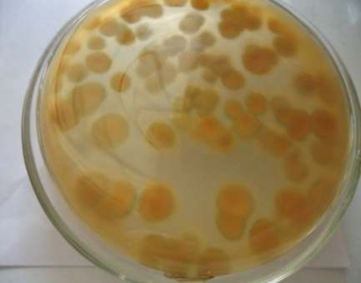
a) Front view b) Reverse view
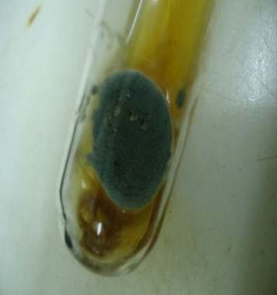
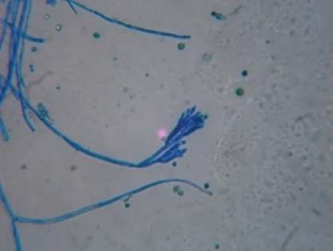
- Exudate production d) Cell morphology
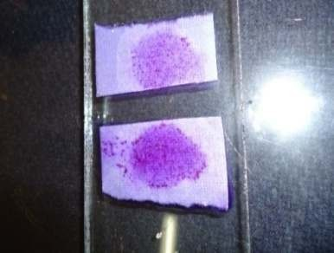
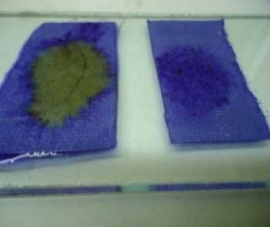
Negative Positive
- β- Lactamase test
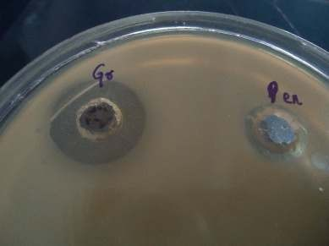
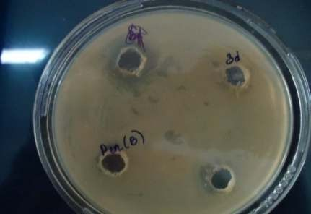
- Penicillin production g) Citrinin production
Fig. 1. Colony and cell morphology of psychrotrophic Penicillium spp.

Among the mold isolates, only Penicillium spp., produced typical citrine yellow exudate confirming the species and negative to Ehrlich reaction which are in conformation with the other two studies [20, 24]. Isolate was a producer of antibiotic penicillin which showed antibacterial activity against Staphylococcus aureus and citrinin showed antibacterial activity against S. aureus but not on E. coli in addition to positive results of β-lactamase test. Similar characteristics were noticed in one of the study [21] with respect to Penicillium spp. Citrinin and penicillin production by P. chrysogenum was determined in the present study while the same things were confirmed in other studies [24, 25]. In a study [26], fruity odour from the mold colony showed ter means 3 or quart means 4 branched smooth phialides under microscope. The same was observed in the present isolate hence confirmed as Penicillium sp. and the same was in relevance to the features of mold by one more study [27]. Penicillium spp., release the mycotoxins such as citrinin, patulin, penicillic acid, ochratoxin A and sterigmocystin in cheese and other fermented dairy products which are difficult to destroy during milk processing to produce FDPs [3]. Citrinin production mainly by P. citrinicum and also by P. chrysogenum found to be involved in nephrotoxicosis issues by disfunctioning of renal veins of kidney and also caused Balkan nephropathy and Yellow rice fever when the food contaminated with the mold was consumed. Various cytotoxic effects were offered by patulin like damage to the immune system; pancreas; liver and gastrointestinal tract [14, 15].

The colony of mold isolate – 2 was brownish red at the surface and brownish black colour at the bottom with raise at the center. Microscopic examination of mold showed pear or club shaped spores with both longitudinal septa, cross walls with septate hyphae and mycelium. The mold produced alkaloids determined by positive Ehrlich test. All the features. The colony and cell morphology revealed the mold isolate as Alternaria sp., (Fig. 2). The mold was identified based on the asexual spores conidia over conidiophore and confirmed it as Alternaria by a study based on cell structure [28], while another study [21] identified the mold based on alkaloid production.

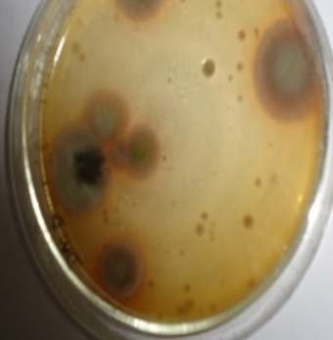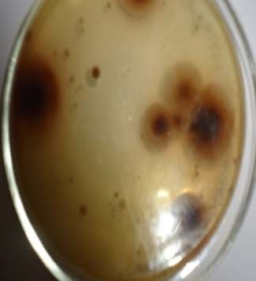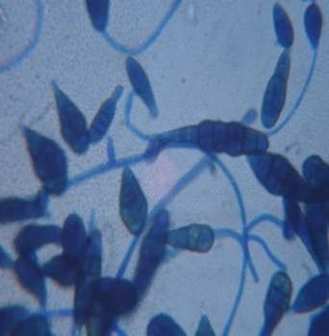
a) Colony Front view b) Colony Reverse view c) Cell morphology
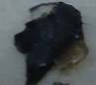
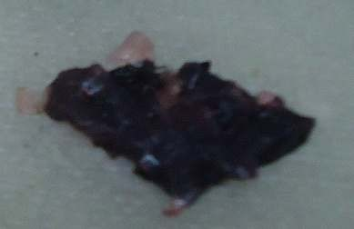
Negative Positive
- Ehrlich test
Fig. 2. Colony and cell morphology of Alternaria spp.
Psychrotrophic mold isolate - 3 was black at surface bearing pin heads of the aerial spores, with non-septate hyphae bearing round sporangiophore and phenotyped as Mucor spp., (Fig. 3). A similar results as non-septate hyaline hyphal elements bearing globose sporangia above the sporangiophore confirming Mucor spp., was found [29]. A mucor species, Mucor circinelloides is recognized as an opportunistic pathogen, which can produce the mycotoxin 3-nitropropionic acid. It has been suspected of causing nausea, vomiting and diarrhea, following ingestion of contaminated yogurt stored at 5°C [16].
The colony with dark green on surface and back at the bottom with aseptate hyphae ie., conidiophores bearing 1 to 2 celled conidia in branched chains was observed for mold isolate – 4 under microscope and identified as Cladosporium spp., (Fig. 4). The mold isolate - 4 was identified as Cladosporium spp., based on colony and cell morphology[30]. Preliminary and specific tests revealed the identity of psychrotrophic molds as Penicillium spp. (12 nos.), Alternaria spp. (6 nos.), Mucor spp. (2 nos.) and Cladosporium spp., (1 no.).
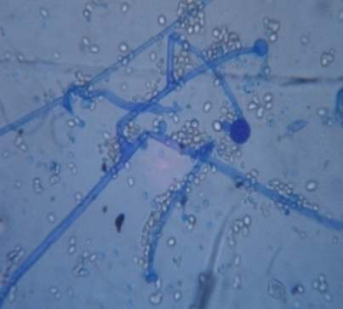
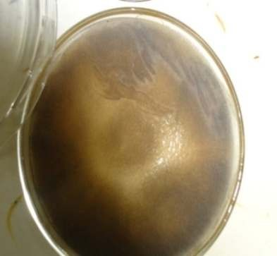
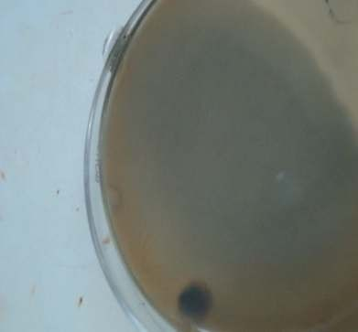
(a) Colony Front view (b) Colony Reverse view c) Cell morphology
Fig. 3. Colony and cell morphology of Mucor spp.
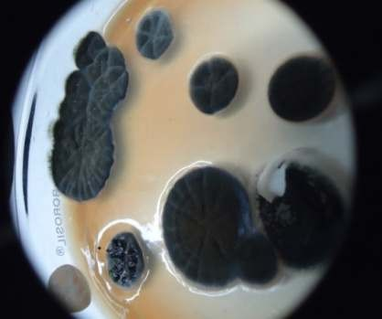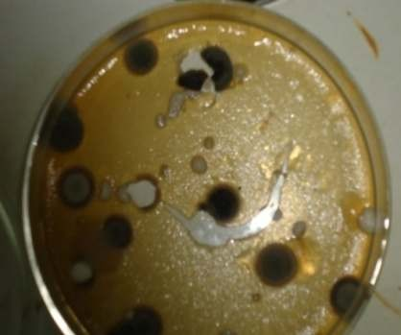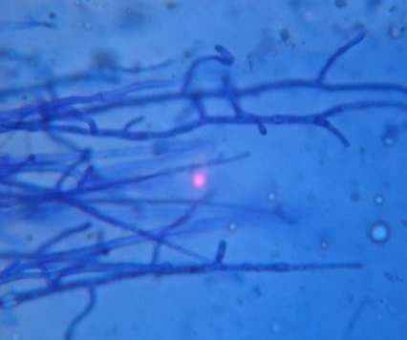
(a) Colony Front view (b) Colony Reverse view c) Cell morphology
Fig. 4. Colony and cell morphology of Cladosporium spp.

Genotypic Identity of the Isolates: Predominating phenotyped psychrotrophic molds 1, 2, 3 and 4 isolated from Indigenous Fermented Milk Products were identified based on 18S rRNA sequencing as Penicillium chrysogenum, Alternaria alternata, Cladosporium cladosporioides and Mucor meheii, respectively (Table 3).

Table 3. Genotypic identity of the predominating psychrotrophic mold isolates with the accession number

Isolate | Accession number | Identity
Isolate – 1 | JQ015265.1 | Penicillium chrysogenum
Isolate – 2 | JN210895.1 | Alternaria alternata
Isolate – 3 | KF983515.1 | Cladosporium cladosporioides
Isolate – 4 | KG983517.1 | Mucor mehei
The same identification tool of 18s rRNA sequencing was used in the mold classification by other studies [31, 32, 33].
Out of the psychrotrophic mold isolated (21 nos.) from refrigerated IFDPs, Penicillium spp. (12 nos.) predominated followed by Alternaria spp., (6 nos.), Mucor spp., (2 nos.) and Cladosporium spp., (1 no.) in the present study. These molds may enter from the air, utensils used, sugar added for preparation and unhygienic handler as mentioned in one of the study. Post processing contamination especially by local producers may introduce the spores of molds into product, low pH and low temperature help in favouring their growth [9]. On par with the present study, psychrotrophic mold count was noticed during storage of shrikhand, an IFDP at refrigeration temperature for 10 days [6]. The predominance of Penicillium spp. was observed in yoghurt and cheese samples stored at refrigeration condition followed by Alternaria spp [34, 9]. On the contrary to the present study, predominance of psychrotrophic Aspergillus spp., followed by Fusarium, Mucor and Penicillium in case of low temperature stored yoghurt samples while in milk samples occurrence of the Alterneria spp., was observed [3]. In some cases, contamination of yogurt products with dimorphic mold e.g., Mucor has been shown to cause yogurt spoilage [5]. The most predominant species of Mucor, Absidia, Penicillium, Geotrachum candidum, Cladosporium, Phoma, Fusarium, Asperigellus flavus, Asperigellus niger and Asperigellus fumigatus were identified from, a total of 125 random samples from raw milk, locally manufactured kareish cheese, hard cheese (Rass cheese), plain yoghurt and flavored yoghurt (25 of each) collected from dairy shops and super markets in Beni Suef city, Egypt but samples were free of aflatoxin M1 [8]. FMPs such as yoghurt and sour milk with low pH (2.9–3.6) from Western Kenya were contaminated with the common molds such as species of Penicillium and Aspergillus that cause spoilage, as the of these products favour their growth [11]. Fungal count on an average of 4.99 (77 samples), 5.29 (111 samples) and 4.23(111 samples) were found in raw milk cheese, pasteurized milk cheese and Kajmak samples (a thick, tangy clotted cream from the Balkans usually made with sheep's or cow's milk) collected from small scale producers of Serbia, respectively. The study was conducted for only enumeration and isolation as well as identification of molds was not carried out [12]. The molds in IFDPs need to be considered for their mycotoxin production having public health importance. The mycotoxins that are the secondary metabolites produced by certain molds like species of Penicilium, Aspergillus, Mucor which have been found to be present in most food substances like in livestock and their byproducts therefore of public health significance [13].

CONCLUSION: A total of 21 psychrotrophic mold isolates were obtained from the Indigenous Fermented Dairy Products such as Mishti Doi, Shrikhand, Lassi and Buttermilk collected from Bengaluru market, Karnataka, India, out of which 6 isolates were from unbranded samples while 15 from branded samples. Pheno and genotypic characterization of the isolated psychrotrophic molds from indigenous fermented milk products revealed predominance of Penicillium chrysogenum (12 nos.) followed by Alternaria alternata (6 nos.), Mucor mehei (2 nos.) and Cladosporium cladosporioides (1 no.) among isolated psychrotrophic molds.

REFERENCES

[1] BAHS- Basic Animal Husbandry Statistics, Major highlights of milk production, 2023, Dept. of Animal husbandry and Dairying, Ministry of Fisheries, Animal husbandry and Dairying, Krishi Bhavan, Government of India, New Delhi.

[2] Gaikwad US. Status of dairy industry in India. Conference of ‘Current Status of Indian diary’ presentation

2019. DOI:10.13140/RG.2.2.12922.24004

[3] Obandae GE, Azua ET. Extent of microbial contamination of nono, fresh cow milk and yoghurt sold in

Makurdi, Benue State, Nigeria. J Microbiol Biotech Res. 2013; 3(3):6-14.
[4] U.S. Food and Drug Administration, Chobani, Inc. voluntarily recalls Greek yogurt because of product
concerns. 2015. http://www.fda.gov/Safety/Recalls/ucm367298.htm
[5] Snyder AB, Churey JJ, Worobo RW. Characterization and control of Mucor circinelloides spoilage in
yogurt. Int J Food Microbiol. 2016; 228:14–21

[6] Karche RV, Thakare VM, Bhagat AV, Shirsath SA. Microbiological quality of cow milk shrikhand blended

with sapota pulp. Int J Food Agri Vet Sci. 2015; 5(1):18-22.

[7] Basavabharati, N. Suchitra, and R. Prabha. Characterization of psychrotrophic molds from indigenous

fermented dairy products. Microbiol. Res J Int. 2017;19 (4):1-9.

https://doi.org/10.9734/MRJI/2017/33106.

[8] El-shinawy SA, El-Kholy, AM, Meshref AMS, Sharkawy SW. Mycological evaluation of milk and some milk

products in Beni-Suef city. Assiut Vet Med J. 2018; 64(156): 117-122
[9] Martin NH, Snyder A, Wiedmann M. Yeasts and Molds: Spoilage mold in dairy products. In book: Reference
Module in Food Science. 2020. doi:10.1016/b978-0-08-100596-5.23017-5
[10] Shi C, Knøchel S. Sensitivity of molds from spoiled dairy products towards bioprotective lactic acid
bacteria cultures. Front Microbiol. Sec. Food Microbiology 2021;12 https://doi.org/10.3389/fmicb.2021.631730
[11] Ogwaro BA, Gibson H, Hill DJ, O’Gara EA. Microbiological quality of typical traditional fermented milk from
Northern Uganda and Western Kenya dairy. 2023; 4, 445–461. https://doi.org/10.3390/dairy4030030
[12] Aleksic B, Udovicki B , Kovacevic J, Miloradovic Z, Djekic I, Miocinovic J, Tomic N, Smigic N. Microbiological
assessment of dairy products produced by small-scale dairy producers in Serbia. Foods. 2024; 13(10):1-17
https://doi.org/10.3390/foods13101456.
[13] Adeyeye SAO. Fungal mycotoxins in foods: A review. Cogent Food Agric. 2016; 2(1): 1213127
https://doi.org/10.1080/23311932.2016.1213127.
[14] Garnier L, Valence F, Mounie J. Diversity and control of spoilage fungi in dairy products: An Update.
Microorganisms. 2017; 5:1- 42 doi: 10.3390/microorganisms 5030042

[15] Omotayo OP, Omotayo AO, M, Babalola OO, Prevalence of Mycotoxins and Their Consequences on
Human Health. Toxicol Res. 2019; 35(1): 1–7. doi: 10.5487/TR.2019.35.1.001
[16] WHO (2023, October 3). Mycotoxins. https://www.who.int/news-room/fact-sheets/detail/mycotoxins.
[17] IS: SP: 18, ISI Handbook of Food Analysis, Part XI, Dairy Products. 1981. Indian Standards Institution, Manak
Bhavan, New Delhi, India.
[18] Harrigan WF. Laboratory methods in Food and Dairy Microbiology, Reading, Academy Press Inc. (London)
Ltd. UK; 1998.
[19] Rai MK, Bonde SR, Ingale AP, Gade AK. Mycotoxin: Rapid detection, differentiation and safety. J Pharm
Educ Res. 2012; 3(1):22-34.
[20] Asnaashari M, Ghanbary MAT, Tazick Z. Optimization of penicillin G production by Penicillium
chrysogenum. Annals Biol Res. 2012; 3(12):5434-5440.
[21] Alsaree OJ, Jassim KN, Hassen TA. Determination of patulin by TLC from moldy apples. Iraqi J Vet
Med. 2010; 34:201-209.

[22] Rehman SU, Rasool MH, Rafi M. 2012. Penicillin production by wild isolates of Penicillium chrysogenum in

Pakistan. Brazilian J Microbiol. 43(2):476-481.
[23] Frisvad JD, Samson RA. Filamentous fungi in foods and feeds: Ecology, Spoilage and mycotoxin
production. In: Handbook of Applied Mycology. Edt. Arora DK, Mukerji KG, Marth EH. Edt.1st. Marcel
Dekker Inc. New York; 1991.
[24] Devi R, D’souza L, Kamat T, Rodrigues C, Naik CG. Batch culture fermentation of Penicillium
chrysogenum and a report on isolation, purification, identification and antibiotic activity of citrinin.
Ind J Mar Sci. 2009; 38(1):38-44.
[25] Bullerman LB. Public health significance of molds and mycotoxins in fermented dairy products. J Dai Sci.
1981; 64: 2439-2452.
[26] Lu XL, Najafzadeh MJ, Dolatabadi S, Ran YP, Gerrits VE, Shen YN, et al. Taxonomy and epidemiology
of Mucor irregularis, agent of chronic Cutaneous mucormycosis. Persoonia. 2013; 30:48–56.
[27] Machouart M, Larche J, Burton K, Collomb J, Maurer P, Cintrat A, et al. Genetic identification of the
main opportunistic Mucorales by PCR-restriction fragment length polymorphism. J Clin Microbiol.
2006;44(3):805-810.
[28] Tasic S, Tasic NM. Professional Article: Cladosporium spp. cause of opportunistic Mycoses. Acta Fac
Med Naiss. 2007; 24(1):15-19.
[30] Kirk PM, Cannon PF, David JC, Stalpers JA. Ainsworth and Bisby’s dictionary of the Fungi. 9th Ed. CABI
Publishing, Wallingford; 2008.
[31] Torrey GS, Marth EH. Isolation and toxicity of molds from foods stored in homes. J Fd Prot.1977;40:187
[32] Frisvad JC, Samson RA. Mycotoxins produced by species of Penicilllium and Aspergillus occurring
in cereals, in “Cereal grain mycotoxins, fungi and quality in drying and storage” (Chelkowski, J., Ed.). 1991;
pp. 441–476. Elsevier, Amsterdam.

[33] Cappa F, Cocconcelli PS. Identification of fungi from dairy products by means of 18S rRNA analysis
Int J Food Microbiol. 2001; 69(1-2):157-160 DOI:10.1016/S0168-1605(01)00587-6
[34] Kumar A, Solanky MJ, Chauhan AK. Study of contaminants in Lassi during storage. J Dai Food
Home Sci. 2003; 22(3):191-195.

