COLOR MANAGEMENT TECHNIQUES AND TOOLS FOR LIBRRAY PUBLICATIONS

Abstract
This paper describes color management and the compounds used for publications. One of the crucial tools for publishing is desktop publishing, and how it handles color standards is quite significant. The main focus of this paper is to explore the primary colors, secondary colors, process colors, color gamut’s, device-dependent or independent solutions, color conversion from one device to another device, and creating the profile. It also explains the characterization of colors, color management principles, standards, editing tools and their usage. This paper also projects an overview of using publication software such as Adobe Photoshop, Illustrator, and InDesign to create library internal publications.
Keywords: Publishing System, Colour Mode, Colour Management, Colour Space, Colour Profile.
INTRODUCTION
The publishing industry is omnipresent in the twenty-first century, taking the form of information exchange, idea exploration, and peer knowledge sharing, and it forms the fourth pillar of the country, aiding in the preservation and dissemination of national history. Other avenues for the nation's scientific development include the publication of studies and papers. How then can this color management assist the publishing sector in the creation of printed resources? The library is one of the sites where data is gathered and kept for future research. For its patrons, libraries publish a wide variety of publications and information.
Throughout the entire printing process, from different devices to the final printing, color management assists prepress printing in maintaining and regulating color accuracy. The purpose of color management is to adjust the color of the copy that is printed from the computer. The color management module, an important part of the publishing industry, ensures that the colors of images and graphics in printed products match the hues that are intended. Color management is crucial when it comes to publishing since images and graphics can be produced using a variety of hardware and software tools, leading to a large range of color spaces and color gamut.
OBJECTIVES
- To explore about the needs of Colours Managements in Publishing
- To understands the Standard colour management in Print.
- To find out how Colour Management tools helps the library Publication activities.
BASICS OF COLOUR AND COLOUR MANAGEMENT
How do we see Colour?
It's just a different wavelength of radiation. Thus, what we can see and how it is determined by the wavelength of light. Visible light is actually among a wavelength that ranges from 390 and 750 nanometres, so that's what we call visible light, which is every light we can see right now. It starts with gamma rays and goes up to x-rays ultraviolet lights visible light infrared light and radio waves depending on the wavelength.
The longer the wavelength is, the more intense it goes up. How do we to be humans view that colour? We need a pair of eyes of course to see color and a brain and then while the array of radiation hits our eye it passes through the iris via a lens and gets focused on the retina and retina has rods and combs rods are responsible for the intensity of light combs are responsible for the color of light so different type of combs have responses to different basic colors the red, green a d blue. That is essentially how it works: information from all of those rods and cones is transmitted to your brain by several nerves, and the occipital lobe region of your brain interprets that information to enable color vision.
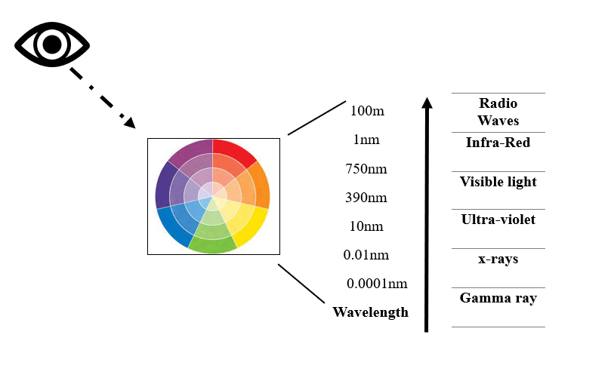
Figure 1(Wavelength Colours views)
Colour Mode
There are two fundamentally different colour models out there that we use on a day-to-day basis, you have RGB (red, green and Blue) and CMYK one is used for our camera and display the other is used for print. So, the RGB is called additive and the CMYK is known as Subtractive because with RGB you start with zero black and we add colors to get brighter colors up to white and with the paper we do the same and the opposite of that we have a white paper and now we subtract colors until we get black.

RGB CMYK
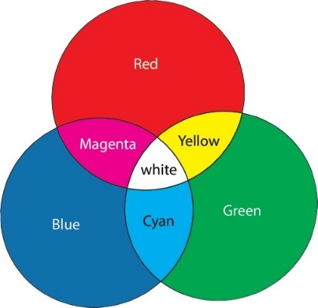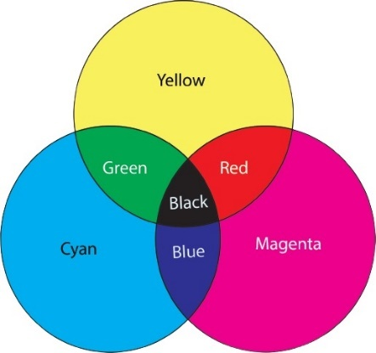
Eg: Camera, Scanner, Display Eg: Printer/Press+Ink+Paper
Figure 2.1 Figure 2.2
Colour Managements
The pre-press color reproduction is where color management first emerged. It quickly evolved from the switch from electronic color reproduction to desktop publishing, bringing about a significant technical advancement in the 1980s and 1990s. These technological advancements are intended to make digital color information interchangeable. Every color management program needs a color profile to ensure that hues are consistent from device to device. A set of configuration data known as a color profile (sometimes called an ICC profile) instructs a computer how to display colors on a certain device. The manufacturers of digital cameras, monitors, scanners, and printers all include color profiles with each of their products. These profiles add unique details about a device's resource acquisition or color display.
ICC- Profile
ICC- Profile

Camera Pr Profile Connection Space Print, Monitor, Tablet,
Scanner (PCS) Smartphone

Device-dependent Device-independent Device- dependent
Figure 3 (Colour Management transformation concept)
ICC Profile
According to ICC (International Colour Consortium), an ICC profile is a set of data that characterizes a color input or output device. The Profile typically describes the color attributes of a particular device by defining the mapping between the device source and a profile connection space. In a typical color correction pipeline, input colors are first transformed through input profiles to a device-independent color space (like Lab), and then through output profiles to the output color space.

Example
Output Profile
Input Profile
CMYK Input Lab CMYK Output
OR
Device Link Profile

CMYK Input CMYK Output

System Setting
The most important thing is to make sure that hardware and software are set up to integrate with the color management system. After that, our monitor needs to be calibrated and profiled.
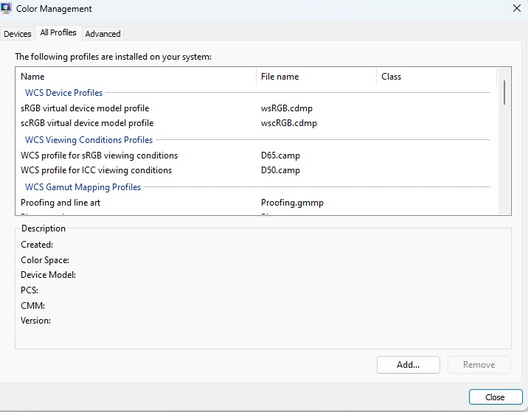
Figure 4
In this, Figure 4 explains about how to set the colour management system in our monitor. Go to Control Panel and choose colour Management which helps to check the calibration and Profiled.

Adobe Illustrator
Colour set-up in the Adobe creative Application
The Colour Options dialogue, found in the Edit choices, is the main tool for managing colors in Adobe applications. To ensure that all available options have been adjusted to your preferences, specify the settings in Adobe Photoshop, or Illustrator the application with the most options.
STEP 1 Open Adobe Illustrator application.
STEP 2 Select Colour Settings via the Edit menu. Working Spaces, Colour Control Regulations, and Converting Options comprise the dialogue window's three primary components.
STEP 3 Select North American Prepress 2 (NAP 2) from the Settings menu located above within the Working Spaces panel. The settings that are used here are the best ones for a print manufacturing workflow.
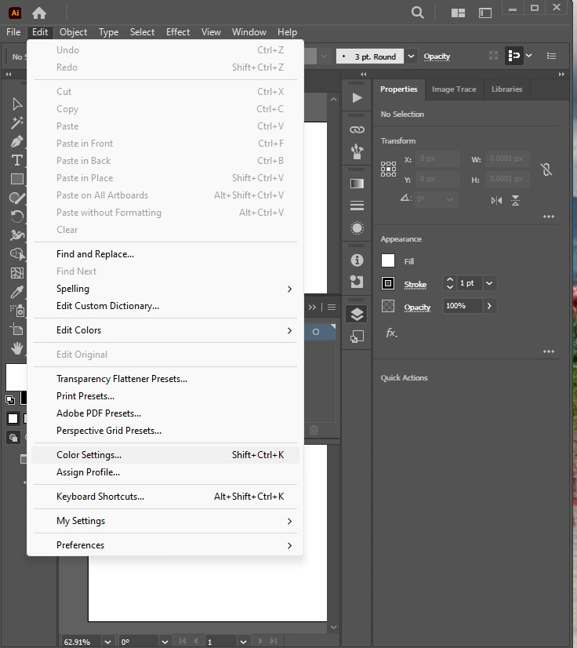
Figure 5.1

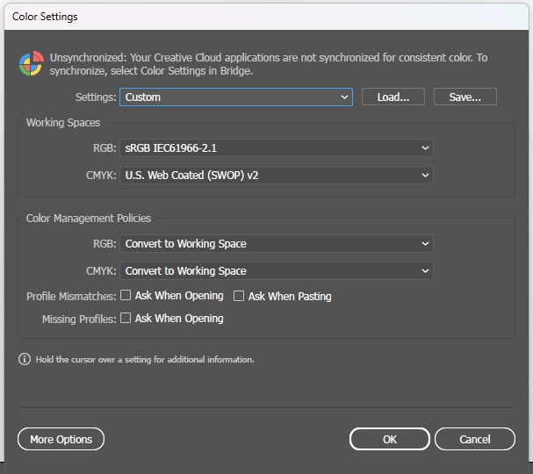  Figure 5.2 | 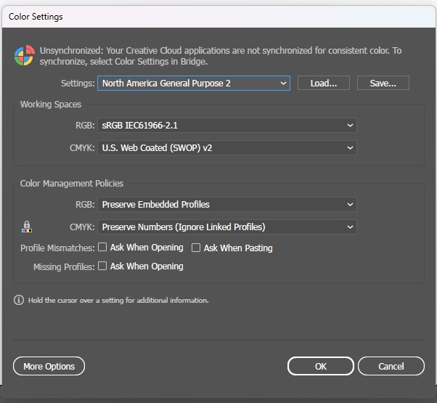  Figure 5.3
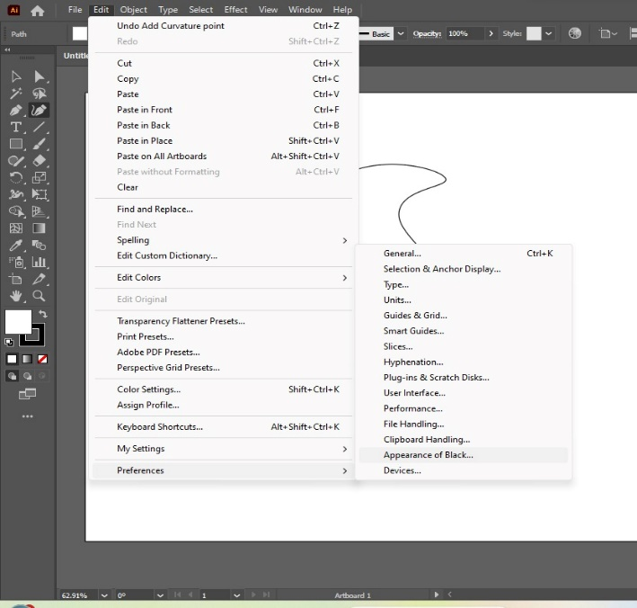  Figure 5.4 | 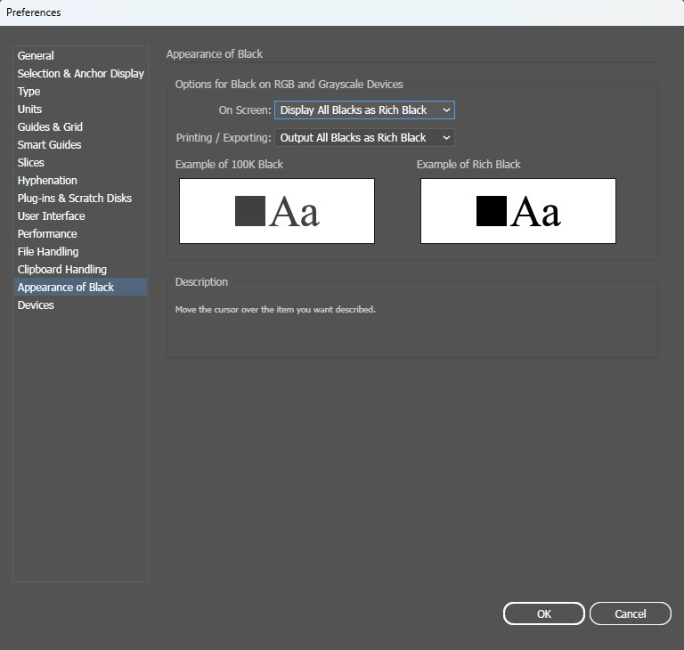  Figure 5.5

STEP 4 To access preferences in Adobe Illustrators when CMKY appears, select the Edit menu. Choose "Black Appearance." There are two screens that we can select from: Display All Backs Accurately (helps distinguish between rich black and pure black). Display All Black as Rich Black is an additional option that renders pure black and rich black on the screen identically.

Adobe Photoshop
Same as the Adobe Illustrators, we can see edit menu which helps to set the colour settings in the Abode Photoshop. Windows and Mac OS operating systems are supported by Photoshop, which is developed by Adobe Systems.
STEP 1 Open Adobe Photoshop
STEP 2 Select the Edit menu in the tool box and colour setting
STEP 3 Choose the RGB and CMYK values for printing workflow.

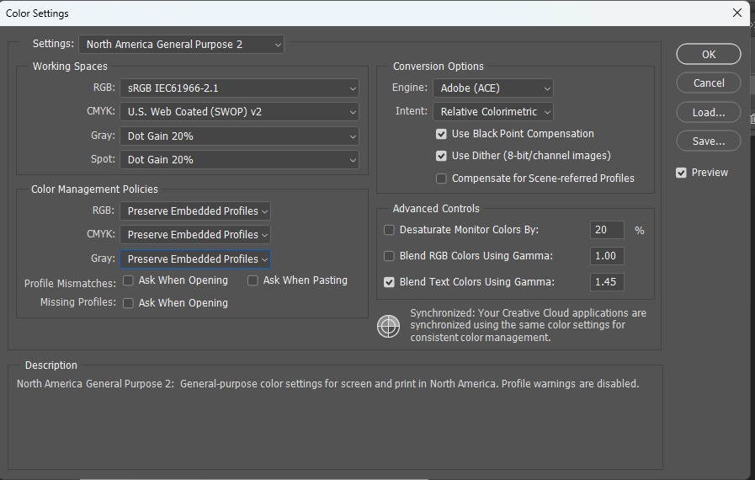
Figure 6
This Figure 4 explains about the colour setting menu in Adobe Photoshop. It will help to adjust the colour setting in the Photoshop for Printing and digital images.
Adobe InDesign
STEP 1 Go to Edit setting in InDesign
STEP 2 Then, chick on colour setting to adjust colours.

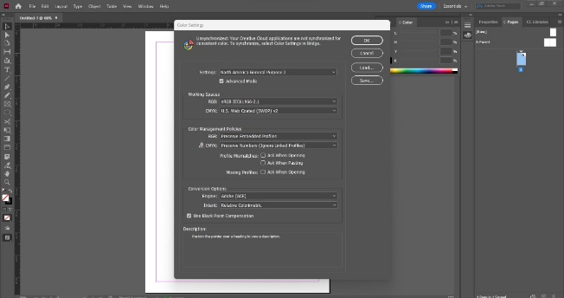
Here, we can select colour space value-RGB, CMYK
Figure 7 (Adobe InDesign)
The RGB default for the North American Prepress 2 setting, Adobe RGB (1998), is a perceptually even RGB space, making it an excellent choice for editing and one of the Working Spaces alternatives. If you are certain of the final output device, choose a profile for it in the CMYK box. These are the colour settings in the Adobe application that make publications like banners, newsletters, and posts more obvious.
CONCLUSION
This paper gives a detailed overview of the value of color management systems for publications and how they aid the printing industry in producing uniform printing results. In the library, we can design a fantastic printing workflow by utilizing several color management systems. A color management system's objectives include predictability and uniformity in color representation. Only a production workflow that is standardized and regularly audited makes this possible. How to create beautiful printouts in the library using Adobe Photoshop, Illustrator, and InDesign. We attempt to precisely manage each device's color behavior using our understanding of it. Other devices, such as cameras, scanners, and printers, must also be monitored in addition to display monitors.

REFERENCES
[1] M. R. Gupta, E. K. Garcia, and E. Chin, “Adaptive Local Linear Regression With Application to Printer Color Management,” IEEE Trans. on Image Process., vol. 17, no. 6, pp. 936–945, Jun. 2008, doi: 10.1109/TIP.2008.922429.
[2] M. Boscarol, “An introduction to digital color management,” Jan. 2002, Accessed: Dec. 29, 2023. [Online]. Available: https://www.academia.edu/51770041/An_introduction_to_digital_color_management
[3] Phil Green, COLOR MANAGEMENT UNDERSTANDING AND USING ICC PROFILES. John Wiley & Sons Ltd, 2012.
[4] A. Sharma, Understanding Color Management, 1st ed. Wiley, 2018. doi: 10.1002/9781119223702.
[5] The basics of color and color management. Accessed: Dec. 29, 2023. [Online Video]. Available: https://www.youtube.com/watch?v=fq-kNtwifFk
[6] O. Vauderwange, D. Curticapean, P. Dreβler, and P. Wozniak, “Digital devices: big challenge in color management,” G. G. Gregory, Ed., San Diego, California, United States, Sep. 2014, p. 91880B. doi: 10.1117/12.2061885.
[7] Gaurav Sharma and Raja Bala, Digital color imaging handbook. CRC press, 2017.
[8] A. Rodney, Color Management for Photographers: Hands on Techniques for Photoshop Users. New York: Routledge, 2005. doi: 10.4324/9780080456393.
[9] T. Grey, Color confidence: the digital photographer’s guide to color management, 2nd e Indianapolis, IN: Wiley Pub, 2006.
[10] F. Yang, Y. Murakami, and M. Yamaguchi, “Digital color management in full-color holographic three-dimensional printer,” Appl. Opt., AO, vol. 51, no. 19, pp. 4343–4352, Jul. 2012, doi: 10.1364/AO.51.004343.
[11] F. Yang, Y. Murakami, and M. Yamaguchi, “Digital color management in full-color holographic three-dimensional printer,” Appl. Opt., AO, vol. 51, no. 19, pp. 4343–4352, Jul. 2012, doi: 10.1364/AO.51.004343.
[12] H. N. Dharavath, “Statistical evaluation of a Color Managed Digital Printing Workflow (CMDPW) consistency [4th C of CMW],” Journal of Graphic Engineering and Design, vol. 12, no. 4, pp. 17–31, Dec. 2021, doi: 10.24867/JGED-2021-4-017.
[13] A. V. Golunov, S. A. Shcheglov, A. S. Golunova, O. A. Kolozova, and O. V. Trapeznikova, “Control and testing of the additive systems color gamut in engineering,” J. Phys.: Conf. Ser., vol. 1546, no. 1, p. 012062, May 2020, doi: 10.1088/1742-6596/1546/1/012062.
[14] A. Sharma, “Color management,” 2008, doi: 10.1036/1097-8542.YB080590.
[15] P.-C. Wu and C.-H. Lin, “A Green and Practical Color Photograph Printing Technology Based on Color Difference Model and Human Perception,” IEEE Access, vol. 10, pp. 649–666, 2022, doi: 10.1109/ACCESS.2021.3138270.
[16] F. K. N. Nunoo, E. A. Antwi, I. Moro, I. K. Appiah, and E. W. Churcher, “Colour Consistency in Print: Ghanaian Printers’ Knowledge and Awareness of Colour Management,” ijird, vol. 8, no. 12, Dec. 2019, doi: 10.24940/ijird/2019/v8/i12/DEC19039.
[17] Z. Dandan and Z. Jingyuan, “Multimodal communication: a social semiotic approach to text and image in print and digital media: by May Wong, Cham, Palgrave Macmillan, 2019, xvii + 192 pp., €49.99 (Hardback), ISBN 9783030154271,” Critical Studies in Media Communication, vol. 37, no. 2, pp. 201–203, Mar. 2020, doi: 10.1080/15295036.2019.1707380.
[18] Y. Wang, Q. Yi, Y. Ding, G. Wu, J. Zhang, and N. Wang, “A Comparative Study of Camouflage Printing Color Matching Based on Monitor and Paper Card,” Fibers Polym, vol. 22, no. 4, pp. 1009–1015, Apr. 2021, doi: 10.1007/s12221-021-9329-1.

