ORIGINAL RESEARCH

Evaluation of Compressive and Flexural Strengths of Two Resin-based Core Materials with an Alkasite Material:
An In Vitro Study

ABSTRACT
Aim: To compare and evaluate the compressive and flexural strengths of two resin-based core build-up materials with an alkasite material. Materials and methods: ParaCore, Tetric N ceram Bulk-fill composite, and Cention N were used. A total of 90 specimens were prepared. Customized cylindrical split molds of dimension 6 ± 1 mm (height) × 4 ± 1 mm (diameter) were used to fabricate 15 samples of each core material for testing the compressive strength and rectangular split metal molds of dimensions 25 ± 1 mm (length) × 2 ± 1 mm (width) × 2 ±
1 mm (height) were used to fabricate 15 samples of each core material for testing the flexural strength. Then the samples were tested using a Universal testing machine (UTM).
Results: The compressive and flexural strengths of Cention N were significantly less than ParaCore® but higher than Tetric® N-CeramTM Bulk-fill core build-up material.
Conclusion: Within the limitations of this study, it was concluded that Cention N may be used as an alternative to other core build-up materials after further in-vitro and in-vivo studies.
Clinical significance: Cention N had the added advantage that self-cure polymerization alone was sufficient to achieve good physical properties when compared to the other two resin-based core build-up materials.
Keywords: Alkasite, Cention N, Core build-up materials.

INTRODUCTION
Prosthetic rehabilitation of root canal-treated teeth with inadequate structure poses a challenge to Prosthodontists’. Biologic, esthetic, and functional demands have to be met while ensuring the retention and stability of subsequent prosthetic restorations. A core build-up restoration is indicated when the remaining coronal tooth structure is not sufficient to create retention and resistance for crown and bridge restorations. The core material should have compressive strength to resist intraoral forces and flexural strength to prevent dislodgement during function. Composites, resins, glass ionomer, cast metal alloy, and dental amalgam have been recommended for coronal build-up after completion of root canal treatment.^{1,2}
Several dental materials have been used for core build-up procedures, some as direct and some as indirect, such as a custom cast post and core. The material used for direct core build-up was not specifically developed for this purpose but did find applications

in core build-up due to properties such as fluoride release, adhesion to the tooth structure, choice of curing mechanism, and better

handling properties to name a few. Each of these materials has its advantages and disadvantages, a thorough knowledge of which helps in the selection of the appropriate material for a particular clinical situation.³
Various versions of resin composite build-up materials like Tetric N Ceram and ParaCoreTM have been introduced with a rationale to develop a better material to overcome the limitations of previous materials. Tetric N Ceram Bulk-fill contains bisphenol A-diglycidyl dimethacrylate (Bis-GMA), ethoxylated bisphenol a dimethacrylate
(Bis-EMA), and urethane dimethacrylate (UDMA). It represents the medium viscosity type Bulk-fill. The curing depth of 4 mm is achieved mainly due to the patented photo-initiator, Ivocerin, which is far more reactive than conventional initiators.⁴ ParaCore is a dual-cured, glass-reinforced, radiopaque composite system available in three shades. The material simplifies the post and core restorative technique because it is ideal for post-cementation as well as core-build-ups. It exhibits a stackable, non-slumpy consistency and is formulated to cut similarly to dentin, allowing

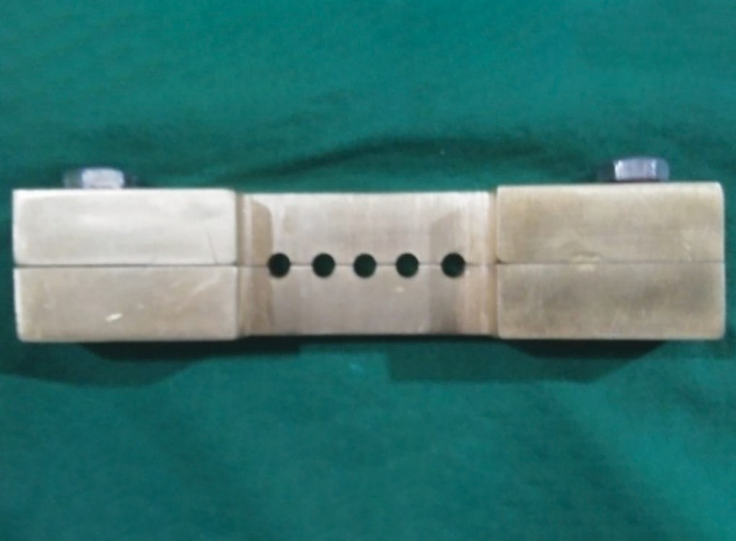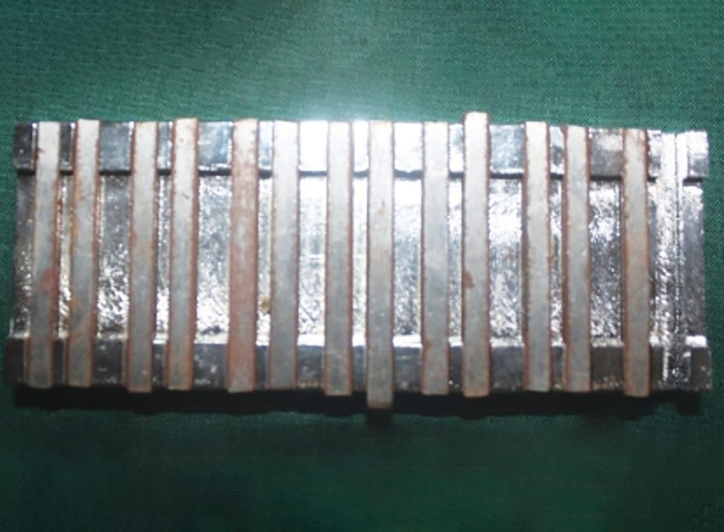
Fig. 1: Cylindrical brass mold Fig. 2: Rectangular metal mold

the bur to move smoothly between the natural tooth structure and the material without creating troughs and grooves. It incorporates glass particles that impart high strength.⁵ Cention N is a recently introduced esthetic, resin-based Bulk-filling material. It is an alkasite restorative material that is essentially a subgroup of the composite material class and utilizes an alkaline filler that is capable of releasing acid-neutralizing ions like fluoride, calcium, and hydroxyl ions.^{6,7} Cention N is a self-cure restorative material that can also be polymerized with a light cure.⁸ The purpose of this study was to evaluate the efficacy of the newly introduced material Cention N as a core build-up material. The aim and objective of this study were to compare and evaluate the compressive and flexural strengths of Tetric® N- CeramTM Bulk-fill composite, ParaCore™, Cention N.

MATERIALS AND METHODS
This study was approved by the Institutional Review Board and conducted in the Department of Prosthodontics and Crown & Bridge at Mahe Institute of Dental Sciences, Mahe from March 2020 to September 2020.

Sample Preparation
Three commercially available core build-up materials were used. The specimen dimensions for each property were selected according to International Standards Organization (ISO) 4049 (ISO, 1992). A total of 90 specimens were fabricated with 30 samples of each type of core material namely Tetric N ceram Bulk-fill composite, ParaCoreTM and Cention N. The specimen dimensions for each property were selected according to International Standards Organization (ISO) 4049 (ISO, 1992). A custom-made cylindrical split brass mold (Fig. 1) of dimensions 6 ± 1 mm (height) × 4 ± 1 mm (diameter) was used to fabricate 15 samples of each core material for testing the compressive strength and custom-made rectangular split metal molds (Fig. 2) of dimensions 25 ± 1 mm (length) × 2 ± 1 mm (width) × 2 ± 1 mm (height) were used to fabricate 15 samples of each core material for testing the flexural strength.
The light cured materials (Bulk-fill & ParaCoreTM) were packed in 2 mm layers to fill the mold and the excess material was removed. The specimens were polymerized using a blue light-emitting diode light source for 40 seconds per layer. The tip of the light source was held within 3 mm – 4 mm of the surface to cure the material to a depth of 2 mm – 2.5 mm. The specimens were then removed from

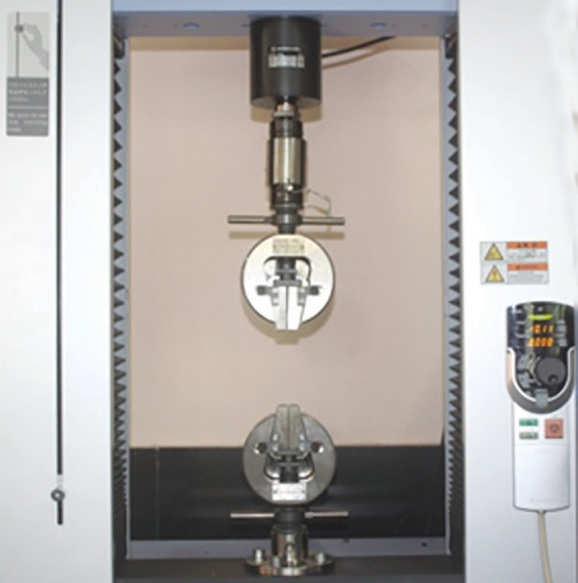
Fig. 3: Universal testing machine

the mold and inspected for voids, and those with voids or other defects were discarded. To have complete curing, each specimen was post-cured 10 minutes after removal from the mold for 60 seconds from all directions to ensure a good polymerization depth. The specimens were stored in distilled water at 37 ± 1°C for 24 hours prior to testing. Cention N consists of a separately packaged powder and liquid those are mixed by hand directly before use. One scoop of powder is used per one drop of liquid, corresponding to a powder/liquid weight ratio of 4.6–1. It was then loaded into the mold, tightly packed, and light cured for 20 seconds with LED curing light (woodpecker).⁹ Each cylindrical specimen was attached to a base which was made with self-cure clear acrylic resin of height and width of 2 cm. Rectangular molds were filled with the materials and polymerized in the same manner.

Sample Evaluation

For Compressive Strength
The samples were tested using a Universal testing machine (Fig. 3). The specimen was connected to a load measuring cell, which continuously recorded the load applied to the samples at a cross-head speed of 0.75 ± 0.25 mm/min until the specimen fractured.

Table 2: Tukeys post hoc test for mu | ltiple comparison | of flexural strength
Dependent variable | MD | p-value
Tetric N Ceram Bulk-fill
Cention N | –40.55 | p = 0.103 (NS)
ParaCore | –68.19 | p = 0.003**
Cention N
ParaCore | –27.6 | p = 0.336 (NS)
Tetric N Ceram Bulk-fill | 40.55 | p = 0.103 (NS)
ParaCore
Tetric N Ceram Bulk-fill | 68.19 | p = 0.003**
Cention N | 27.6 | p = 0.336 (NS)

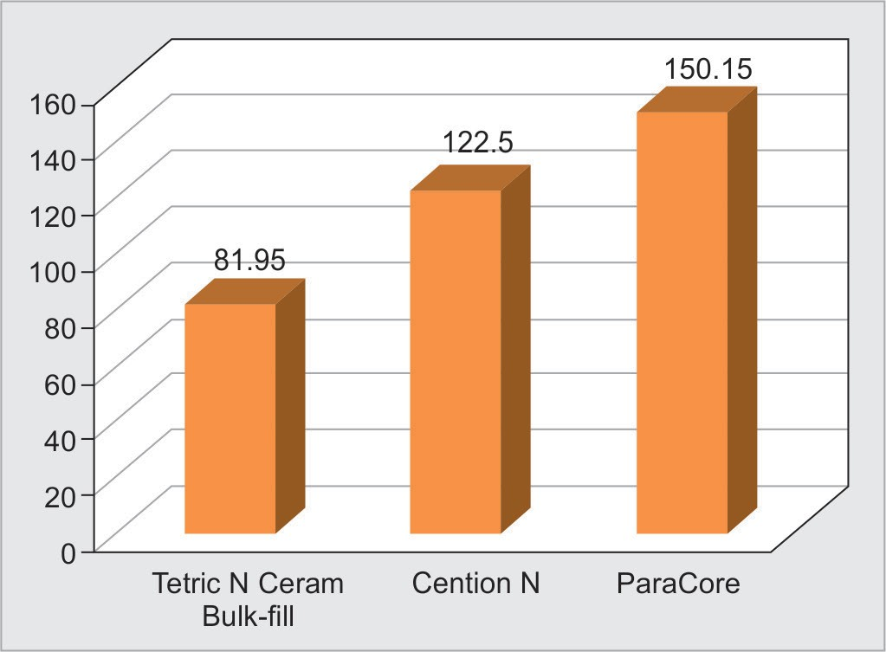
Fig. 4: Mean Flexural strength of ParaCore, Tetric N Ceram Bulk-fill and Cention N

Table 1: Comparison of mean flexural strength between ParaCore, Tetric N Ceram Bulk-fill and Cention N

 | N | Mean | SD | p-value
Tetric N Ceram Bulk-fill | 15 | 81.95 | 39.72 | p = 0.004**
Cention N | 15 | 122.5 | 39.41
ParaCore | 15 | 150.15 | 72.82
**Statistically significant at p < 0.01 using one way ANOVA. N, number; SD, standard deviation

For Flexural Strength
The samples were tested using the three point bending test. The samples were connected to a load measuring cell, which continuously recorded the load applied at the center of the samples at a crosshead speed of 0.5 mm/min until the specimen fractured. The data were obtained and subjected to statistical analysis.

STATISTICAL ANALYSIS
Statistical analysis to compare the mean compressive (N = 15 for each group) and flexural strength (N = 15 for each group) of core materials was performed. Data were analyzed using the statistical package for social sciences (SPSS) version 11.5 (SPSS Inc, Chicago IL). Mean values of compressive and flexural strength between the groups were compared using one-way ANOVA (Analysis of variance) and inter-group comparisons were made based on post-hoc values from Tukey’s test at 5% level of significance (p ≤ 0.05).

RESULTS
The highest flexural strength was recorded for ParaCoreTM followed by Cention N and the least flexural strength was recorded for Tetric N Ceram Bulk-fill composite (Fig. 4). The difference in mean flexural strength between the three core build-up materials was statistically significant (p = 0.004) (Table 1). A post hoc Tukey test revealed a statistically significant difference between Tetric N Ceram Bulk-fill composite and ParaCoreTM (p = 0.003) (Table 2).
The highest compressive strength was recorded for ParaCoreTM followed by Cention N and the lowest compressive strength was recorded for Tetric N Ceram Bulk-fill composites (Fig. 5). The difference in mean flexural strength between the three core
**Statistically significant using post hoc Tukeys test. MD, mean difference; NS, not significant
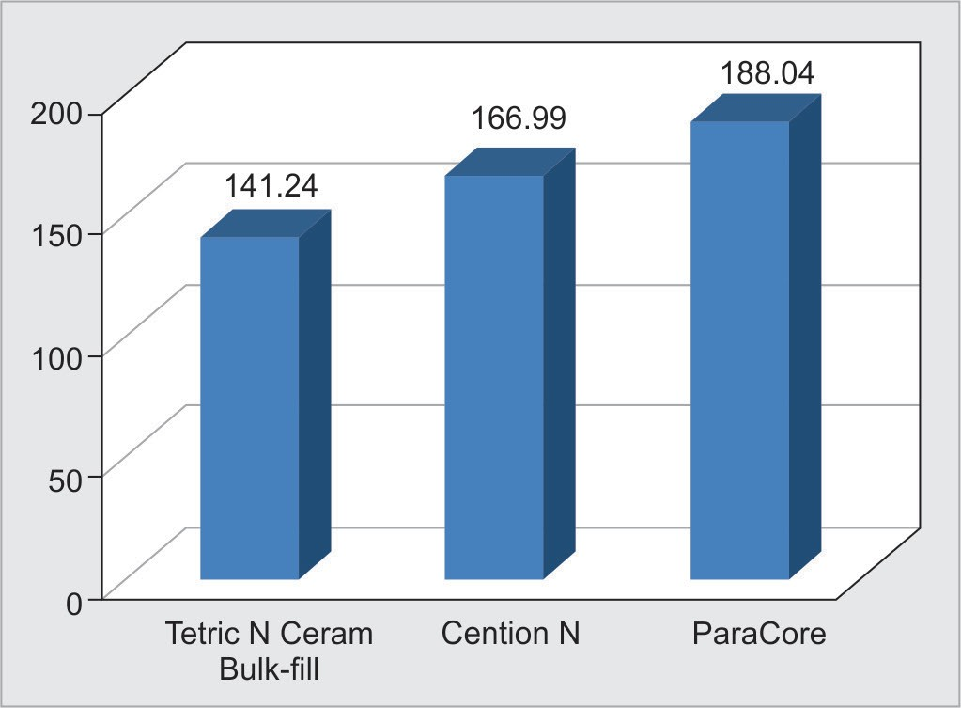
Fig. 5: Mean compressive strength of ParaCore, Tetric N Ceram Bulk-fill and Cention N

Table 3: Comparison of mean compressive strength between ParaCore, Tetric N Ceram Bulk-fill and Cention N

 | N | Mean | SD | p-value
Tetric N Ceram Bulk-fill | 15 | 141.24 | 50.31 | p = 0.013*
Cention N | 15 | 166.99 | 18.45
ParaCore | 15 | 188.04 | 47.27
*Statistically significant at p < 0.05 using one way ANOVA. N, number;
SD, standard deviation

build-up materials was statistically significant (p = 0.013) (Table 3). A post hoc Tukey test revealed a statistically significant difference between Tetric N Ceram Bulk-fill composite and ParaCoreTM (p = 0.001) (Table 4).

DISCUSSION
The long-term success of post-endodontic restorations depends mainly on the adequacy of remaining healthy tooth structure and the effectiveness of the restorative materials used. Conservative access openings, absence of clinical and radiographic features of breakdown, enamel and dentin fracture, and bone resorption would contribute to a fair prognosis. However, scientific literature has revealed that endodontically treated teeth are more susceptible to fracture than vital teeth.^{9,10}

Table 4: Tukeys post hoc test for multiple comparison of compressive strength

Dependent variable | MD | p-value
Tetric N Ceram Bulk-fill
Cention N | 25.75 | p = 0.213 (NS)
ParaCoreTM | 46.8 | p = 0.001**
Cention N
ParaCoreTM | 21.05 | p = 0.344 (NS)
Tetric N Ceram Bulk-fill | –25.75 | p = 0.213 (NS)
ParaCoreTM
Tetric N Ceram Bulk-fill | –46.8 | p = 0.001**
Cention N | –21.05 | p = 0.344 (NS)
**Statistically significant using post hoc Tukeys test. MD, mean difference; NS, not significant

In the present study, among the three resin-based materials, ParaCoreTM had the highest compressive and flexural strength when compared to Tetric N Ceram Bulk-fill composites and Cention N. This finding is consistent with results from studies conducted by Sharma et al. and Majumder et al. where compressive and flexural strength was found to be highest in ParaCoreTM core material when compared to other core build-up materials.^{11,12} ParaCoreTM is fiber-reinforced, dual-cured radiopaque core build-up material. Its improved physical properties can be attributed to its dual- cure nature that ensures complete cure in addition to its resin being reinforced with glass fibers. These fibers affect the fracture process resulting in interrupted crack growth progression thereby enhancing the fracture toughness of ParaCoreTM. Furthermore, the addition of Trimethylolpropane trimethacrylate (TMPTMA) acts as a crosslinking agent with its polymeric matrices and improves its physical properties.¹³ A study by Agarwal and Mala also reported similar findings with respect to its physical properties.¹
In the present study, Cention N had more flexural strength than Tetric N Ceram Bulk-fill composites but lesser than ParaCoreTM core material. The findings were not consistent with the results from Chole et al. where Cention N had the highest flexural strength when compared to Bulk-fill composites, nanocomposites, and resin-modified Glass Ionomer cement (GIC).¹⁴ Yet, in other studies, Hiremath et al. and Mishra et al. found that Cention N had higher flexural strength than Amalgam, resin-modified GIC, and lower flexural strength than nano-hybrid com^{15,16} The compressive strength of Cention N in the present study was less than the compressive strength of ParaCoreTM. Nevertheless, Kaur et al. and Verma et al. reported a superior compressive strength for Cention N than GIC type IX with lesser microleakage compared to GIC and composite restorations demonstrating a better sealing ability as reported by Sujith et al.^{17–19} The higher compressive strength of Cention N can be attributed to the higher filler content that is found in Cention N powder while liquid comprises of dimetharcylates and initiators. Urethane dimethacrylate (UDMA) is the main component that exhibits moderate viscosity and yields strong mechanical properties.
In addition to a better compressive and flexural strength, Cention N exhibits lower microleakage, prevents the recurrence of caries (due to long-term release of fluoride, calcium, and hydroxyl ions), has proximal contact tightness, has dual cure mechanism and possesses superior micro-hardness and fracture resistance properties.^{20–24}
The present study also found that Bulk-fill composites had the lowest flexural and compressive strength among the three materials used in the present study. Hegde et al. also found reduced physical properties of Bulk-fill composites when compared to newer nanocomposites.²⁵ Tetric Ceram is a micro-hybrid, light-cured composite that contains radiopaque fine particles often used for restorative therapy. Kim et al. attributed the reduction in physical properties to fibrous structures of microfill fillers that limit paste filler loadings resulting in poor handling and subsequent reduction in mechanical properties.²⁶ In addition, Mitra et al. reported that due to the small primary particle size, microfills retain the glossy appearance but produce poor bonds between the filler particle and resin matrix that lowers mechanical properties.²⁷
The limitations of the present study were that it did not mimic the clinical scenario and other physical properties of Cention N material could not be evaluated. The next leap of this study should be to evaluate the long-term clinical success of these materials under functional forces.

CONCLUSION
ParaCoreTM had the highest compressive and flexural strengths when compared with Cention N and Tetric® N-CeramTM Bulk-fill composite. The compressive and flexural strengths of Cention N were less than ParaCoreTM but higher than Tetric® N-CeramTM Bulk- fill core build-up material.

REFERENCES
- Agrawal A, Mala K. An in vitro comparative evaluation of physical properties of four different types of core materials. J Conserv Dent 2014;17(3):230–233. DOI: 10.4103/0972-0707.131782.
- Kumar G, Shivrayan A. Comparative study of mechanical properties of direct core build-up materials. Contemp Clin Dent 2015;6(1):16–20. DOI: 10.4103/0976-237X.149285.
- Jayanthi N, Vinod V. Comparative evaluation of compressive strength and flexural strength of conventional core materials with nanohybrid composite resin core material – An in vitro study. J Indian Prosthodont Soc 2013;13(3):281–289. DOI: 10.1007/s13191-012-0236-4.
- Abuelenain DA, Neel EAA, Al-Dharrab A. Surface and mechanical properties of different dental composites. Austin J Dent 2015;2(2):1019.
- ParaCore. COLTENE Group. Scientific description. Available from: http//www.global.coltene.com/products/resoration/luting/ paracore. Last. Accessed on: 25 April 2023.
- Ivoclar Vivadent. Scientific documents: Cention N. pp. 7. Available from: https://www.scribd.com/document/420227633/Cention-N-1#.
- Mann JS, Sharma S, Maurya S, et al. Review article Cention N: A Review. Int J Curr Res 2018;10(5):69111–69112. Available from: https://www. journalcra.com/sites/default/files/issue-pdf/30356.pdf.
- Jayaraj D, Simon EP, Kumar MR, et al. Cention N: A review. Dental Bites 2018;5(4):14. Available from: https://www.kmctdentalcollege. org/source/Files/journal/2018/5-4.pdf#page=15.
- Levartovsky S, Kuyinu E, Georgescu M, et al. A comparison of the diametral tensile strength, the flexural strength, and the compressive strength of two new core materials to a silver alloy-reinförced glass-ionomer material. J Prosthet Dent 1994;72(5):481–485. DOI: 10.1016/0022-3913(94)90118-x.

- Gowda S, Quadras DD, Sesappa SR, et al. Comparative evaluation of fracture strength of different types of composite core build-up materials: An in vitro study. J Contemp Dent Pract 2018;19(5):507–514. PMID: 29807959.
- Sharma A, Shetty PP, Ali A, et al. Comparative evaluation of the compressive, tensile, and flexural strengths of ParaCore®, FlouroCore®2+, and MultiCore® resin-based core build-up materials - An in vitro study. J Conserv Dent 2021;24(6):576–579. DOI: 10.4103/ jcd.jcd_529_21.
- Mazumdar P, Das A, Das UK. Comparative evaluation of microleakage of three different direct restorative materials (silver amalgam, glass ionomer, Cention N) in class II restorations using stereomicroscope: An in vitro study. Indian J Dent Res 2019;30(2):277–281. DOI: 10.4103/ ijdr.IJDR_481_17.
- Silva EM, Miragaya L, Noronha-Filho JD, et al. Characterization of an experimental resin composite organic matrix based on a tri- functional methacrylate monomer. Dent Mater J 2016;35(2):159–165. DOI: 10.4012/dmj.2014-307.
- Chole D, Shah HK, Kundoor S, et al. In vitro comparison of flexural strength of Cention-N, bulk-fill composites, Light-cure nanocomposites and resin-modified Glass Ionomer cement. IOSR Journal of Dental and Medical Sciences (IOSR-JDMS) 2018;17(10): 79–82. Corpus ID: 212431360.
- Hiremath G, Horati P, Naik B. Evaluation and comparison of flexural strength of Cention N with resin-modified glass-ionomer cement and composite - An in vitro study. J Conserv Dent 2022;25(3):288–291. DOI: 10.4103/jcd.jcd_627_21.
- Mishra A, Singh G, Singh SK, et al. Comparative evaluation of mechanical properties of Cention N with conventionally used restorative materials – An in vitro study. Int J Prosthodont Restor Dent 2018;8(4):120–124. DOI: 10.5005/jp-journals-10019-1219.
- Kaur M, Mann NS, Jhamb A, et al. A comparative evaluation of compressive strength of Cention N with glass ionomer cement: An in-vitro study. Int J Appl Dent Sci 2019;5(1):05–09. ISSN PRINT: 2394-7489.

- Verma V, Mathur S, Sachdev V, et al. Evaluation of compressive strength, shear bond strength, and microhardness values of glass-ionomer cement Type IX and Cention N. J Conserv Dent 2020;23(6):550–553. DOI: 10.4103/JCD.JCD_109_19.
- Sujith R, Yadav TG, Pitalia D, et al. Comparative evaluation of mechanical and microleakage properties of cention-n, composite, and glass ionomer cement restorative materials. J Contemp Dent Pract 2020;21(6):691–695. PMID: 33025941.
- Rajkumar B, Iqbal M, Boruah LC, et al. Comparative evaluation of microleakage of three recent resin based core materials: An in vitro study. Endodontology 2012;24(2):97–102. DOI: 10.4103/0970- 7212.352101.
- Donly KJ, Liu JA. Dentin and enamel demineralization inhibition at restoration margins of Vitremer, Z 100 and Cention N. Am J Dent 2018;31(3):166–168. PMID: 30028936.
- Deepak S, Nivedhitha MS. Proximal contact tightness between two different restorative materials – An in vitro study. J Adv Pharm Edu Res 2017;7(2):153–156. E-ISSN: 2249-3379.
- Rai N, Shetty S, Gupta R. Comparative evaluation of the microleakage of Cention N and glass ionomer cement in open-sandwich class II restorations – An in vitro study. J Int Oral Health 2023;15(1):113–118. DOI: 10.4103/jioh.jioh_234_21.
- Mazumdar P, Das A, Guha C. Comparative evaluation of hardness of different restorative materials (restorative gic, Cention N, nanohybrid composite resin and silver amalgam) – An in vitro study. Int J of Adv Res 2018;6(3):826–832. DOI: 10.21474/IJAR01/6737.
- Hegde MN, Hegde P, Bhandary S, et al. An evaluation of compressive strength of newer nanocomposite: An in vitro study. J Conserv Dent 2011;14(1):36–39. DOI: 10.4103/0972-0707.80734.
- Kim KH, Ong JL, Okuno O. The effect of filler loading and morphology on the mechanical properties of contemporary composites. J Prosthet Dent 2002;87(6):642–649. DOI: 10.1067/mpr.2002.125179.
- Mitra SB, Dong WU, Holmes BN. An application of nanotechnology in advanced dental materials. J Am Dent Assoc 2003;134(10):1382–1390. DOI: 10.14219/jada.archive.2003.0054.

