TITLE: A Determination of Phytoremediation by Native Species in Bauxite Spoil Dump: A Case Study of Kara-Kara, Linden

Running Title: Phytoremediation by Native Species in a Bauxite Spoil Dump in Linden, Guyana

ABSTRACT
The difficulty in selecting the species which can grow in degraded bauxite areas is as a result of limited information on the Silviculture and ecological requirements of tropical native/exotic species. The main aim of this project was to assess the phytoremediation properties of the native species in areas degraded by bauxite mining. This study was conducted on an experimental site located in Kara Kara bauxite mined dump in Linden, Guyana. Soil and plant samples were collected from the study area. The study site was colonized by four native species Chrysobalanus icaco (Fat pork), Tapirira guianensis (Duka), Maprounea guianensis (Awati) and Anacardium occidentale (Cashew). Elemental heavy metal concentration was analyzed using Statistix 10 Software Package. Very low levels of heavy metals presence were observed from the results of soil analysis in the study area. Lead (Pb) recorded the highest heavy metals concentration (13ppm) in the soil. Cadmium (Cd) had the lowest (0.3ppm) when compared to Arsenic (As) and Mercury (Hg) which had 3ppm and 1ppm respectively. The presence of heavy metals (Arsenic and Mercury) were found in plant tissues of the four species that colonized the study area. Awati and Cashew had the highest heavy metal concentration of Arsenic with 4ppm for Awati and 3ppm Cashew. The concentration of the other three heavy metals were too negligible to report on. In conclusion, the four native species Chrysobalanus icaco (Fat pork), Tapirira guianensis (Duka), Maprounea guianensis (Awati) and Anacardium occidentale (Cashew) have the ability to phytoremediate Arsenic and Mercury however not Cadmium and Lead. More trials are need to be conducted at different bauxite mined sites on the two species Awati and Cashew for phytoremediation and rehabilitation. This research should be replicated over a longer period of time at different bauxite sites with other species in order to identify those that can phytoremediate Pb and Cd.
Mycorrhizal Association Determination should be conducted on plant roots at depths greater than 30cm in the soil profile and on finer roots to identify the mycorrhizae in the species on the bauxite mined out site.

Keywords: Bauxite mining, Phytoremediation, Heavy Metals, Native Species, Guyana

INTRODUCTION
Mineral extraction, such as gold and bauxite, are the major contributors to deforestation and land degradation and their operations are associated with serious environmental hazards (Lewis & Rosales, 2020). Artisanal gold and bauxite mining possess a major threat to the environment and human health (Lewis, Hossain, & Rao, 2020). Bauxite mining operations involves the removal of forest cover to allow stripping, degrade significant areas of land and replace existing ecosystem with undesirable waste materials in the form of mine spoil dump (Singh, Singh, & Singh, 2007). Mineral extraction, such as gold, bauxite, and diamond mining are major contributors to the Guyana’s economy, providing foreign earnings and job opportunities (Guyana Forestry Commission, 2014). Bauxite are formed on a variety of parent rocks in the Guiana countries (Guyana, French Guiana, and Suriname), ranging from tertiary sedimentary rocks to Precambrian igneous and metamorphic basement lithologies (Monsels & van Bergen, 2017). The development of bauxite mining in Guyana has a long history which resulted in changes to the landform, soil structure, and functioning. Santini and Fey (2013) stated that after 100 years of bauxite mining the soil evolved over time toward a spolic Technosol (calcaric and arsenic) and found that its properties were still dominated by the influence of bauxite residue as parent material in either vegetated or un-vegetated areas and within and older and younger storage areas in Linden, Guyana. Heavy metals occur naturally in the soil environment from the pedogenetic processes of weathering of parent materials at levels that are regarded as trace and rarely toxic (Kabata-Pendias & Pendias, 1992). Geologic and anthropogenic activities increase the concentration of heavy metals to amounts that are harmful to both plants and animals (Kabata-Pendias & Pendias, 1992). These heavy metal concentrations are greatly increased in mining-polluted soils, reaching levels that are more than 100 times higher than those found in uncontaminated or low-contaminated soils (Fijałkowski, Kacprzak, Grobelak, & Placek, 2012). Once in the soil, the ore mine fragments undergo oxidation and other weathering reactions leading to metal ion distribution within the soil system in forms more mobile and also potentially more bioavailable than the original ones (Kabata-Pendias & Pendias, 1992). Mine soils often contains excess amounts of heavy metals (Ålmås, McBride, & Singh, 2000). Heavy metals initially are accumulated on the soil surface without causing noticeable changes (Adriano, 2001), however overtime become contaminants in the soil environments (D'Amore, Al-Abed, Scheckel, & Ryan, 2005). The soil environment has limited protective capacity against the emission of heavy metals. Moreover, as time passes, there is an accumulation of contaminants in the soil and an increase in the uptake of heavy metals by plants (Prasad & Freitas, 2003). Heavy metal toxicity in plants depends on the type of metal, its content in the soil and forms of occurrence. Some heavy metals reduce the amount of chlorophyll in plants, thereby reducing the efficiency of photosynthesis and, consequently leading to an inhibition of the growth of plants (Dimkpa, Marten, Ales, Buchel, & Kothe, 2009). Knowledge about the effect of bauxite residue to bioavailable metal nutrient and toxicant stored in native plants are limited. Santini and Fey (2013) could not identify if pH, EC and total alkalinity differed between vegetated and un-vegetated sites prior to vegetation establishment in Linden bauxite storage facilities. This information is critical for assessing the possible success of bioremediation and phytoremediation. Plants were proposed for use in the treatment of waste water, land, and water pollution from heavy metals around 300 years ago (Carolin, Kumar, Senthil, Joshiba, & Naushad, 2017). This technique known as Phytoremediation was considered innovative and less costly solution in removing the accumulation of heavy metals in the environment (Ansari, Naeem, Sarvajeet, & Fahad, 2020). The native species population on a post-mining lands may have phytoremediation abilities. Plants require suitable below-ground ecosystems, particularly in post-mining environments. Bioavailable metals such as Cu, Mn, and Fe are prevalent in natural soils and play an important role in plant nutrition (Lewis, Hossain, & Rao, 2020). Because only a portion of metals are mobile in the soil profile and available for absorption by plant roots, the total content of metals in soil is generally not a suitable indicator for estimating their availability in soils (Mescouto, et al., 2011). Cadmium (Cd) is one of the most dangerous metals due to the high mobility and small concentration at which its effects on plant begin to appear (Benavides, Gallego, & Tomaro, 2005), it is the most phytotoxic among the frequently studied heavy metals (Lewis, Hossain, & Rao, 2020) . In this study, we aimed to determine the presence of heavy metals in (i) the soil and (ii) the native species colonizing Kara-kara bauxite spoil dump. To our knowledge this is an inception report of heavy metals presence in native plant species in bauxite spoil dumps in Guyana.

MATERIAL AND METHODS

Study site
This study was conducted at the Kara Kara bauxite spoil dump, which is located in Linden, Region # 10, approximately 104 km (65 miles) south of Georgetown. The Kara Kara bauxite spoil dump is situated in the Mackenzie Mining District of Linden having a geographic coordinate of 21N 0358242 UTM 0665028.
Kara-kara spoil dump is located south of the Soesdyke-Linden highway having a geographical coordinate of 6.01499°N -58.28084°E (Fig. 1). The monthly average rainfall in 2018 was 350 mm during the month of August and March was recorded the driest month 0.5 mm in April (Hydrometeorological Department, 2018). The forest type of the area is classified locally as Dry Evergreen Forest dominated by Wallaba (Eperua) and Dakama (Dimorphandra conjugate) species. This type of forest formation occur on white sand (Fanshawe, 1961). The forest has been disturbed by forest fires. Apart from this, the forest has been previously used to produce charcoal (Lichtenwald, 2001).
Fat pork (Chrysobalanus icaco) and belongs to the Chrysobalanaceae family. This species is found mostly near sea beaches and inland throughout tropical Africa, tropical America and the Caribbean. Fat pork either grows a shrub approximately 1–3 meters or bushy tree approximately 2–6 meters. It has evergreen broad-oval to nearly round somewhat leathery leaves (3 to 10 cm long and 2.5 to 7 cm wide). The fruit is edible with a mildly sweet flavor and is sometimes used for jam (Shepherd, 1974). This species prefers a position in full sun or light shade and has the ability to succeed in ordinary soil. It is known to have the ability to thrive in both poor and fertile soils and requires a well-drained soil. When this species is established, then they are deemed as having the tolerance to drought and salt-laden winds (Brown & Frank, 2018). The coastal form of this plant is highly tolerant of salt, so it is often planted to stabilize beach edges and prevent erosion. Chrysobalanus icaco is frequently found in spoil dumps in Linden.
Tapirira guianensis is the scientific name for Duka, a species of plant in the Anacardiaceae family. It is native to Cerrado and Atlantic Forest (ecoregions) vegetation in Brazil. Duka, which is the species common name, is an evergreen tree with a dense, rounded crown; usually growing 8 - 14 meters tall in Brazil, but to 25 meters or more in Panama. Young plants grow away quickly and can easily reach a height of 3 meters within 2 years (Lorenzi, 2002). This species is found in a wide range of habitats, mainly in denser forests and secondary growth areas. It grows principally in wetter soils, though it can also tolerate drier, hillside conditions, and savannah forest (Oliveira-Filho & Ratter, 1995). The plant also bears edible fruits purple, globose drupe which are easily sought by the native fauna (Lorenzi, 2002).). Duka produces oleoresin which is obtained from the stem and is recommended to treat syphilitic ulcer (Steyermark et al., 2005). The tree also has its agroforestry uses which act as a fast – growing very adaptable plant that is naturally pioneered which makes a good choice for re-establishing native woodland especially in moist soils.
Maprounea guianensis is the scientific name for Awati. It is an evergreen shrub or tree with a dense, globose, very characteristic crown growing 4 - 14 metres tall. The short, cylindrical bole is usually slightly grooved and can be 30 - 50cm in diameter. This species is found in a wide range of habitats including savannah, semi deciduous forests and rainforests, growing mainly in primary and secondary forest formations where it prefers well-drained, clay soils on gentle slopes. When this species is growing on the savannah it is sometimes no more than a shrub. The tree is sometimes harvested from the wild for local use as a medicine and source of wood and ink. It is an ornamental plant that furnishes a good shade (Lorenzi, 2002).
Cashew, scientifically known as Anacardium occidentale, is a much branched, evergreen shrub or small tree with a spreading crown that can grow up to 15 metres tall. It generally starts branching about 50 - 150cm from the ground while the crooked bole can be 20 - 40cm in diameter. This species grows well in hot, semi-arid, frost-free climates. It occurs in warm and humid climates with an annual rainfall of 1,000 - 3,500 mm and prefers a pronounced dry season of 3 - 4 months. It is found on a well-drained sandy and can bear heavy, waterlogged clay soils or saline soils but with an extreme poor growth. This species is fast growing and it tolerates a pH in the range 4.5 - 6.5 (Wickens, 1995).

Sampling methodology
A purposeful soil sampling collection were conducted on the Kara-kara bauxite waste dump situated about 400m above sea level (Fig. 1). Soil samples were collected at 0-15 cm and 15-30 cm depths in 2018. The dimensions of the experimental was 55 m x 55 m (0.3025 ha) on the bauxite waste dump This area was selected to sample because of ease to access and the presence of abundant vegetation from which eight plots were selected randomly. With an auger soil samples were taken from the midpoint of eight randomly chosen plots. The 8 plots represent 30% of the experimental area. The process of randomization was done according to the methodology of Gomez and Gomez (1984) (Gomez & Gomez, 1984). All species found in the experimental area were identified and recorded according to their local and scientific names.

Sample processing and chemical analysis

Collection of Soil Samples
At each of the identified sample plots, four random partial soil samples were collected at depths of 0 to 15 cm and 15 to 30 cm. The samples were collected with the use of a 20 mm soil auger and were mixed thoroughly and then a composite sample weighing 0.5 kg was taken. Each of the 0.5 kg composite sample was further segregated into two portions. 3/4 of the sample was used for chemical analysis, while the remaining 1/4 was used to determine the pH of the soil.

Identification of Plant Samples

For each plant of the four species dominated the area (Fat Pork, Awati, Cashew and Duka) a sample was collected from each sample plots and placed in a ziploc bags and transported to the University of Guyana Laboratory.

Laboratory Procedures

Soil pH testing using Hanlon Methodology

The soil drawn in the auger was placed into Ziploc bags and Transported to the University of Guyana Laboratory for chemical analysis preparation. The soil samples were sieved to remove particles such as roots, stone or organic matter with a 2 mm sieve. Portion (1/3) of the soil was used for pH analysis. The soil samples were then crushed into small particles and placed into a beaker where distilled water was added proportional. The pH meter was then collaborated using a pH 7 buffer solution. 9g of soil was weighed and placed into a 100mL beaker. 20 mL of distilled water was added and stirred with a glass rod and left to stand for approximately 30 minutes. The electrode (rods) were suspended into the solution and the reading on the meter was observed and recorded. This procedure was repeated for each sample from the different plots sampled.

Soil Elemental Analysis

The other portion of the soil (3/4) were analyzed by the Canadian based Company. ACT Laboratory, which used the 1H-Total digestion-ICP, INAA package conducted by Hoffman (1992). INAA is an analysis technique dependent on measuring gamma radiation induced in the soil samples by irradiation with neurons. The primary source of neutrons for irradiation is usually a nuclear reactor. Each activated element emits a “fingerprint” of gamma radiation which can be measured and quantified. The procedure involves : (i) a 30 g aliquot which was encapsulated in a polyethylene vial and irradiated with flux wires and an internal standard (1 for 11 samples) at a thermal neutron flux of 7 x 10¹² n cm⁻² s⁻¹, (ii) after a 7-day period, to allow Na-24 to decay, the samples were counted on a high purity Ge detector with resolution of better than 1.7 KeV for the 1332 KeV Co-60 photopeak, (iii) using the flux wires, the decay-corrected activities were compared to a calibration developed from multiple certified international reference materials. The standard present is only a check on accuracy and is not used for calibration purposes, (iv) from 10-30 % of the samples were rechecked by re-measurement and values exceeding the upper limits, assays were recommended and (v) One standard was run for every 11 samples.

Total Digestion - ICP Portion

Each soil sample weighing 30g was analyzed to the 0.25 g of each soil sample was digested with four acids beginning with hydrofluoric, followed by a mixture of nitric and perchloric acids. This was then heated using precise programmer controlled heating in several ramping and holding cycles which took the samples to incipient dryness. After incipient dryness was attained, samples were brought back into solution using aqua regia. The samples were then analyzed using an Agilent 735 ICP. QC for the digestion was 14% for each batch, 5 method reagent blanks, 10 in-house controls, 10 samples duplicates, and 8 certified reference materials. An additional 13% QC was performed as part of the instrumental analysis to ensure quality in the areas of instrumental drift. It can be noted with this digestion; certain phases may be only partially solubilized. These phases include zircon, monazite, sphene, gahnite, chromite, cassiterite, rutile and barite. Ag greater than 100 ppm and Pb greater than 5000 ppm should be assayed as high levels may not be solubilized. Only sulphide sulfur will be solubilized.

Data Analysis

Boxplots were constructed to summarize soil properties of Kara-Kara bauxite spoil dump. The soil data collected in the study site were tested for normality by Shapiro-Wilk’s test. The data was non-normal; therefore, non-parametric test was performed on the data collected. A non-parametric independent sample test A Mann-Whitney test was performed to determine the significant differences between the medians of the study site and the effect of soil depth at a confidence level of 95% (α = 0.05). Microsoft Excel was used to produce charts and graphs for the heavy metals and micro nutrients present in the soil. The statistical analysis was performed in the SPSS Statistics version 20 to determine the difference in means of heavy metals concentrations in the samples.

RESULTS

Heavy metal concentration found in the Soil
The median for the study parameters were not different across the soil depths in Kara-kara bauxite waste dump (Figure 4). Soil pH varied for each sample, an acidic pH ranged from 3.9 to 5.5 for most of the samples (n = 15) at two sampling periods. However, the remaining samples were observed having a neutral pH ranged from 6.2 to 7.2 (Figure 3).
The soil elemental analysis indicated that Kara-kara bauxite waste dump have very low levels of heavy metals concentration (As, Cd, Hg, Pb). Pb was found having the highest concentration (of merely 13 ppm) when compared to the other heavy metals, while Cd was found having the lowest (0.3 ppm) (Figure. 4).
Among all the elements analyzed, the Macro nutrient element Al and Micro nutrient element Fe were found to have the two highest concentration (55600 ppm and 4000 ppm respectively) (Figure 4).
Other heavy elements or extractable micro-nutrients such as Mn, Cu, Cr, Co, V and Zn were also found in the soil. In this category, Mn was found having the highest average concentration of (98ppm), while Co was found to have the least concentration of merely 1ppm (Figure 5).

Heavy metal concentration found in the Native Species

Four dominant native woody species (Fat pork, Awati, Duka and Cashew) were identified in the waste dump at Kara-kara. The analysis results showed the presence of Heavy metals in their tissues. Awati contained the highest concentrations of heavy metals, followed by Cashew, Fat pork and then Duka. It is important to note that out of the four main heavy metals, only As and Hg were found in the native species. Awati contained 4ppm of As in its plant tissue, which was the highest concentration extracted by any of the native species. Hg was found in all the species with Duka having the highest concentration for Hg at a merely 0.06 ppm and the lowest concentration for As. All the other species had lower levels of Hg.
The native species did not phytoremediate Cd and Pb even though it was found that Pb had a very high concentration and Cd was low in the soil. In general, plants do not absorb or accumulate Pb. However, in soils testing high in Pb, it is possible for some Pb to be taken up (Figure 6).
Other heavy metals found in the native species include Fe, Co, Cr, Co and Zn. Awati was also found having high concentration (1050 ppm) of Fe whereas Fat pork had the lowest average concentration (525 ppm) of Fe among the native species. However, it is important to note that no V, Al, Mn were found in the native species’ plant tissue. Cashew, Fat pork, Awati and Duka all contained varying levels of concentration of Cr, Co, Zn (Figure 7).

DISCUSSION

Heavy metal concentration found in the Soil

Soil pH is an indicator of the chemical processes that occur in the soil and is a guide to the likely deficiencies and toxicities (Hazelton and Murphy, 2007). Soil pH affects the mobility of heavy metals in soil. It has been found that soil pH is correlated with the availability of nutrients to the plant (Gray et al., 1998). Consequently, as pH decreases, the solubility of metallic elements in the soil increases and they become more readily available to plants (Oliver et al., 1998). The low pH of the Kara-kara bauxite mined-site may be due to the weathering of the sulphide minerals. Similarly, Santini and Fey (2013) found lower pH and total alkalinity in vegetated sites than on non-vegetative sites in the Kara-kara areas impacted by bauxite mining. According to Odu et al., (1985), the acidic soil may tend to have an increased micronutrient solubility and mobility as well as increased heavy metal concentration in the soil.
This study examined at a total of 12 heavy metals, including Arsenic (As), Aluminum (Al), Cadmium (Cd), Cobalt (Co), Copper (Cu), Chromium (Cr), Iron (Fe), Lead (Pb), Manganese (Mn), Mercury (Hg), Zinc (Zn) and Vanadium (V). Heavy metals or metalloids comprised As, Cd, Hg, Pb, other heavy metals or extractable micro-nutrients are Co, Cr, Cu, Fe, Mn, V, Zn and the macro nutrients Al as documented by Chibuke et al., (2014). The study site has significantly lower level of heavy metals (As, Cd, Hg and Pb). The highest concentration of Pb (of merely 13ppm) when compared to the other heavy metals, and the lowest concentration of Cd (0.3ppm), corroborated with the findings of a study conducted by Al-Turki and Helal (2004) who reported that Pb and Cd are anthropogenic metals, and without serious external interference, are normally not abundant in upper layer of the soils. The major elements present in vegetative areas of the waste dump in highest concentration were Al and Fe. This is due to fact that calcined bauxite (Al₂O) is composed of hydrated aluminum oxides, hydrated alumino silicates, iron oxides, hydrated iron oxides, titanium oxide, and silica (Debney, 1993). Similar results by Maiti and Nandhini (2005) found in mined-sites having high concentrations of Al and Fe. These levels were found to be lower than results obtained by Maiti et al, 2005.

Heavy metal concentration found in the Native Species

The heavy metals that are available for plant uptake are those that are present as soluble components in the soil solution or those that are easily solubilized by root exudates (Blaylock 2000). Although plants require certain heavy metals for their growth and upkeep, excessive amounts of these metals can become toxic to plants. The ability of plants to accumulate essential metals equally enables them to acquire other nonessential metals (Djingova and Kuleff, 2000).
The results showed presence of low concentration of As and Hg in the plant tissue of the four native woody species identified growing naturally in the waste dump. The native species phytoremediate As and Hg but did not phytoremediate Cd and Pb even though it was found that Pb had a very high concentration and Cd was low in the soil. In general, plants do not absorb or accumulate Pb. However, in soils testing high in Pb, it is possible for some Pb to be taken up. Itn was noted that Pb does not readily accumulate in the fruiting parts of vegetable and fruit crops (e.g., corn, beans, squash, tomatoes, strawberries, and apples). In most cases, higher concentrations are more likely to be found in leafy vegetables (e.g., lettuce) and on the surface of root crops (e.g., carrots) (Rosen, 2002). The levels of concentrations extracted by the native species depend on the levels found in the soil and their mobility. Cd and Hg, just like all the other heavy metals, bioavailability determines whether plant uptake occurs to a significant degree (Weggler, 2004). Metal uptake by plants depends on the bioavailability of the metal in the water phase, which in turn depends on the retention time of the metal, as well as the interaction with other elements and substances in the water. Furthermore, when metals have been bound to the soil, the pH, redox potential, and organic matter content will all affect the tendency of the metal to exist in ionic and plant-available form. Plants will affect the soil through their ability to lower the pH and oxygenate the sediment, which affects the availability of the metals (Fritioff and Greger, 2003). Additionally, the uptake of a compound is affected by plant species characteristic (Burken, 1996). These results were somewhat similar and contrasting with Freitas et al., (2004) who reported that native species had the ability to accumulate high concentrations of As and Pb but not Cd and Hg.
These results are both similar and contrasting with the study conducted by Maiti and Nandhini (2005), where they found high levels of Fe, Mn and Zn was present in the native species of the mined out site.
Maiti et al., (2005) conducted a study with the aim to identify pioneering species that naturally colonize Fe tailings and accumulate heavy metals. This study highlighted four tree species (Tectona grandis, Alstonia scholaris, Azadirachta indica and Peltaphorum spp.) that were found growing naturally, having the ability to extract heavy metals. This indicated that some native species could accumulate relatively high metal concentrations indicating internal detoxification of metals. The study also revealed that T. grandis accumulated a higher concentration of metals than A. scholaris in the Fe tailings, but all concentrations were within the normal range. Another study conducted on the Fe tailings of Noamundi, Tata - Steel plant in India by Maiti and Nandhini (2005) found that nine plant species were able to grow naturally on the Fe tailings out of which four species namely Borhevia repens, Oxalis corniculata, Blumea lacera and Avera aspera were analyzed for total metal contents in the whole plant. Maximum accumulation of Fe was found in Oxalis (7442 mg kg-1) whereas Mn and Zn were observed maximum in Blumea lacera (88 mg kg-1) and Avera aspera (109 mg kg-1) respectively. Das and Maiti (2007) conducted a field study in an abandoned copper mine tailing (Rakha Mine, Jharkhand, India) to find out accumulation of metals (Cu, Ni, Mn, Zn, Pb, Cd and Co) in the naturally colonizing vegetation. They found that out of eleven species Ammania baccifera growing on copper tailings, levels of Cu accumulation in the root parts was found even more than 1000 mg kg−1 dry weight (DW). Metals accumulated by A. baccifera were mostly distributed in root tissues, suggesting that an exclusion strategy for metal tolerance widely exists in them. Thus, establishment of such plant on copper tailings can be a safe method to stabilize the metals. Freitas et al., (2004) studied the metal accumulation in the natural vegetation in the degraded copper mine of São Domingos, Portugal. Plants belonging to 24 species, 16 genera and 13 families were collected and samples were analyzed for Ag, As, Cu, Ni, Pb, and Zn. With respect to plants, the higher concentrations of Pb and As were recorded in the semi-aquatic species Juncus conglomeratus with 84.8 and 23.5 mg kg−1 DW respectively, Juncus efusus with 22.4 and 8.5 mg kg−1 DW, and Scirpus holoschoenus with 51.7 and 8.0 mg kg−1 DW, respectively. Thymus mastichina also showed high content of As in the aboveground parts, 13.6 mg kg−1 DW. The results indicated that accumulation of various metals by different plant species.
As such As, Cd, Hg and Pb are metalloids, generally referred to as heavy metal that do not have any beneficial effect on organisms and are thus regarded as the “main threats” since they are very harmful to both plants and animals (Chibuike et al., 2014).

CONCLUSION
Heavy metals uptake, by plants using phytoremediation technology, is proven to be a cheap and safe way in remediating heavy-metals-contaminated environment due to mining. Therefore, it was found that some of the native species of the bauxite waste dump in Kara Kara, Guyana do have the ability to phytoremediate heavy metals thus decontaminating the area. However, the native species were only able to accumulate As and Hg even though Pb had the highest concentration when compared to the other heavy metals. Additionally, it is important to note that even though the heavy metal concentrations of the mined out area were of low levels, it seems that their persistence in the soils of the mined-sites may lead to increase uptake of these heavy metals by plants in the future. Out of the species examined, it can be suggested that both Awati and Cashew can be considered the best suited candidates for rehabilitation of bauxite mined out sites.

LIST OF ABBREVIATIONS
Parts per Million: ppm; ACT: Accredited Independent Testing Laboratory; ICP: Inductively Coupled Plasma; INAA: Instrumental Neutron Activation Analysis; Ge Detector: Germanium detectors; KeV; Kiloelectron volt; QC: Quality control; SPSS: Statistical Package for Social Science.

REFERENCES
Adriano, D. C. (2001). Trace Elements in Terrestrial Environments (Second ed., Vol. 1). Verlag New York Berlin Heidelberg: Springer Science + Business Media, LLC. doi:doi:10.1007/978-0-387-21510-5
Ålmås, A. R., McBride, M. B., & Singh, B. R. (2000). Solubility and liability of cadmium and zinc in two soils treated with organic matter. Soil, 165(3), 250-259. doi:10.1097/00010694-200003000-00007
Ansari, A., Naeem, M., Sarvajeet, S., & Fahad, A. (2020, March 20). Phytoremediation of contaminated waters: An eco-friendly technology based on aquatic macrophytes application. The Egyptian Journal of Aquatic Research. doi:https://doi.org/10.1016/j.ejar.2020.03.002
Benavides, M., Gallego, S., & Tomaro, M. (2005). Cadmium toxidity in plants. Braz. J. Plant Physiol, 17(1), 21-34. Retrieved May 2, 2022, from https://www.researchgate.net/publication/262653187_Cadmium_Toxicity_in_Plants/link/03919e7b0cf2b378a8ad3cfb/download
Berti, W., & Cunningham, S. (2000). Phytostabilization of metals. In E. B. Raskin, Phytoremediation of toxic metals- Using Plants to clean up the environment (pp. 71-88). New York: John Wiley & Sons.
Brown, S. H., & Frank, M. S. (2018, March). Cocoplum (Chrysobalanus icaco L.) Identification and Uses. UF| IFAS Extension, University of Florida, 2.
Carolin, F. C., Kumar, P., Senthil, S. A., Joshiba, G. J., & Naushad, M. (2017, June). Efficient Techniques for the Removal of Toxic Heavy Metals from Aquatic Environment; A Review. Journal of Environmental Chemical Engoneering, 5(3), 2782-2799. doi:https://doi.org/10.1016/j.jece.2017.05.029
Chibuike, G., & Obiora, S. (2014). Heavy Metals Polluted Soils. Effects on Plants and Bioremediation Methods. Applied and Environmental Soil Science.
D'Amore, J., Al-Abed, S., Scheckel, K., & Ryan, J. (2005, September 8). Methods for Speciation of Metals in Soils: A Review. Journal of Environmental Quality, 34, 1707-1745. Retrieved from https://www.researchgate.net/publication/7611345
Das, M., & Maiti, S. (2007). Metal Accumulation in 5 native plants growing on an abandoned Cu-tailings ponds. Applied Ecology and Environmental Research 5 (1), 27-35.
Dimkpa, C., Marten, D., Ales, S., Buchel, G., & Kothe, E. (2009). Metal-induced oxidative stress impacting plant growth in contaminated soil is alleviated by microbial siderophores. Soil Biology & Biochemistry, 41, 154-162. doi:doi:10.1016/j.soilbio.2008.10.010
Fanshawe, D. (1961). Principal Timbers-Part I. Forestry Bulletin No. 1, Third Edition, Guyana Forestry Commission (GFC), Forestry Department, Georgetown.
Fijałkowski, K., Kacprzak, M., Grobelak, A., & Placek, A. (2012). The influence of selected soil parameters on the mobility of heavy metals in soils. Inżynieria i Ochrona Środowiska, 15(1), 81-92. Retrieved from https://www.researchgate.net/publication/282734701
Freitas, H., Prasad, M., & Pratas, J. (2004). Plant community tolerant to trace elements growing on the degraded soils of São Domingos mine in the south east of Portugal: Environmental Implications. Environmental International 30 (1), 65-72.
Gomez, K., & Gomez, A. (1984). Statistical Procedures for Agricultural Research. New York, United States of America: A Wiley-Interscience Publication, John Wiley & Sons.
Guyana Forestry Commission. (2014). Guyana REDD+ Monitoring Reporting & Verification System (MRVS). Georgetown: Guyana Forestry Commission. Retrieved October 18, 2016
Hu, Z., Caudle, R., & KXhong, S. (1992). Evaluation of farmland reclamation effectiveness based on reclaimed mine soil properties. International Journal of Surface Mining, Reclamation and Environment, 6(3).
Hydrometeorological Department, M. O. (2018). Precipitation data, Georgetown. Retrieved 2018
Josiah, B. (2011). Another Approach: Organizing Bauxite Production. In: Migration, Mining and the African Diaspora. In B. P. Josiah, Migration, Mining and the African Diaspora. New York: Palgrave Macmillam. doi:10.1007/978-0-230-33801 (ebook)
Kabata-Pendias, A., & Pendias, H. (1992). Trace Elements in Soils and Plants. Boca, Raton, Florida.: Lewis Publication Incorporated.
Lewis, L., Hossain, M., & Rao, R. (2020, February 21). Physicochemical assessment of a waste rock dump in the hidden valley gold mine: a case study for bioremediation in Papua New. Environmental Earth Sciences, 79:97. doi:10.1007/s12665-020-8841-8
Lewis, S., & Rosales, J. (2020, November 11). Restoration of Forested Lands under bauxite mining with emphasis on Guyana during the first two decades of the XXI century: A review. Journal of Geoscience and Environment Protection, 8, 41-67. doi:10.4236/gep.2020.811003
Lichtenwald, S. (2001). Atlas of the pilot area for regional land use planning. Atlas, GNRA/GFA Terra Systems/GTZ, Georgetown. Retrieved 2002
Maiti, S., & Nandhini, S. (2005). A case of Noamundi Fe ore tailings. International Journal of Environmental Studies 62 (5), 400-403.
Maiti, S., & Saxena, N. (1998). Biological reclamation of coalmine spoils without topsoil: An amendment study with domestic raw sewage and grass-legume mixture. International Journal of Surface Mining, Reclamation and Environment, 12(2), 87-90.
Maiti, S., Nandhini, S., & Das, M. (2005). Accumulation of metals by naturally growing herbaceous and tree species in iron ore tailings. International Journal of Environmental Studies 62 (5), 593-603.
Mescouto, C., Lemos, V., Dantas Filho, H., da Costa, M., Kern, D., & Fernandes , K. (2011). Distribution and availability of Copper, Iron, Manganese and Zinc in the Archaeological Black Earth Profile from the Amazon Region. The Journal of the Brazilian Chemical Society, 22(8), 1484-1492. doi: https://doi.org/10.1590/S0103-50532011000800012
Monsels, D., & van Bergen, M. (2017, June 20). Bauxite formation on Proterozoic bedrock of Suriname. Journal of Geochenical Exploration, 180, 71-90. Retrieved from http://dx.doi.org/10.1016/j.gexplo.2017.06.011
National Development Strategy (Guyana). (1996). Environmental Policy. Retrieved October 18, 2016, from http://www.guyana.org/NDS/chap18htm
National Development Strategy. (1995). Environment. Retrieved October 18, 2016, from http://www.devnet.org.gy/sdnp/nds/chapter5.pgf
Oliveira-Filho, A., & Ratter, J. (1995). A study of the origin ofcentral Brazilian forests by the analysis of plant species distribution patterns. Edinburgh Journal of Botany, 52(2), 141-194. doi:doi:10.1017/s0960428600000949
Prasad, M., & Freitas, H. (2003). Metal Hyperaccumulation in Plants. Biodiversity prospecting for phytoremediation. Technology Journal of Biotechnology, 6(3), 285-321.
Santini, T., & Fey, M. (2013, October 7). Spontaneous vegetation encroachment upon bauxite residue (red Mud) as an indicator and facilitato of in situ remediation process. Environmental Science and Technology, 47, 12089-17096. doi:dx.doi/10.102/es40292q
Singh, R., Singh, P., & Singh, G. (2007). Evaluation of land degradation due to coal mining. First International Conference on MSECCMI, (p. 129133). New Delhi, India.
Tome, F., Rodriquez, P., & Lozano, J. (2008). Elimination of natural uranium and radon from contaminated waters by rhizofiltration using Helianthus annuus L. Science of the total Environment, 351-357.

TABLES AND CAPTIONS

Table 1. Median, mean values (±SD) and Mann–Whitney test p value of soil properties and heavy metals content of the soils in natural regeneration in Kara-kara degraded area impacted by bauxite mining
 |  | Soil depths
Soil character | N =20 | 0-15 (N =10) | 15-30 (N=10) | p value | Mann-Whitney U
 | Median | Mean±SD | Mean±SD
pH (1:5 w/v soil: water) | 4.95 | 11.00±13.194 | 10.25±13.194 | 0.739 | 45.000
Exchangeable Al (ppm) | 23050.00 | 10.25±13.224 | 10.65±12.644 | 0.853 | 52.500
Exchangeable Cu (ppm) | 4.00 | 10.65±12.644 | 10.35±12.644 | 1.000 | 48.500
Exchangeable Fe (ppm ) | 6950.00 | 10.05±13.194 | 8.95±13.194 | 0.247 | 34.500
Total Cd (ppm) |  | 10.50±.000 | 10.50±.000 | 1.000 | 50.000
As (ppm) | 1.05 | 10.55±13.85 | 10.45±13.84 | 0.971 | 49.500
Pb (ppm) | 4.00 | 10.40±12.753 | 10.55±13.85 | 1.000 | 51.000
Co (ppm) | 1.00 | 10.65±10.607 | 10.35±10.607 | 0.912 | 48.500
Cr (ppm) | 21.50 | 9.85±13.164 | 11.15±13.164 | 0.631 | 56.500
Mn (ppm) | 84.00 | 10.10±13.219 | 10.90±13.219 | 0.796 | 54.000
V (ppm) | 20.00 | 10.50±13.194 | 10.50±13.196 | 1.000 | 50.000
Zn (ppm) | 6.50 | 11.05±13.184 | 9.95±13.186 | 0.684 | 44.500
Median was significant (*) went p < 0.05 and median was highly significant (**) went p < 0.000

FIGURE LEGENDS

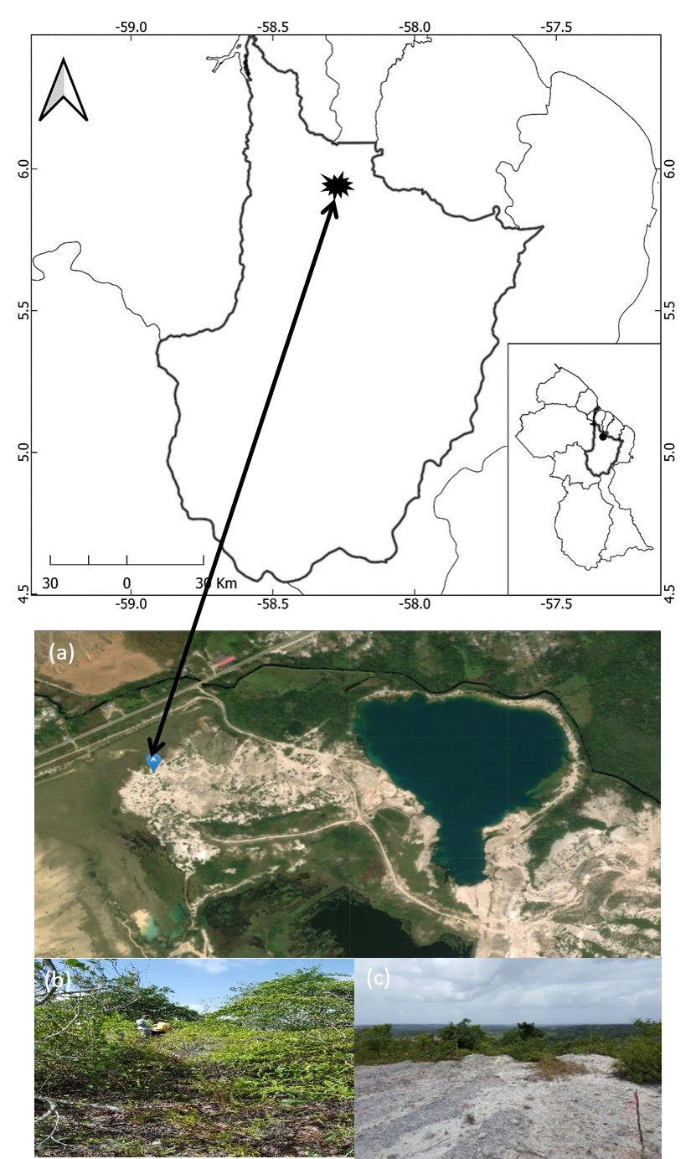
Figure 1 Location of the study site. (a) Google Earth satellite image of Kara-kara spoil dump; (b) natural vegetation found in the spoil dump; (c) spoil dump without vegetation cover.
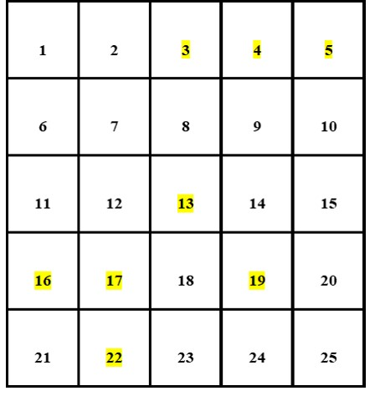
Figure 2 Design and layout of plots the experimental area; Size = 55m x 55m, Size of Sample, Plots = 11m x 11m, Total Sample Plots = 25, Sample Intensity = 30% Number of Plots Sampled = 8
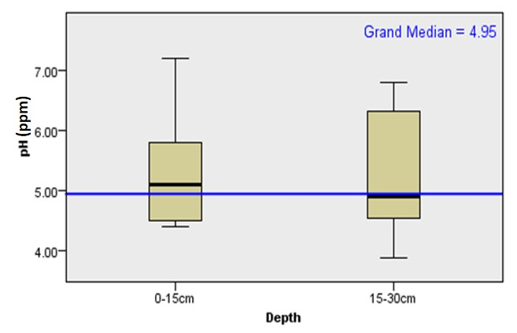
Figure 3 Independent sample median test (median = 4.950, df = 1, p = 0.656) of pH within the sample plots at two sampling depth. Multiple comparison was not performed because the overall test does not show significant differences across samples.
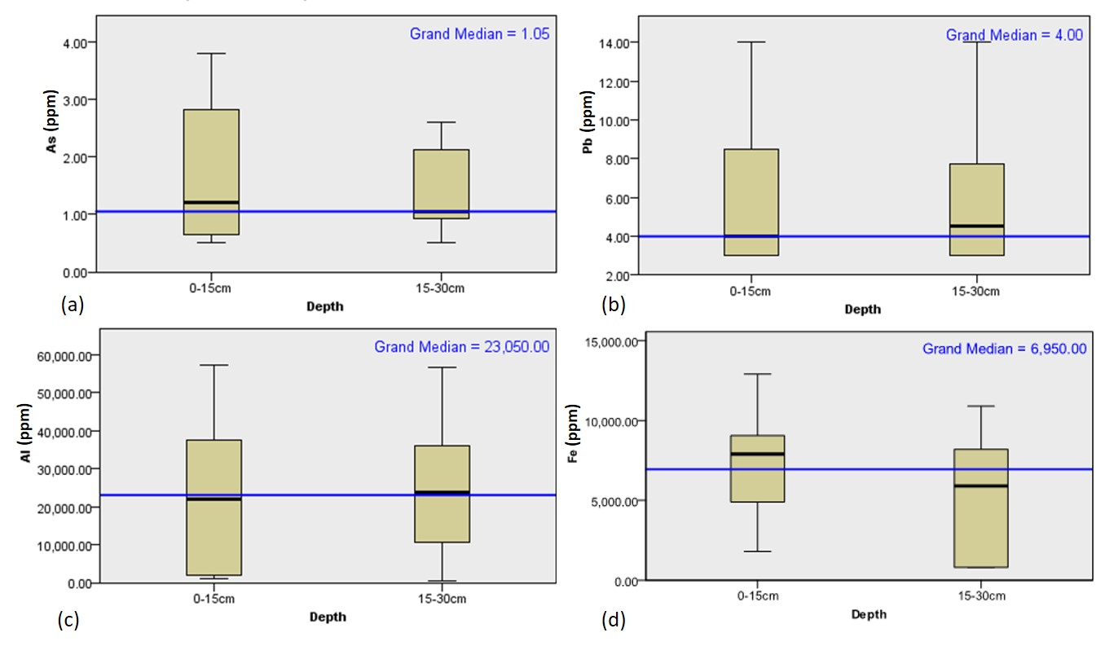
Figure 4 Box plot of depth-wise distribution of heavy metals present in the soil of the sample plots at two soil sampling depth in Kara-Kara spoil dump. Whiskers show the minimum and maximum values, box boundaries show interquartile ranges, horizontal line inside box represent median value and the blue line represent the grand median.
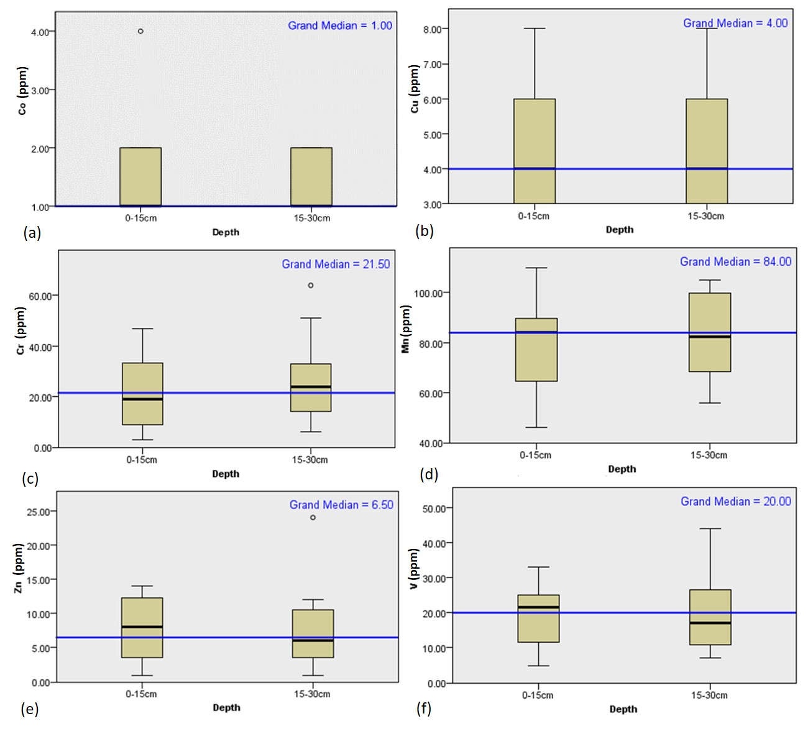
Figure 5 Box plot showing depth-wise distribution of other heavy metals concentrations (extractable micro-elements) of the sample plots at two soil sampling depths in Kara-Kara spoil dump. Whiskers show the minimum and maximum values, box boundaries show interquartile ranges, horizontal line inside box represent median value and the blue line represent the grand median.
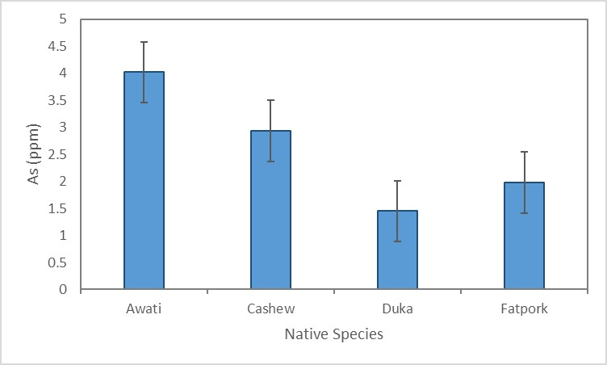
Figure 6 Barchar showing heavy metals concentration of As (Arsenic) found in the native species at two soil sampling depths. Vertical bars represent the standard error of the mean (n=4).
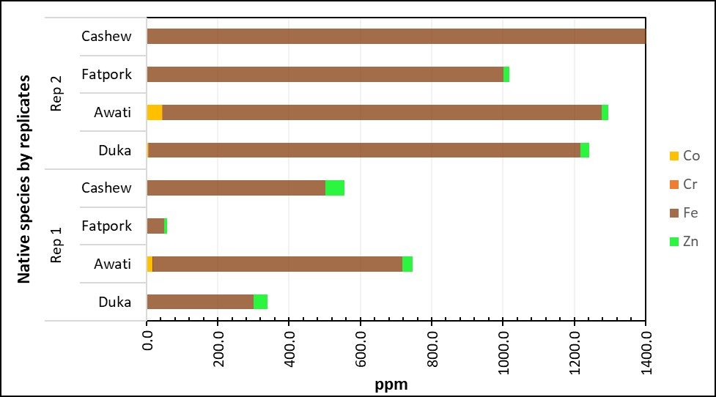
Figure 7 Barchar showing other heavy metals (micro elements) concentration found in the native species by replicate.

