Asbestos Presence in 20th Century Buildings

ABSTRACT
Asbestos is a naturally occurring mineral, useful for its high chemical resistance, its mechanical resistance and its insulating capacity. For this reason, it appears in building constructive materials, of very different types of construction and use. When we refer to old buildings we mean constructions of the second half of the 20th century. In Europe, America and many other places in the world, a lot of buildings built between 1960s and 1980s contain asbestos. It can appear in some construction elements or in some facilities elements.

However, these asbestos properties have been set aside now, because scientific research has shown that asbestos is a dangerous substance that can cause a lot of irreversible respiratory diseases, most of them fatal, and other non-respiratory diseases, some of them fatal as well. All these dis-eases can appear many years after worker’s exposure to asbestos begins. Thus, asbestos has been and still being the cause of a very large number of serious occupational diseases and deaths. For this reason, asbestos was prohibited in a lot of countries. But after this prohibition, the problem of managing the previously used asbestos arose. Thus, this section analyzes the procedure to follow when we need to rehabilitate a building that may contain some element with this material or when we simply decide to demolish that construction. In fact, to diagnose the presence of asbestos inside the building is the first problem: asbestos is invisible and odorless, so its detection is not easy. Later, once its presence is verified, asbestos removal is the next problem: for this, there are very strict protocols to reduce asbestos health risk.

Keywords: Asbestos, 20th Century Buildings, Inspection, Chrysotile, Deasbestos

Introduction
Nature and Varieties of Asbestos
Asbestos is Greek origin word (“ἄσβεστος”) which means inextinguishable and unerasable: In fact, in ancient Greece they used it for combustion lamps [1,2].

When we talk about asbestos, we are referring to a natural mineral fibers group, very resistant to fire and stresses. Therefore, asbestos is a material composed by natural origin mineral fibers [1]. It is formed by diverse composition silicates, whose fibrous structure is and whose appearance is silky [2]. For this reason, asbestos has been widely used in sectors such as construction sector, automotive sector, naval sector or industrial sector, among many others.

These fibers are the key: fibers provide strength and, unfortunately, those same fibers cause the terrible diseases [3,4]. The size of some of these fibers is tiny, so it is necessary to use a microscope to observe them [5,6].

Asbestos fibers are clasificated in two varieties groups: serpentine asbestos and amphibole asbestos [2] (Figure 1).
- Serpentine asbestos. We have chrysotile (white asbestos) in this group. This group consists of silicates of magnesium
and iron. Its simplified mineral formula is (MgFe)3 Si2O5 (OH)₄ [3,7]. We can see its molecular structure, according to phyllosilicates, in Figure 2. There, we represent the silicon
atoms in blue, the oxygen atoms in black, the hydroxyl atoms in red and magnesium in yellow.

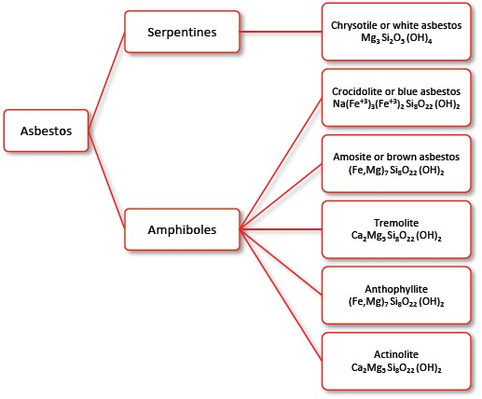
Figure 1: Classification Scheme of Asbestos Main Varieties [2].

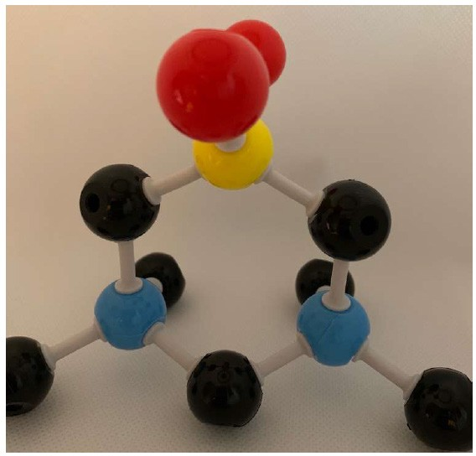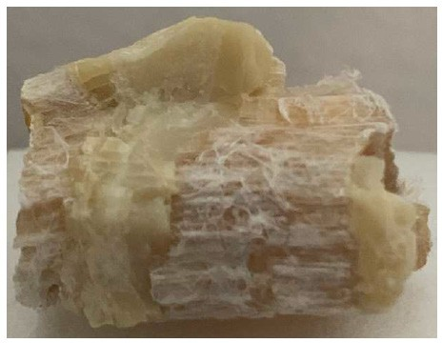In its natural state, chrysotile crystalline structure has strata or layers (Figure 5, Figure 7 and Figure 8), which can form small fibers with diameters between 0.02 and 0.03 µm, and can reach length-diameter ratios around 100/1 [3,7]. Figure 5 shows us size comparison between a chrysotile fibers bundle (Figure 4), also formed by thousands of small fibers as well, and a male eyelash.

Figure 2: Mineral Chrysotile Molecular Structure (author’s Photograph)

Serpentines are a group of minerals formed by single-chain silicates that do not occur in the form of crystals (except in the case of pseudomorphisms). Its name is due to the undulations and banding that arise from the high metamorphic pressures during its formation. In Figure 3 we can see a linear chain of serpentine fragment. This string becomes indefinite. Tetrahedra (SiO₄) are attached vertex to vertex (oxygen atom to oxygen atom) in a particular row [7]. We represent silicon atoms in blue and oxygen atoms in black again.

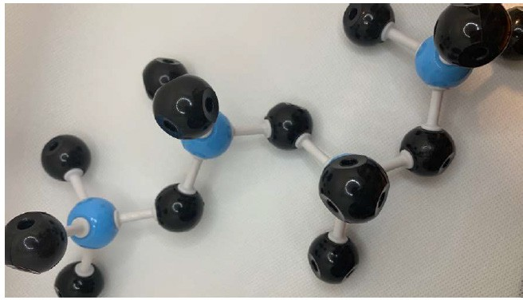
Figure 3: Linear Serpentine Chain Structure (author’s Photograph)

They are alteration products of certain magnesium silicates, especially olivine and pyroxenes:
- Olivine is magnesium iron silicate [(Mg,Fe)₂ SiO₄]. It is easily transformed into serpentine (hydrated magnesium silicate), losing the iron in the form of magnetite [8]. It is one of the most abundant minerals on earth crust [7].
- Pyroxenes are monoclinic silicates of iron and calcium, unalterable to the attack of hydrochloric acid thanks to their chemical composition [3,8].

There are three polymorphic forms that crystallize in the monoclinic system. However, here we are interested in the fibrous polymorphic form, known as chrysotile or more commonly “white asbestos” (Figure 4 and Figure 6).

Serpentine is a very common mineral, resulting from the alteration of olivine or pyroxenes. Chrysotile is the fibrous variety of serpentine. It frequently appears associated with magnesite, chromite or magnetite [9]. Chrysotile fibers are formed by bending sheets of antigorite (lamellar serpentine) to form tubes or fiber bundles. Its genesis is hydrothermal.

Figure 4: Mineral chrysotile sample from Arizona, USA (author’s photograph)
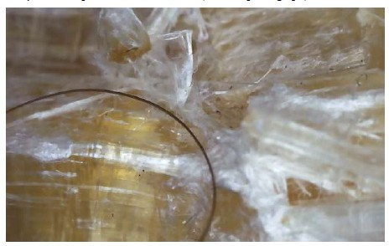
Figure 5: Chrysotile Fiber Group (Thousands of Tiny Fibers Packed Together) from Figure 4, 50X Compared to a Male Eyelash (author’s Photograph)
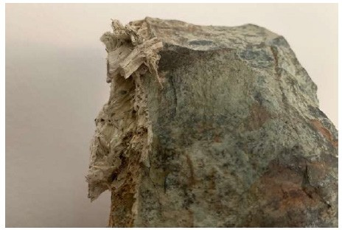
Figure 6: Mineral Chrysotile Sample on Matrix from Sierra Nevada, Spain (author’s Photograph).

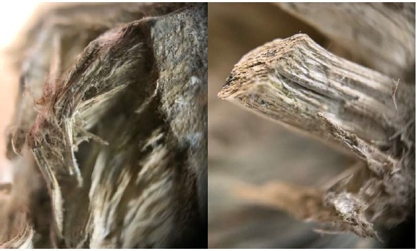
Figure 7: Chrysotile Fibers from Figure 6, 50X (author’s Photograph)

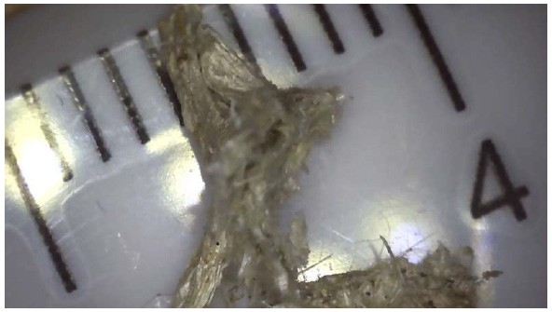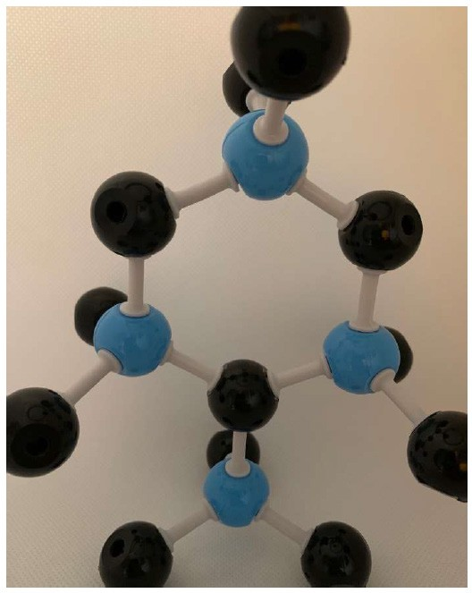Structure of amphiboles is related to structure of pyroxenes [7,9]: two laterally linked tetrahedral chains of pyroxenes (Figure 11). This double chain of silicates gives them different properties from serpentines [10].

Figure 8: Chrysotile Fibers from Figure 6, 50X, with Size Reference Ruler (author’s Photograph)

Serpentine appears disseminated in igneous rocks and in metamorphic rocks. In the Figure 9 we can see a sample from the extensive areas of regional metamorphism of Madagascar: accumulations of very fine grain, whose color varies between light green and yellowish green. For the purposes of this paper, the sample is interesting for the bright veinlets of chrysotile that can we discover on it. (Figure 10).

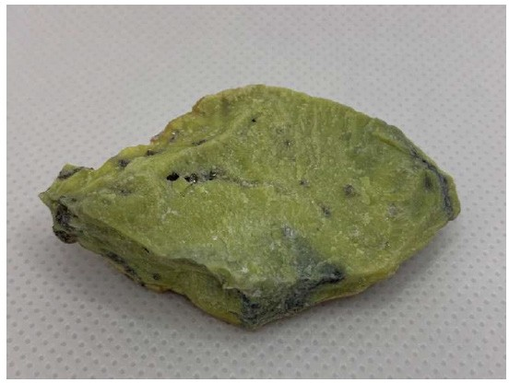
Figure 9: Mineral Serpentine from Madagascar (author’s Photograph).

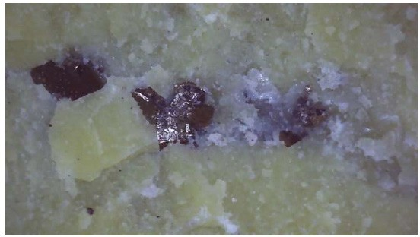
Figure 10: Veinlets of Chrysotile over the Figure 9 Sample Mineral, 25X (author’s Photograph)

Figure 11: Double-chain Inosilicate Structure (Amphibole), in Four SiO₄ Tetrahedrons Fragment (author’s Photograph)
Crocidolite, the most dangerous variety of asbestos, is metasomatic: it means that it is generated by contact metamorphism (temperature increase caused by the intrusion of magma into cooler country rock).

These fibers are straight; its diameter is ten times greater than serpentine fibers, with differences between the different varieties. So, crocidolite size is between 0.06 and 1.2 µm (Figure 12 and Figure 13), amosite between 0.15 and 1.5 µm and anthophyllite between 0.25 and 2.5 µm [3,7].

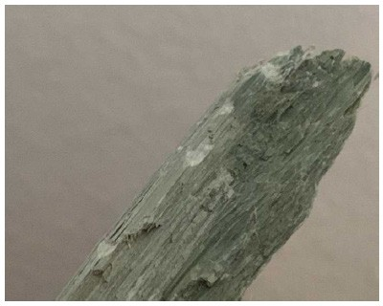
Figure 12: Blue Crocidolite Sample from Brazil (author’s Photograph).

- 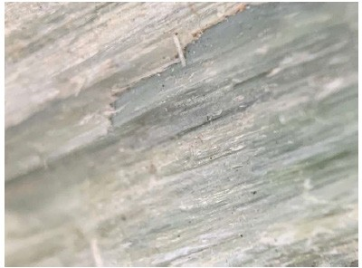Amphibole asbestos. This is a group of minerals formed by double-chain silicates with the same type of elements as pyroxenes (Figure 11), to which hydroxyl groups (OH) are added. It generally has elongated or acicular shapes, being found mainly in igneous and metamorphic rocks. In this group, among others, are [11]:
- Crocidolite or “blue asbestos” (whose simplified mineral
formula is Na(Fe⁺³) (Fe⁺³) Si O (OH) )
3 2 8 22 2

- Amosite or “brown asbestos” ((Fe,Mg)7 Si8O22 (OH)2),
- Tremolite (Ca2Mg5 Si8O22 (OH)2),
- Anthophyllite ((Fe,Mg)7 Si8O22 (OH)2),
- Actinolite (Ca2Mg5 Si8O22 (OH)2).

Figure 13: Crocidolite Bundle Fibers from Figure 12, 50X (author’s Photograph)

The most used types of asbestos are chrysotile, amosite and crocidolite. Leaving aside the general classification of serpentines and amphiboles each of the types analyzed above has its distinctive properties and different applications, due to that different chemical composition already mentioned [3-5] (Table 1):

Table 1: Most Common Asbestos Varieties [12,13]
Asbestos Varieties | Asbestos Name | Colour | Origin | Fiber Diameter | Fiber length | Silicate-associated elements
Serpentine | Chrysotile | White | Canada, Russia,  Zimbabwe, Italy | 0.02 μm | 2.00 - 3.00 μm | Mg
Amphiboles | Amosite | Brown Gray | South Africa, India | 0.10 μm | 0.15 - 1.5 μm | Mg, Fe
Amphiboles | Crocidolite | Blue | Bolivia, South  Africa, India | 0.08 μm | 0.06 - 1.2 μm | Fe, Na

- Chrysotile or “white asbestos”. It is made up of flexible fibres, thin, silky to the touch, easy to spin and highly resistant to heat but not resistant to the acids action. More than 90% of the asbestos used is chrysotile [12,13]. Asbestos was used primarily for fire protection and for acoustic insulation. Later, over the years, it was used for many other uses. We have up to 5,000 products containing this asbestos variety. It was the most used variant in construction [3].
- Amosite or “brown asbestos”. It is a variety that, due to its composition and unlike the previous one, is resistant to acids, in addition to heat. Its main use has been as thermal insulation and elements that required high resistance to friction, such as brakes and clutches for automobiles, among many other uses. [12,13].
- Crocidolite or “blue asbestos”. This variety has straight fibers and, like the previous one, is very resistant to acids [12,13]. It has been used in the manufacture of asbestos- cement pressure pipes, in construction as fireproof insulation and as a reinforcing element for plastics and battery casings [3]. Due to its danger, crocidolite was the first variety of asbestos prohibited by law [14].

With all this, and by way of conclusion, the following table (Table 2) is drawn up:

Table 2: Main Properties and Applications of the Different Types of Asbestos [13]

Asbestos varieties  / Properties | Heat-resistant | Acid resistant | Spinnable
Chrysotile | ✓ |  | ✓
Amosite | ✓ | ✓
Crocidolite | ✓ | ✓
Therefore, different asbestos varieties have different properties. It makes them to have different uses also. Such is the case that, as we have seen, the same property can even be shared by two (or more) varieties of asbestos. Thus, for example, crocidolite and amosite have excellent resistance to heat and acids [2]. The following properties of asbestos can be highlighted:
- Thermal stability. Asbestos is capable of maintaining its integrity at high temperatures, which is why it is used in the manufacture of different fire-resistant materials. Thus, chrysotile has a limit temperature of 600 ºC.
- Chemical resistance. Asbestos is highly resistant to most chemicals, especially amphiboles.
- Thermal insulation and condensation control. Asbestos has a low heat exchange power, which allows it to be used as a material for thermal insulation and to prevent water vapor condensation on cold surfaces.
- Non-biodegradable. An inorganic mineral fiber, such as asbestos, cannot be broken down by any living organism, such as bacteria, fungi or rodents. This gives it greater resistance.
- Tensile strength. Very interesting in the construction sector, given the limitation, as seen in section 1, of the tensile strength of materials such as stone or concrete.
- Resistance to wear, abrasion and friction, which allows it to
enjoy great durability.
- Electrical isolation. Asbestos does not conduct electricity, so it is used as an electrical insulator.
- Acoustic isolation.
- Possibility of weaving its fibers. The longer fibers can be spun and woven for use in clothing and other coverings.
- Workability. Mixed with cement or other products, asbestos is very easy to treat.

Asbestos Fibers Health Risks Exposure
We have already said that asbestos benefits of are due to its fibers, among other properties (there are many other fibers materials not useful). Knowing asbestos and its varieties, we must point out that asbestos is not the only fibrous compound used at industry. However, asbestos fibers, until now, are the only industrial fibers whose pernicious effects on people’s health are recognized and demonstrated [15].

We have said that fibers are microscopic too (Figure 5, Figure 7, Figure 8 and Figure 13). The danger of asbestos are those fibers. These microscopic fibers are suspended in the air and, when a person inhales them, the fibers are not retained by any respiratory system defense mechanism. This is different from other bigger pollutants particles. For this reason, asbestos fibers can travel through the respiratory passages until reach the lungs, and lodge in them for a long time. So, fibers can be ingested and cause disease.

With the fibers lodged in the lungs, the probability of contracting very serious diseases increases alarmingly. Studies have shown that exposure to asbestos can cause various diseases [16]: some benign and some more serious, such as asbestosis (or pulmonary fibrosis), lung cancer, malignant mesothelioma (cancer of the pleura, pericardium, peritoneum, etc.) and other types of tumor processes (Figure 14), in addition to cause insufficiency breathing and a large increase in cough [17].

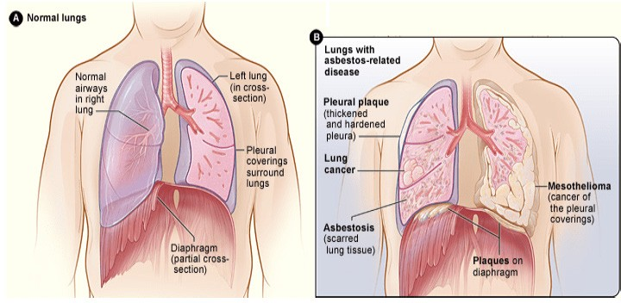
Figure 14: Asbestos-related Diseases, Comparing a Normal, Healthy Respiratory System, Left, with a Respiratory System Afflicted with the Serious Diseases that Asbestos Can Cause, Right [18].

The respiratory tract is the asbestos main access to the body [19]. Due to the small size of the asbestos fibers, due to the fineness of the asbestos fibers, due to the shape of the asbestos fibres, they can remain in the air for a long time and, therefore, they can be breathed in. Being breathed in, they can easily penetrate tissues and, due to their biopersistence (also called biological resistance, which is the ability to remain in the body), they can remain in the body for a lot of years [20].

The more biopersistent and biorespirable a fiber is, the more dangerous that fiber is. When we speak of breathability, we speak of the ability of a fiber to remain in the environment and reach the pulmonary alveoli.

To understand how this situation can affect the health of the worker, we need to know the functioning of the respiratory system and its defense mechanisms to protect itself from the possible contaminants action and invasion.

Living organisms take in oxygen from the environment that surrounds them through the physiological process of respiration, giving off carbon dioxide. In the particular case of human beings, this exchange process occurs thanks to lung expansion and contraction. Therefore, the respiratory system is responsible for the supply of oxygen and the elimination of carbon dioxide. In addition, the functioning of the respiratory system is closely related to the circulatory system and, therefore, to the blood and the heart [20].

The respiratory system begins in the nose, continues through the larynx (where asbestos has come to cause several cases of cancer as well), trachea and bronchi, which, in turn, divide into bronchioles (increasingly smaller), until ending in the pulmonary alveoli. The air that is breathed enters through the nose (and/or through the mouth) and passes through all the previous respiratory passages, until it reaches the pulmonary alveoli.

The oxygen contained in the inhaled air crosses the alveolar walls and, thanks to them, passes into the blood, heading for the heart. The heart will then send it throughout the body. Once the oxygen has been used by the cells, the carbon dioxide-laden blood goes back the other way: it is now a waste product generated by the cells of the body. On this occasion, it circulates in reverse: it crosses the walls of the pulmonary alveoli, from where it passes into the bronchi, then the trachea and thus, when an expiration is made, it is expelled to the outside.
In conclusion, it should be clear that the most important function of the respiratory system, along with the circulatory system, is the oxygen exchange (necessary for life) for carbon dioxide. This carbon dioxide is a waste product that passes from the blood into the air to be later eliminated, expelling it to the outside.

Among the diseases that are recognized as having their origin in
exposure to asbestos are:
- Asbestosis (pulmonary fibrosis). When a worker is exposed to asbestos fibers, the fibers are retained in the lungs and gradually lead to pulmonary fibrosis. This fibrous causes hardening of the lung tissue.

Asbestosis, known as “asbestos disease” due to its direct relationship with the inhalation of asbestos fibers, is a slow and gradual lung disease: fibers accumulate in the lungs. Studies show that this disease usually develops after a long period of exposure to asbestos: this period is at least five years, although its mean latency period is much longer (more than twenty years).

The appearance of this disease can depend on many factors. Among others, we can expose the following [19,21]:
- Inhalation of many asbestos fibers.
- Inhalation of fibers for a long time.
- Approximately constant inhalation.

The fibers cause wounds in the lung tissue (Figure 15). When the lung tries to heal itself, unable to expel the fiber, the tissue dies around the fiber and lung loses its ability to supply the blood with needed oxygen. Thus, the heart has to work much harder to get oxygen-rich blood to all the cells of the body. Ultimately, this respiratory distress can lead to heart failure and, as it is a progressive disease, ultimately lead to death.

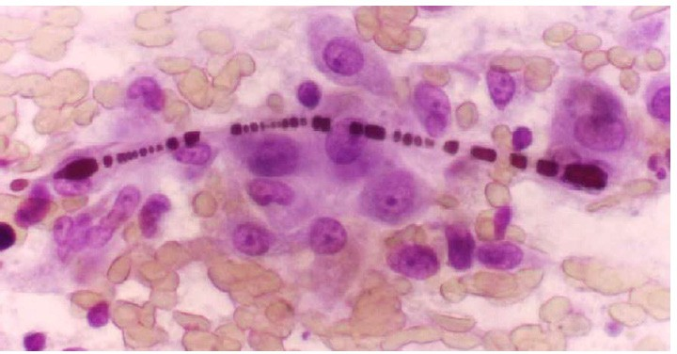
Figure 15: Enlarged Histological Image of an Asbestos Fiber Embedded in Lung Tissue [23].

Every asbestos variety can cause asbestosis. Therefore, we cannot speak of good asbestos: all asbestos fibers are harmful.

Once the development of the disease begins, there are no symptoms in the initial phase. The first symptoms appear in more advanced stages, and they are dyspnea (shortness of breath) or dry cough. In a more advanced state cyanosis already appears; and finally, as an extreme case, heart failure due to respiratory insufficiency.

Asbestosis is a very disease, which evolves very slowly and, in general (but not always), progressively. Quite the opposite, the disease continues to progress until it reaches respiratory and heart failure, which can cause death, as we have already mentioned. This rate, of course, is going to be greatly increased in smokers than in non-smokers, because a smoker’s lung tissue is more vulnerable [19].

Unfortunately, this disease currently has no cure. Asbestosis does not disappear but tends to increase. There are not many effective treatments yet; and the treatments that exist are the only ones that try to slow down the progress of the disease. Thus, when the first symptoms are diagnosed, the worker begins to undergo periodic medical surveillance and, above all, is removed from the source of exposure (if he is still exposed to it). In addition, if appropriate, the worker is advised to stop smoking.

- Lung cancer. Cancer is an accelerated, disorderly and uncontrolled multiplication of cells of the affected tissue. These cells can grow or even spread to other parts of the body. Lung cancer usually begins in the area of the lining of the bronchi and, although less frequently, can also begin in other areas of the respiratory system, including the trachea, bronchioles, or lungs alveoli.

Lung cancer is associated with a series of risk factors, such as lifestyle, diet, smoking or work context, including exposure to asbestos [24].

Despite knowing different types of lung cancer, cancer associated with asbestos exposure can belong to any histological family (mostly, but not completely). In the same way, it can be linked to a previous asbestosis process (asbestosis can degenerate into lung cancer) [25].

Exposure to asbestos fivefold increases the risk of contracting lung cancer, reaching a ninety-fold increase in smokers [17].

As we commented about asbestosis, lung cancer develops over a long period (comprising several years), with a minimum latency period of ten years [24].

- Malignant mesothelioma, whether pleural or peritoneal. In spite of being studied under a different heading, mesothelioma is a variety of cancer, which affects the cells of the outer lining of the lungs, the inner part of the ribs (the pleura) or around the abdominal organs (the peritoneum) [26].

This disease has a latency period greater than the previous two: this period is estimated at more than twenty years, normally rising to thirty or even forty years.

We can say that it is a rare tumor, being pleural mesothelioma the most frequent of all variants. In spite of this rarity, its incidence is expected to increase in the coming years due to the years of massive use of asbestos and its high latency period.

Crocidolite (“blue asbestos”) is the variety most likely to cause mesothelioma [23, 27]. Unlike asbestosis and lung cancer, malignant mesothelioma can occur at low exposure levels. On the contrary, smoking has no influence on the risk of developing this disease [19], in the case of mesothelioma. 85% of diagnosed cases of pleural mesothelioma are caused by occupational exposure to the contaminant [17].

The symptoms of malignant mesothelioma are shortness of breath, weight loss, loss of appetite, weakness, persistent cough, and chest pain. As the tumor spreads through the pleura, the pleura thickens, reducing its flexibility. Thus, the lungs become locked up and oppressed, unable to expand and contract in order to perform their respiratory function [28].
Unfortunately, mesothelioma also has no cure (there is currently no treatment) and the median survival time is approximately one year. All current treatments are palliative in nature, that is, medical therapies to reduce pain [29].

Apart from these three diseases, cases of direct relationship with other types of tumors and diseases have also been found [27].

All these injuries, especially the three that have been listed in the previous sections, have a series of points in common [19, 30]:
- Its long latency period; that is the period of time elapsed from the beginning of exposure to asbestos until the manifestation of the disease. We can speak of a period of between twenty and forty years, or even more. For this reason, it is suspected that, at present, those cases in which exposure occurred during the time of maximum use of asbestos in all its varieties, at a low level of prevention (when there is no non- existent).
- Its irreversible prognosis.
- Its non-existent cure treatment. In all three cases, these are diseases that currently have no cure.
- There is no exposure level below which there are no health risks.
- The risk persists throughout life.

Any pathology related to exposure to asbestos can only be diagnosed through medical examinations. If a worker has worked with asbestos, that worker is not necessarily going to have any of these diseases; however, the worker must report this to his doctor and undergo specific periodic medical check-ups.

For all these reasons, and as the investigations were obtaining results of the asbestos fibers danger, legislation was advancing until, for example, the European Union prohibited any use of asbestos as of January 1, 2005 through the EC Directive 1999/77 [31]. This standard would soon be reinforced by others, such as Directive 2009/148/EC of the European Parliament and of the Council of 30 November 2009 on the protection of workers from the risks related to exposure to asbestos at work [32]. This legal document reinforces the business obligation to guarantee effective protection of the safety and health of workers, applied to the specific case of asbestos; this obligation was already established by Council Directive 89/391/EEC of 12 June 1989 on the introduction of measures to encourage improvements in the safety and health of workers at work [33]. Prevention laws of all the member countries of the European Union were born from this Council Directive.

Since the 1970s, as research has progressed, more and more countries have totally or partially banned the use of asbestos [14]. So, 67 countries and territories (including all members of the European Union) in the world have banned the use of asbestos to date [34].

As we have already said, not all fibers are equally aggressive: it depends on their size, their diameter and their stiffness. According to that, the most dangerous fibers are the ones that [13]:
- Length (L) > 5 µm.
- Diameter (D) < 3 µm.
- Shape ratio (L/D) > 3.

The long, fine fibers are the worst and are most likely to reach the alveoli of the lungs. For this reason, the worst fibers are blue asbestos fibers. In any case, there is a direct relationship between the characteristics of the fibers and the appearance of the respiratory diseases that we have discussed (Table 3).

Table 3: Pathogenesis due to exposure to asbestos, according
to the morphology of the fibers [17]

Illness | Relevant Exposure Indices
Asbestosis | Fiber surface area with:  Length > 2 μm; Diameter < 0.15μm
Lung cancer | Number of fibers with:  Length > 10 μm; Diameter < 0.15μm
Malignant mesothelioma | Number of fibers with:  Length > 5 μm; Diameter < 0.15μm

Uses of Asbestos in Old Constructions
Due to the combination of excellent physical and chemical properties with a reasonable price, asbestos has been widely used in the past [3,35]. And it is that some of its advantageous properties have been known since time immemorial: its softness, flexibility and resistance made it consider centuries ago the silk of the mineral world.

There is evidence of the use of asbestos for four thousand years, as well as its use throughout history: from the most remote antiquity, through the Middle Ages until reaching the contemporary age, where its use became widespread [36].

It was then, already in the 20th century, when the technological innovation of this material began to develop thanks to the combination of asbestos and rubber. A much more flexible material
was thus obtained, ideal for sealing joints and internal parts of the steam engine compared to pure asbestos, which was too rough and abrasive. Its use was later extended to all kinds of construction and naval engineering products, to telephones, buttons and electrical panels; in short, to the entire plastics industry, which found in asbestos fibers the perfect ally to reduce the weight of components and improve thermal resistance.

More than 3,000 different applications of asbestos have been known and, in fact, in one way or another, asbestos has been found present in almost all industries (construction, automobile, aeronautics, food, pharmaceutical, naval, textile, railway, nuclear, etc.) and even in household consumer products.

As we mentioned in section 1, Nature and Varieties of Asbestos, asbestos different varieties have different properties. Asbestos, therefore, has multiple applications, and its range of marketed products is tremendously wide. However, as its adverse effects have been discovered, its use has been limited, even being prohibited.

Next, we can look at the many uses of asbestos in industrial buildings (Figure 16) and in residential buildings (Figure 17), according to Health and Safety Executive (HSE), the United Kingdom government agency responsible for the encouragement, regulation and enforcement of workplace health, safety and welfare in United Kingdom [35].

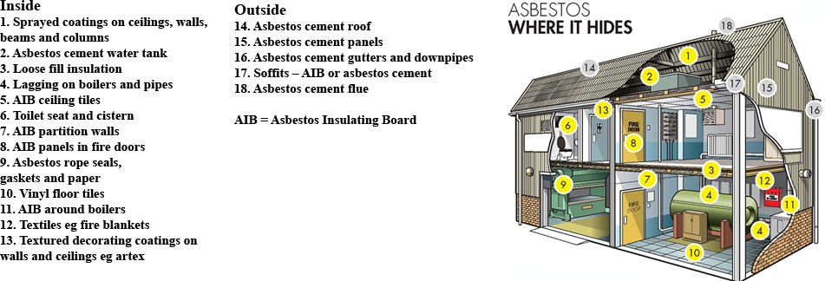
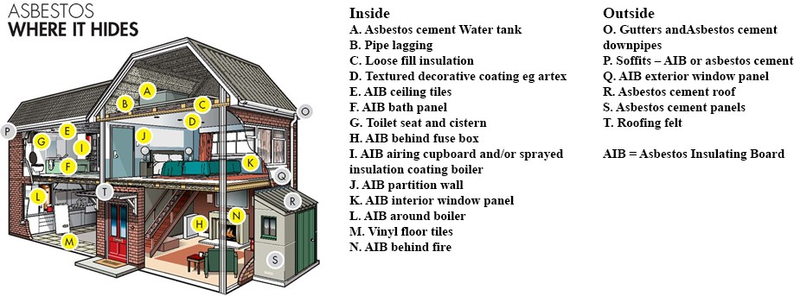Figure 16: Common Materials used in the Industrial Building where We Can Find Asbestos [35]
Figure 17: Common Materials used in the Residential Building Where We Can Find Asbestos [35]

To list the great diversity of materials that contain asbestos in construction, we will follow the classification that attends to its physical appearance that follows the French National Institute for Research and Safety (INRS, Institut National de Recherche et de Securite), which distinguishes five groups [12]:
- Bulk asbestos. Asbestos was used as an insulating material against fire due to its high fire retardant power. Under this aspect is:
- Asbestos waste for ovens, boilers or tubes heat insulation.
- Asbestos removal for doors, fire partitions or refrigeration material for ships, vehicles or industrial equipment.
- Projected asbestos, pure or mixed with other fibers on metal structures, on the underside of concrete slabs, for fire protection or even for acoustic insulation of buildings.

It should be remembered that sprayed asbestos was one of the first to be banned [14,27]. It was used to protect metal structures and as a thermoacoustic coating.
- Asbestos in sheets or plates. Until thirty years ago, asbestos was widely used in chemistry and biology laboratories, especially for protection against the heat and flame of bunsen burners. Asbestos in sheets or plates was very useful to protect metal structures and specific sources of heat. Under this aspect we can find:
- Asbestos paper and cardboard for thermal insulation in fireplaces (Figure 18), heaters, laboratory equipment, food- heating appliances such as stoves, irons, toasters, etc., for making joints or for thermal protection of surfaces when welding (plumbing).
- Plates for the realization of false ceilings (Figure 19), fireproof walls, fire doors, light divisions or acoustic insulation, among others.

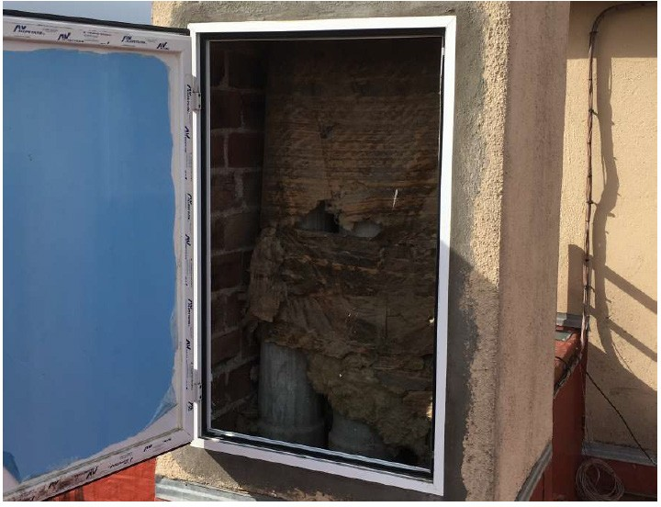
Figure 18: Fiber Cement Chimney Ducts, Protected with Asbestos Sheets for Thermal Insulation, in a Residential Building in Madrid, Spain (author’s Photograph).

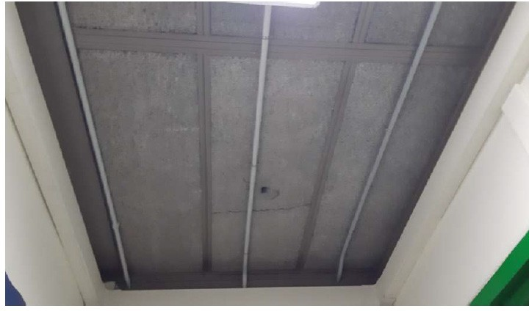
Figure 19: False Ceiling Plate with Asbestos-reinforced Material in a School (author’s Photograph)
- Braided or woven asbestos. Asbestos braid was mainly used for joints in heating boilers. However, in this form we can find:
- Asbestos rope or braid for sealing furnace or boiler doors,
laboratory applications or lagging.
- Textile bands for protection against heat.
- Sealing and lagging joints for heating pipes, engine exhaust,
etc.
- Fire-resistant protection covers for welding in boilermaking.
- Fire curtains.
- Air, gas and liquid filters.
- Electrical insulation tapes for appliances and electrical wrapping.
- Cable glands.
- Fire-resistant or anti-noise joints on structures and partitions, etc.

- Asbestos incorporated in cement products (asbestos-cement, popularly known as fiber cement). Fiber cement was used in the form of corrugated and flat plates and for water pipes, sewage downspouts, water tanks, flues and shunts. It is perhaps the most noteworthy application in construction.

Chrysotile was also used as a decorative stone due to its characteristic appearance and color. However, we can find fiber cement in:
- Corrugated or flat plates for roofs and surface coverings (Figure 20). It is one of the uses of asbestos best known by people and, at the same time, most visible (Figure 21).
- Windowsills and facade plates.
- Interior partition plates and panels.
- False ceilings.
- Construction panels and shelves.
- Chimney flues (Figure 18).
- Pipes and channels for wastewater, downspouts, water tanks, water and gas channels or ornamental and gardening elements, etc.

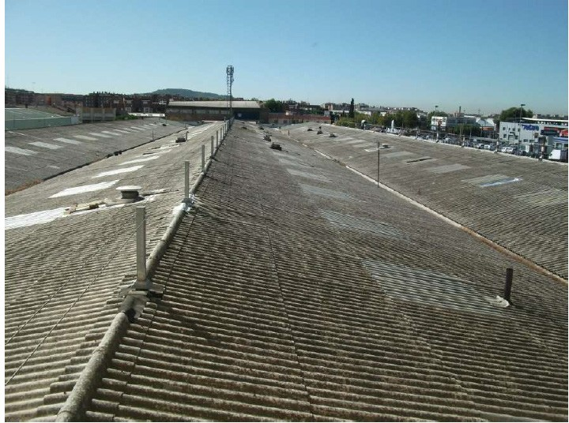
Figure 20: Corrugated Fiber-cement (Asbestos) Sheets Installed in 1970, Forming the Roof of an Industrial Building in Alcalá de Henares, Spain (author’s Photograph).

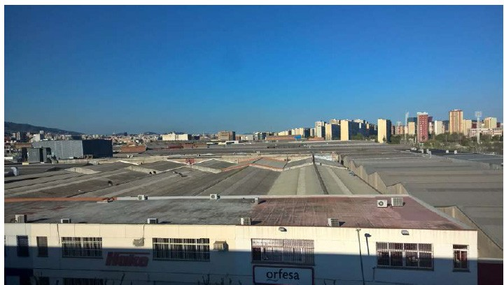
Figure 21: Industrial Building Roofs in Bellvitge, in Hospitalet de Llobregat, Spain, where We Can See a lot Corrugated Fiber Cement Roofs Builts in the 1970s (author’s Photograph)

- Asbestos incorporated in different mortars (resins, bitumen, etc.). Between 1970 and 1987 the clutch pads, shoes and discs of most car models contained crocidolite and amosite asbestos.

The old PVC vinyl flooring has an asbestos content of 10 to 25%. However, under this aspect we can find:
- Friction elements for brakes and clutches of automobiles, trains, presses, lathes, mobile bridges, elevators and motors of different machines. This is hardly applicable to this case, except for some industrial building.
- Asbestos vinyl flooring for floors, decorative boards, tiles, etc.
- Plumbing accessories, heating, motors, etc. where asbestos can be combined with rubber, metals, plastic materials, etc.
- Floor plaster layers and interior divisions.
- Glues with asbestos for tiles.
- Mortars for fire protection.
- Paints with asbestos.
- Electrical insulation based on resins.
- Porous cylinder filling elements for some industrial gases such as acetylene, etc.

Environmental Exposure Assessment
We have already seen the asbestos danger and health risks and the old buildings elements which can contain it. The problem arises when we have to repair, move or remove elements that contain asbestos: there we already have a considerable risk of fiber inhalation, since such operations can lead to the release of particles or dust, leaving the fibers in suspension.

We must also keep in mind all those installation or renovation works that may require cutting or drilling materials that could release asbestos particles or that may expose elements whose surface is erodible.

Asbestos fibers are only harmful to health when they are released and remain suspended in the air. In other words, as long as there is no fiber release, discovering an asbestos- containing item need not raise any alarms. Thus, if the asbestos present in materials for the construction of a building remains as a solid matter, the fibers will not be released and will not enter into suspension. Consequently, since they are not suspended in the air, they cannot be released by anyone.

Asbestos is no longer used in most of the world’s buildings today. According to this, today, the actions in which there is going to be contact with asbestos and whose particles can be released, are going to be works that are going to be carried out on a pre-existing building; these actions will be fundamentally rehabilitation works or demolition works [38]. In any of the cases, making an adequate approach to the building constitutes the first step in the action process.

For the evaluation and control of worker exposures we will need:
- The centres, premises and workplaces in which asbestos is used evaluation and control. These processes have to be carried out by the companies themselves, with the support of specialized laboratories.
- The determinations of the concentrations of asbestos fibers in the environment of the premises and workplaces, also carried out by the companies, by means of a technically reliable method that allows the comparison of results and their continuous monitoring over time.
- The taking of samples for the determination of concentrations and the subsequent evaluation of results. These operations may only be carried out by specialized laboratories. In many cases, public administration will have to recognize the suitability of the laboratory through certification.
- The samples will necessarily be personal (Figure 22), arranging the capture element on the worker, so the value of the sample is representative for worker’s exposure, taking into account the conditions of the job and the exposure time, being able to complete the study with general environmental sampling of the premises and work areas [26].

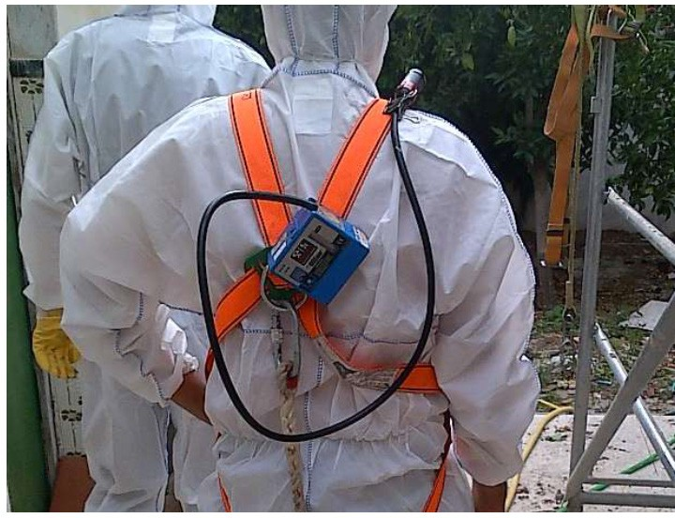
Figure 22: Personal Sampling Asbestos Fiber Content, with Equipment Arranged on a Worker in the Vicinity of an Industrial Building with Various Asbestos-Containing Elements (author’s Photograph)

Over the years, as the health risks of exposure to asbestos fibers have been discovered, governments have lowered the permissible exposure limits. They were always more restrictive with blue asbestos and with brown asbestos than with white asbestos.

Now, we know that repeated short-term exposure to asbestos high concentrations implies a high risk. In other words, and unlike other compounds, there is no concentration limit value for asbestos; there is no limit value that, once exceeded, poses a danger to people health. Currently, if sample results indicate a concentration equal to or less than 0.01 fibers per cubic centimeter of air, we can consider free of asbestos zone. Above this value, the area will be dangerous and workers will have to be protected.

Inspection and Location of Asbestos in Old Buildings
In many countries, there is a legal framework to regulates the control asbestos risk, which establishes the different instruments for its control [12,17]. In this chapter, we study what the asbestos control instruments are, as well as everything related to its management, what objectives they pursue and how they are processed. It will also describe how asbestos materials can be identified and located in buildings, how to assess their risk and the control measures that must be adopted.

So much so that a lack of knowledge of the building (or insufficient knowledge) and the consequent lack of rigor when undertaking the action will lead to the application of a poorly structured methodology, which, in turn, can lead to the development of an inadequate or unviable project, the appearance of surprises during the execution of the works, constant modifications to the initially projected idea and, of course, extension of the execution period and increase in costs. Besides, in the specific case of a

rehabilitation, it should be taken into account that an adequate approach to the building is vital to avoid the loss of value of some of the existing elements, as well as the disconnection with the history of the building.

Asbestos materials do not represent a risk by themselves. As long as the asbestos- containing materials are in good condition and are not altered, they do not imply problems. When these materials are damaged or when they have to be handled, the risk appears (Figure 23). When a material is degraded or when it is handled, the fibers it contains can be released into the environment and be breathed in by people [39]. For this reason, it is necessary to locate and identify the existing asbestos materials in a building [3]. In this sense, friability concept is very important. By friability we understand, in technical terms, the ability of a material to release the asbestos fibers it contains. Thus, a material is said to be friable when it disintegrates easily simply with manual pressure. Friable materials are much more dangerous than non-friable materials.

Materials are classified as friable when dry, they can crumble, disintegrate or crumble with the fingers. It includes the most of the materials used for fire protection and thermal and acoustic insulation. Two main groups of friable materials can be established that will later help to locate them:
- Surface coatings (walls, beams, floor) in the form of sprayed asbestos (flocking) or asbestos-based plasters (Figure 18).
- The lagging of steam and hot water pipes or insulating blankets that cover boilers and hot water tanks.

When material dry cannot be crumbled, disintegrated, or crumbled by manual pressure is termed non-friable (Figure 20, Figure 24). Materials in which asbestos is retained with a strong binder such as cement, resins, fillers, glues, paints, etc., will be therefore considered in this group.

Non-friable materials can become friable. This occurs when non- friable materials are subjected to strong mechanical activities such as those required for demolition or restoration work. With these activities, the materials can be easily disintegrated and reduced to powder and therefore release the asbestos fibers they contain, that is, they become friable.

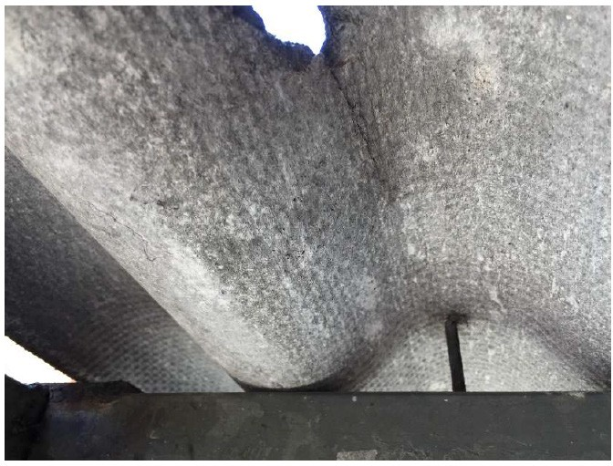
Figure 23: Fiber Cement Plate Fracture. Despite not being a friable material, the deterioration of this material implies the release of fibers and its consequent danger for people who are in the environment, so it is necessary to remove asbestos (author’s Photograph)

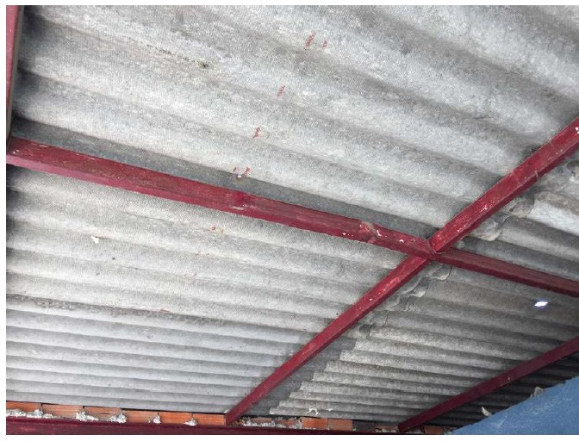
Figure 24: Fiber Cement Shed Arranged for the Protection of Vehicles in a Surface car park. The plates are in good condition and this material is not friable. However, it must be controlled in case it deteriorates (author’s Photograph)

For a building complete evaluation we need to sample all questionable materials; that is, all materials that may contain asbestos have to be analyzed. However, we have to have judgment and be careful: laboratory analysis and subsequent repair of the sampled areas (if applicable) entails an economic cost that can be very high. For this reason, the technician who carries out the evaluation must be a qualified worker (Figure 25), who has knowledge about the classification of materials with asbestos due to their use, the different way in which they were once supplied on site and their different applications. Locating asbestos-containing materials is the first step we must take to assess and control the risks produced by asbestos- containing materials. This applies to any demolition, rehabilitation or maintenance of old buildings.

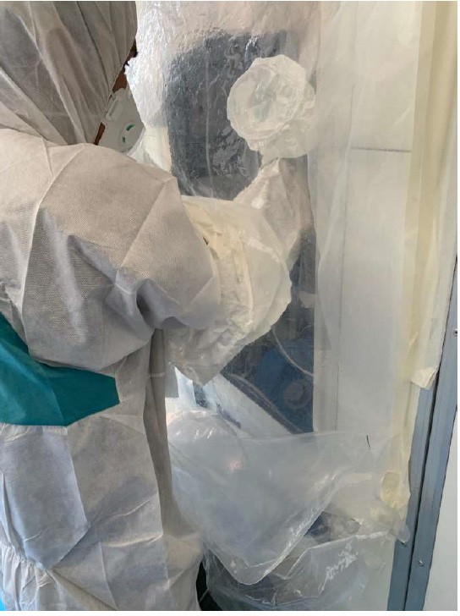
Figure 25: Encapsulation Simulation for a Possible Asbestos Element Recognition, in a Qualification Course for Future Building Inspectors and future Asbestos Removers (author’s Photograph)

The material location process should include four stages [3,13,38]:
- Examination of the data and documents of the building to look for references on the use of materials with asbestos in its construction or in subsequent works. In this sense, special care must be taken with buildings built from the 50s of the 20th century and up to the prohibition date corresponding to the country where the building is located. In this sense, special care must be taken with those buildings with metal structures, because they were the ones that used projected crocidolite as a fire retardant agent.
- Examination of the building to locate materials and identify those that contain (or may contain) asbestos.
- Taking samples of suspicious materials, to confirm or rule out the presence of asbestos.
- Preparation of a location map and marking of materials containing asbestos (confirmed) or that may contain asbestos (suspicious).
Asbestos-based pipe and boiler insulation (heat insulation) is the most likely to be found in most buildings. Magnesia plasters with preformed asbestos (tape, blankets, corrugated paper or similar) are common.

Unless the construction of the building is recent, it is almost certain that the lagging is based on asbestos. If the lagging is in good condition, we should not break it to try to take a sample and confirm the presence of asbestos. It is much more convenient to assume that the material contains asbestos.

Most of the materials not included in the two groups mentioned: surface coatings or lagging, are compact and non-friable materials (boards, tiles, tiles, etc.). Taking samples of them can cause damage and unnecessary release of fibers, so it would not be justified unless a demolition or demolition was to be carried out. The information on whether or not these materials contain asbestos should be sought primarily through the documentary records or building personnel [3,12].

All activities related to the location of materials in buildings must be carried out by qualified persons (Figure 25) and adequate means and when the presence of asbestos is doubtful, the material must be considered as if it had it. In any case, the sampling of friable materials must be carried out with personal respiratory protection.

Obviously, everything changes depending on a possible diagnosis: the verification of the presence of asbestos through the analysis of the material will be what will mark the need for specific prevention measures or that ordinary prevention measures will suffice (Figure 26).

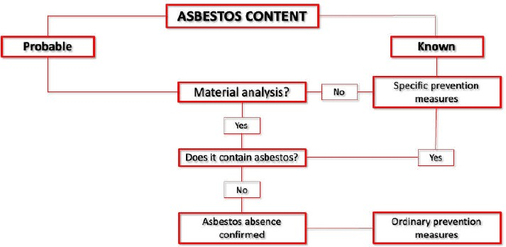
Figure 26: Alternatives and Decision Diagram on Asbestos Materials [13]
Taking samples of an asbestos-containing element means handling it. For this reason, material sampling must be carried out by qualified persons. The affected area should be repaired and cleaned after a material sample is taken. Subsequent analysis of sample materials is performed using polarized light and scattering optical microscopy.

When workers are going to handle asbestos, the employer has to provide workers with the necessary individual protection equipment. To do this, company must carry out a detailed risks analysis which the worker may be exposed, based on the work to be carried out, the levels of exposure and the planned work procedures. For this, the most important thing is the selection of the appropriate respiratory protection equipment and special work clothes.

Respiratory protection is chosen according to the following four
parameters:
- Duration of exposure.
- Environmental concentration.
- Working conditions.
- Physical constitution of the worker.

Thus, according to these parameters, we will choose the option that guarantees the adequate protection factor (the higher the protection factor of the equipment, the greater respiratory protection it provides to the worker.), between:
- Self-filtering masks against particles.
- Half masks, with filters against particles plus face adapter.
- Full mask, with filters against particles plus face adapter.
- Particulate filtering devices for assisted ventilation with mask or mask.
- Particulate filtering devices with assisted ventilation with a helmet or hood.
- Breathing apparatus independent of the ambient atmosphere. Work clothing must completely protect worker from skin contact with asbestos. The best option is to use disposable clothing, which never comes home worker.

Asbestos Removal Procedures In Old Buildings
Discovering material with asbestos immediately raises a problem: what should we do with it? We must never look for a hasty solution: it will lead, in all probability, to inappropriate interventions. And these interventions will always involve high risks, even higher than those risks we try to avoid.

Asbestos removal is one of the most dangerous interventions. Experience has shown us that, even carrying out asbestos removal with strict prevention measures (Error! Reference source not found), it can cause serious contamination with irreversible effects [40].

We have to assume that asbestos removal is an inadvisable operation if materials with asbestos discovered are in good condition or if there are alternatives to improve their conditions. Thus, the risk of fiber release into the environment would be practically nil. However, we are not always going to have one of the two previous situations. For this reason, circumstances may force us to resort to removal of asbestos.

There are two measures that must always be adopted, and also immediately, when discovering the presence of asbestos-containing materials:
- Cleaning of the area where asbestos materials have been discovered, in order to eliminate the fibers that could have

been released during the exploration tasks and contaminate the environment.
- A maintenance program establishment to prevent materials from suffering subsequent damage or wear [41].

The most important thing to know is the element discovered danger or the element on which we need to act danger. We must bear in mind that not all asbestos products are equally dangerous. This danger magnitude is quantified through two factors: the friability material and the conservation state.

- Friability. It is the possibility that asbestos fibers become loose or come off, freeing themselves in order to pass into the air in suspension. So, we can differentiate between friable materials and non-friable materials.
- Friable materials, on the one hand, are those materials that, being dry, can be crumbled, pulverized or reduced to poder, simply with hand pressure or even minor effort.
- Non-friable materials, on the other hand, are those materials in which asbestos is firmly retained and the fibers release is not easy.
- Conservation state material. If materials are in good condition and they cannot be easily degraded, the fibers release to the environment will be unlikely.

As a general rule, the higher percentage of asbestos contains a
material, the more easily that material will be damaged.

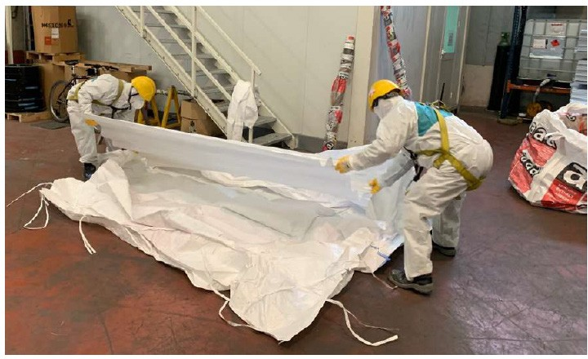
Figure 27: Asbestos Removal Simulation in a Qualification Course for Future Building Roof Removal Operators (author’s Photograph)

Friable materials are those with the highest level of risk. They must be kept in a good state of conservation, preventing them from deteriorating and releasing asbestos fibers [42].

Non-friable materials also have to be controlled. If their state of preservation is good, they do not usually emit fibers into the air, but if these materials are broken or sanding, polishing, cutting, drilling, etc. are performed on them. they release fibers into the environment and high concentrations of asbestos dust can be reached.

When undertaking removal operations, two types will be distinguished, depending on one of the above parameters: removal of friable materials and removal of non-friable materials [13]. Friable or non-friable, we will always have to adopt measures that minimize the release of fibers (Error! Reference source not found).
The methodology to be used depending on each case is very diverse, and its appropriate choice generally lies in the experience of the technicians employed.

Logically, operations aimed at removing friable asbestos are much more complex (work in confined areas under negative pressure) and should not be carried out by people without extensive experience and great technical knowledge.

Faced with the urgent need to have containment barriers that enclose the work area, when it comes to non-friable materials, such limiting elements will not always be used, normally due to the impossibility of their installation. The dispersion of the fibers, therefore, will be avoided by keeping the pieces intact and using wetting equipment during the removal, cleaning and suction tasks.

Final cleaning is one of the most important phases [3,5]. The way in which it is carried out lies the success of the removal of asbestos.

It is also very important to take into account the subsequent use that will be given to the area of action. In cases where the building, warehouse, factory, etc. is going to be reused, the final cleaning and a good sampling strategy to verify the degree of cleaning are critical points in the work.

To the specific knowledge of asbestos removal, knowledge in the area of construction must be added. Many times it is necessary to use machinery and equipment to access work areas such as elevators, scaffolding, etc.

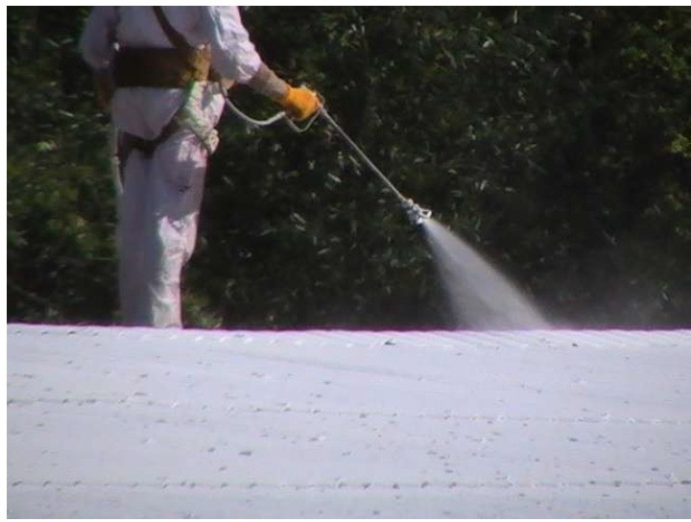
Figure 28: Fiber Fixing Polymer Application over Corrugated Roofing Plate, Prior to Deasbestos Removal. (author’s Photograph)

Conclusion
Asbestos is a fibrous silicates set from minerals origin with variable chemical composition, used as a raw material in many different building materials during the 20th century. All material containing asbestos in a building must be monitored because asbestos has been shown to cause very serious lung disease and carcinogenicity years after exposure.

An element that contains asbestos, if it is consistent and it is in a good conservation state, is not dangerous. The dangerous element is the one that can release asbestos fibers into the air: these fibers can be breathed in by workers and cause serious illnesses caused by asbestos. In other words, unless the asbestos-containing item may appear brittle or erodible, or is otherwise damaged in some way, there is no risk as long as the asbestos-containing item is not tampered with.

Therefore, fiber release can be the result of the presence of a deteriorated asbestos- containing material or an inappropriate intervention on an asbestos-containing item. This release of fibers is a risk, among others, for the workers who carry out the intervention on these products / materials that contain asbestos, for the workers who are in the vicinity of these interventions, for the people who are in the environmental environment of the source of emission of asbestos fibers and for the people who occupy the premises once the intervention on the products / materials that contain asbestos has been carried out [25].

Friable materials are those with the greatest risk, as they are the ones that most easily release the asbestos fibers they contain. In a building, most of the friable materials will be found in the surface coatings and in the lagging. The remaining products are generally non- friable, although it is important to insist that this condition may vary depending on their state of preservation or as a result of aggressive operations that make the release of fibers likely.

All activities related to the location of materials in buildings must be carried out by qualified people and appropriate means. The first phase of the location of the materials will be done in the documentary records of the building. Sampling is a risky operation and may not always be necessary and may even be discouraged. Prudence recommends that wherever the presence of asbestos is in doubt, the material should be treated as if it were present. Building workers and occupants have the right to be informed of the presence of asbestos materials.

The law regulates work with asbestos risk in all countries that have banned asbestos. In many countries there are registries of companies with asbestos risk. These records are an instrument to find out which companies handle asbestos in each country. Those companies that carry out activities or operations in which asbestos or materials containing it are used must register in said registry.

References
- Ross M, Kuntze RA, Clifton RA (1984) A Definition for Asbestos. From Levadie B, (Ed.). Definition for Asbestos and Other Health – Related Silicates, ASTM STP 834. American Society for Testing and Materials, Philadelphia, USA 139- 147.
- Virta RL (2002) Asbestos: Geology, Mineralogy, Mining, and Uses. From U.S. Geological Survey Publication 2002-149.
- Brassens François, Touron Michel (2016) Guide technique de l’amiante dans les bâtiments: Du dossier technique amiante aux travaux de retrait (in French). Editions Le Moniteur, Antony, France, 11-65 and 87-145.
- Dewees Donald N (1986) Controlling Asbestos in Buildings: An Economic Investigation. Routledge Revivals, Washington DC, USA 9-23 and 50-58.
- Cavariani Fulvio, D’Orsi Fulvio (2020) Il responsabile del rischio amianto. Metodi di valutazione e di gestione del rischio dovuto alla presenza di materiali contenenti amianto negli edifice e negli impianti con riferimenti ai materiali sostitutivi (in Italian). EPC Editore Rome, Italy 23-74.
- Bernardo Antonio, Puche Paco (2019) Todo sobre el amianto. Una guía visual (in Spanish). Ediciones del Genal, Malaga, Spain 15-46.
- Calvo Pérez B (2003) Cristalografía y Mineralogía (in Spanish). Fundación Gómez Pardo, Madrid, Spain 248-280.
- Champness PE, Cliff G, Lorimer GW (1976) The identification of asbestos. From Journal of Microscopy 108: 231-249
- Ballirano P, Bloise A, Gualtieri AF, Lezzerini M, Pacella A,
et al. (2017) The crystal structure of mineral fibres. From: Gualtieri, Alessandro F. Mineral Fibres: Crystal Chemistry, Chemical - Physical Properties, Biological Interaction and Toxicity 18: 17-64.
- Belluso Elena, Cavallo Alessandro, Halterman Don (2017) Crystal habit of mineral fibres”. From Mineral Fibres: Crystal Chemistry, Chemical-Physical Properties, Biological Interaction and Toxicity 18: 65-110.
- Ross Malcolm, Langer Arthur M, Nord Gordon L, Nolan Robert P, Lee Richard Jet al. (2008) The mineral nature of asbestos”. From Regulatory Toxicology and Pharmacology 52: S26-S30.
- Institut National de Recherche et de Securite (2022) Amiante (in French). Available online: https://www.inrs.fr/dms/inrs/ GenerationPDF/accueil/risques/amiante/Amiante.pdf
- Gonzalo Terente, Mónica, Arroyo Buezo, Mª Carmen, Camporro Ayuso, et al. (nd). Manual para la gestión del amianto instalado (in Spanish). Fundación Laboral de la Construcción del Principado de Asturias, Oviedo, Spain, no date 19-54 and 99-113. Available online: https://www.cogersa. es/mtsp_cache/24199.pdf
- Kazan-Allen Laurie (2021) Chronology of Asbestos Bans and Restrictions. International Ban Asbestos Secretariat, United Kingdom. Available online: http://www.ibasecretariat.org/ chron_ban_list.php
- Furuya, Sugio, Chimed-Ochir Odgerel, Takahashi Ken, David Annette Takala Jukka (2018) Global Asbestos Disaster. From International Journal of Environmental Research and Public Health 15: 1000.
- Puche Paco (2017) Amianto. Una epidemia oculta e impune (in Spanish). Los Libros de la Catarata, Madrid, Spain 17-22 and 34-59.
- Instituto Nacional de Seguridad e Higiene en el Trabajo (1992) Estudio de la incidencia y evaluación de la población laboral expuesta a amianto en la industria española (in Spanish). Instituto Nacional de Seguridad e Higiene en el Trabajo, Madrid, Spain.
- Clydeside Action on Asbestos (nd). Asbestos-Related Disease. Available online: https://www.clydesideactiononasbestos.org. uk/asbestos-related-disease
- Berry Terri-Ann, Belluso Elena, Vigliaturo Ruggero, Gieré Reto, Emmett Edward A, et al. (2022) Asbestos and Other Hazardous Fibrous Minerals: Potential Exposure Pathways and Associated Health Risks. International Journal of Environmental Research and Public Health 19: 4031.
- Bernstein David M, Pavlisko Elizabeth N (2017) Differential pathological response and pleural transport of mineral fibres. From: Gualtieri Alessandro F. Mineral Fibres: Crystal Chemistry, Chemical - Physical Properties, Biological Interaction and Toxicity 18: 417-434. European Mineralogical Union and Mineralogical Society of Great Britain & Ireland, London, UK.
- European Mineralogical Union and Mineralogical Society of Great Britain & Ireland, London, UK.
- Caraballo-Arias Yohama, Caffaro Paola, Boffetta Paolo, Saverio Violante Francesco (2022) Quantitative Assessment of Asbestos Fibers in Normal and Pathological Pleural Tissue-A Scoping Review 11: 287.
- Battenstein Rolf W, Battenstein, Miriam G (nd). Asbestose- Asbesterkrankungen (In German). Rechtsanwälte, Düsseldorf (Germany). Available online: https://asbestose.de/asbestose- berufsgenossenschaften.pdf
- Cavone Domenica, Caputi Antonio, De Maria Luigi, Silvana Cannone Enza Sabrina, Mansi Francesca, et al. (2019)

Epidemiology of Mesothelioma. From Environments 6: 76.
- An Jin, Song Minjeong Chang Boksoon (2021) Asbestosis Mimicking Metastatic Lung Cancer: Case Report 57: 402.
- Petriglieri Jasmine Rita, Bersani Danilo, Laporte-Magoni Christine, Tribaudino Mario, Cavallo Alessandro, et al. (2021) Portable Raman Spectrometer for In Situ Analysis of Asbestos and Fibrous Minerals. From Applied Sciences 11: 287.
- Craighead John E, Mossman Brooke T, Bradley Bruce J (1980) Comparative Studies on the Cytotoxicity of Amphibole and Serpentine Asbestos”. From Environmental Health Perspectives 34: 37-46.
- Gaudino Giovanni, Xue Jiaming, Yang Haining (2020) How asbestos and other fibers cause mesothelioma. From Translational Lung Cancer Research 9: S39-S46.
- Binazzi Alessandra, Di Marzio Davide, Verardo Marina, Migliore Enrica, Benfatto Lucia, et al. (2022) Asbestos Exposure and Malignant Mesothelioma in Construction Workers-Epidemiological Remarks by the Italian National Mesothelioma Registry (ReNaM). International Journal of Environmental Research and Public Health 19: 235.
- Markowitz Steven B (2022) Lung Cancer Screening in Asbestos-Exposed Populations. International Journal of Environmental Research and Public Health 19: 2688.
- Council of the European Union (1999) Commission Directive 1999/77/EC of 26 July 1999 adapting to technical progress for the sixth time Annex I to Council Directive 76/769/EEC on the approximation of the laws, regulations and administrative provisions of the Member States relating to restrictions on the marketing and use of certain dangerous substances and preparations (asbestos). Available online: https://eur- lex.europa.eu/legal-content/EN/TXT/?uri=CELEX%3A319 99L0077&qid=1654791651869
- Council of the European Union (2009) Directive 2009/148/ EC of the European Parliament and of the Council of 30 November 2009 on the protection of workers from the risks related to exposure to asbestos at work. Available online: https://eur-lex.europa.eu/legal- content/EN/ ALL/?uri=CELEX%3A32009L0148
- Council of the European Union (1989) Council Directive 89/391/EEC of 12 June 1989 on the introduction of measures to encourage improvements in the safety and health of workers at work. Available online: https://eur-lex.europa.eu/ legal- content/EN/ALL/?uri=celex%3A31989L0391
- Kazan-Allen Laurie (2019) National Asbestos Bans. International Ban Asbestos Secretariat, United Kingdom Available online: http://ibasecretariat.org/alpha_ban_list. php#
- Health and Safety Executive (nd). Where can you find asbestos? London, UK, nd. Available online: https://www. hse.gov.uk/asbestos/building.htm
- Bartrip Peter WJ (2004) History of asbestos related disease. From Postgraduate Medical Journal 80: 72-76.
- Obmiński Andrzej (2020) Asbestos in building and its destruction”. From Construction and Building Materials 249: 118685.
- Perkins Robert A, Hargesheimer John, Fourie Walter (2007) Asbestos Release from Whole – Building Demolition of Buildings with Asbestos – Containing Material. Journal of Occupational and Environmental Hygiene 4: 889-894.
- Mlynarek Steven, Corn Morton, Blake Charles (1996) Asbestos Exposure of Building Maintenance Personnel. Regulatory Toxicology and Pharmacology 23: 213-224.
- Brown Stephen K (1987) Asbestos Exposure During Renovation and Demolition of Asbestos-Cement Clad Buildings. American Industrial Hygiene Association Journal 48: 478-486.
- Kim Young-Chan, Hong Won-Hwa (2017) Optimal management program for asbestos containing building materials to be available in the event of a disaster. Waste Management 64: 272-285.
- Lee RJ, Van Orden DR (2008) Airborne asbestos in buildings. Regulatory Toxicology and Pharmacology 50: 218-225.

