CROSSING THE FINISH LINE: A STUDY OF SPORTING METAPHORS AS A REFLECTION OF CULTURAL IDENTITY IN MOUNTAIN PROVINCE

Abstract
The objective of this study is to analyze the utilization of metaphors in academic conversations regarding sports in Mountain Province. This will be achieved by applying Geeraert's theory of lexical semantics and Pragglejaz's Metaphor Identification Procedure. During the CARASUC MEET, MT. PROVINCE PROVINCIAL MEET, and the CARAA MEET in 2023, interviews were done with student-athletes, coaches, and trainers. The researchers examined authentic conversations, screenshots of publications, textual comments on Facebook, and chat chats in order to evaluate metaphorical phrases. The research revealed that Facebook posts during and after incidents primarily utilize metaphorical language, which is comprehended and utilized within particular contexts. This study enhances the current understanding of data analysis and its associated conceptual and theoretical framework.
Keywords. corpora, cultural discourse, Lexical Semantic Theory, Metaphor, Metaphorical Identification Procedure, sports discourse
Background of the Study
The project examines the role of language in team sports during the CARASUC MEET, Mt. Province Provincial Meet 2023, and CARAA MEET 2023, following a three-year hiatus due to the pandemic. It covers topics such as identity development, interactional elements, and participants' responses from sports-related interviews. The study explores the construction of meaning through metaphors in various articles, examining themes, functions, and the significance of in-group language as a symbol of identification.
The researchers, who are language teachers, focus on studying academic language, sports language, cuisine, and politics. They explore the ways in which individuals like athletes, coaches, spectators, fans, sports columnists, and sports enthusiasts utilize language to participate in sports activities that rely on prevailing cultural norms. Studying the language of sport means studying the development of local sports culture, which has significance in the lives of all student-athletes.
The applied linguistic aspect of sports research involves coaches and professional athletes needing various communication abilities to interact with fans on social media and operate in languages they are unfamiliar with. The study aims to determine the main linguistic characteristics of theme-generated metaphors in different languages used during or after the game, comments posted on social media, or headlines in local newspapers published on the web or in print.
The researchers' interest in studying the language used in and about sports and their desire to gain a better understanding of the variety of metaphors investigated in this study are based on a comprehensive review of related literature.
Conceptual/Theoretical Framework
Sports discourse is a cultural manifestation characterized by its rituals and communication channels, with athletes, coaches, journalists, and fans playing a significant role in shaping the language used in sports. Metaphors are commonly used in sports discourse, as they are crucial linguistic instruments for depicting, recounting, and analyzing sports. Lexical semanticists study the process of defining word meanings and how meaning is influenced by contextual factors. The study focuses on the key linguistic features of metaphors used in cultural discourses during sports-related activities involving local student players, coaches, trainers, and spectators.
The research aims to analyze the linguistic aspects of cultural discourse in sports activities, specifically focusing on identifying the metaphors used in lexis and structures. The study also seeks to understand how these events were perceived by the audience seeking such information. The research examines sports metaphors employed in social media posts and interviews collected during and after sports events.
The study is based on the "Metaphor Identification Procedure" (MIP), a tool derived from the Pragglejaz' Group for identifying metaphorical language in texts, and draws on Dirk Geeraert's (2009) theory of lexical semantics, which explores the relationship between the meaning of words and the structure of language. The method for identifying metaphors was adapted from Pragglejaz's group.
Statement of the Problem
Specifically, this paper will answer the following questions:
- What sport metaphors are common during and after the games?
- What are the pragmatic functions of the sport metaphors?
- What is the literal and contextual meaning of the metaphors using Geeraert’s (2009) theory of lexical semantics and the Metaphor Identification Procedure (MIP)?

Design and Methods
Research Design
A qualitative-narrative-descriptive survey was used in this investigation. In a survey, data is gathered and analyzed from a small sample of subjects or subjects that are thought to be typical of the total group in order to study a larger group of subjects or subjects (Nworgu, 2015).
Participants
To carry out this research, the CARASUC, the Provincial Meet, and the CARAA were chosen because it is timely to be the first ever after the three-year hiatus of pandemic last 2020. The chosen respondents had completed one or more years of training, competing, or coaching. The chosen respondents [despite the efforts to reach more participants] were all given fictitious names enclosed in parentheses as SA for student-athlete, C for Coach, T for Trainor, and S for spectators/supporters.
Research Procedure
The research was conducted during the CARASUC 2023 event, the Mountain Province Provincial Meet 2023, and the CARAA MEET 2023 in Baguio City. The study collected reports from players, coaches, and team supporters, as well as social media and local newspapers, to analyze metaphors and their practical purposes. The "Metaphor Identification Procedure" (MIP) was used to examine the denotative and connotative significance of metaphors. The study aimed to determine how linguistic choices facilitated communication among fans of different teams during these events. The data was analyzed topically, including news stories, text and chat comments from Facebook pages, and interview transcripts. The researcher translated the vernacular data into English and verified the accuracy of the translation. The data was collected from a Facebook page focused on the events, and the linguistic characteristics associated with sports-related language were identified, categorized, and assessed using Geeraert's (2015) Lexical Semantics Theory and MIP.
Results and Discussions
A study examining the use of metaphorical expressions in daily and academic life revealed that 56 instances of metaphors related to triumph were found in the corpus, out of 313 metaphors found in news items, online comments, and interview transcriptions. Animal-related metaphors were found to be more prevalent than combat and engagement metaphors, with 87 instances. The number of emotion metaphors was 39, while sports as life metaphors were 47. Teamwork and sportsmanship were the lowest-ranked themes, with the theme of losing being the lowest. The study highlights the potential difficulties language instructors may face when dealing with metaphorical expressions. The findings highlight the importance of understanding and utilizing these expressions in language teaching.

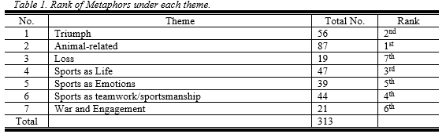

The study examines the portrayal of sporting events on social media platforms, primarily Facebook, using sports as a socio-linguistic framework. Data from interview transcriptions of athletes, coaches, and trainers from various institutions and text/chat comments from individual Facebook accounts are used to analyze specific linguistic structures within sports discourse. The corpus explores how identities are formed through communication and how speakers indicate various societal factors, such as the connection between student-athletes and their teams, gender expectations, and institutional identity. Sports teams are found to be productive locations for analyzing identity expression in cultural discussions.

Themes Generated from the Sports Metaphors Common During and After the Games
Researchers used metaphors from collected data to create themes highlighting the experiences of sports discourse subjects in communication. These themes were developed by assimilating phenomena from linguistic studies and were validated among researchers to address the first research question. They analyzed and identified the topic expansion in sports discourse through a complex structure of metaphors, categorizing themes such as triumph, loss, war, sports as life, emotion, and teamwork and sportsmanship.
- Triumph Metaphors
The study found that 18% of sports news articles on social media and questionnaire responses tend to present triumph over defeat, as the central character is often the winning team or athlete. Sports articles use various metaphorical terms and linguistic forms, with triumph often announced through a verb in English. The data was gathered from Facebook pages of institutions.

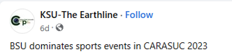
Figure 5. A headline from the Kalinga State University news article (Source: https://www.facebook.com/KSUearthline. April 23, 2023).

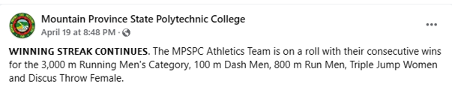
Figure 6. A headline from MPSPC news article (Source: https://www.facebook.com/search/top?q=carasuc%20mpspc. April 19, 2023).
The examples use verbs as metaphors to demonstrate the protagonist's superiority, with one metaphor being hyperbole due to exaggeration, and the other personifying the verb phrase “winning streak” as a noun in figure 5.

- Animal-related Metaphors
Basing from the corpora, this theme-generated metaphor is 28%. Furthermore, in the headline posted by Abra province on social media (see figure 12), “Abra Stallions, Go for Gold” is a specific example of this theme because it is a name given to a team aiming for winning. This metaphor is often described in terms related to a precious stone, so that the attainment of the title is seen as owing a most expensive stone the “gold”.
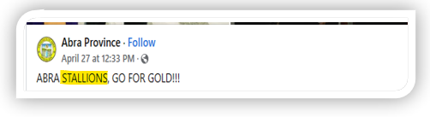
Figure 12. A headline of triumph metaphor from the Abra Province news article. April 27, 2023. (Source. www.facebook.com).
The characteristics of the animal are projected onto the team when a sports team has an animal-related nickname, and these characteristics drive the headline writers to express the metaphor of the team's win in a distinctive way.
Because the salient characteristics of the stallion (horse) as a source domain were mapped into the athletes on the Abra team—the target domain—the team's nickname was derived from the name of an animal as part of a broader conceptual metaphor.
During the interviews, athletes compared themselves with animals (see the highlighted words) that possess characteristics which they could describe them. In light of this fact, the following metaphorical examples were provided based on the respondents' responses to the question of what animal they most resemble when engaged in combat:
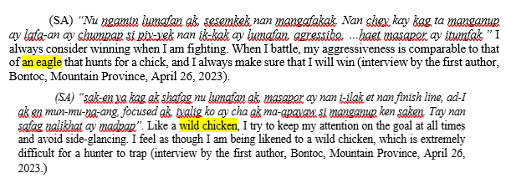
The conceptualization of the athletes as birds (linguistically manifested in the name comparison to an eagle and wild chicken) allowed the creative use and innovative extension of the metaphor. Thus, the metaphor of triumph with a bird-related nickname is conceptualized as a bird’s characteristic.

- Metaphor of Loss
There are sports articles and comments that present defeat in different metaphorical terms and varied lexical categories. Samples are presented in Table 2 below (see the highlighted words and phrases).
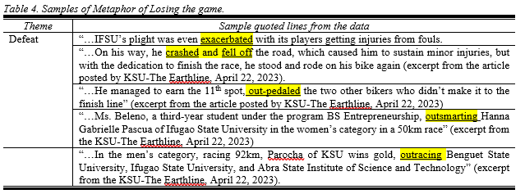
From the 19 (6%) mapped metaphors in the corpus, the loss metaphors “exacerbated,” “crashed,” “fell-off,” “out-pedaled,” and “outracing” are a few examples. The sample metaphors indicate a situation where a team or athlete displays a downfall crisis and is about to receive negative feedback on social media because the metaphors that were used are related to the opponent’s failures in the contest like the example below (see fig 18).
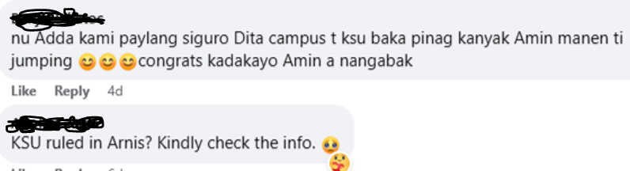
Figure 18. A sample of negative feedback from a spectator posted on FB. (Source. www.facebook.com).

- War and Engagement Metaphor
War and engagement metaphors are common in daily life and speech, serving as mediators between various conversational domains. They are frequently used in social media, particularly when sharing winning moments. These metaphors have been significant in sporting competitions, such as the "clash" metaphor used by DepEd Tayo Cordillera during the CARAA MEET 2023. These metaphors, particularly those based on war and engagement experiences, are frequently used in daily conversations.
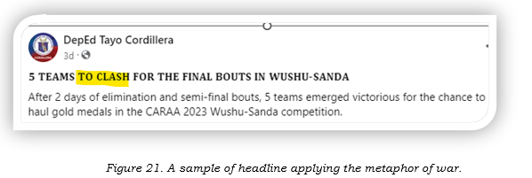
A widely acknowledged student-athlete in IFSU retorted that, “Winning does not always mean coming in first…. Real victory is arriving at the finish line with no regrets because you know you’ve gone all out” (excerpt from an interview of Mr. Dornagon, a criminology student cyclist in IFSU, April 22, 2023, posted in KSU-The Earthline.)

- Metaphor of Sport as Life
"Sport as life" was the category that was mentioned the most by participants during the interview sessions with 15%. Based on the first interview question, "Sports to you is like...because...," anything relevant to this category of "sports as life" was briefly evaluated. Participants left certain questions unanswered, and some answers lacked metaphorical expression in favor of opinions or definitions. Due to the aforementioned reasons, irrelevant responses were eliminated from the study's main data because the researchers were only intended to assess metaphoric phrases.
The sample metaphors featured by this category are provided as follows:
A coach was asked about this line, Sport is like ________ because…, and this is what he answered:
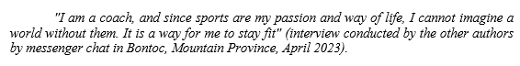
Another coach retorted:
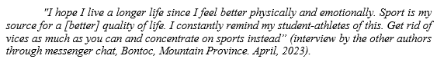
From an athlete herself who won gold during the CARASUC underscored the interview questions in her interface with the author after she attended her class under him. During the interview, she mentioned:
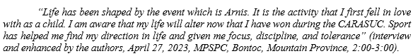
The interview excerpts reveal the internal and external forces that shaped them [the respondents] from the outside views and inside views of themselves in relation to the category of Metaphor of Sport as Life.
- Metaphor of Sport as an Emotion
Aside from the individual benefits, doing sports can help individuals enhance their self-confidence and better comprehend the meaning of life by balancing work and daily life, which affects the individual psychologically and sociologically as cited from Çaredar and Cengizel (2022). Some examples of metaphors taken from the respondents’ responses were as follows:

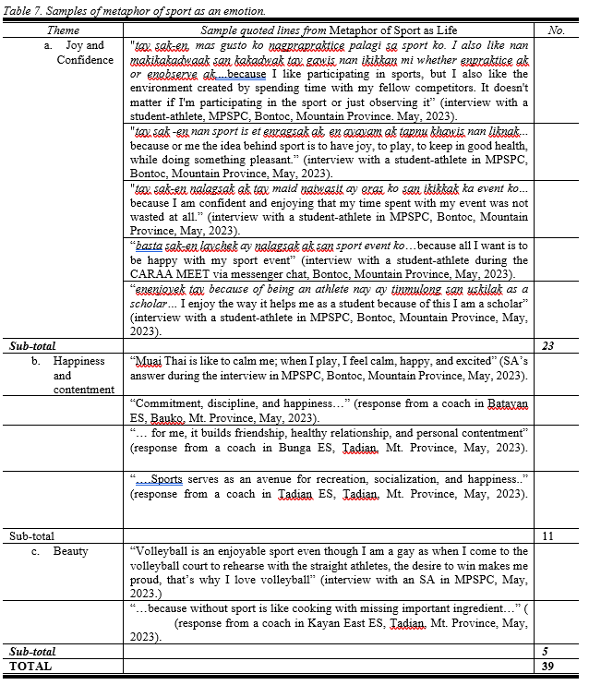
The collected transcriptions of the respondents to the questionnaire revealed that 24% of them considered sport to be an element of emotion. The chosen participants categorically identified this metaphorical idea based on their participation in their individual experiences in their separate sports as a time they feel delight, beauty, and happiness with their teams and teammates and experience the pleasant emotions of success.
- Metaphor of Teamwork and Sportsmanship
The team and teamwork metaphor emphasizes cooperation and a cooperative spirit, but it also carries ambivalence. A sports team is more of a cooperative competition than a completely cooperative setting. Team members are motivated by the prospect of effective collaboration and individual performance to maintain their positions. While everyone wants their team to win, they also want to outperform others to keep their positions. The metaphor implies that teammates are interested in their individual standing on the team and are driven to maximize team success. When urged to put aside personal interests, team players are often urged to be team players.
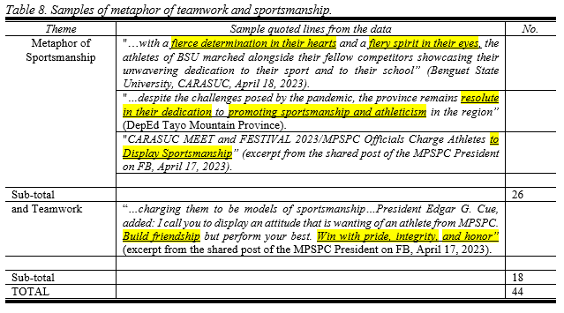
Pragmatic Functions of the Metaphors
To answer the second problem, what are the pragmatic functions of the metaphors? As can be seen from the tables and figures above, the texts contain a wide variety of linguistic metaphors that can be classified according to their conceptual domains. Despite having different linguistic backgrounds, all of the metaphors used refer to the categorized themes; the following section discusses their pragmatic purposes:
- The Emotive Function
Emotions are subjective realities influenced by one’s interactions, circumstances, and language. Metaphors are frequently used in text to impact rhetoric. The researchers carefully selected conceptual metaphors to evoke readers' emotions, causing them to react in the writer's or participants' intended manner. The collected articles and transcriptions were analyzed under sub-functions to identify metaphors with emotive functions. This function replaces expressions with metaphors to convey positive emotions and demonstrate intentions. It replaces the common notion of defeat in sports, highlighting the pleasure of winning and culturally unacceptable loss. Metaphors function also to portray a game, as there must be a winner and a loser. The authors and respondents' responses to these questions can seem exaggerated, but they convey the idea of winning and losing in sports.
The emotive feature enhances and adds interest to the writing; see the example screenshot article below for more information.
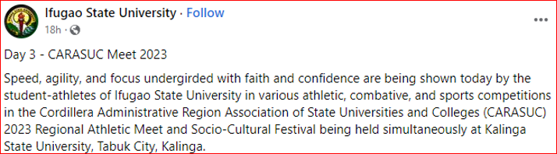
Figure 23. A sample screenshot of emotive function of a metaphor (Source. www.facebook.com).
- The Persuasive Function
The metaphors from this study are effective in realizing the speaker’s underlying goal of persuading the readers because of their potential for moving them. Under this function are the following sub-functions. The study highlights the frequent metaphors used to compare student-athletes, coaches, and trainers to animals, highlighting their talent and comparing them to animals. These metaphors are used by news writers to highlight the athletes' efforts and the physical preparation they put forth. The metaphorical function replaces the idea of players' sacrifice during games and highlights the results of their training and effort. The metaphors used in the texts have persuasive properties, as they aim to heighten competitiveness and guide readers towards the author's objective.
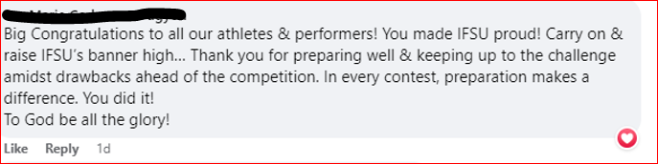
Figure 24. A sample screenshot of persuasive function of a metaphor (Source. www.facebook.com).
- Antagonism Function
Despite their entertainment value, comments on articles and opinions often contain a gloomy disposition, leading to antagonistic remarks. This issue is common among spectators who have defeated their teams. Interview transcripts show that some spectators feel a need to engage in hating behavior if a game is politically influenced or favoritisms. They may also engage in "hateful" arguments with the comments posted on Facebook.
The Literal and Contextual Meaning of the Metaphors
The study used 20 Facebook news articles with metaphorical expressions to solve problem number 3. These articles were selected from Facebook pages covering CARASUC, MP Provincial Meet, and CARAA events. The linguistic traits related to sports-related language were recognized, coded, and evaluated using Geeraert's (2015) lexical semantics theory. Samples were provided, including several metaphors used to answer problems No. 1 and No. 3, coded as Article 5 and Article 12.

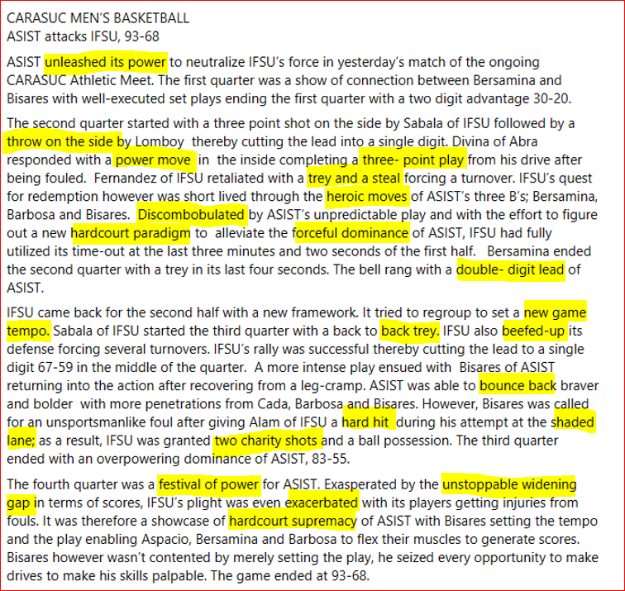
Figure 25. An extracted sample of Article 5 posted and shared from FB on April 20, 2023. (Source. www.facebook.com).
The researchers analyze lexical units using Geeraerts' Theory and the MIP, selecting metaphors from an article. They determine if the chosen words and phrases are metaphorically used in the context of the article for each lexical unit. The study aims to determine how metaphors facilitate communication among supporters and readers, focusing on the choice of unit of analysis, justification for the analysis method, and the use of a dictionary.
- Unleashed its power
(a) Contextual Meaning: In this context, “unleashed” indicates effort of success in achieving a goal to win the game between ASIST and IFSU.
(b) Literal Meaning: The basic meaning of the verb “unleashed” is to free from or as if from a leash, let loose, to throw, shoot, or set in motion forcefully. Unleashed a superb shot … (Mirriam-Webster Dictionary)
(c) Metaphorically used? Yes
- Throw on the side
(a) Contextual Meaning: In this context, the metaphor “throw on the side” means that it is a method of putting the ball into play in a basketball game.
(b) Literal Meaning: The basic meaning of this phrase is “in-bound pass” (Mirriam-Webster Dictionary).
(c) Metaphorically used? Yes.
It was noted that the author of the post purposefully chose the phrase "unleashed its power" to characterize the attacker (ASIST). The majority of the author's vocabulary comes from the language of basketball. This shows that they were able to effectively communicate in perfect solidarity using this register. In this case, "throw on the side" refers to the move made by IFSU's Lomboy, who reduces the deficit to another score by his team. The context of use prevents the antonym of the prepositional phrase "on the side" from being referred to as "backward," "posterior," or "regress."
- Heroic moves
- Contextual Meaning: The "best move" in sports is meaningless without a clear path or purpose. It's like asking someone to visit Mt. Pokis without any information about the location or why. Players' contributions to "the best move" are uneducated attempts to increase their score without recognizing the importance of teamwork. Understanding the position and expectations of athletes who perform heroic feats or actions similar to those in myths can help locate the best moves and gain an advantage in the game.
- Literal Meaning: courageous, noble, or self-sacrificing action or behavior (Mirriam-Webster Dictionary).
- Metaphorically used? Yes.
- Beefed-up
(a) Contextual Meaning: From the sentence above “IFSU also beefed-up its defense forcing several turnovers”, there is 1 metaphor found, that is the verb “beefed-up”. From the sentence “beefed-up” means IFSU did an effective motivation to be bringer of victory to their team however they forced several turnovers during the game.
(b) Literal Meaning: to make something bigger, better, more interesting, etc. (Mirriam-Webster Dictionary).
(c) Metaphorically used? Yes.
In addition, the writer only uses the adjectives "heroic moves" and "beefed-up" while describing the basketball game between ASIST and IFSU. It makes sense that Halliday (1990) referred to them as restricted or closed resisters since they have a variety of definite, finite, and potentially small conceivable interpretations. In a competition between two opponents, "heroic moves" refers to an unexpected progression, while "beefed-up" refers to scoring more to defeat the opponent.
- Bounce back
(a) Contextual Meaning: This metaphor refers to the resilience of a team or player who is able to recover from a defeat or setback.
(b) Literal Meaning: to return quickly to a normal condition after a difficult situation or event (Mirriam-Webster Dictionary).
(c) Metaphorically used? Yes.

The article uses basketball terminology to discuss players' progress, using the metaphor "bounce back" to describe the team's resilience after a defeat or setback. This metaphor is not limited to bouncing or jumping but is commonly used in games to describe a team's ability to recover. The writer below also uses similar terms in other fields, as seen in a news extract.

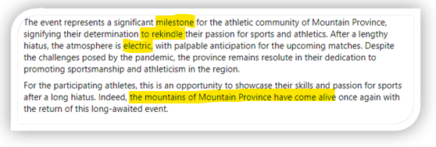
Figure 26. An extracted sample from Article 12 posted by DepEd Tayp, Mountain Province covering the PROVINCIAL MEET 2023 (Source. www.facebook.com).

- Milestone
(a) Contextual Meaning: Accordingly, the event or accomplishment marking a significant advance in an endeavor; a notable achievement; as, preparing the young athletes for the athletic community in Mountain Province.
(b) Literal Meaning: to describe how the players in a team generally prepare themselves to participate in sports
(c) Metaphorically used? Yes.
- To rekindle
(a) Contextual Meaning: It speaks about the interests, feelings, or thoughts the young athletes in Mt. Province used to have before the pandemic hiatus. It makes think about the sport they used to play or feel it again to be part of the event.
(b) Literal Meaning: To start or stir up again.
(c) Metaphorically used? Yes.
- electric
(a) Contextual Meaning: This text is used to describe the atmosphere in every sports event being watched by spectators.
(b) Literal Meaning: connected with electricity
(c) Metaphorically used? Yes.
- the mountains have come alive
(a) Contextual Meaning: The mountain typically represents wishes, dreams, and hopes due to its extreme height. Additionally, because of how durable it appears, it is viewed as a hallowed location where the secular sufferings of humans are cleaned. Additionally, it stands for benevolence or a large mind.
(b) Literal Meaning: It refers to the geological processes that underlie the formation of mountains.
(c) Metaphorically used? Yes.

The article discusses the upcoming Provincial Meet, 2023, using terms like "milestone," "to rekindle," "electric," "palpable anticipation," and "the mountains have come alive" to describe the event. The "milestone" refers to the significant point of development for team players, while the "electric" adjective describes the atmosphere of the event. The "mountains have come alive" personification refers to Mountain Province's athletes' performance in the CARAA MEET, showcasing their courage, confidence, and resiliency. The athletes made decisions after finishing bottom two in previous events, demonstrating their readiness for competition and commitment to personal and professional growth. The CARAA MEET 2023 provided them with the opportunity to handle difficulties, fostering courage and confidence, and resulting in the phrase "the mountains have come alive" with the sound of sportsmanship.

CONCLUSIONS AND RECOMMENDATIONS

The research analyzed metaphors in sport news articles, text/chat comments, and interview transcriptions from selected respondents. The qualitative method was used to provide descriptive details about the subject matter. The study found that from 313 collected metaphors, 56 Triumph Metaphors, 87 Animal-Related Metaphors, 19 Loss Metaphors, 21 War and Engagement Metaphors, 47 Metaphors of Sport as Life, 39 Metaphors of Sports as Emotions, and 44 Metaphors of Teamwork and Sportsmanship were used. The Emotive Function, Persuasive Function, and Antagonism Function were assessed using classified data. The study found that articles posted on Facebook during and after events predominately employ metaphorical language that is used and understood inside contexts. This adds to the body of knowledge in the field of data and the applicable conceptual and theoretical framework. The researchers advised English teachers to incorporate sports terminology into their lessons and provided student-researchers the freedom to pursue additional studies on sports terminology, such as the role of journalism in sports hooliganism and the role of language on sports audience behavior.

REFERENCES

Çaredar, N., Pekel, A. Ö., & Cengizel, Ç. Ö. (2022). Children's Perceptions of Basketball through Metaphors and Drawings. Education Quarterly Reviews, 5(2), 117-127. ISSN 2621-5799 DOI: 10.31014/aior.1993.05.02.473
File, K. A., & Wilson, N. (2017). Adapting self for private and public audiences: The enactment of leadership identity by New Zealand rugby coaches in huddles and interviews. In Dorien Van De Mieroop & Stephanie Schnurr (Eds.), Identity Struggles. Evidence from Workplaces around the World, 317–333. Amsterdam: John Benjamins.
Geeraerts , D. (2009) Theories of lexical semantics. Oxford: Oxford University Press.
Geeraerts, D. (2017). Lexical semantics. International Lexical Semantics Encyclopedia of the Social & Behavioral Sciences (2nd Ed.). Retrieved from www.reserachgate.com.
Galindo Cáceres, J. (2010). Comunicología, comunicometodología y deporte. Crítica epistemológica de las Ciencias y las ingenierías del deporte. In Martínez, S. (Coord.). Fútbol-espectáculo, Cultura y Sociedad. 53-67. Mexico City: Afínita.
Groppaldi, A. (2009). Il lessico degli appassionati di pallavolo: lingua speciale e gergo per tifosi. In Hernán GómezPrieto, B. (Ed.). Il linguaggio dello sport, la comunicazione e la scuola. 107-120. Milan: Edizioni Universitarie di Lettere Economia Diritto.
Herráez Pindado, A. J. (2004). “La metáfora en la formación del vocabulario del ciclismo en francés”. Ibérica, 7: 107-123
Kowalikowa, J. (2009). “Language of sport in the context of communication and culture”. Studies in physical culture and tourism, 16/1: 63-67.
Lakoff, G. (1992). Metaphor and war: The metaphor system used to justify war in the Gulf. In Pütz, M. (Ed.) Thirty Years of Linguistic Evolution, Philadelphia/ Amsterdam: John Benjamins. https://doi.org/10.1075/z.61.36lak
Lavric, E., & Steiner, J. (2017). Personal assistants, community interpreting, and other communication strategies in multilingual football teams. In D. Caldwell, J. Walsh, E. W. Vine & J. Jureidini (Eds.), The discourse of sport: analyses from social linguistics (Routledge studies in sociolinguistics 12), 56–70. New York ; London: Routledge.
Lavric, E., & Steiner, J. (2018). Multilingualism in football teams. The Aesthetics, Poetics, and Rhetoric of Soccer. Routledge.
Nworgu, B.G. (2015). Educational research: basic issues and methodology (3rd ed.). Nsukka: University Trust Publishers.
Meân, L. J., & Halone, K. K. (2010). Sport, language, and culture: Issues and intersections. Journal of Language and Social Psychology, 29(3), 253–260. doi:10.1177/0261927X10368830
Pragglejaz Group. (2007). MIP: A Method for Identifying Metaphorically Used Words in Discourse. METAPHOR AND SYMBOL, 22(1), 1–39.
Segrave, J. O. (2000). The sports metaphor in American cultural discourse. Culture, Sport, Society, 3/1: 48-60. https://doi.org/10.1080/14610980008721862
Shekhovskaya, J. A. (2020) Metaphors in English-language sports discourse: Linguistic means of “MetaSelf” expression. In SKASE Journal of Theoretical Linguistics [online]. 2020, vol. 17, no. 1 [cit. 2020-06-03].Available on web page http://www.skase.sk/Volumes/JTL43/pdf_doc/05.pdf. ISSN 1336-782X

