LIFE CYCLE ASSESSMENT OF FISH CARBON FOOTPRINTS

Abstract: Fish is one of the few animal-source foods most consumed worldwide. However, transportation of fish releases harmful greenhouse gases, posing serious threat of global warming effects. The sustainable transport system for fish that is efficient and emits minimal greenhouse gases as compared to others is not known. Life Cycle Assessment framework was used to quantify the carbon footprints of fish from landing, through transportation to consumption. The general objective of the study was to assess the life cycle of fish carbon footprints with a specific objective to analyze the carbon footprint of fish per weight-kilometer moved using different motorized modes of transport. The research adopted a descriptive design and involved a sample population of 98 motors (14-seater van (matatu), probox van and motorcycles). Stratified random sampling was employed. Primary data was collected using questionnaires and direct observations. Results showed that matatu emits averagely 0.66 L per kg-km; Probox emit 1.10 L per kg-km; motorcycles emit 2.17 L per kg-km when transporting fish. Analysis of Variance (ANOVA) showed there was a statistically significant difference in the carbon footprints of the motorized modes of transport (F (2,77) =22.477, p<0.0005, α=0.05). The study concluded that there is need for sustainable and efficient transportation practice and policy that aims at mitigating the effect of CO₂ on climate change. The study recommended that the dominance of lower fish carrying capacity modes be discouraged and initiate high fish carrying capacity modes.
Keywords: Carbon footprints, Global warming, Life Cycle Assessment

Introduction
More people than ever rely on fisheries and aquaculture for food and as a source of income. Global fish production was estimated to have reached about 179 million tonnes in 2018, making fish and seafood amongst the most traded food commodities [6]. However, just like other consumable products, fish also contributes to environmental burdens that are experienced in urban areas today. For each ton of fish eaten, an equal volume of fish material is discarded either as waste or as a low-value by-product [14].
In many African countries, fish is transported from landing beaches to retail markets via road, for consumers to buy [12]. When analyzing the amount of Carbon (IV) Oxide (CO₂) by the European Union (EU), it was found out that transportation is responsible for 28 percent of greenhouse gas (GHG) emissions and 84 percent of these are caused by road transport [4]. Fish production chain contributes to greenhouse emissions [7].

Kenya‟s fisheries and aquaculture sector contribute approximately 0.54 per cent, making a small but increasing contribution to Kenya‟s gross domestic product (GDP) [9]. However, the processes involved in the distribution of fish, and the addition of value to fresh fish releases emissions and wastes that are harmful to the environment.
While distance is certainly an important parameter in the accounting for emissions from transportation, studies [5] indicate that „food miles‟ is a poor indicator of transport emissions, as there are many other parameters (e.g. transport mode, load factor, cooling requirements) that affect transport emissions. This study ventured into transport mode because of the evolution of various transport modes in urban areas today whose efficiency in terms of emissions is unknown.

Statement of the Problem
The 1997 Kyoto Protocol on Climate Change required countries to ensure that their aggregate anthropogenic carbon dioxide equivalent emissions of the greenhouse gases are minimized every year. The adoption of green transport or sustainable transport would encourage shifting to more environmentally-friendly modes of transport that protects the global climate. This has not been possible due heavy reliance on fossil fuel and energy usage which continuously increases greenhouse gases into the atmosphere and in turn makes it harder to reduce GHG footprints.
Fish, being an extremely perishable food item, has seen the introduction of faster means of transport to its destination for sale. It was expected that environmental sustainability would be attained by use of sustainable transport systems that are efficient and emit minimal greenhouse gases as compared to others during its transportation. However, in the life cycle of fish, indicate that transportation of fish release harmful gases that pose serious threat to both aquatic environments and the atmosphere [11]. The problem is that we do not know what each mode of transport emits and its contribution to greenhouse emission during the transportation of fish.
Data showing the contribution of carbon emissions from automobiles during fish landing, transporting, and consumption of fish is scanty. Emissions cannot be reduced unless the efficient mode of transport for fish is known in terms of its greenhouse gas emission. It is for this reason that the study sought to compare greenhouse gas emissions for the three most common modes (14-seater van, commonly referred to as matatu, probox van and motorcycle) of transport used from Usenge Beach to transport fish.

Research Hypothesis
H₀: There is no statistically significant difference in carbon footprints of fish per weight-kilometer moved by different motorized modes from Usenge beach to Bondo market.
H₁: There is statistically significant difference in carbon footprints of fish per weight-kilometer moved by different motorized modes from Usenge beach to Bondo market.

Methodology
The study covered Usenge beach environment and Bondo market. Figure 1 below shows the map of study area in Kenya.

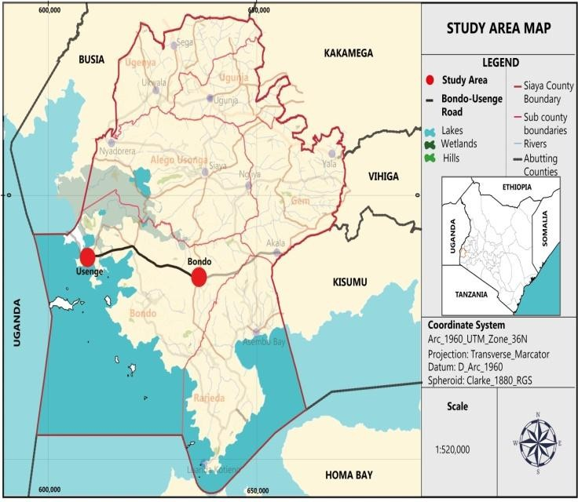
Figure 1: Map showing Usenge Beach and Bondo Town, Kenya
The study adopted the Life Cycle Assessment (LCA) framework. LCA is a technique for assessing the environmental aspects associated with a product over its‟ life cycle [12]. The tool was used to assess carbon footprints of fish from its‟ landing point when being transported to consumption point in hotels and restaurants. The system boundary of the LCA was from “gate to gate”, meaning from fish production to use and not getting to disposal.
The sample size for automobiles was 98 (32 matatus, 14 probox van and 52 motorcycles). The functional unit used was, the volume of CO₂ (liters) equivalent to 1kilogram of fish per kilometer (kg-km⁻¹). The sampling techniques employed were stratified random sampling and convenience sampling. Primary data was collected using a questionnaire and direct observation. The tool was administered to drivers of vehicles and riders of motorcycle.

Mass Balance Formula
Quantitative data was analyzed by a combustion formula using the mass balance approach. The Mass balance approach is a methodology developed by the Intergovernmental Panel on Climate Change, to estimate carbon content in fuel [3]. The cost of fuel was converted to the amount of fuel used by multiplying with the unit cost per liter. It was then converted to the volume of CO₂ liberated using the EPA standards considering the combustion equation. The volume was divided by the mileage in kilometers to get the volume of CO₂ liberated per kilometer, which was then divided by the amount of fish being transported in kilograms to get

the volume of CO₂ liberated per kilogram-kilometer of fish being transported as shown in the equations below:

CO₂ liberated as a function of Petrol
Petrol carbon content = 2,421 grams per US gallon [15] 1US gallon = 3.785L
Price of petrol = Ksh. 106.6/L in Bondo (Nov 16th to December 16th, 2020) Relative Molecular Mass (RMM) of CO₂=12+(16x2) =44 [8]
Molar Gas Volume (Ideal gas) at Room Temperature and Pressure, RTP (25⁰C, 1 atmosphere) =24.465= 24L (to the nearest 1L).
CO₂ emission from a gallon of petrol (at 99% oxidation) = 2,421g x 0.99 x (44/12) = 8,788g
1L of petrol therefore produces 8,788/3.785 = 2,321.8g of CO₂ which is equivalent to (2,321/44) x 24L of CO₂ = 1,266.4L of CO₂ at RTP.
If 1L of petrol produces 1,266.4L of CO₂ at RTP when burnt, then considering the Nov 2020 cost of petrol at Ksh. 106.6/L in Bondo (assuming that all vehicles are fueled at Bondo), it implies that for every ksh.106.6 spent on petrol, 1,266.4L of CO₂ was being emitted. Therefore, the volume of CO₂ per kilogram-kilometer can be calculated as (1,266.4/106.6) x cost per kg-km.

CO₂ as a function of diesel
Diesel carbon content = 2,778 grams per US gallon [15] 1US gallon = 3.785L
Price of diesel = Ksh. 91.7 /L in Bondo (Nov 16th to December 16th, 2020) Relative Molecular Mass (RMM) of CO₂=12+(16x2) =44 [8]
Molar Gas Volume (Ideal gas) at Room Temperature and Pressure, RTP (25⁰C, 1 atmosphere) =24.465= 24L (to the nearest 1L).
CO₂ emission from a gallon of diesel (at 99% oxidation) = 2,778g x 0.99 x (44/12) = 10,084g
1L of diesel therefore produces 10,084/3.785 = 2,664.2g of CO₂ which is equivalent to (2,664.2/44) x 24L of C0₂ = 1,453.2L of CO₂ at RTP.
If 1L of diesel produces 1,453.2L of CO₂ at RTP when burnt, then considering the Nov 2020 cost of petrol at Ksh. 91.7L in Bondo (assuming that all vehicles fueled at Bondo), it implies that for every ksh.91.7 spent on diesel, 1,453.2L of CO₂ was being emitted. Therefore, the volume of CO₂ per kilogram-kilometer can be calculated as (1,453.2/91.7) x cost per kg-km.

Test of Hypothesis
The null hypothesis was tested using Analysis of Variance (ANOVA). This technique enables the researcher to examine the significance of the difference amongst more than two sample means at the same time using

the F-test [10]. The null hypothesis was tested after comparing the F-values with the critical values of the F- distribution table at a 0.05 significance level.
Multiple linear regression analysis was carried out to indicate the relationship between CO₂ emission and transportation factors (the distance of travel (km), the weight of fish being transported (kg), and the amount of fuel (L) that contribute to the emission at α = 0.05 significance level. The relationship between dependent variable represented by Y and independent variable, also referred to as regression coefficients, represented as X, and was presented by a multiple linear regression model below. The subscript a is the intercept while b₁ is the regression coefficients.
Y= a + b₁X₁ + error (1)

Results and Discussion
The emission of CO₂ was calculated as a function of petrol and diesel cost. The study used the cost of fuel to derive the amount of fuel used which was then converted to liters of CO₂ using mass balance. The results are shown in the table 1 below:
Table 1: Volume of CO₂ in Liters Kg⁻¹ Km⁻¹

Mode | Lowest Emission | Highest Emission | Midpoint
Matatu | 0.11 | 1.22 | 0.66
Probox van | 0.41 | 1.79 | 1.10
Motorcycle | 0.53 | 3.81 | 2.17

Test of Hypothesis for Statistical Difference in CO₂ emission
Table 2 gives the analysis of variance between and within groups as analyzed by ANOVA. The study given by variance ratio follows F distribution with d.f. (2, 77).

Table 2: Analysis of Variance Between and Within groups

 | Sum of Squares | Df | Mean Square | F | Sig.F
Between Groups | 97.590 | 2 | 48.795 | 22.477 | .0005
Within Groups | 167.160 | 77 | 2.171
Total | 264.750 | 79

At 5% level of significance, the critical value is 3.15 which is smaller than the computed value which is
22.477. Therefore, we reject the null hypothesis, meaning that the statistical difference is significant. In this case, the study concludes that there was a statistically significant difference in carbon footprints while transporting fish by different motorized modes of transport (matatu, probox van and motorcycle) from Usenge beach to Bondo market as evidenced by one-way ANOVA, Turkey Post hoc test (F (2,77) =22.477, p<0.0005).

Transportation Factors and CO₂ Emission
The relationship between transport factors (travel distance, amount of fuel, and the weight of fish) and carbon emission was determined.
Table 3: Relationship Between Carbon Emitted and Transportation Factors

Unstandardized Coefficients
Standardized Coefficients
95.0% Confidence Interval for B

 |  |  |  |  | Lower | Upper
Model | B | Std. Error Beta | T | Sig. | Bound | Bound
(Constan
t) 3.435 .121 28.284 .0005 3.194 3.675
km) -.121 .035 | -.314 | -3.465 | .001 | -.191 | -.052
fish-.232 .041 | -.510 | -5.602 | .0005 | -.314 | -.150
of  .023 .028 | .108 | .842 | .04 | -.031 | .078

Distance (

Weight of (kg)

Amount fuel (L)

Discussion
The results showed that matatu release averagely 0.66 L per kg-km; Probox emits 1.10 L per kg-km while motorcycles emit 2.17 L per kg-km. This shows that the motorcycles emit about 3 times the volume of CO₂ emitted by the 14-seater matatu per kilogram of fish transported in every kilometer. This study is in agreement with studies [1] on Implications of Motorized Road Transport on CO₂ emission standards which found out that cycles emit about 5 times the volume of CO₂ emitted by the 14-seater PSVs per passenger- kilometer.
The study found out that distance and weight showed a negative correlation with CO₂ L per kg⁻¹ km⁻¹ with -
0.314 and -0.510 respectively. This indicates that automobiles traveling for longer distances emit less CO₂ per weight kilometer than those traveling for shorter distances. This is also the case for the weight of fish. Automobiles carrying more fish liberate lower volumes of CO₂ per weight kilometer than those carrying less.

These findings can be compared to those from authors [2] who sought to compare carbon emission from pooled vehicles and unpooled. They found out that as seating capacity increases, less CO₂ is emitted per passenger kilometer, meaning that even though matatu carries fewer people it emits more CO₂ as compared to buses which carry many people. In this study, matatu carries more fish but emits lower carbon as compared to probox van and motorcycle.
There was, however, a positive relationship between amount of fuel and CO₂ liberated at 0.108. This indicates that matatu which consumes more fuel than probox van, and probox van more than motorcycle; emit higher volumes of CO₂ L per kg⁻¹km⁻¹. This is because larger engines have many larger compression cylinders translating into higher fuel consumption while smaller engines have few smaller cylinders which translate to less fuel consumption. Nevertheless, the significance of the relationship between distance travelled and weight to carbon emitted overrides that of amount of fuel used. Figure 2, 3 and 4 are the modes of transport used in the study.
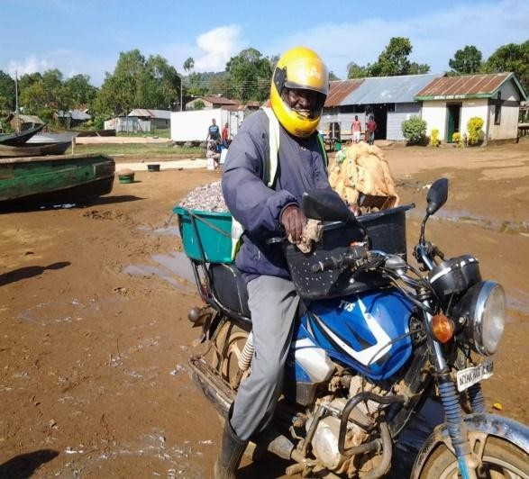
Figure 2: Transportation by motorcycle

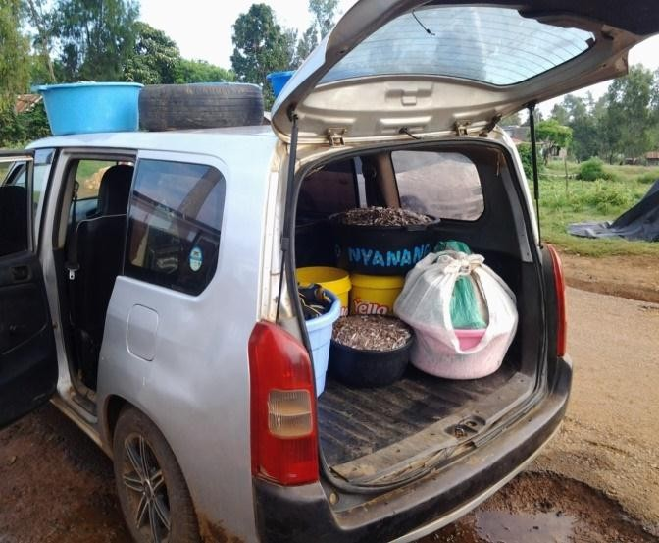
Figure 3: Transportation by probox van
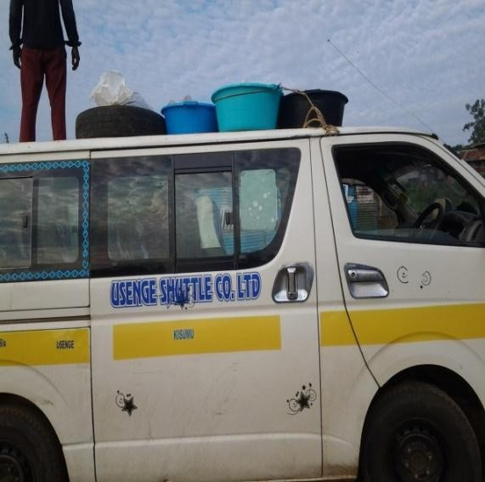
Figure 4: Transportation by 14-seater van (matatu)

4. Conclusion and Recommendations
As the population increases, the rate of fish consumption will also increase, meaning faster and efficient transportation will be required. The main findings in this study can be used to promote sustainable transportation practice and policy. Bold and deliberate actions have to be taken by cities and regions to improve lives and reduce the impacts of climate change right from production of goods, their transportation and consumption.
Urban Environmental Planning and Management is tasked with the responsibility of coming up with strategies that would design an environment which is suitable for human living but does not limit other organisms in their ecosystem from enjoying the same environment. In view of the findings that motorcycles emit more carbon than probox van and consequently more than matatu, the study recommends that there is a reduction of the dominance of lower fish carrying capacity modes and initiate high fish carrying capacity modes.

References
- Achola, M. (2020), Motorized Road Transport and its Implications on Carbon Dioxide Emission Standards. phd dissertation Submitted to School of Spatial Planning and Natural Resources Management of Jaramogi Oginga Odinga University of Science and Technology. Pp 56-70
- Achola, M., Hayombe, P., Akenga, T., and Owino, F., (2018).Transport Pooling as a Mitigating Strategy for Carbon Dioxide (CO₂) Emission’, Vol 6, N0.3, pp.17-26, August 2018. UK: European Center for Research Training and Development, ISSN:2056-7537 (print), ISSN: 2056-7545 (Online).
- Bhupendra, K., and Munish, K. (2017). Life cycle assessment of potential municipal solid waste management strategies for Mumbai, India.
- Cioca, L., Ivascu, L., Rada, E., Torretta, V., and Lonescu, G. (2015). Sustainable Development and Technological Impact on CO₂ Reducing Conditions in Romania.
- Farmery, A., Green, B., Gardner, C., and Watson, R. (2015b). Domestic or imported? An assessment of carbon footprints and sustainability of seafood consumed in Australia. Environmental Science and Policy 54, 35– 43.
- FAO, (2020), The State of World Fisheries and Aquaculture. Sustainability in action. https://doi.org/10.4060/ca9229en
- Henriksson, P., Heijungs, R., Dao, H., Pham, L., de Snoo, G. and Guinée, J. (2015a). Product carbon footprints and their uncertainties in comparative decision contexts. PLoS ONE 10, e0121221.
- International Union of Pure and Applied Chemistry, (1993). Quantities, Units and Symbols in Physical Chemistry, 2nd Edition. Oxford, Blackwell Science.
- Kimani E.N., Okemwa G.M. and Aura C.M., (2020) The status of Kenya Fisheries, published January, 2020 by Kenya Marine and Fisheries Research Institute. Available at https://mahb.stanford.edu/library- item/the-status-of-kenya-fisheries/
- Kothari, C. (2013). Research Methodology; Methods and Techniques. Published by New Age International (P) Limited, New Delhi. Page 195-214.

- Kumer, A. Andrade, L. Gomes, S., Fazolo, A., Hasan, S., Machado, F.(2011). Tratamento de Efluente de Abatedouro de Tilapia com adicao de Manipueira na Fase Anoxica.
- Muralikrishna, I. and Manickam, V. (2017). Environmental Management; Science and Engineering for Industry. Pg 57-75.
- Nowsad, A. (2016). Supply and Value chain of fish in Super-shop outlets in Dhaka city. BAU Department of fisheries technology. 49p.
- Singh, R., and Heldman, D.(2013). Introduction to Food Engineering, 5th edition. Academic Press ISBN: 9780123985309
- US EPA, (2005), Emission Facts: Average Carbon Dioxide Emissions Resulting from Gasoline & Diesel Fuel, USA: US EPA.

