The Metsamor Nuclear Power Plant in an Active Tectonic Zone of
Armenia is a Potential Caucasian Fukushima

Abstract

This article describes complex geological structure of the region where Metsamor Nuclear Power Plant (MNPP) in Armenia is located. This region of the Lesser Caucasus is characterized by high volcanic activity, tectonic stresses, and movements along the edges of active, highly seismic tectonic blocks. Moreover, this station literally sits on the active tectonic fault of compression type. When construction of the plant commenced, seismic risks were significantly understated. This fact was confirmed by destructive Spitak earthquake with over 25 thousand death tolls. Analysis of intensitys of the earthquakes in the area of the MNPP, their focal mechanisms and risks of movements along active tectonic faults is given in the article. With reference to numerous papers of Armenian, Russian and European researchers regarding seismic hazards and risks in the area of the Nuclear Power Plant, the conclusion about the soonest shutdown and conservation of Metsamor Nuclear Power Plant has been made.

Key words:Nuclear disaster, Metsamor, nuclear power plant, evaluation of seismic hazards, earthquake, tectonic active zone, earthquake intensity, Aragats-Spitak tectonic fault, South-Yerevan tectonic fault, Fukushima, Armenia.

Introduction
The Metsamor Nuclear Power Plant (Armenian Nuclear Power Plant, ANPP) located in the city of Metsamor to the west of Yerevan, Armenia’s capital and in vicinity of Turkish border (Fig.1), constructed in 1976 is a potential source of danger and of a growing risk over time. The power plant has two WWER-440 /230 type reactors, each with the gross electric output of 408 MW. The nuclear plant is at the distance of 36 km from Yerevan, the capital of Armenia, 100 km from the city of Kars of Turkey, 30 km from Ighdir of Turkey, and at a not very long distance from the borders of the Islamic Republic of Iran and the Nakhichivan Autonomous Republic of Azerbaijan. The ANPP has the most unreliable active reactors in the world in use. During the construction of the power plant, the Soviet experts had objected to the realization of the project expressing concerns over its construction within the Ararat (Agridag) active seismic zone.
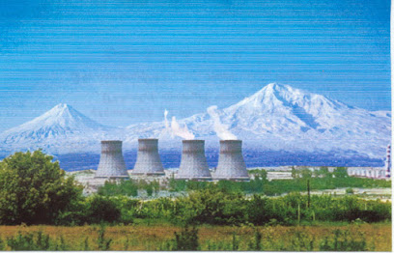
Fig.1. The Metsamor Nuclear Power Plant at Turkish border.
The epicenter of the Spitak earthquake that occurred in 1988 in Armenia was at the distance of 75 km of the Metsamor Nuclear Power Plant. After the earthquake, as part of the cautionary measures, the plant was shut down. However, in 1995, facing acute energy scarcity, Government of Armenia reopened the power plant despite the international warnings. In spite of the millions of dollars allocated by the European states and the U.S. to ensure the plant meets the up-to-date safety standards, the plant had been assessed to be “oldest and least reliable” by the EU.
By the international and regional organizations, the operation of the power plant has been assessed to fail meeting the internationally accepted safety standards. Metsamor is an old station with no protective shield over it, constructed over solid basalt near the crystalline basement carrying no risk of deformation. According to the estimates of experts, the plant should have operated for 30 years. While this period ended in 2001, the plant is still operating, posing a threat to the regional safety.

Geological setting and volcanism
Geologically, in the area where Armenia’s capital Yerevan is located, it has been noted that over the layer of Paleozoic-Triassic period sedimentary deposits is the Alpine structural complex made up by the rocks from the Cretaceous and Paleogene period. In this zone, the occurrence of the upper Cretaceous ultrabasite intrusions has also been found out. The intrusions of different types of granitoids have been attributed to the pluton bearing the same name.
In terms of the geological development, in Armenia, the Yerevan-Ordubad synclinorium had been of the character of geoanticline in the Jurassic period, had intensively depressed in the Paleogene period before being exposed to an intensive uplift in the Miocene period. [1]
The intrusive magmatism of Armenia can be categorized in two stages: In the upper Cretaceous period, ultra-major magma products pour into the intrusive rifts creating ultrabasite mass, formulating the granitoid intrusions in the Paleogene-Neogene period. All aforementioned could be obviously observed from the Map of the Deep Structure of the Caucasus according to the Space Data [2].
As seen from the map, the area of Metsamor where the Armenia Nuclear Power Plant is located is a seismically active territory. This territory is mainly made up by the complex of the mountainous rocks created as a result of the metamorphosis of the magmatic rocks in the upper layer of the lithosphere (the Paleozoic Period) under the influence of different erosive factors in a continental condition.
It has to be noted that the Metsamor power plant had been constructed in spite of the objection of the Soviet scholars to the choice of its site. The complex landscape of that area, the presence of a plenty of intrusive faults confirm the high rate of tectonic activity of the area.
The thickness of the layer of sedimentary deposits in that area is small. The thickness of the layer of the Quaternary sedimentary deposits over the Paleozoic metamorphic foundation is very small. This in turn reveals the high risk of the earthquake occurrence, a high scope of the ensuing destruction, the non-occurrence of the deformation.
The site of the power plant is over big intrusive faults, also, a geodynamic belt. As indicated by the space data map, this area as a network of different intrusive faults of closely located “microblock”s, exposed to the fracturing due to the pressing of the tectonic blocks has deformed and remains as a zone of high seismic activity. The low thickness of the deposit layer indicates the once occurrence of the orogenic regime and erosion in the region, very active erosion, closeness of the metamorphic foundation to the surface, while the location of blocks in an area exposed to the pressing denotes the high activeness of the geodynamic situation in the territory. [2]
The studies point out that as indicated by the comparative analysis of the geological structures of Caucasus, Lesser Caucasus and the Anatolia plateau, these regions resemble one another in terms of their tectonic conditions and the activity of the volcanoes there.
According to some assumptions, in the geological structuring of Lesser Caucasus and Armenia, the collision with the Eurasian continent located to far south of them plays an important role. As a result of that, along the transform faults (northern Anatolia, Eastern Anatolia), different microplates sliding past one another relatively fast and stripes have emerged. Then, the pressing and pulling segments had emerged; subduction, sliding had occurred, and from the edges of the bordering massifs, snaps (in the form of spanning massifs) had come about. [3]
In the geological structure of the region, Menderes, Artvin-Bolnisi, Alagoz-Julfa tectonic units have played an important role, which are presumably parts of the greater Central Iran tectonic unit. During the Oligocene-Miocene period, the Central Iran massif had been divided into separate uplifts and troughs creating Middle Aras depression zone [4].
The North Anatolian fault stretching till Erzurum is divided into two branches: One of them stretches past the Kars volcanic plateau, extending to Armenia, while the other one rises in the upstream of the Aras River. The last branch after diversification is divided into Arazyani and Nakhichivan faults confining the Middle Aras depression zone. These faults with the North Anatolia fault being joint are active as part of a transform fault and resemble each other a lot in terms of geochemical features.
The aforementioned faults along with others indicate the region (Yerevan and Nakhichivan) has a structure made up by blocks and have caused the creation of large amounts of horst-anticlinal and graben-synclinal tectonic elements, the accumulation of the Oligocene-Quaternary sedimentary deposits. Located perpendicular to the Aras River, the “island” uplifts (Aghridagh, Daridagh, Aghgaya etc.) have got divided into little lowlands [5].
The study of the internal structure of this zone through the space data and the tectono-physical analysis of wrinkles over there indicate that as a result of large-small several plates and their parts sliding past one another, a lowland along a fault has emerged and developed.
The first impulse to the creation of this paleogeographic basin had been given by the activation of the rift processes in the Aden and Red Seas, triggered by the sliding of the Arabian plate. The influence of the region on the small plates squeezed in between the Arabic and Eurasian plates and their parts has increased. As a result of relatively active, strong pressing of little plates and their parts against one another, pulling and other deformation movements, intrusive faults have emerged. The sliding deformation caused by the movement of the Central Iran massive has further complicated the tectonic structure of the region, galvanizing the geotectonic activity.
Intensive ground volcanic processes had taken part till the anthropogenic period. Lava layers have covered not only east of Anatolia but also central and southern parts of Lesser Caucasus and Iran.
The Lesser Caucasus (Bazum, Pambak-Sevan), Zangazur, Vardenis, and Geghama mountain ranges surround most of the country located in the Transcaucasian volcanic plateau. There is a lowland between the Geghama and Sevan mountains. Aragats (originally Alagyoz) is the largest volcanic massif in South Caucasus. Its highest point is the Northern Summit (4090 m). Additionally, there are summits of Kaputjugh (3904 m), Vardenis (3522 m) and Ajdaak (3597 m). In north-west of Armenia, there is the Shirak plain, while in south-west is the Ararat plain. The average altitude of the area is 900 m. Over 90% of Armenia is located over the altitude of 1000 m. The average height is 1800 m. The areas with the lowest altitude are located on the basin of Debed and Aras Rivers (380 m). The size of the lowlands is small. Most of the settlements on the basin of the Vorotan, Vokhchi, and Aras Rivers are located in areas with inclination of 30 degrees, which hampers the organization and the development of the urban transportation. Geologically, Armenia is located in Lesser Caucasus and in area of collision and obduction of multiple micro-plates, island arcs and active margins and between Black sea and Caspian relicts of the Tethys paleo-oceanic systems.

Earthquakes and Seismic Hazard and Risk
Armenia borders with Georgia, Azerbaijan, Turkey and Iran, and factors such as it being a landlocked state and sharing no border with Russia affect its economic development. The transportation links with Russia are realized through highways. The railway links through Abkhazia and Azerbaijan were discontinued due to the conflicts blocking access to these areas. Consequently, Armenia has come to rely on the port of Poti of Georgia for the imports and exports and on the transport-communication lines with Iran. The country is located in low-lands having a complex landscape in the north-west of the Armenian Highlands. In the area, there are mountains, plateaus, flatlands, river valleys and lowlands around lakes. All of the country are within a seismic zone with 7-11 magnitude. In Armenia, in 20th century, there had been devastating earthquakes in 1926, 1931 and 1988 (in the city of Spitak).
The potential hazard of a nuclear catastrophe in near future is not denied by sapient Armenian specialists also. after Spitak earthquake average level of earthquake intensity, registered by the Armenian seismic stations network, increased. As Kazaryan A.E. indicated in [ 6 ] “after Spitak earthquake average level of earthquake intensity, registered by the Armenian seismic stations network, increased” in the area.
In most cases earthquakes in the region are intra-crustal, with the average focal depth 4 to 15 km from the surface. Statistical characteristics of seismicity of the investigated region were obtained based on processing of the master catalog of earthquakes provided by the National Seismic Service (NSS) of the Republic of Armenia, and are shown below as histograms Fig 1. [ 6 ].
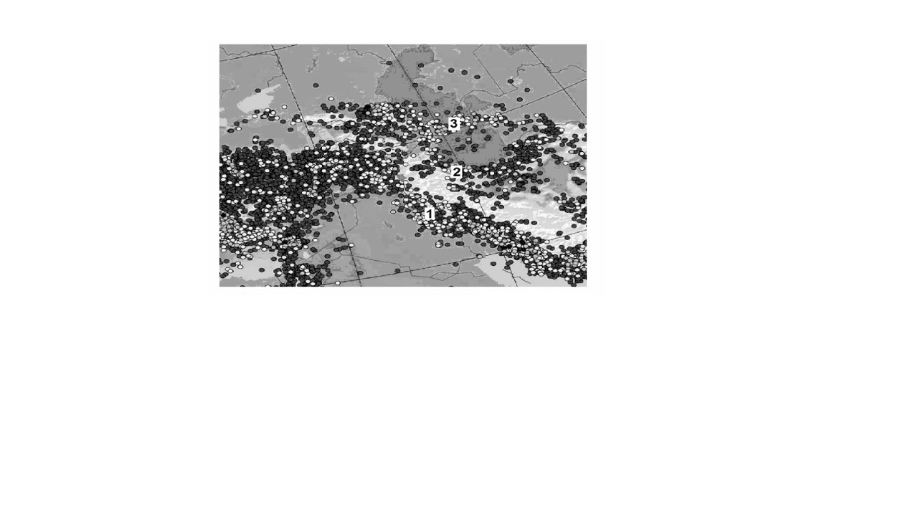
Fig. 1. Schematic map of the territorial distribution of earthquakes at the territory of South Caucasus and in adjacent areas.

The most power magnitude earthquakes in vicinity of the Metsamor Nuclear Power Plant have magnitudes M between 7 and 10. Fig.2 [7].
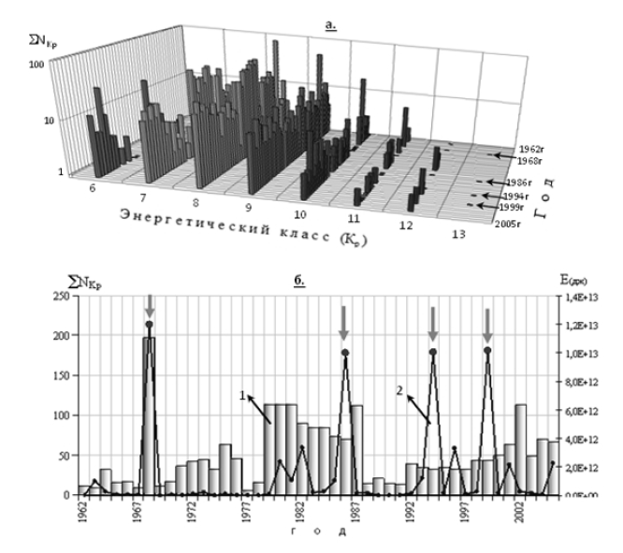
Fig. 2. a) 3D graph – quantitative breakdown of earthquakes during the period of 1962-2005 on the territory of the south-eastern part of the Lesser Caucasus by years and energy classes. b) Distribution of seismic events (1) and total released energy (2).

The Armenian Nuclear Power Plant over a tectonic fault with a large and wide depth poses a great danger. Besides its technogenic factors, the Metsamor plant together with its geological position can endanger the region. As mentioned above, both Turkey and Armenia are located in seismically active zones. That deep tectonic fault crosses the area where the Armenia nuclear power plant is located increases the likelihood of the occurrence of the tectonic developments including earthquakes. This is related to the abovementioned tectonic faults crossing the territory. Earthquakes periodically recur in the tectonic fault zones regularly over some period of time. Therefore, a high risk of the occurrence of a natural disaster in the area of the location of the plant is existent.
It is seen obviously from the map prepared (fig.3) by the National Service of Seismic Defense of the Ministry of Emergency situations, the Metsamor NPP is located on the deep fault and the area encircled by earthquakes with Mw≥7.0 [8].

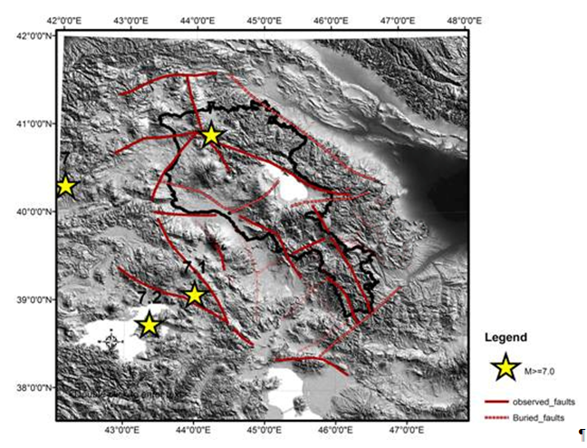
Fig. 3. Map of Deep Faults and Powerful Earthquakes Mw≥7.0 [8]

A group of famous Russian scientists from Institute of the Earth's Physics including such famous researchers as academicians Nikolayev A.V. and Ulomov V.I., professors Steinberg V.V. and Rogozhin E.A. were invited by Government of Armenia in 1992 to analyze all available seismological, geological, geophysical, seismotectonical and soil mechanical data from the Nuclear Power Plant site to make an authoritative decision about further fate of the Metsamor NPP. Here are a few citations from the "Expert Evaluation of Seismic Hazard for the Site of Armenian Nuclear Power Plant" dated in 12.05.1992 [9]:
- Most dangerous for the site of Atomic Power Plant (APP) is a tectonic cross-point close to it (0.5 km), on the intersection of sub-meridian Aragats-Spitak tectonic fault with South-Yerevan fault, having high seismic potential (M=6.5). In one of tectonic cross-points of this fault, less than 50 km to the east from APP, in 851-893 years, series of destructive Dvin earthquakes took place, with intensity at least 9 and huge fatalities.
- Thus, most realistic evaluation of the potential earthquake intensity for the site of Armenian APP should be 8.5 M, maximum calculated earthquake intensity 9.5 M. In the area of maxima of spectral-response characteristics of bedded formation oscillations incremental intensity may reach 1M.
- At a distance minimum 0-5 km of this potential earthquake origin from the site of Armenian APS, with occurrence depth about 10 km and accounting for the specific character of macro-seismic field, seismic effect at the site is 9M, whilst for maximum estimated magnitude (MEM), even if we take Mmax = 6.5, will exceed this value significantly and earthquake intensity will be 9.5M.
- Concluding, it should be noted that in recent decades we observe increased seismic activity of the whole Armenian highlands, Caucasus and neighbour regions, induced by the seismic-geodynamic processes in Iran-Caucasus-Anatolian region (detailed note of the expert group is enclosed)[4].

A members of this expert group, academician Ulomov V.I. in 2004 in his another expert conclusion concerning of safe usage of the Bilibin nuclear power station in Russia, did not hesitate to mention the Metsamor NPP in Armenia again [10] and wrote " It was decided to that Armenian NPP must be abandoned because it is located in very seismologically dangerous area of Armenia [10].

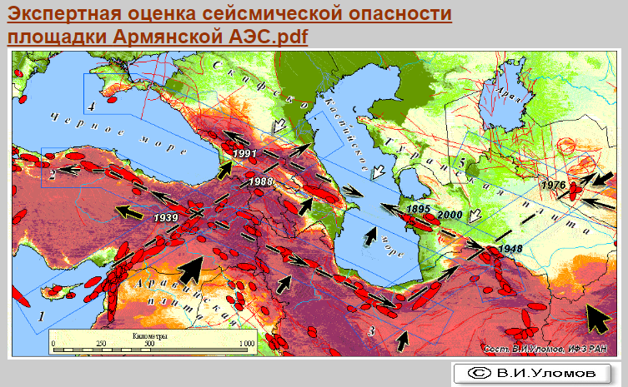

Fig. 4. From Expert Conclusion of Safe Usage of the Bilibin NPP [10]

Conclusion
Overall, the major natural and technogenic factors bolstering the threat of the Metsamor power plant for the regional states can be reduced to following conclusion. Although the plant during the construction had been planned to persist up to an 8-magnitude earthquake, it is located in a region that can potentially experience an 11-magnitude earthquake.
Any delay of this safe and wise decision to abandon the Metsamor nuclear power plant will be resulted a big catastrophe for all the region could be called as the Caucasian Fukushima.

References:
- Azizbekov Sh.A. Geology of Nakhchivan ASSR/ Moscow State Geological Mechanical Publishing House. 1961. p.489 [In Russian]
- Map of the Deep Structure of the Caucasus according to the Cosmic Data. Ministry of Geology of the USSR, based on satellite images of structural lineaments. M 1: 1000000. 1989.
- Trifanov V.G. Late Quaternary Tectogenesis. 1983. p.224 [In Russian]
- Echle W. Zur mineralogic und Petrogese jungteriarer tuffitischer Sedimentsim Neogen Becken nordlich Mihalicck (Westanatolien. Turkey. Neus Sahrb. Mineral.Abhaudl.-1974, 12, №1.
- O.A.Rzayev “The Intrusive Structure of Nakhchivan Lowland and Its Tectonic Features”. Baku, 2015, p.35 [In Azerbaijani]
- Kazaryan A.E. Analysis of seismic-dynamic status of the territory of Armenia as one of the factors for the evaluation of current seismic hazard. Izvestiya of the Russian Academy of Sciences, Earth Sciences. 2011, 64, No 2. [In Russian].
- Uvsepian N.V., Mkrtchian G.A. Time-Power distribution of areal seismicity of South-East part of the Lesser Caucasus. In: Proceedings of All-Russian geological conference “Geology, Geo-ecology and Resource Potential of Urals and adjacent areas”. Ufah 2014. pp.77-84. [In Russian].
- Armenian News. Society 01.11.2011. National Service of Seismic Defense of the Ministry of Emergency situations has analyzed results of the Earthquake in Turkey happen on 23th October 2011.
- "Expert Evaluation of Seismic Hazard for the Site of Armenian Nuclear Power Plant" dated 12.05.1992.
- Ulomov V.I. Nuclear Power Plants - Seismic Hazards. Expert Conclusion of Safe Usage of the Bilibin NPP. №ДНП-5-441-2002. Dated 21.06.2004.

