Assessment of Heavy Metal Exposure in Soils of Ihwrekreka Communities, Delta State, Nigeria

Abstract
Crude oil pollution in the Niger Delta, perpetrated by both local communities and industrial actors, has brought about soil pollution with its consequent ecological, human health and food challenges. The purpose of this research was to examine the concentration and distribution of heavy metals in soil from communities contaminated by crude oil in Niger Delta, and to evaluate the potential health risks to residents from exposure to these contaminants. To achieve this, soil samples were collected from the Ihwrekreka community and analyzed for heavy metal content using inductively coupled plasma mass spectrometry (ICP-MS). The analytical results in mg/kg revealed a significant metals pollution level derived from the oil spill in the soil ranging from 4.85 - 17,078 (Cu), 1.01 - 16.1 (Cd), 0.22 - 36.8 (Cr), 8.28 - 40.9 (Ni), 7.51 - 6474
(Pb), and 8.84 - 12,851 (Zn) respectively. Most of the metals were above the permissible limits of World Health Organization, with Cu, Zn, and Pb as the most contaminating metals. Lead was found to be the main contributor to the hazard index (HI) values for both children and adults in the study area, with its concentration exceeding the permitted limits set by the WHO and the EC. The hazard index (HI) values of Pb, Cu, Zn, Cd, Ni, and Cr were significantly higher than 1. These findings suggest that the release of heavy metals from an oil-contaminated site may pose a risk to human health and the environment.

Keywords
Cancer, Exposure Pathway, Toxic Metals, Health Risks

Introduction
Natural geological process, such as ore formation, weathering of rocks, leaching or degassing could introduce heavy metals as contaminant in soil (Gautam et al., 2014; Ali et al., 2019). However, human activities such as illegal refining of fossil fuels, petroleum prospecting, mining, and crude oil pollution can contribute to excessive release of these metals into soils or agricultural lands, resulting in in- creased concentrations of heavy metals in soil (Okoye et al., 2022; Njoku et al., 2016; Aigberua et al., 2017a; Moslen & Aigberua, 2019; Gwary et al., 2019; Ug- boma et al., 2020). In the Ihwrekreka community, identified causes of pollution include illegal refining of crude oil and oil bunkering from pipelines carrying crude oil products (Nwaichi et al., 2016; Ogunkeyede et al., 2022). These activi- ties have left the soil in the area barren and damaged agricultural lands, affecting the livelihood of the indigenous people who rely on ecosystem services for sur- vival and resulting in increased poverty and displacement of people (Abayomi et al., 2021; Richard et al., 2022). Furthermore, residents in communities with crude oil pollution face health risks with the intent of predicting and sustainably manage future environmental or health problems in Delta State (Omozue, 2021; Howard et al., 2021). It is crucial to employ environmental and health tools in order to assess pollution loads by correlating sources and conducting a health risk assessment. This study aims to determine concentration and distribution of heavy metals in soils for agricultural purposes from communities in the Niger Delta that have been contaminated by crude oil, and to evaluate the potential health risks to residents from exposure to these heavy metals.

Materials and Methods

Sampling Area
Ihwrekreka is a community located in the Delta State of Nigeria, specifically in the Ughelli South Local Government Area of Delta State. It is situated between the Latitudes of 050, 27N and 050, 33N and Longitudes of 0050, 53 E and 0060, 04 E. The community is home to a crude oil pipeline that transports oil through the area. However, the community’s agricultural lands have suffered from crude oil pollution due to years of illegal oil bunkering, refining of crude products, and the frequent use of agricultural pesticides (Nwaichi et al., 2016). The conse- quences of this pollution on the soil have been significant, leading to soil conta- mination and damage to agricultural lands, which can affect the livelihoods of the home-grown people who rely on these lands for their survival (Kadafa, 2012; Elum et al., 2016; Zabbey et al., 2017; Osuagwu & Olaifa, 2018). The sampling points for the study are revealed in Figure 1.

Sample Collection and Storage
In this study, soil samples were collected from Ihwrekreka community in Ughelli South LGA of Delta State. Sampling was done in nine different points in the

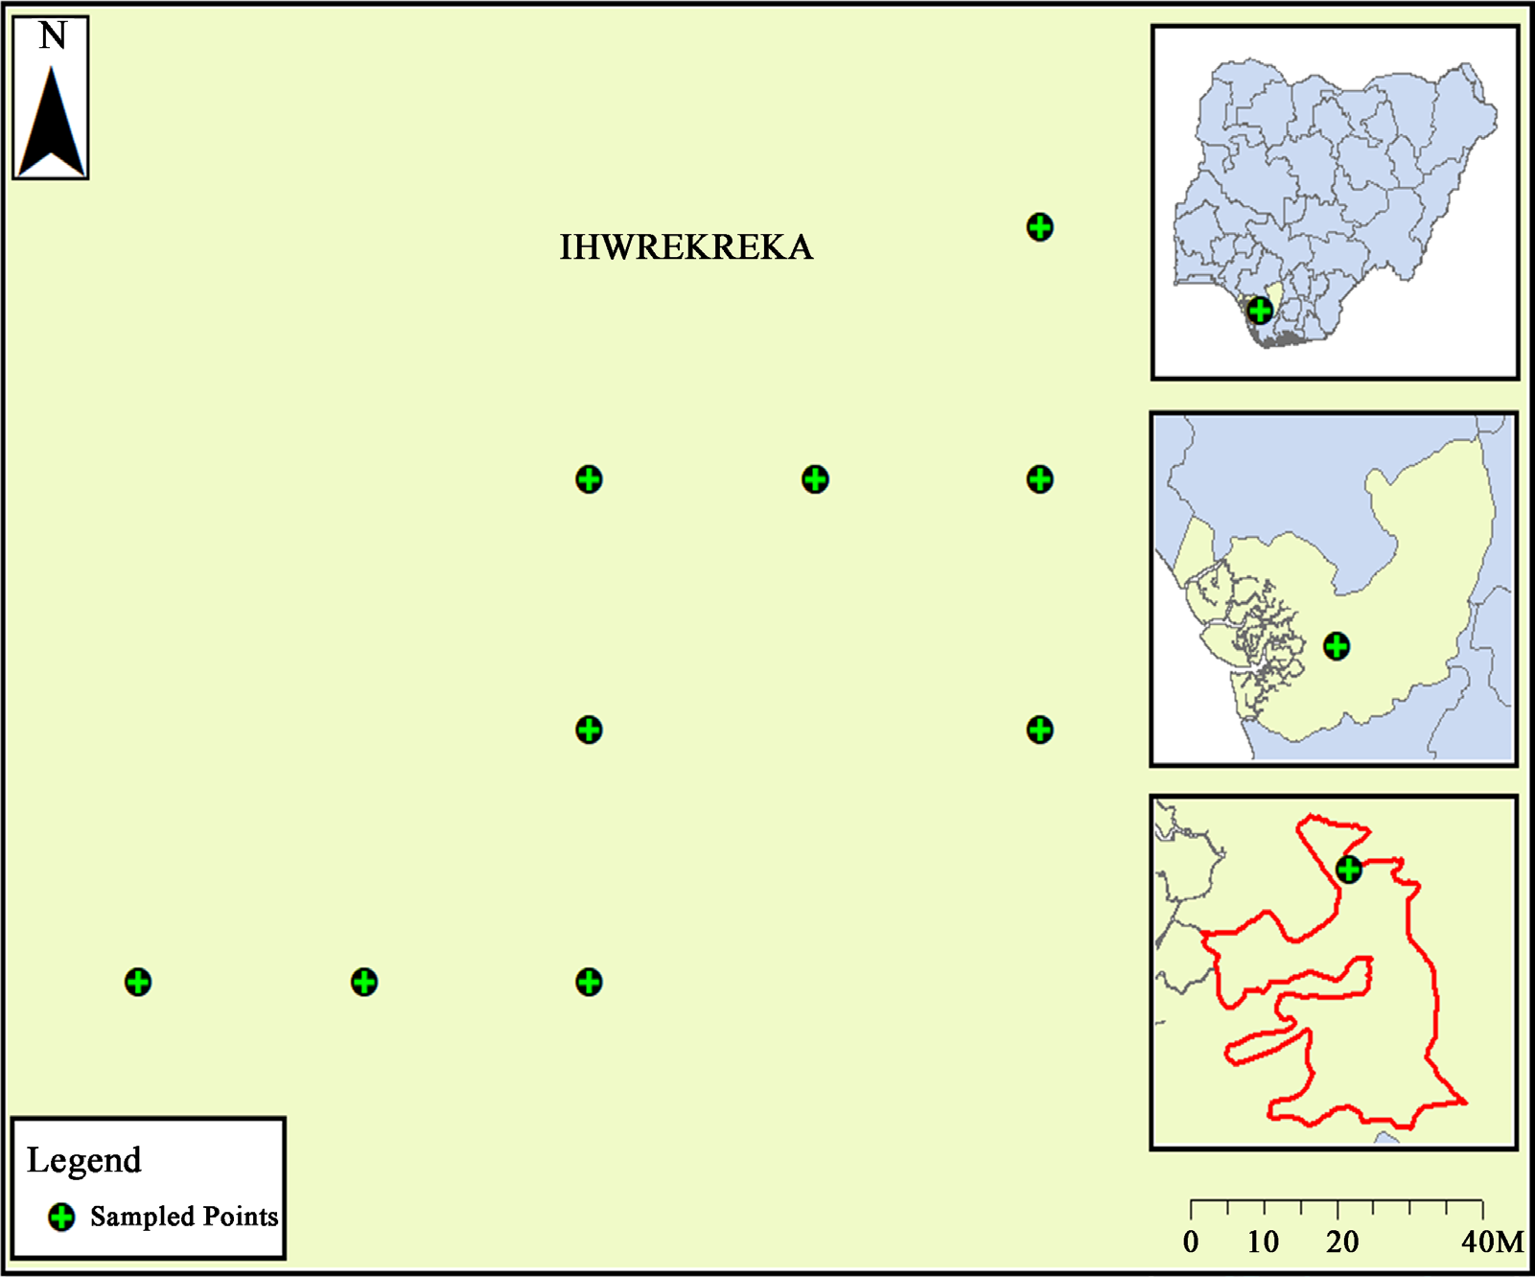
Figure 1. Map of Ihwrekreka community showing sample points.

community, with multiple samples collected from areas with dense pollution which made the samples collected accumulate to 24 in total. The 24 samples of soil samples were collected and labeled P1 through P24. A control sample was also collected from a farm inside the University premises of the Federal Univer- sity of Petroleum Resources, Effurun, Delta State, where no crude oil pollution was present. Soil samples were collected using a hollow stem soil auger at 0 - 15 cm of soil depth. The soil auger was thoroughly decontaminated with n-hexane after each sample was collected to prevent contamination. The samples were then placed in Aluminum foils and labeled, and transported to the laboratory in an ice chest at 4˚C. Once in the laboratory, the samples were stored in a refrigerator.

Sample Preparation and Analysis
The soil samples we reanalyzed for heavy metal content using inductively coupled plasma mass spectrometry (ICP-MS). This method is widely used in trace element analysis and allows for the determination of a wide range of ele- ments in a single sample. Leite et al. (2017) procedure was used to prepare the samples for analysis. Briefly, the samples were dried at 60˚C for 48 hours, ground to a fine powder using a mortar and pestle, and passed through a 2 mm sieve. The powdered samples were then subjected to acid digestion using a mix- ture of concentrated nitric acid and hydrochloric acid. The resulting solution

was analyzed for heavy metal content using the ICP-MS.
The potential dangers to health that may be caused by high levels of heavy metals in soil were evaluated using the hazard index (HI) and Cancer risk (CR) method as described by the United States Environmental Protection Agency (USEPA) (2004). The Hazard Quotient (HQ) is a measure used to determine the likelihood that an individual will experience negative effects from exposure to a particular substance or hazard and is often calculated by dividing the estimated daily intake of a particular substance by the chronic reference dose (RfD) for that substance. The chronic reference dose is the amount of a substance that a person can be exposed to on a daily basis over a lifetime without experiencing any adverse effects (Table 1).
The HI is the summation of the heavy metal HQs in the soil. Values for HI above 1.00 indicate an increased likelihood of non-cancer health problems in the human population.
In addition to evaluating non-carcinogenic risks, cancer risk level (CRL) me- thod was used to examine the metals potential carcinogenic risk in the soil. The CRL is the probability of an individual developing cancer over a lifetime due to ex- posure to a particular chemical. A CRL of 1.00 × 10−6 means that there is a proba- bility of one cancer case per 100,000 people in a given population. The CRL was measured for each metal in the soil samples using the formula CRL = (concentra- tion of soil heavy metal (mg/kg)) × (slope factor (mg/kg/day)−1).

Data Analysis
Descriptive analysis (mean and standard deviation), carcinogenic and non-car- cino-genic risk indices were performed in Microsoft excel (2016). Principal component analysis (P.C.A.) was conducted using XLSTAT.

Results and Discussion

Physicochemical Properties of Crude Oil-Polluted Site in Ihwrekreka Community
The concentration of copper in the crude oil polluted soil samples from the

Table 1. Reference doses (RfD) in (mg/kg/day) and cancer slope factors (CSF) for the different heavy metals.

Heavy Metal Oral Rfd Dermal |  |  | Inhalation | Oral | Dermal | Inhalation
 |  | Rfd | Rfd | CSF | CSF | CSF
Pb | 0.00 | - | - | 0.01 | - | 420.00
Cd | 0.00 | 0.00 | 0.00 | - | - | 630.00
Cr | 0.00 | - | 0.00 | 0.50 | - | 41.00
Ni | 0.02 | 0.01 | - | - | - | -
Cu | 0.04 | 0.02 | - | - | - | -
Zn | 0.30 | 0.08 | - | - | - | -

Ihwrekreka community was well above the permissible limit of 100 mg/kg set by the World Health Organization (WHO) and the maximum allowable limit of 50 mg/kg set by the European Union (EC) (Table 2). The highest concentration of copper, 17,078 mg/kg, was found in sample PT16. Copper is a vital nutrient for humans and is important for the operations of the immune system, but excessive levels of copper can lead to negative health effects such as nausea, vomiting, and diarrhea (Chasapis et al., 2020). The Zinc concentration within the crude oil polluted soil samples from the Ihwrekreka community was also above the per- missible limit of 300 mg/kg set by the WHO and the maximum allowable limit of 50 mg/kg set by the EC (Table 2). The highest concentration of Zinc, 12852 mg/kg, was found in sample PT16. While Zinc is a vital nutrient for humans and is important for immune operations and wound healing, excessive levels of Zinc can lead to negative health effects such as anemia, diarrhea, and nausea (Chasa- pis et al., 2020).
The Copper concentration within the oil polluted soil samples from the Ih- wrekreka community was well above the permissible limit of 100 mg/kg set by the World Health Organization (WHO) and the maximum allowable limit of 50 mg/kg set by the European Union (EC) (Table 3). PT16 had the maximum con- centration of Copper, with a level of 17,078 mg/kg. Copper is a vital nutrient for humans and is important for the functioning of the immune system, but exces- sive concentrations of copper could result in negative health effects such as nau- sea, vomiting, and diarrhea (Taiwo et al., 2020).
The concentration of zinc in the crude oil polluted soil samples from the Ih- wrekreka community was also above the permissible limit of 300 mg/kg set by the WHO and the maximum allowable limit of 50 mg/kg set by the EC (Table 3). The maximum concentration of zinc at PT16 was 12,851.5 mg/kg. While Zinc is an important nutrient for humans and is important for immune activities and wound healing, negative health occurs when Zinc metals are excessive (anemia, diarrhea, and nausea) (Kan et al., 2021).
The level of Lead in the petroleum contaminated soil samples from the Ih- wrekreka community exceeded the permissible limit of 85 mg/kg set by the
Table 2. Concentration of heavy metals in crude oil polluted soil from the Ihwrekreka community and comparison with maximum allowable limits in various countries.

Heavy Metal | Concentration (mg/kg) | Maximum Allowable Limit (mg/kg)
Copper | 4.85 - 17,078 | 100 (WHO) - 50 (EC)
Zinc | 8.84 - 12,852 | 300 (WHO) - 50 (EC)
Lead | 7.51 - 6474 | 85 (WHO) - 50 (EC)
Nickel | 10.2 - 40.9 | 50 (WHO) - 20 (EC)
Chromium | 0.22 - 36.8 | 100 (WHO) - 50 (EC)
Cadmium | 1.01 - 16.1 | 3 (WHO) - 5 (EC)
Note: EC = European Union.

WHO and the maximum allowable limit of 50 mg/kg set by the EC (Table 2). The highest concentration of Lead, 6474 mg/kg, was found in sample PT9. Lead is a toxic metal that can lead to a range of adverse health outcomes, including neurological problems, kidney damage, and high blood pressure (Chasapis et al., 2020; Collin et al., 2022).
The concentration of Nickel in the crude oil polluted soil samples from the Ihwrekreka community was relatively low compared to the permissible limit of 50 mg/kg set by the WHO and the maximum allowable limit of 20 mg/kg set by the EC (Table 3). The highest concentration of Nickel, 40.9 mg/kg, was found in sample PT16.
The presence of high concentrations of heavy metals in the soil of the Ihwre- kreka community poses a significant risk to the health and well-being of those living in the community and the surrounding environment. The presence of these metals in the soil may lead to the contamination of food crops and water sources, leading to potential ingestion or inhalation of these toxins by the resi- dents of the community.
Lead, in particular, is particularly toxic and can cause a range of harmful health impacts, including developmental delays in children, high blood pressure, kidney damage, and even death (Nriagu, 1989). Copper, Zinc, and Cadmium have also been linked to negative health effects, including gastrointestinal issues, anaemia, kidney damage, and neurological disorders (Wang et al., 2013a). Nickel has been linked to respiratory problems and an increased risk of cancer, particu- larly lung and nasal cancer (Duda-Chodak & Blaszczyk, 2008). Chromium has been associated with skin and respiratory irritation, kidney and liver problems, and even respiratory cancer (Wilbur et al., 2012, Alvarez et al., 2021).
It is important to note that these heavy metals may be present in the oil itself or in the materials and products used in the extraction, transportation, and processing of the oil (Wang et al., 2013b). The potential for exposure to these metals through soil, water, or air contamination may depend on the specific cir- cumstances of the oil-polluted site and the activities occurring in the area (Lawal et al., 2021). For example, if the oil-polluted site is located near a residential area, the potential for exposure to these metals through air contamination may be higher than if the site is located in a more remote area.
Given the potential risks associated with the high concentrations of heavy metals in the soil of the Ihwrekreka community, it is important to implement measures to reduce the levels of these toxins in the environment. This may in- clude implementing remediation strategies, such as soil washing or bioremediation, to remove the heavy metals from the soil (Lawal et al., 2021). It may also be neces- sary to consider alternative sources of drinking water and food for the residents of the community to minimize their exposure to these toxins. In addition, it may be necessary to consider the potential impacts of these metals on the local ecosystem, including plants, animals, and microorganisms. The concentrations of Chro- mium (Cr) levels in the soil samples (PT1-PT24) from the Ihwrekreka commu- nity as detailed in Figure 2 shows that Cr is generally below the permissible

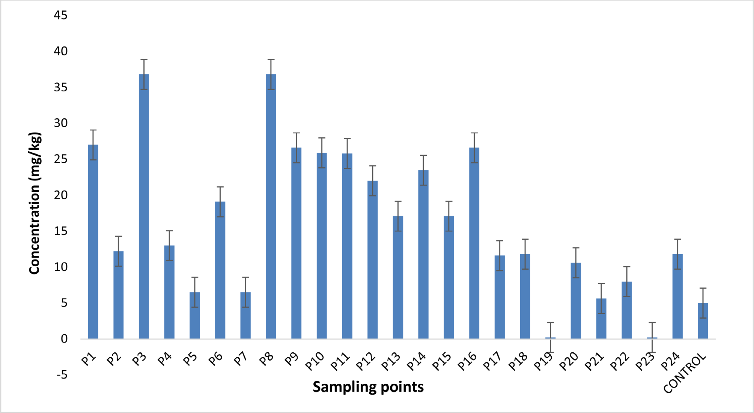
Figure 2. Concentration of Cr in crude oil-polluted soil in Ihwrekreka community.

allowable limits set by the World Health Organization (WHO) of 100 mg/Kg in soil (Osmani et al., 2015).
There is a need for the continuous monitoring of these concentrations as an increase can result to potential health risks, and ecological disruptions, may en- sue, necessitating immediate attention and remediation measures. Possible eco- logical disruptions resulting from elevated Chromium concentrations in the soil include contamination of water sources, bioaccumulation in plants and animals, disruption of the food chain, and adverse impacts on aquatic ecosystems, poten- tially leading to the decline of certain species and overall biodiversity (Ao et al., 2022; Saidon et al., 2024). Previous research has indicated that exposure to in- creased concentration of Cr can cause a variety of adverse health impacts, in- cluding skin and respiratory irritation, kidney and liver problems, pulmonary congestion and edema, upper abdominal pain, nose irritation and damage, and potentially respiratory cancer (Wilbur et al., 2012).
It is important to carefully consider the potential risks linked with Cr exposure in the soil, and to take steps to minimize the potential for exposure to this metal. This may involve implementing appropriate remediation techniques to reduce the Chromium soil concentration, as well as monitoring metal concentration in the environment and implementing measures to prevent further contamination. It may also be necessary to consider the potential impacts of high levels of Cr on the local ecosystem, including plants, animals, and microorganisms. The Cr soil con- centration from the Ihwrekreka community was higher than the Cr concentration in polluted soil in Shandong, China (Gao et al., 2022), but lower than the Cr con- centration in polluted plant samples in Akwa Ibom, Nigeria.

Figure 3 shows that the Zn concentration in the soil samples from the Ihwre- kreka community are significantly higher than the permissible limit of 50 mg/Kg (Osmani et al., 2015) as specified by WHO with the exception of PT17 to PT24. These levels may pose significant risk to human health and the environment.
This elevated Zn content, particularly in plants where it tends to bioaccumu- late, may result in health issues upon consumption, as Zn is stored in plant tis- sues and can lead to ecological effects such as disruption of the food chain and adverse impacts on biodiversity (Pérez-Hernández et al., 2021). Previous re- search has linked high Zn concentrations in the soil to kidney damage, neuro- logical disorders, and an increased risk of cancer (Lawal et al., 2021; Leal et al., 2023). Notably, the Zn levels in Ihwrekreka surpass those found in mechanic store clusters in Gboko and Makurdi, Nigeria (Pam et al., 2013), as well as levels in anthropogenically polluted soils.
It is important to carefully consider the potential risks related to high Zn soil concentration, and to take steps to minimize the potential for exposure to this metal. This may involve implementing appropriate remediation techniques to reduce the Zn soil concentration, as well as monitoring metal concentrations in the environment and implementing measures to prevent further contamination. It may also be necessary to consider the potential impacts of high levels of Zn on the local ecosystem, including plants, animals, and microorganisms. Previous research has advised that high Zn concentrations in the environment can lead to negative impacts on a range of species (Baker et al., 2003).
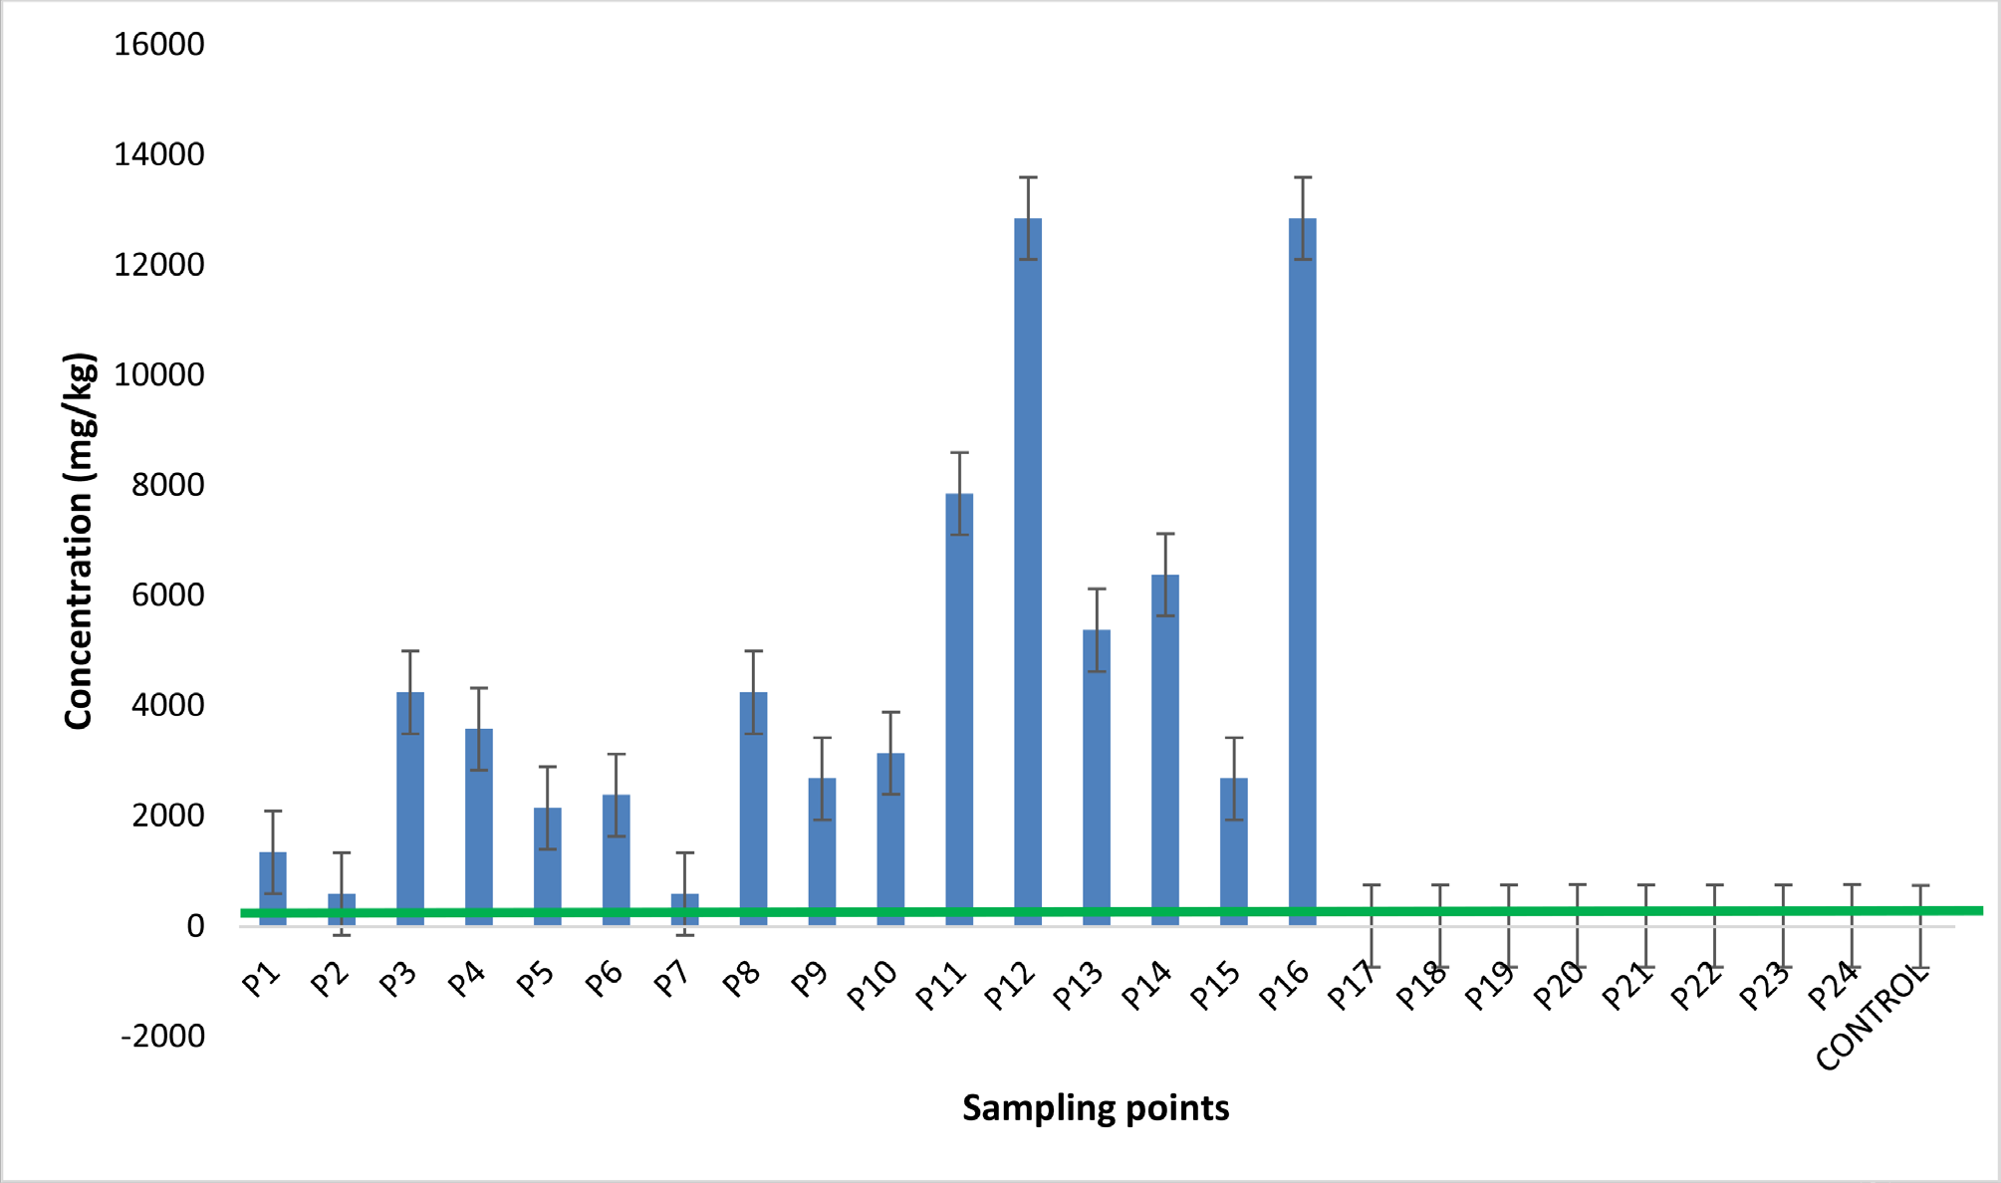
Figure 3. Zinc concentration in crude oil-polluted soil in Ihwrekreka community.

While Zn is a vital element for human health, with important functions in immune function, wound healing, and blood clotting, excessive Zn concentra- tions in the body can impact multiple facets of the immune structure (Chasapis et al., 2020). It is important to ensure that levels of Zn in the environment are within safe limits.
The concentrations of Cu in the soil samples from Ihwrekreka community as shown in Figure 4 are significantly higher than the permissible limit of 36 mg/Kg (Osmani et al., 2015) set by the WHO, and that these levels may pose a significant risk to human health.
Previous research has indicated that high levels of Cu in the soil can cause se- ries of adverse health impacts, including kidney damage, neurological disorders, and a higher chance of cancer risk (Adebiyi & Ayeni, 2022). In addition, the soil Cu concentration in the samples from the Ihwrekreka community was signifi- cantly higher than the concentrations derived from mechanic workshops in Za- ria, Kaduna state, Nigeria (Garba et al., 2013).
It is important to carefully consider the potential risks related with high Cu concentrations of Cu in the soil, and to take steps to minimize the potential for exposure to this metal. This may involve implementing appropriate remedia- tion techniques to reduce the soil Cu concentrations, as well as monitoring metal levels in the environment and implementing measures to prevent further contamination. It may also be necessary to consider the potential impacts of high levels of Cu on the local ecosystem, including plants, animals, and mi- croorganisms.
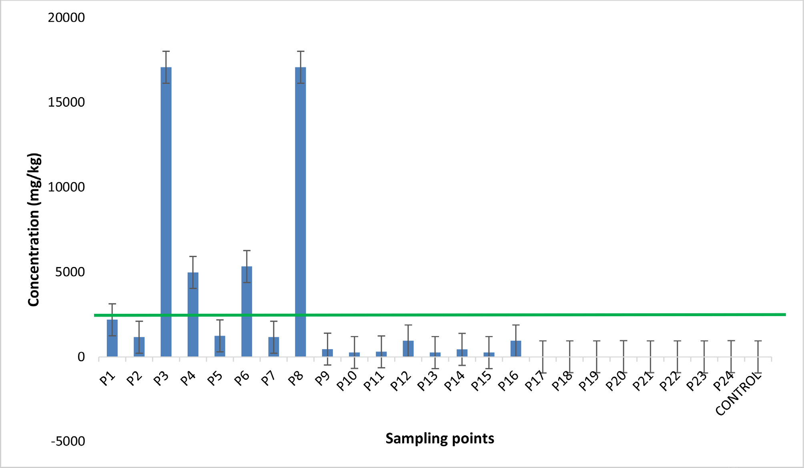
Figure 4. Copper concentration in crude oil-polluted soil in Ihwrekreka Community.

Previous research has revealed that high Cu concentrations in the environment can lead to negative impacts on a series of species (Baker et al., 2003).
Nickel (Ni) soil concentrations in the samples (Figure 5) from the Ihwrekreka community suggests that these levels are relatively lower than the permissible limit of 35 mg/Kg set by the WHO (Osmani et al., 2015).
The potential for an elevation in Ni levels due to continuous spills of crude oil and the use of pesticides should not be ignored, as high levels of Ni can cause a se- ries of negative health effects, including lung, nose, sinus cancer, and throat and stomach cancer (Duda-Chodak & Blaszczyk, 2008). It is important to monitor Ni levels in the environment and implement measures to prevent further contamina- tion in order to minimize the potential risks to human health and the environment. The concentration of Pb as shown in Figure 6 depicts that Pb concentration in soil samples from the Ihwrekreka community are higher than the permissible limit of 85 mg/Kg (Osmani et al., 2015) set by the WHO (PT1 to PT16 had Pb concentrations above the permissible levels, ranging from 99 - 6425 mg/kg), and
that these levels may pose a risk to human health and the environment.
Previous research has indicated that exposure to high levels of Pb can cause a range of negative health effects, including neurological disorders, kidney dam- age, and an increased risk of cancer. In addition, the concentration of Pb in the soil samples from the Ihwrekreka community was found to be higher than the concentration of Pb in soil samples from crude oil polluted areas in Kokori, Kolo in the Niger delta (Fatoba et al., 2016), and Ogale in Eleme local government area of Rivers state, Nigeria (Afolabi & Adesope, 2022). It is important to
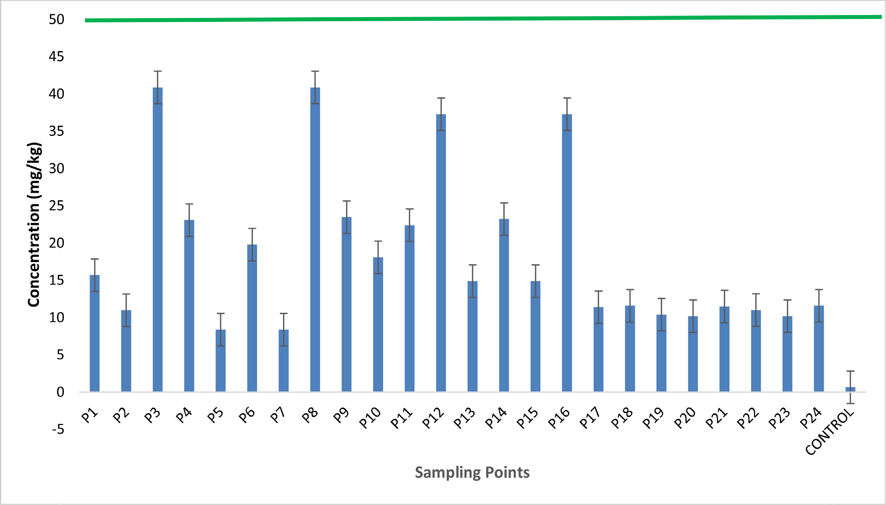
Figure 5. Concentration of Ni in the crude oil-polluted soil in Ihwrekreka community.

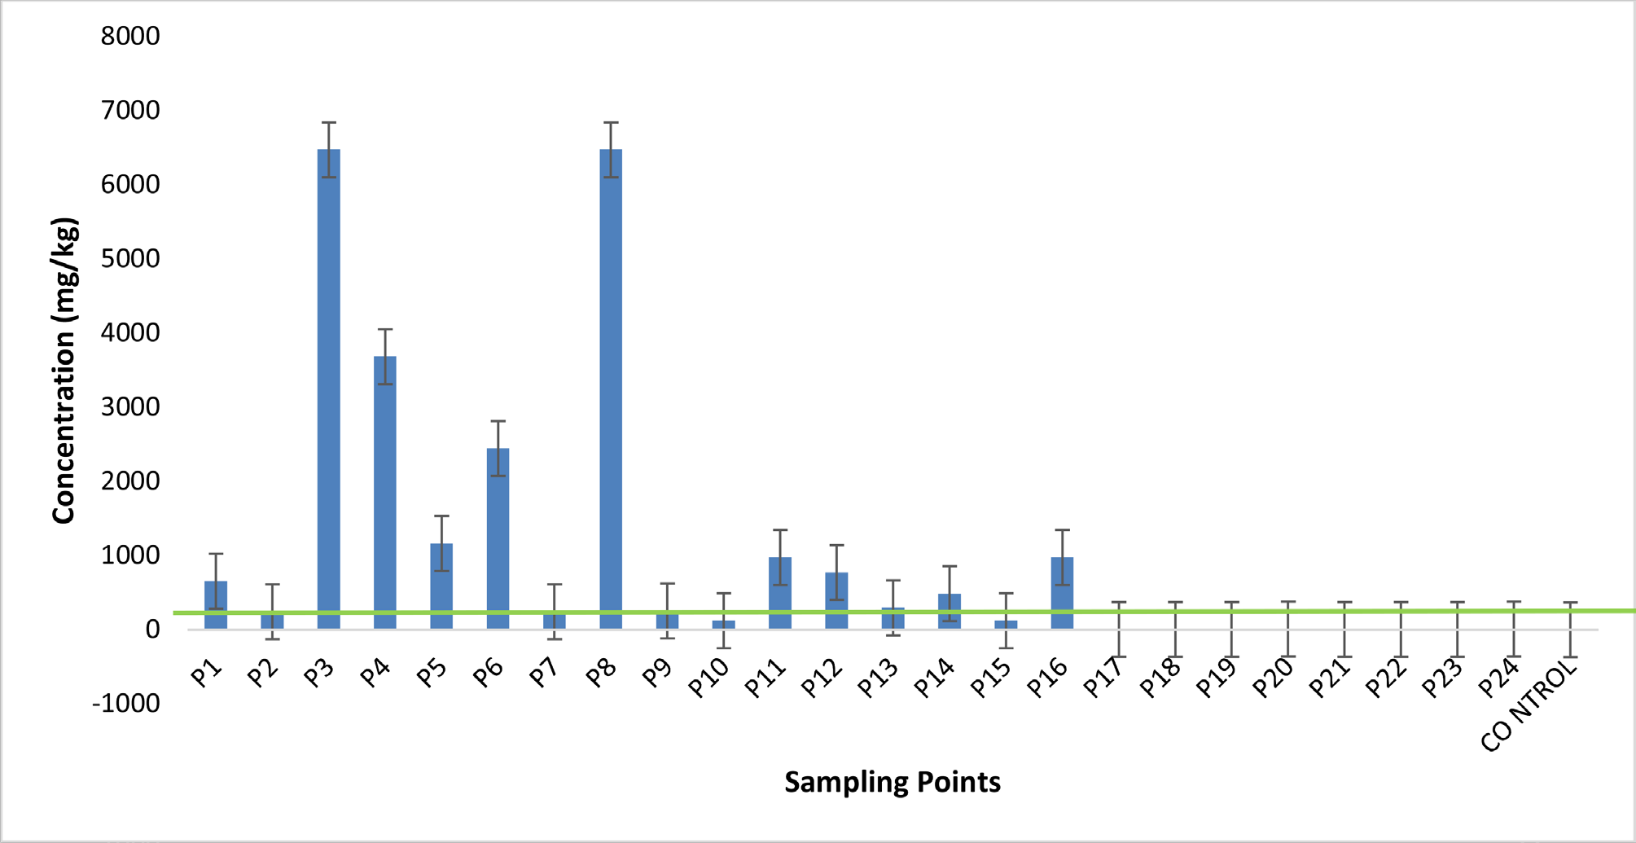
Figure 6. Concentration of Pb in crude oil-polluted soil in Ihwrekreka community.

carefully consider the potential risks related with high concentrations of Pb in the soil, and to take steps to minimize the potential for exposure to this metal. This may involve implementing appropriate remediation techniques to reduce the levels of Pb in the soil, monitoring metal concentrations in the environment and implementing measures to prevent further contamination. It may also be necessary to consider the potential impacts of high concentrations of Pb on the local ecosystem, including plants, animals, and microorganisms (Grenni et al., 2018; Prata et al., 2021). Previous research has suggested that high Pb concentra- tions in the environment can lead to negative impacts on a series of species (Baker et al., 2003).
Figure 7 suggests that the Cd concentrations in the soil samples from the Ihwre- kreka community are higher than the permissible level set by the World Health Organization (WHO) (PT1 to PT16, with concentrations ranging from 4 - 16 mg/kg), and that these levels may pose a risk to human health and the environment.
Previous research has indicated that exposure to high levels of Cd can lead to a range of negative health effects, including kidney damage and an increased risk of cancer (Nriagu, 1989). Also, the soil Cd concentrations in the samples from the Ihwrekreka community was higher than the Cd concentration in the petro- leum polluted soils from Obiobi/Obrikom in the Niger delta (Osuji & Onojake, 2004), but lower than the Cd level in the soil samples from the Liaohe River Del- ta in China (Yan et al., 2018).
It is important to carefully consider the potential related risks with high Cd concentration in the soil, and to take steps to minimize the potential for expo- sure to this metal. This may involve implementing appropriate remediation techniques to reduce the levels of Cd in the soil, as well as monitoring metal

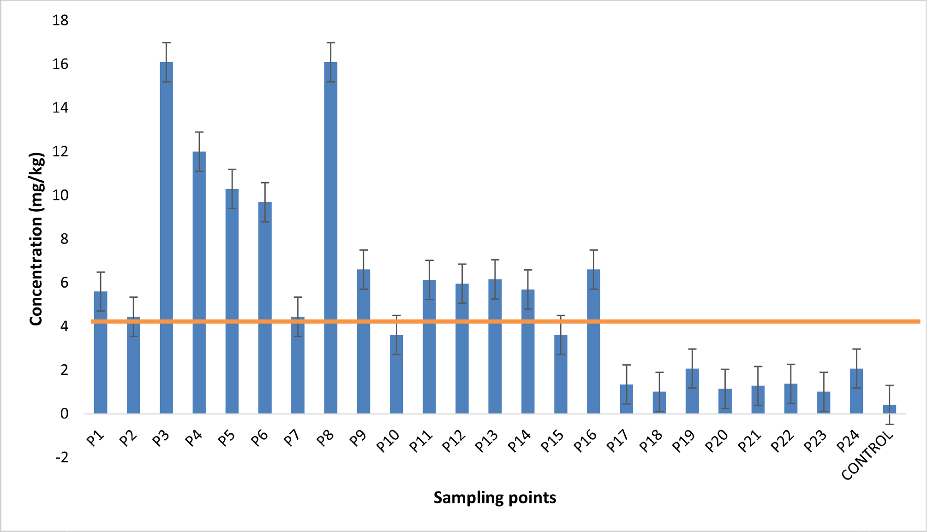
Figure 7. Cadmium concentration in the crude oil-polluted soil in Ihwrekreka community.

levels in the environment and implementing measures to prevent further con- tamination. It may also be necessary to consider the potential impacts of high Cd concentrations on the local ecosystem, including plants, animals, and mi- croorganisms. Previous research has suggested that high Cd concentrations in the environment can lead to negative impacts on a series of species (Baker et al., 2003).

Principal Component Analysis (P.C.A.) of Dataset Showing Heavy Metals in Soils of Crude Polluted Ihwrekreka Community
Principal component analysis (P.C.A.) was used to investigate the data from samples of soil taken in the Ihwrekreka community. The results showed that Factors 1 and 2 significantly influenced the variables and contributed approx- imately 88.1% to the variability and correlations in the data (Table 3). Factor 1 represents the influence of crude oil on the concentration of heavy metals, while Factor 2 represents the influence of crude oil spills and natural and anthropo- genic sources on the concentration of heavy metals. Factor 1 had a strong influ- ence on the levels of Pb, Cd, Zn, Cu, Zn, and Ni, while Factor 2 influenced the concentration of Cr.
The biplot in Figure 8 showed that Factor 1 had a strong influence on the ex- istence of heavy metals at PT9, PT11, PT12, PT14, and PT16, while Factor 2 was influenced by PT1, 4, and 6. The loadings of chromium (Cr), nickel (Ni), and zinc (Zn) in Principal Component 1 (PC1) were higher than those of other elements

Table 3. Correlation between variable and factor loading with eigenvalues and cumulative variability of heavy metals across all the sampling points at the Ihwrekreka community.

Metals (mg/kg) | F1 | F2 | F3 | F4 | F5 | F6
Pb | 0.908 | −0.391 | −0.107 | −0.056 | −0.024 | 0.087
Cd | 0.912 | −0.221 | −0.189 | 0.284 | 0.048 | −0.026
Cr | 0.842 | 0.260 | 0.459 | 0.117 | −0.017 | 0.012
Zn | 0.559 | 0.791 | −0.237 | 0.017 | −0.073 | −0.001
Cu | 0.874 | −0.455 | 0.028 | −0.140 | −0.068 | −0.064
Ni | 0.918 | 0.320 | −0.009 | −0.210 | 0.101 | −0.009
Eigenvalue | 4.284 | 1.204 | 0.314 | 0.161 | 0.023 | 0.013
Variability (%) | 71.4 | 20.1 | 5.24 | 2.69 | 0.39 | 0.21
Cumulative % | 71.4 | 91.5 | 96.7 | 99.4 | 99.8 | 100
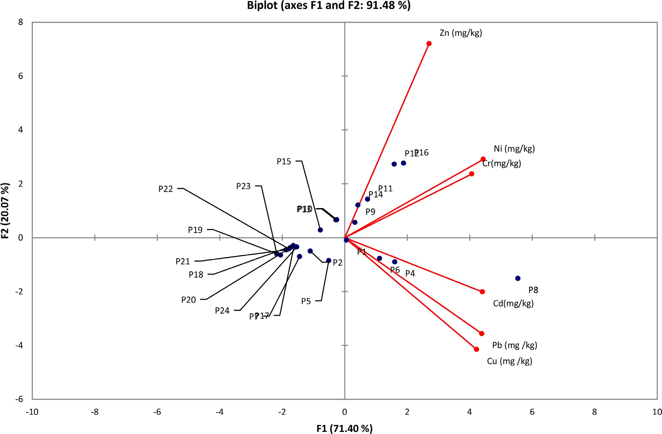
Figure 8. Principal component analysis diagram for average Cd, Cr, Cu, Ni, Zn, and Pb concentrations in each segment of crude oil polluted soil samples from Ihwrekreka.

in Principal Component 2 (PC2), except for Zn, which recorded a value of 0.791. This suggests a strong correlation and a singular identifiable source for ele- ments in PC1, despite the influence of other sources. Zn has a strong association with Ni in PC1, contributing 71.4% to the total variance with high loadings. The high loadings (91.5%) and strong relationship between Cr, Ni, and Zn indicate

contributions from crude oil pollution, as well as contributions from geological origins (Ogunlaja et al., 2019). The reduced loadings (20.1%) and close relation- ship between cadmium (Cd), Pb, and copper (Cu) could suggest their common anthropogenic origin, such as vehicular emissions, indiscriminate waste disposal, and the use of pesticides in agricultural lands (Bradl, 2005). These findings indi- cate that the heavy metals in the soils from Ihwrekreka were connected with crude oil contamination and possibly other identified anthropogenic activities.

Human Health Risk Assessment

Non Cancer Risk Assessment
According to the findings of this study, heavy metal concentrations in the soil in the Ihwrekreka community could potentially be harmful to children and adults who engage in activities such as farming that bring them into contact with the soil. This is due to the potential health risks associated with exposure to these metals. The hazard index (HI) is a measure that is used to evaluate the potential non-carcinogenic health risks associated with exposure to specific metals present in the soil samples. In this study, residents of the study area were found to be at a high probability of cancer risk due to daily exposure to Cr via dermal contacts, ingestion, and inhalation (Tables 4-6).
Table 4. Hazard quotients and hazard index for the ingestion pathway of Zn in children and adults’ population in soil from Ihwrekreka community for carcinogenic risk assessment.
Children Adult
Points
 | Ingestion | Inhalation | Dermal | Total | Ingestion | Inhalation | Dermal | Total
P1 | 0.06 | 0.00 | 0.03 | 0.09 | 0.01 | 0.00 | 0.01 | 0.01
P2 | 0.03 | 0.00 | 0.01 | 0.04 | 0.00 | 0.00 | 0.00 | 0.00
P3 | 0.18 | 0.00 | 0.09 | 0.27 | 0.01 | 0.00 | 0.02 | 0.03
P4 | 0.15 | 0.00 | 0.08 | 0.23 | 0.01 | 0.00 | 0.02 | 0.02
P5 | 0.09 | 0.00 | 0.05 | 0.14 | 0.00 | 0.00 | 0.01 | 0.01
P6 | 0.10 | 0.00 | 0.05 | 0.15 | 0.00 | 0.00 | 0.01 | 0.02
P7 | 0.03 | 0.00 | 0.01 | 0.04 | 0.00 | 0.00 | 0.00 | 0.00
P8 | 0.18 | 0.00 | 0.09 | 0.27 | 0.01 | 0.00 | 0.02 | 0.03
P9 | 0.11 | 0.00 | 0.06 | 0.17 | 0.00 | 0.00 | 0.01 | 0.02
P10 | 0.13 | 0.00 | 0.07 | 0.20 | 0.01 | 0.00 | 0.01 | 0.02
P11 | 0.34 | 0.00 | 0.17 | 0.51 | 0.01 | 0.00 | 0.04 | 0.05
P12 | 0.55 | 0.00 | 0.28 | 0.83 | 0.02 | 0.00 | 0.06 | 0.08
P13 | 0.23 | 0.00 | 0.12 | 0.35 | 0.01 | 0.00 | 0.02 | 0.03
P14 | 0.27 | 0.00 | 0.14 | 0.41 | 0.01 | 0.00 | 0.03 | 0.04
P15 | 0.11 | 0.00 | 0.06 | 0.17 | 0.00 | 0.00 | 0.01 | 0.02
P16 | 0.55 | 0.00 | 0.28 | 0.83 | 0.02 | 0.00 | 0.06 | 0.08

Continued

P17 | 0.00 | 0.00 | 0.00 | 0.00 | 0.00 | 0.00 | 0.00 | 0.00
P18 | 0.00 | 0.00 | 0.00 | 0.00 | 0.00 | 0.00 | 0.00 | 0.00
P19 | 0.00 | 0.00 | 0.00 | 0.00 | 0.00 | 0.00 | 0.00 | 0.00
P20 | 0.00 | 0.00 | 0.00 | 0.00 | 0.00 | 0.00 | 0.00 | 0.00
P21 | 0.00 | 0.00 | 0.00 | 0.00 | 0.00 | 0.00 | 0.00 | 0.00
P22 | 0.00 | 0.00 | 0.00 | 0.00 | 0.00 | 0.00 | 0.00 | 0.00
P23 | 0.00 | 0.00 | 0.00 | 0.00 | 0.00 | 0.00 | 0.00 | 0.00
P24 | 0.00 | 0.00 | 0.00 | 0.00 | 0.00 | 0.00 | 0.00 | 0.00
Control | 0.00 | 0.00 | 0.00 | 0.00 | 0.00 | 0.00 | 0.00 | 0.00
Total | 3.11 | 0.00 | 1.60 | 4.71 | 0.14 | 0.00 | 0.33 | 0.47

Table 5. Hazard quotients and hazard index for the ingestion pathway of Cu in children and adults’ population in soil from Ihwrekreka community for carcinogenic risk assessment.
Children Adult
Points
 | Ingestion | Inhalation | Dermal | Total | Ingestion | Inhalation | Dermal | Total
P1 | 0.76 | 0.00 | 0.15 | 0.91 | 0.08 | 0.00 | 0.03 | 0.11
P2 | 0.40 | 0.00 | 0.08 | 0.48 | 0.02 | 0.00 | 0.02 | 0.03
P3 | 5.90 | 0.00 | 1.17 | 7.07 | 0.25 | 0.00 | 0.24 | 0.49
P4 | 1.72 | 0.00 | 0.34 | 2.06 | 0.07 | 0.00 | 0.07 | 0.14
P5 | 0.43 | 0.00 | 0.08 | 0.51 | 0.02 | 0.00 | 0.02 | 0.04
P6 | 1.84 | 0.00 | 0.36 | 2.21 | 0.08 | 0.00 | 0.08 | 0.15
P7 | 0.40 | 0.00 | 0.08 | 0.48 | 0.02 | 0.00 | 0.02 | 0.03
P8 | 5.90 | 0.00 | 1.17 | 7.07 | 0.25 | 0.00 | 0.24 | 0.49
P9 | 0.16 | 0.00 | 0.03 | 0.19 | 0.01 | 0.00 | 0.01 | 0.01
P10 | 0.09 | 0.00 | 0.02 | 0.11 | 0.00 | 0.00 | 0.00 | 0.01
P11 | 0.10 | 0.00 | 0.02 | 0.12 | 0.00 | 0.00 | 0.00 | 0.01
P12 | 0.33 | 0.00 | 0.06 | 0.39 | 0.01 | 0.00 | 0.01 | 0.03
P13 | 0.09 | 0.00 | 0.02 | 0.11 | 0.00 | 0.00 | 0.00 | 0.01
P14 | 0.15 | 0.00 | 0.03 | 0.19 | 0.01 | 0.00 | 0.01 | 0.01
P15 | 0.09 | 0.00 | 0.02 | 0.11 | 0.00 | 0.00 | 0.00 | 0.01
P16 | 0.33 | 0.00 | 0.06 | 0.39 | 0.01 | 0.00 | 0.01 | 0.03
P17 | 0.00 | 0.00 | 0.00 | 0.00 | 0.00 | 0.00 | 0.00 | 0.00
P18 | 0.00 | 0.00 | 0.00 | 0.01 | 0.00 | 0.00 | 0.00 | 0.00
P19 | 0.00 | 0.00 | 0.00 | 0.00 | 0.00 | 0.00 | 0.00 | 0.00
P20 | 0.01 | 0.00 | 0.00 | 0.01 | 0.00 | 0.00 | 0.00 | 0.00
P21 | 0.00 | 0.00 | 0.00 | 0.00 | 0.00 | 0.00 | 0.00 | 0.00

Continued

P22 | 0.00 | 0.00 | 0.00 | 0.00 | 0.00 | 0.00 | 0.00 | 0.00
P23 | 0.00 | 0.00 | 0.00 | 0.00 | 0.00 | 0.00 | 0.00 | 0.00
P24 | 0.01 | 0.00 | 0.00 | 0.01 | 0.00 | 0.00 | 0.00 | 0.00
Control | 0.00 | 0.00 | 0.00 | 0.00 | 0.00 | 0.00 | 0.00 | 0.00
Total | 18.70 | 0.00 | 3.70 | 22.40 | 0.85 | 0.00 | 0.77 | 1.62

Table 6. Hazard quotients and hazard index for the ingestion pathway of Pb in children and adult population in soil from Ihwrekreka community for non-carcinogenic risk assessment.
Children Adult
Points
 | Ingestion | Inhalation | Dermal | Total | Ingestion | Inhalation | Dermal | Total
P1 | 2.33 | 0.00 | 0.00 | 2.33 | 0.25 | 0.00 | 0.00 | 0.25
P2 | 0.88 | 0.00 | 0.00 | 0.88 | 0.04 | 0.00 | 0.00 | 0.04
P3 | 23.00 | 0.00 | 0.00 | 23.00 | 0.99 | 0.00 | 0.00 | 0.99
P4 | 13.10 | 0.00 | 0.00 | 13.10 | 0.56 | 0.00 | 0.00 | 0.56
P5 | 4.14 | 0.00 | 0.00 | 4.14 | 0.18 | 0.00 | 0.00 | 0.18
P6 | 8.68 | 0.00 | 0.00 | 8.68 | 0.37 | 0.00 | 0.00 | 0.37
P7 | 0.88 | 0.00 | 0.00 | 0.88 | 0.04 | 0.00 | 0.00 | 0.04
P8 | 23.00 | 0.00 | 0.00 | 23.00 | 0.99 | 0.00 | 0.00 | 0.99
P9 | 0.92 | 0.00 | 0.00 | 0.92 | 0.04 | 0.00 | 0.00 | 0.04
P10 | 0.45 | 0.00 | 0.00 | 0.45 | 0.02 | 0.00 | 0.00 | 0.02
P11 | 3.47 | 0.00 | 0.00 | 3.47 | 0.15 | 0.00 | 0.00 | 0.15
P12 | 2.75 | 0.00 | 0.00 | 2.75 | 0.12 | 0.00 | 0.00 | 0.12
P13 | 1.07 | 0.00 | 0.00 | 1.07 | 0.05 | 0.00 | 0.00 | 0.05
P14 | 1.73 | 0.00 | 0.00 | 1.73 | 0.07 | 0.00 | 0.00 | 0.07
P15 | 0.45 | 0.00 | 0.00 | 0.45 | 0.02 | 0.00 | 0.00 | 0.02
P16 | 3.47 | 0.00 | 0.00 | 3.47 | 0.15 | 0.00 | 0.00 | 0.15
P17 | 0.03 | 0.00 | 0.00 | 0.03 | 0.00 | 0.00 | 0.00 | 0.00
P18 | 0.03 | 0.00 | 0.00 | 0.03 | 0.00 | 0.00 | 0.00 | 0.00
P19 | 0.03 | 0.00 | 0.00 | 0.03 | 0.00 | 0.00 | 0.00 | 0.00
P20 | 0.04 | 0.00 | 0.00 | 0.04 | 0.00 | 0.00 | 0.00 | 0.00
P21 | 0.03 | 0.00 | 0.00 | 0.03 | 0.00 | 0.00 | 0.00 | 0.00
P22 | 0.03 | 0.00 | 0.00 | 0.03 | 0.00 | 0.00 | 0.00 | 0.00
P23 | 0.03 | 0.00 | 0.00 | 0.03 | 0.00 | 0.00 | 0.00 | 0.00
P24 | 0.04 | 0.00 | 0.00 | 0.04 | 0.00 | 0.00 | 0.00 | 0.00
Control | 0.00 | 0.00 | 0.00 | 0.00 | 0.00 | 0.00 | 0.00 | 0.00
Total | 90.50 | 0.00 | 0.00 | 90.50 | 4.03 | 0.00 | 0.00 | 4.03

Pb was the main contributor to the HI values (Pb > Cu > Zn) for both child- ren and adults in the study area (Table 6). This is consistent with previous re- search that has identified lead as a potentially toxic element in soil and has sug- gested that it may pose a risk to human health through various routes of expo- sure, including through contact with soil (Canfield et al., 2003). In addition, our results showed that the HI values for Cu and Zn were higher at certain sampling points for children. Copper and zinc have also been identified as potentially tox- ic to humans in certain circumstances, and previous research has suggested that they may pose a risk to human health through soil exposure (Budryn et al., 2016).
It is worth noting that the HI values for Pb were higher than 1 at 14 sampling points for children and 2 sampling points for adults. This suggests that the con- centration of lead in the soil at these locations may pose a particularly significant health risk to children and adults in the study area. Further research is needed to fully understand the potential health impacts of these exposures and to deter- mine appropriate strategies for minimizing these risks.
It is also important to consider the potential long-term health impacts of heavy metal exposure in the Ihwrekreka community. Previous research has sug- gested that chronic exposure to heavy metals, particularly during early life, may lead to a range of negative health outcomes, including developmental delays, reduced cognitive function, and increased risk of certain diseases (e.g. cardi- ovascular disease, diabetes) later in life (Nriagu et al., 1996). Further research is needed to determine the long-term health impacts of heavy metal exposure in the Ihwrekreka community and to identify appropriate interventions to minim- ize these risks.

Cancer Risk Assessment
Cancer risks analysis in this study suggest that the levels of Ni, Cr, and Cd in the oil-polluted site pose a potential risk to human health, particularly for children. The most significant concerns were at sampling points P3 and P8, which had high cancer risk values 3.5E−2 (Figure 9). It is important to implement controls to reduce the release of these metals into the environment and to clean up con- taminated sites in order to minimize the potential health risks associated with exposure to these metals. The levels of Ni, Cr, and Cd in the oil-polluted site may also pose a risk to adult health. The high cancer risk values (Figure 10) at all of the sampling points (P1 to P17) suggest that there is a significant concern with regard to the potential health effects of these metals. It is important to take steps to minimize exposure to these metals in order to reduce the risk of adverse health effects. This may include implementing controls to reduce the release of these metals into the environment and cleaning up contaminated sites. It is also important to continue monitoring the levels of these metals in the environment over time to ensure that they are not posing a continued risk to human health.
These findings indicated that the release of Ni, Cr, and Cd from the oil-polluted site may pose a risk to human health and the environment, particularly if the

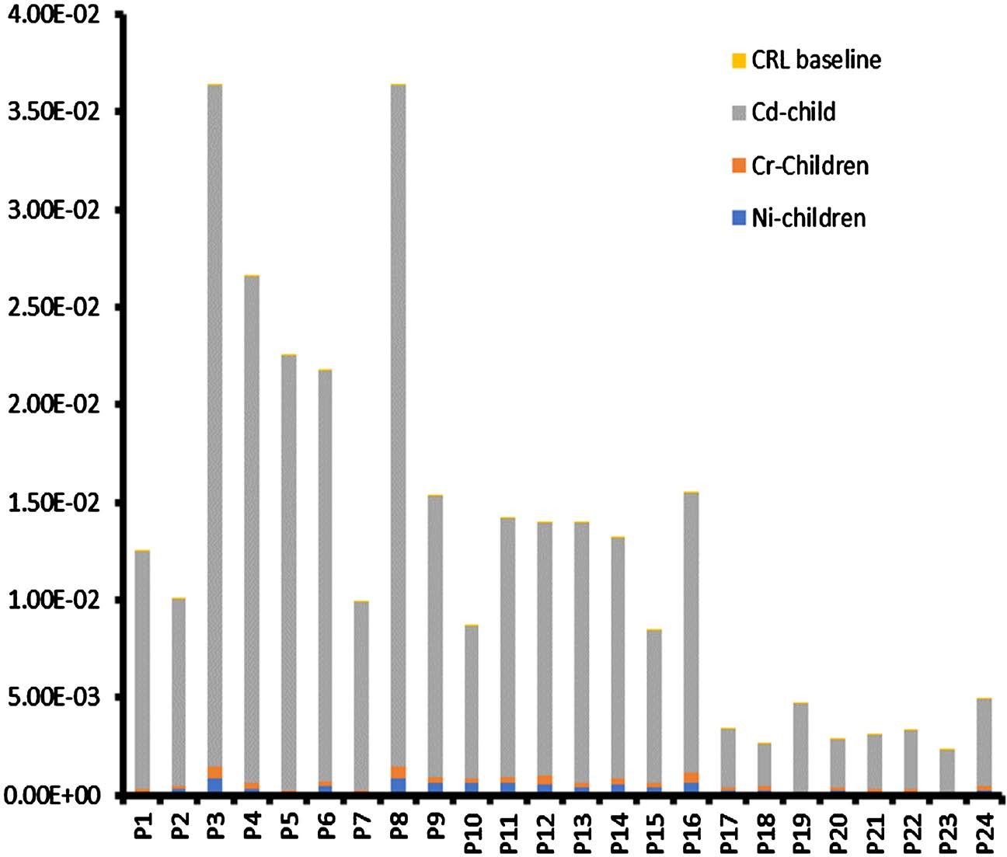
Figure 9. Predicted cancer risk values for children living within the study area.
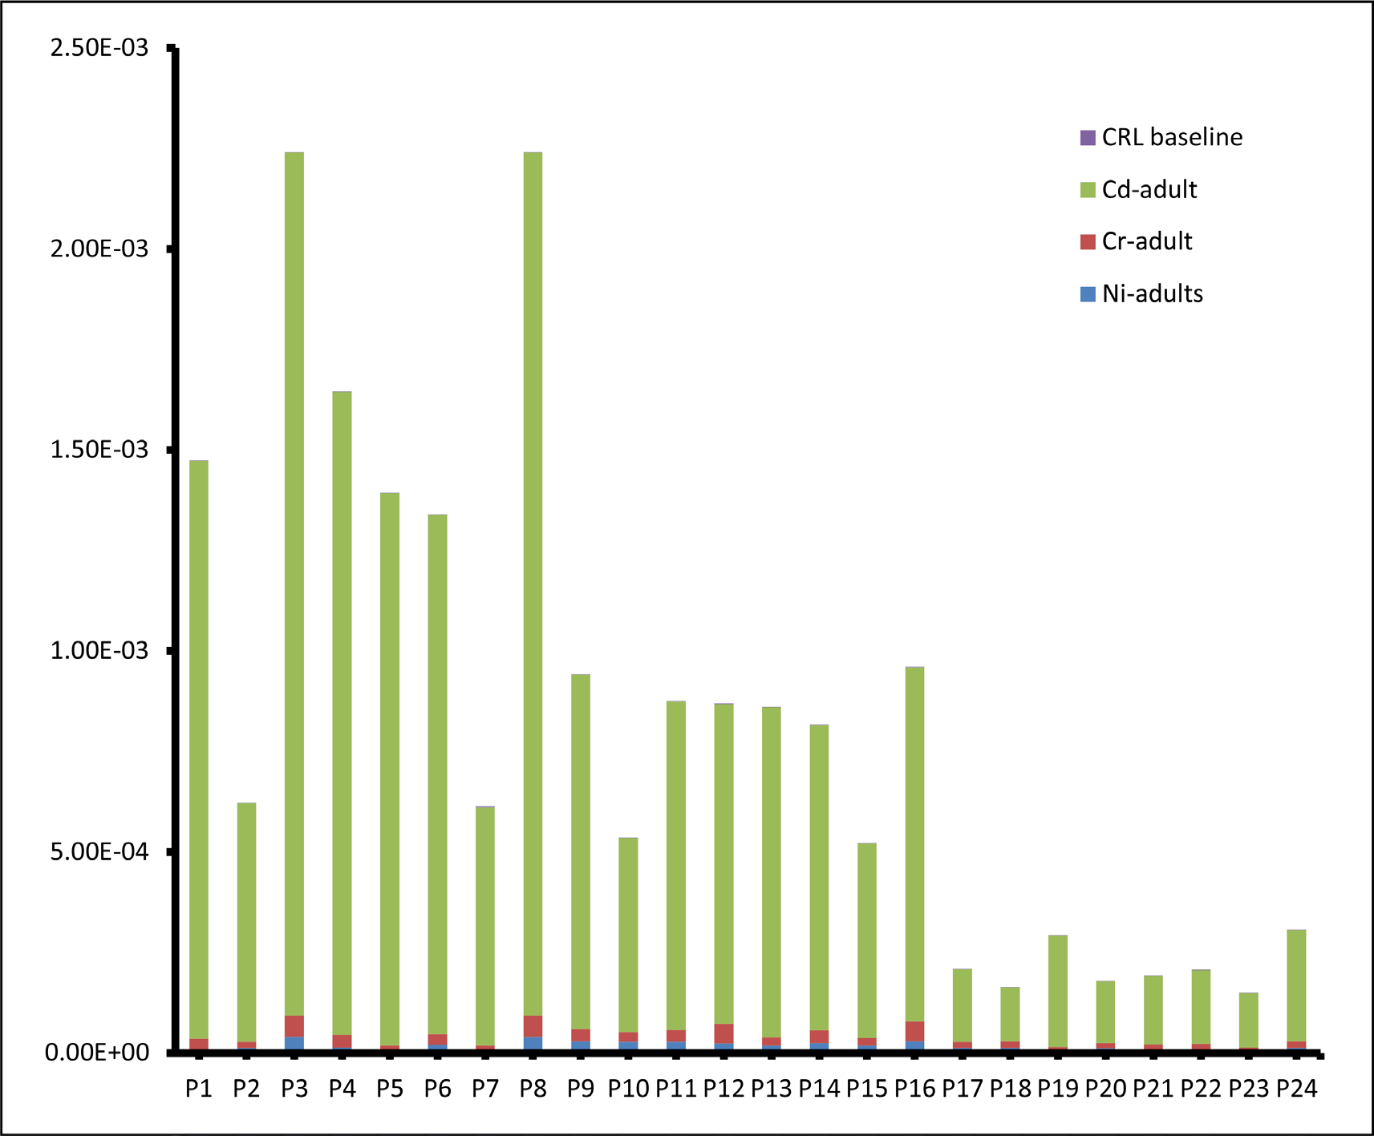
Figure 10. Predicted cancer risk values for adult’s resident within the study area.

concentrations of exposure are high (Lu & Wang, 2014b). Previous research has indicated that exposure to high concentrations of these metals can cause a series of adverse health impacts, including respiratory problems, neurological disord- ers, and cancer (Ohiagu et al., 2022; Budi et al., 2024). For example, the study by Lu and Wang (2014a) found that high levels of Ni in soil can lead to respiratory problems in humans, including asthma and bronchitis. Another study by Ha et al. (2012) found that exposure to high concentrations of Cr in drinking water was associated with an increased risk of stomach cancer. Similarly, the study by Nriagu (1989) found that exposure to high levels of Cd can lead to kidney dam- age and an elevated cancer risks.
It is important to mentioned that these metals may be present in the oil itself or in the materials and products employed in the extraction, transportation, and processing of the oil (Wang, Liu, & Zhang, 2013a). The potential for exposure to these metals through soil, water, or air contamination may depend on the spe- cific circumstances of the oil-polluted site and the activities occurring at the study site (Okonofua et al., 2023). For example, if the oil-polluted site is located near a residential area, the potential for exposure to these metals through air contamination may be higher than if the study location is located in a more re- mote area.
This study results highlighted the need for further research to fully under- stand the potential impacts of Ni, Cr, and Cd from oil-polluted sites on human health and the environment, and to identify appropriate strategies for minimiz- ing these risks. This may include measures such as regular monitoring of metal concentrations in soil, water, and air in the study site, and the implementation of appropriate remediation techniques to reduce the levels of these metals in the environment (Wang et al., 2022).
To reduce the risks related to Ni, Cr, and Cd in an oil-polluted site, it is im- portant to identify the sources of heavy metals and implement strategies to re- duce the release of heavy metals from the site (Chris et al., 2023). This may in- volve a blend of efforts to reduce materials and products that contain these met- als, to properly store and transport oil and oil-related products, and to remediate contaminated soil and water (Silva et al., 2022). In addition, it is necessary to regularly monitor metal levels in the environment and implement appropriate remediation techniques to reduce the heavy metal concentrations in the envi- ronment.
There are a number of different approaches that could be applied to remediate contaminated soil and water, depending on the specific circumstances of the site and the nature of the contamination (Grifoni et al., 2022). Some common ap- proaches include physical removal of contaminant environmental media, chem- ical treatment to neutralize or remove the contaminants, and biological treat- ment using microorganisms to break down the contaminants (Mahesh et al., 2022). It is important to carefully consider the potential impacts of these remed- iation techniques on human health and the environment, and to choose the ap- proach that is most appropriate for the specific circumstances of the site (ur

Rehman et al., 2023).

Conclusion
In conclusion, the study results indicated that the release of Ni, Cr, and Cd from an oil-polluted site may pose a peril to human health and the environment. Fur- ther investigation is required to fully understand the potential impacts of these metals and to identify appropriate strategies for minimizing these risks. This may include measures such as regular monitoring of metal levels in the envi- ronment and the implementation of appropriate remediation techniques to re- duce the heavy metals concentrations in the environment (Shen et al., 2022). It is important to carefully consider the potential dangers associated with exposure to Ni, Cr, and Cd in the context of the specific circumstances of the oil-polluted site and the activities occurring in the area, and to take steps to minimize the poten- tial for exposure to these metals.

Life Science Reporting
No life science threat was practiced in this research.

References
Abayomi, O., Olayemi, T. E., & Ogungbade, T. (2021). Environmental Pollution and Its Ecological Consequences on the Niger Delta: A Review of the Literature. African Jour- nal of Environment and Natural Science Research, 4, 27-42. https://doi.org/10.52589/AJENSR-BJGGACSV
Adebiyi, F. M., & Ayeni, D. A. (2022). Chemical Speciation, Bioavailability and Risk As- sessment of Potentially Toxic Metals in Soils around Petroleum Product Marketing Company as Environmental Degradation Indicators. Petroleum Research, 7, 286-296. https://doi.org/10.1016/j.ptlrs.2021.08.006
Afolabi, O. O., & Adesope, O. M. (2022). Ecotoxicological Risk Assessment of Heavy Metals from Remediated Oil Spill Site in Niger Delta Region, Nigeria. Environmental Chemistry and Ecotoxicology, 4, 186-193. https://doi.org/10.1016/j.enceco.2022.10.001
Aigberua, A. O., Ekubo, A. T., Inengite, A. K., & Izah, S. C. (2017a). Assessment of Some Se- lected Heavy Metals and Their Pollution Indices in an Oil Spill Contaminated Soil in the Niger Delta: A Case of Rumuolukwu Community. Biotechnological Research, 3, 11-19.
Aigberua, O. B., Akpomrere, R. A. E., & Ojo, M. A. (2017b). Heavy Metal Contamination

in Soils of Niger Delta, Nigeria: A Review. International Journal of Environmental Science and Development, 8, 111-120.
Ali, H., Khan, E., & Ilahi, I. (2019). Environmental Chemistry and Ecotoxicology of Ha- zardous Heavy Metals: Environmental Persistence, Toxicity, and Bioaccumulation. Journal of Chemistry, 2019, Article ID: 6730305. https://doi.org/10.1155/2019/6730305
Alvarez, C. C., Gómez, M. E. B., & Zavala, A. H. (2021). Hexavalent Chromium: Regula- tion and Health Effects. Journal of Trace Elements in Medicine and Biology, 65, Article 126729. https://doi.org/10.1016/j.jtemb.2021.126729
Ao, M., Chen, X., Deng, T., Sun, S., Tang, Y., Morel, J. L. et al. (2022). Chromium Bio- geochemical Behaviour in Soil-Plant Systems and Remediation Strategies: A Critical Review. Journal of Hazardous Materials, 424, Article 127233. https://doi.org/10.1016/j.jhazmat.2021.127233
Baker, A. J., Edwards, A. C., Cresswell, J., & Heathwaite, A. L. (2003). The Impact of Trace Metal Contamination on Terrestrial and Aquatic Ecosystems: A Review. Envi- ronmental Pollution, 122, 437-451.
Borah, G., & Deka, H. (2023). Crude Oil Associated Heavy Metals (HMs) Contamination in Agricultural Land: Understanding Risk Factors and Changes in Soil Biological Properties. Chemosphere, 310, 136890. https://doi.org/10.1016/j.chemosphere.2022.136890
Bradl, H. (Ed.) (2005). Heavy Metals in the Environment: Origin, Interaction and Re- mediation. Elsevier.
Budi, H. S., Catalan Opulencia, M. J., Afra, A., Abdelbasset, W. K., Abdullaev, D., Majdi,
A. et al. (2024). Source, Toxicity and Carcinogenic Health Risk Assessment of Heavy Metals. Reviews on Environmental Health, 39, 77-90.
https://doi.org/10.1515/reveh-2022-0096
Budryn, G., Zaczyńska, D., & Oracz, J. (2016). Effect of Addition of Green Coffee Extract and Nanoencapsulatedchlorogenic Acids on Aroma of Different Food Products. Lwt, 73, 197-204. https://doi.org/10.1016/j.lwt.2016.06.019
Chasapis, C. T., Ntoupa, P. A., Spiliopoulou, C. A., & Stefanidou, M. E. (2020). Recent As- pects of the Effects of Zinc on Human Health. Archives of Toxicology, 94, 1443-1460. https://doi.org/10.1007/s00204-020-02702-9
Chris, D. I., Onyena, A. P., & Sam, K. (2023). Evaluation of Human Health and Ecological Risk of Heavy Metals in Water, Sediment and Shellfishes in Typical Artisanal Oil Min- ing Areas of Nigeria. Environmental Science and Pollution Research, 30, 80055-80069. https://doi.org/10.1007/s11356-023-27932-z
Collin, M. S., Venkatraman, S. K., Vijayakumar, N., Kanimozhi, V., Arbaaz, S. M., Stacey,
R. S., & Swamiappan, S. (2022). Bioaccumulation of Lead (Pb) and Its Effects on Hu- man: A Review. Journal of Hazardous Materials Advances, 7, Article 100094. https://doi.org/10.1016/j.hazadv.2022.100094
Duda-Chodak, A., & Blaszczyk, U. (2008). The Impact of Nickel on Human Health.
Journal of Elementology, 13, 685-693.
Elum, Z. A., Mopipi, K., & Henri-Ukoha, A. (2016). Oil Exploitation and Its Socioeco- nomic Effects on the Niger Delta Region of Nigeria. Environmental Science and Pollu- tion Research, 23, 12880-12889. https://doi.org/10.1007/s11356-016-6864-1
Fatoba, P. O., Ogunkunle, C. O., Folarin, O. O., & Oladele, F. A. (2016). Heavy Metal Pollution and Ecological Geochemistry of Soil Impacted by Activities of Oil Industry in the Niger Delta, Nigeria. Environmental Earth Sciences, 75, Article No. 297. https://doi.org/10.1007/s12665-015-5145-5

Gao, Y., Wang, H., Xu, R., Wang, Y., Sun, Y., Bian, R., & Li, W. (2022). Remediation of Cr(VI)-Contaminated Soil by Combined Chemical Reduction and Microbial Stabiliza- tion: The Role of Biogas Solid Residue (BSR). Ecotoxicology and Environmental Safety, 231, Article 113198. https://doi.org/10.1016/j.ecoenv.2022.113198
Garba, N., Abdullahi Y, Y. Isma’Ila, A. Habiba, S.A., Garba, Z. Musa, Y., & Kasim, S. (2013). Heavy Metal Concentration in Soil of Some Mechanic Workshops of Za- ria-Nigeria. International Journal of Physical Sciences, 8, 2020-2034.
Gautam, R. K., Sharma, S. K., Mahiya, S., & Chattopadhyaya, M. C. (2014). Contamina- tion of Heavy Metals in Aquatic Media: Transport, Toxicity and Technologies for Re- mediation. In S. Sharma (Ed.), Heavy Metals in Water: Presence, Removal and Safety (pp. 1-366). The Royal Society of Chemistry.
Grenni, P., Ancona, V., & Caracciolo, A. B. (2018). Ecological Effects of Antibiotics on Natural Ecosystems: A Review. Microchemical Journal, 136, 25-39. https://doi.org/10.1016/j.microc.2017.02.006
Grifoni, M., Franchi, E., Fusini, D., Vocciante, M., Barbafieri, M., Pedron, F.et al. (2022). Soil Remediation: Towards a Resilient and Adaptive Approach to Deal with the Ev- er-Changing Environmental Challenges. Environments, 9, 18. https://doi.org/10.3390/environments9020018
Gwary, D. T., Dangana, A. D., & Bala, S. Z. N. (2019). Heavy Metal Contamination in Agricultural Soil and Vegetables in the Niger Delta Region of Nigeria. Environmental Geochemistry and Health, 41, 577-594.
Ha, M., Kim, H., Lee, J., & Kim, H. (2012). Chromium in Drinking Water and Stomach Cancer: A Systematic Review and Meta-Analysis. Environmental Health Perspectives, 120, 814-820.
Howard, I. C., Okpara, K. E., & Techato, K. (2021). Toxicity and Risks Assessment of Po- lycyclic Aromatic Hydrocarbons in River Bed Sediments of an Artisanal Crude Oil Re- fining Area in the Niger Delta, Nigeria. Water, 13, Article 3295. https://doi.org/10.3390/w13223295
Kadafa, S. (2012). The Impacts of Crude Oil Pollution on the Environment and Public Health in Nigeria’s Niger Delta Region. Environment and Natural Resources Research, 2, 71-80.
Kan, X., Dong, Y., Feng, L., Zhou, M., & Hou, H. (2021). Contamination and Health Risk Assessment of Heavy Metals in China’s Lead-Zinc Mine Tailings: A Meta-Analysis. Chemosphere, 267, Article 128909. https://doi.org/10.1016/j.chemosphere.2020.128909
Lawal, K. K., Ekeleme, I. K., Onuigbo, C. M., Ikpeazu, V. O., & Obiekezie, S. O. (2021). A Review on the Public Health Implications of Heavy Metals. World Journal of Advanced Research and Reviews, 10, 255-265.
https://wjarr.com/content/review-public-health-implications-heavy-metals https://doi.org/10.30574/wjarr.2021.10.3.0249
Leal, M. F. C., Catarino, R. I., Pimenta, A. M., & Souto, M. R. S. (2023). The Influence of the Biometals Cu, Fe, and Zn and the Toxic Metals Cd and Pb on Human Health and Disease. Trace Elements and Electrolytes, 40, 1-22. https://doi.org/10.5414/TE500038
Leite, A. I. N., Pereira, C. G., Andrade, J., Vicentini, N. M., Bell, M. J. V., & Anjos, V. (2019). FTIR-ATR Spectroscopy as a Tool for the Rapid Detection of Adulterations in Butter Cheeses. Lwt, 109, 63-69. https://doi.org/10.1016/j.lwt.2019.04.017
Lu, J., & Wang, C. (2014a). Health Risk Assessment of Heavy Metals in Soil-Plant System in Oil-Contaminated Sites. Environmental Science and Pollution Research, 21, 1834-1844.
Lu, X., & Wang, X. (2014b). The Health Risk Assessment of Heavy Metals in Crude Oil to

the Workers in Offshore Oil Platform. Environmental Science and Pollution Research, 21, 2824-2832.
Mahesh, N., Balakumar, S., Danya, U., Shyamalagowri, S., Babu, P. S., Aravind, J. et al. (2022). A Review on Mitigation of Emerging Contaminants in an Aqueous Environ- ment Using Microbial bio-Machines as Sustainable Tools: Progress and Limitations. Journal of Water Process Engineering, 47, Article 102712. https://doi.org/10.1016/j.jwpe.2022.102712
Moslen, B., & Aigberua, A. A. (2019). Crude Oil Pollution of Soils in the Niger Delta: A Review. Environmental Science and Pollution Research 26, 2053-2069.
Moslen, M., & Aigberua, A. (2018). Heavy Metals and Hydrocarbon Contamination of Surface Water in Azuabie Creek within Bonny Estuary, Nigeria. Journal of Applied Sciences and Environmental Management, 22, 1083-1088. https://doi.org/10.4314/jasem.v22i7.15
Njoku, A. C., Ofoefule, C. C., & Isiorho, O. N. E. (2016). A Review of the Environmental and Health Impacts of Crude Oil Pollution in the Niger Delta Region of Nigeria. Envi- ronmental Science and Pollution Research, 23, 327-338.
Nriagu, J. O. (1989). A Global Assessment of Natural Sources of Atmospheric Trace Met- als. Nature, 338, 47-49. https://doi.org/10.1038/338047a0
Nriagu, J. O., Blankson, M. L., & Ocran, K. (1996). Childhood Lead Poisoning in Africa: A Growing Public Health Problem. Science of the Total Environment, 181, 93-100. https://doi.org/10.1016/0048-9697(95)04954-1
Nwaichi, E. O., Chuku, L. C., & Ighoavwogan, E. (2016). Polycyclic Aromatic Hydrocar- bons and Selected Heavy Metals in Some Oil Polluted Sites in Delta State Nigeria. Journal of Environmental Protection, 7, 1389-1410. https://doi.org/10.4236/jep.2016.710120
Ogunkeyede, A. O., Isukuru, E. J., Adebayo, A. A., Adedosu, T. A., & Tawari-Fufeyin, P. (2022). Health Risk Assessment of Organochlorine Compounds at a Crude Oil-Impacted Soil in at Okpare-Olomu and Ihwrekreka Communities the Niger Delta. Science Journal of Chemistry, 10, 81-92.
Ogunlaja, O. O., Ogunlaja, A., Morenikeji, O. A., & Okewole, D. M. (2019). Risk Assess- ment and Source Identification of Heavy Metal Contamination by Multivariate and Hazard Index Analyses of a Pipeline Vandalised Area in Lagos State, Nigeria. Science of the Total Environment, 651, 2943-2952. https://doi.org/10.1016/j.scitotenv.2018.09.386
Ohiagu, F. O., Chikezie, P. C., Ahaneku, C. C., & Chikezie, C. M. (2022). Human Expo- sure to Heavy Metals: Toxicity Mechanisms and Health Implications. Materials Science and Engineering, 6, 78-87.
https://www.researchgate.net/profile/Paul-Chikezie/publication/362090618_Human_exp osure_to_heavy_metals_toxicity_mechanisms_and_health_implications/links/62d8296b4 5865722d7790136/Human-exposure-to-heavy-metals-toxicity-mechanisms-and-health-i mplications.pdf
https://doi.org/10.15406/mseij.2022.06.00183
Okonofua, E. S., Atikpo, E., Lasisi, K. H., Ajibade, F. O., & Idowu, T. E. (2023). Effect of Crude Oil Exploration and Exploitation Activities on Soil, Water and Air in a Nigerian Community. Environmental Technology, 44, 988-1000. https://doi.org/10.1080/09593330.2021.1992508
Okoye, E. A., Ezejiofor, A. N., Nwaogazie, I. L., Frazzoli, C., & Orisakwe, O. E. (2022). Heavy Metals and Arsenic in Soil and Vegetation of Niger Delta, Nigeria: Ecological Risk Assessment. Case Studies in Chemical and Environmental Engineering, 6, Article

100222. https://doi.org/10.1016/j.cscee.2022.100222
Omozue, M. (2021). The Destruction of Illegal Refineries on the Niger Delta Environ- ment: An Appraisal. LASJURE, 2, 113-119.
Osmani, M., Bani, A., & Hoxha, B. (2015). Heavy Metals and Ni Phytoextractionin in the Metallurgical Area Soils in Elbasan. Albanian Journal of Agricultural Sciences, 14, 414-419.
Osuagwu, E. S., & Olaifa, E. (2018). Effects of Oil Spills on Fish Production in the Niger Delta. PLOS ONE, 13, e0205114. https://doi.org/10.1371/journal.pone.0205114
Osuji, L. C., & Onojake, C. M. (2004). Trace Heavy Metals Associated with Crude Oil: A Case Study of Ebocha-8 Oil-Spill-Polluted Site in Niger Delta, Nigeria. Chemistry & Biodiversity, 1, 1708-1715. https://doi.org/10.1002/cbdv.200490129
Pam, A. A., Sha’Ato, R., & Offem, J. O. (2013). Evaluation of Heavy Metals in Soils around Auto Mechanic Workshop Clusters in Gboko and Makurdi, Central Nigeria. Journal of Environmental Chemistry and Ecotoxicology, 5, 298-306.
Pérez-Hernández, H., Pérez-Moreno, A., Sarabia-Castillo, C. R., García-Mayagoitia, S., Medina-Pérez, G., López-Valdez, F. et al. (2021). Ecological Drawbacks of Nanomate- rials Produced on An Industrial Scale: Collateral Effect on Human and Environmental Health. Water, Air, & Soil Pollution, 232, Article No. 435. https://doi.org/10.1007/s11270-021-05370-2
Prata, J. C., Da Costa, J. P., Lopes, I., Andrady, A. L., Duarte, A. C., & Rocha-Santos, T. (2021). A One Health Perspective of the Impacts of Microplastics on Animal, Human and Environmental Health. Science of the Total Environment, 777, Article 146094. https://doi.org/10.1016/j.scitotenv.2021.146094
Richard, G., Izah, S. C., & Ogwu, M. C. (2022). Implications of Artisanal Crude Oil Re- fining on Sustainable Food Production in the Niger Delta Region of Nigeria. Journal of Environmental Bioremediation and Toxicology, 5, 69-77. https://doi.org/10.54987/jebat.v5i2.775
Saidon, N. B., Szabó, R., Budai, P., & Lehel, J. (2024). Trophic Transfer and Biomagnifica- tion Potential of Environmental Contaminants (Heavy Metals) in Aquatic Ecosystems. Environmental Pollution, 340, Article 122815. https://doi.org/10.1016/j.envpol.2023.122815
Shen, X., Dai, M., Yang, J., Sun, L., Tan, X., Peng, C. et al. (2022). A Critical Review on the Phytoremediation of Heavy Metals from Environment: Performance and Chal- lenges. Chemosphere, 291, Article 132979. https://doi.org/10.1016/j.chemosphere.2021.132979
Silva, I. A., Almeida, F. C., Souza, T. C., Bezerra, K. G., Durval, I. J., Converti, A., & Sa- rubbo, L. A. (2022). Oil Spills: Impacts and Perspectives of Treatment Technologies with Focus on the Use of Green Surfactants. Environmental Monitoring and Assess- ment, 194, 143. https://doi.org/10.1007/s10661-022-09813-z
Taiwo, A. M., Aigbodion, C. O., Ojekunle, O. Z., & Akinhanmi, T. F. (2020). Health Risk Assessment of Metals in Selected Drinks from Abeokuta, Southwestern Nigeria. Bio- logical Trace Element Research, 197, 694-707.
https://doi.org/10.1007/s12011-020-02029-7
Ugboma, C. J., Sampson, T., & Mbonu, N. E. (2020). Bioremediation of Heavy Metals from Artisanal Crude Oil Refinery (Kpo-Fire) Impacted Soil Using Bacillus Flexus and Pseudomonas aeruginosa in Ngie Community, Degema Local Government Area, Riv- ers State, Nigeria. Journal of Applied Sciences and Environmental Management, 24, 2049-2054. https://doi.org/10.4314/jasem.v24i12.6
ur Rehman, Z., Junaid, M. F., Ijaz, N., Khalid, U., & Ijaz, Z. (2023). Remediation Methods

of Heavy Metal Contaminated Soils from Environmental and Geotechnical Stand- points. Science of the Total Environment, 867, Article 161468. https://doi.org/10.1016/j.scitotenv.2023.161468
Wang, X., Liu, G., & Zhang, C. (2013a). Health Risk Assessment of Heavy Metals in Oil-Polluted Soils and Vegetables. Environmental Science and Pollution Research, 20, 4891-4901.
Wang, Y., Feng, J., Lin, Q., Lyu, X., Wang, X., & Wang, G. (2013b). Effects of Crude Oil Contamination on Soil Physical and Chemical Properties in Momoge Wetland of Chi- na. Chinese Geographical Science, 23, 708-715.
https://doi.org/10.1007/s11769-013-0641-6
Wang, Z., Luo, P., Zha, X., Xu, C., Kang, S., Zhou, M. et al. (2022). Overview Assessment of Risk Evaluation and Treatment Technologies for Heavy Metal Pollution of Water and Soil. Journal of Cleaner Production, 379, Article 134043. https://doi.org/10.1016/j.jclepro.2022.134043
Wilbur S., Abadin H., & Fay M. (2012). Toxicological Profile for Chromium. Agency for Toxic Substances and Disease Registry (US). https://www.ncbi.nlm.nih.gov/books/nbk158851/
Yan, X., Liu, M., Zhong, J., Guo, J., & Wu, W. (2018). How Human Activities Affect Heavy Metal Contamination of Soil and Sediment in a Long-Term Reclaimed Area of the Liaohe River Delta, North China. Sustainability, 10, Article 338. https://doi.org/10.3390/su10020338
Zabbey, N., Sam, K., & Onyebuchi, A. T. (2017). Remediation of Contaminated Lands in the Niger Delta, Nigeria: Prospects and Challenges. Science of the Total Environment, 586, 952-965. https://doi.org/10.1016/j.scitotenv.2017.02.075

