Characterization and Identification of Major Constraints and Potentials of Kiltu Sorsa Watershed, in Guji Zone,

Southern Ethiopia

ABSTRACT
Ethiopia is a country seriously affected by different natural resource degradation that included soil, vegetation, biodiversity and water degradation and climate deterioration. The study was conducted at Adola Rede District of Guji Zone, in Southern Ethiopia. The objectives of the study were to document baseline information on socioeconomic aspects and to document major biophysical and socio-economic constraints and potentials of the study watershed. The survey data were collected using key informant interview, focus group discussions, semi-structured interviews and guided field observations. A total of 60 respondents were selected for semi-structured interviews by means of simple random sampling methods. The majority (65%) of the respondent households were practiced physical and biological soil and water conservation activities. However, about 35% of the sampled households were not practiced soil and water conservation activities due to lack of awareness, lack of materials and labor. In the study watershed five major constraints such as land and soil related constraints, production related constraints, institutional and infrastructure related constraints, livestock related constraints and socio-economic related constraints were identified.

However, suitable agro-ecology, availability of labor force, youth and women associations and informal institutions were the major identified potentials in the study watershed. Therefore, by using the potentials/opportunities of the study watershed and through providing quality extension services and training on soil and water conservation practices it is possible to enhance farmers participation and technical limitations. Moreover, for sustainable watershed management of the study area different soil and water conservation structures are very significant in various land use system of the study watershed through active participation of the local communities.
Keywords: Characterization; constraints; kiltu Sorsa; potentials; soil and water conservation; socio- economic; technical limitations; watershed.

INTRODUCTION
“In many developing countries, population pressure has pushed farmers in to marginal lands, aggravating soil and water degradation and destroying unique habits” [1]. “This means the growing population and environmental degradation on one hand and the need to enhance agricultural production, on the other hand are now emerging as interlocked triple challenges across the globe” [2].
“Ethiopia is also a country seriously affected by land degradation which included soil and water degradation, vegetation degradation, biodiversity degradation and climate deterioration” [3-4]. “Due to this, Ethiopia is ranked the ninth most susceptible country in the world to natural resource degradation” [5]. “To solve the watershed problem, the government of Ethiopia was adopted watershed management strategies that strongly focused on participatory approaches which have resulted in ecological, economic and social benefits to farmers” [6].
“In Ethiopia, watershed management programs commenced in a formal way in the 1970s. From that time up to the late 1990s, it was a government-led, top-down, and incentive based (food-for-work) approach that prioritized engineering measures that focused primarily on reducing soil erosion. Since then the government, non-governmental organizations and local community efforts on rural development have been based on watershed development program” [7]. “In the early 2000s, community- based integrated watershed development was introduced to promote watershed management as a means to achieve broader integrated natural resource management and livelihood improvement objectives within prevailing agro-ecological and socioeconomic environments” [8].
“Previously, watershed management approach was top down approach that was followed to
implement different activities in the watershed” [9-10]. “That means orders, plans and types of activities sent from the center to the community. This approach has failed in different watershed as a result of absence of consultation of the community during planning. Later, the approach was changed to bottom up, where the community discuss, plan, implement and the officers, authorities and policy makers support the planning and activities. This one has registered various successes in different watershed across Ethiopia” [5,10,11].
“Factors that contribute to the success of watershed management are multidimensional, including biophysical, institutional and socioeconomic elements. The presence of supporting institutional structures and the extent of community participation were also other factors found to significantly influence the success of watershed management” [8]. “The lack of integration from the different disciplines, sectors and limited level of participation of the stakeholders are among the limiting factors contributed to low level of success” [12,13].
“Baseline characterization helps to understand the initial livelihood condition of the people in the watershed before intervention. It builds necessary foundation for the plan and obtains proper information for effective planning, implementation and monitoring” [14,15,16]. “Some impact studies have showed that investments in watershed management in the developing world do pay off in economic terms. However, such impact studies do not typically include detailed socio-economic components” [17]. Similarly, in Kiltu Sorsa watershed detail study on characterization, identification and prioritization of major constraints and potentials of the watershed is not so far conducted. There fore, the overall objectives of the study’s were: to document baseline information on socioeconomic aspects and to document major biophysical and socio-economic constraints and potential of the study watershed.

MATERIALS AND METHODS

Description of the Study Area

The study was conducted in Adola Rede District of Guji zone, in Southern Ethiopia, which is located 468 km away from Addis Ababa to the South. The location of the District is between 5o44'10”N- 60o12'38”N and 38o45'10”E -
39o12'37”E (Fig. 1). It has a total area of about 1401km2. The topography of the District is characterized by ups and down arrangement. Moreover, it has land surface with an elevation ranging from 1500 to over 2000 meters. The major soil of the District is Nitosols (red basaltic soils) and Orthc Acrosols. The district is characterized by three agroclimatic zones, namely high land, midland and lowland and the percentage coverage of each climate zones are highland (11%), midland (29%) and lowland (60%). The type of rainfall of the study area is bi- modal with longest rain season that has the maximum
rainfalls which falls between 1200-1800mm annually and the shortest rainfalls records between 800- 1200mm with an erratic distribution patterns. The study watershed has an area of 547.787ha and the local communities living in the watershed practice mixed farming which consists of crop production,animal husbandry and forest plantation which could be managed in association.

Methods of Data Collection

Before data collection started, the interdisciplinary team consisted of four research process included natural resource process, livestock process, crop process and extension and socio-economics process were formed from Bore Agricultural Research Center for characterization, identification and prioritization of major constraints and potentials study of Kiltu Sorsa watershed, in Guji Zone, Southern Ethiopia.

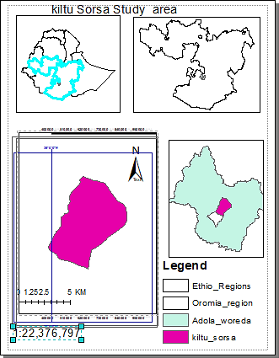

Fig. 1. Map of study area

The socio-economic survey involves various data collection techniques, such as key informant interview, semi-structured interviews, focus group discussions and field observations. In addition to the household interviews, necessary information was collected from 15 key informants. These key informants are those living in the watershed area for a long time were selected by using snow ball sampling method. This information provides an overview of the socio-economic and biophysical environment of the selected watershed area. Semi-structured interviews were used with 60 respondent households randomly selected from kiltu Sorsa watershed. Furthermore, a discussion were made with the development agents within the micro watershed and secondary data information were also collected from kebele‘s of community watershed.

Data Analysis
The collected and arranged data was analyzed by using the software programs Microsoft Excel and Statistical Packages for Social Sciences (SPSS) version 20. Based on the data gathered descriptive statistical tools like frequency and percentage were used and represented by figures, tables and graphs.

RESULTS AND DISCUSSION

Socio-Economic Characteristics
In order to have a picture of the social strata of the community in terms of wealth or well being, ranking exercise was carried out by a group of farmers. At first, the farmers were identified the criteria on the basis of which they locally
differentiate people into different wealth categories. The top most important criteria identified were number of ox and other livestock (cow, sheep, goat, horse, and donkey), household income level, area of crop production, size of land holding, and type of housing.
Based on these criteria, the group of farmers have grouped the local people into three wealth strata such as rich, medium and poor. This study showed that, majority of the respondent households were medium in terms of wealth category (66.7%) and they have informal education (48.3%) (Table 1). With regard to religion of the respondents, majority of them were protestant (93.3%) and (95%) of the respondents were male (Table 1). In terms of marital status and age category, (96.7%) and (75%) of the respondents were married and < 50 years old respectively (Table 1).

Land Size and Household Income Sources
In Kiltu Sorsa watershed, the major type of land use can be categorized into four such as cultivated land, hillside, settlement, bare/grazing lands. The greatest proportion of the land in the watershed is occupied by farmland. The land holding size of local communities of the study watershed varies from <1ha to 5-10 hectares. Key informants and respondent households indicated that, most of the time parents give a piece of land to their newly married sons for house construction and for crop cultivation. This form of continued land reallocation and transfer has resulted in fragmentation of landholding to the extent that the farm sizes are no more economically viable.

Table 1. Socio economic status of respondent households in Kiltu Sorsa Watershed, Guji Zone, Southern Ethiopia

Variable | Group | Frequency | Percentage (%)
Marital status | Married | 58 | 96.7
 | Divorced | 2 | 3.3
Age | <50 | 45 | 75
 | >50 | 15 | 25
Sex | Male | 57 | 95
 | Female | 3 | 5
 | Protestant | 56 | 93.3
Religion | Orthodox | 3 | 5
 | Muslim | 1 | 1.6
Wealth category | Rich | 5 | 8.3
 | Medium | 40 | 66.7
 | Poor | 15 | 25
Educational status | Un educated | 8 | 13.3
 | Informal education | 29 | 48.3
 | 1st Cycle and above | 23 | 38.3

The findings of this study also showed that, the landless groups are ranked as economically most disadvantaged groups and they undergo various forms of coping mechanisms such as land renting and involved in petty trading activities. Therefore, from the findings of this study observed that access to land is an ultimate form of social and economic security for local communities of Kiltu Sorsa watershed. According to the key informants and focus group discussion held with group of selected farmers, the major income sources of the local communities of Kiltu Sorsa watershed was crop and livestock production respectively. Moreover, most of the communities of the study watershed have culture of recycling cash rather than saving as it is. For example, livestock which were sold changes other kind which may be seasonally important for their livelihood.

Farming System Practiced in the Watershed Area

Crop production
The communities of the watershed area indicated that, before 40 years ago the upper part of the watershed was fully covered with forest lands. The land use change is also by far increased and clearing the forest land for expansion of crop production is very common in Kiltu Sorsa watershed area. In crop production, the major annual crops produced are maize, teff, food barely and bread wheat. However, teff and common bean are the main dominant cereal and pulse crops of the study watershed (Table 2).

This study showed that, barley, wheat, maize and common bean are cultivated as an essential food crop. While, from cereal crop only teff is produced with main crop production for market and staple food. The result is in line with [18] which was reported that barley, maize, wheat and teff are the most commonly cultivated crops in order of their importance in Hadiya Zone,
Southern Ethiopia. Furthermore, in Medo watershed, Central rift valley of Ethiopia maize, teff and haricot bean were the major cultivated crops [19]. In addition to cereal and pulse crops, small amount of vegetables and root crops (hot pepper, cabbage, sweet potato and irish potato) and horticultural crops grown in the watershed area were mango, avocado and banana

Method of crop production in kiltu sorsa watershed

In the study watershed, 90% of the respondent households reported that they have their own farm lands. In terms of sowing method, (30%) and (11.7%) of the respondents were used raw planting and broad casting methods respectively and (58.3%) of the respondents were used both methods (Table 3). Regarding variety used about (15%) and (20%) of the sampled households were used improved and local varieties respectively. However, (65%) of them were used both varieties. This study showed that the majority (98.3%) of the respondent households were used conventional farming practice. This practice could be lead to decrease soil fertility and increase soil erosion of the watershed area.

Fertilizer and chemical used for crop production
The types of fertilizer local communities of the Kiltu Sorsa watershed area used were Urea, NPS, and a limited amount of organic fertilizer from farm yard manure for different crop production. Survey results revealed that, (46.7%) of the respondents were used NPS fertilizer and (33%) of the sampled households were used Urea and NPS fertilizers. Where as, only (3.3%) of the respondents were not used either organic or inorganic fertilizers (Fig. 2). In terms of herbicide and pesticide application, the majority (75%) of sampled households were used herbicide and (6.7%) of them were not used both herbicide and insecticide application (Fig. 3)..

Table 2. Major crops grown in Kiltu Sorsa Watershed, Guji Zone, Southern Ethiopia

Type of crops | Major crops grown | Frequency | Percentage (%)
Cereals | Maize and Teff | 39 | 65.0
 | Maize, Teff and Food barley | 10 | 16.7
 | Maize, Teff, Food barley and Bread wheat | 11 | 18.3
 | Total | 60 | 100
Pulse | Common bean | 55 | 91.7
 | Not cultivate common bean | 5 | 8.3
 | Total | 60 | 100

Table 3. History of land, Variety used, sowing methods, Cropping system and Type of practice in the study watershed

History of land | Freq. | % | Variety used | Freq. | % | Cropping system | Freq. | %
Owned | 54 | 90 | Improved | 9 | 15 | Mono cropping | 1 | 1.7
Shared | 1 | 1.7 | Local | 12 | 20 | Rotational | 3 | 5
Both | 5 | 8.3 | Both | 39 | 65 | Inter cropping | 1 | 1.7
Total | 60 | 100 | Total | 60 | 100 | Double cropping | 8 | 13.3
Sowing methods | Freq | % | Type of practice | Freq. | % | Mono, double,inter cropping & rotational | 35 | 58.3
Row  planting | 18 | 30 | Conventional | 59 | 98.3 | Mono and double  cropping | 12 | 20
Broad casting | 7 | 11.7 | Conventional & Conservation | 1 | 1.7 | Total | 60 | 100
Both | 35 | 58.3 | Total | 60 | 100
Total | 60 | 100
Source: Base line survey data, 2022

Table 4. Major and Minor Seasonal Calendar of Crops grown in the watershed area

Major crops grown | Planting time of the crops in both cropping season
Maize | April –main season | September –off season
Teff | April –off season | September- main season
Wheat | April –off season | September- main season
Barley | April –off season | September- main season
Common bean | April –main season | September –off season
Source: Base line survey data, 2022
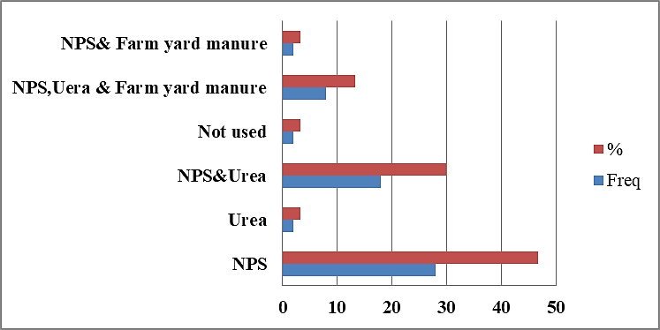

Fig. 2. Type of organic and inorganic fertilizer used in Kiltu Sorsa watershed
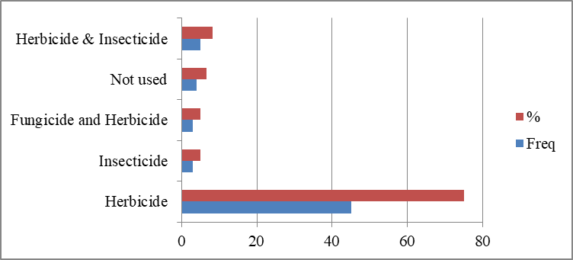

Fig. 3. Insecticide, herbicide and fungicide used in Kiltu Sorsa watershed

    - Seasonal calendar for crop production
In the study watershed, ploughing, planting, weeding, harvesting and threshing are the major
cropping activities undertaken one after the other based on main and off seasonal calender of the study area specific to the crop type. Seasonal operations of crop production of the study

watershed is adapted to the rainfall pattern as it is the bases for all agricultural activities of the study area. For the major crop types which are planted in main season, land preparation started in April and planting time was in May. However, land preparation started in September and their planting time was in October for the crop types planted in off season of the study watershed (Table 4).

Livestock production
Livestock is an integral part of agriculture and provides meat, milk, cash, draft power, hauling services, insurance, and social capital [20]. Livestock rearing is the major means of livelihood in the study watershed. The farmers of the study watershed area rearing cows, sheep, goat, poultry, donkey, mule and bee hive. The survey results showed that, about 33%, 20%, 19% ,10
% of the farmers owned cows, sheep, goat, and poultry respectively (Fig. 4). Where as, about 7%, 6% and 5.% of the respondent households owned donkey, mule, and bee hive respectively (Fig. 4).

Natural Resource Status of the Study Watershed
      - Soils characteristics of the watershed

There is a distinct difference between soils found at the up slope and valley bottom of the watershed. Red- soil is dominating the valley
bottom while brown soil is prevalent in the up slope areas. The majority (43.3%) soil color of the Kiltu Sorsa watershed is red and about 25%
,16.7% and 15% soil colors of the study watershed were brown, black and gray respectively (Table 5). The fertility of the soil is diminishing from time to time due to land degradation, inappropriate farming and limited conservation practices and the consequences resulting in low production and productivity of the area. According to this study results, about 11.6% 36.7%, 51.7% of soil fertility status of the study watershed were high, low, and medium respectively (Table 5).

      - Soil and water conservation structures in the study watershed
As the field survey result depicted, physical and biological soil and water conservation were implemented in Kiltu Sorsa watershed. This study showed that about 21.7%, 13.3% and 30% of the respondent households were used physical, biological, and both soil and water conservation structures respectively. However, about 35% of the respondent households were not used soil and water conservation structures (Fig. 5). Both key informants and sampled households indicated that the reason farmers of the study watershed not practiced soil and water conservation structures were lack awareness on SWC (55%), lack of materials (13.3%), lack of labor (21.7%) and due to their farmlands are fertile (10%) (Fig. 6).

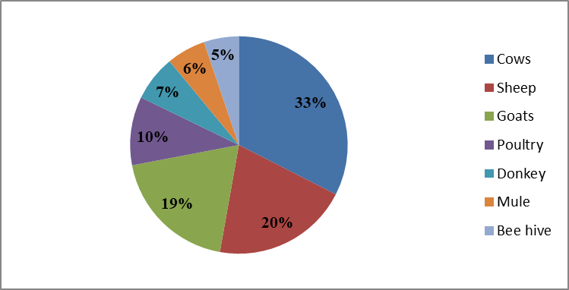

Fig. 4. Livestock types in the study watershed

Table 5. Soil fertility, Slope of the land, Soil color and Soil erosion of Kiltu Sorsa Watershed

Variable | Group | Frequency | %
 | Low | 22 | 36.7
Soil fertility | Medium | 31 | 51.7
 | High | 7 | 11.6
 | Slight | 14 | 23.3
Soil erosion | Moderate | 25 | 41.7
 | Severe | 16 | 26.7
 | Flat | 16 | 26.7
Slope of the land | Medium | 36 | 60.0
 | Steepy | 8 | 13.3
 | Red | 26 | 43.3
Soil Color | Black | 10 | 16.7
 | Grey | 9 | 15
 | Brown | 15 | 25
Source: Base line survey data, 2022
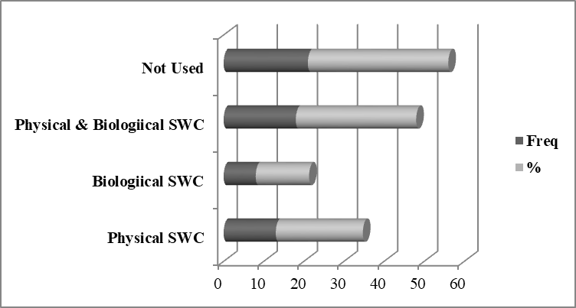

Fig. 5. Soil and water conservation structures implemented in the watershed area
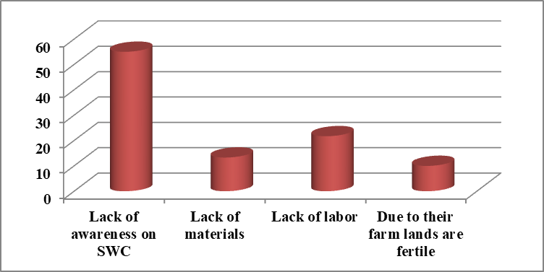
Fig. 6. Farmers reason of not implemented soil and water conservation structures in the watershed area

      - Wild animal and plant species

The elders of the surrounding watershed stated that 50 years ago most of the area was covered with indigenous trees such as Olea africana and Acacia species. Mainly agricultural land
expansions have resulted in destruction of forest trees. Besides, before two decade ago the steep slope area was densely covered with indigenous tree species such as Podocarpus falcatus and Cordia africana and different wild animals like lion, tiger, leopard, and etc. (Table 6). Currently,

unsustainable management of the natural resource is manifested by cultivation of farm land without any soil and water conservation practice, clearing trees, changing pasture land into cropland, soil erosion and less water infiltration due to devotion of vegetation, and organic matter deterioration are resulting in overall loss of land productivity. Moreover, local communities in the study watershed indicated that expansion of land degradation is highly correlated with population growth and of course unwise use of land. The degree of degradation of the natural resource base was explained by the farmers as follows:

- Soil fertility decreased as a result of the frequent cultivation
- Lack of conservation measures increased run-off
- The coverage of natural forest decreased due to cutting of the forest over the past
- years
- Reduction of range lands and animal feed deterioration

Major constraints and potentials of the kiltu sorsa watershed
A total of 60 community members were participated to identify major constraints and potentials of the watershed area. The discussion with local communities in the study watershed were focused on agreeing on the list of problems identified and presented by the study, ranking (prioritizing) the problems and identifying causes of each problem, seeking solutions and community contributions for successful implementation of the watershed management.

      - Constraints identified in the watershed area

Those identified constraints were included, Land and soil related constraints, Production related
constraints, Institutional and infrastructure related constraints, Livestock related constraints and Socio-economic related constraints (Table 7). According to this study, climate change, soil fertility and deforestation were the top three ranked land and soil related constraints of the watershed area (Table 7). This finding is argued with the findings of Hadush [21]. “His study has found out that climate variability is becoming a significant factor for recurrent droughts and this is associated with high rainfall variability, which have long been a feature in Ethiopia, and contributed to the decline in vegetation cover, loss of biodiversity and ultimately worsening land degradation” [22].

In terms of production related constraints, agricultural inputs, termite and crop productivity were the major constraints identified in Kiltu Sorsa watershed respectively. Regarding institutional and infrastructural constraints, lack of credit access, drinking water and lack of animal clinic were the top three problems of the watershed area. In the case of livestock related constraints, respondent households pointed out that shortage of feed and fodder, animal disease and grazing system were the major problem of Kiltu Sorsa watershed (Table 7).
The findings of this study showed that, population growth, employment opportunity and lack of other income sources were the main socio-economic related constraints of the watershed area (Table 7). The result of this study is similar to the findings of Hurni et al. [23] and Teshome [24]. In their study findings reported that rapid population growth is one of the major socio-economic constraints that could be contribute for land degradation and worsening of poverty in Ethiopia. Because, as the population growth rapidly the need for food, energy, water and other land resources could also grow simultaneously.

Table 6. Different extinct tree and wild animals species in Kiltu Sorsa watershed

Extinct wild animal species |  | Extinct Tree species
Scientific name | Local name | Scientific name | Local name
Panthera pardus | Qeerransa | Juniperus procera Hochst. | Gaattiraa
Orycteropus afer | Awwaaldigessa | Prunus africana | Hoomii
Phacochoerus africanus | Goljaa | Cordia africana | Waddeessa
Tragelaphus scriptus | Borofa gurraacha | Podocarpus falcatus | Birbirsa
Felis serval | Deeroo | Hygenia abyssina | Heexoo
Panthera leo | Leenca | Olea europaea | Ejersa
Source: Base line survey data, 2022

      - Major potentials and development options in the study watershed

The survey results showed that the watershed area have different potentials which could be very vital for development and intervention activities of the Kiltu Sorsa watershed. There fore, suitable agroecology, availability of labor force, youth and women associations and informal institutions are some of the major potentials identified in the study watershed area (Fig. 7).

Based on the discussion made with the local communities of the watershed area, their interest
for development was highly encouraging. Moreover, farmers of the Kiltu Sorsa watershed have an awareness of community participation on soil and water conservation activities and afforestation and reforestation of the degraded land. Thus, their willingness to participate in any developmental activities is appreciable. In support of this study, Worku and Sangharsh [25], Hadush [21] and Birhanu [26] indicated that there are various opportunities under watershed management such as working together, getting benefits together, conserving the nature and reducing negative impacts together in different watershed area of the country.

Table 7. Major constraints of the Kiltu Sorsa watershed, in Guji Zone, Southern Ethiopia

Variable | Category | Frequency (N=60) | Rank
Land and soil related constraints | Soil erosion | 18 | 5
 | Soil fertility | 40 | 2
 | Land shortage | 20 | 4
 | Deforestation | 35 | 3
 | Climate change | 50 | 1
Production related constraints | Category
 | Agricultural inputs | 60 | 1
 | Crop disease | 25 | 4
 | Crop productivity | 28 | 3
 | Wild life | 15 | 5
 | Termite | 30 | 2
Institutional and infrastructure related  constraints | Category
Institutional and infrastructure related  constraints | Drinking water | 35 | 2
 | Credit access | 40 | 1
 | Market | 22 | 4
 | Road accessibility | 20 | 5
 | Animal clinic | 25 | 3
Livestock related constraints | Category
 | Feed and fodder | 45 | 1
 | Animal disease | 30 | 2
 | Grazing system | 20 | 3
Socio-economic related constraints | Category
 | Human disease | 16 | 5
 | Population growth | 55 | 1
 | Employment opportunity | 40 | 2
 | Other income sources | 30 | 3
 | Inflation | 20 | 4
Source: Base line survey data, 2022
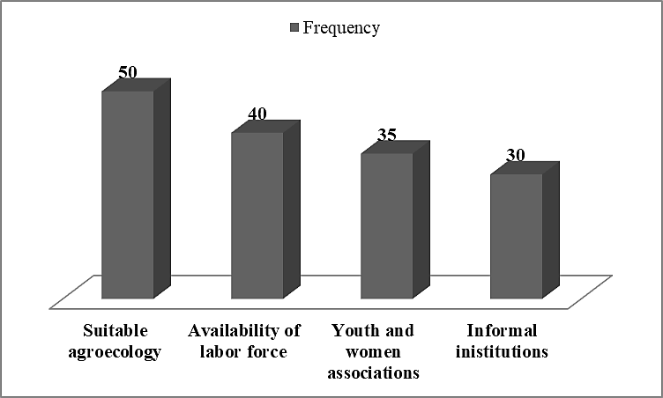

Fig. 7. Major potentials/opportunities in the study watershed

Based on the findings of this study, the local communities of Kiltu Sorsa Watershed were participated on soil and water conservation activities by their labor and through very few local material provisions. However, they need technical support and incentives (tools and other). Therefore, in order to use the opportunities organizing the community resources, strengthening and encouraging community participation at different level in the intervention project implementation process should be very important.

CONCLUSION AND RECOMMENDA- TION
Based on the findings of this study, unsustainable management of the study watershed is manifested by cultivation of farm land without any soil and water conservation practice, clearing trees, changing pasture land into cropland, soil erosion and less water infiltration due to devotion of vegetation, and organic matter deterioration are resulting in overall loss of land productivity. In the study watershed, majority of the respondent household heads were practiced soil and water conservation activities. However, some of the sampled household heads were not practiced soil and water conservation activities due to lack of awareness, lack of materials and labor. Therefore, through providing quality extension services and training on soil and water conservation practices it is possible to enhance farmers participation and the technical limitations on different soil and water conservation structures.

The findings of this study showed that, in Kiltu Sorsa watershed five major constraints were identified. The constraints included, land and soil related constraints, production related constraints, institutional and infrastructure related constraints, livestock related constraints and socio-economic related constraints. However, in the watershed area there is some major potentials/ opportunities identified. In this regard, local communities of the study watershed were ranked suitability of agroecology, availability of labor force and informal institutions, 1st, 2nd and 3rd respectively. Therefore, for sustainable management of the study watershed, restoration practice is vital through area closure to restore endangered plant tree species. Moreover, different agroforestry practice and soil and
water conservation structures are very important for sustainable land use system of the watershed area.

REFERENCES
- German L, J Mowo J, Opondo C.” Integrated Naturaral Resource Management: From Theory to Practice.’’ In Integrated Natural Resource Management in The Highlands of Eastern Africa. World Agroforestry Centre and International Development Research Centre; 2012.
- Merkineh M, Aklilu B, Debebe D.” Integrated watershed management for ecosystem balance and climate change: Ethiopia.” Civil and Environmental Research. 2017;9(9):01-12.
- Temu A.B, Chakeredza S, Mogotis K, Munthali D, Mulinge R. Rebuilding Africa’s capacity for agricultural development: the role of tertiary education. Reviewed papers presented at ANAFE Symposium on Tertiary Agricultural Education. ICRAF, Nairobi, Kenya; 2004.
- Haileslassie A, Priess J, Veldkamp E, Teketay D, Lensschen JP. Assessment of soil nutrient depletion and its spatial variability on smallholders’ mixed farming systems in Ethiopia using partial versus full nutrient balances. Agriculture, Ecosystems and Environment. 2005; 108(1):1-16
- Tongul H, Matt H. Scaling up an integrated watershed management approach through social protection programmes in Ethiopia: The MERET and PSNP schemes. Hunger Nutrition Climate Justice. A New Dialogue: Putting

People at the Heart of Global Development. Case studies policy response; 2013.
- FDRE/MOARD (Federal Democratic Republic of Ethiopia/ Ministry of Agriculture and Rural Development). Community based participatory watershed development: a guideline. Addis Ababa, Ethiopia; 2005.
- Blaikie P. Is policy reform pure nostaligia? a himalayan illustration: barkeley workshop on environmental politics. California, Berkeley: Institute of International Studies, University of California; 2001.
- Gebregziabher G, Abera DA, Gebresamuel G, Giordano M, Langan S. An assessment of integrated watershed management in Ethiopia. International Water Management Institute (IWMI). 2016;170.
- Lal R. Integrated watershed management in the global ecosystem. Washington, D.C: CRC Press; 2000.
- Haile M. Sustainable land management: A new approach to soil and water conservation in ethiopia; 2006.
- Solomon AY. Agroforestry for sustainable agriculture and climate change: A Review. Int J Environ Sci Nat Res. 2019;19(5): 556022.
- Anantha KH, Suhas PW, Sreedevi TK. Baseline socio-economic characterization of watersheds. International Crops Research Institute for the Semi-Arid Tropics (ICRISAT) Patancheru 502 324,
Andhra Pradesh; 2009.
- CSA (Central Statistical Agency). Addis Ababa, Ethiopia. EPC (Ethiopia Population Census). Draft report. Addis Ababa, Ethiopia; 2008.
- Brooks NK, Folliot PF, Thames JL. Watershed management: A global perspective, hydrology and the management of watersheds. Ames, Iowa: Iowa State University Press. 1991;1-7
- Mekonnen Z, Kassa H, Lemenih M, Campbell B. The role and management of Eucalyptus in Lode Hetosa District, Central Ethiopia. Forests Trees Livelihoods. AB Academic Publishers, UK. 2007;17(4):309–323.
- Temesgen D, Rashid M.H, Ringler C. Measuring Ethiopian farmers’ vulnerability to climate change across regional states. IFPRI Discussion. 2008; 00806.
- Datta SK, Virgo KJ. Towards sustainable watershed development through people's participation: Lesson from the Lesser Himalaya, Utter Pradesh, India. Mountain Research and Development. 1998;18(1); 213-233.
- Yohannes HM, Kibemo DA. Assessment of farm characteristics and woody species diversity in hadiya zone, Southern Ethiopia. J. Mountain Res; 2021. P-ISSN: 0974-3030
- Kedir J, Muleta G, Guta B. Description and evaluation of the present resource use, management practices, and socio- economic conditions in the medo watershed, central rift valley area of Ethiopia. Glob Acad J Agri Biosci. 2023;5(4):86-99.
- Food and Agriculture Organization. The future of livestock in Ethiopia. Opportunities and challenges in the face of uncertainty. Rome. 2009;48. License: CC BY-NC-SA 3.0 IGO.
- Hadush M. The Role of community based watershed management for climate change adaptation in adwa, central tigray zone. International Journal of Weather, Climate Change and Conservation Research. 2015;1(1):11–35.
- Jilo BF, Fida GT, Komicho DN. Socio-economic and bio- physical resources characterization of ‘warja’watershed in adami tulu jido kombolcha district, East Shewa Zone, Oromia, Ethiopia. American Journal of Modern Energy. 2020, Dec;6(6):101- 16.
- Hurni H, Kebede T, Gete Z. The Implications of Changes in Population, Land Use, and Land Management for Surface Runoff in the Upper Nile Basin Area of Ethiopia. Mountain Research and Development. 2005;25(2): 147–54.
- Teshome M. Population growth and cultivated land in rural Ethiopia: Land Use Dynamics, Access, Farm Size, and Fragmentation. 2004;4(3):148–61. Available:https://doi.org/10.5923/j.re.2014 0403.03.
- Worku T, Sangharsh KT. Watershed management in highlands of Ethiopia: A review watershed management in highlands of Ethiopia. Open Access Library Journal. 2015;2: e1481.

Available:https://doi.org/10.4236/oalib.110 1481.
- Birhanu A. Environmental degradation and management in Ethiopian highlands: Review of
lessons learned. Journal of Environmental Protection and Policy. 2014; 2:24-34.
Available:http://dx.doi.org/10.11648/j.ijepp
.20140201.14.

