EXPERIMENTAL APPLICATION OF DIRECT SOLAR DRYING METHOD FOR TOMATO SLICES

Abstract
This study applied a novel direct solar drying method for tomato slices, using a box-shaped dryer with three trays, a transparent glass cover as a solar collector, and a blower. The performance and product quality were compared between solar drying and open sun drying methods. Tomato slices underwent sorting, bleaching, drying, and packaging, becoming ready for commercialization. The tomato slices dried until the final moisture content reached 25–50% (w.b) from an initial moisture content of 90% (w.b). The solar dryer achieved the highest average drying rate of 0.644 g/min on the first tray and a drying efficiency of 25.09%, with total energy consumption of 193.85 kJ/kg and 0.0111 kg/kJ for SEC and SMER, respectively. Quality assessments included color, texture, vitamin C content, and SEM testing. Dried tomato slices turned significantly browner compared to fresh ones, had different texture attributes from open sun drying-dried slices, experienced vitamin C degradation due to high temperatures, and showed brittle walls due to moisture loss, as indicated by SEM testing.

Keywords
Direct solar drying, Drying kinetics, Energy consumption, Tomatoes, Physical and nutritional quality

- Introduction
Tomato (Lycopersicon esculentum) is the most widely consumed dietary vegetable product worldwide due to its vitamin A content in carotenoid terpenes (Djebli et al., 2019). Tomatoes contain high fiber and serve as a primary source of lycopene and various phenolic compounds with high antioxidant activity, which are beneficial in preventing chronic diseases such as heart disease and cancer (Tan et al., 2021). Despite its numerous benefits, tomatoes are highly perishable, especially during storage if improperly handled. Tomatoes also have a high water content, which accounts for up to 95% of their total weight, making them spoil quickly (Kamarulzaman et al., 2021).
Tomatoes are climacteric fruits, which means they undergo a spike in respiration and ethylene production as they begin to ripen. Therefore, they do not need to be fully ripe at harvest, as they can ripen perfectly after being picked. This increase in respiration at the start of storage, followed by a gradual decline, affects the quality of tomatoes during storage (Quinet et al., 2019). However, weather conditions, seasonal changes, and the day-night cycle can further complicate this process. Unfavorable weather can increase water content, promoting mold and fungal growth, especially if drying occurs outdoors. This will lead to contamination from dust, dirt, and other foreign particles, degrading tomato quality. Thus, mechanical drying is essential to improve productivity, hygiene, and the sustainability of dried tomato production (Dufera et al., 2021; Tan et al., 2021).
Solar drying is a promising solution for drying fruits and vegetables in developing countries (Hossain et al., 2008). The drying process requires a relatively large amount of energy, especially with industrial-scale mechanical dryers that rely on coal as an energy source, leading to high investment and operational costs that are impractical for developing nations. Additionally, mechanical dryers produce high temperatures and long drying times, which can degrade the product quality and nutritional value (Elwakeel et al., 2024). Solar drying offers a viable alternative by harnessing renewable solar energy, which is environmentally friendly, sustainable, and economically feasible for these regions. Various crops have dried using solar dryers, achieving good product quality and safe moisture levels for storage, with drying times dependent on the specific dryer design and configuration (Karthikeyan & Murugavelh, 2018; Murali et al., 2020; Suherman et al., 2021). Research has also explored solar drying for tomatoes using different configurations, such as mixed solar dryers (Djebli et al., 2019), PV thermal regeneration solar dryers (Dorouzi et al., 2018), and solar tunnel dryers (Dufera et al., 2021).
In this study, a novel solar dryer with real-time automated data measurement will be implemented for drying tomato slices. The objective is to assess how well a solar dryer performs for drying tomato slices by analyzing its drying characteristics and comparing them to conventional open-sun drying methods. Quality assessment will be conducted to assess the impact of the solar dryer on the physical and nutritional quality of the tomato slices post-drying. Four quality parameters to be investigated include Vitamin C content, SEM analysis, texture analysis, and color analysis.

- Solar drying method principle
A simple solar dryer consists of a box-shaped drying chamber for placing food items and transparent glass on the top. Solar radiation will hit the glass cover, allowing some short-wavelength radiation to pass through while the rest is reflected in the environment. The food products inside the drying chamber will absorb the solar radiation, causing the surface of the products to heat up. The heated products then emit long-wavelength radiation that cannot pass through the glass cover, increasing the air temperature inside the chamber. The rise in air temperature around the food creates a temperature gradient with the surface temperature of the products, leading to a rapid and efficient drying process (Jha & Tripathy, 2021). The main goal of solar drying innovation is to provide a new and improved method to address the limitations of the open sun drying method. In recent decades, many researchers have begun developing solar drying technologies utilizing natural or forced circulation and additional heat sources (such as electricity and biomass) to achieve an effective, efficient, and economical drying configuration (Kumar et al., 2016). The solar dryer setup used in the research by Suherman et al. (2023) is shown in Figure 1.
Figure 1. Solar dryer setup for drying tomato slices
A solar dryer is box-shaped with dimensions of 90 cm length, 90 cm width, and 120 cm height. The outer surface is coated with 1 mm thick aluminum, while the inner frame is made of 1.2 mm thick stainless steel. The inner walls are lined with glass wool insulation. This solar dryer utilizes solar energy as its primary heat source, leveraging the high conductivity of aluminum and stainless steel to store and conduct heat from the exterior to the interior. A 90 x 90 x 0.5 cm acrylic panel is positioned inclined atop the dryer to absorb solar radiation, adjustable for optimal sunlight exposure during drying. It features four wheels for mobility. Inside, three drying trays measuring 80 cm x 80 cm are spaced 27.5 cm apart, and made of perforated plates to allow air circulation. Aluminum edges and holders are installed to support the trays. An exhaust chimney at the top facilitates the humid air inside the dryer to flow outside, while a bottom-mounted blower ensures even heat distribution and air circulation. Temperature and relative humidity indicators are placed inside, including on each tray, with a control panel on the left side featuring touch LED displays for monitoring and controlling the blower operation, temperature, and humidity levels.

- Pre-treatment tomato slices before the drying process
The sequence of stages in the tomato slice drying process, from pre-treatment to marketing, is presented in Figure 2. Firstly, Tomatoes undergo visual sorting based on bright red color, size, ripeness, and other physical characteristics to avoid damage or spoilage. Selected tomatoes are running clean water to remove dirt adhering to the skin. The washed tomatoes are then sliced to a uniform thickness using a sharp knife to increase the surface area and ensure the drying process evenly affects the material. After that, the tomato slices undergo a pretreatment by soaking (bleaching) in a solution at room temperature for 5 minutes, then drained and stored in the refrigerator (4 – 5°C). The soaking solution can use 3% sodium chloride (30 g/L H₂O) or 10% (100 g/L H₂O), 6% sodium metabisulfite (60 g/L H₂O), or 5% lemon juice. The tomatoes are taken out of the refrigerator at least 2 hours before the drying experiment and placed in outdoor conditions to reach ambient temperature (Azumah et al., 2024; Dorouzi et al., 2018; Hamdi et al., 2023). The drying process of tomato slices is carried out in a drying chamber where the slices are evenly spread on trays. Data is collected at regular intervals, including sample weight, drying air temperature, relative humidity, solar intensity, and air velocity.
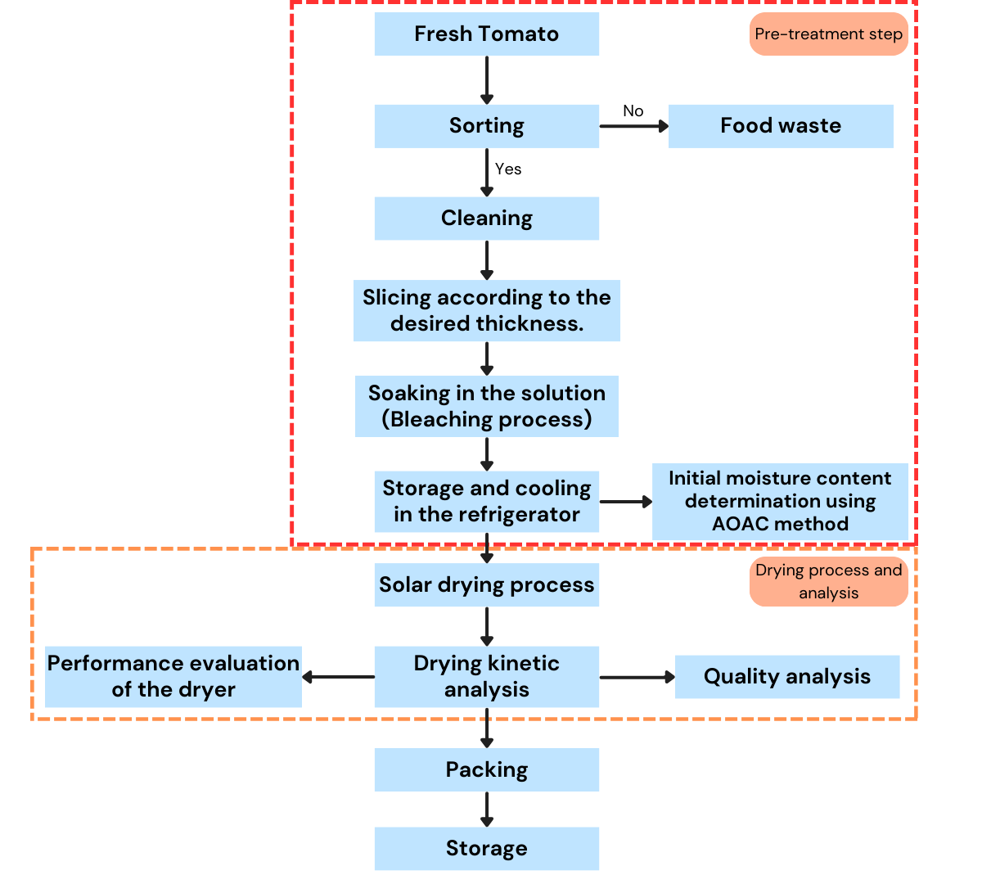
Figure 2. Stages of the tomato slice drying process

- Drying kinetics in solar drying method
- Moisture content
The initial moisture content determination of the sample is carried out by drying 5 to 10 g using an oven at a temperature of 105°C for 6 hours. The average initial moisture content of tomatoes, based on AOAC standards, is found to be 94% on a wet basis, and the final moisture content limit for dried material is 15% on a wet basis (Ebadi et al., 2021; Samimi-Akhijahani & Arabhosseini, 2018). The initial moisture content can be calculated using the following equation.
$\% Initial MC=\frac{\left(W_{i}-W_{f}\right)}{W_{f}}×100\%$ (1)
Where, W_{i} and W_{f} are the initial and final weights of the sample (gram). Meanwhile, the determination of moisture content on a wet basis during the drying process can be measured by calculating the equivalent percentage of the weight of water lost compared to the wet weight of the material (Sukkanta et al., 2023).
$MC=\frac{\left(W_{w}-W_{d}\right)}{W_{w}}×100\%$ (2)
Where, MC is the moisture content on a wet basis (%w.b), W_{w} and W_{d} are the wet and dry weights of the sample (gram). The moisture content relationship during the drying period can be represented in a curve diagram, as shown in Figure 3.

Figure 3. Moisture content curve for tomato slices drying
Figure 3 shows the relationship between the moisture content of tomato slices and drying time in a solar dryer for each tray, as well as open sun drying. The tomato slices were dried from an initial moisture content of 90% w.b. They experienced a decrease as drying time increased, with a period of rapid moisture loss during the drying process. The fastest drying occurred in the first tray of the solar dryer due to higher temperatures observed in the first tray compared to the second and third trays, resulting in a higher amount of moisture being removed in the tray (Mugi & Chandramohan, 2022). The final moisture content of the tomato slices in the solar dryer trays and open sun drying were 33.33%, 36.71%, 45.65%, and 79.76%, respectively. The final moisture content of the tomato slices is still acceptable according to international standards, which allow for a moisture content of around 25–50% for the category of high moisture and a soft and pliable texture (UNECE, 2007). Therefore, only the dried tomato products using the solar drying method meet the quality standards. This is due to the solar dryer's enclosed design and stainless-steel construction having good thermal conductivity, which enhances heat retention and increases the amount of water that can be evaporated. On the other hand, open sun drying is highly dependent on hot, sunny weather and dry atmospheric air. Open sun drying has a slow drying rate, requires more attention, and is highly susceptible to environmental contamination (Djebli et al., 2020).

- Drying rate
The difference in weight of moisture of material at two consecutive time intervals (evaporated water vapor mass) divided by period is called the drying time and can be calculated using the equation (Kant et al., 2023).
$DR=\frac{W_{0}-W_{d}}{∆t}$ (3)
Where, DR is the drying rate (g/min), W_{o} – W_{d} is the mass difference between two consecutive measurements (g), Δt is the time interval (min). The drying rate at each drying time can be presented in Figure 4 as follows.

Figure 4. Drying rate curve for tomato slices drying
The drying rate profile in Figure 4 shows that the drying process in the first hour has a higher drying rate, which gradually decreases over time. This is because the solar radiation energy absorbed by the surface of the tomato slices is higher, evaporating more of the free water content and resulting in faster drying (Azeez et al., 2019). The average drying rate for solar drying on each tray and open sun drying was 0.644 g/min, 0.638 g/min, 0.618 g/min, and 0.383 g/min, respectively. The fastest drying rate occurred on tray 1 for the solar drying method. The position of tray 1 is at the very top, so the heat radiation from the solar collector directly hits the first tray, then the middle tray, and finally the bottom tray. A similar phenomenon was observed in previous studies on drying cassava slices (Suherman et al., 2020) and ginger (Suherman et al., 2021).
Another phenomenon shows that drying under direct sunlight has the lowest drying rate compared to solar drying on each tray. Drying under direct sunlight relies solely on the surrounding fresh air that hits the material's surface. Meanwhile, fresh air in the solar dryer is supplied through forced convection using a blower, so the drying air speed exceeds that of the atmospheric air (Muthuvairavan & Kumar Natarajan, 2023). This is similar to previous studies by Bhaskara Rao & Murugan (2023), which compared drying neem leaves using an evacuated tube solar dryer and conventional direct sunlight drying. Likewise, (Kant et al., 2023) compared drying peppermint leaves using a greenhouse solar dryer and open sunlight drying.

- Performance evaluation of solar dryers
- Solar dryer efficiency
The solar dryer efficiency ($η_{sd}$) is the ratio of the thermal energy used to evaporate water from the sample to the solar radiation hitting the collector and the sample surface. The efficiency of a solar dryer indicates how effectively the drying chamber utilizes a given amount of energy input to remove the moisture content from the sample (Owureku-Asare et al., 2022). The overall solar dryer efficiency can be calculated using this equation.
$η_{sd}=\frac{M_{w}×h_{fg}}{A×I×∆t}$ (4)
Where, $M_{w}$ is the weight of the evaporated sample (kg), $h_{fg}$ is the latent heat of water evaporation assumed to be 2260 kJ/kg, $A$ is the collector area (m²), $I$ is the solar radiation intensity (W/m²), and $∆t$ is the drying time difference (s). A graphical representation of the solar dryer efficiency over the drying period is shown in Figure 5.

Figure 5. Solar drying efficiency curve
The solar dryer efficiency depicted in Figure 5 fluctuates due to changes in solar radiation and the rate of moisture loss from tomato slices. Efficiency peaks early in the drying process as the material surface, rich in free water, evaporates readily. However, efficiency step-by-step declines over subsequent hours as the moisture content in the tomato slices decreases (Arunkumar et al., 2024; Suherman, Hadiyanto, et al., 2024). On average, efficiencies on each tray are 25.09%, 24.38%, and 23.61%, respectively, with the highest efficiency on tray 1 (top tray), followed by tray 2 (middle tray), and the lowest on tray 3 (bottom tray). Tray 1 removes the most water from tomato slices at 425 g, compared to 421 g on tray 2 and 408 g on tray 3, attributed to its direct exposure to solar radiation at the top position (Mugi & Chandramohan, 2022).

- Energy consumption of a solar dryer
Specific energy consumption (SEC) indicates the ratio of the total energy input to the drying system ($E_{T}$) to the total moisture removed from the product ($M_{w}$) during the drying process (Kalita et al., 2024). Meanwhile, the specific moisture extraction rate (SMER) indicates the ratio of the amount of moisture removed to the total energy input to the drying system (Chi et al., 2023).
$SEC=\frac{E_{T}}{M_{w}}$ (5)
$SMER=\frac{M_{w}}{E_{T}}$ (6)
The energy consumption analysis required during the drying process is shown in Figure 6, expressed in SEC and SMER, calculated using equations (5) and (6). The average values of SEC and SMER for solar drying on each tray are 193.85, 180.13, 187.95 kJ/kg, and 0.0111, 0.0108, and 0.0104 kg/kJ, respectively. The correlation between SEC and SMER is inversely proportional; as drying time increases, the SEC value rises while the SMER value decreases. When the water transfer from inside the tomato slices to the surface decreases, the moisture weight (Mw) in the tomato slices also decreases. As a result, the overall SMER and the efficiency of the solar dryer decline, while the SEC increases (Chi et al., 2023; Hadibi et al., 2022). This phenomenon aligns with previous studies on energy reviews in indirect solar dryers for drying bitter gourd slices (Madhankumar et al., 2023) and sweet potatoes (Abdelkader et al., 2024).
(A)
(B)
Figure 6. Evaluation of energy consumption requirements during the drying process in terms of SEC (A) and SMER (B)

- Quality parameters assessment for tomato slices
The quality parameters of products after the drying process are crucial in the agricultural sector. The goal is to ensure the dried product's condition throughout the supply chain until it reaches the consumer as the final product. Factors such as temperature and drying duration significantly influence product quality. High temperatures can degrade essential nutrients in some food products during drying. For example, tomato slices, which have an initial moisture content of 95%, are dried to a final moisture content of 7% over 36 hours, with a maximum permissible temperature of 60°C (Kamarulzaman et al., 2021). Key quality parameters to review for dried tomato slices include color, texture, and vitamin C content. In addition, SEM analysis was also observed in this experiment to examine the effect of the drying process on the surface morphology of tomato slices.

- Color analysis
Color analysis is one of the key parameters in assessing product quality as a physical indicator of the success of the drying process. The color changes in tomato slices were carried out using a colorimeter following the CIE L*, a*, and b* system. The L* value represents how bright an object is, with L* = 0 for black and L* = 100 for white. The a* value represents the color position, with positive a* values indicating red and negative a* values indicating green. Similarly, positive b* values indicate yellow, while negative b* values indicate blue (Suborna et al., 2024).
The results of the color analysis of tomato slices during the moisture removal process are presented in Table 1. The dried tomato slices in this study showed L*, a*, and b* values of 43.42, 0.31, and 4.40, respectively. Compared to fresh tomato slices from a previous study by Hamdi et al. (2023), there is a noticeable degradation of color to brown. Short-term intense direct solar radiation exposure through the glass collector causes materials vulnerable to photodegradation to experience a decline in product quality (Suherman, Asy-Syaqiq, et al., 2024). Additionally, the high drying temperature reaching 60°C and the presence of oxygen can destroy cell structures and break down pigments from the color-giving substance matrix in the tomato slices, accelerating non-enzymatic browning reactions such as the Maillard reaction (Liu et al., 2024; Zheng et al., 2024). Therefore, controlling the drying temperature is crucial to achieve an optimal temperature with a rapid drying rate to reduce drying duration while maintaining product quality.
Table 1. Comparison of color analysis on fresh and dried tomato slices
No | Sample’s name | Results |  |  | References
No | Sample’s name | L* | a* | b* | References
1 | Fresh tomatoes | 50.90 | 20.51 | 20.01 | Hamdi et al. (2023)
2 | Tomatoes dried in the solar dryer | 43.42 | 0.31 | 4.40 | This study

- Texture analysis
Texture Profile Analysis (TPA) is a widely used method to assess the texture of dried materials using a texture analyzer. The texture analysis of tomato slices under different drying conditions is reviewed against the TPA curve, yielding texture attribute values such as hardness, cohesiveness, springiness, and adhesion. Hardness measures the peak force needed to compress the dried product, indicating its resistance to crushing or cutting. Cohesiveness describes the material's ability to retain its structural integrity under pressure, reflecting the strength of its internal bonds. Springiness assesses the elasticity of the dried product, showing how well it can return to its original shape after being deformed. Finally, adhesion measures the force required to detach the dried product from a contact surface (Ding et al., 2023).
Two drying methods, solar drying and open sun drying, were compared to assess their impact on the texture properties of tomato slices, as shown in Table 2. The results of the four measured texture attributes indicated that the solar drying method had a significant impact except for adhesion. Solar drying produced the highest hardness values, reaching 644.5 g and 557.5 g. This rapid moisture loss from the material's surface, driven by hot forced air circulation through a blower, led to the formation of a hard outer layer (Fan et al., 2024). However, the uniform final moisture content during the drying process led to minimal differences in cohesiveness and springiness between the two methods, with values of 0.67, 0.39, and 2.9 mm, 1.5 mm, respectively (Fan et al., 2024). The reduction in texture properties is likely due to increased void spaces and porosity from the breakdown of the tomato's cellular structure, held together by turgor pressure, resulting from the release of RONS on the sample surface, as observed in microstructural analysis (Obajemihi et al., 2023, 2024).
Table 2. Results of texture profile analysis on different drying methods
No | Sample’s name | Yield (skin) |  |  |  |  | Test method
No | Sample’s name | Hardness I (g) | Hardness II (g) | Cohesiveness | Springiness (mm) | Adhesion (mJ) | Test method
1 | OSD | 392.5 | 367.0 | 0.67 | 2.9 | 0.01 | TPA
2 | SD | 644.5 | 557.5 | 0.39 | 1.5 | 0.01 | TPA

- Vitamin C analysis
The measurement of total vitamin C in tomatoes includes the amounts of L-ascorbic acid (AA) and dehydroascorbic acid (DHAA), both of which are active as vitamin C. L-ascorbic acid is easily and reversibly oxidized to dehydroascorbic acid. Vitamin C is measured using High-Performance Liquid Chromatography (HPLC), based on extraction with 0.3 M trichloroacetic acid, enzymatic conversion of AA to DHAA using ascorbate oxidase, and derivatization with 1,2-o-phenylenediamine (Georgé et al., 2011). HPLC results can be seen in Figure 7, showing the highest peak for vitamin C (ascorbic acid) with a retention time of 2.155 minutes, peak area of 3,283,493 units area, peak height of 219,102 units length, and vitamin C concentration of 8 mg/100 grams of dried tomatoes. The vitamin C content in dried tomatoes significantly decreases compared to fresh tomatoes because the drying process requires high temperatures, causing ascorbic acid degradation due to heat oxidation (Abioye et al., 2024). Vitamin C is unstable and easily oxidized by air and heat because of its highly reactive hydroxyl (OH) group. The decrease in vitamin C content occurs due to spontaneous oxidation without the need for enzymes and is influenced only by temperature and surrounding air. Additionally, vitamin C retention is affected by the combination of temperature and time during drying (Dufera et al., 2021). Therefore, careful consideration of quality is crucial to preserving the nutritional content of tomatoes during the drying process.
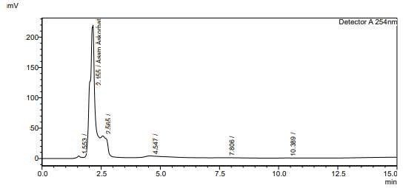
Figure 7. Analysis of vitamin C content using the HPLC method

- SEM analysis
SEM is an instrument tool used to analyze the surface morphology or structural changes of food samples after the drying process, resulting in black-and-white images with various magnifications focused on points located on the dried food sample (Sengar et al., 2023). Figure 8 shows the results of SEM testing of a cross-section of tomato slices at 500 times magnification (A) and 1000 times magnification (B). At 1000 times magnification, the pore size is 10 µm, while at 5000 times magnification, the pore size is 5 µm. Morphologically, dried tomato slices have a higher degree of wall fragility than fresh tomatoes. Dried tomato slices are hygroscopic and reconfigure upon rehydration. Water moves freely across the gradient and is absorbed by the tomato walls. Therefore, the rate of cell wall collapse during drying is proportional to the amount of water lost during the drying process from cell pores (Jha & Tripathy, 2020).
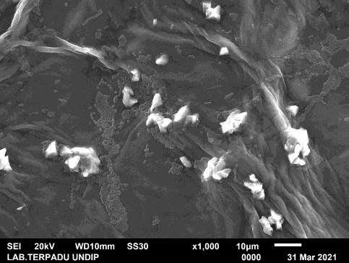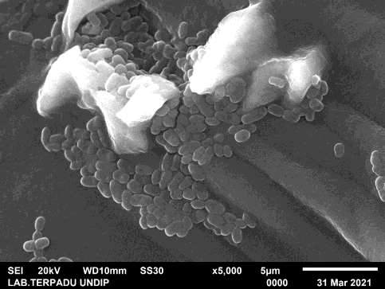
(A)
(B)
Figure 8. Surface morphology of dried tomatoes at 1000x magnification (A) and 5000x magnification (B)

- Conclusion
The performance evaluation of the solar dryer focused on moisture content, drying rate, drying efficiency, and energy consumption. Tomato slices with an initial moisture content of 90% (w.b) were dried for 10 hours using a solar dryer and open sun drying for comparison. The final moisture content was 33.33%, 36.71%, 45.65%, and 79.76% for each tray of the solar dryer and the open sun drying, respectively. All slices, except those open sun drying, met the SNI quality standards. The solar dryer achieved faster drying rates of 0.644 g/min, 0.638 g/min, and 0.618 g/min compared to open sun drying at 0.383 g/min. The highest energy consumption was in the first tray of the solar dryer, with 193.85 kJ/kg and 0.0111 kg/kJ for SEC and SMER, respectively, and a drying efficiency of 25.09%. Additionally, the quality assessment of the dried product was reviewed as a parameter before commercialization to consumers, including color, texture, vitamin C content, and SEM testing. The color of the dried tomato slices showed a significant change to brown compared to fresh tomatoes. The texture attributes measured by the solar drying method showed a significant difference compared to the open sun drying method. The vitamin C content in dried tomato slices experienced ascorbic acid degradation due to high temperatures during the drying process. SEM testing indicated that the dried tomato slices had brittle walls due to the loss of moisture from the surface of the tomato slices.

- References
Abdelkader, T. Kh., Sayed, H. A. A., Refai, M., Ali, M. M., Zhang, Y., Wan, Q., Khalifa, I., Fan, Q., Wang, Y., & Abdelhamid, M. A. (2024). Machine learning, mathematical modeling and 4E (energy, exergy, environmental, and economic) analysis of an indirect solar dryer for drying sweet potato. Renewable Energy, 227, 120535. https://doi.org/10.1016/j.renene.2024.120535
Abioye, A. O., Hussein, J. B., Olanrewaju Oke, M., & Bolarinwa, I. F. (2024). Modelling some quality attributes of a convective Hot-Air dried tomato slices using ANN and ANFIS techniques. Measurement: Food, 13, 100140. https://doi.org/10.1016/j.meafoo.2024.100140
Arunkumar, P. M., Balaji, N., & Madhankumar, S. (2024). Performance analysis of indirect solar dryer with natural heat energy retention substances for drying red chilli. Sustainable Energy Technologies and Assessments, 64, 103706. https://doi.org/10.1016/j.seta.2024.103706
Azeez, L., Adebisi, S. A., Oyedeji, A. O., Adetoro, R. O., & Tijani, K. O. (2019). Bioactive compounds’ contents, drying kinetics and mathematical modelling of tomato slices influenced by drying temperatures and time. Journal of the Saudi Society of Agricultural Sciences, 18(2), 120–126. https://doi.org/10.1016/j.jssas.2017.03.002
Azumah, L. C., Abu, M., Kaburi, S. A., & Lamptey, F. P. (2024). Effect of pre-drying treatments on the quality of solar-dehydrated tomato (Lycopersicon esculentum L.) fruits. Applied Food Research, 4(1), 100422. https://doi.org/10.1016/j.afres.2024.100422
Bhaskara Rao, T. S. S., & Murugan, S. (2023). Experimental investigation of drying neem (Azadirachta indica) in an evacuated tube solar dryer: Performance, drying kinetics and characterization. Solar Energy, 253, 270–284. https://doi.org/10.1016/j.solener.2023.02.031
Chi, X., Tang, S., Song, X., Rahimi, S., Ren, Z., Han, G., Shi, S. Q., Cheng, W., & Avramidis, S. (2023). Energy and quality analysis of forced convection air-energy assisted solar timber drying. Energy, 283, 128718. https://doi.org/10.1016/j.energy.2023.128718
Ding, H., Yang, C., Cao, S., Gu, J., Li, Y., Zang, Y., Yao, X., Zhu, R., Wang, Q., Dong, W., & Huang, Y. (2023). Prediction models of texture attributes for radiofrequency assisted hot air drying of jujube slices based on morphological parameters. LWT, 190, 115527. https://doi.org/10.1016/j.lwt.2023.115527
Djebli, A., Hanini, S., Badaoui, O., & Boumahdi, M. (2019). A new approach to the thermodynamics study of drying tomatoes in mixed solar dryer. Solar Energy, 193, 164–174. https://doi.org/10.1016/j.solener.2019.09.057
Djebli, A., Hanini, S., Badaoui, O., Haddad, B., & Benhamou, A. (2020). Modeling and comparative analysis of solar drying behavior of potatoes. Renewable Energy, 145, 1494–1506. https://doi.org/10.1016/j.renene.2019.07.083
Dorouzi, M., Mortezapour, H., Akhavan, H. R., & Moghaddam, A. G. (2018). Tomato slices drying in a liquid desiccant-assisted solar dryer coupled with a photovoltaic-thermal regeneration system. Solar Energy, 162, 364–371. https://doi.org/10.1016/j.solener.2018.01.025
Dufera, L. T., Hofacker, W., Esper, A., & Hensel, O. (2021). Physicochemical quality of twin layer solar tunnel dried tomato slices. Heliyon, 7(5), e07127. https://doi.org/10.1016/j.heliyon.2021.e07127
Ebadi, H., Zare, D., Ahmadi, M., & Chen, G. (2021). Performance of a hybrid compound parabolic concentrator solar dryer for tomato slices drying. Solar Energy, 215, 44–63. https://doi.org/10.1016/j.solener.2020.12.026
Elwakeel, A., Gameh, M., Eissa, A., & Mostafa, M. (2024). Recent Advances in Solar Drying Technology for Tomato Fruits: a Comprehensive Review. International Journal of Applied Energy Systems, 6(1), 37–44. https://doi.org/10.21608/ijaes.2023.240781.1021
Fan, Y., Guo, C., Zhu, Y., Liu, D., & Liu, Y. (2024). Effects of different drying methods on physicochemical, textural, flavor, and sensory characteristics of yak jerky. Meat Science, 216, 109570. https://doi.org/10.1016/j.meatsci.2024.109570
Georgé, S., Tourniaire, F., Gautier, H., Goupy, P., Rock, E., & Caris-Veyrat, C. (2011). Changes in the contents of carotenoids, phenolic compounds and vitamin C during technical processing and lyophilisation of red and yellow tomatoes. Food Chemistry, 124(4), 1603–1611. https://doi.org/10.1016/j.foodchem.2010.08.024
Hadibi, T., Boubekri, A., Mennouche, D., Benhamza, A., Mazouzi, K., Kumar, A., Xiao, H.-W., & Allaf, K. (2022). Energy, environmental, economic, and color analysis of geo-exchange energy assisted-insulated north wall solar dryer for onion slices under relatively cloudy and rainy conditions. Solar Energy, 236, 1–16. https://doi.org/10.1016/j.solener.2022.02.037
Hamdi, I., Agrebi, S., ELkhadraoui, A., Chargui, R., & Kooli, S. (2023). Qualitative, energy and economic analysis of forced convective solar drying of tomatoes slices. Solar Energy, 258, 244–252. https://doi.org/10.1016/j.solener.2023.04.021
Hossain, M. A., Amer, B. M. A., & Gottschalk, K. (2008). Hybrid Solar Dryer for Quality Dried Tomato. Drying Technology, 26(12), 1591–1601. https://doi.org/10.1080/07373930802467466
Jha, A., & Tripathy, P. P. (2020). Influence of solar drying and storage conditions on microstructure, crack propagation and nano-hardness of paddy and wheat. Journal of Cereal Science, 95. https://doi.org/10.1016/j.jcs.2020.103054
Jha, A., & Tripathy, P. P. (2021). Recent Advancements in Design, Application, and Simulation Studies of Hybrid Solar Drying Technology. Food Engineering Reviews, 13(2), 375–410. https://doi.org/10.1007/s12393-020-09223-2
Kalita, N., Muthukumar, P., & Dalal, A. (2024). Performance investigation of a hybrid solar dryer with electric and biogas backup air heaters for chilli drying. Thermal Science and Engineering Progress, 52, 102646. https://doi.org/10.1016/j.tsep.2024.102646
Kamarulzaman, A., Hasanuzzaman, M., & Rahim, N. A. (2021). Global advancement of solar drying technologies and its future prospects: A review. Solar Energy, 221, 559–582. https://doi.org/10.1016/j.solener.2021.04.056
Kant, R., Kushwah, A., Kumar, A., & Kumar, M. (2023). Solar drying of peppermint leave: Thermal characteristics, drying kinetics, and quality assessment. Journal of Stored Products Research, 100. https://doi.org/10.1016/j.jspr.2022.102068
Karthikeyan, A. K., & Murugavelh, S. (2018). Thin layer drying kinetics and exergy analysis of turmeric (Curcuma longa) in a mixed mode forced convection solar tunnel dryer. Renewable Energy, 128, 305–312. https://doi.org/10.1016/j.renene.2018.05.061
Kumar, M., Sansaniwal, S. K., & Khatak, P. (2016). Progress in solar dryers for drying various commodities. Renewable and Sustainable Energy Reviews, 55, 346–360. https://doi.org/10.1016/j.rser.2015.10.158
Liu, M., Hu, L., Deng, N., Cai, Y., Li, H., Zhang, B., & Wang, J. (2024). Effects of different hot-air drying methods on the dynamic changes in color, nutrient and aroma quality of three chili pepper (Capsicum annuum L.) varieties. Food Chemistry: X, 22, 101262. https://doi.org/10.1016/j.fochx.2024.101262
Madhankumar, S., Viswanathan, K., Wu, W., & Ikhsan Taipabu, M. (2023). Analysis of indirect solar dryer with PCM energy storage material: Energy, economic, drying and optimization. Solar Energy, 249, 667–683. https://doi.org/10.1016/j.solener.2022.12.009
Mugi, V. R., & Chandramohan, V. P. (2022). Drying Kinetics of Muskmelon Slices and Characteristics of an Indirect Solar Dryer under Natural and Forced Convection: A Comparative Study. Applied Solar Energy, 58(6), 829–846. https://doi.org/10.3103/S0003701X22060123
Murali, S., Amulya, P. R., Alfiya, P. V., Delfiya, D. S. A., & Samuel, M. P. (2020). Design and performance evaluation of solar - LPG hybrid dryer for drying of shrimps. Renewable Energy, 147, 2417–2428. https://doi.org/10.1016/j.renene.2019.10.002
Muthuvairavan, G., & Kumar Natarajan, S. (2023). Experimental study on drying kinetics and thermal modeling of drying Kohlrabi under different solar drying methods. Thermal Science and Engineering Progress, 44. https://doi.org/10.1016/j.tsep.2023.102074
Obajemihi, O. I., Cheng, J.-H., & Sun, D.-W. (2024). Novel cold plasma functionalized water pretreatment for improving drying performance and physicochemical properties of tomato (Solanum lycopersicum L.) fruits during infrared-accelerated pulsed vacuum drying. Journal of Food Engineering, 379, 112050. https://doi.org/10.1016/j.jfoodeng.2024.112050
Obajemihi, O. I., Esua, O. J., Cheng, J.-H., & Sun, D.-W. (2023). Effects of pretreatments using plasma functionalized water, osmodehydration and their combination on hot air drying efficiency and quality of tomato (Solanum lycopersicum L.) slices. Food Chemistry, 406, 134995. https://doi.org/10.1016/j.foodchem.2022.134995
Owureku-Asare, M., Oduro, I., Saalia, F. K., Tortoe, C., Ampah, J., & Ambrose, K. (2022). Drying Characteristics and Microbiological Quality Assessment of Solar-Dried Tomato. International Journal of Food Science, 2022, 1–13. https://doi.org/10.1155/2022/2352327
Quinet, M., Angosto, T., Yuste-Lisbona, F. J., Blanchard-Gros, R., Bigot, S., Martinez, J.-P., & Lutts, S. (2019). Tomato Fruit Development and Metabolism. Frontiers in Plant Science, 10. https://doi.org/10.3389/fpls.2019.01554
Samimi-Akhijahani, H., & Arabhosseini, A. (2018). Accelerating drying process of tomato slices in a PV-assisted solar dryer using a sun tracking system. Renewable Energy, 123, 428–438. https://doi.org/10.1016/j.renene.2018.02.056
Sengar, M., Singhania, R. R., Singh, D., Mishra, P. K., Singh, D., Kumar, M., & Giri, B. S. (2023). Drying kinetics, thermal and morphological analysis of starchy food material: Experimental investigation through an induced type solar dryer. Environmental Technology and Innovation, 31. https://doi.org/10.1016/j.eti.2023.103221
Suborna, M. N., Hassan, J., Rahman, M. M., Raihan, M. S., Gomasta, J., Ahmed, M., Rahman, Md. M., Ozaki, Y., Zubayer, Md., & Alamri, S. (2024). Color, antioxidant and nutritional composition of dehydrated country bean (Lablab purpureus) seeds using solar drying techniques and pretreatments in Bangladesh. Heliyon, 10(10), e30936. https://doi.org/10.1016/j.heliyon.2024.e30936
Suherman, S., Asy-Syaqiq, M. A., Hadiyanto, H., Djaeni, M., & Prasetiyono, B. W. H. E. (2024). Advancements and 4E + Q performance analyses in solar drying for maize kernels preservation: A comprehensive review. Journal of Food Process Engineering, 47(6). https://doi.org/10.1111/jfpe.14659
Suherman, S., Hadiyanto, H., Asy-Syaqiq, M. A., Brastayudha, A. A., & Fahrudin, M. W. (2024). Drying banana slices using photovoltaic ventilation solar dryer. Food Research, 8. https://doi.org/10.26656/fr.2017.8(S1).13
Suherman, S., Rilna, R. M., Afriandi, N., Susanto, E. E., & Hadiyanto, H. (2023). Drying of tomato slices using solar drying method. 020002. https://doi.org/10.1063/5.0112428
Suherman, S., Susanto, E. E., Ayu, A. D., & Dea, S. (2021). Experimental investigation of ginger drying using hybrid solar dryer. Journal of Applied Science and Engineering (Taiwan), 24(4), 553–564. https://doi.org/10.6180/jase.202108_24(4).0011
Suherman, S., Susanto, E. E., Firdauzi, A., & Wuryaningtyas, N. (2020). Solar dryer applications for cassava slices drying. 080007. https://doi.org/10.1063/1.5140947
Sukkanta, P., Eiamkij, K., Junset, N., & Mongkoldhumrongkul, K. (2023). Oyster mushroom drying efficiency using a solar dryer. Energy Reports, 9, 479–486. https://doi.org/10.1016/j.egyr.2023.01.062
Tan, S., Ke, Z., Chai, D., Miao, Y., Luo, K., & Li, W. (2021). Lycopene, polyphenols and antioxidant activities of three characteristic tomato cultivars subjected to two drying methods. Food Chemistry, 338, 128062. https://doi.org/10.1016/j.foodchem.2020.128062
UNECE. (2007). Dry and Dried Produce - Standards DDP-19: Dried Tomatoes. United Nations, New York. https://unece.org/trade/wp7/DDP-Standards
Zheng, Q., Jiang, R., Liu, J., Pan, Y., & Gao, X. (2024). Comparison of various drying methods on color, texture, nutritional components, and antioxidant activity of tumorous stem mustard. LWT, 201, 116241. https://doi.org/10.1016/j.lwt.2024.116241

