Unicornuate uterus with non communicating functional rudimentary horn as a rare cause of Secondary dysmenorrhea- a case report .

Keywords: congenital uterine malformations, dysmenorrhea, Laparoscopic
excision, rudimentary horn, Unicornuate uterus

Abstract:

The female genital tract is formed by the paramesonephric ducts (Mullerian ducts). Most of the time, Paramesonephric ducts don't form properly, fuse together, or are reabsorbed during foetal development, leading to congenital uterine abnormalities. Outflow tract obstruction (hematometra, hematosalpinx), endometriosis, dysmenorrhea, infertility, and chronic pelvic pain are all more common in women with congenital mullerian anomalies, as are obstetric complications like recurrent pregnancy loss, ectopic pregnancies, uterine rupture, preterm labour, malpresentations, and abortions. Dysmenorrhea is a common issue among adolescent girls who seek medical attention at the outpatient clinic due to a congenital uterine anomaly. Since there are multiple presentations and they are difficult to diagnose and manage , this topic remains an interesting field of study in obstetrics and gynaecology. A case report of a unicornuate uterus that has noncommunicating functioning rudimentary horn and hematometra. The patient was a young, unmarried woman who presented with significant, acute abdominal pain.

Keywords: Congenital uterine anomaly, unicornuate uterus, dysmenorrhea, rudimentary horn, laparoscopic excision

Page 1 of 7

2

Introduction:

A unicornuate uterus with a primitive horn results from anomalies in the development of one of the Paramesonephric ducts and an incomplete fusion on the opposing side[1]. A uterus with a unicornuate form may be found in 2.4% to 13% of all Mullerian anomalies, with the non-communicative rudimentary horn being far more common than the communicating horn (83%) [2].After a congenital uterine anomaly diagnosis, screening for ipsilateral renal, skeletal, and abdominal wall abnormalities is advised since people with Mullerian malformations are more likely to have these conditions. [3]. Magnetic resonance imaging (MRI) is gold standard in detection,classification and evaluation of congenital uterine anomalies and associated anomalies[4]. Patients with a unicornuate uterus with a non-communicating, functional, rudimentary horn may have increased premature births, uterine rupture, ectopic pregnancy, infertility, and recurrent pregnancy loss.

Case report:

A 15-year-old single female patient arrived at the emergency department complaining of severe, sudden abdominal pain on the right lower side. On June 23, 2022, she was accepted. She has right lower abdominal pain that worsens after two to three days of her period and lasts for an additional three to four days. Her menstrual cycles were irregular since 5 months associated with dysmenorrhea and soaked 2 pads per day. There was no substantial medical or surgical history, with the exception of a private hospitalisation connected to the same symptoms three months before. She had no addictions. She weighed 40 kilogrammes and had a body mass index of 16.2 kg per sq meter, therefore she

Page 2 of 7

3

was considered to be of thin build. Her blood pressure and pulse rate were both normal, but she looked very pale. Her pulse was going up to 120 beats per minute. On inspection of the abdomen, we found significant hypochondrial discomfort in the absence of guarding. Everything else about the systemic review was standard. On admission patient was administered the combination of mefenemic acid and tranexamic acid per orally and injection paracetamol intravenously but in vain.Consequently biochemical and radiological examination was performed for evaluation. Her biochemical evaluation showed a Hb 13.8 mg

- and raised total leukocyte count of 12080/cumm, a normal thyroid profile. She was negative for HIV, VDRL, HbsAg, and sickling. 2D ECHO suggested normal

study.

On ultrasonography of abdomen and pelvis an impression of bulky right ovary with hemorrhagic follicle was given. The right ovary, which was measured at 3.9 x 1.8 x 4.5 cm (15 cc), seems enlarged in size due to the presence of a hemorrhagic follicle of 2.4 x 2.2 x 2.4 cm (7cc). The left ovary's dimensions, shape, echo pattern, and bloodstream all seem typical. An endometriosed, healthy uterus may be seen connected to a tiny, noncommunicating cavity on the right side of the body, which may be a primitive horn. A left unicornuate uterus with a non-communicating right cavitary horn and hematometra was diagnosed based on the patient's symptoms and the findings of the diagnostic tests.The decision to do a laparoscopic assessment was made after extensive discussion with the patient and her attendants. The intraoperative results confirmed the MRI's diagnosis of a noncommunicating 3x3cm rudimentary horn. Laparoscopic evaluation was suggestive of uterus being well developed on left side and

Page 3 of 7

4

presence of right non communicating functional rudimentary horn. On hysteroscopic examination left Ostia was seen, however right Ostia could not be visualised presumably due to presence of right non communicating cavitary horn. A specimen of the uterine wall, together with the right fallopian tube and rudimentary horn, was surgically removed and submitted for histopathological examination. The operation was successful, and there were no problems throughout the recovery period. Histopathological analysis of the material showed the existence of a primitive horn of the uterus. After 8 days of recovery and the removal of her sutures, she was capable of returning home. On subsequent follow-up, the patient reported that she was no longer experiencing severe dysmenorrhea during period.

Discussion:

The paired mullerian ducts, also known as paramesonephric ducts, unite from below to produce the uterus, fallopian tube, cervix, and two upper vagina during the sixth week of pregnancy.[1]. In unicornuate uterus only one side Müllerian duct is present and on the other side complete agenesis or rudimentary horn is present which can be communicating or non communicating[2]. Most congenital anomalies occur at random, while viruses, ionising radiation, and teratogenic medicines like thalidomide and diethylstilbestrol may all play a role in the first stages of pregnancy and induce abnormalities[1]. As there was nothing in the mother's medical or family history to indicate that the abnormality was acquired during pregnancy, we are inclined to think that it was present at birth.

The patient complained of severe, acute postmenstrual pain, which we first attributed to a hematometra caused by the distention of the rudimentary horn

Page 4 of 7

5

with menstrual blood. In most cases, a uterine rupture caused by a unicoronate uterus increases the likelihood of an ectopic pregnancy and may be fatal. Even if the horn is communicating at the time of diagnosis, it is advised that it be surgically removed and destroyed, preferably via a laparoscopic approach[3].

Three-dimensional abdominal ultrasonography and, if available, transvaginal imaging are the preferred first diagnostic tools. There is no way to rule out the possibility of a congenital uterine anomaly using ultrasound alone. During hysterosalpingography, the uterine cavity and tubal patency may be seen (HSG). While HSG may detect Mullerian abnormalities, positive results are not always indicative of an appropriate diagnosis. On HSG, a uterus that is uniconus looks like a banana, and it has just one Fallopian tube and leaks dye lopsidedly. When it comes to detecting abnormalities in the uterus, magnetic resonance imaging (MRI) is the diagnostic method of choice. [4].

Conclusion:

It's important to be careful when a young female patient presents with dysmenorrhea that doesn't improve with painkillers since patients with uterine anomalies may have a broad variety of symptoms or no symptoms at all.The surgical planning of a patient may be based on the results of radiological imaging tests such transabdominal/transvaginal ultrasound and magnetic resonance imaging (MRI), which can offer a clear diagnosis for the kind of uterine malformation and screening for additional related abnormalities. This case study also explains why laparoscopic removal of the primitive horn and the fallopian tube it attaches to is the best course of action, particularly for younger women of

Page 5 of 7

6

reproductive age who wish to prevent future gynaecological and pregnancy-related issues.

Intra operative findings:

Figure 1: Showing right sided rudimentary horn (black arrow) with left unicornuate uterus (white arrow)
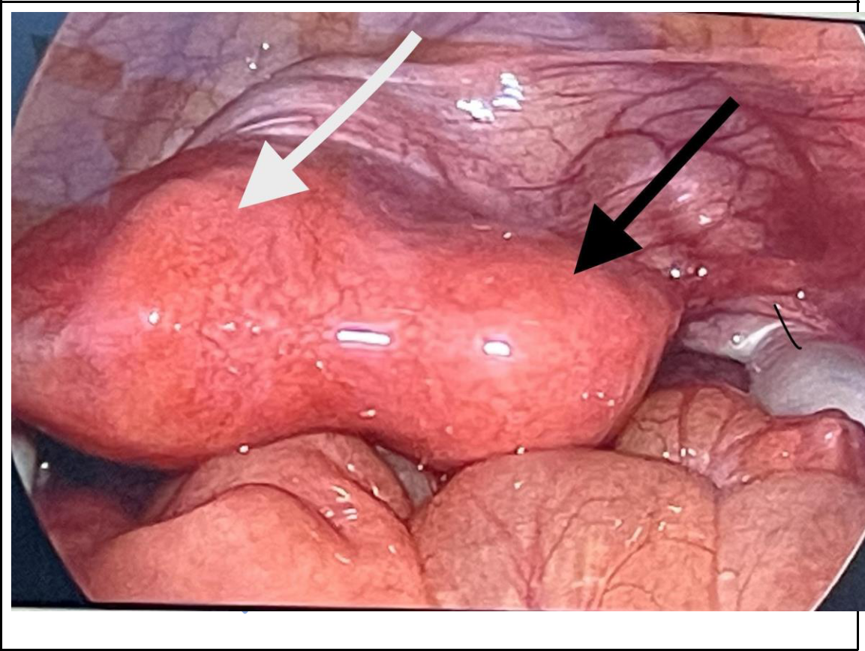

Figure 2: Laparoscopic excision of right non communicating functional rudimentary horn

Page 6 of 7

7

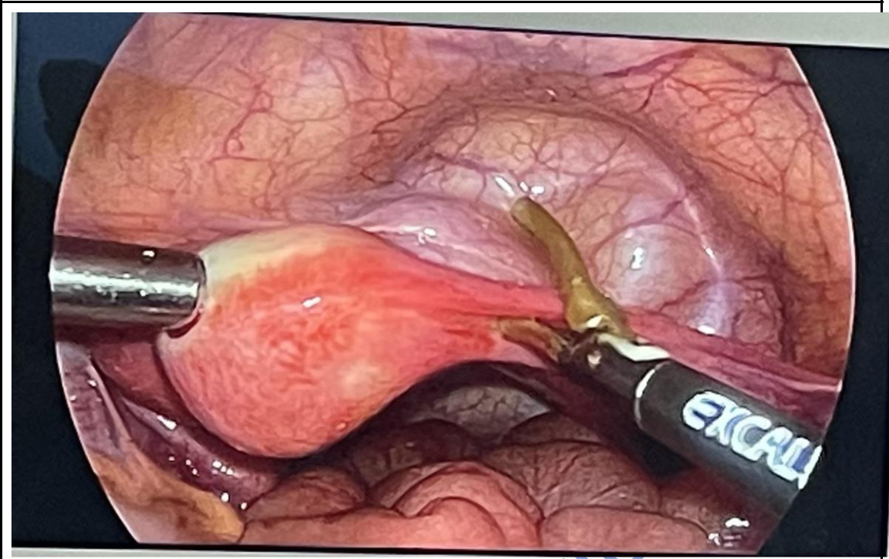

References:

- Nagshabandi ZK, Isaac B, Begum I. Unicornuate uterus with rudimentary horn as a rare etiology of secondary dysmenorrhea: A case report. Dubai Med J [Internet]. 2021;5(1):50–3. Available from: http://dx.doi.org/10.1159/000519872

- Ambusaidi Q, Jha C. Pregnancy in the Rudimentary Uterine Horn: Case report of an unusual presentation. Sultan Qaboos Univ Med J [Internet]. 2014;14(1):e134-8. Available from: http://dx.doi.org/10.12816/0003349

- Obeidat RA, Aleshawi AJ, Tashtush NA, Alsarawi H. Unicornuate uterus with a rudimentary non-communicating cavitary horn in association with VACTERL association: case report. BMC Womens Health [Internet]. 2019;19(1):71. Available from: http://dx.doi.org/10.1186/s12905-019-0768-4

- Khanna V, D’Souza J, Tiwari SS, Sharma RK, Shrivastava AK. Unicornuate uterus with an obstructed rudimentary horn: A report of two cases with an imaging perspective. Med J Armed Forces India [Internet]. 2013;69(1):78–82. Available from: http://dx.doi.org/10.1016/j.mjafi.2012.02.015

Page 7 of 7

