Nanomaterials for Sustainable Pollution Management

Abstract
Nanomaterials offer promising solutions for environmental remediation due to their unique properties at the nanoscale. One prevalent technology involves the use of nanoparticles for the removal of pollutants from air, water, and soil. Different nanoparticles such as carbon nanotube, grapheme, titanium dioxide etc. enabling the degradation of organic pollutants under ultraviolet light. This photocatalysis process offers a sustainable method for wastewater treatment. Additionally, nano-enabled membranes have been developed for water purification, utilizing nanomaterials like zeolites or metal-organic frameworks to selectively filter out contaminants while allowing water molecules to pass through. Despite their efficacy, challenges such as potential toxicity and environmental impact need to be carefully addressed. Nevertheless, nanomaterial-based remediation technologies hold significant promise for addressing environmental pollution due to their high efficiency, selectivity, and versatility in tackling various types of contaminants.

Keywords: Nanomaterials; Water remediation; Air remediation; Soil remediation; Photocatalysis

- Introduction
Nanomaterials are materials that have unique properties and behavior due to their nanoscale dimensions. They are typically composed of nanoparticles, which are particles with sizes ranging
from 1 to 100 nanometers [1]. The field of nanomaterials has gained significant attention in recent years due to their wide range of applications and potential impacts on various industries. Many materials, such as metals, metal oxides, carbon-based mat erials, polymers, and ceramics, can be combined to create nanomaterials. Every substance gives the produced nanoparticles certain properties. Due to the quick speed of industrialization and the byproducts it produces, the environment has been impacted by the release of toxic gas fumes, smoke, and hazardous waste. Adsorption, biological oxidation, chemical oxidation, and incineration are the conventional methods used to treat various forms of organic and hazardous waste [2]. A method called super-critical water oxidation (SCWO) has been proposed as a means of eliminating a variety of organic hazardous waste. It has been receiving attention due to its ability.to destroy a large variety of high-risk wastes resulting from munitions demilitarization and complex industrial chemicals processing. The quality of water and air in the natural environment is significantly impacted by nanomaterials in their many sizes, morphologies, and forms. The ability of magnetic nano adsorbents to be readily retained and separated from treated water makes them very appealing [3] possess distinct patterns of disordered surface areas and reactive surface sites. Furthermore, it has been demonstrated that some synthetic and natural nanomaterials, such as carbon nanotubes (CNTs), silver nanoparticles (nAg), photocatalytic TiO₂, and chitosan, possess potent antibacterial qualities. The detection of pesticides and heavy metals (such as cadmium, copper, lead, mercury, arsenic, etc.) is another application of nanotechnology. Additionally, the redox and photocatalytic characteristics of nanomaterials are improved. Mechanical alloying, grinding, and milling processes, physical or chemical vapor deposition or vacuum evaporation, sol-gel chemical synthesis techniques, gas-phase synthesis techniques, including electro explosion, plasma synthesis, pyrolysis, and laser ablasion; and microwave or combustion methods can all be used to fabricate nanomaterials or delamination (the regulated crystallization of amorphous predecessors) of layered materials [4]. Therefore, in order to get beyond the restrictions of NPs, hybrid nano-composites have been created by coating or impregnating the tiny particles onto larger solid particles. Because of the interaction between the nanoparticles and the matrix, the resulting polymer-based nanocomposite (PNC) maintains the intrinsic qualities of the nanoparticles while offering increased stability, processability, and enhancements. A variety of pollutants and pathogens may be prevented from passing through the membrane by the potential size grading caused by the integrated nanoporous materials . Additionally, nanofibers have the capacity to capture considerably smaller pollutants and offer better filtration with a much smaller porosity. Compared to typical filter materials, nanofibers have substantially larger interior surface areas. An overview of nanomaterial applications in environmental remediation, pollutant sensing and detection, cleaner production, and related topics is given in this study. Nanomaterials can be used to purify air and water that have been contaminated by harmful metal ions, organic and inorganic solutes, bacteria, viruses, and greenhouse gases [5].Nanomaterials are also used in the detection, treatment, and prevention of new environmental pollutants. They can be employed as a "super adsorbent" for numerous substances or to chemically alter pollutants in order to treat a variety of polluted media. Additionally, they are essential and prospective contributors to the creation of quick and accurate environmental sensors that may be used to both inactivate dangerous germs and identify pollutants at the molecular level. Nanoparticles, with their vast surface area, are an excellent way to change environmental toxins that are not conducive to detoxification, thus solving the problem of remediating soil and groundwater. But there are technological issues that need to be resolved, such as getting the particles to their intended location. Furthermore, it is concerning when significant amounts of artificial nanoparticles are released into the soil before undergoing comprehensive testing for toxicity to humans and ecosystems [6]. As of right now, the only commercially effective use of nanomaterials in soil and groundwater remediation is nano-zero-valent iron (nZVI). Nanomaterials are also used in the detection, treatment, and prevention of new environmental pollutants. They can be employed as a "super adsorbent" for numerous substances or to chemically alter pollutants in order to treat a variety of polluted media. Additionally, they are essential and prospective contributors to the creation of quick and accurate environmental sensors that may be used to both inactivate dangerous germs and identify pollutants at the molecular level. Whether or not this is an effective regulatory approach, local environmental and public health agencies will probably have substantial difficulties handling nanotechnology risk issues. Data shortages pose a difficulty for downstream federal statutes, including the CWA, CAA, and RCRA. States and municipalities will probably be responding to any future environmental issues relating to nanotechnology [7].

2. Types of Nanomaterials
2.1 Nanoparticle
Nanoparticles, also known as nanoscale particles, are tiny structures with dimensions ranging from 1 to 100 nanometers. Because of their small size and high surface-to-volume ratio, they display unique physical and chemical properties. A wide range of materials, including metals, metal oxides, polymers, and compounds made from carbon, can be used to produce nanoparticles. Because of their exceptional qualities, nanoparticles have drawn a lot of interest from a variety of sectors. Due to their small size, they have the ability to interact molecularly with other substances, resulting in them being extremely reactive and able to exhibit special optical, electrical, magnetic, thermal, and catalytic capabilities. Because of these characteristics, nanoparticles are perfect for a wide range of uses, such as sensing technologies, energy storage devices, imaging of biology and treatments, electronics, and cleanup of the environment. The enormous surface area-to-volume ratio of nanoparticles is one of their main advantages. Effective adsorption or interaction with target molecules or environmental pollutants is made possible by this property [8]. For example, nanoparticles can be employed as adsorbents or catalysts to remove pollutats in environmental remediation applications like water treatment or air purification systems. This is because their vast surface area offers pollutant molecules lots of places to bind or react. The particular application needs to dictate which material to use for nanoparticles. Because of their exceptional durability and catalytic activity, metal-based nanoparticles such as titanium dioxide (TiO₂), iron (Fe), silver (Ag), and gold (Au) have been extensively studied for environmental remediation applications. For instance, by releasing antimicrobial silver ions into the water matrix, silver nanoparticles have been employed to disinfect water. The unique qualities of nanoparticles make them great instruments for a range of environmental remediation tasks, such as the decomposition of organic pollutants and the removal of heavy metals. Their strong reactivity and wide surface area-to-volume ratio enhance their ability to interact with or capture specific pollutants that are found in water or soil sources. The special properties of nanoparticles make them excellent tools for many kinds of environmental remediation applications, including the removal of heavy metals and the breakdown of organic contaminants. Their capacity to interact with or absorb particular contaminants found in water or soil sources has been enhanced by their strong reactivity and substantial surface area-to-volume ratio [9].
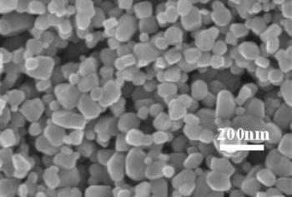
Figure 1: TiO₂ nanoparticle[n]
2.2 Nanostructured material
Materials with a specified structure at the nanoscale are commonly referred to as nanostructured materials. Their small size and high surface-to-volume ratio provide them with exceptional mechanical, chemical, and physical features. In this post, we shall examine many kinds of nanostructured materials and their uses. Nanoparticles are one kind of nanostructured material. Solid particles having sizes between one and one hundred nanometers are called nanoparticles. Molecules such as metals, metal oxides, polymers, and carbon-based compounds can all be used to create them. Applications for nanoparticles are numerous and include environmental remediation, electronics, energy storage, and medicine [10]. One type of nanostructured material is nanoparticles. Nanoparticles are solid particles with dimensions ranging from 1 to 100 nanometres. They can be made from various materials such as metals, metal oxides, polymers, and carbon-based materials. Nanoparticles have diverse applications in fields like medicine, electronics, energy storage, and environmental remediation. Semiconductor nanostructures are another class of nanostructured materials with interesting electrical and optical properties. Quantum dots (QDs) are semiconductor nanoparticles with size-tunable emission colors and high photostability. QDs find applications in optoelectronic devices like light-emitting diodes (LEDs), solar cells, biological imaging agents, and sensor platforms. In addition to QDs, Nanowires exhibit unique electronic, optical, and thermal properties, making them attractive for applications in nanoelectronic devices, sensors, catalysis, and energy storage. Among the carbon-based nanostructures are graphene sheets, graphene oxide (GO), and carbon nanotubes (CNTs)[11]. Graphene is a two dimensional material with a high surface area and excellent electrical conductivity that finds use in gas sensing platforms, catalytic reactions, and electronics. CNTs possess exceptional mechanical strength and electrical conductivity, making them suitable for applications in electronics, aerospace engineering, and energy storage devices such as supercapacitors or batteries. When compared to their bulk counterparts, polymeric nanostructures, which are made up of polymer chains arranged at the nanoscale, offer unique mechanical and chemical properties. Methods like template synthesis or self-assembly can be used to construct these structures. Numerous applications, including drug delivery systems, scaffolds for tissue engineering, sensor platforms, catalysis, etc., use polymeric nanostructures.
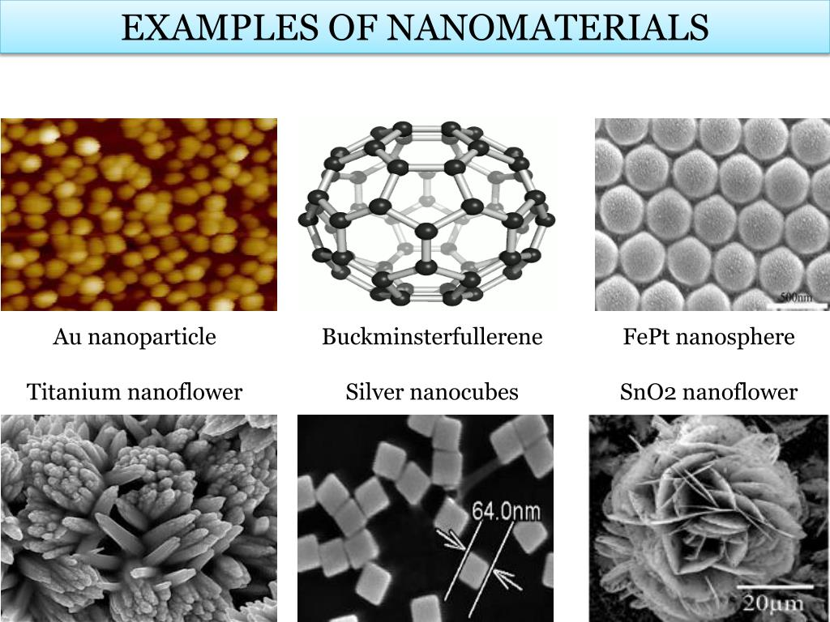
Figure 2: Nanostructure material
Polymeric nanostructures that integrate self-assembling polymer particles facilitate effective medication administration to certain tissues, augmenting therapeutic outcomes while mitigating adverse effects. Inorganic-organic hybrids have a variety of physical-chemical properties that make them useful for gas adsorption, catalysis, and sensor platforms

  - Nanocomposite
Composite materials that combine nanoparticles or nanoscale components with a matrix material are called nanocomposites. Because of their improved qualities and reactivity towards pollutants, these nanocomposites demonstrate considerable potential in environmental remediation. This article will cover the many kinds of nanocomposites and their references that are employed in environmental remediation [12].
    - Metal based nanocomposite
Metal nanoparticles, such as zero-valent iron (nZVI), have been extensively investigated for environmental remediation due to their strong reactivity and capacity to break down a wide range of organic pollutants. Metal-based nanocomposites are produced when these metal nanoparticles are mixed with a matrix material, such as polymers or porous materials. This higher efficacy in pollutant removal is a result of these nanocomposites' improved stability and dispersibility [13].
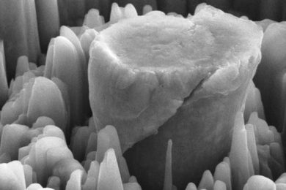

Figure 3: Magnesium based structural metal nanocomposite

    - Carbon based nanocomposite
Carbon-based nanomaterials, such as graphene oxide (GO) and carbon nanotubes (CNTs), are well-suited for environmental remediation applications due to their unique characteristics, namely their large surface area and adsorption capacity. The efficient adsorption of pollutants is rendered possible by the durability of these carbon-based nanomaterials when they are incorporated into polymer matrices or other support structures[14].
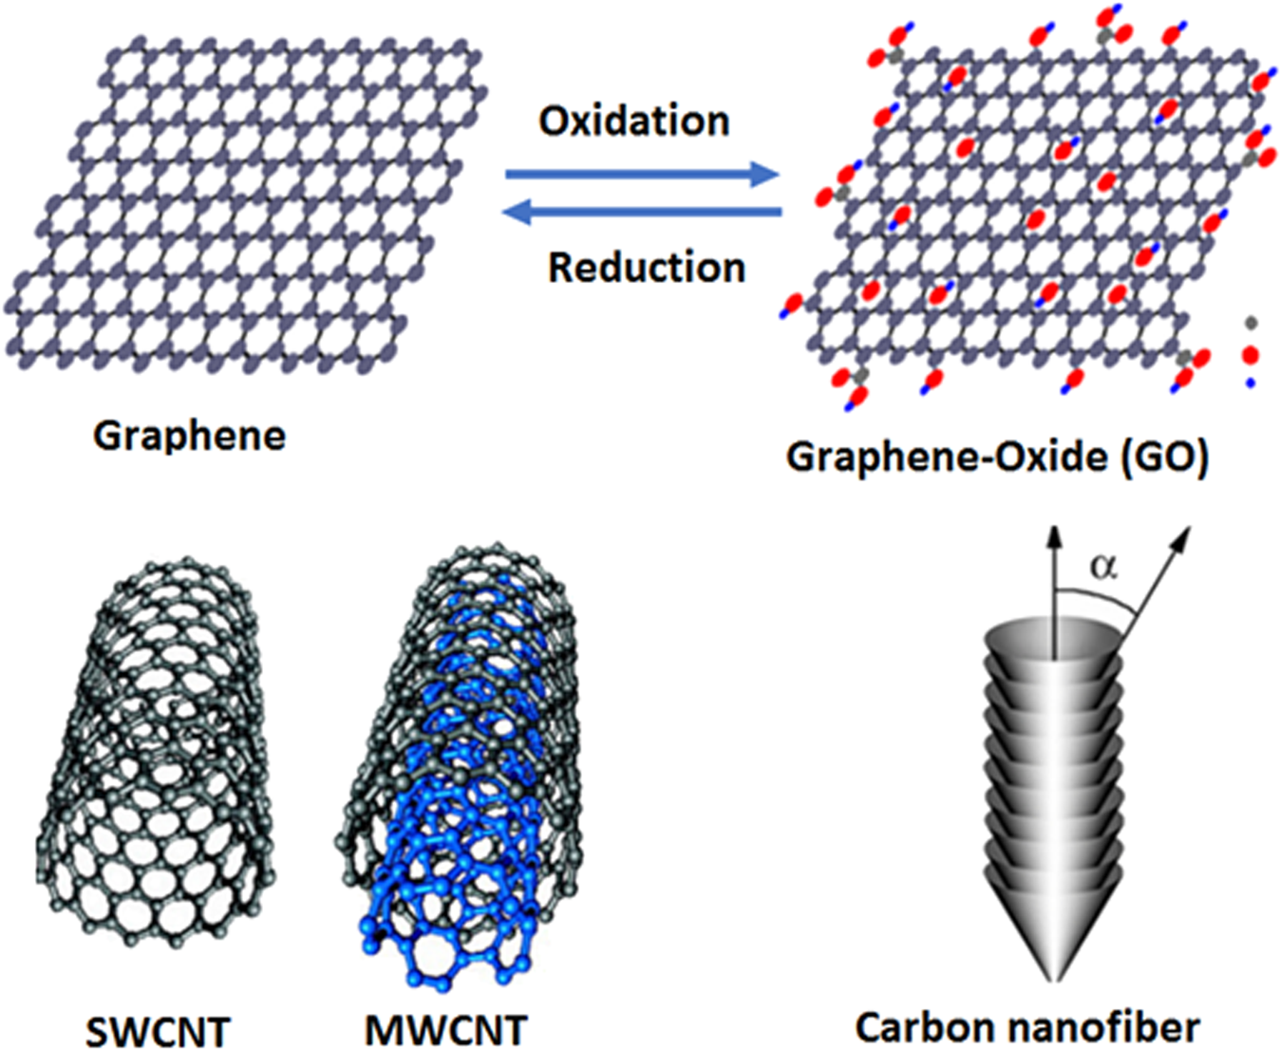
Figure 4: Carbon based nanocomposite for waste water treatment
    - Clay based nanocomposite
Clay-based nanocomposites can be created by adding nanoparticles to the surfaces of clay minerals, like montmorillonite or halloysite. Because the integrated nanoparticles have a larger surface area, these clay-based nanocomposites show better adsorption capabilities for organic pollutants and heavy metals[15].

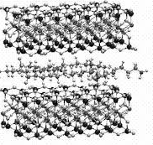
Figure 5: Clay based nanocomposite

- Characterization Technique for Nanomaterials
Nanomaterial characterization methods are essential for understanding the structure, behaviour, and properties of these materials at the nanoscale. These methods give scientists the ability to work with and analyze materials that have sizes between one and one hundred nanometers. Researchers can enhance the properties of nanomaterials for a variety of uses, like electronics, medicine, energy storage, and catalysis, by characterizing them.
The purpose of this article is to give an overview of the numerous characterization methods for nanomaterial research. The imaging techniques that here include transmission electron microscopy (TEM) and scanning electron microscopy (SEM), spectroscopic techniques like Raman spectroscopy and X-ray photoelectron spectroscopy (XPS), diffraction techniques like electron diffraction (ED) and XRD, thermal analysis techniques like thermogravimetric analysis (TGA) and differential scanning calorimetry (DSC), and surface analysis techniques like atomic force microscopy (AFM) and X-ray reflectivity[16].

3.1 Scanning electron microscope
A scanning electron microscope is a powerful scientific instrument used to investigate the surface structure and topography of various materials at high magnification. It utilizes a beam of electrons instead of light to achieve much higher resolution and depth of field compared to traditional optical microscopes. Electron sources, electromagnetic lenses, scanning coils, detectors, and an image handling computer system comprise the fundamental components of a scanning electron microscope. A tungsten filament or a more advanced field emission gun (FEG) are commonly used as the electron source because they both release electrons when heated by electricity.
High voltages in the SEM chamber accelerate the electrons that are released in the opposite direction of the sample surface. The electrons interact with the atoms in the sample material through a variety of interactions because of their high energy and wave-like properties. These interactions include elastic scattering, inelastic scattering (which generates X-rays), secondary electron emission (which produces an imaging signal), and backscattered electrons (which offer compositional information). Electromagnetic lenses are used to focus the primary beam onto a tiny area of the sample surface. Following that, in a raster pattern, the concentrated beam is moved across various spots on the sample by the scanning coils. Depending on how the incident electrons interact with every region on the surface, different signals are generated as this takes place. Secondary electron emission is the imaging signal that is most frequently used. When primary electrons undergo blasting into near-surface regions, these low-energy electrons are released. Fine qualities and topographical details about the surface can be shown in intricate images created by gathering these secondary electrons with specific detectors positioned above or below the sample.
Backscattered electrons can also be detected and used to provide additional compositional contrast in SEM images since they depend on atomic number differences between different materials within the sample.



Figure 6: Scanning electron microscope
Numerous fields, such as materials science, nanotechnology research, geology study, forensic analysis, biological research (using particular preparation techniques), semiconductor industry inspection/characterization, and a number of others, find application for scanning electron microscopes [17].
3.2 Transmission electron microscopy
Transmission Electron Microscopy (TEM) is another powerful imaging technique that allows scientists to visualize the internal structure of materials at atomic resolution. An ultra-thin sample goes through via an electron beam, which reacts with the material to form an image on a camera or fluorescent screen. TEM may employ energy-dispersive X-ray spectroscopy or spectroscopy of electron energy loss to offer knowledge about composition, grain boundaries, lattice defects, crystal structure, and nanoparticle size distribution.
An electron gun produces a high-energy electron beam in a transmission electron microscopy, which is then concentrated using electromagnetic lenses on the specimen. Usually, the thin specimen is created through the formation of a thin film on a support grid or by cutting it into extremely thin parts. The specimen's atoms interact with the electrons as they move through it, producing an array of scattering consequences [18].
After that, an imaging device known as an electron detector collects the sent electrons, magnifies the signal it receives, and records it. Detailed details about the sample's shape, composition, and internal structure are given by the generated image. Because TEM can achieve such excellent resolution, this allows researchers to see details at atomic scales. Many scientific domains, like materials science, biology, nanotechnology, and semiconductor research, can benefit by its applications.
Furthermore, to learn more about the chemical composition or crystallographic structure, respectively, TEM can be used when combined with other methods such as energy-dispersive X-ray spectroscopy (EDS) or electron diffraction. the chemical composition or crystallographic structure, respectively, TEM can be used together with other methods such as energy-dispersive X-ray spectroscopy (EDS) or electron diffraction[19].
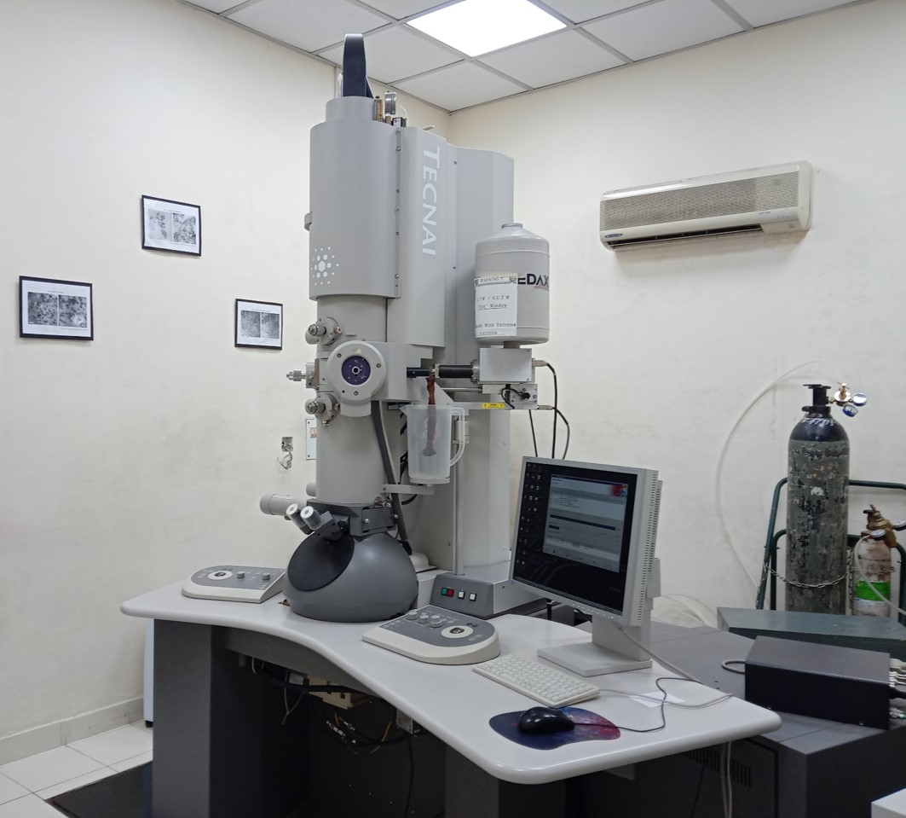
Figure 7: Transmission electron microscope (tem)
Usually, the thin specimen is created through the formation of a thin film on a support grid or by cutting it into extremely thin parts. The specimen's atoms interact with the electrons as they move through it, producing an array of scattering impact. TEM can achieve such excellent resolution, this allows researchers to see details at atomic scales. Many scientific domains, like materials science, biology, nanotechnology, and semiconductor research, can benefit by its applications [19].
  - X-ray diffraction
X-ray diffraction is based on the principle of wave-particle duality, where X-rays behave as both electromagnetic waves and particles called photons. When a beam of X-rays encounters a crystalline sample, it interacts with the regular arrangement of atoms within the crystal lattice. The interaction between X-rays and the crystal lattice leads to constructive interference if certain conditions are met. According to Bragg's law (proposed by father-son duo William
Henry Bragg and William Lawrence Bragg), when X-rays strike a crystal lattice at an angle that satisfies the equation:
nλ = 2dsinθ
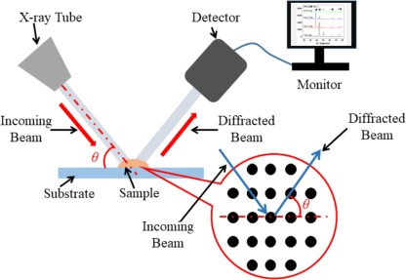
where n is an integer (representing different orders of reflection), λ is the wavelength of incident X-rays, d is the spacing between planes in the crystal lattice (also known as interplanar spacing), and θ is the angle between incident X-rays and reflecting planes; then constructive interference occurs.

Figure 8: X-ray diffraction
A detector screen behind the crystal exhibits a pattern of bright spots known as diffraction patterns or diffraction peaks as a result of this occurrence. Interplanar spacing (d) can be determined using Bragg's rule by measuring these angles (θ) at which constructive interference occurs for various values of n (e.g., n = 1 for first-order reflection).
A detector screen behind the crystal shows a pattern of bright spots known as diffraction patterns or diffraction peaks as a result of this occurrence. Interplanar spacing (d) can be determined using Bragg's rule by measuring these angles (θ) at which constructive interference occurs for various values of n (e.g., n = 1 for first-order reflection). By carefully examining these diffraction patterns and applying mathematical techniques such as Fourier transformation or direct methods, researchers are able to determine crucial details about the atomic arrangements within crystals, such as bond lengths, bond angles, packing arrangements, unit cell dimensions, and symmetry elements[20].
X-ray diffraction experiments can be performed using various types of instruments such as powder diffractometers or single-crystal diffractometers depending on whether powdered samples or single crystals are being investigated respectively. In powder diffractometry experiments, finely powdered samples are used so that all possible orientations contribute to obtain overall structural information. Conversely, single-crystal diffractometry entails the attachment of individual crystals to goniometer heads, enabling accurate rotation alignment for the acquisition of data from particular locations within single crystals.
X-ray sources commonly used include rotating-anode generators or synchrotrons which provide intense beams with high photon fluxes over broad energy ranges enabling detailed analysis for small samples with low scattering power [21].
- Traditional methods of removing pollutants and their side effects
Traditional methods like coagulation, adsorption, and advanced oxidation processes combined with electrochemical and biological processes have been used before the revelation of Nano biotechnology.
Adsorption is a fundamental process that plays a crucial role in removing pollutants from water and air. Unlike coagulation and flocculation, which involve the aggregation of particles to form larger masses for easier removal, adsorption works on the principle of molecules adhering to the surface of a solid substance. This process is widely used in various industries and environmental remediation efforts due to its effectiveness in removing a wide range of pollutants. Imagine you have a sponge. When you dip the sponge in water, it absorbs the liquid, trapping it within its pores. Similarly, adsorption involves the trapping of pollutants onto the surface of a solid material, often referred to as an adsorbent [22]. This adsorbent can be a natural material like activated carbon derived from coconut shells or synthetic materials like zeolites. The mechanism behind adsorption is based on the attractive forces between the molecules of the pollutant and the surface of the adsorbent. These forces can be physical (Van der Waals forces) or chemical (electrostatic interactions, hydrogen bonding, etc.). When the pollutant molecules come into contact with the surface of the adsorbent, they adhere to it, effectively removing them from the surrounding medium. One of the key advantages of adsorption is its versatility. It can effectively remove both organic and inorganic pollutants from water and air. Organic pollutants such as pesticides, dyes, and pharmaceuticals can be adsorbed onto the surface of activated carbon, while heavy metals like lead, cadmium, and arsenic can be removed using specific adsorbents designed to target these contaminants [23].
Moreover, adsorption is a highly efficient process that can achieve high pollutant removal rates even at low concentrations. This makes it particularly suitable for treating water and air streams with low pollutant levels, where other methods like coagulation and flocculation may not be as effective.Another advantage of adsorption is its ability to selectively target specific pollutants. By choosing the appropriate adsorbent material and optimizing operating conditions such as pH and temperature, it is possible to tailor the adsorption process to remove specific contaminants of concern while leaving other substances unaffected[24].
Heterogeneous photocatalysis is a method that uses special materials like titanium dioxide, zinc oxide, and others to clean up pollution usin g sunlight. These materials break down pollutants into harmless compounds and even remove things like inorganic chemicals and halide ions that can be harmful. Ozonation is another way to clean up pollution, especially pesticides. It works by using ozone to break down harmful chemicals, reducing their impact on the environment. This process is great at removing pollutants and making the water safer.Electrochemical processes are traditional methods for cleaning up pollution, too. Electrocoagulation uses a special metal anode to treat water, which helps remove pollutants without making the water too salty. It's easy to use, produces less sludge, and requires fewer chemicals. Electrochemical Advanced Oxidation Processes take it a step further by completely breaking down pollutants using electricity and special catalysts. This method is environmentally friendly and can be automated for large-scale use. Electrokinetic remediation is a technique used to clean up areas contaminated with pollutants. It helps separate and remove both organic and inorganic pollutants from the soil or water, making the environment cleaner and safer for everyone [25].
Direct oxidation processes, which involve directly breaking down pollutants, aren't commonly used because they're not very effective at getting rid of organic pollutants. However, they do produce powerful oxidizing agents that can be used in other processes to clean up pollution indirectly.Biological methods are a popular choice for removing pollutants because they're affordable and environmentally friendly. They've been around for a while, so we know a lot about how they work, and they can be adapted to fit the needs of different communities. These biological methods can also be combined with other techniques, like wet air oxidation or ozonation, to make them even more effective at removing pollutants that are especially toxic or hard to break down. This combination approach increases efficiency and ensures better removal of harmful substances from the environment. So, while direct oxidation processes might not be the best option on their own, they can still play a role in helping to clean up pollution indirectly. And biological methods, with their low cost and green nature, remain a reliable and widely used approach for tackling pollution problems [26].

Environmental and health consequences of pollutants
In recent decades, with the development of advanced technology, trace contaminants have been identified and examined. Pollutants like plastics and chemicals that are dumped onto land without permission pose serious risks to the natural world and its inhabitants. These pollutants, which include plasticizers and aromatic hydrocarbons, are dangerous because they can alter living things and potentially have a role in the onset of cancer. Additionally, they upset the delicate soil balance, which hinders plant growth and ultimately reduces food harvests. It is necessary to look more closely at the contaminants involved, their effects on the ecosystem, and potential mitigating techniques in order to fully understand the repercussions of illegal dumping. Aromatic hydrocarbons are organic compounds containing benzene rings, commonly found in petroleum products and industrial processes. Plasticizers, on the other hand, are additives used to increase the flexibility and durability of plastics. While both substances serve various industrial purposes, their disposal without proper regulation can have dire consequences. When these pollutants are dumped onto land, they can leach into the soil and groundwater, contaminating essential resources for both humans and wildlife [27].
Aromatic hydrocarbons, for example, are known to persist in the environment for long periods, posing a threat to ecosystems and human health. Exposure to these chemicals can result in harmful effects such as DNA damage, reproductive problems, and neurological disorders.
When these pollutants are dumped onto land, they can leach into the soil and groundwater, contaminating essential resources for both humans and wildlife. Aromatic hydrocarbons, for example, are known to persist in the environment for long periods, posing a threat to ecosystems and human health. Exposure to these chemicals can result in harmful effects such as DNA damage, reproductive problems, and neurological disorders. Plasticizers, likewise, can have detrimental effects on the environment. As plastics degrade, they release toxic additives into the soil and water, posing risks to aquatic life and ecosystems. Moreover, microplastics tiny plastic particles that result from the breakdown of larger plastic items can accumulate in soil and water, leading to widespread pollution and potential harm to wildlife. One of the most significant impacts of unauthorized dumping is its effect on soil quality and fertility. Soil serves as the foundation for agriculture, providing essential nutrients and support for plant growth. When contaminated with pollutants, however, soil loses its ability to sustain healthy plant life. Aromatic hydrocarbons and plasticizers can alter soil pH, nutrient levels, and microbial activity, inhibiting seed germination and root development [39].Additionally, these pollutants can interfere with essential biological processes in plants, such as photosynthesis and nutrient uptake, further compromising their growth and productivity. As a result, crop yields may decline, leading to food shortages, economic losses, and social instability. To address the challenges posed by unauthorized dumping, proactive measures must be taken at various levels. Strict regulations and enforcement mechanisms are needed to prevent the illegal disposal of pollutants and hold perpetrators accountable for their actions. Public awareness campaigns can also play a crucial role in educating communities about the importance of proper waste management and environmental stewardship [29].
Furthermore, investment in sustainable practices and technologies is essential to minimize the generation of hazardous waste and promote the adoption of cleaner alternatives. This includes investing in recycling infrastructure, developing eco-friendly alternatives to conventional plastics, and supporting research into innovative remediation techniques for contaminated sites.The presence of mutagenic and carcinogenic pollutants like heavy metals (zinc, cadmium, lead), chemical pesticides, and fertilizers in terrestrial ecosystems decreases agricultural productivity by affecting seed dormancy and overall plant health. Municipal sewage and intensive farm fertilization exacerbate this issue, leading to increased levels of pollutants in groundwater through leaching. This contamination not only poses risks to human health but also affects the quality of water resources. Nutrient runoff from land areas contributes to water nutrient enrichment, leading to eutrophication, which disrupts aquatic ecosystems. Furthermore, areas contaminated with radioactive pollutants face heightened risks of forest fires due to the altered ecosystem dynamics caused by pollution. These interconnected environmental challenges underscore the urgent need for comprehensive management strategies to mitigate pollution's impacts on terrestrial ecosystems, safeguard water resources, and reduce the risk of ecological disasters like forest fires [30].
New pollutants entering aquatic bodies, like pesticides, synthetic fertilizers, sdyes, detergents, and heavy metals, pose risks to human health. When water becomes eutrophic, meaning it's overly rich in nutrients like nitrogen, it can cause skin and eye irritation, stomach inflammation, and vomiting. High nitrogen levels can even lead to "Blue Baby Syndrome," which reduces the oxygen-carrying capacity of infants' blood, posing serious health risks.Heavy metals found in drinking water, such as arsenic, lead, mercury, and phthalates, can disrupt the body's hormonal balance, leading to neurological or reproductive issues. These pollutants can mimic, block, or interfere with natural hormones, causing adverse health effects [31].
Another concerning pollutant is PFAS (per- and polyfluoroalkyl substances), which has been linked to infertility, thyroid problems, cancer, and obesity. These substances can accumulate in the body and cause long-term health issues. Contaminated water can also spread diseases like diarrhea, cholera, typhoid, malaria, and even cause congenital problems in newborns. It's crucial to address these pollutants to protect both the environment and human health. Measures such as proper waste management, reducing the use of harmful chemicals, and investing in water treatment technologies are essential to mitigate these risks and ensure clean and safe water for everyone. This contamination not only poses risks to human health but also affects the quality of water resources. Nutrient runoff from land areas contributes to water nutrient enrichment, leading to eutrophication, which disrupts aquatic ecosystems.
Furthermore, areas contaminated with radioactive pollutants face heightened risks of forest fires due to the altered ecosystem dynamics caused by pollution. These interconnected environmental challenges underscore the urgent need for comprehensive management strategies to mitigate pollution's impacts on terrestrial ecosystems, safeguard water resources, and reduce the risk of ecological disasters like forest fires. Another concerning pollutant is PFAS (per- and polyfluoroalkyl substances), which has been linked to infertility, thyroid problems, cancer, and obesity. These substances can accumulate in the body and cause long-term health issues Additionally, they upset the delicate soil balance, which hinders plant growth and ultimately reduces food harvests [32].
It is necessary to look more closely at the contaminants involved, their effects on the ecosystem, and potential mitigating techniques in order to fully understand the repercussions of illegal dumping. Aromatic hydrocarbons are organic compounds containing benzene rings, commonly found in petroleum products and industrial processes. Plasticizers, on the other hand, are additives used to increase the flexibility and durability of plastics.
6. Nanomaterials and Environment
6.1 Nanomaterials for remediation water pollution
Water pollution remediation is a major application of nanomaterials. Their unique features, like their large surface area, reactivity, and ability to adsorb substances, enable them to effectively remove a wide range of pollutants from water [33]. The following are a few notable examples of nanoparticles used for the removal of water pollution.
- Carbon nanotubes
Because of their amazing adsorption abilities, large surface area, and chemical durability, carbon-based nanomaterials have become progressively attractive options for the treatment of water. Particular uses for carbon-based nanoparticles in water purification include the following:
- Adsorption of contaminates
Due to their large surface areas and porosities, carbon nanomaterials like activated carbon, carbon nanotubes (CNTs), and graphene oxide (GO) can adsorb a variety of pollutants, such as organic pollutants, heavy metals, and water-soluble dyes. By offering a sufficient number of active sites for the adsorption process, the large surface area efficiently eliminates pollutants from the water matrix [34].

- Enhanced filtration
Carbon nanomaterials can be incorporated into filtration membranes to enhance their performance. Functionalized carbon nanotubes or graphene can improve the permeability and selectivity of membranes, allowing for more efficient removal of contaminants while maintaining high water flux rates.
- Nanostructured carbon composite
Researchers have developed nanostructured carbon composites by combining carbon nanomaterials with other substances such as polymers or metal nanoparticles. These composites exhibit synergistic effects, leading to enhanced adsorption capacity and selectivity for specific contaminants in water.
- Removable of organic pollutant
Carbon-based nanomaterials are particularly effective in removing organic pollutants such as pesticides, pharmaceuticals, and industrial chemicals from water. The π-π stacking interactions and electrostatic forces between the aromatic structures of carbon nanomaterials and organic pollutants facilitate their adsorption and removal from water.
- Heavy metal removal
Carbon nanomaterials possess high affinity for heavy metal ions due to their surface functional groups and π-electron-rich structures. They can effectively adsorb heavy metals such as lead, cadmium, mercury, and arsenic from water, mitigating their harmful effects on human health and the environment[35].
- Regeneration and reusability
One of the advantages of carbon-based nanomaterials in water purification is their potential for regeneration and reusability. After adsorbing contaminants, these materials can be regenerated through processes such as thermal treatment or desorption, allowing them to be reused multiple times, thus reducing operational costs and minimizing waste generation.

- Point of use water purification device
Carbon nanomaterials can be integrated into point-of-use water purification devices such as filters or cartridges for household or community-level water treatment. These devices offer cost-effective and decentralized solutions for providing clean drinking water, particularly in rural or underserved areas lacking access to centralized water treatment facilities
6.2 Nanomaterials in remediation of air pollution
Through a variety of procedures, such as filtration, catalysis, and photocatalysis, nanomaterials have shown their potential in the remediation of air pollution. The following is how various kinds of air pollution are tackled with nanomaterials:
- Particulate matter(pm) filtration
Filters based on nanoparticles are good at catching airborne particulate matter. Filters are enhanced in gathering efficiency by adding materials like metal oxide nanoparticles, graphene oxide (GO), and carbon nanotubes (CNTs). Because of the high surface area and porosity of these nanomaterials, small particles can be trapped and kept from entering the atmosphere[36].
- Volatile organic compounds (vocs) removal
To remove volatile organic compounds (VOCs) from air streams, nanomaterials such as porous carbon nanoparticles, zeolites, and metal-organic frameworks (MOFs) are used. These nanomaterials' high surface areas and adjustable pore architectures aid in the adsorption of volatile organic substances (VOCs), hence reducing the concentration of these molecules in the air.
- Catalytic conversion of pollutants
When dangerous gases like nitrogen oxides (NOx), carbon monoxide (CO), and volatile organic compounds (VOCs) are transformed into less dangerous molecules, nanomaterials act as catalysts. Because of their distinctive electrical properties and huge surface area, metal nanoparticles supported on different nanocarbons or metal oxides exhibit strong catalytic activity [37].

- Photocatalytic degradation
Under the influence of ultraviolet (UV) light, nanomaterials possessing photocatalytic features, like tungsten trioxide (WO₃), zinc oxide (ZnO), and titanium dioxide (TiO₂), have the ability to breakdown down air contaminants. Upon absorption of light, these nanomaterials generate reactive oxygen species (ROS) that oxidize and break down harmful molecules into safe chemical compounds, effectively cleansing the air.
- Nanomaterial-based sensors
High sensitivity and selectivity air quality monitoring sensors are also developed using nanomaterials. In order to identify different air contaminants in real-time and enable prompt intervention and mitigation actions, carbon nanotubes, metal oxide nanoparticles, and quantum dots are combined into sensor devices.
- Self-cleaning surfaces
Surfaces exposed to air pollution can be cleaned using self-cleaning nanomaterials, such as photocatalytic coatings containing TiO2 or ZnO nanoparticles. When exposed to sunlight, these coatings allow organic contaminants to break down and particle matter to be eliminated, resulting in cleaner and more sustainable urban settings[38].
- Nanofluids for air purification
Air purification systems use nanofluids that contain suspended nanoparticles, including metal or graphene oxide, to successfully eliminate contaminants and transmit heat. In HVAC systems, these nanofluids can be circulated via filters or heat exchangers to improve heat transfer and pollutant removal efficiency. After that, an imaging device known as an electron detector collects the sent electrons magnifies the signal it receives, and records it. Detailed details about the sample's shape, composition, and internal structure are given by the generated image. Because transmission electron microscope can achieve such excellent resolution, this allows researchers to see details at atomic scales. Many scientific domains, like materials science, biology, nanotechnology, and semiconductor research, can benefit by its applications. Through a variety of procedures, such as filtration, catalysis, and photocatalysis, nanomaterials have shown their potential in the remediation of air pollution [39]. The following is how various kinds of air pollution are tackled with nanomaterials. Upon absorption of light, these nanomaterials generate reactive oxygen species (ROS) that oxidize and break down harmful molecules into safe chemical compounds, effectively cleansing the air. These interactions include elastic scattering, inelastic scattering (which generates X-rays), secondary electron emission (which produces an imaging signal), and backscattered electrons (which offer compositional information).
Electromagnetic lenses are used to focus the primary beam onto a tiny area of the sample surface [40].
6.3 Nanomaterial remediation in soil pollution
In the field of soil pollution remediation, nanomaterials have shown great promise in providing creative methods for addressing a variety of contaminants, such as pesticides, heavy metals, organic pollutants, and new toxic substances. They are extremely useful in a variety of remediation techniques due to their special qualities, which include high surface area, reactivity, and adjustable features. The various uses of nanomaterials in the remediation of soil pollution, their modes of action, and the difficulties and challenges accompanying their application are all going to be addressed in this essay.
Adsorption is one of the main methods that nanomaterials clean up soil pollution. With their exceptionally high surface area-to-volume ratios, nanomaterials which includes metal oxide nanoparticles, carbon nanotubes, and graphene oxide, can effectively adsorb pollutants. These tiny particles bond to particular pollutants selectively through chemical and physical interactions, removing them from the soil matrix and decreasing their bioavailability[41].
Adsorption depends on a number of variables, such as the contaminants’ chemical composition and solubility as well as the characteristics of the nanomaterials (e.g., surface chemistry, pore size distribution). The negative impacts of pollutants on the environment and human health can be lessened by storing them and preventing their uptake by plants or circulation into groundwater through using the adsorption powers of nanomaterials. Another significant remediation technique made possible by nanomaterials is chemical degradation. Engineered nanoparticles have the ability to accelerate chemical reactions that break down soil pollutants. For instance, reductive degradation of chlorinated solvents and other organic pollutants is a common application of nanoscale zero-valent iron (nZVI). Hazardous pollutants can be converted into less hazardous or non-toxic compounds by nZVI, which contains a reactive surface and potential electron transfer capabilities[42].
Based on the type of contaminants and the surrounding conditions, the degradation mechanisms could include processes like hydrolysis, photolysis, oxidation, reduction, or hydrolysis. More selectivity, faster reaction rates, and less energy consumption are just a few benefits of using nanomaterial-based catalysis over conventional remediation techniques. But to guarantee the security and efficacy of this strategy, issues like the aggregation and stability of nanoparticles in soil and the possible production of dangerous byproducts must be addressedIn addition, nanomaterials are vital for immobilizing pollutants in soil. Through precipitation or surface complexation reactions, heavy metals and other contaminants can be stabilised by adding nanoparticles like iron oxide and clay minerals to polluted soil. Because of their immobilization, contaminants are less mobile and bioavailable, which lessens the probability that they may seep into groundwater or be absorbed by planting. The kind and concentration of nanoparticles, the characteristics of the soil, and the surrounding environment all affect how effective immobilization is. Techniques for immobilization based on nanomaterials provide an economical and sustainable substitute for conventional methods like excavation and disposal. However, adequate site characterization and monitoring are required to address issues including long-term stability and the potential remobilization of immobilized pollutants. The widespread application of nanoparticles in soil remediation raises concerns with regard to prospective hazards and environmental effects despite their potential benefits. Nanoparticles have the potential to cause unanticipated harm, travel across the environment, and accumulate within living things. Therefore, in order to make sure the safe and long-term use of nanomaterials in soil remediation operations, rigorous risk assessments and environmental impact studies are required [43].
In general, a variety of uses, including adsorption, degradation, immobilization, and monitoring, shows how adaptable and effective nanoparticles are in tackling soil pollution. In order to fully utilize nanomaterials and reduce associated hazards, more research and development in this area is necessary. This will ultimately help to preserve and restore soil quality and environmental health.
Conclusion
Nanoparticles, due to their unique physical and chemical properties at the nanoscale, offer a versatile platform for environmental remediation. Their high surface area-to-volume ratio, tunable surface chemistry, and reactivity make them exceptionally effective in adsorbing, degrading, or transforming pollutants into less harmful substances. Moreover, nanoparticles can be engineered to target specific contaminants, enhancing their selectivity and efficiency in remediation processes. One of the significant advantages of nanoparticle-based remediation is its potential to mitigate the adverse effects associated with conventional methods. Unlike traditional approaches that may generate toxic byproducts or require large amounts of chemicals, nanoparticle-based technologies offer more sustainable and eco-friendly alternatives. Furthermore, nanoparticles can be integrated into hybrid systems, combining different remediation mechanisms to enhance pollutant removal efficiency. However, despite their immense potential, the deployment of nanoparticle-based remediation technologies necessitates careful consideration of potential risks, including nanoparticle toxicity, mobility, and long-term environmental impacts. Nanoparticle-based remediation presents a promising paradigm shift in environmental management, offering efficient and sustainable solutions for mitigating pollution while minimizing adverse impacts on Earth's ecosystems. Continued research, development, and responsible deployment of these technologies are crucial for addressing the pressing challenges of environmental degradation in the 21st century
Data availability

The data that support the findings of this study are available from the corresponding author upon reasonable request.

Declarations

Competing interests: The authors declare that they have no known competing financial interests or personal relationships that could have appeared to influence the work reported in this paper.

Ethical approval
There are no human or animal subjects included in this article.

References
- Guisbiers. G, (2012), Nanomaterial Properties: Size and Shape Dependencies, Journal of Nanoparticle Research, 14:112-125.
- Zhang. B, Zhu. Y, Liu. T, Yu. L, (2020), Recent advances in nanomaterials and their environmental applications: A critical review, Journal of Environmental Management, 258: 110020.
- Zhang. Y, Xu. M, Liu. Q, Li. G, Zhou. S, Li. W, (2016), Recent advances in supercritical water oxidation technology for the treatment of hazardous organic wastes: A review, Chemosphere, 144: 1373-1387.
- Somasundaran. P, Klabunde. KJ, (2001), Applications of nanomaterials in environmental science, Journal of Hazardous Materials, 85: 166-178.
- Pedro. J, Alvarez. J, Lowry. GV, (2009), Nanotechnology applications for environmental challenges, Environmental Science & Technology, 43: 8191-8197.
- Sharma. R, Singh. S, (2020), Nanotechnology applications for environmental challenges, Environmental Science: Nano, 7:764-778.
- Zhang. R, Zhang. Z, Fang. S, Chen. Y, Li. S, (2019), Nanotechnology in soil and groundwater remediation: A review, Journal of Environmental Management, 242:395-405.
- Mekuye. B, (2023), Nanomaterials: An overview of synthesis, classification, and applications, Journal of Materials Chemistry, 4: 486-501.
- Zhang. Y, Wang. Y, Yang. Y, Zhang. H, (2015), Nanoparticles for environmental remediation: A review of potential risks and benefits, Journal of Hazardous Materials, 285:699-709.
- Bhatia. SN, (2004), Nanostructured materials: Basic concepts and applications, Journal of Nanoparticle Research, 6:55-60.
- Yang. L, Chan. CY, Xu. L, Chan. CT, (2002), Semiconductor nanostructures: methods, fabrication, and applications, Nanotechnology, 13: R35-R45.
- Ahmad. M, Ahmad. K, Usman. M, Ahmad. Y, (2017), Nanocomposites in environmental remediation: A review, Journal of Hazardous Materials, 326:55-71.
- Hussain. S, Khan. RSM, Sultan. MS, Khan. N, (2015), Metal nanoparticles and their composites in environmental remediation: A review, Journal of Hazardous Materials, 285:692-709.
- Li. Y, Zhang. L, Yang. GGM, Zhang. S, (2019), Carbon-based nanomaterials for environmental remediation, Chemical Engineering Journal, 360: 155-168.
- Wang. X, Zhang. Y, Zhang. Q, Xie. H, (2014), Clay-based nanocomposites for environmental remediation, Applied Clay Science, 96:105-115.
- Kumar. A, Dixit. PK, Varma. SK, (2009), Characterization methods for nanomaterials: A review, Advances in Colloid and Interface Science, 152:1-15.
- Smith. A, Johnson. B, (2017), Applications of scanning electron microscopy in various fields, Microscopy and Microanalysis, 23:180-181.
- Reimer. L, Kohl. H, (1998), ransmission electron microscopy: a textbook for materials science, Reports on Progress in Physics, 61:1477-1524.
- Hawkes. PW, (2007), Transmission electron microscopy: a textbook for materials science, Ultramicroscopy, 107:503-512.
- Reimer. L, Kohl. H, (1998), Transmission electron microscopy: a textbook for materials science, Reports on Progress in Physics, 61:1477-1524.
- Freund. A, (2019), Rotating anode X-ray generators: current trends and future directions, Journal of Applied Crystallography, 52:665-677.
- Oh. YY, Kang. DH, Lee. J, (2011), Adsorption of Organic Compounds by Carbon Nanomaterials: A Review, Environmental Science & Technology, 45:760-766.
- He. X, Feng. Y, Ren. Q, (2016), Adsorption of Organic and Inorganic Pollutants on Functionalized Nanoporous Materials: A Review, Environmental Science & Technology, 50:6374-6387.
- Liu. Y, Jiang. G, Zhang. Q, (2012), Adsorption of organic pollutants from water using carbon nanotubes: A review, Chemical Engineering Journal, 206-207:111-117.
- Mansouri. M, Faramarzi. MA, Movahedi. AKM, (2017), Review of advanced physical, chemical and biological methods for phenolic compounds removal from different effluents, Chemosphere, 178:155-166.
- SChoudhary. S, Kumar. R, Thakur. AK, (2018), Bioremediation strategies for organic and inorganic pollutants: A review of recent advances, Environmental Science and Pollution Research, 25:3991-4006.
- Herrera. SP, Penuela. GP, Giraldo. LD, (2013), Identification and characterization of plasticizers in human adipose tissues, precipitation, and river water by GC-MS and GC×GC-TOFMS, Environmental Science & Technology, 47:5635-5642.
- Wagner. M, Scherer. C, Lambert. F, (2022), Microplastics in the terrestrial ecosystem: Implications for organisms and ecosystem processes, Environmental Pollution, 292:125465.
- Susnik. J, Elenin. LB, Vuga. J, (2018), Public perceptions of illegal waste disposal and littering: a review of research, Environmental Science & Policy, 90: 27-37.
- Hajek. M, Zhukovskyy. M, (2009), Radioactive contamination of forests in the eastern part of the Ukraine and potential long-term consequences, Environmental Pollution, 157:318-324.
- Braga. L, Almeida. ED, Ribeiro. R, (2010), Emerging pollutants in the environment: Present and future challenges in biomonitoring, ecological risks and bioremediation, Science of the Total Environment, 408:3871-3878.
- Lohmann. R,Cousins. I, Goldenman. G, (2019), r- and Polyfluoroalkyl Substances (PFAS): Their Impact on the Environment and Human Health, Environmental Science & Technology, 53:4785-4805.
- Soltani. P et al, (2019), Nanotechnology for Environmental Remediation: Materials and Applications, ournal of Environmental Management, 230:88-96.
- Golovin. VB et al, (2017), Carbon-based nanomaterials for removal of chemical and biological contaminants from water: A review of mechanisms and applications, Journal of Hazardous Materials, 325:190-215.
- Li. YZ, et al, (2018), Carbon nanomaterials for the removal of heavy metals from water, Environmental Science and Pollution Research, 25:28859-28872.
- Kim. JH, et al, (2016), Nanoparticle filtration performance of NIOSH-certified particulate respirators: evaluation and improvements, Aerosol Science and Technology, 50:560-571.
- Huang. H, et al, (2015), Nanocarbons for the development of advanced catalysts, Chemical Society Reviews, 44:6954-6980.
- Sun. H, et al, (2010), Application of Nanomaterials in Self-Cleaning Technology for Environmental Sustainability, Environmental Science & Technology, 44:5196-5201.
- Khomeiri. M, et al, (2014), A review of applications of nanotechnology in food industry, Journal of Environmental Chemical Engineering, 2:1-9.
- Qilin L et al, (2017), Nanotechnology-Enabled Water Treatment and Its Potential Implications for the Water Sector, Environmental Science & Technology, 51:2538-2553.
- Hafiz MN, Iqbal et al, (2016), Nanomaterials for environmental remediation: A review, Chemical Engineering Journal, 286:618-641.
- Zhu. TG, et al, (2002), Applications of Nanotechnology in Water and Wastewater Treatment, Environmental Science & Technology, 36:728A-734A.
- Deng. B, Zhao. D, (2011), Nanomaterials for Environmental Remediation: Materials Systems and Toxicological Implications, Environmental Science & Technology, 45: 9837-9843.

