VASCULITIS

Introduction
Vasculitis encompasses a diverse group of syndromes characterized by inflammation and damage to blood vessels, which can vary widely based on the size and location of the affected vessels. The clinical presentation of vasculitis may include symptoms such as unexplained ischemic events, mononeuritis multiplex, microscopic hematuria, palpable purpura, pulmonary infiltrates, and sinusitis [23,24].
In the clinical evaluation of vasculitis, it is crucial to distinguish true vasculitis from conditions that mimic its presentation, which can be broadly categorized into infectious and non-infectious causes. Infectious causes include Hepatitis C, HIV, and Syphilis, infective endocarditis, lyme disease , while non-infectious causes encompass Drugs, Malignancy (specifically Adenocarcinoma), genetic and autoimmune disordersand other conditions such as Rheumatoid Arthritis, Inflammatory Bowel Disease, and Hypocomplementemic Urticarial Vasculitis [25].
Pathophysiology
Understanding the pathophysiology and pathogenesis is also vital; major pathogenic mechanisms involve immune complex formation, as well as antineutrophil cytoplasmic antibodies [26]. Additionally, pathogenic T-lymphocyte responses and granuloma formation play a significant role in the development of vasculitis. This structured approach ensures a thorough and accurate diagnosis, guiding effective treatment strategies [27].
In the realm of immunology, antineutrophil cytoplasmic antibodies (ANCA) play a pivotal role in diagnosing various vasculitis disorders [28]. These antibodies target proteins within the cytoplasmic granules of neutrophils and monocytes, leading to two distinct staining patterns: cytoplasmic ANCA (c-ANCA) and perinuclear ANCA (p-ANCA) [29,30]. c-ANCA is characterized by diffuse, granular cytoplasmic staining, often associated with proteinase 3 (PR3), and is seen in over 90% of active cases of granulomatosis with polyangiitis (GPA) as shown in Fig 1(a). On the other hand, p-ANCA shows localized perinuclear staining and is primarily linked with myeloperoxidase (MPO), along with other enzymes like elastase, cathepsin G, lactoferrin, and lysozymeas shown in Fig 1(b). These patterns are not only crucial for diagnosis but also for understanding the pathogenesis of diseases such as GPA, microscopic polyangiitis (MPA), eosinophilic granulomatosis with polyangiitis (EGPA), and isolated crescentic glomerulonephritis.
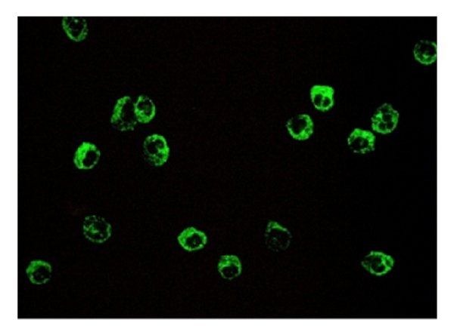
Fig 1(a). Appearance of cytoplasmic indirect immunofluorescence pattern (C-ANCA) on ethanol-fixed human neutrophil cells which is mainly caused by autoantibodies targeting serine protease proteinase-3 (PR3-ANCA)

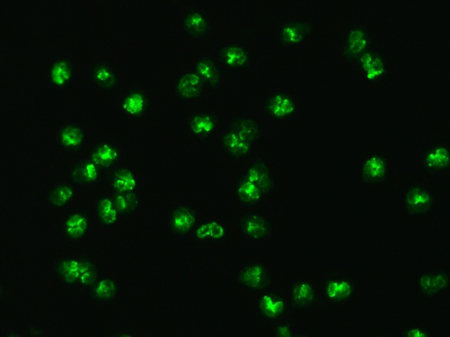
Fig 1(b). Immunofluorescence pattern of MPO or p-ANCA antibodies. Produced using serum from a patient on neutrophils with a FITC conjugate.

Classification
The classification of vasculitis based on vessel size further aids in the precise categorization and treatment of these conditions which is given below Fig 2.
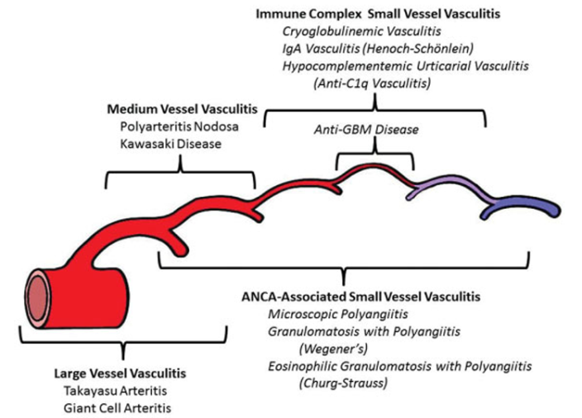

Fig 2 Classification of primary childhood vasculitis based on revised Chapel Hill criteria

While assessing vascular diseases, clinicians consider various clinical presentations that are often categorized by vessel size:
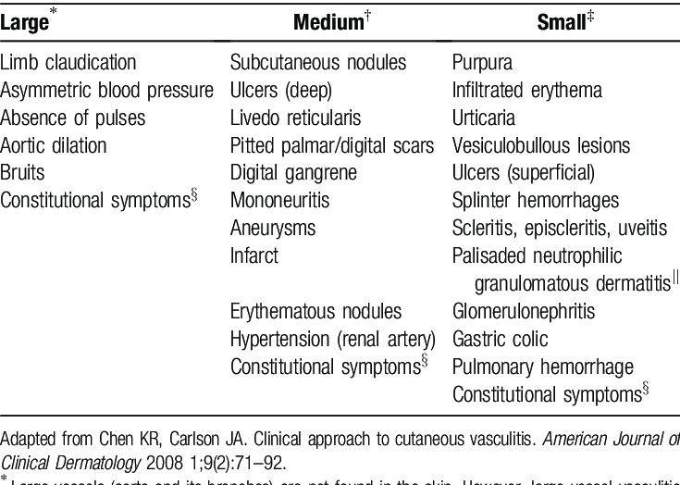
Fig 3 Clinical manifestations of vasculitis based on vessel size affected
Here is a brief discussion about various types of vasculitis
- Giant Cell Arteritis (Temporal Arteritis):
Medium and large sized arteries; mainly carotid branches.
- Incidence and Prevalence:Incidence rates up to 69.3/100,000 per year with onset typically at >50 years. Approximately 40-60% of patients with giant cell arteritis also have polymyalgia rheumatica (PMR)

- Pathology:It involves all layer of arterial wall (Panarteritis) along with mononuclear infiltration of the intima which results in intimal proliferation and fragmentation of the internal elastic lamina.
Pathogenesis:Antigen enters the arterial wall which leads to CD4 cells infiltration through vasa vasorum.These cells further produce interleukin-2 (IL-2) and interferon-gamma (IFN γ) which are responsible for formation of giant cell and granulomas.

Clinical Features:
- Patients present with anorexia, weight loss, fever, malaise, headaches with tenderness of the scalp, polymyalgia rheumatica, sudden blindness (Ischemic Optic Neuropathy - ION) or arm claudications.
Laboratory Findings: Non specific findings including - Elevated ESR, CRP, AOCD, Increased ALP levels, Increased IgG and complement.

- 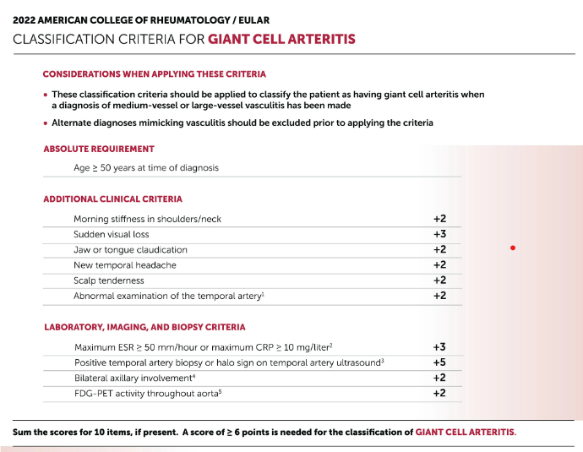
Fig 4. 2022 ACR classification criteria for Giant cell arteritis.
Diagnosis:
Fever + Anaemia + ESR in >50 yrs:
Biopsy is confirmatory but not essential. While taking biopsy length should be considered . For examination different radiological modilities such as CT , MRI angiography and USG can also be used .
Treatment:
Goal of treatment is to Reduce Symptoms and Prevent Vision Loss , to achieve such goal patient can be started on Prednisolone at 40-60mg/day for 1 month, followed by tapering along with aspirin administration . Biologics including Tocilizumab can also be used . In cases of steroid contraindications , sparing agent such as methotrexate can also be used .
- Takayasu Arteritis:
Inflammation and stenotic disease of medium and large sized arteries with strong predilection for aorta and branches
- Incidence and Prevalence:The onset of disease is mainly in adolescent age with a higher prevalence in females of around 1.2-2.6 per 100,000 girls per year.

- Pathology:It affects medium and large arteries at their origin from the aorta. Disease is characterized by panarteritis with inflammatory mononuclear infiltrates, intimal proliferation, and scarring.Stenosis is commonly seen along with vasa vasorum involvement.

- Clinical Features:
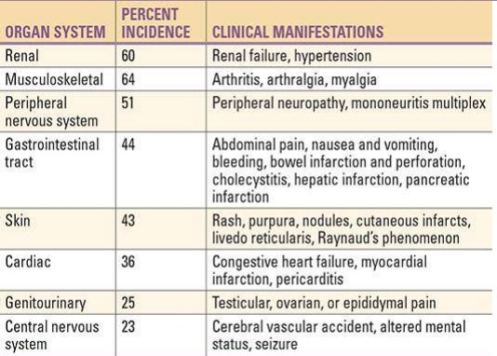

Fig 5 Clinical features of Takayasu arteritis.

- Laboratory Findings:Elevated ESR (erythrocyte sedimentation rate) and CRP (C-reactive protein) , Increased IgG levels.
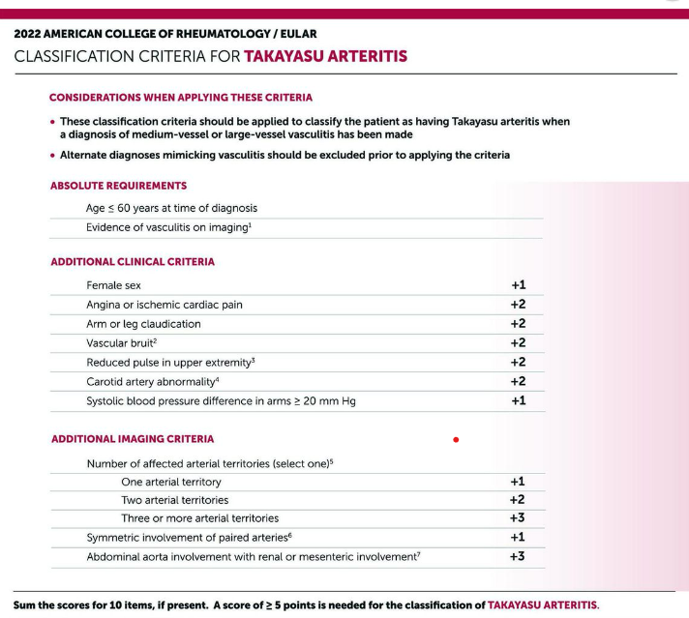
Fig 6. 2022 ACR classification criteria for Takayasu arteritis
Diagnosis: One should raise suspicion of Takayasu arteritis in presence of symptoms including asymmetric pulse, BP differences, and arterial bruits in a young female patient . Arteriography will demonstrate irregular vessel walls and stenosis. The disease need to be differentiate from IgG4-related disease histologically.
Treatment:
- Treatment mainly involves symptom control with prednisolone (40-60 mg/day). In some case a steroid-sparing agent such as methotrexate can be considered. Till now, Tocilizumab has not been proven effective.
- Granulomatosis with Polyangiitis
It is clinicopathological entity characterized by granulomatous vasculitis of upper and lower respiratory tracts with glomerulonephritis . The age of onset is 40 years with a prevalence of 3 per 100000 with similar male to female preponderance.
Pathogenesis:
- Necrotizing Vasculitis involves all types of vessels including small arteries and veins, often accompanied by granuloma formation. Chronic nasal carriage such as staphylococcus aureus is associated with a higher relapse rate of GPA. Elevated levels of IFN-gamma and TNF-alpha secretion from mononuclear cells, indicating an unbalanced Th1 type T cell cytokines.

- Systemic involvement - Pulmonary Involvement is characterized by multiple bilateral nodular cavitary lesions in the lungs. Renal Consequences can lead to focal segmental changes progressing to RPGN, although renal involvement is rarely seen.

The fig 7 given below depicts the classification criteria for granulmatosis with polyangitis given by American college of Rheumatology . A score of more than or equal to 5 is needed for classification of granulmatosis with polyangitis.
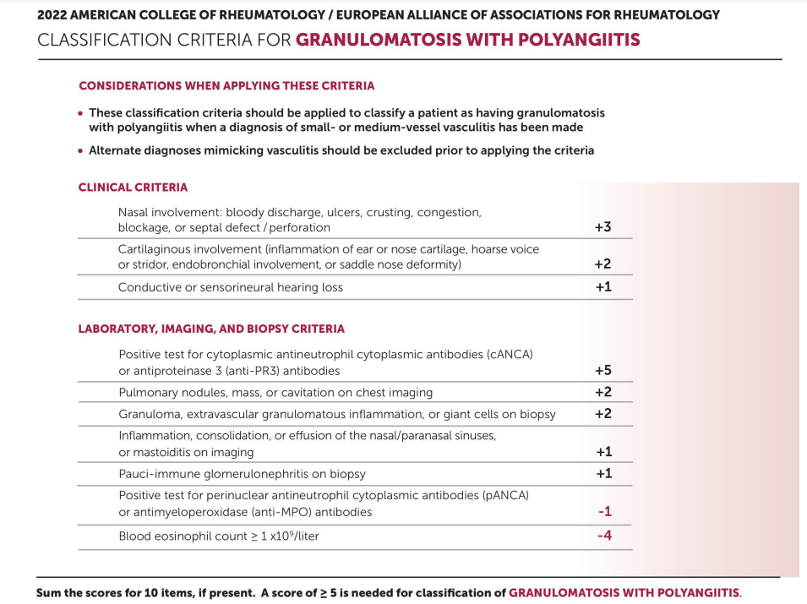
Fig 7. 2022 ACR classification criteria for Granulomatous with polyangitis
Clinical manifestation :
- Upper airway involvement is noted in 95% of cases, with conditions like serous otitis media and subglottic stenosis. Lung involvement in 85-90% of cases, with symptoms like cough and hemoptysis; cardiac complications include hemopericarditis and coronary vasculitis.Skin affected in 46% of cases, CNS in 23%, presenting with mononeuritis multiplex and cranial neuritis. Renal involvement seen in 77% cases with proteinuria, hematuria, and RBC casts. Fig (4)

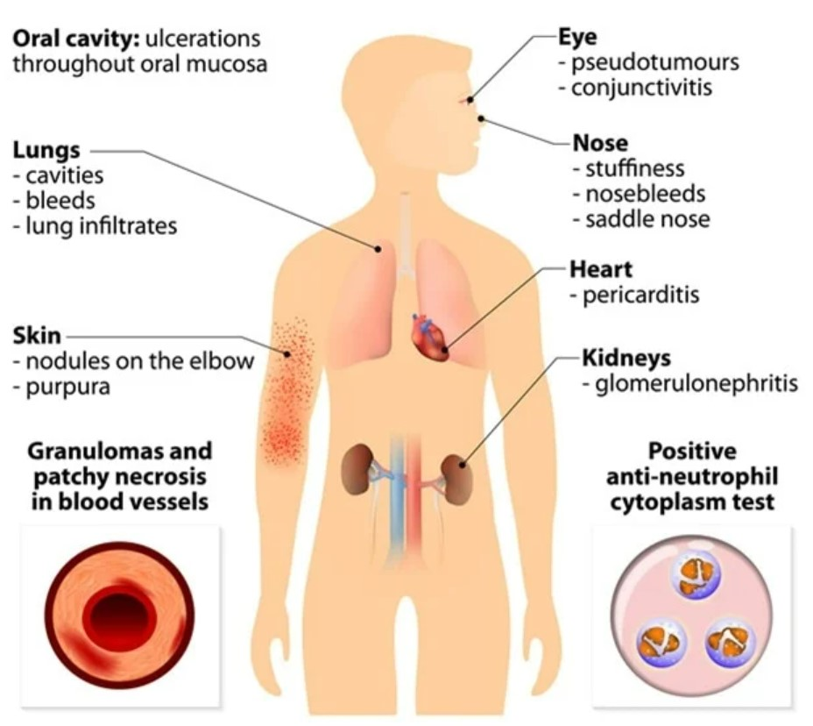
Fig 8 Clinical manifestation of granulomatous with polyangitis
Elevated Laboratory Markers: High ESR and CRP levels , Mild hypergammaglobinemia, especially IgA. Elevated ANCA and RF, indicating active granulomatosis with polyangiitis (GPA).

Diagnosis: Pulmonary tissue biopsy has the highest diagnostic yield information . Anti-PR3 antibody test shows high specificity although false positives can occur in infectious or neoplastic conditions.
- Various Diffenentials through Biopsy Findings: GPCRs, airway malignancy, endocarditis, rhinoscleroma, and mucocutaneous leishmaniasis
- 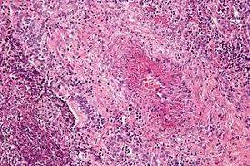
Fig 9 High magnification micrograph of granulomatosis with polyangiitis and ANCA-associated granulomatous vasculitisLung biopsy. H&E stain.
Treatment Recommendations:
- Initial therapy is a combination of daily cyclophosphamide and glucocorticoids, with Rituximab for induction in severe cases at 375 mg/m^2 once a week for four weeks , followed by maintenance therapy with options including Azathioprine, Methotrexate, and MMF (Mycophenolate Mofetil).
- Microscopic Polyangiitis (MPA) :
Incidence is 3-5 per 100,000 individuals, with a mean onset age of 57 years, and is more common in males. Pathogenesis involves necrotizing vasculitis affecting small vessels, typically without immune complex deposition, which is a differentiating feature from GPA.
- Clinical Features include fever, weight loss, musculoskeletal pain, and specific organ involvement such as glomerulonephritis (79%) and hemoptysis (12%). Upper airway and pulmonary nodules are typically absent.
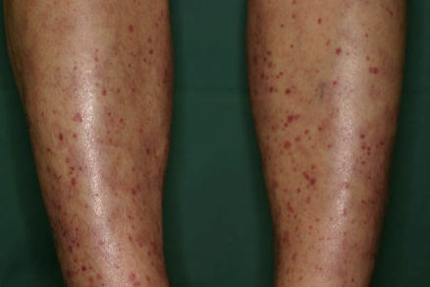
Fig 10 The skin lesions in MPA demonstrate mainly palpable purpura, erythematous macules, livedo reticularis, nodules, and cutaneous ulcerations, scattered over the lower extremities.
Diagnostic Criteria: Laboratory parameters showing presence of ANCA, elevated ESR, and CRP levels are indicative. Further Biopsy is essential for confirming diagnosis, showing vasculitis with few or no immune complexes. Diagnosis is made with clinical feature , histological findings and ANCA reports.
- The fig 11 given below depicts the classification criteria for microscopic polyangitis given by American college of Rheumatology . A score of more than 6 is needed for classification of microscopic polyangitis
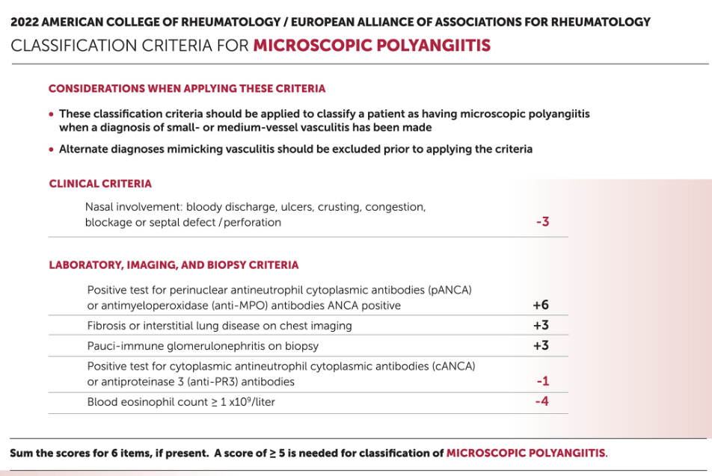
Fig 11. 2022 ACR classification criteria for Microscopic polyangitis.
- Eosinophilic Granulomatosis with Polyangiitis (EGPA):
It is a rare disorder with prevalence of 1-3 cases per million and a mean onset age of 48 years with slightly more prevalence in females. Pathophysiology includes tissue eosinophilia, extravascular granuloma formation, and vasculitis.
Clinical Phases: Divided in subsequent three clinical phases based upon order of presentation . First phase is Prodromal/Allergic Phase , which has Upper respiratory tract symptoms, worsening asthma, and sinusitis , followed by Eosinophilic Phase showing Eosinophilia with organ involvement, especially in the respiratory and gastrointestinal systems. Third pase is Vasculitic Phase leading Necrotizing vasculitis with involvemtn of small to medium vessels, resulting into end-organ damage.
Clinical features include fever, malaise, Anorexia, weight loss, Severe asthmatic attacks with pulmonary infiltrates. 72 % cases shows Mononeuritis multiplex with lesser incidence of Allergic rhinitis and sinusitis seen in 61% cases . Cardiac involvement in the form of Myocarditis, pericarditis, endocarditis, or coronary vasculitis is seen in 14% cases. Skin involvement in the form of Purpura with cutaneous and subcutaneous nodules is seen in 51% cases . Compared to GPA renal involvement is found to be less severe in EGPA .
Lab investigation : Eosinophilia ( >1000 cells per mm3 in CBC ) with elevated ESR, CRP, fibrinogen, alpha2-globulins in 81% cases , followed by anti MPO positivity in 48% cases .
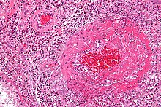
Fig 12. Micrograph showing an eosinophilic vasculitis consistent with eosinophilic granulomatosis with polyangiitis. H&E stain.

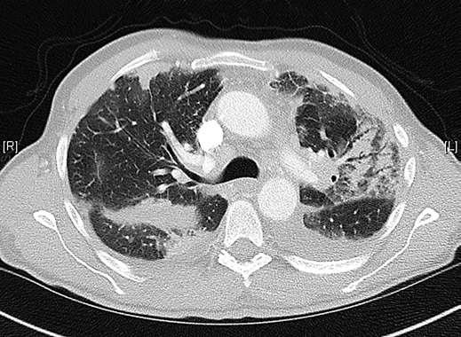

Fig 13. Chest CT in a patient with eosinophilic granulomatosis with polyangiitis. Areas of consolidation, ground glass opacity, and air bronchogram correspond to eosinophilic pneumonia. Pleural effusion related to cardiac failure is also visible

  - 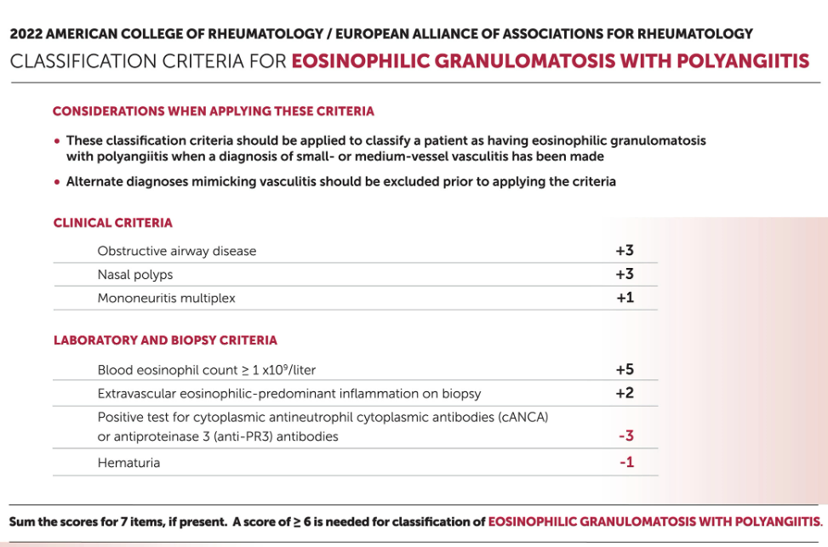
Fig 14. 2022 ACR classification criteria for eosinophillic granulomatosis with polyangitis.
Treatment
- The survival rate in treated and untreated groups showed a significant difference I.e. 72% vs 25 % respectively.
- The most common cause of death is myocardial involvement i.e. 39%
- In asthmatic patient long term glucocorticoids can be considered
- If disease is involving multiple system, then Cyclophosphamide and Prednisolone are effective). In some case a steroid-sparing agent such as methotrexate can be considered.
- In relapsing or resistant asthma requiring glucocorticoidsMepolizumab (anti IL-5) can be used. Some studies have taken Rituximab in consideration.

- Polyarteritis Nodosa (PAN)
- It is a multisystem vessel diseasemanifesting as necrotizing vasculitis of small- and medium-sized muscular arteries- renal and visceral arteries.
Pulmonary arteries are not involved along with no granuloma formation or no eosinophilia.
Pathogenesis:
It involves necrotizing inflammation of small- and medium-sized muscular arteries. Polymorphonuclear cells infiltartion leads to intimal proliferation and degeneration of vessel wall resulting in fibrinoid degeneration.
- Circulating immune complexes (IC) have hepatitis B antigen.
  - Positive IgM.
  - Also reported in Hepatitis C and hairy cell leukemia.
- Deficiency of ADA2 Type 2:
  - It is a PAN-like vasculitis with childhood predominance. Disease shows a good response towards TNF inhibitors.
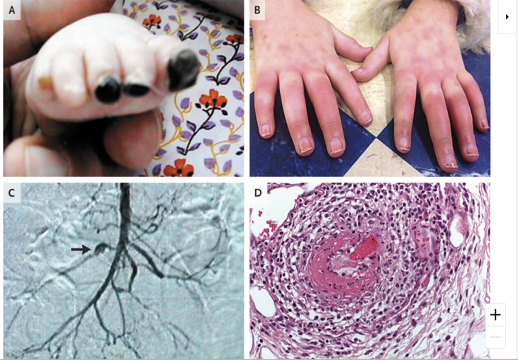
Fig 15. Clinical Features of Polyarteritis Nodosa Associated with Adenosine Deaminase 2 (ADA2) Mutations.

Clinical feature:

- Fig 16 Clinical features of polyarteritis nodosa.

Diagnosis:
Laboratory Findings mainly includes elevated ESR (erythrocyte sedimentation rate) and CRP (C-reactive protein) along with presence of neutrophilic leukocytosis (>75%) and hypergammaglobulinemia.
Based on clinical features , biopsy findings and arteriography
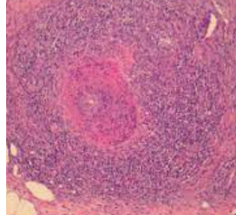
Fig17 showing leukocystoclastic vasculitis with fragmentation of neutrophils in and around blood vessels.
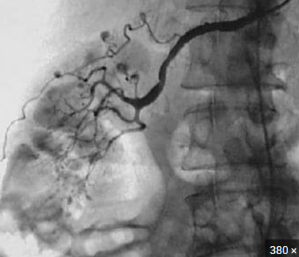
Fig 18. Right renal arteriogram reveals multiple microaneurysms within the upper pole of the kidney on this selective right renal artery injection (upper pole branch)
Treatment:
The 5 yr- survival rate in untreated patient is 10-20%. Death mainly occur due to GI and CV complications. Treatment mainly includes prednisolone and cyclophosphamide. In patients with Hepatitis B or Cantiviral therapy can be taken into consideration.
- IgA Vasculitis (Henoch-Schönlein Purpura):
Definition: IgA vasculitis, also known as Henoch-Schönlein purpura (HSP), is a small vessel vasculitis characterized by palpable purpura, arthralgia, and gastrointestinal (GI) involvement, often accompanied by glomerulonephritis.
- Age Group: Typically affects children aged 4-7 years.
- Gender Ratio: Male-to-female ratio is approximately 1.5:1.
- Pathology:
  - Immune complex deposition triggers the disease.
  - Antigens (e.g., URI, gas, drugs, foods, immunization) initiate and complete the immune response.
- Clinical Features:
Palpable purpura is present in all patients.Polyarthralgia is also commonly seen.
There can be presence of microscopic hematuria and proteinuria (70% of cases).
or abdominal pain, nausea/vomiting, diarrhea or constipation, GI bleeding, or melena.
Diagnosis:
    - Clinical assessment combined with skin biopsy (renal biopsy rarely needed).

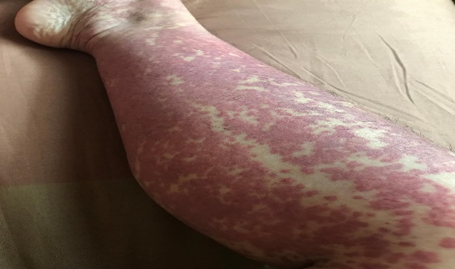
Fig 19 Palpable purpura and petechiae of the foot
- Laboratory Findings includes normal leukocyte count in approximately half of cases or mild leukocytosis and normal platelet count.
along with elevated erythrocyte sedimentation rate (ESR).
Treatment:
  - Most of the patients recover spontaneously whereas only 1-5% children progress to ESRD.
Prednisolone 1mg/kg and will be tapered as per response. In case of RPGN, steroids and other immunosuppressive agents can be considered. Recurrence will be seen in 10-40% patients.

Cryoglobulinemic Vasculitis:
Cryoglobulins- cold precipitable monoclonal or polyclonal Ig
Most common association- Hep C; MM, CTDs, infections, liver diseases
- Types of Cryoglobulinemia:
  - Monoclonal (Type I): >90% of cases. Associated with conditions like multiple myeloma.
  - Mixed (Type II and III):
    - Type II: >50% monoclonal component.
    - Type III: <50% monoclonal component.
  - Secondary to:
    - Hepatitis C infection.
    - Connective tissue diseases (e.g., Sjögren’s syndrome, systemic lupus erythematosus, rheumatoid arthritis).
Clinical Features:
Patient mainly present with cutaneous vasculitis, arthritis, peripheral neuropathy
or glomerulonephritis (renal disease in 10-30%).
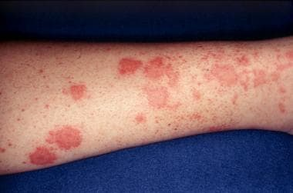

Fig 20 Classical Cryoglobulinemia-related small vessel vasculitis of lower extremities characterized by erythematosus palpable maculopapular rash

- Laboratory Findings include presence of Rheumatoid factor (RF) along with circulating cryoprecipitates. There can be presence of hypocomplementemia (observed in 90% of cases), elevated ESR (erythrocyte sedimentation rate) and CRP (C-reactive protein). In some patients, hepatitis C RNA and antibodies can be present. Monoclonal IgMkappa/IgMlambda (Type I cryoglobulins) can be present.
  - ACR criteria for classification of vasculitis:
    - Age at onset >16 years.
    - Palpable purpura.
    - Biopsy showing granulocytes in arterioles/venules.
- Dermatological Aspects:
  - Relapse is rare but can occur.
  - Skin manifestations include livedo racemosa, cutaneous ulcers, and acrocyanosis.
- Prognosis:
  - Variable, but most cases recover within a few months.
  - Even recurrent cases tend to resolve.

  - 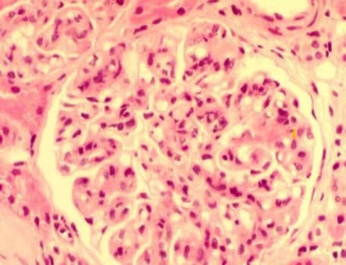
  - Fig 21. Renal biopsy: diffuse endocapillary hypercellularity characterized by mesangial matrix and endothelial cell expansion with few neutrophil infiltration were demonstrated. Lobulation of the glomeruli was revealed by light microscopy (PAS stain, × 400).

- Treatment:
  - Antiviral therapy can be given to reduce circulating cryoglobulins. Rituximabalongwith antivirals can be given in relapses
References:
- https://www.researchgate.net/publication/263744968/figure/fig1/AS:1088619917914115@1636558622521/Appearance-of-cytoplasmic-indirect-immunofluorescence-pattern-C-ANCA-Figure-1a-and.jpg
- https://upload.wikimedia.org/wikipedia/commons/c/c6/P_ANCA.jpg
- https://emorymedicine.wordpress.com/wp-content/uploads/2023/10/004.jpg?w=534
- https://encrypted-tbn0.gstatic.com/images?q=tbn:ANd9GcSs8YoDddBPfJeWw58fszznqPiPyL-RgeZ5Zw&s
- https://encrypted-tbn0.gstatic.com/images?q=tbn:ANd9GcRDrRQw2RbR2Tdi6vS-dGmHHoQ2-AYreBngEw&s
- https://encrypted-tbn0.gstatic.com/images?q=tbn:ANd9GcSpM7I4CF2EG0-vRNfiSgSdZu-JKqM7xPOUhA&s
- https://www.researchgate.net/publication/365285531/figure/fig1/AS:11431281110121801@1672330132922/The-final-2022-American-College-of-Rheumatology-EULAR-classification-criteria-for.png
- https://encrypted-tbn0.gstatic.com/images?q=tbn:ANd9GcQv2eAD7PzoCTbhBEaYBNIO1wr8XVb7Tx_hHQ&s
- https://d2jx2rerrg6sh3.cloudfront.net/image-handler/picture/2019/5/shutterstock_305422031.jpg
- https://encrypted-tbn0.gstatic.com/images?q=tbn:ANd9GcRKmYNLe3jgKPAjPT554UFyvkMZM2iexrIBLg&s
- https://www.dermatologyadvisor.com/wp-content/uploads/sites/20/2019/03/ch1210.fig1_.jpg
- https://encrypted-tbn0.gstatic.com/images?q=tbn:ANd9GcTY0F7LEoTMn1uS422QbZpnhkBH5wHALiPr8w&s
- https://upload.wikimedia.org/wikipedia/commons/thumb/3/34/Churg-Strauss_syndrome_-_high_mag.jpg/1200px-Churg-Strauss_syndrome_-_high_mag.jpg
- https://www.researchgate.net/publication/326195532/figure/fig1/AS:687540206043138@1540933767555/Chest-CT-in-a-patient-with-eosinophilic-granulomatosis-with-polyangiitis-Areas-of.ppm
- https://ard.bmj.com/content/annrheumdis/81/3/309/F1.large.jpg
- https://encrypted-tbn0.gstatic.com/images?q=tbn:ANd9GcSjHLJkxAG0hLgUHUmTsO3P76wM-7pPVMnKJA&s
- https://cdn1.byjus.com/wp-content/uploads/2019/12/symptoms-of-polyarteritis-nodosa.png
- https://cdn1.byjus.com/wp-content/uploads/2019/12/symptoms-of-polyarteritis-nodosa.png
- https://cdn1.byjus.com/wp-content/uploads/2019/12/symptoms-of-polyarteritis-nodosa.png://img.medscapestatic.com/pi/meds/ckb/60/22760tn.jpg
- https://www.niddk.nih.gov/-/media/Images/HealthInformation/Kidney/henochachonlein_purpura.jpg19
- https://img.medscapestatic.com/pi/meds/ckb/27/39027tn.jpg
- https://img.medscapestatic.com/pi/meds/ckb/28/39028tn.jpg
- Watts, R. A., Hatemi, G., Burns, J. C., & Mohammad, A. J. (2022). Global epidemiology of vasculitis. Nature reviews rheumatology, 18(1), 22-34.
- Younger, D. S. (2019). Overview of the vasculitides. Neurologic Clinics, 37(2), 171-200.
- Younger, D. S. (2023). Adult and childhood vasculitis. Handbook of Clinical Neurology, 195, 653-705.
- Saadoun, D., Vautier, M., & Cacoub, P. (2021). Medium-and large-vessel vasculitis. Circulation, 143(3), 267-282.
- Sahu, M. R., Wairagade, T. D., Wairagade, S. D., Ambad, R. S., & Chandi, D. H. (2021). Evolving Trends and Changing Perspectives in ANCA Associated Vasculitis– A Review. Journal of Pharmaceutical Research International, 33(37B), 207–212. https://doi.org/10.9734/jpri/2021/v33i37B32041
- Hilhorst, M., Shirai, T., Berry, G., Goronzy, J. J., & Weyand, C. M. (2014). T cell–macrophage interactions and granuloma formation in vasculitis. Frontiers in immunology, 5, 432.
- Fijołek, J., & Wiatr, E. (2020). Antineutrophil cytoplasmic antibodies–their role in pathogenesis, diagnosis and treatment monitoring of ANCA-associated vasculitis. Central European Journal of Immunology, 45(2), 218-227.
- Gómez-Puerta, J. A., & Bosch, X. (2009). Anti-neutrophil cytoplasmic antibody pathogenesis in small-vessel vasculitis: an update. The American journal of pathology, 175(5), 1790-1798.

