INSULIN USE IN CLINICAL PRACTICE: FITTER GUIDELINES

ABSTRACT
Insulin delivery methods play a pivotal role in the management of diabetes mellitus. This chapter provides an overview of various insulin delivery methods utilized in clinical practice.Subcutaneous injections remain the cornerstone of insulin administration, offering flexibility with different insulin types—rapid-acting, short-acting, intermediate-acting, and long-acting,tailored to individual patient needs. Insulin pens provide a convenient alternative, offering prefilled cartridges or disposable units that simplify dosing and enhance patient adherence.For patients requiring intensive insulin therapy, insulin pumps offer continuous subcutaneous infusion, delivering basal insulin throughout the day with bolus doses at meal times. These devices provide flexibility in dosing and lifestyle management, although they require regular monitoring and maintenance.Implantable insulin pumps, though less common, provide continuous insulin infusion via surgically placed devices under the skin. . They enhance predictability and flexibility in insulin therapy, reducing the risk of hypo- and hyperglycemia.Continuous glucose monitoring (CGM) systems complement insulin delivery methods by providing real-time glucose readings, facilitating personalized insulin adjustments based on glucose trends.Selecting the appropriate insulin delivery method is pivotal in diabetes management, considering patient preferences, lifestyle factors, and treatment goals. Tailored approaches ensure optimal glycemic control and improve quality of life for individuals with diabetes mellitus

INTRODUCTION :
“ Laughter is the best medicine -unless you are diabetic ,then insulin comes pretty high on the list “
-Jasper carrot
The opening discusses the crucial role of insulin in regulating cellular energy absorption and the metabolism of fats and proteins. Islet clusters produce this hormone, but when cells become less responsive to its signals, insulin resistance develops. In some cases, the immune system targets these islets, causing type 1 diabetes(1) by disrupting insulin production. Type 2 diabetes arises from a combination of insulin resistance and inadequate insulin production. Insulin injections can help offset insulin resistance, with various types available depending on the speed and duration of blood sugar control needed.
Insulin offers superior control over HbA1c compared to other antidiabetic medications(2) Health-care professionals in India frequently manage injection or infusion therapies in persons with diabetes (PWD). Patients taking insulin should know the importance of proper needle size, correct injection process, complication avoidance, and all other aspects of injection technique from the first visit onward. To assist health-care practitioners in their clinical practice, Forum for Injection Technique and Therapy Expert Recommendations, India(2), has updated the practical advice and made it more comprehensive evidence-based best practice information. Adherence to these updated recommendations, learning, and translating them into clinical practice should lead to effective therapies, improved outcomes, and lower costs . Early initiation of insulin therapy has been observed to enhance beta cell function(3). Short-term insulin treatment, when introduced early in the disease progression, demonstrates long-lasting effects. The injection technique is pivotal for the success of insulin therapy.
The Worldwide Injection Technique Questionnaire (ITQ) (4)conducted from February 1, 2014, to June 30, 2015, represents the largest survey in diabetes. It involved 13,289 insulin-using patients from 423 centers across 41 countries, with India contributing 1011 participants from 20 centers. In the Indian context, nearly 40% of participants utilized 4 and 5 mm needle lengths, while approximately 18% used 8 mm needles. Moreover, 80% of participants reused needles more than three times.
Lipohypertrophy (LH)(5) emerged as the most common complication, self-reported by 26% of participants and identified by healthcare professionals in 22%. Patients with LH exhibited higher HbA1c levels and a heightened frequency of unexpected hypoglycemia and glucose variability. Incorrect rotation of injection sites and needle reuse were significantly associated with elevated HbA1c levels. Additionally, the majority of diabetic sharps ended up in public trash, posing a high risk for needle-stick injuries (NSI).
窗体顶端
窗体底端
The method of administering injections is crucial for the effective therapeutic outcome of insulin. The initial human insulin injection was accompanied by a severe reaction. Incorrect utilization of injection devices can result in adverse effects such as pain, bleeding, bruising, and the needle breaking or becoming lodged under the skin, leading to inaccurate dosages and potentially causing lipohypertrophy.

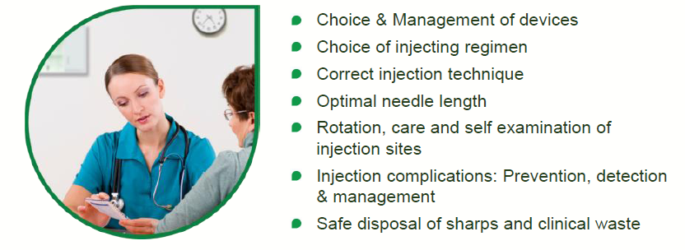
Fig 1 represent what need to be educated in diabetic population on method of insulin injection

FITTER India aims to advance evidence-based clinical guidelines, safety protocols, and self-management strategies for diabetes treatments involving injections and infusions. These efforts are geared towards enhancing health outcomes, promoting well-being, reducing healthcare expenses, and alleviating the burden on healthcare providers and society. FITTER, or the "Forum for Injection Technique and Therapy Expert Recommendations," pertains to the 2017 initiative(2) in India. It involved a systematic literature review of peer-reviewed studies and publications on insulin injections and infusions from 2008 to 2015. An international panel of experts convened over an 18-month period to analyze this literature and develop recommendations. These draft recommendations were then reviewed by 183 experts from 54 countries during the FITTER workshop in October 2015, with an additional 15,000 participants joining virtually.

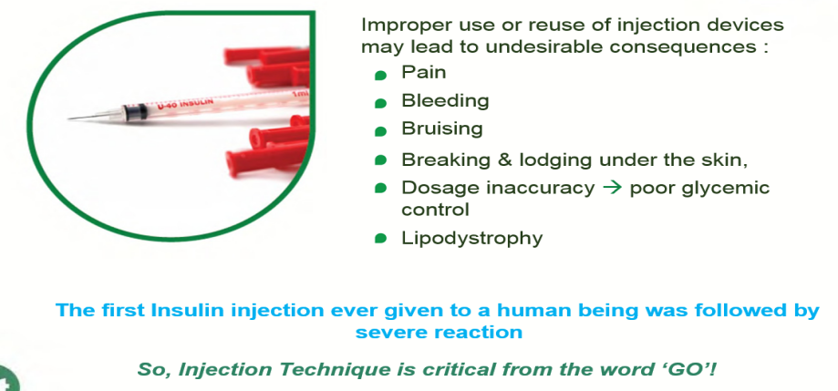
Fig 2 represents adverse effects of improper or reuse of injection devices

When a physician recommends insulin therapy to a patient, the patient may decline due to feelings of distress, anxiety, frustration, fear of needles, the perception of lifelong dependency on insulin, fear of weight gain, low self-esteem, and concerns about interference with their quality of life. Effective patient counseling is essential in this context, aiming to facilitate decision-making with the active involvement of both the patient and their caregiver, as appropriate. Insulin can be administered using either syringes or insulin pens. While syringes are the primary injection device used in India, there is ongoing debate regarding the safest and most effective method of insulin delivery. For individuals new to insulin therapy, pens are often preferred due to their ease of use and teaching.

Table 1 represent compares insulin pen vs insulin syringe as method of insulin delievery
Insulin Pen | Insulin Syringe
More convenient insulin delivery | Can be used for preparation from different manufacturers
More accurate dosing | Syringe barrel can be chosen based on insulin dose
Less pain because of small gauze of needles | Patients can see the number and scale lines together to have accurate dosing
Less intrusive/socially more acceptable | Allow use of split-mix regimens
More flexibility because of disposable or reusable option | Less expensive
The optimal technique for administering insulin involves lifting the skin fold, inserting the needle into the skin at a 90-degree angle, leaving the needle in the subcutaneous tissue for 10 seconds after fully depressing the plunger, withdrawing the needle from the skin, and releasing the skin fold. Proper disposal of used needles or syringes is essential for safety. Intramuscular (IM) injections(6) are more common with longer needles, particularly in slimmer and younger patients, males, and individuals who inject into limbs rather than truncal sites for insulin delivery.
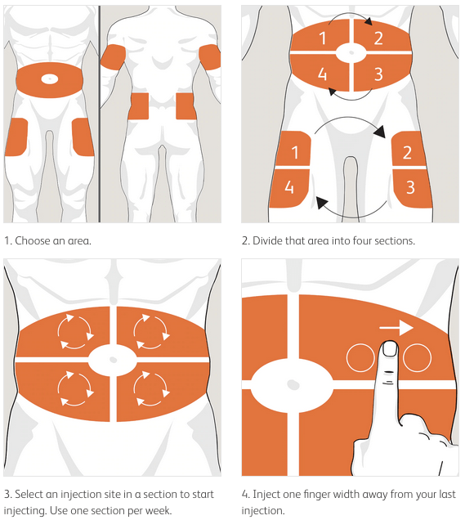
Fig 3 represent site ,method and rotation practice to be followed for insulin delivery
Rotation of site of insulin injection is necessary for accurate dose delievery and prevent lipohypertrophy . An easy to follow rotation scheme should be taught to the patients from the onset of injection therapy .Dividing the injection site into quadrants (or halves when using thighs or buttocks), using one quadrant per week and moving always in the same direction, either clockwise or anticlockwise, has been proven to be effective(7).Injection within any quadrant or half should be spaced at least 1 or 2 cms apart to avoid repeat tissue trauma(7).Rotation scheme should be audited during every visit and advice is to be provided where needed .
Reusing needles can lead to the blunting and bending of the needle tip, increasing the risk of bleeding, bruising, scarring, dosage inaccuracies, and lipohypertrophy. Healthcare professionals should educate patients about the potential adverse effects of needle reuse and discourage this practice. Injecting through clothing is not advisable, and patients should be informed about the consequences of missing injections. If there is a need to change insulin, patients should be fully informed about the reasons behind the change and the potential need for additional glucose monitoring. Changing the species, type, or brand name of insulin should only be done if absolutely necessary. Hazards associated with needle reuse include pain, bleeding, bruising, lipohypertrophy, contamination, infection, dosage inaccuracies, and the risk of the needle breaking off and becoming lodged under the skin.

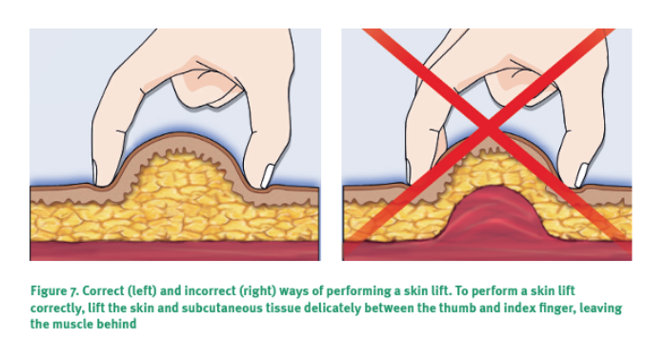
Fig 4 represent correct and incorrect method of performing a skin lift for insulin delivery .hold skin fold between first finger and thumb leaving muscle behind
The injection site and hands should be thoroughly cleaned before insulin administration. For adults, children, and adolescents, it is recommended to use 4mm pen needles or 6mm syringe needles(8). Preferred injection sites include the abdomen, upper thighs, upper arms, and upper buttocks. Individuals using insulin should regularly self-inspect their injection sites for signs of lipohypertrophy (LH). Healthcare professionals should inspect and palpate the injection site at least once a year, or more frequently if LH is detected. Reusing needles and sharing insulin pens, cartridges, or vials should be avoided, and proper disposal of insulin needles and accessories should be ensured.

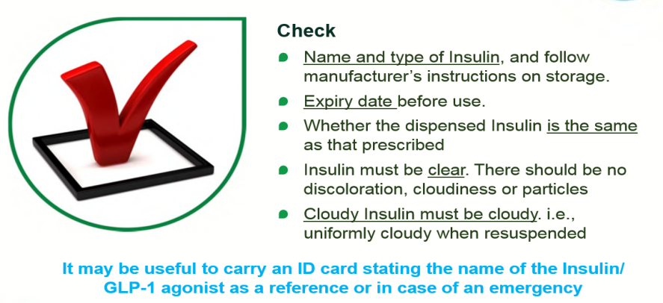
Fig 5 represent what specifications need to be checked before injecting insulin
During pregnancy, there should be no change in insulin site or technique in the first trimester. In the second trimester, insulin can be injected into the lateral parts of the abdomen, avoiding the skin overlying the fetus. In the third trimester, insulin can be injected into the lateral abdomen while ensuring proper skin fold elevation. Alternative injection sites for apprehensive patients include the thigh, upper arm, or buttock.
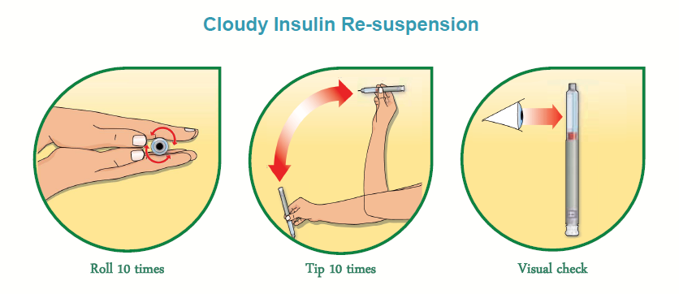
Fig 6 shows method of repsuspension of cloudy insulin

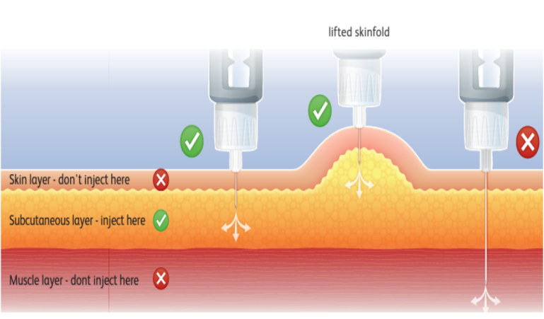
fig 7 shows right tissue space to inject insulin
Lipohypertrophy(5) presents as thick, soft to firm swelling with a rubbery consistency at insulin injection sites, typically due to repeated needle reuse. It may appear as raised swelling that cannot be pinched together. Inspections reveal large LH sites, while others may only be evident upon palpation. A significant proportion of patients with LH experience unexplained hypoglycemia and glycemic variability. Regular inspection of injection sites is crucial, and patients should be trained to detect lipohypertrophy themselves. Ultrasonography can aid in LH detection, especially when visual examination and palpation are inconclusive, and histopathological examination may be necessary for differentiation from insulin-derived amyloidosis.(9)
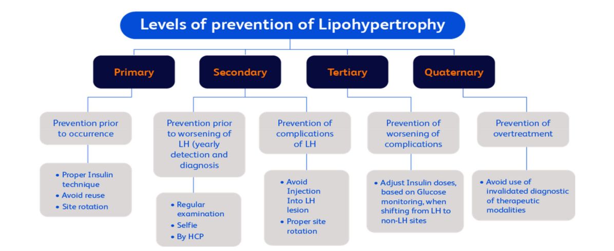
Fig 8 represent levels of prevention of lipohypertrophy

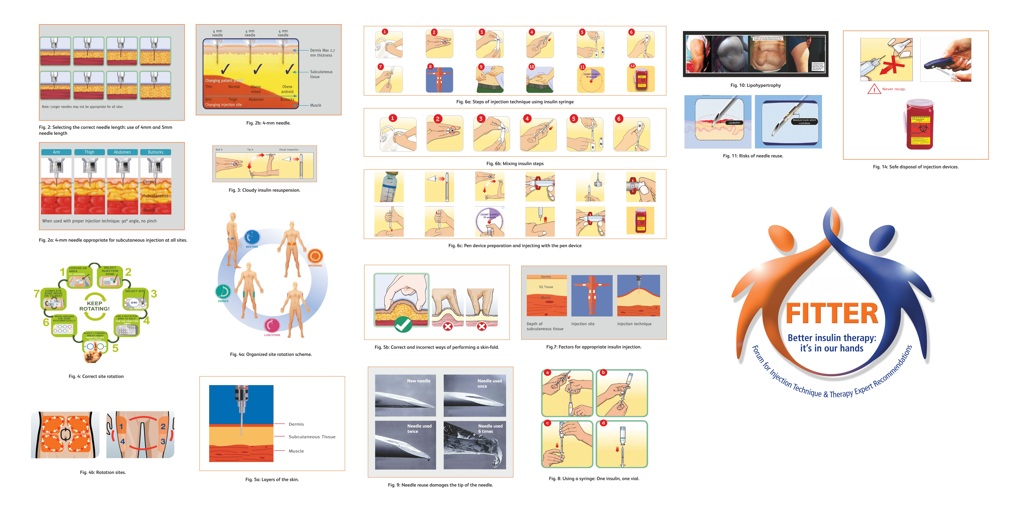
Fig 9 represent sites of lipohypertrophy post injection injection
Timely detection of hypoglycemia is critical for improving quality of life and preventing complications. Despite advancements in insulin pumps and continuous glucose monitoring (CGM), only a third of individuals achieve desired glycemic targets. Calculating basal insulin is simpler than bolus insulin doses due to variability in food intake. Scientific methods such as carbohydrate counting and insulin-to-carbohydrate ratios help calculate bolus doses for optimal control, aiming to prevent hypoglycemia and achieving target glucose levels .

Fig 10 represent sites of insulin injection (10)
ORDER OF RATE OF ABSORPTION ABDOMEN >ARM>THIGH>BUTTOCK
ABDADD

Manual bolus calculations can be laborious, leading to the adoption of empirical doses. However, relying on empirical doses can result in errors and adverse clinical outcomes. Automated bolus advisors offer a solution by automatically quantifying bolus insulin dosages, incorporating factors such as carbohydrate intake and addressing abnormal blood glucose levels based on individualized insulin parameters. When setting bolus dose calculations, several factors are considered on an individual basis, including the insulin-to-carbohydrate ratio (ICR), insulin sensitivity (correction factor), target blood glucose levels, and active insulin time (insulin on board). Therefore, ensuring the correct use and method of insulin injections is crucial for achieving glycemic control in diabetes mellitus.

REFERENCES
1. Diabetes Prevention Trial--Type 1 Diabetes Study Group. Effects of insulin in relatives of patients with type 1 diabetes mellitus. N Engl J Med. 2002 May 30;346(22):1685–91.
2. Tandon N, Kalra S, Balhara YPS, Baruah MP, Chadha M, Chandalia HB, et al. Forum for Injection Technique and Therapy Expert Recommendations, India: The Indian Recommendations for Best Practice in Insulin Injection Technique, 2017. Indian J Endocrinol Metab. 2017;21(4):600–17.
3. Swinnen SG, Hoekstra JB, DeVries JH. Insulin therapy for type 2 diabetes. Diabetes Care. 2009 Nov;32 Suppl 2(Suppl 2):S253-259.
4. Frid AH, Hirsch LJ, Menchior AR, Morel DR, Strauss KW. Worldwide Injection Technique Questionnaire Study: Population Parameters and Injection Practices. Mayo Clin Proc. 2016 Sep;91(9):1212–23.
5. Kalra S, Kumar A, Gupta Y. Prevention of lipohypertrophy. JPMA J Pak Med Assoc. 2016 Jul;66(7):910–1.
6. Shah RB, Patel M, Maahs DM, Shah VN. Insulin delivery methods: Past, present and future. Int J Pharm Investig. 2016;6(1):1–9.
7. Frid A, Linde B. Intraregional differences in the absorption of unmodified insulin from the abdominal wall. Diabet Med J Br Diabet Assoc. 1992 Apr;9(3):236–9.
8. Torii-Goto A, Hirai K, Inukai Y, Hoshina Y, Shiomi K, Ito J, et al. Investigation of appropriate needle length considering skin thickness with the real injection posture for insulin injections in diabetic patients. J Pharm Health Care Sci. 2023 Jun 1;9(1):19.
9. Samlaska C, Reber S, Murry T. Insulin-derived amyloidosis: The insulin ball, amyloidoma. JAAD Case Rep. 2020 Apr;6(4):351–3.
10. Hirsch LJ, Strauss KW. The Injection Technique Factor: What You Don’t Know or Teach Can Make a Difference. Clin Diabetes Publ Am Diabetes Assoc. 2019 Jul;37(3):227–33.

