Design Principle of Hue Imperial Palace, Nguyen Dynasty (1802-1945), Vietnam

Analyzing design methods of the Floor Plans

_______________________________________________________________________________________
Abstract
The Complex of Hue Monuments (abb., the Monuments), the first UNESCO’s World Cultural Heritage site of Vietnam, has been well-known as a plentiful and richness scientific material for scientific study field. Continuously, in this paper, we would introduce in general about the construction history and architectural typology of the Hue Imperial Architectures (abb., the Architecture), an important component of the Monuments. The Architecture includes the existing heritage buildings located inside the Hue Imperial City and the complex of Imperial Mausoleums of the Nguyen’s Emperors which were planned, built and repaired during the Nguyen dynasty (1802-1945).
Previously on the paper “Practicing on the re-construction study of “Can Chanh Dien” Palace, Hue Imperial City, Vietnam-World cultural heritage” we have presented the study results on the restorated design drawing of the Can Chanh Dien palace. In this paper, we try to examine the designing methods of Floor-plan of the Architecture, especially concerning to the type of “Trung Thiem Diep Oc” (Twin-Ridge Beam Building, abb., the Twin-Buildings) which is unique in ancient Asia. The name of this type of architecture comes from its characteristic composed by two or three buildings connected together and placed on the same platform. This is the highest class in the constructional institution of the Nguyen dynasty, used only for special functions such as the palaces for residences of royal family, worshiping halls of the imperial ancestors and the mausoleum temples of the succeed Emperors.
Mainly basing on the historic documents of the Nguyen dynasty, surveying on the remaining heritage Twin-Buildings, dimensional analyzing, investigation on the traditional designing method, interviewing with the traditional master carpenters, we try to do studying on designing method of Floor-plan of the Architecture, and experimental re-determined of their primary architectural designing method. Through this study, the units used for designing, parametric factors in the designing principle and designing processes on Floor-plan of the Twin-Buildings have been defined concretely. The study results could provide an important database for the restoration and re-construction works of the Monuments, giving amount of scientific material for academic education on the field of architectural heritage conservation.
Keywords: Design Principle, Floor-Plan, Hue Imperial Palace, Nguyen Dynasty, Vietnam, World Cultural Heritage

- General introduction of the Architecture
  - Construction history and modification
According to the historical sources of the Nguyen dynasty, although the construction of Hue capital city was started in the early Gia Long period (1802-1820), it only took place on a small scale, mainly was a construction work of buildings used for the activities of the Nguyen’s cabinet, accommodation for the royal family and a part of the imperial mausoleums placed in the South-West hilly area of Hue capital city [1,2].
In Minh Mang period (1820-1841), second cucceed Emperor of Nguyen dynasty (tab.1), construction activities took place on a large scale synchronously. In order to construct the whole capital city gradually and re-plan the Citadel (fig.1), the Nguyen court moved out 10 villages from the lands, dug a lake to fill the citadel-walls, and flowed the stream flow of two natural rivers (Kim Long river and Bach Yen river) to establish an uninterrupted hydrological system inside the Citadel. Besides, a series of buildings such as palaces, temples, pavilions inside imperial city and many other places were also constructed [3,4].
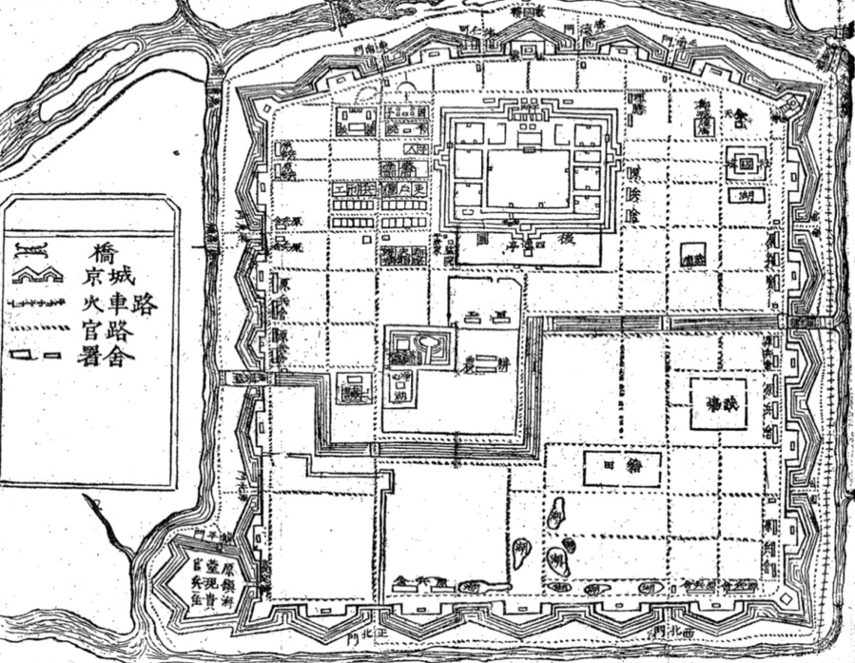
Fig.1 Drawing of Site-plan of the Hue Citadel (Historic document of the Nguyen dynasty published under Duy Tan period 1907-1916)
In Thieu Tri period (1841-1847), basically the capital institutions and architecture of the citadel were completed, the main construction activities were to build more necessary buildings and improve some residences inside the imperial city.
From Tu Duc period (1847-1883) to Thanh Thai period (1889-1907), mainly were the renovation, repairing and maintenance activities of the buildings and the citadel were built before. Renovation and repairing activities took place at a large density during Tu Duc period inside the imperial city and forbidden city. Starting from Thanh Thai period, new construction materials from Europe began to be imported into Vietnam (such as cement, printing decorative bricks, mirror glass), which had a significant impact on the construction of architecture in Hue capital city. The traditional mortar materials are gradually replaced by cement or have been used in combination [5-7]. Due to the impact of those material factors, construction techniques also gradually changed, laying the base for the transformation of architectural styles and construction techniques in the later period of Nguyen dynasty.
After Thanh Thai period to Dong Khanh period (1885-1889), due to the changing political and economic circumstances, there were not many new construction activities, on the contrary, many buildings were destroyed or moved to use for other functions, the rest were small repairing and improvement activities [8-10].
Since the Khai Dinh period (1916-1925) onwards, the Architectures of Nguyen dynasty has undergone a major change. Reinforced concrete has gradually replaced the traditional wood materials, allowing the construction of many tall and magnificent structures, western garden style was also appeared in the forbidden city. Architectural decoration of this period used a combination of two types of decorative motifs of East and West which typicalized by the architectural decoration style fromed during Khai Dinh period.
The construction history of the Complex of Hue Monuments can be divided into 4 stages as follows:
- First stage: From Gia Long period to Minh Mang period (1802-1841) was the period of planning and starting construction.
- Second stage: From Thieu Tri period to early half of Tu Duc period (1841-1865) was the period of repairing and renovation of the construction works that were built before.
- Third stage: From the later half of Tu Duc period to Thanh Thai period (1865-1907) was the period of maintenance and reduction in scale.
- Fourth stage: From Khai Dinh period to the end of Bao Dai period (1916-1945) was the period of transformation in architectural style and changing of construction techniques.
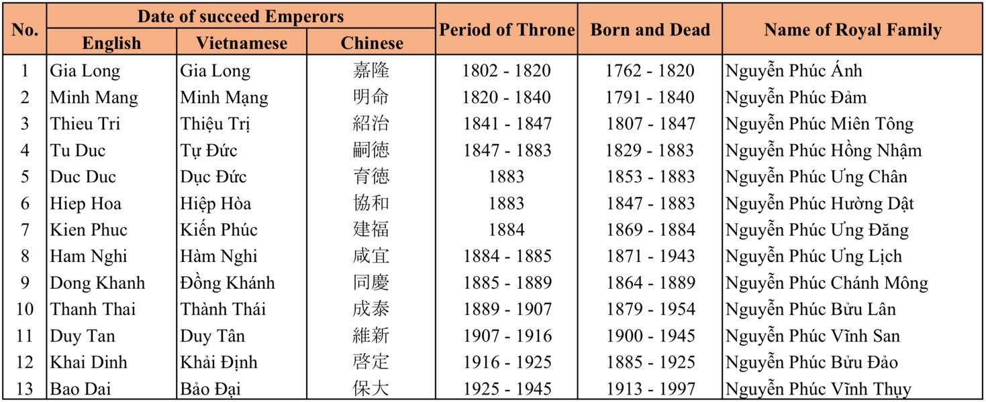
Tab.1 Chonology of the Nguyen’s Emperors
  - Types of the Architecture
    - Classify according to the categories recorded in historic documents
According to the descriptions of the “Cong Bo” Minstry of construction of Nguyen Dynasty, the building categories listed under each functional group include: “Cung Dien” royal palace (宮殿) defines the civil architecture inside the imperial city and the citadel; “Dan Mieu” altar and shrine (壇廟) defines the architecture used for religious and beliefs; “Hanh Cung” residence of travel inspection (行宮) defines the architecture in the citadel or in the provinces serving for travel inspection of the Emperors; “Thanh Dai” military port (城臺); “Dinh Thu” edifice (營署) defines the architecture in the citadel or in the provinces used for government office; “Lang Tam” imperial mausoleum (陵寝) of the Nguyen imperial family.
The architectural hierarchy on each type of building includes “Dien” palace/temple (殿), “Mieu” shrine (廟), “Duong” hall (堂), “Vu” eave (廡), “Lau” pavilion (樓), “Cac” pavilion tower (閣), “Vien” institute (院), “Phong” chamber (房), “Mon” gate (門), “Dinh” public hall (亭), “Ta” floating pavilion (榭), “Phu” residence (府), “Sanh” office building (廳) etc., depending on their function of use or/and their important in symbol. In which, the “Dien” palace/temple (殿) and “Mieu” shrine (廟) categories always show in largest scale and in highest class, playing the role of the main architecture of each imperial residence (fig.2, 3).
Additionally, category of the “Dien” (殿) is divided into two different types of functions: “Chinh Dien” main imperial palace (正殿) located inside the Hue Imperial City or inside the Citadel, the “Tam Dien” mausoleum temple (寝殿) located at the Imperial Mausoleums used for worshiping of the Emperors. Furthermore, the category of the “Mieu” imperial shrine (廟) used for worshiping of the ancestors of the Nguyen royal family appearing in sacred areas of the Imperial City, and serve the purpose of religious beliefs over Hue ancient capital city.
    - Classify according to the architectural typology
If classifying the Architecture according to their appearance, there are the following typical typologies such as: Single-ridge beam buildings (abb., the Single-Buildings), Twin-ridge beams building (abb., the Twin-Buildings), Pavilion tower buildings (abb., the Pavilions), the Storey gates (abb., the Gates) and the others. Remaining of the Monuments consit of the below-mentioned main typologies and the corresponding percentages are 52%, 26%, 11% and 11% (in the total number of statistical investigation woks).

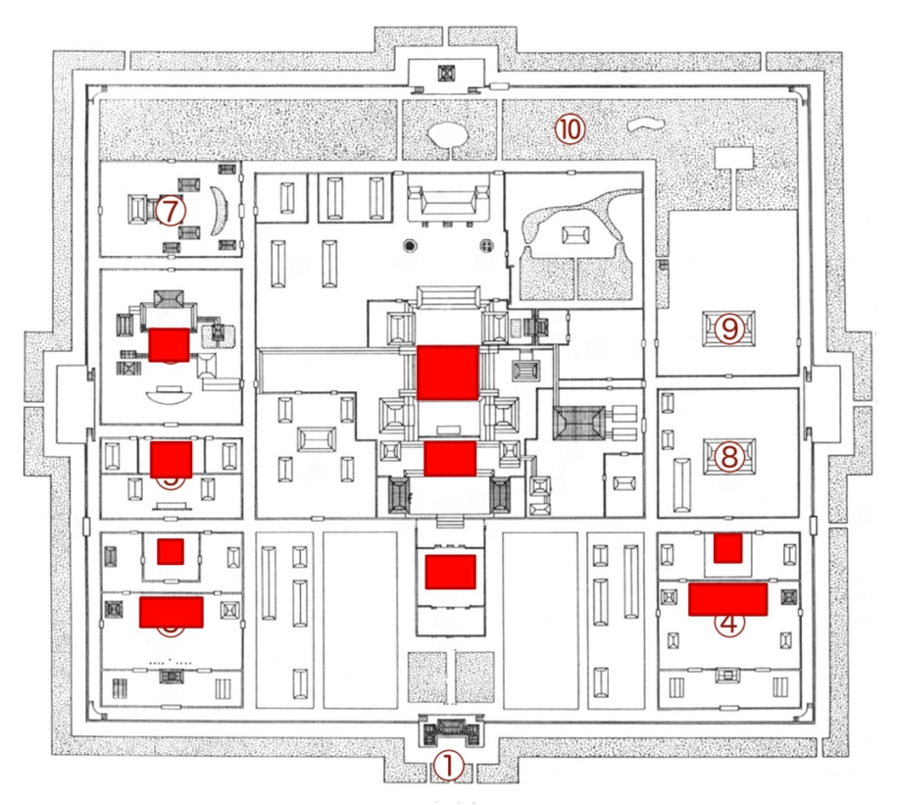
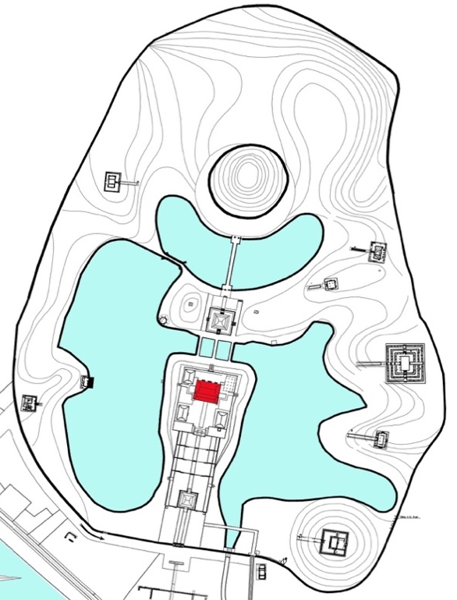
Fig.2&3 Location of the targeted Twin-Buildings in the Imperial City and in the Mausoleum of Emperor Minh Mang
a) The type of Single-Buildings is defined as an independent structure, plays the role of supporting function for main building or playing function itseft. Basically, each Single-Building consists of a wooden frame placed on a square or rectangle-saprated platform, covered by one or two layers of roof, including two types: doulbe layers-roof and single layer-roof. The type of doulbe layers-roof has a higher class than other, located in the important areas or/and play as a special role; the type of single layer-roof has lower class is a common used-type in the Monuments (fig.4).
b) The type of Twin-Buildings always plays a role of the main architecture in each imperial residence, usually has a largest scale and appeared in higest class, consists of two or three buildings connect together. This is the most unique type of often called “Trung Thiem Diep Oc” (means two or three buildings connected together placed on the same platform). The front building is called “Tien Doanh” (前楹), back building is called “Chinh Doanh” (正楹). If in case of there are three buildings connected together, the front building is called “Tien Doanh”, middle building is called “Chinh Doanh” and the back building is called “Hau Doanh” (後楹). These buildings are connected to each other by a structure called “Thua Luu” (承霤), there is a drainage gutter placed in upper side of this structure that leads the rain water flowing out to the both left and right hand sides of the buildings (fig.5).
c) Type of Pavilion building normally consists of two or three floors, located in important residence used for special functions such as a symbolic, monument of winning or/and siprit tower, square or rectangular in platform. Division between the floors is the wooden floor that divides the roofs into upper, middle and lower roof. This type of architecture is a special case that plays a dominant role of height in the residences (fig.6).
d) Type of Storey gate normally consits of two or three floors serving as the main gate of each residence, ussally rectangular in platform, consits three paths at the central, also called “Tam Quan”, appeared in almost residences of the Monuments (fig.7).
e) The others including a various type of buildings, but they were also created basing on the four main types mentioned above.
Among the above-mentioned categories, the category of Twin-Buildings has the largest scale and shown as highest class, often used for the Palaces, Temples and Shrines, located on the center-symmetrical axis of each important resindence of the Monuments. Therefore, this category has been selected to be our main study object (tab.2). Within a scope of this study, we mainly focus on the Floor-plan, its components and used-function, to decipher the spatial conception of the architecture corresponding to their wooden-frame. From the view-point of architectural designing methodology, we would conduct a series of dimentional analyzing to re-ditermine the designing method of the Floor-plans.
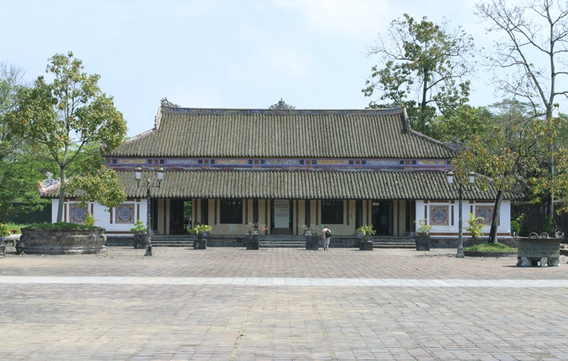 | 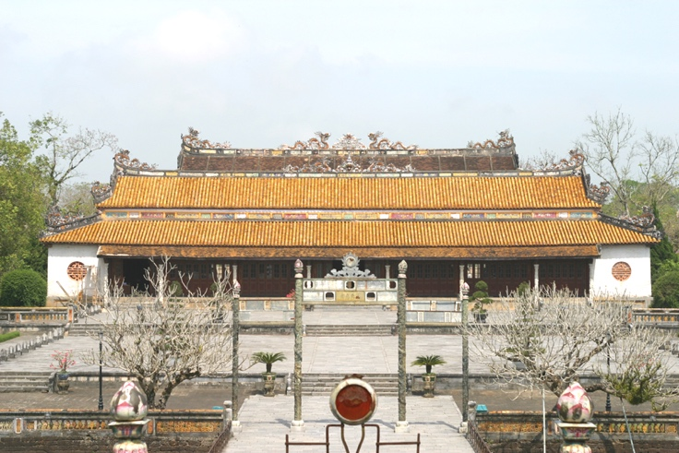
Fig.4 Ta Vu eave (Single-Building) | Fig.5 Thai Hoa Dien palace (Tiwn-Building)
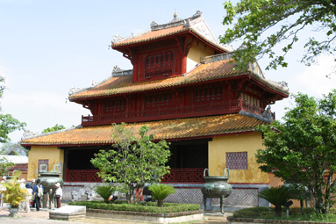 | 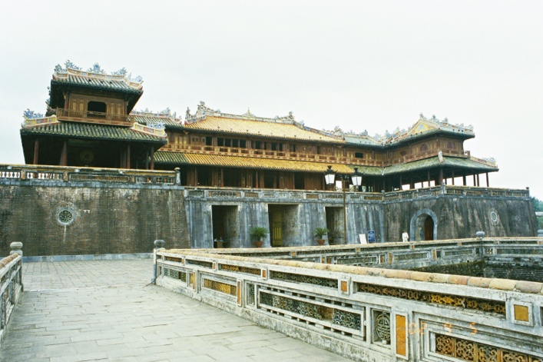
Fig.6 Hien Lam Cac pavilion (Pavilion) | Fig.7 Ngo Mon main gate (Storey Gate)
- Targeted buildings and measuring methods
  - Study objects
Table 2 shows a list of Twin-Buildings that were subject to the measuring survey. They include five main imperial palaces (hereafterby the Palaces), four imperial shrines (hereafterby the Shrines) located at the Imperial City and inside the Citadel, and five mausoleum temples (hereafterby the Temples) located at the complex of Imperial Mausoleums. Among the Palaces, the Shrines and the Temples, Can Thanh Dien palace, Can Chanh Dien palace, Thai To Mieu shrine and Phung Tien Dien shrine have lost their wooden structure and roofs (only ruins of their platform are remained) while the wooden structure and roofs of the others still exist. We will refer to the above three types of Palace, Shrine, and Temple collectively as the Twin-Buildings and analyze in total of 14 buildings based on the results of measuring surveys (tab.2).
  - Measuring methods
We conducted in both of the longitudinal and latitudinal transverse wooden-structure measuring survey of 10 buildings whose wooden structure still exists, and the four buildings in which only the platform now exists were analyzed using the center-to-center measurements of their remaining basement stones.
Before reconstructing the original designning procedure and designing method of the Floor-plan based on actual measuring results, it is necessary to replicate the line that serves as a designing reference line and/or the center line of columns rows as same as the central symmetric axese which now invisible on the sites.
Hardly there was’t any possible trace of the cross ink-line of column rows have been found in the ruin-flatforms that are in existence today. However, basing on the diameter of column traced on the upper-surface of the basement stones of the ruin-flatforms in combination with the expriences thoughtly as a case-study of the ruin-platform of Can Chanh Dien palace (fig.8, 9, 10), the design reference line system on the Floor-plan called “Luoi Cot” (grid of column rows) may has been confirmed. We also refer to it as appropriate in the analysis discussed here in this study.
Tab. 2 List of the remaining Twin-Builings of the Monuments
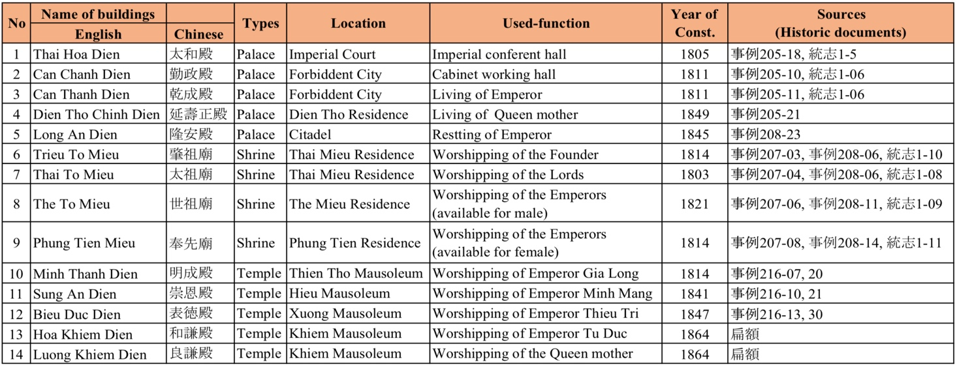
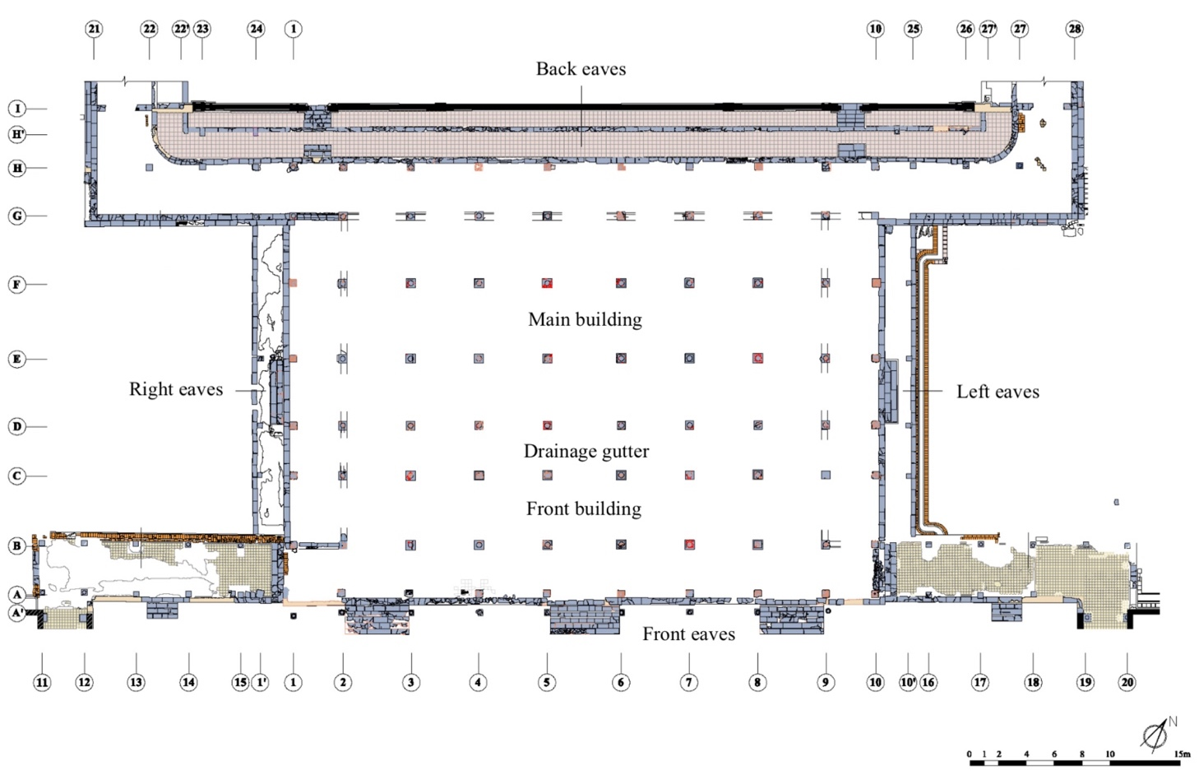
Fig.8 Present status drawing of the ruin-flatform of Dien Can Chanh palace
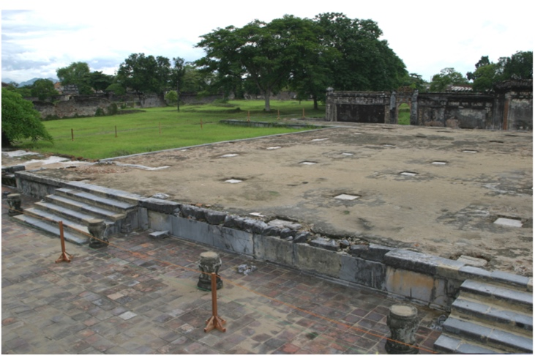 | 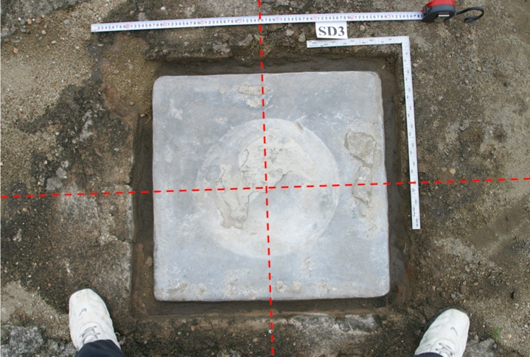
Fig.9 Ruin-platform of Can Chanh Dien palace | Fig.10 Diameter traced on the basement stone (D3)

  - Measurement unit for analyzing
Identifying the specific unit of measurement used in the construction of a building should be a priority concern in restoration designing. It was not uncommon for different buildings to be constructed according to a different measure, so a “building-specific measure” should be ascertained for each building. In this study, we will estimate platform-specific measures based mainly on the analysis of the floor-plan of buildings. Before we do so, let us take a look at the specific units of measurement used in the Nguyen dynasty.
Several items provide a reference of the official measurement units used in the Nguyen dynasty that are preserved in the museums in Vietnam (tab.3 & fig.11). It appears that the official measures units of the Nguyen dynasty were available in several different types for different applications. Among them, the “Quan Moc Xich” ruler (官木尺) and the “Lu Ban Xich” ruler (魯班尺) were used for the construction of buildings. The measures are based either on a decimal or octal number system, but it seems unlikely that the two number systems were used separately in different situations when planning the dimensions of a building.
Based on the above, we shall assume that a “Quan Moc Xich” ruler = 424 ~ 428mm/unit (abb., the Large ruler) and a “Lu Ban Xich” ruler = 382 ~ 384mm/unit (abb., the Small ruler) were used during the early periods of the Nguyen dynasty.
Tab.3 & Fig.11 List and fearture of the investigated Rulers
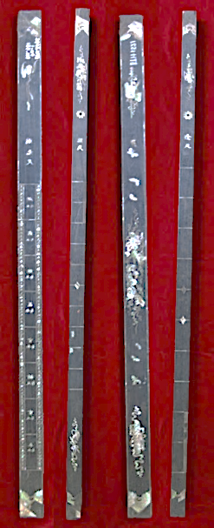
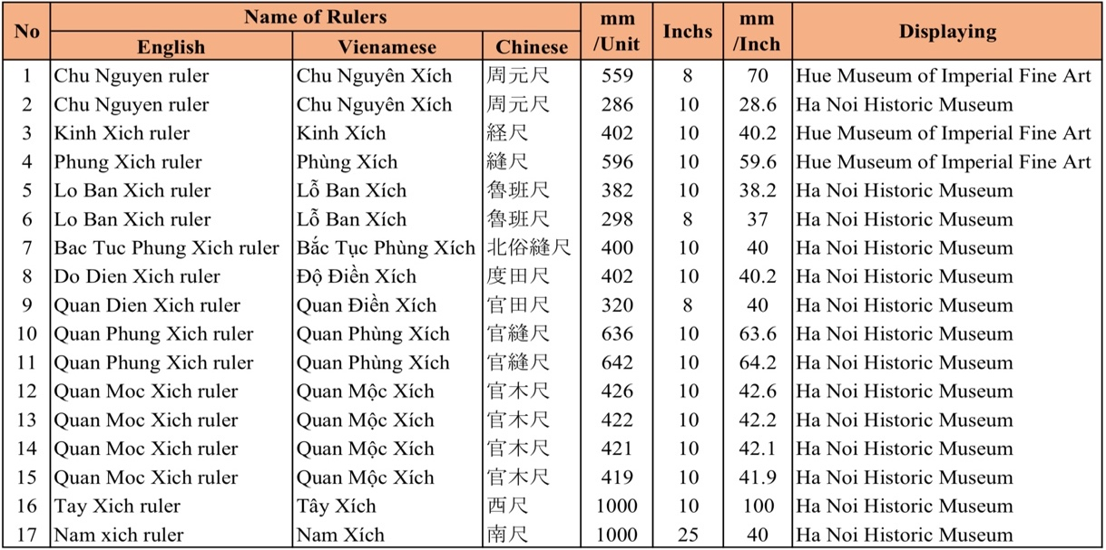

- The Twin-Buildings seen from historical documents
  - Description in the investigated historic documents
The historic documents of the Nguyen dynasty mainly refer to special or/and important buildings, the others are mentioned only briefly. As the above-mentioned Twin-Buildings are paramount architecture built for three types of functions: the Palace, Shrine and Temple, so they were often focused on more carefully described, but these discriptions are also couldn’t provide enought necessary information for our analyzing in this study. However, we still need to use the information related to the scale of architecture in the historic documents to verify and carry out study against actual survey results.
Typically, historical records refer only to the location of the buildings, the year of construction and repairation, the height of the foundation, the number of compartement and wing, the type of wooden-fram and the roofs briefly. The detail informations about interior and architectural structure inside the Twin-Buildings weren’t mentioned, especially the concreted dimensions of compartment, wing and the height of building.
Perhaps, recording of the interior is a taboo in the history of the Nguyen dynasty, so that historians can only described the building from the outside. Or, there may have been technical documents that record in detail of architectural construction techniques under the Nguyen dynasty, but were lost or burned during the war, natural disasters and fires. Specifically, there was the building called Tang Thu Lau pavilion (located at central of Ho Hoc Hai lake, inside the Citadel) designed to be built with the function of storing books and administrative documents of the country under Nguyen dynasty, but this building was burned during the period of Vietnam-France war so it is possible that these important documents were burned or were lost.
  - Relationship between the types and scale of the Twin-Buildings
In table 4 below, we only statistically filter the information related to architectural scale for analyzing the relationship between types and scale of the Twin-Buildings, including information about the number of compartment, wing and height of the platform. In addition, we carry out comparative study the recorded-information in historic documents with the actual measurement results of the existing buildings to verify the database and try to find out the relationship between the type of Twin-Building and its scale. The analytical results allow to comment as follows:
Firstly, there seems to be no proportional relationship between the scale of building and the height of its platform, and even information about the height of platform of some buildings has been omitted. In case the platform of Can Thanh Dien palace has the largest ground area, but the height of its platform is only equal to that of Can Chanh Dien palace while the ground area of ​​this building is only approximately 1/2 of the Can Thanh Dien palace. The case of Thai To Mieu shrine has the largest number of compartment (in ridge direction), but the height of its platform is almost the lowest compared to the others.
Second, the total number of compartment and wing of Thai To Mieu shrine (in ridge direction) is the largest, but the scale of its ground area is much smaller than that of Can Thanh Dien palace. However, this can be understood that Can Thanh Dien palace has three ridge beams while Thai To Mieu shrine has only twin ridge beams. Another case is that the number of compartment and wing is the same, so the ground area is the same as in the case of The To Mieu shrine and Phung Tien Mieu shrine, Thai Hoa Dien palace and Can Chanh Dien palace. In the case is that the number of compartment and wing is the same, but the ground area was different as in the case of Minh Thanh Dien temple and Sung An Dien temple. Thus, all three different cases are also happened even though they can be of the same category or different category.
Thirdly, the Can Thanh Dien palace was built under Gia Long period (1811) as the living place of Emperor Gia Long (and later for the succeed Emperors of the Nguyen dynasty) has a largest ground area of platform (approximated 2,257m2). Meanwhile, the Minh Thanh Dien temple was also built under Gia Long period (1814) as a temple to worship Emperor Gia Long's soul, but has a smallest ground area of platform (approximated 347m2), only about 1/6 of Can Thanh Dien palace. In another case, although the number of compartment and wing mentioned in the historic documents are completely similar between the Palace category (in the case of Thai Hoa Dien palace, Can Chanh Dien palace) and Temple category (Minh Thanh Dien temple, Sung An Dien temple and Bieu Duc Dien temple), but in fact, the dimentional scale of the Palace category is almost 3 times larger than the Temple category (table 4).
Thus, the architectural scale described in the historic documents doesn’t accurately reflect the actual dimentional scale of the buildings. This description can be only qualitative difference among the buildings and doesn’t include quantitative factors of architectural dimensions. Why is there such a big difference between the acctual dimentional scale of the Palace category and Temple category while those scales mentioned in the historic documents are the same? As the above-mentioned two types of ruler and observing the analysis results in tables 5, 6, and 7 below, we assume that the first quantitative factor for the architectural scale applied during the Nguyen dynasty was parameterized by the length of the above-mentioned Large ruler and Small ruler rulers (Parametric 1). Thoughtly, it is possible that Large ruler was applied to constructure the Palaces and the Shrines (in Imperial City), while Small ruler was applied for the Temples (in the complex of Imperial Mausoleum). Therefore, if it is only necessary to change the length of the rulers, the entire dimentional scale (quantitative factors) of the building will be changed.
Table 4. Relationship between the types and scale of the Twin-Buildings
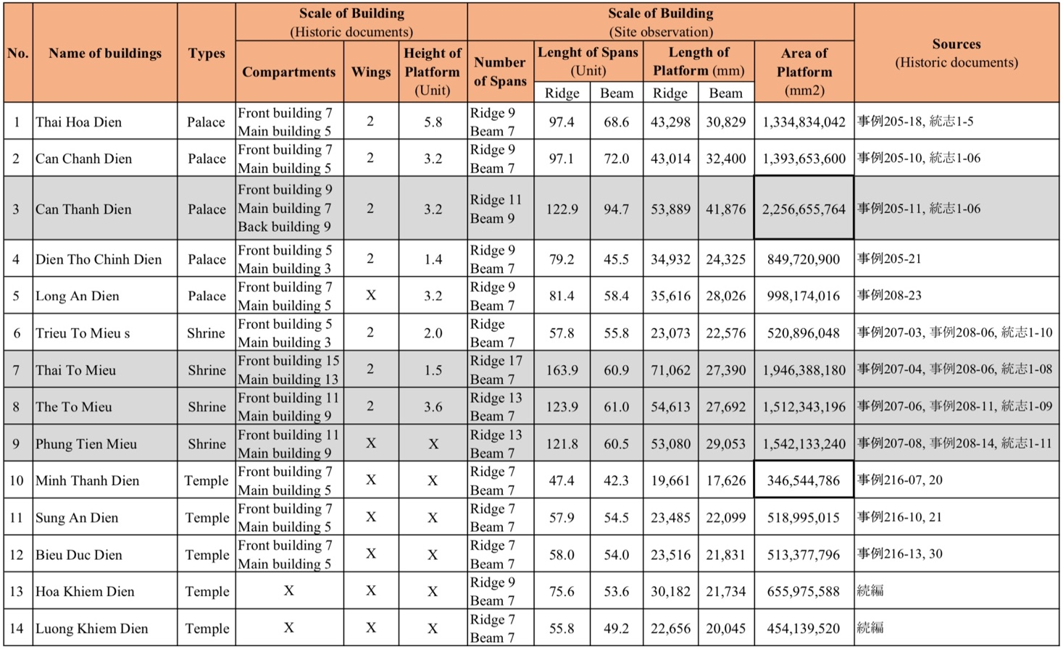
Note: Miss information in historic documents (X)

- Characteristis of the Floor Plan of the Twin-Buildings
  - Components of the interior spatials
Based on literary references, the parts of the Floor-plan will be referred to as: “Chinh Trung Gian” central compartment (正中間, hereafterby A), “Thu Gian” left/right-compartment (左/右次間, hereafterby B), “Noi Suong” inter wing (内廂, hereafter C) and “Ngoai Suong” outer wing (外廂, hereafterby D) in the ridge direction (latitude); “Chinh Doanh Luong Tam” big beam-span of main building (正楹梁心, hereafterby E), “Tien Doanh Luong Tam” big beam-span of front building (前楹梁心, hereafterby F), “Thua Luu” drainage gutter-span (承霤, hereafterby G), “Tien Khuynh” front diagonal beams-span (前傾, hereafterby H) and “Hau Khuynh” back diagonal beams-span (後傾, hereafterby H), “Tien Suong” front wing-span (前廂, hereafterby I) and “Hau Suong” back wing-span (後廂, hereafterby I) in the beam direction (longitude), “Tien/Hau Quyet” front/back corners (前後決, hereafterby K) and “Ta/Huu Quyet” left/right corners (左右決, hereafterby K) at the four outermost-corners.
Besides, according to the ridge direction, the interior space from drainage gutter-span forwards to front side of the building is defined as the “Tien Doanh” front building (前楹, hereafter by the Front building), the space from drainage gutter-span backwards to back side of the building is defined as the “Chinh Doanh” main building (正楹, hereafterby the Main building). Additionally, the stairs made of natual stone attached symetrically on the central, both front/back-left and right sides of the Floor-plan (fig.12).
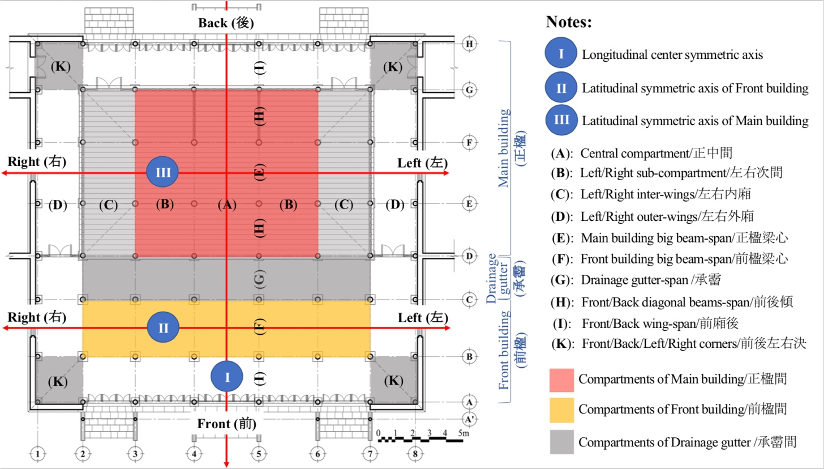
Fig. 12 Spatials arrangement on the Floor-plan of the Twin-Buildings

  - Symmetrical axese and column rows
Accordingly, the concepts of central, left and right, front and back expressing on the floor-plan determine that the component spatial of the Floor-plan arranged according to the symmectrical axese designed in both latitudinal and longitudinal direction. The above-displayed figuge 12 shows the feature and location of the longitudinal center symmetric axis (I) palys as an important role for not only constructional technique but also fot the spirit thought. Thus, the central compartment which contained the longitudinal center symmetric axis is ussually designed as a largest span (will be discussed below), then the most treasure items of the Dynasty such as throne and altar of the Emperpors must placed at this central compartment. Beside, the latitudinal symmetric axis of the Front building (II) and the Main building (III) are also necessary for arrangement of latitude column rows as same as assembling of the other component timbers. The column rows therefore drawn parallel followed the symmetrical axese and setted symmetrically acoording to them.
Specifically, in the figuge 13, line 5 would be the first-left longitudinal column row, line 4 would be the first-right longitudinal column row, and so on. Besides, line B and line C would be the first-front and first-back latitudinal column rows of the front building; line E and line F would be the first-front and first-back latitudinal column rows, line D and line G would be the second-front and second-back latitudinal column rows of the main building. Continuously, the position E5 and E4 will be the front first-left and front first-right big column, F5 and F4 will be the back first-left and back first-right big column of the Main building; B5 and B4 will be will be the front first-left and front first-right big column, C5 and C4 will be back first-left and back first-right big column of the Front building, and so on (fig.13).
- Analyzing design method of Floor Plan of the Twin-Buildings
  - Dimensional analysis
We firstly analyzed the estimated construction measure of each Tiwn-Building for reference. Actual measurements were converted to units according to the existing measures units of the Nguyen dynasty mentioned above, and at the same time, they were calculated based on measurement values described in literary materials. To examine the validity of the estimated construction measures, we compared the actual measurements of all column spans and platform length with restoration values derived from the estimated construction measures. Maximum margin of error was 88mm, minimum marging of error was 0mm, and the average difference was about 25mm (tab.5). Therefore, the estimated construction measures were basically proven to be highly valid.
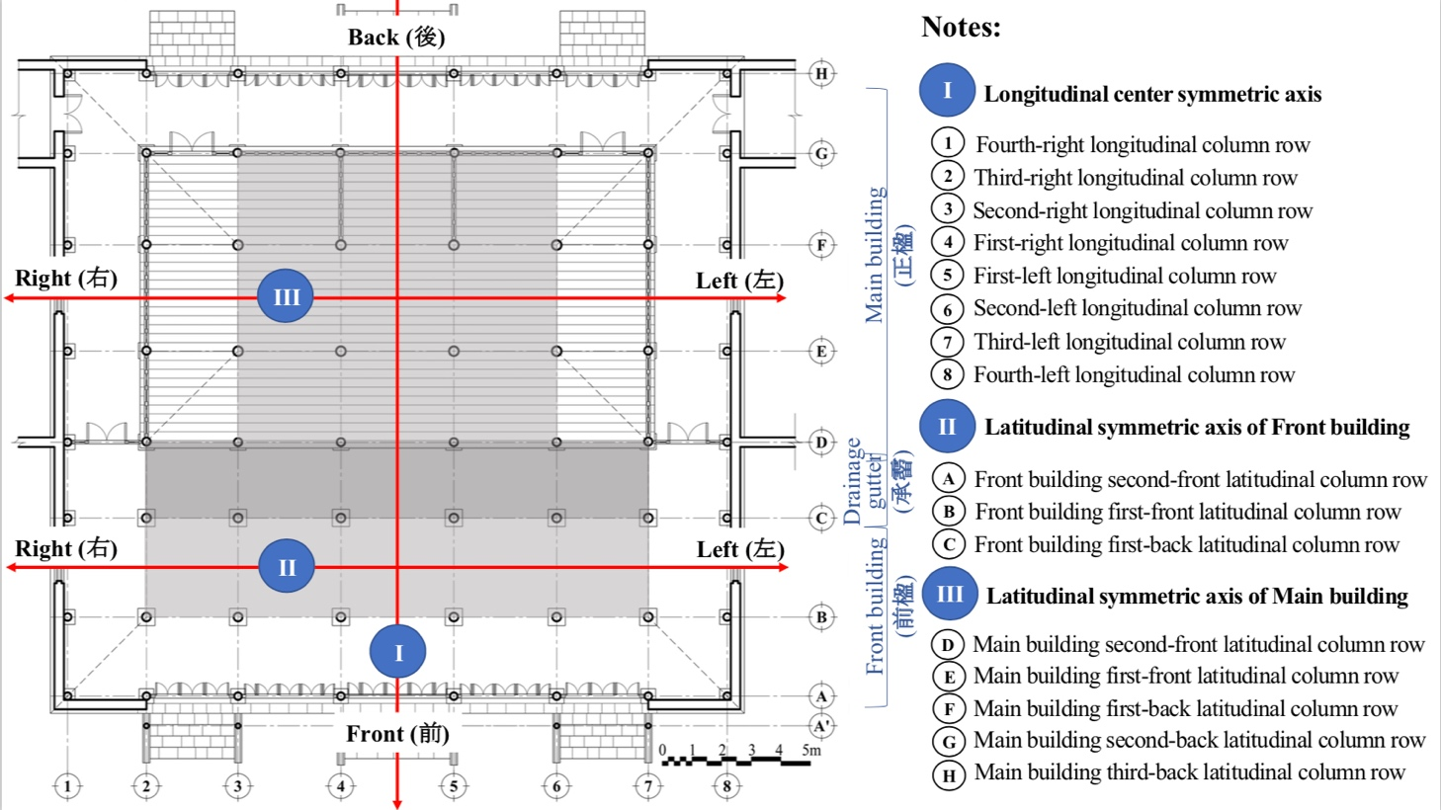
Fig.13 Axese and column rows of the Twin-Buildings shown on the Floor-plan

The above-mentioned literary references of the Nguyen dynasty haven’t contained information on unit measurements of the platforms of the Architecture, as well as unit measurements of the height of big columns in a number of the Twin-Buildings. But according to these, the central compartment in the ridge direction (above-mentioned the A) officially called “Chan Tam” (振心), and the main span of the main building in the beam direction (above-mentioned the E) called “Luong Tam” (梁心). Thoughtfully, it can be determined that the A and/or the E are dimentional origins of the Architecture, thus, they have the offcial names expressing special concept recorded in the historic documents of Nguyen dynasty. The major findings of our analysis are presented below.
- Column span is largest in the central compartment
In both the ridge direction and beam direction, column span is largest in the central span (span 4-5, above-mentioned the A) and main span (span E-F, aboved-mentioned the E). It becomes smaller toward the outer sides. First of all, in the Palaces and the Shrines, the largest column span is around 12 units up to 13 units (by the Large ruler), and in the Temples, it is around 10 units (by the Small ruler). Other column spans were probably designed based on this standard, with each span being established to a tenth of a unit based on a decimal number system. For example, adjacent compartments have spans of ±1 unit, ±0.9 units, ±0.1 units, and so on (tab.6). This system, based not on proportion but on addition or/and subtraction, is called “Gia-Giam” method in the traditional technique of Hue, and there are skillful master carpenters who possess this traditional method.
- Three types of mutual relationships among column spans
Accordingly, the master carpenters who possess the above-mentioned traditional skill, the mutual relationship between columns is based on three default principles (fig.14).
- First principle: “Khep Chuong” means the spans between all big columns is the same, that can be seen in the dimentional relationships: span 4-5 = span E-F, and span 5-6 = span B-C.
- Second principle: “Con Lon Me” means the spans between a subsequent pair of columns is smaller than the initially established spans, that can be seen in the dimentional relationships: span 4-5 > span 5-6 > span 6-7 > span 7-8; span E-F > span B-C; span D-E > span C-D.
- Third principle: “Bat Van” means the spans between conner columns is the same, that can be seen in the dimentional relationships: span D-E = span 6-7; span A-B = span 7-8.
Table 5. Dimentional analyzing on the total spans of the Twin-Buildings
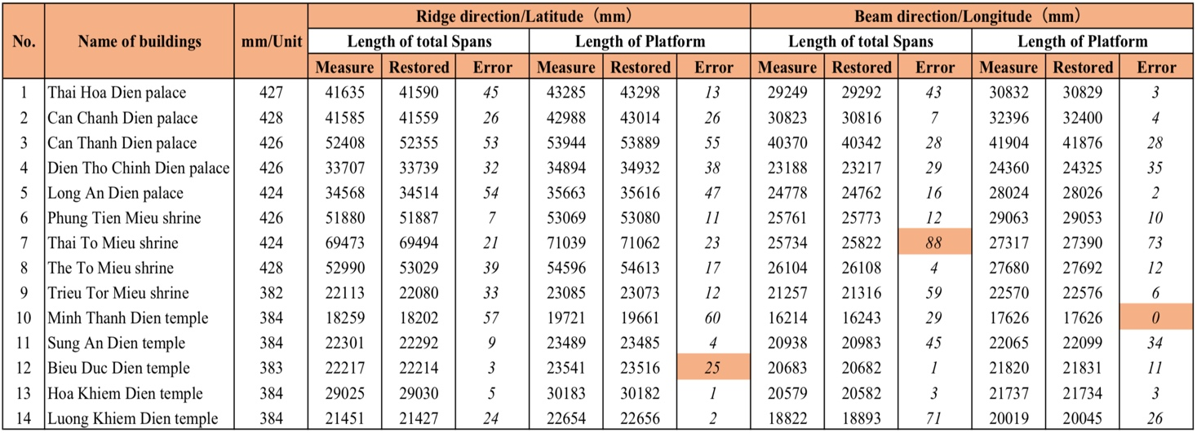
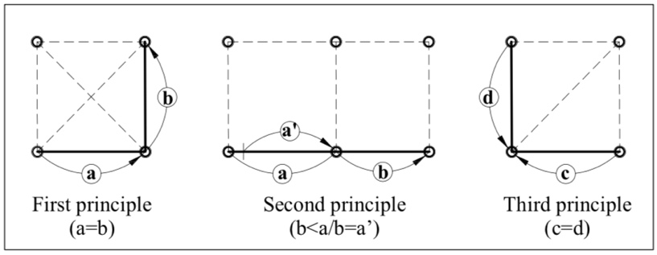
Fig.14 Three basic principles applied for Platform
- Central span (A) in the ridge direction is first established
In general Twin-Buildings, the the central span in the ridge direction (span 4-5), was probably established first according to either the Large ruler or the Small ruler. The actual measurement of the relevant span was in range from 9 units up to 13 units.
Each Twin-Building has a different span, probably because a measurement value that has certain meaning to the size, function, and position of the building was firstly established. Deciding on the span of columns in the ridge direction is important to the elevation structure of a building. Because there is normally no column inclination, the length of the horizontal ridge-direction element becomes the span in the beam direction, and adjustments and changes are appropriately made. On the other hand, establishing it may be easier to arbitrarily establish spans in the ridge direction first, concretely the central span (A) was probably established first, helped also by its repetitiveness. Spans in the ridge direction can easily set the scale and expression of the entire architecture, while spans in the beam direction are deeply related to technical factors (tab.6).
- The next spans in the ridge direction (B) is smaller than central span (A)
The next spans (above-mentioned the B), or the spans on the outer sides of the A are clearly meant to be smaller than A (above-mentioned second principle). Case by case, B smaller than A in range from 0.4 unit up to 1 unit. In terms of actual values, it is interesting to note that the measurement of the B is a fraction of the A in the Can Thanh Dien palace, Can Chanh Dien palace and Thai Hoa Dien palace located on the center symmetric axis of the Imperial City, while it is a whole number of 10 units in the Thai To Mieu shrine, The To Mieu shrine, Phung Tien Mieu shrine and Dien Tho Chinh Dien palace are all located on other sub-parallel axes. It is also a whole number in all buildings inside the complex of the Imperial Mausoleums: B = 8 units in the Minh Thanh Dien temple and B = 9 units in the other four temples. It seems that column span was consciously established according to the location and function of the buildings.
Table 6. Dimentional analysis of column spans on the ridge direction (latitude) of the Twin-Buildings
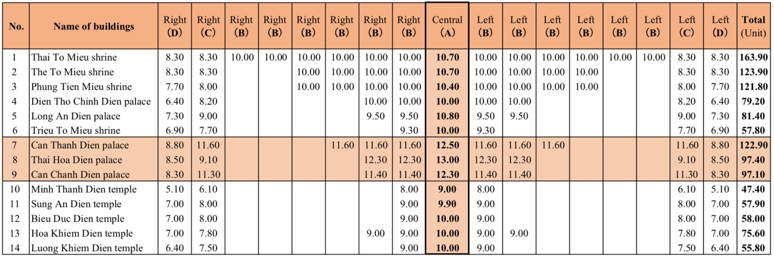
- Main spans in beam direction (E, F) and inward column inclinations
The A and E are interrelated in one of three ways: (i) E = A (center-to-center measurement between column bases); (ii) A = E + 2e + 2f (both inward-inclinations of columns in span E and span F (span B-C); (iii) E = A ± 0.1 unit (tab.6, 7, 8).
The relationship between the E and the B is such that the span E (center-to-center measurement between column bases, or center-to-center measurement of the beams) is equal to either E = B, or E = B – 1 unit, or E = B ± 0.1 unit. The span F is equal to either F = B, or in range of F = E – 0.4 units up to 1 unit. Only in the case of Dien Tho Chinh Dien palace, F = E – 1.7 units (table 6, 7, 8).
Table 7. Dimentional analysis on the beam direction (longitude) of the Twin-Buildings
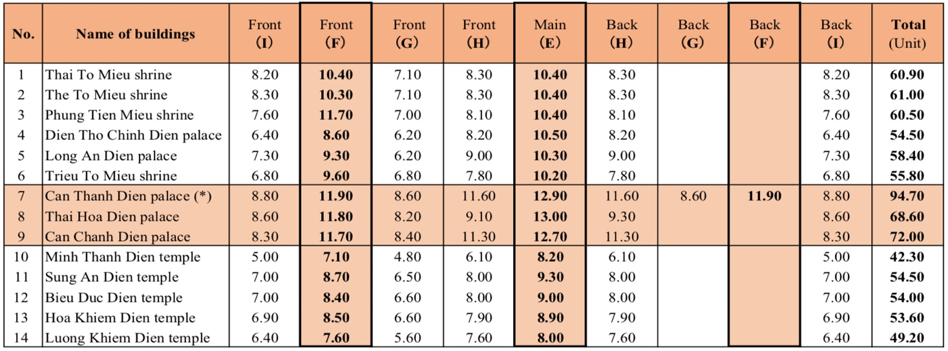
- Span of wings (C, D and H)
Span C (span 6-7) can be discussed in relation to the A or B. If considered in relation to the A, it is equal in range of C = A – 0.9 units up to 2.4 units. In the case of Thai Hoa Dien palace, the span reduction is large, it is 3.9 units shorter in the ridge direction (C = A – 3.9 units) and 3.7 units shorter in the beam direction (G = A – 3.7 units). If considered in relation to the B, span of the C is equal in range of C = B – 1 unit up to 1.9 units.
Span H (span D-E) should be similar to the C (span 6-7) in the above-mentioned third principle (location corresponding to the corner of the hip-and-gable roof), but inreality is 0.1 unit longer than the C. This adjustment was probably made in consideration of the inclination of the columns according to the beam direction. Therefore, the span H was probably established in consideration of column inclination, based on the span C in the ridge direction.
Span D (span 7-8) in the ridge direction is determined based on the C, and is equal to the span I (span A-B). In some cases, D equal C or a little shorter than C. Depending on the type of Twin-Building, it tends to be 0.3 upto 0.8 units shorter (case of the Shrines), 0.6 upto 3 units shorter (case of the Palace), or 0.8 upto 1.1 units shorter (case of the Temples). The span of the I in the beam direction is about 0.1 unit shorter or longer than the D and was probably established in a manner similar to the relationship between C and H (tab.6, 7, 8).
- Span of drainage gutter (G)
A relationship exists between the span G and H when analyzing the distance between the top of the columns in the drainage gutter (span C-D) or the centers of medium columns of the main building, and the point where the center of the big columns in the front building and the center line of beams intersect. This distance is equal to span of the H minus a certain unit or fraction of a unit. It seems that span of the G was arbitrarily decided on the precondition that it be smaller than that of the H. It may have been adjusted so that the buildings correspond to the general layout plan of their respective building (tab.8, 9).
Table 8. Analyzing on the interrelation between column spans in ridge direction and beam direction (1)
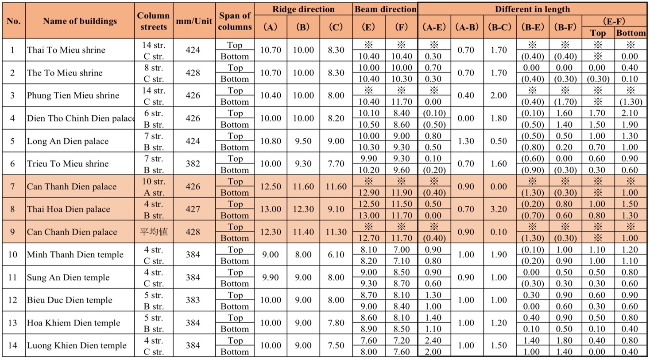
Table 9. Analyzing on the interrelation between column spans in ridge direction and beam direction (2)
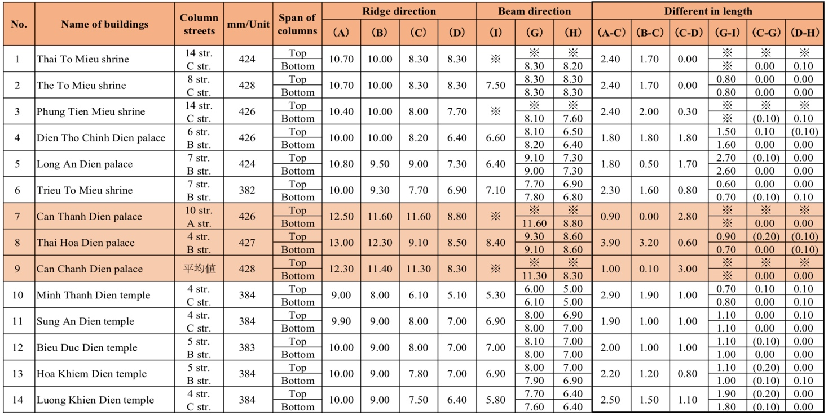

  - Categorise on the types of the Floor-plans
The above analysis results can be sorted into the following three types of Twin-Builing (fig.7).
- Type A: “10 units Twin-Building”
These are Twin-Buildings whose E = B = 10 units (in the Large ruler). They include the Thai To Mieu shrine, The To Mieu shrine, Phung Tien Mieu shrine and Dien Tho Chinh Dien palace.
- Type B: “12 units Twin-Building”
These are Twin-Building whose E = A = 12 units up to 13 units (in Large ruler). They include the Thai Hoa Dien palace, Can Chanh Dien palace and Can Thanh Dien palace those can be re-categorise as the “Big-Palaces”. Situated along the principle symmetric axis line of the Imperial City, these Twin-Buildings are of primary importance, and were probably specially designed to be large in scale, for that specific reason.
- Type C: “Mausoleum Twin-Building”
These are Temples located inside the complex of Imperial Mausoleums. Spans in the ridge direction are specified in actual measurements whose A = 10 units (in Small ruler), the B is always a subtraction of the A.
Regarding to the re-located Twin-Buildings, this is not a category based on design method, but base on their curcumtancy those have been relocated or/and rebuilt, the spans in ridge direction and beam direction and/or other measurements may have changed in that process. For example, the Long An Dien palace and Thai Hoa Dien palace are both the relocated palaces, some of their dimentions look seem to be strange from the others (tab.6, 7; fig. 7).
  - Assuming on the designing principle of the Floor-plans seen from analyzing results
As the above-mentioned, categories of Twin-Buildings consisted of the Palaces, the Shrines and the Temples are defined based on the historical hierarchy of buildings, and this has suggested an effective theme for our analyzing to re-determine the designing principles that may have been applied for the floor-plans of the targeted Twin-Buildings mentioned in this study.
Logically, span A thought as the first dimentional origin from which other dimensions will be generated. Combination with the above-mentioned (3.2), it can be assumed that A is the second quantitative factor that has been parameterized (Parametric 2) in the architectural designing principles of the Nguyen dynasty. Thus, if just changing the dimention of A, then the grid of column rows of the whole building will simultaneously be changed. Based on the qualitative factors of the buildings that therefore number of unit and/or dimention of A concurrently with relationship among A and the others will be decided. Based on the results of dimentional analysis mentioned above, we can realize that spans in the ridge direction (latitude) expressed in magical number that can easily set the aesthetical scale of the architecture, while the spans in the beam direction (longitude) are expressed in various different number that can be thought deeply related to technical issues (comlumn inclination for reducing the pressure of loading weight and aesthetic sensation adjustment).
Additionally, the spans B (sub-compartment) seem to be established in terms of a whole number unit in both of the Shrines and the Temples, and the rule of setting the floor-plan is also appear to be established according to the function of the important sanctuaries. This is similar to the difference between the Twin-Buildings inside the Imperial City where the former was designed according to the Large ruler, also can be considered as the positive measure applied for the “Yang” (available for living life), and the Twin-Buildings in the complex of Imperial Mausoleums where the former was designed according to the Small ruler, also can be considered as the negative measure applied for the “Yin” (available for the life after death). Only the Trieu To Mieu shrine is an exception, however, though it is a Shrine, it is uniquely considered a Twin-Building that is built like a Temple according to the Small ruler for the “Yin” due to the special resons.
In the previously mentioned (5.1, d), the measurement of span B is a fraction of the A in case of the Tiwn-Buildings those located on the center-symmetric axis of the Imperial City, while it is a whole number of 10 units in the Twin-buildings those located on other left/right-parallel symmetric axes of the Imperial City, as same as it is also in all Twin-buildings (those located on the main center symmetric axis of the complex of the Imperial Mausoleums) that B is a subtraction from A (ranges from 0.9 unit upto 1 unit). It seems that column span was consciously established according to the location and function of the Twin-Buildings (tab.6).
The figuge 15 below is a summary of the typologyical categorise on floor-plan of the Twin-Buildings basing on the anlyzing results. Accordingly, it shows that the ground area dosen’t necessarily to be met to the level of how important they are, but depend on their used-function and where they are located. The mix between similarities and differences in design principles comes from either the change of construction techniques in each period or the movement and re-construction of the buildings was also happened.
However, once there are parametric factors appearing in architectural designing principles, it means the phenomenon of modularization and formulaization is very high, showing the level of mathematics and logicality in architectural construction activities under Nguyen dynasty. The change of architectural dimensions based on parameters creates architectural style consistency, simplifies the designing process and minimizes construction time and costs. To clarify that, below we try to hypothesize about the designing method of the floor-plans of the Twin-Buildings that is considered as the typical type of the Architecture.

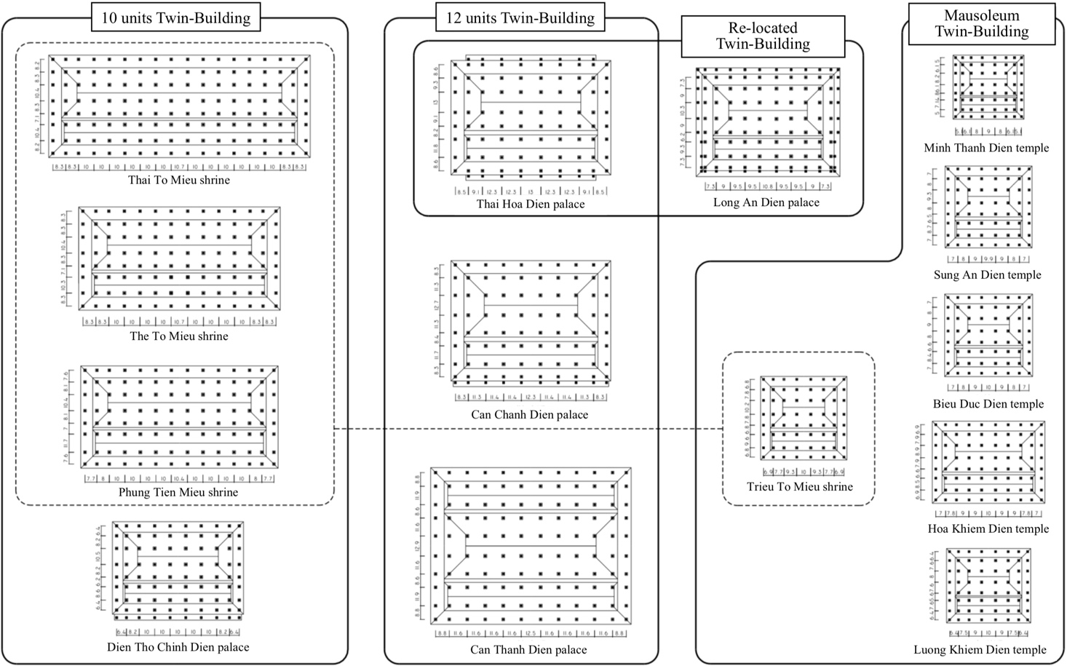
Fig. 15 Categorise on the types of Floor-plan of the remaining Twin-Buildings

- Re-determined design methods of the Floor Plans
Accordingly, column spans that are principal to the floor-plan design (fig.12): A (span 4-5), B (span 5-6), E (span E-F) and F (span B-C). In terms of mutual relationships, the general trend shows that A = E > B ≥ F in the Palaces (Square shape at the central spans), A > E = B ≥ F in the Shrines and the Temples (Rectangle shape at the central spans). Based on this trend, it seems that there were two designing methods of floor-plan that could be re-determined below.
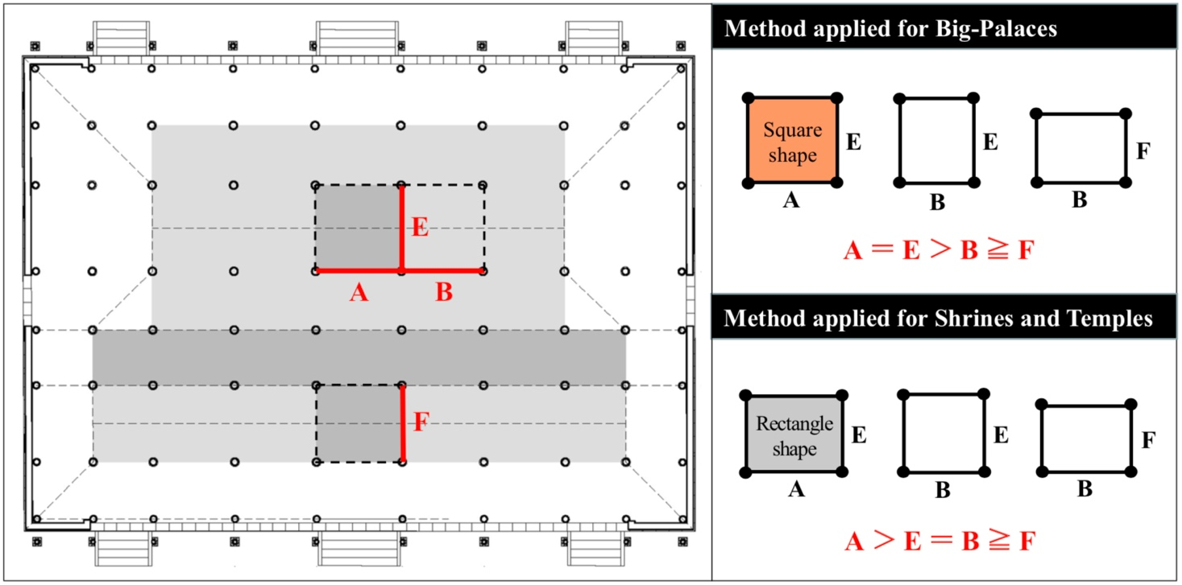
Fig.16 Explained drawing on the relationship among the spans

  - Designing method applied for the Big-Palaces
In this method, either span A or span E is firstly established. In principle, they are the same spans in dimention. The established span is the measurement between the top of column or between the intersection-points of the both big column center lines and the big beam center line of the main building. At column bases, it takes into account the width of column inclinations. Next, span B is established by subtracting a certain unit or fraction of a unit from A, and span F is set so that it is roughly the same as the B. Span C is derived from the B, and the D is derived from the C. Lastly, span G (drainage gutter) and span I are sequentially set to be the same as the D according to the third principle (fig. 17a, 17b, 17c, 17d).
This designing method is intently applied for the Big-Palaces placed on the center symmetrical axis of the Imperial City includning Thai Hoa Dien palace, Can Chanh Dien palace and Chan Thanh Dien palace whose were earliest built in Gia Long period, used for working and living places of the succeeded Emperors. Thus, the ideal designing methos is more hight parameterized and constructional regulation was more realizable and strict than the others.
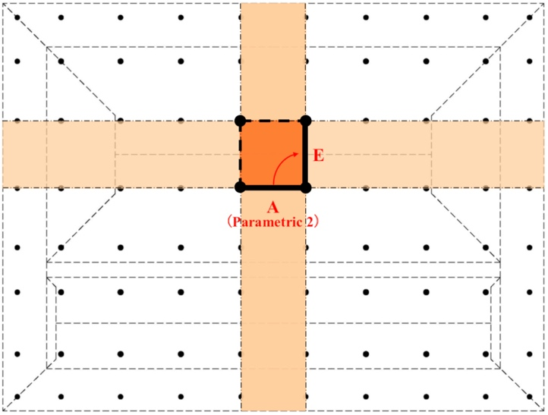 | 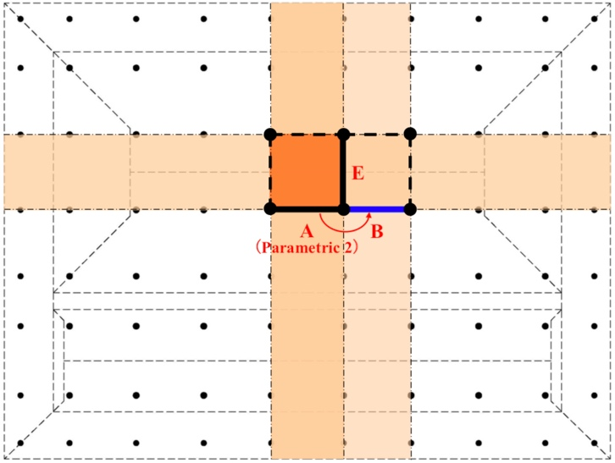
Fig.17a Relationship between A and E (dimetional origin) | Fig.17b Relationship between A or E and B
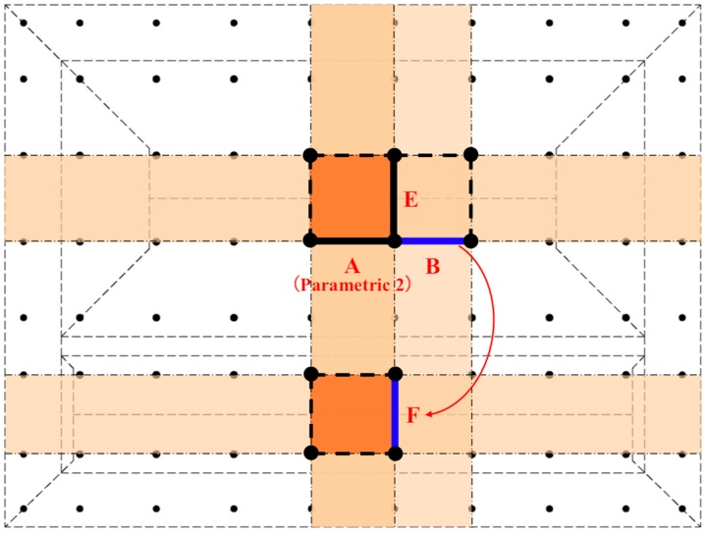 | 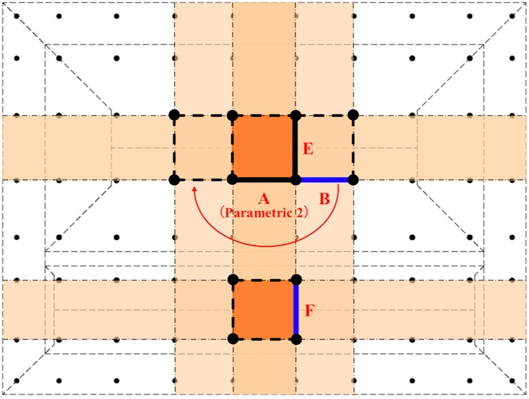
Fig.17c Relationship between B and F | Fig.17d Relationship between B and the others

  - Design method applied for the Shrines and the Temples
In this method, span A is firstly established, span B is set to be smaller than the A. Next, span E (at the top of column) is set to be roughly the same as the B. From here, the method differs from that of the Big-Palaces. Span F is established based on the E, span C based on the B and span D based on the C, then span G and span I take on the same measurement based on the D according to the third principle (fig. 18a, 18b, 18c, 18d).
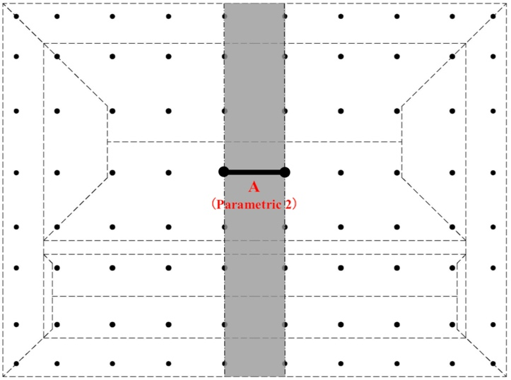 | 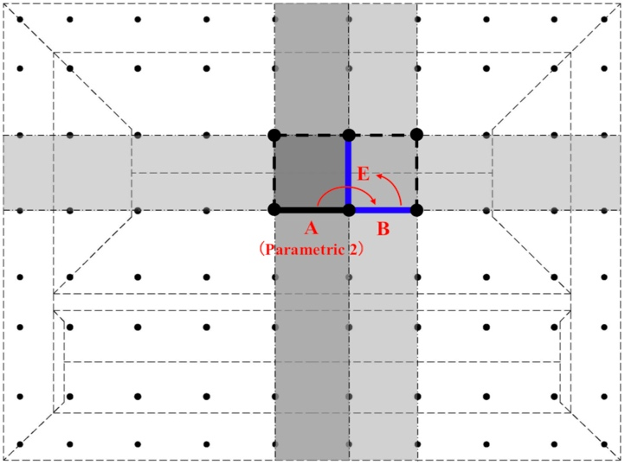
Fig.18a A is dimentional origin plays as a parametric 2 | Fig.18b Relationship between A and B, B and E
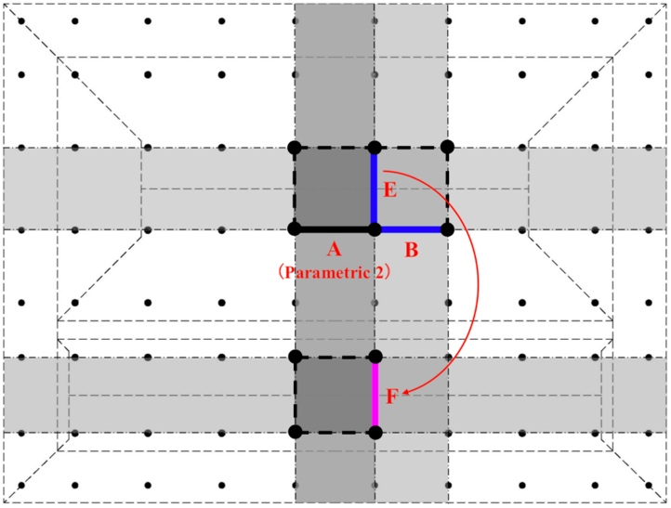 | 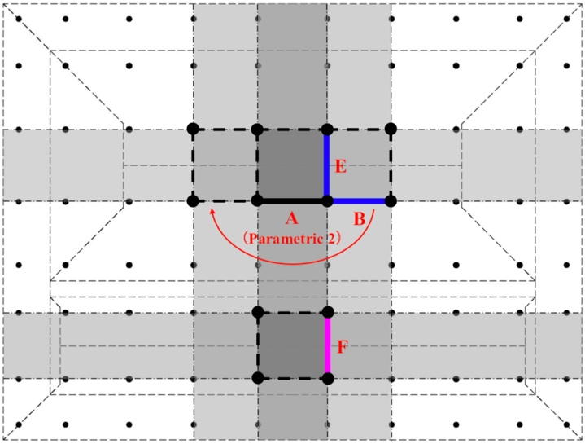
Fig.18c Relationship between E and F | Fig.18d Relationship between B and the others

This designing method is mainly applied for the Twin-Buildings located on the left/right-parallel axese of the Imperial City which belonging to the category of “10 units Twin-Buildings”, they are including Thai To Mieu shrine, The To Mieu shrine, Phung Tien Mieu shrine and Dien Tho Chinh Dien palace. Additionally, this designing method also can be applied for the the Twin-Buildings located at the main center axese of the complex of Imperial Mausoleum which belonging to the category of “Mausoleum Twin-Buildings”, they are including Minh Thanh Dien temple, Sung An Dien temple, Bieu Duc Dien temple, Hoa Khiem Dien temple and Luong Khiem Dien temple.
In the case of Dien Tho Chinh Dien palace, evently it was built as the palace for Queen mother, but it is located on the rightside-parallel axis, then perhaps it was effected by the regulation applied for whose placed on the parallel aixs (belonging to category of “10 units Twin-Buildings”). In the case of the Long An Dien palace, it was a resting-palace of Emperor Thieu Tri, relocated and rebuilt at the current place (outside of the Imperial City) under Khai Dinh period, then perhaps there were some changings during the reconstruction.
In case of Trieu To Mieu shrine, evently it was built as the shrine located on the leftside-parallel axis of the Imperial City, but it was perhaps thought as a temple and effected by the regulation applied for the category “Mausoleum Twin-Buildings”, thus the Small ruler was also applied for design, then its dimentional scale is as same as the Temples accordingly.
- Conclusion
As a result of conducting a comparative analysis of the relevant Twin-Buildings and a chonological observation, it was found that the Twin-Builings of the Architecture can be categorized as three types according to their floor-plan regulation, they are including: “10 units Twin-Buildings”, “12 units Twin-Building” and “Mausoleum Tiwn-Buildings” those applied for each used-funtion and belonging to the axis where they are located on. In which, there are two designing methods of floor-plan have been comfirmed, once applied for the Big-Palaces used for working and living of the succeed Emperors which located on the center symmetric axis of the Imperial City, and the other applied for the Shrines and Temples both used for worshipping located on the left/right-parallel axese of the Imperial City or located on the center main axese of the complex of Imperial Mausoleums.
While the Twin-Buildings in the Imperial City are designed according to the Large ruler considered to be applied for the “Yang”, the Twin-Buildings in the complex of Imperial Mausoleums are designed according to the Small ruler considered to be applied for the “Yin”. Evently, they were designed in different size numbers from each other, but those all implied the philosophy of “living life and the life after death are running as the same way” that has been common thought in traditional society of Vietnam.
The principle of spatial-symmetry arrangement according to the axese applied in both latitudinal and longitudinal direction on floor-plan of the Twin-Buildings, which is also an outstanding charateristic of the site planning principle of the Hue Imperial City and of the Hue Citadel. This partly shows the consistency in the architectural thinking and the rule of the country under Nguyen dynasty from early 19th century to the early-halft of the 20th century in Vietnam.
The concept of parameterize has been applied skillfully in the architectural designing methodology since early time of the Nguyen dynasty made unique of the whole Monuments. The first quantitative factor of the architectural design has been parameterized into the length of the rulers (Parametric 1), then the second applied to the real dimention of the central-origin spans (Parametric 2). If either one of two or/and both of them has increased or decreased, the total two-dimentional scales (2D) of the floor-plan will be accordingly changed. Thoughtly, this is an amazing mathematic thougth has been created since early period of the Nguyen dynasy in Vietnam. Those mentioned assumings direct to understand the way how to take a balance between qualitative and quantitative conscious in the architectural designing that may contribute to create the new architectural designing methodology in a term of social modernization and industrialization.

References
- Kim S, Park S, Kim H, Yu K. Deep floor plan analysis for complicated drawings based on style transfer. Journal of Computing in Civil Engineering. 2021 Mar 1;35(2):04020066.
- Ahmed S, Weber M, Liwicki M, Langenhan C, Dengel A, Petzold F. Automatic analysis and sketch-based retrieval of architectural floor plans. Pattern Recognition Letters. 2014 Jan 1;35:91-100.
- Gao X, Asami Y, Zhou Y, Ishikawa T. Preferences for floor plans of medium-sized apartments: A survey analysis in Beijing, China. Housing Studies. 2013 Apr 1;28(3):429-52.
- Lobos D, Trebilcock M. Building performance information and graphs approach for the design of floor plans. Arquiteturarevista. 2014;10(1):23-30.
- Rodrigues E, Gaspar AR, Gomes Á. Automated approach for design generation and thermal assessment of alternative floor plans. Energy and Buildings. 2014 Oct 1;81:170-81.
- Ishikawa T, Nakata S, Asami Y. Perception and conceptualization of house floor plans: An experimental analysis. Environment and Behavior. 2011 Mar;43(2):233-51.
- Flack RW, Ross BJ. Evolution of architectural floor plans. Springer Berlin Heidelberg; 2011.
- Langenhan C, Petzold F. The fingerprint of architecture-sketch-based design methods for researching building layouts through the semantic fingerprinting of floor plans. International electronic scientific-educational journal: Architecture and Modern Information Technologies. 2010;4(13):1-8.
- Wang XY, Liu YF, Zhang K. A graph grammar approach to the design and validation of floor plans. The Computer Journal. 2020 Jan 17;63(1):137-50.
- Moon JS, Park J, Kim J. Enhanced method for evaluating remodeling floor plans for apartment complexes with an emphasis on efficiency and accuracy. Journal of Building Engineering. 2024 Oct 15;95:110255.

UNESCO World Heritage List, https://whc.unesco.org/en/list/678 (Description is available under license CC-BY-SA IGO 3.0).
Vinh An Le and Ngoc Quynh Chau Truong, Practicing on the re-construction study of “Can Chanh Dien” Palace, Hue Imperial City, Vietnam-world cultural heritage, International Journal of Architectural Heritage, Taylor & Francis Group. https://doi.org/10.1080/15583058.2019.1612483.
Remaning historical sources of Nguyen dynasty are including a various kind of documents, they all written in Chinese and old Vietname character (called Han-Nom) and published under the periods of Nguyen dynasty (1802-1945). Our study is mainly refered to 欽定大南會典事例正編, 欽定大南會典事例続編, 大南寔録 and大南一統志.
Par L. Cadière la Citadelle de Hué: Onomastique, des Missions Etrangères de Paris, Bulletin des Amis du Vieux Huế, 20 Annee No.12, Janvier-Juin 1933, p.75, Planche XXXII. Les quartiers de la Citadelle de Huế (Dessin par M. Nguyễn Thứ). Par le L-Colonel Ardant du Picq, Commandant d’Armes, Les Fortifications de la Citadelle de Hue, Bulletin des Amis du Vieux Huế, 11 Annee No.3, Juillet-Sept. 1924, pp. 222-227, Planche LXXXIV. Hydrographie suppose de Hué avant 1805, LXXXV. La Contruction de la Citadelle de Hué en 1805.
The style of architecture and art of decoration created under Khai Dinh period (1916-1925) is wellknown as the colonial style common in the latest periods of Nguyen dynaty from the years of 1920s to 1945s. Typical buildings can be refered to as the Kien Trung Dien palace (for living of the Emperor, located at the Forbiddent City) and the Ung Lang mausoleum of Emperor Khai Dinh was built from 1920-1931 (located at Thuy Bang comune, Huong Thuy district, Thua Thien Hue province nowaday).
The “Cong Bo” (工部) Minstry of Construction was an one of six Administrative Ministries of Nguyen dynasty, played as an important role of construction and buildings during the periods. Volume of the “Cong Bo” is the collected reports on the field of construction works and a recording of the official regulations on architecture, worte in short writing and very compendious by Chinese and old Vietnamese charaters (called Han-Nom), established as a part of the documents欽定大南會典事例正編, 欽定大南會典事例続編 and大南寔録 under the Nguyen dynasty.
This is a part of the site investigation that we conducted from 2005-2007, supported by the “Fund of the Japanese Scientific Research Association for environmental rehabilitation of the Hue Imperial Palaces using GIS, GPS and CG technologies (Research representative: Prof. Dr. Takeshi Nakagawa), “Research Support Project of the Ministry of Education, Culture, Sports, Science and Technology of Japan”, the “Private university scientific research promotion project (Academic frontier promotion project)”. In addition, this is a joint academic survey conducted at the request of the People's Committee of Thua Thien Hue Province and the Director of the Hue Monuments Conservation Center (HMCC).
8 Vinh An LE, Takeshi NAKAGAWA, Shin Ichiro NAKAZAWA, Hideaki HAYASHI, Study on the Foundation of the Can Chanh Dien main palace of the Nguyen dynasty, Collection of National Japanese Academic Science Reports (黄表紙), Japan, 2009.
Historic document欽定大南會典事例続編,工部205-10 has recored that “勤政殿基高二尺三寸” (means height of platform equal 2.3 units), the actual height of its platform is: 985mm ÷ 2.3 units = 428mm/unit (case of Can Chanh Dien palace); Historic documents 欽定大南會典事例続編,工部207-03, 208-06 and大南一統志, 京師1-06 have recored that “肇祖廟基高二尺” (means height of platform equal 2.0 units), the actual height of its platform is: 765mm ÷ 2.0 units = 382mm/unit (case of Trieu To Mieu shrine).
Nakazawa Shin-Ichiro, “ものさしの用い方と単位長さについて” (Regarding to the Traditional Rule and Unit for measurement) ヴィエトナム・フエ・阮朝王宮の復原的研究（No. 5）, 日本建築学会大会学術講演梗概集F-2,1996, pp. 491-492; Phan Thanh Hải, “Hệ thống thước đo thời Nguyễn” (Measurement units of the Nguyen dynasty), Magazine of Hue Study, Vol. 5, Hue Research Center 2003, pp. 319-327; Nguyễn Đình Đầu, “Nghiên cứu Địa bạ triều Nguyễn” (Study on the Land Register of Nguyen dynasty), Thua Thien province, Ho Chi Minh City Publisher, 1997, pp. 42-43.
Quoc Su Quan Trieu Nguyen (Asociation of History of Nguyen dynasty), Dai Nam Nhat Thong Chi (大南一統志), Volumn 01 (京師), Tu Cam Thanh (Forbidden City), Thuan Hoa publisher, Hue 2006, p. 26.
Nguyễn Bá Chí, Compte-rendud’une mission a Hué, DÂN VIỆT NAM, No. 1, Ecole Française d’Extrême-Orient, Hanoi 1948, pp. 81-85.
Refers to as the above-mentioned note No.5 and the “Dien Duong Danh Hieu Do Thuc” (殿堂名號圖式) historic drawings of the Nguyen dynasty; Le Vinh An, Reconstruction study on the Plan and Section of the “Can Chanh Dien” main palace of the Nguyen dynasty (Doctor thesis), Waseda University, Tokyo-Japan 2009, pp. 19-22, table 2, 3, 4, fig.10, 11, 12, 13.
Remaining of the relics on the Monuments such as: Throne is placed at the central spatial of the Thai Hoa Dien palace (the Imperial City), the Altar of the succeed Emperors and their wife placed at the central spatial of the Mausoleum Temples (the complex of Imperial Mausoleums).
Refer to the historic document of Nguyen dynasty: 大南會典事例正編, 大南會典事例続編, 大南寔録正編, 大南一統志, 殿堂名號圖式; Le Vinh An, Reconstruction study on the Plan and Section of the “Can Chanh Dien” main palace of the Nguyen dynasty (Doctor thesis), Waseda University, Tokyo-Japan 2009, pp. 19-22, table 2, 3, 4, fig.10, 11, 12, 13.
We have done the interviewing surveys with 20 Vietnamese master carpenters whose knowledgeable and skillful in the traditional construction technique of Vietnam, jointed the restoration and conservation works at the Complex of Hue Monuments from the years of 1994-1999. Results of these interviewing surveys have been assumed in the Master thesis of Kyotsue Takahiro (清末隆廣), Waseda University, Tokyo-Japan 2004 and the Docter thesis of Hayashi Hideaki (林英昭), Waseda University, Tokyo-Japan, 2013.
The Trieu To Mieu shrine is used for worshipping of Lord Nguyen Kim (阮淦, 1468-1545) founder of Nguyen royal family located on the leftside-parallel axis (in the ​​Thai Mieu area) and Hung To Mieu shrine is used for worshipping of Lord Nguyen Phuc Luan (阮福㫻, 1733-1765) father of Emperor Gia Long located on the rightside-parallel axis (in the The Mieu area). Due to the chaotic wars, these two Lords did not have a mausoleum (the burial place of the body cannot be determined), so that Emperor Gia Long gave an order to build these two shrines to worship their souls instead of restoring their mausoleum was destroyed during the civil war that happened in Vietnam from 1787-1802. Thus, category of these two shrines perhaps thought as the mausoleum temples instead.
Par L. Cadière la Citadelle de Hué: Onomastique, des Missions Etrangères de Paris, Bulletin des Amis du Vieux Huế, 20 Annee No.12, Janvier-Juin 1933, p.91, Planche XXXII. Les quartiers de la Citadelle de Huế (Dessin par M. Nguyễn Thứ).

