Antagonistic Mechanisms of Bacillus methylotrophicus and Bacillus subtilis: Insights into Cell Wall-Degrading Enzymes and Siderophore Production for Controlling Foliar Blight Pathogens in Wheat

ABSTRACT
Bacillus methylotrophicus (P10) and Bacillus subtilis (UP11) are effective biocontrol agents against foliar blight pathogens Alternaria triticina and Bipolaris sorokiniana. Dual culture assays showed significant growth inhibition, with P10 and UP11 reducing pathogen growth by 77.56% and 67.83% for A. triticina and 73.97% and 62.16% for B. sorokiniana. These strains produce cell wall-degrading enzymes (chitinase, protease, β-1,3-glucanase) and siderophores, peaking at 96 hours in co-cultures with pathogens. Antibiosis and direct inhibition are the primary mechanisms, highlighting the potential of these strains in sustainable wheat disease management. Further studies on Bacillus-plant interactions are recommended.
INTRODUCTION
Fungal diseases in plants pose a significant threat to global agriculture, causing considerable economic losses. Among the key soil-borne pathogens affecting wheat are Pythium, Pyrenophora triticirepentis, Fusarium, Alternaria triticina, Rhizoctonia, and Bipolaris sorokiniana. Notably, Bipolaris sorokiniana and Alternaria triticina are major causal agents of foliar blight disease, the most destructive disease of wheat, leading to yield losses ranging from 50% to as high as 85% under conducive conditions (relative humidity > 70% and an average temperature of 20–30°C) (Aboukhaddour et al., 2020; Al-Sadi, 2021).
An eco-friendly alternative to chemical control methods for managing phytopathogenic fungi is the use of biological control agents (BCAs). Among BCAs, bacteria from the genus Bacillus are key microorganisms for combating plant diseases in various crops (Aktuganov GE et al., 2007). These bacteria are highly effective against phytopathogens and possess practical advantages such as ease of culture, storage, and large-scale production due to their ability to form endospores (Etesami et al., 2023).
In recent years, Bacillus-based biological pesticides have gained global prominence. Bacillus subtilis and Bacillus methylotrophicus are among the most utilized species within this genus for controlling plant diseases through both direct and indirect mechanisms (Miljaković et al., 2020). They produce an array of antimicrobial compounds, including cyclic lipopeptides such as surfactins, iturins, and fengycins, which antagonize a broad spectrum of pathogens, including bacteria, fungi, and oomycetes. Furthermore, they secrete cell wall-degrading enzymes (CWDEs) like chitinases, β-1,3-glucanases, and proteases, which target key structural components of fungal cell walls, effectively restricting pathogen growth and activity (Saini et al., 2024).
The antifungal activities of extracellular metabolites from Bacillus species against various fungi have been well-documented by researchers such as Dahiya et al. (2006) and Gajera et al. (2012). Fungal cell walls are primarily composed of chitin, β-1,3-glucan, and structural proteins, forming a complex matrix. Enzymes such as chitinases, proteases, and β-1,3-glucanases play pivotal roles in degrading these components, facilitating plant defense, fungal cell wall breakdown, and competitive interactions among microorganisms like Trichoderma spp. and fungal pathogens (Saravanakumar et al., 2016).
Several studies have demonstrated that Bacillus subtilis and Bacillus methylotrophicus also produce secondary metabolites such as phytohormones, hydrolytic enzymes, siderophores, and antibiotics, which contribute to soil fertility, phytopathogen suppression, and their effectiveness as eco-friendly biocontrol agents (Ku et al., 2021; Guo et al., 2019; Chakraborty et al., 2022; Mulk et al., 2022).
This study aims to compare the enzymatic profiles, effects on fungal cell walls, and antifungal activities of Bacillus subtilis and Bacillus methylotrophicus against Bipolaris sorokiniana and Alternaria triticina at various time intervals. Understanding the induction and activity of these enzymes is crucial for selecting the most effective Bacillus strains for biocontrol applications, offering sustainable solutions to manage foliar blight disease in wheat.
Material Method
2.1 Biocontrol Agents
The antagonistic wheat rhizobacteria strains Bacillus methylotrophicus (P10, 94.04%, GenBank Accession: MN099430.1) and Bacillus subtilis (UP11, 97.43%, GenBank Accession: MN099431.1) were cultured and maintained on Nutrient Agar (NA).
2.2 Fungal Pathogens
The fungal pathogens Bipolaris sorokiniana (ITCC 4869) and Alternaria triticina (ITCC 1186) were procured from the Indian Type Culture Collection (ITCC), IARI, New Delhi. The pathogens were maintained on Potato Dextrose Agar (PDA) plates at 25±2°C for 5–7 days.
2.3 Dual Culture Assay
The antagonistic potential of Bacillus strains (P10, UP11) against B. sorokiniana and A. triticina was assessed using the dual culture method (Skidmore and Dickinson, 1976). Fungal discs (5 mm) were placed at the center of plates containing NA and PDA (1:1), while bacterial strains were inoculated 2 cm away from the fungal disc. Plates were incubated at 27±1°C for 5–7 days. Growth inhibition was calculated as:
% Inhibition = [(𝐶 – 𝑇)/𝐶] 𝑋 100
(Where, C= Radius of fungal growth in control plate, T = Radius of fungal growth in dual culture
plate)
2.4 Enzyme Production
2.4.1 Chitinase Production
Chitinase production was tested using minimal agar medium supplemented with 0.5% colloidal chitin, prepared as described by ( Hsu and Lockwood, 1975). Halo zones around bacterial colonies indicated positive chitinase activity.
2.4.2 β-1,3-Glucanase Production
Minimal agar medium with 0.25% laminarin served as the substrate for β-1,3-glucanase activity. Plates were incubated at 30°C for 72 hours and stained with Congo red. Zones around colonies indicated activity.
2.4.3 Protease Production
Protease activity was determined on skim milk agar (Berg et al., 2002). Clear zones around bacterial colonies confirmed proteolytic enzyme production.
2.5 Siderophore Production
Bacillus strains were tested for siderophore production on CAS agar medium (Schwyn and Neilands, 1987). Zone formation around colonies indicated positive results.
2.6 Quantification of Enzyme and Siderophore Production
Bacterial monocultures and co-cultures with fungal pathogens were grown in NB-PDB (1:1) broth for 5 days. Samples were collected at 24-hour intervals, centrifuged, and the supernatants used for enzyme assays.
2.6.1 Chitinase Assay
Chitinase activity was quantified using the DNS method (Miller, 1959) with colloidal chitin as the substrate. Activity was measured at 540 nm and expressed in units releasing 1 μmol of N-acetyl-β-D-glucosamine per hour.
2.6.2 β-1,3-Glucanase Assay
β-1,3-glucanase activity was determined by measuring reducing sugars released from laminarin (Masih and Paul, 2002). Activity was expressed as μmol glucose equivalents released per hour.
2.6.3 Protease Assay
Protease activity was assessed using casein as the substrate (Takami et al., 1989). Tyrosine release was measured at 660 nm, with activity expressed as μg tyrosine released per minute.
2.6.4 Siderophore Quantification
Siderophore production was estimated using CAS reagent (Payne, 1994). Absorbance was measured at 630 nm, and percent siderophore units were calculated as:
% Siderophore units = [(A_{r}− A_{s})/ A_{r}] ×100
Where A_{r} = absorbance of reference; A_{s}= absorbance of the sample
2.7 Statistical Analysis
All experiments were conducted in triplicates, and data were analyzed using SPSS v21.0. Results are expressed as mean ± SE, with significance levels Values p < 0.05 and p< 0.01.
3. Result & Discussion
3.1 Antagonistic Activity of Bacillus Strains P10 and UP11 against Foliar Blight Pathogens
The antagonistic potential of the biocontrol agents Bacillus methylotrophicus strain P10 and Bacillus subtilis strain UP11 was evaluated by measuring their ability to inhibit the mycelial growth of foliar blight pathogens Alternaria triticina and Bipolaris sorokiniana. The results showed that P10 exhibited the highest percent mycelial growth inhibition against Alternaria triticina (77.56%) and Bipolaris sorokiniana (73.97%), followed by UP11, which showed 67.83% and 62.16% inhibition, respectively, at 6 days after infection (DAI) (Table 1, Fig. 1). These findings suggest that Bacillus methylotrophicus strain P10 is more effective in inhibiting the growth of both pathogens compared to Bacillus subtilis strain UP11.
Table 1: Percent similarity and GenBank accession numbers of the bacterial isolates
Bacterial isolates | Percent inhibition  (Alternaria triticina) | Percent inhibition  (Bipolaris sorokiniana )
P10 | 77.56ª ± 2.15 | 73.97ª ± 2.53
UP11 | 67.83^{b} ± 2.24 | 62.16^{b} ± 2.76
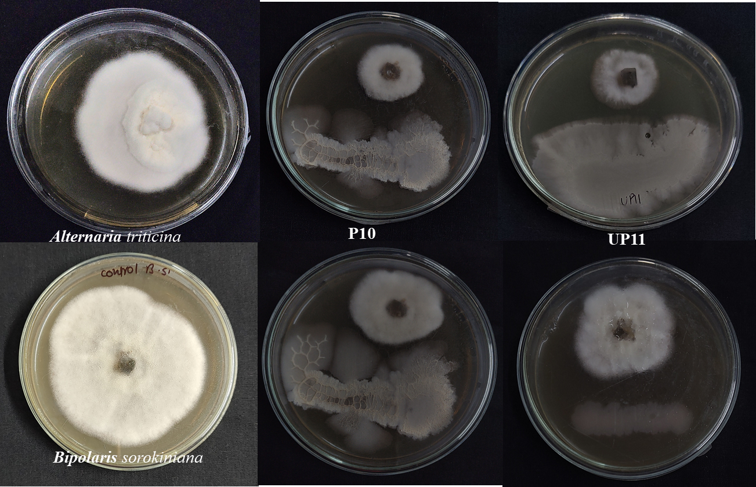
Values are expressed as the means of three replications ± standard deviation. Means within each column followed by the same letter are not significantly different (p<0.05), according to one-way ANOVA and Duncan’s multiple range test (DMRT).

Figure 1: Antagonistic activity of P10 & UP11 against the Alternaria triticina and Bipolaris sorokiniana after 6 DAI (Day after infection).
3.2 Production of Hydrolytic Enzymes and Siderophores
The ability of Bacillus methylotrophicus strain P10 and Bacillus subtilis strain UP11 to produce hydrolytic enzymes, including chitinase, β-1,3-glucanase, and protease, as well as siderophores, was evaluated through the formation of clear zones around the bacterial colonies. These results confirm that both Bacillus strains are potent antagonists, capable of degrading critical components of the fungal cell wall, such as chitin and glucans, thereby inhibiting the growth of the pathogens. Furthermore, the production of siderophores suggests that these bacteria are competing for iron, a key nutrient required for pathogen growth, thereby further suppressing the fungal pathogens (Fig. 2).
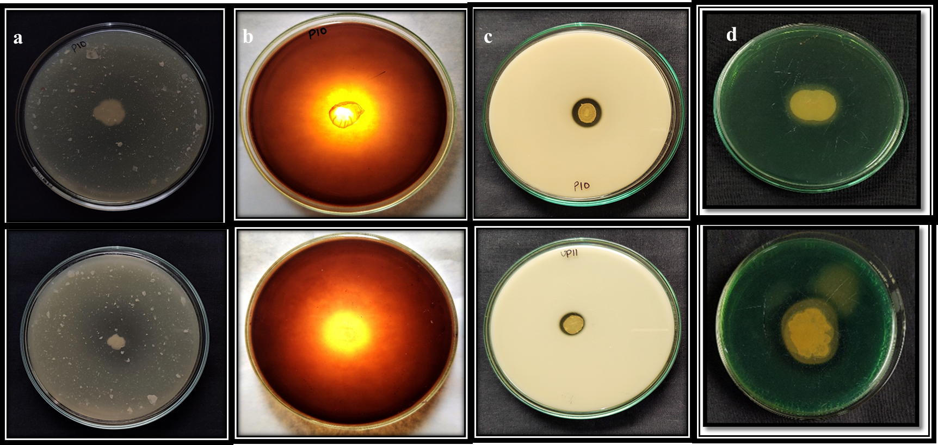

Figure 2: Production of antagonistic properties by Bacillus strains (P10 & UP11): (a) Chitinase, (b) β-1,3 glucanase, (c) Protease, (d) Siderophore.

3.3 Effect of Co-Culturing Bacillus Strains with Pathogens on Hydrolytic Enzyme and Siderophore Production
The production of hydrolytic enzymes and siderophores was enhanced when Bacillus methylotrophicus and Bacillus subtilis strains were co-cultured with the foliar blight pathogens Alternaria triticina and Bipolaris sorokiniana. The maximum production of chitinase, β-1,3-glucanase, and protease was observed at 48 hours when Bacillus strains were cultured alone, but the activity of these enzymes significantly increased when the strains were co-cultured with the pathogens. The highest enzyme activity was recorded at 96 hours, indicating the synergistic effect between the antagonistic bacteria and the pathogens. This suggests that the antagonistic bacteria actively produce more hydrolytic enzymes and siderophores in response to the presence of the pathogens, which aids in their biocontrol efficacy.
For example, the highest chitinase activity was observed in the consortium treatments (T8 CNS and T9 CNS) at 96 hours, followed by other treatments such as T4, T5, and T6. Similarly, the β-1,3-glucanase and protease activities were highest in the consortium treatments (T9 CNS and T8 CNS), followed by treatments involving individual Bacillus strains and the pathogens. The siderophore activity was also highest in the consortium treatments (T8 CNS and T9 CNS), with values reaching up to 77.03% and 76.37%, respectively, indicating a strong competition for iron and suppression of pathogen growth (Fig. 3).

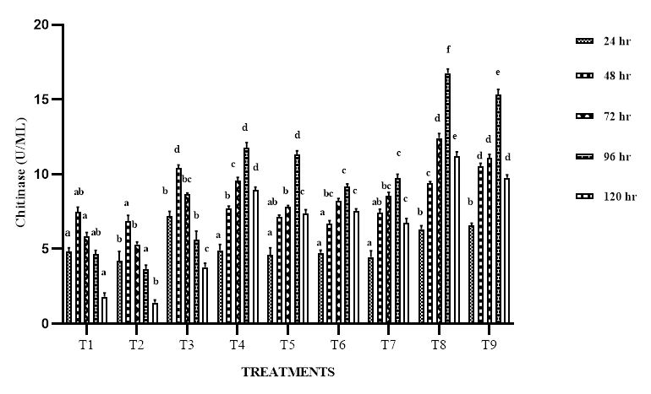
(a)

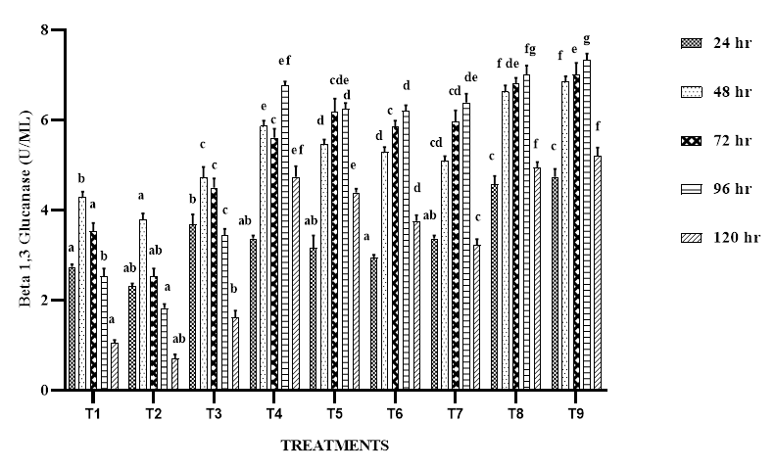
(b)

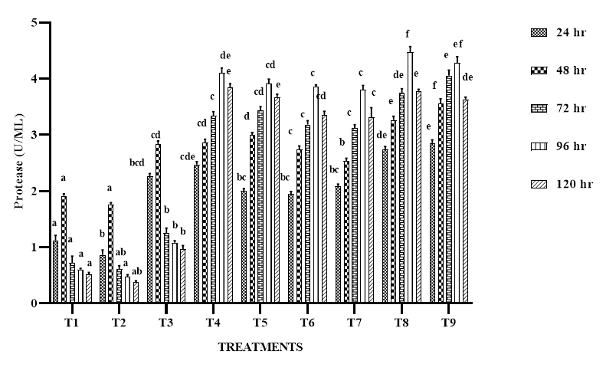
(c)
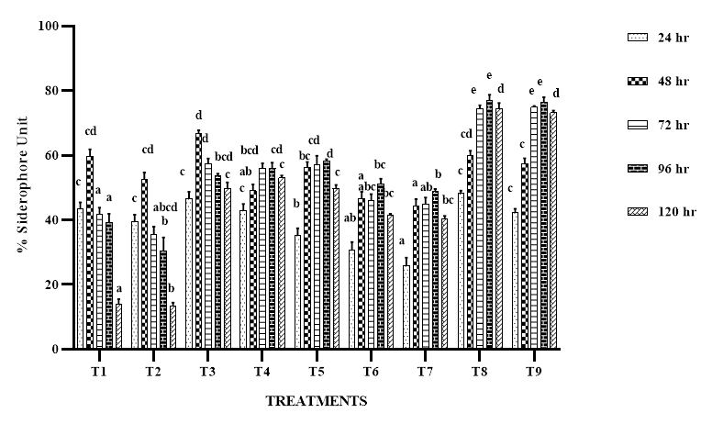
(d)
Figure 3: Cell wall degrading enzymes and siderophore in absence and presence of fungal pathogens Alternaria triticina (F1) & Bipolaris sorokiniana (F2) (a) shows effect of different time duration on chitinase activity (b) shows effect of different time duration on β-1,3-glucanase activity (c) shows effect of different time duration on protease activity (d) Siderophore production at different time duration (T1- P10 alone, T2- UP11 alone, T3- P10+UP11 (CNS) T4- P10+F1, T5- P10+F2, T6- UP11+F1, T7- UP11+F2, T8- CNS+F1, T9- CNS+F2. Values are presented as mean ± SE (n = 3).
4. CONCLUSION
These results highlight that the co-culturing of Bacillus strains with foliar blight pathogens enhances the production of hydrolytic enzymes and siderophores, thus improving their antagonistic activity. This synergetic interaction between the bacterial strains and pathogens results in a more effective suppression of fungal growth. The findings are consistent with previous studies by Alamri (2015) and Khatri et al. (2017), which also observed increased enzyme production and biocontrol efficacy when antagonistic bacteria were exposed to pathogens. Additionally, Bacillus strains often produce higher amounts of proteases to inhibit the activity of pectinase and chitinase enzymes produced by plant pathogens, further contributing to the suppression of pathogen growth.
Ethical approval
There are no ethical concerns regarding the organisms and the topic of this research.
REFERENCES:
Aboukhaddour, R., Fetch, T., McCallum, B. D., Harding, M. W., Beres, B. L., & Graf, R. J. Wheat diseases on the prairies: A Canadian story. Plant Pathology. 2020;69(3): 418-432.
Aktuganov GE, Galimzyanova NF, Melent’Ev AI, Kuz’mina LY. Extracellular hydrolases of strain Bacillus sp. 739 and their involvement in the lysis of micromycete cell walls. Microbiol. 2007;76:413-420.
Alamri, S. A. Enhancing the efficiency of the bioagent Bacillus subtilis JF419701 against soil-borne phytopathogens by increasing the productivity of fungal cell wall degrading enzymes. Archives of Phytopathology and Plant Protection. 2015; 48(2):159-170.
Al-Sadi, A. M. Variation in resistance to spot blotch and the aggressiveness of Bipolaris sorokiniana on barley and wheat cultivars. Journal of Plant Pathology. 2016;97-103.
Berg G, Roskot N, Steidle A, Eberl L, Zock A, Smalla K. Plant-dependent genotypic and phenotypic diversity of antagonistic rhizobacteria isolated from different Verticillium host plants. Appl Environ Microbiol 2002;68(7):3328-3338.
Chakraborty, K., Kizhakkekalam, V. K., Joy, M., & Chakraborty, R. D. Bacillibactin class of siderophore antibiotics from a marine symbiotic Bacillus as promising antibacterial agents. Applied Microbiology and Biotechnology. 2022; 106(1):329-340.
Dahiya, N., Tewari, R., & Hoondal, G. S. Biotechnological aspects of chitinolytic enzymes: a review. Applied microbiology and biotechnology. 2006;71: 773-782.
Guo M, Li M, Zhang C, Zhang X, Wu Y. Dietary administration of the Bacillus subtilis enhances immune responses and disease resistance in chickens. Front microbiol. 2020;11: 1768.
Gajera, H. P., & Vakharia, D. N. Production of lytic enzymes by Trichoderma isolates during in vitro antagonism with Aspergillus niger, the causal agent of collar rot of peanut. Brazilian Journal of Microbiology. 2012;43: 43-52.
Khatri, D. K., Tiwari, D. N., & Bariya, H. S. Chitinolytic efficacy and secretion of cell wall degrading enzymes from Trichoderma spp. in response to phyto-pathological fungi. Journal of Applied Biology and Biotechnology. 2017;5(6): 1-8.

Hsu, S. C., & Lockwood, J. Powdered chitin agar as a selective medium for enumeration of actinomycetes in water and soil. Applied microbiology. 1975; 29(3): 422-426.
Ku Y, Yang N, Pu P, Mei, Cao L, Yang X, Cao C. Biocontrol mechanism of Bacillus subtilis C3 against bulb rot disease in Fritillaria taipaiensis PY Li. Front Microbiol. 2021; 12:756329.
Masih, E. I., & Paul, B. Secretion of β-1, 3-glucanases by the yeast Pichia membranifaciens and its possible role in the biocontrol of Botrytis cinerea causing grey mold disease of the grapevine. Current microbiology. 2002;44:391-395.
Miljaković, D., Marinković, J., & Balešević-Tubić, S. (2020). The significance of Bacillus spp. in disease suppression and growth promotion of field and vegetable crops. Microorganisms. 2020; 8(7): 1037.
Miller GL. Use of dinitrosalicylic acid reagent for determination of reducing sugar. Analytical chem 1959;31(3): 426-428.
Mulk S, Wahab A, Yasmin H, Mumtaz S, El-Serehy HA, Khan N, Hassan MN. Prevalence of wheat associated Bacillus spp. and their bio-control efficacy against fusarium root rot. Front microbiol 2022;12: 798619.
Khatri, D. K., Tiwari, D. N., & Bariya, H. S. (2017). Chitinolytic efficacy and secretion of cell wall-degrading enzymes from Trichoderma spp. in response to phytopathological fungi. J. Appl. Biol. Biotechnol, 2017;5(6): 1-8.
Skidmore, A. M., & Dickinson, C. H. Colony interactions and hyphal interference between Septoria nodorum and phylloplane fungi. Transactions of the British Mycological Society, 1976; 66(1): 57-64.
Saravanakumar, K., Yu, C., Dou, K., Wang, M., Li, Y., & Chen, J. Synergistic effect of Trichoderma-derived antifungal metabolites and cell wall degrading enzymes on enhanced biocontrol of Fusarium oxysporum f. sp. cucumerinum. Biological control. 2016;94: 37-46.
Payne, S. M. [25] Detection, isolation, and characterization of siderophores. Methods in enzymology. 1994;235: 329-344.
Takami, H., Akiba, T., & Horikoshi, K. Production of extremely thermostable alkaline protease from Bacillus sp. no. AH-101. Applied Microbiology and Biotechnology. 1989;30: 120-124.
Saini, N., Sahgal, M., & Singh, A. V. Mechanisms of Cell Wall Degrading Enzymes from Bacillus methylotrophicus and Bacillus subtilis in Suppressing Foliar Blight Pathogens. Journal of Advances in Biology & Biotechnology. 2024;27(8): 239-249.
Schwyn, B., & Neilands, J. (1987). Universal chemical assay for the detection and determination of siderophores. Analytical biochemistry. 1987;160(1): 47-56.

