Investigations on Foliar Epidermal In Some Acanthaceae

Abstract :
The paper communicates observations on Foliar epidermal characteristics of hitherto uninvestigated 22 species belonging 17 genera of the family Acanthaceae. Except few other types, diacytic type of stomata in generally noticed. The other types are rarely to occasionally on the same foliar surface. The other foliar features such as stomatal index and frequency, types of subsidiaries, stomatal abnormalities, cell inclusions, cell wall contours, etc. are described in detail. Their taxonomic significance is discussed pertinently.
Key Words : Foliar epidermis, Stomata, Cell wall contours, Cell inclusions, Acanthaceae.

Introduction :
The family Acanthaceae is documented for anatomy of foliar epidermis especially by Solereder (1908), Metcalfe and Chalk (1950) and Karlstrom (1979, 1980). Of late, Indian workers studied occurrence, structure, development and taxonomic significance of foliar epidermal features of the family (Pant and Mehra, 1963; Paliwal, 1966; Kumar and Paliwal, 1975, 1978, 1982; Inamdar, 1970, 1983;
Ahmad, 1974, 1975, 1976, 1979; Selvaraj and Subramanian, 1983; Varma and Murty, 1989; Shendage and Yadav, 2009). The present authors extended

observations on hitherto unstudied 17 genera and 22 species of Acanthaceae, the results of which are being presented in this communication.

Materials and Methods:
The plants were collected from various places like Tropical Botanic Garden and Research Institute, Palode, Thiruvanthapuram District ( Kerala ) ; Malbar Botanical Garden, Kozhikode (Kerala); Munnar, Idukki District (Kerala); Forest Research Institute, Peechi, Trichur (Kerala); Calicut University, Botanical Garden, Kozhikode (Kerala); Lal Bag Garden, Bangalore (Karnataka); Government Batanic Garden, Ootacamund (Tamilnadu) and Charanmal, District Dhule ( Maharashtra). They were preserved in F.A.A. solution. The chemical method was followed for the separation of peels. Diluted nitric acid and chromic acid (5-10%) were used in different proportions. In some cases, Three Acid Treatment (TAT Method) was followed (Ramayya and Vanaja, 1979). Epidermal peels were stained in safranin (1%). They were and mounted in glycerin and made semi-permanent slides by ringing with nail paints. The cellular sketches were drawn using prism type of camera lucida. They were inked by using Camligraph or Rotring isographs technical pens with 0.1, 0.2, 0.3 points. The stomatal index (SI) was decided as defined by Salisbury (1932). Stomatal frequency was calculated as by Ghosh and Davis (1973). The terms describing stomata are those of Metcalfe and Chalk (1950), Van-Cotthem (1970), Stace (1965, 1989) and Dilcher (1974). The typification of subsidiary cells is after Ramaya and Rajagopal (1980). The stomatal indices and frequencies of each taxon are presented in Table-I.

Abbreviations used :
FC - Foot Cells of Trichomes, Ct – Cystolith; S.I.-Stomatal Index; S.F. – Stomatal Frequency.

Observations :
- Andrographis wightiana Arn.ex Nees : Leaves hypostomatic.
Leaf Adaxial: Epidermal cells chlorophyllous, cells papillate, sides 4-6, undulate sinuses U or V-shaped. Foot cells of trichomes and cystoliths present (Fig.1a).

Leaf Abaxial: Stomata diacytic, superficial, orientation random, distribution diffuse. S.I.13.88, S.F. 222.00. Subsidiaries 2, sides 3-5, F-type, walls undulate. Guard cells elliptical, chlorophyllous. Epidermal cells chlorophyllous, sides 5-8, undulate, sinuses U-shaped. Foot cells of trichomes present (Fig.1b).
- Barleria prattensis Santapau: Leaves hypostomatic.
Leaf Adaxial: Epidermal cells chlorophyllous, cells papillate, sides 5-7, undulate sinuses U or V-shaped. Foot cells of trichomes and cystoliths present (Fig.2a).
Leaf Abaxial: Stomata diacytic, superficial, orientation random, distribution diffuse.
S.I. 15.38, S.F. 120.60. Subsidiaries 2, papillate, sides 3-7, F-type, walls undulate. Guard cells elliptical, chlorophyllous. Epidermal cells chlorophyllous, cells papillate, sides 5-7, undulate, sinuses U-shaped. Foot cells of trichomes and cystoliths present (Fig. 2b).
- Beloperone comosa Nees : Leaves hypostomatic.
Leaf Adaxial: Epidermal cells chlorophyllous, sides 6-7, undulate, sinuses U-shaped. Foot cells of trichomes and cystoliths present (Fig.3a).
Leaf Abaxial: Stomata diacytic, superficial, orientation random, distribution diffuse.
S.I. 11.62, S.F. 37.50. Subsidiaries 2, sides 3-5, F-type, walls undulate. Guard cells elliptical, chlorophyllous. Epidermal cells chlorophyllous, sides 5-8, undulate, sinuses U-shaped. Foot cells of trichomes and cystoliths present (Fig.3b).
- Beloperone plumbaginifolia ( N. Jacquin ) Nees : Leaves hypostomatic.
Leaf Adaxial: Epidermal cells chlorophyllous, cells papillate, sides 4-7, mostly straight and slightly oblique, rarely sinuses U-shaped. Foot cells of trichomes and cystoliths present (Fig. 4a ).
Leaf Abaxial: Stomata diacytic, superficial, orientation random, distribution diffuse.
S.I. 18.57, S.F. 244.00, stomata with aborted guard cells and with arrested development rarely present. Subsidiaries 2, sides 3-6, mostly F-type, rarely C - type, walls straight and slightly arched, usually isodiametric. Guard cells elliptical, chlorophyllous. Epidermal cells chlorophyllous, cells papillate, sides 5-8, undulate, rarely sinuses U-shaped. Foot cells of trichomes and cystoliths present (Fig.4b ).

- Dicliptera foetida ( Forsskal ) Blatter : Leaves hypostomatic.
Leaf Adaxial: Epidermal cells chlorophyllous, sides 5-7, undulate, sinuses U and V- shaped. Foot cells of trichomes and cystoliths present (Fig. 5a ).
Leaf Abaxial: Stomata diacytic, superficial, orientation random, distribution diffuse.
S.I. 21.81, S.F. 240.00. Subsidiaries 2, sides 3-5, F-type, walls undulate. Guard cells elliptical, chlorophyllous. Epidermal cells chlorophyllous, sides 5-7, undulate, occasionally sinuses U-shaped. Foot cells of trichomes and cystoliths present (Fig.5b).
- Fittonia gigantea Linden ex Andre. : Leaves hypostomatic.
Leaf Adaxial: Epidermal cells chlorophyllous, cells papillate, sides 5-7, slightly arched. Foot cells of trichomes and cystoliths present (Fig. 6a ).
Leaf Abaxial: Stomata diacytic, superficial, orientation random, distribution diffuse.
S.I. 13.23, S.F. 112.50, stomata with arrested development rarely present. Subsidiaries 2, papillate, sides 3-6, F-type, walls undulate. Guard cells elliptical, chlorophyllous. Epidermal cells chlorophyllous, cells papillate, sides 4-7, undulate, sinuses U-shaped. Foot cells of trichomes present (Fig.6b).
- Goldfussia anysophylla ( G. Lodd ) Nees : Leaves hypostomatic.
Leaf Adaxial: Epidermal cells chlorophyllous, sides 4-6, undulate, sinuses U- shaped. Foot cells of trichomes and cystoliths present (Fig. 7a ).
Leaf Abaxial: Stomata diacytic, superficial, orientation random, distribution diffuse.
S.I. 17.07, S.F. 235.00, stomata with arrested development rarely present. Subsidiaries 2, sides 3-5, F-type, walls undulate or arched. Guard cells elliptical, chlorophyllous. Epidermal cells chlorophyllous, sides 6-8, undulate, sinuses U- shaped. Foot cells of trichomes and cystoliths present (Fig.7b).
- Hygrophila schulli (Buch. – Ham.) M.R. Almeida and S.M. Almeida. :
Leaves amphistomatic.
Leaf Adaxial: Stomata diacytic, superficial, orientation random, distribution diffuse.
S.I. 9.09, S.F. 38.50. Subsidiaries 2, sides 3-7, F-type, walls undulate. Guard cells

elliptical, chlorophyllous. Epidermal cells chlorophyllous, sides 5-6, undulate, sinuses U-shaped. Foot cells of trichomes and cystoliths present (Fig. 8a ).
Leaf Abaxial: Stomata diacytic, superficial, orientation random, distribution diffuse.
S.I. 13.33, S.F.80.00, stomata with aborted guard cells rarely present. Subsidiaries 2, sides 3-5, F-type, walls undulate. Guard cells elliptical, chlorophyllous. Epidermal cells chlorophyllous, sides 4-10, undulate, sinuses U-shaped. Foot cells of trichomes and cystoliths present (Fig.8b ).
- Justicia trinervia Vahl : Leaves amphistomatic.
Leaf Adaxial: Stomata diacytic, superficial, orientation random, distribution diffuse. S.I.4.16, S.F. 30.00. Subsidiaries 2, sides 3-5, F-type, walls undulate. Guard cells elliptical, chlorophyllous. Epidermal cells chlorophyllous, sides 5-7, undulate, sinuses U or V-shaped. Foot cells of trichomes and cystoliths present (Fig.9a).
Leaf Abaxial: Stomata mostly diacytic, rarely pericytic, superficial, orientation random, distribution diffuse. S.I. 16.88, S.F. 243.50, stomata with single guard cell rarely present. Subsidiaries 2, sides 3-7, F-type, walls undulate. Guard cells elliptical, chlorophyllous. Epidermal cells chlorophyllous, sides 4-8, undulate, sinuses U-shaped. Foot cells of trichomes and cystoliths present (Fig.9b ).
- Justicia wynaddensis ( Nees.) Heyne ex T. Ander. : Leaves hypostomatic.
Leaf Adaxial: Epidermal cells chlorophyllous, cells papillate sides 5-8, undulate, sinuses U- shaped. Foot cells of trichomes and cystoliths present (Fig.10a ).
Leaf Abaxial: Stomata diacytic, superficial, orientation random, distribution diffuse.
S.I. 14.03, S.F.110.00. Subsidiaries 2, sides 3-7, F-type, walls undulate. Guard cells elliptical, chlorophyllous. Epidermal cells chlorophyllous, sides 4-7, undulate, sinuses U-shaped. Foot cells of trichomes and cystoliths present (Fig.10b).
- Mackenzia intergrifolia (Dalz.) Bremek. : Leaves hypostomatic.
Leaf Adaxial: Epidermal cells chlorophyllous, sides 5-9, undulate, sinuses U- shaped. Foot cells of trichomes and cystoliths present (Fig. 11a ).
Leaf Abaxial: Stomata mostly diacytic, rarely polocytic, superficial, orientation random, distribution diffuse. S.I. 12.72, S.F. 100.00. Subsidiaries 2, sides 3-6, F-

type, walls undulate. Guard cells elliptical, chlorophyllous. Epidermal cells chlorophyllous, sides 4-7, undulate, sinuses U-shaped. Foot cells of trichomes and cystoliths present (Fig.11b ).
- Micranthes oppositifolius Wendl. : Leaves amphistomatic.
Leaf Adaxial: Stomata diacytic, superficial, orientation random, distribution diffuse.
S.I. 3.84, S.F. 12.00. Subsidiaries 2, sides 3-5, F-type, walls undulate. Guard cells elliptical, chlorophyllous. Epidermal cells chlorophyllous, sides 5-6, undulate, sinuses U-shaped. Foot cells of trichomes and cystoliths present (Fig.12a ).
Leaf Abaxial: Stomata diacytic, superficial, orientation random, distribution diffuse.
S.I. 17.64, S.F. 98.50. Subsidiaries 2, sides 3-8, F-type, walls undulate. Guard cells elliptical, chlorophyllous. Epidermal cells chlorophyllous, sides 7-9, undulate, sinuses U-shaped. Foot cells of trichomes present (Fig.12b).
- Pachystachys lutea Nees : Leaves hypostomatic.
Leaf Adaxial: Epidermal cells chlorophyllous, sides 4-7, arched. Foot cells of trichomes and cystoliths present (Fig. 13a).
Leaf Abaxial: Stomata mostly diacytic, rarely polocytic, superficial, orientation random, distribution diffuse. S.I.11.40, S.F. 165.00. Subsidiaries 2, sides 3-6, F- type, walls undulate. Guard cells elliptical, chlorophyllous. Epidermal cells chlorophyllous, sides 4-7, straight or arched. Foot cells of trichomes and cystoliths present (Fig.13b).
- Peristrophe montana Nees : Leaves amphistomatic.
Leaf Adaxial: Stomata diacytic, superficial, orientation random, distribution diffuse.
S.I. 2.32, S.F. 13.03. Subsidiaries 2, sides 4-7, F-type, walls undulate. Guard cells elliptical, chlorophyllous. Epidermal cells chlorophyllous, sides 4-11, undulate, sinuses U-shaped. Foot cells of trichomes and cystoliths present (Fig.14a ).
Leaf Abaxial: Stomata mostly diacytic, rarely pericytic and polocytic, superficial, orientation random, distribution diffuse. S.I. 14.92, S.F. 122.50, stomata with arrested development rarely present. Subsidiaries 2, sides 3-6, F-type, walls undulate. Guard cells elliptical, chlorophyllous. Epidermal cells chlorophyllous, cells

papillate, sides 3-9, undulate, sinuses U-shaped Foot cells of trichomes and cystoliths present (Fig.14b ).
- Pseuderanthemum malabaricum (C. B. Clarke) Gamble :
Leaves hypostomatic.
Leaf Adaxial: Epidermal cells chlorophyllous, sides 5-7, undulate, sinuses U-shaped. Foot cells of trichomes and cystoliths present (Fig.15a ).
Leaf Abaxial: Stomata diacytic, superficial, orientation random, distribution diffuse.
S.I. 14.70, S.F. 83.33, stomata with single guard cell rarely present. Subsidiaries 2, sides 3-6, mostly F-type rarely C-type, walls undulate. Guard cells elliptical, chlorophyllous. Epidermal cells chlorophyllous, cells papillate sides 5-9, undulate, sinuses U-shaped. Foot cells of trichomes and cystoliths present (Fig.15b).
- Rungia parviflora (Retz.) Nees : Leaves hypostomatic.
Leaf Adaxial: Epidermal cells chlorophyllous, sides 4-7, undulate, sinuses U-shaped. Foot cells of trichomes and cystoliths present (Fig. 16a ).
Leaf Abaxial: Stomata diacytic, superficial, orientation random, distribution diffuse.
S.I. 18.51, S.F. 82.00, stomata with arrested development rarely present. Subsidiaries 2, sides 3-5, mostly F-type rarely C-type, walls undulate. Guard cells elliptical, chlorophyllous. Epidermal cells chlorophyllous, sides 5-7, undulate, sinuses U-shaped. Foot cells of trichomes and cystoliths present (Fig.16b).
- Staurogyne zeylanica ( Nees) O.Ktze. : Leaves hypostomatic.
Leaf Adaxial: Epidermal cells chlorophyllous, sides 5-6, undulate, sinuses U-shaped. Foot cells of trichomes present (Fig. 17a ).
Leaf Abaxial : Stomata mostly diacytic, rarely pericytic and amphipericytic, superficial, orientation random, distribution diffuse. S.I. 21.05, S.F. 160.00. Subsidiaries 1-2, sides 3-5, mostly F-type, rarely A and C- type, rarely contagious, walls undulate. Guard cells elliptical, chlorophyllous. Epidermal cells chlorophyllous, sides 4-8, undulate, sinuses U-shaped. Foot cells of trichomes present (Fig.17b).

- Stenosiphonium cordifolium (Vahl ) Alston. : Leaves hypostomatic.
Leaf Adaxial: Epidermal cells chlorophyllous, sides 5-7, undulate, sinuses U-shaped. Foot cells of trichomes and cystoliths present (Fig. 18a ).
Leaf Abaxial: Stomata mostly diacytic, rarely staurocytic, and anomotetracytic, superficial, orientation random, distribution diffuse. S.I. 15.84, S.F. 265.50. Subsidiaries 2, sides 2-7 , mostly F-type, rarely C-type, walls undulate. Guard cells elliptical, chlorophyllous. Epidermal cells chlorophyllous, sides 4-9, undulate, sinuses U-shaped. Foot cells of trichomes present (Fig. 18b ).
- Strobilanthes barbatus Nees : Leaves amphistomatic.
Leaf Adaxial: Stomata mostly diacytic and rarely copericytic, superficial, orientation random, distribution diffuse. S.I. 03.84, S.F. 23.50. Subsidiaries 2, sides 3-5, F-type, walls undulate. Guard cells elliptical, chlorophyllous. Epidermal cells chlorophyllous, sides 4-6, undulate, sinuses V-shaped. Foot cells of trichomes and cystoliths present (Fig.19a).
Leaf Abaxial: Stomata mostly diacytic, rarely pericytic, amphipericytic and axillocytic, superficial, orientation random, distribution diffuse. S.I. 21.42, S.F.166.66. Subsidiaries 2, sides 3-9, F-type, walls undulate. Guard cells elliptical, chlorophyllous. Epidermal cells chlorophyllous, sides 5-9, undulate, sinuses U- shaped Foot cells of trichomes and cystoliths present (Fig.19b ).
- Strobilanthes hamiltoniana ( Steud. ) Bosser and Heine : Leaves hypostomatic.
Leaf Adaxial: Epidermal cells chlorophyllous, cells papillate, sides 4-7, undulate, sinuses U-shaped. Foot cells of trichomes and cystoliths present (Fig. 20a ).
Leaf Abaxial: Stomata diacytic, superficial, orientation random, distribution diffuse.
S. I. 15.49, S.F. 164.50. Subsidiaries 2, papillate, sides 2-5, F-type, walls undulate. Guard cells elliptical, chlorophyllous. Epidermal cells chlorophyllous, cells papillate, sides 5-8, undulate, sinuses U-shaped. Foot cells of trichomes and cystoliths present (Fig. 20b ).

- Strobilanthes kunthianus (Nees) Anders. ex Benth. Leaves hypostomatic.
Leaf Adaxial: Epidermal cells chlorophyllous, sides 4-6, straight, slightly oblique, mostly penta to hexagonal, usually isodiametric. Foot cells of trichomes and cystoliths present (Fig. 21a ).
Leaf Abaxial: Stomata mostly diacytic, rarely pericytic and anomocytic, superficial, orientation random, distribution diffuse. S. I.32.43 , S.F. 320.50. Subsidiaries 2-5, sides 3-7, mostly F-type, rarely A and C-type, rarely contagious (superposed) walls undulate. Guard cells elliptical, chlorophyllous. Epidermal cells chlorophyllous, sides 5-9, walls straight, slightly arched, usually isodiametric. Foot cells of trichomes present (Fig.21b ).
- Strobilanthes lupulinus Nees : Leaves amphistomatic.
Leaf Adaxial: Stomata diacytic, superficial, orientation random, distribution diffuse.
S.I. 01.51, S.F. 10.00. Subsidiaries 2, sides 3-6, F-type, walls undulate. Guard cells elliptical, chlorophyllous. Epidermal cells chlorophyllous, sides 5-7, undulate, sinuses U-shaped. Foot cells of trichomes and cystoliths present (Fig. 22a ).
Leaf Abaxial: Stomata mostly diacytic, rarely amphidiacytic, superficial, orientation random, distribution diffuse. S.I. 18.91, S.F. 235.00, stomata with arrested development, aborted guard cells and single guard cells rarely present. Subsidiaries 2, sides 3-6, F-type, walls undulate. Guard cells elliptical, chlorophyllous. Epidermal cells chlorophyllous, sides 5-9, undulate, sinuses U- shaped. Foot cells of trichomes present (Fig. 22b).

Discussion :
The foliar epidermal characteristics of 22 species belonging to 17 genera of the Acanthaceae are investigated. This study ascertains various features of stomata, epidermal cells and cell inclusions. The leaves are hypostomatic in majority of the species studied. Only six species exhibited amphistomatic condition. The stomata are generally, diacytic type. However, the types such as anomocytic, amphidiacytic, staurocytic, anomotetracytic, polocytic, axillocytic, pericytic, co-pericytic, and amphipericytic, are occasionally recorded on the same surfaces. Subsidiaries belong usually to the F-type. In few cases, they are observed rarely of C or A type on the

same surfaces. All the three types of subsidiaries viz., F, A and C types are noted in case of Staurogyne zeylanica and Strobilanthes kunthianus. The walls of subsidiaries are always undulate, except Strobilanthes kunthianus.
Other epidermal cells are usually undulate on both surfaces with U-shaped sinuses. However, they are udulate but V-shaped on both surfaces in case of Strobilanthes barbatus and Strobilanthes lupulinus and straight or slightly arched abaxially in Pachystachys lutea and Strobilanthes kunthianus. Highest stomatal index is observed adaxially (9.09) and abaxially (38.50) in Hygrophila schulli. Lowest stomatal index is observed adaxially (1.51) in Strobilanthes lupulinus and abaxially (10.00) noted in Strobilanthes lupulinus.
The highest frequency (21.42) is observed on adaxial surface of Strobilanthes barbatus, whereas it is the lowest in Peristrophe montana adaxially (13.33). It is the lowest abaxially (80.00) in Hygrophila schulli and the highest (320.50) in Strobilanthes kunthianus. Stomatal anomaly as single guard cell, aborted guard cells, contiguous stomata and stomata with arrested development have been noted.
Occurrence of cystoliths has been recorded in the Acanthaceae (cf. Solereder, 1908; Metcalfe and Chalk, 1950; Ahmad, 1979; Inamdar, Chaudhari and Rao, 1990). Their features such as (i) shape, (ii) size, (iii) distribution, (iv) single, twin or in aggregates, (v) cystolith acute or obtuse, etc. have found systematically useful. In the present account, they are noted in the epidermal cells abaxially as well as adaxially. In most species, they occur in both surfaces. They appear restricted abaxially in Andrographis wightiana, Fittonia gigantea, Micranthes oppositifolius and Stenosiphonium cordifolium They are mostly singly and elongated with one end pointed. They appear to be of systematic significance, however, more in-depth studies are still desired.
Although stomates are mostly diacytic type and the members of the family show homogeneity, the features e.g. distribution of stomata, types of subsidiaries, cell wall contours, presence/absence of cystoliths, their distribution and other characteristics appear helpful in identification of different taxa at species level.

Conclusions:
- Stomata are generally diacytic, other types e.g. anomocytic, amphidiacytic, staurocytic, anomotetracytic, polocytic, axillocytic, pericytic, co-pericytic, and amphipericytic, are of rare to occasional occurrence.
- Subsidiaries usually belong to F-type, C & A types are rather rare.
- Leaves are generally hypostomatic, with few exceptions.
- Cell wall are usually undulate, rarely otherwise.
- The S.I. range from 1.51 to 38.50.
- The S.F. range from 13.33 to 320.50.
- Cystoliths are present in both surfaces in majority of species.
- Stomatal anomaly as single guard cell, aborted guard cells, contiguous stomata and stomata with arrested development have been noted.
- All these features appear taxonomically significant in the species investigated.

Table -I : Stomatal Index and Stomatal Frequency (Per sq.cm.)

Sr.  No. | Taxon studied | Stomatal Index |  | Stomatal Frequency
Sr.  No. | Taxon studied | Leaf Adaxial | Leaf Abaxial | Leaf Adaxial | Leaf Abaxial
1 | Andrographis wightiana | A | 13.88 | A | 222.00
2 | Barleria prattensis | A | 15.38 | A | 120.60
3 | Beloperone comosa | A | 11.62 | A | 97.50
4 | Beloperone plumbaginifolia | A | 18.57 | A | 244.00
5 | Dicliptera foetida | A | 21.81 | A | 240.00
6 | Fittonia gigantea | A | 13.23 | A | 112.50
7 | Goldfussia anysophylla | A | 17.07 | A | 235.00
8 | Hygrophila schulli | 9.09 | 38.50 | 14.92 | 80.00
9 | Justicia trinervia | 4.16 | 30.00 | 16.88 | 243.50
10 | Justicia wynaddensis | A | 14.03 | A | 110.00
11 | Mackenzia intergrifolia | A | 12.72 | A | 100.00
12 | Micranthes oppositifolius | 3.84 | 12.00 | 17.64 | 98.50
13 | Pachystachys lutea | A | 11.45 | A | 165.00
14 | Peristrophe montana | 2.32 | 13.3 | 13.33 | 122.50
15 | Pseuderanthemum malabaricum | A | 14.70 | A | 83.33
16 | Rungia parviflora | A | 18.51 | A | 82.00
17 | Staurogyne zeylanica | A | 21.05 | A | 160.00
18 | Stenosiphonium cordifolium | A | 15.84 | A | 265.50
19 | Strobilanthes barbatus | 3.84 | 23.50 | 21.42 | 166.66
20 | Strobilanthes hamiltoniana | A | 15.49 | A | 164.50
21 | Strobilanthes kunthianus | A | 32.43 | A | 320.50
22 | Strobilanthes lupulinus | 1.51 | 10.00 | 18.91 | 235.00
*The figures relate to a mean of ten counts.

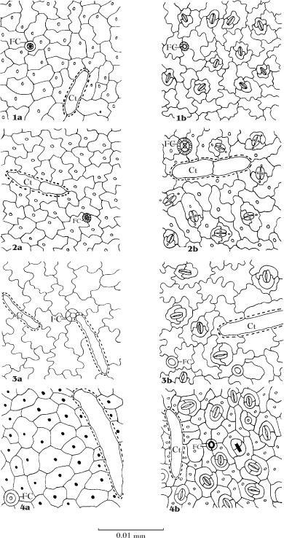

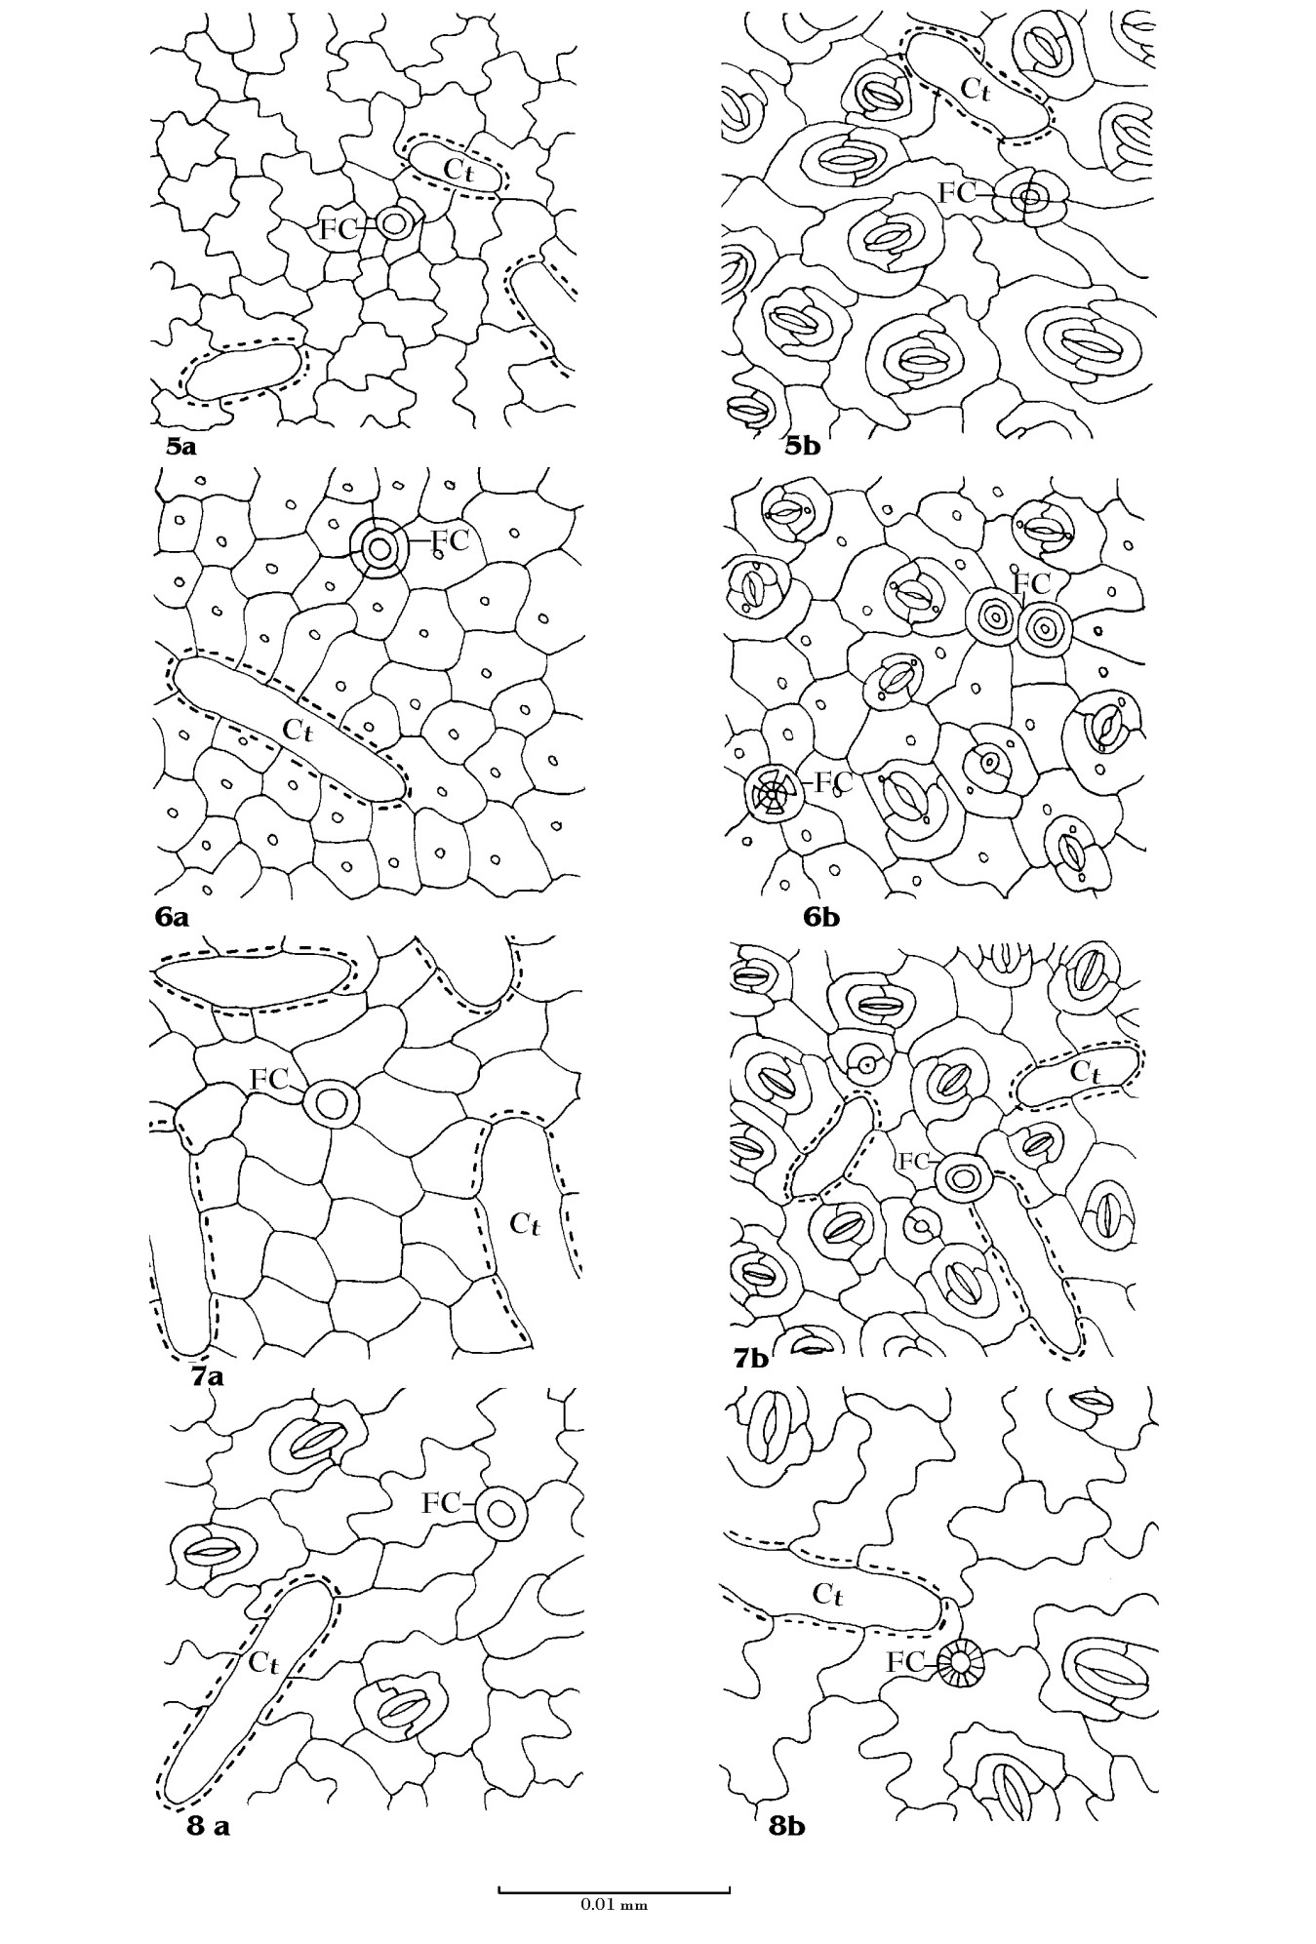

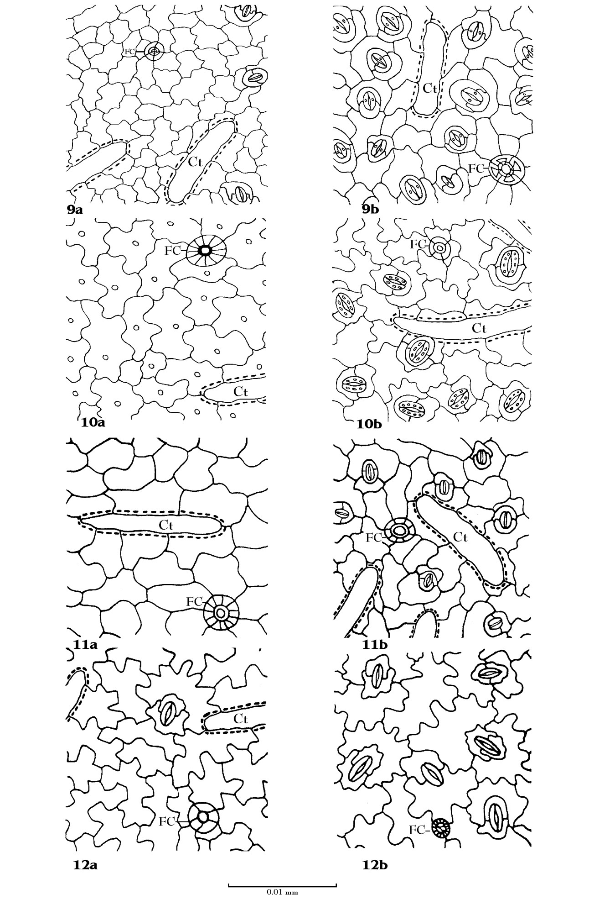

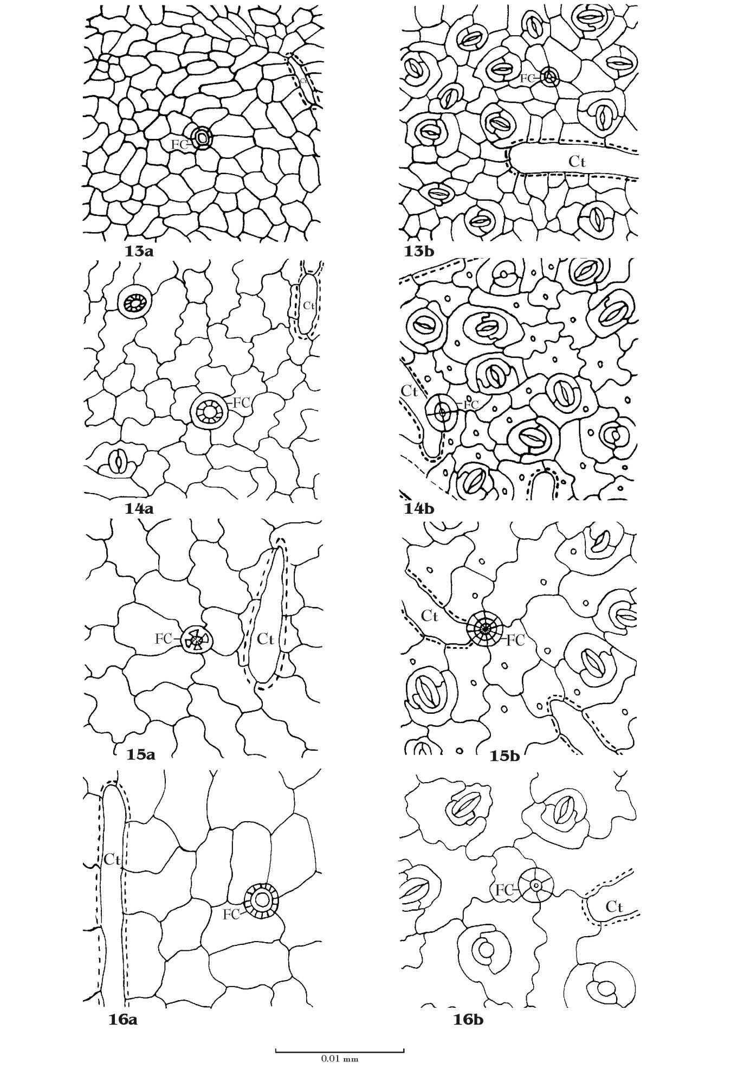

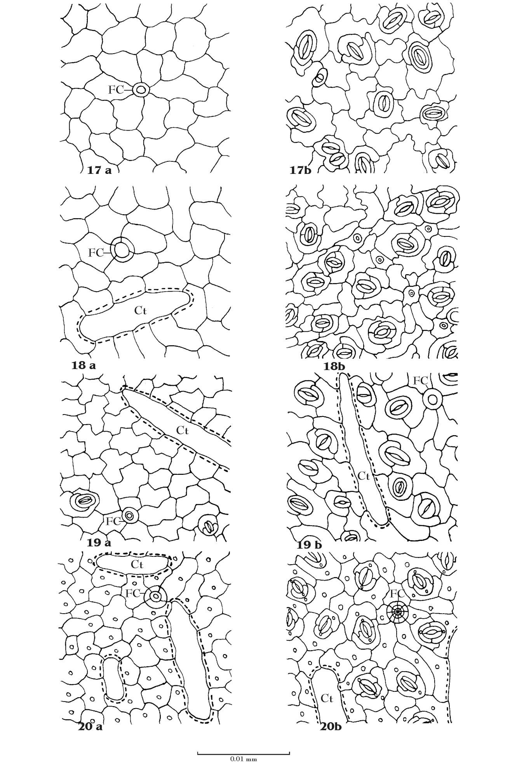

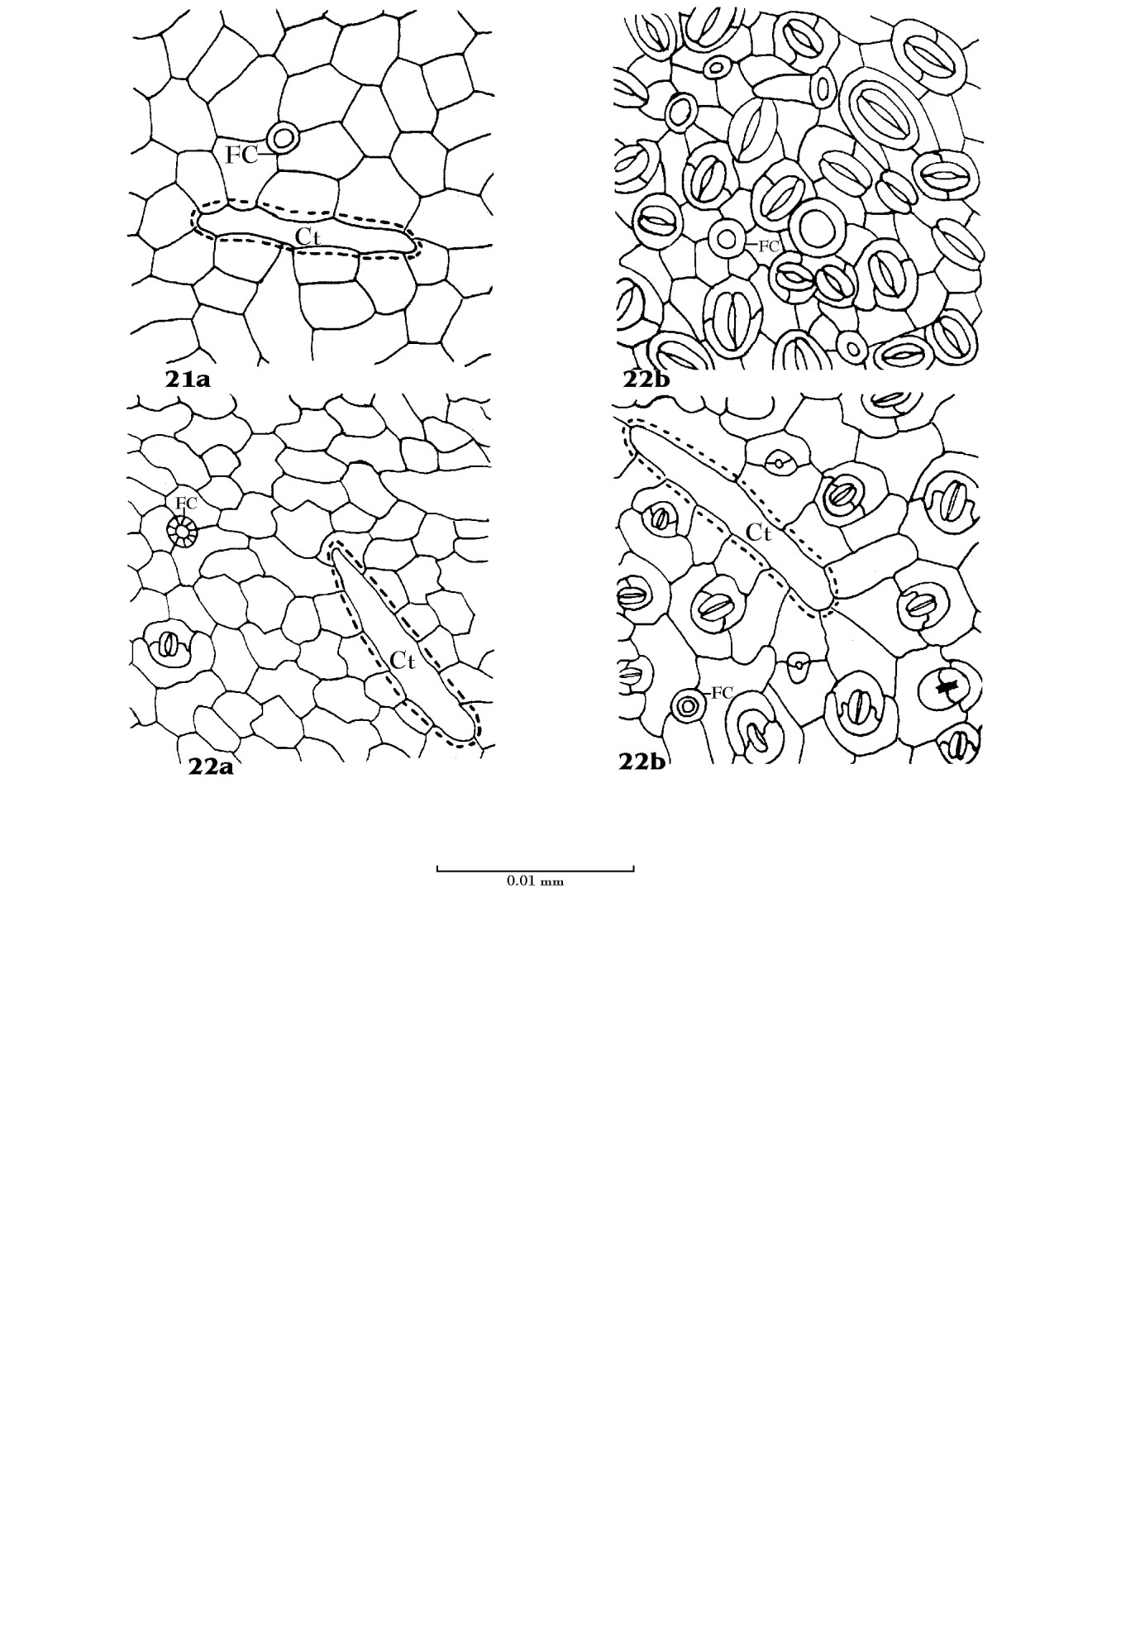

References :
Ahmad, K. J. (1974a). Cuticular studies in some species of Hemigraphis and Strobilanthes. Proc. Ind. Acad. Sci. 79 : 29-40.
Ahmad, K. J. (1974b). Cuticular and epidermal structures in some species of Eranthemum and Pseuderanthemum (Acanthaceae). Bot. Not. 127(2) : 256 – 266 .
Ahmad, K. J. (1974c). Cuticular studies in some Nelsonoideae (Acanthaceae). Bot.
J. Linn. Soc. 68:73-83.
Ahmad, K. J. (1974d). Cuticular studies in some species of Mendoncia and
Thundergia (Acanthaceae). Bot. J. Linn. Soc. 69:53-63.
Ahmad, K. J. (1975a). Cuticular studies in some species of Lepidagathis and Barleria. Bot. Gaz. 136 (1): 129-135.
Ahmad, K. J. (1975b). Cuticular studies in some Acanthaceae and Solanaceae. New Botanist 2(2): 94-100.
Ahmad, K. J. (1976). Epidermal studies in some species of Hygrophila and
Dyschoriste (Acanthaceae) J. Indian Bot. Soc. 42-52.
Ahmad, K. J. (1978a). Epidermal hairs of Acanthaceae. Blumea 24:101-117. Ahmad, K. J. (1978b). Epidermal studies in Fittonia coemans (Acanthaceae).
Feddes Repert. 89 (5/6): 369-374.
Ahmad, K. J. (1979a). Taxonomic significance of epidermal characters in (Acanthaceae). In : Progress in Plant Research. Today and Tomorrow’s Printers and Publishers. New Delhi. Vol.1.pp. 135-160.
Ahmad, K. J. (1979b). Stomatal features of Acanthaceae. In : Structure, Function and Ecology of Stomata. Bishen Singh Mahendra Pal Singh, Dehra Dun. pp. 43-60.
Dilcher, T.L. (1974). Approaches to the identification of angiosperm leaf remains.
Bot. Rev. 14:1-157.

Ghosh, M. and Davis, T. A. (1973). Stomata and trichomes in leaves of young plants. Phytomorphology, 23 : 216-229.
Inamdar, J. A. (1970). Epidermal structure and ontogeny of caryophyllaceous stomata in some Acanthaceae. Bot. Gaz. 131 (4) : 261 – 268.
Inamdar, J.A., D.C. Bhatt and G.S.Chaudhari (1983). Structure and development of stomata in some Acanthaceae. Proc.Indian Acad.Sci. (Plant Sci.) 92(3):285- 296.
Inamdar, J. A., Chaudhari and Ramana Rao 1990. Studies of the cystoliths of Acanthaceae. Fedds Repert. 101 ( 7/8) : 417- 424.
Karlstrom, Per-Olof 1979.Epidermal leaf structure in species of Strobilanthae and Petalidieae (Acanthaceae). Bot. Not. 131 (4) : 423-433.
Karlstrom, Per-Olof 1980. Epidermal leaf structure in species of Asystasieae,
Pseuderanthemeae, Graptophylleae and Odontonemeae (Acanthaceae). Bot. Not. 133 (1) : 1-16.
Kumar and G. S. Paliwal (1975). Foliar anatomy of the family Acanthaceae II. The tribe Thunbergieae and Nelsonieae. Acta Botanica Indica 3 : 121 – 131.
Kumar and G. S. Paliwal (1978). Foliar anatomy of the family Acanthaceae I. The tribe Justiceae. Bot. Surv. India 20 (1-4):54–63.
Kumar and G. S. Paliwal (1982). Foliar anatomy of Scrophulariaceae and Acanthaceae. Geophytology. 12 (1) : 22 – 29.
Metcalfe, C.R. and L. Chalk (1950). Anatomy of dicotyledons Vol. I. Clarendon Press, Oxford.
Paliwal, G. S. (1966). Structure and ontogeny of stomata in some Acanthaceae.
Phytomorphology 12 : 527 – 532.
Paliwal, G. S. and Shashi K. Anand (1978). Anatomy in relation to taxonomy : some recent trends. Acta Botanica Indica 6: 1 - 20.
Paliwal, G.S. (1974). Plant anatomy – Laboratory manual. Central Book Depot.
Allahabad, India.

Pant, D. D. and Bharati Mehra (1963). Development of caryophyllaceous stomata in
Asteracantha longifolia Nees. Ann. Bot. N.S. Vol.27, No. 108 : 647 – 652.
Patil, A. M. and D.A.Patil (2009). Proc. Of National Conference on Biodiversity, Sustainable Development & Human Welfare. (Ed. Nandan, S.N., D.A.Patil, B.D.Borse and V.B. Salunkhe) pp.296-310.
Ramayya, N. and T. Rajagopal, (1980). Classification of subsidiaries according to interstomatal relationship. Curr.Sci. 14(17):671-673.
*Salisbury, E.J. (1932). The interpretation of soil climate and the use of stomatal frequency as an interesting index of water relation to the plant. Bein Bot Zentrib 49:408-420.
Selvaraj, R. and Subramanian D. (1983) Epidermal studies in some species of Acanthaceae. J.Indian Bot. Soc.62:253-258.
Soleredar, H. (1908). Systematic anatomy of the dicotyledons. Transl. L. A. Boodle and F. E. Fritsch. Revis. D. H. Scott. Oxford.
Stace, C.A. (1965).Cuticular studies as an aid in plant taxonomy.
Bull.Br.Mus.Nat.Hist.(Bot.) 4:1-78.
Van-Cotthem. W. (1970) A classification of stomatal types. J.Linn. Bot. Soc. 69:235- 246.
Varma, S.K. and Murty, Y.S. (1989). Structure and ontogeny of stomata in vegetative and floral organs of Thunbergioideae (Acanthaceae). J.Indian Bot. Soc. 68:53-58.

