Eco-Friendly Stability Indicating HPLC Method for Estimation of Elbasvir and Grazoprevir by Quality by Design Approach

Abstract
Introduction: The pharmaceutical industry faces a significant problem as a result of the worldwide requirement to modify processes in order to comply with the green analytical chemistry (GAC) requirements. An enormous amount of organic hazardous waste is produced by high-performance liquid chromatography (HPLC), one of the methods employed the most frequently at different stages in the pharmaceutical sector. Aim: To develop analytical quality by design-aided stability indicating green high-performance liquid chromatography (HPLC) method for estimation of Elbasvir and Grazoprevir in a dosage form. Material and Methods: The critical chromatographic factors were the % of ethanol in the mobile phase, flow rate, and their overall effect on the responses like asymmetry, theoretical plates, and resolution were studied to optimize the method. Green analytical chemistry (GAC) has mainly focused on developing analytical methods that are safe for the environment. Therefore, it is imperative that the GAC principles be applied in pharmacological analysis. A rotatable central composite design was employed, and the optimized conditions for chromatographic separation were made with a run time of 5 minutes using Zorbax C18 column (4.6× 150 mm, 5 µm) with 0.1% Trifluoroacetic acid and ethanol (40:60 v/v) as components of a mobile phase, flowing at a rate of 1.0 ml/minute. Photodiode array detection was carried out at 253 nm. Results: The retention time was 1.8 min for EBS and 2.84 min for GZP. According to the ICH guidelines, the proposed method was validated and stress studies revealed that Elbasvir and Grazoprevir are prone to acidic, basic, and oxidation stress conditions. An analytical eco-scale score evaluated the greenness profile and a software-based evaluation. Conclusion: The developed HPLC method is eco-friendly and shall be adopted in the routine quality control of Elbasvir and Grazoprevir in a tablet dosage form.
Keywords: Green assessment, Elbasvir and Grazoprevir, Method Validation, QBD, Stability testing.
- Introduction
Green chemistry is widely used in worldwide manufacturing, government policy, educational practice, and technology development. The main purpose of the circular economy is to establish a balance between economic growth, resource sustainability, and environmental protection. Green analytical chemistry (GAC), which results in a change in attitudes and behaviour in the chemical industry, can be viewed as an important tool for achieving sustainability.[1] The GAC refers to the development of new, effective analytical techniques that will allow for the reduction and/or removal of hazardous chemicals and chemical waste while also allowing for faster and more energy-efficient analysis. As a result, the aforementioned 12 green chemistry principles were adjusted to construct the main characteristics influencing the green character of analytical chemistry and place it in the role of GAC.[2] The development of greener analytical methods using quality by design (QbD) provides valuable knowledge about the use of greener chemicals and their impact on method performance.
Elbasvir (EBS) is first line therapy classified Direct-acting antiviral (DAA) and prevents viral replication in HCV genotypes 1a, 1b and 4 of Hepatitis C. It is chemically known as Dimethyl N,N+ - ([(6S)-6H-indolo[1,2-C][1,3] benzoxazine-3, 10- diyl] bis{1H- imidazole- 5, 2- diyl- (2S)- pyrrolidine-
- 1330 -

2, 1-diyl[(2S)-1-oxo-3-methylbutane-1, 2-diyl]})biscarbamate.[3]Elbasvir is an inhibitor of the HCV non-structural protein 5A. Potential modes of action of NS5A inhibitors like elbasvir include blocking signaling interactions, redistribution of NS5A from the endoplasmic reticulum to the surface of lipid droplets, and modification of the HCV replication complex[4].

Figures & Tables:
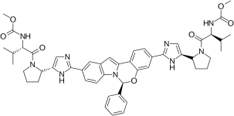
[Table/Fig- 1]: Chemical structure of EBS
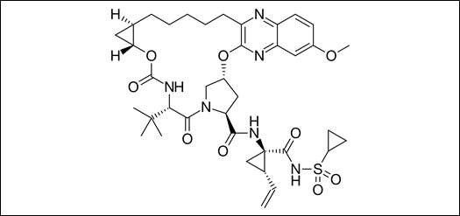
[Table/Fig- 2]: Chemical structure of GZP

Factors Responses
Ru n A: Ethanol (mL) | B: Flow Rate (mL/Min) | C:  Temperature (ºC) | Resolution | Theoretica l plates | RT2
1 60 | 0.50 | 35.00 | 5.45 | 4488 | 2.84
2 63 | 0.53 | 36.80 | 5.52 | 4472 | 2.90
3 60 | 0.50 | 32.00 | 5.35 | 4259 | 2.67
4 57 | 0.47 | 36.80 | 5.51 | 4845 | 2.75
5 63 | 0.53 | 33.20 | 5.41 | 4327 | 2.89
6 60 | 0.50 | 35.00 | 5.43 | 4488 | 2.85
7 60 | 0.55 | 35.00 | 5.22 | 4524 | 2.72
8 60 | 0.50 | 35.00 | 5.42 | 4478 | 2.84
9 60 | 0.50 | 38.00 | 5.62 | 4691 | 2.85
10 57 | 0.47 | 33.20 | 5.39 | 4437 | 2.55
11 60 | 0.50 | 35.00 | 5.42 | 4460 | 2.86
12 60 | 0.50 | 35.00 | 5.46 | 4460 | 2.87
13 55 | 0.50 | 35.00 | 5.21 | 4807 | 2.50
14 57 | 0.53 | 36.80 | 5.43 | 4922 | 2.60
15 63 | 0.47 | 36.80 | 5.73 | 4233 | 3.03
16 60 | 0.45 | 35.00 | 5.73 | 4333 | 2.84
17 60 | 0.50 | 35.00 | 5.46 | 4460 | 2.88
18 57 | 0.53 | 33.20 | 5.03 | 4431 | 2.54
19 63 | 0.47 | 33.20 | 5.86 | 4152 | 2.88

Eco-Friendly Stability Indicating HPLC Method for Estimation of Elbasvir and Grazoprevir by Quality by Design Approach

20 65 0.5 35 5.76 4179 3.03

[Table/Fig-3]: rCCD matrix is used in conjunction with the response's specifications for the suggested technique.
Grazoprevir (GZP) is chemically known as (1R, 18R, 20R, 24S, 27S)- N- {(1R, 2S)-1- [(cyclopropylsulfonyl) carbamyl]- 2-vinyl(cyclopropyl)- 7-methoxy-24-(2- methyl-2-propanyl)-22,25- dioxo-2, 21-dioxa-4, 11, 23, 26-tetraazapentacyclo [24.2.1.03.12.05.1.0.0.18. 20] nonacosa-3,5,7,9,11- pentaene-27-carboxamide.[5] Grazoprevir is a second-generation protease inhibitor approved for the treatment of hepatitis C virus (HCV) in combination with Elbasvir as the fixed-dose combination product Zepatier (FDA)By inhibiting protease activity, Grazoprevir prevents the formation of structural and non-structural proteins required for replication and assembly [6]. Elbasvir and grazoprevir are direct-acting antiviral agents against HCV; elbasvir is a potent inhibitor of HCV nonstructural protein 5A (NS5A) and grazoprevir is a potent reversible inhibitor of HCV nonstructural protein 3/4A (NS3/4A) protease. Elbasvir and grazoprevir are P-glycoprotein (P-gp) substrates, but intestinal P-gp transporters minimally affect the absorption of either drug. Both elbasvir and grazoprevir are metabolized by CYP3A enzymes, but metabolites of either drug are not found in plasma. [6-7]. The Chemical structure of EBS and GZP are shown in [Table/Fig 1,2]
Thus, the prime goal of green chemistry is to reduce and/or eliminate the use of chemicals that are more hazardous and to search the solvents that are comparatively safe. A literature survey for EBS and GZP revealed that several methods based on varied techniques like spectrophotometry [8-11], HPLC [12- 24], and LC-MS [25] UPLC [26] are available for individual and combination drugs. Analytical quality by design (AQbD) has promoted the advancement of GAC principles in analytical procedures. The major goal was to provide a new framework for incorporating GAC principles alongside AQbD philosophies. This integrated framework was utilized to advance an environmentally friendly and robust HPLC evaluation of the pharmaceuticals in bulk and marketed formulations. The current study focused on determining the greenness of the method utilizing the National Environmental Method Index (NEMI), Green Analytical Procedure Index (GAPI), and Analytical Greenness (AGREE). [27-28]

Materials And Methods Materials and Reagents
EBS and GZP were procured from Spectrum Pharma Research Solutions, Hyderabad, India. The fixed- dose combination Zepatier tablet containing elbasvir-grazoprevir (50 mg/100 mg) is FDA-approved for the treatment of chronic hepatitis C and purchased from the local market; Ethanol, HPLC grade was supplied by Sigma Aldrich, Germany. Water used throughout the procedure was HPLC grade

Equipment
Agilent Technologies 1260 LC system with binary gradient pump, LC-10 AT VP solvent delivery system, Qualisial C18(250 cm × 4.6 mm) 5 µm column, UV chamber (Camag), SPD M-10AVP photo diode array detector.

Preparation of calibration standards
Standard stock solutions of EBS and GZP were prepared with ethanol at 100 µg/mL concentrations. Further diluted to the concentrations of about 5, 10, 15, 20, 25, and 30 µg/mL for EBS and 10, 20, 30,40,50, and 60 µg/mL for GZP. The working sample solution was filtered into a vial using a 0.22 µm polyvinylidene fluoride (PVDF) filter.

Pharmaceutical formulation analysis
Ten tablets of Zepatier containing 50 mg EBS and 100mg GZP were weighed and their average weight was calculated for tablet dosage form analysis. The tablets were finely powdered, and the powder equivalent to 20 mg EBS and 40 mg GZP, transferred into a 50 mL Volumetric flask and solubilized in 25 mL ethanol and sonicated for 15 min, made up to the mark with ethanol and filtered over Whatman filter paper. An aliquot part from the sample solution was transferred into a 25 mL volumetric flask and diluted using a mobile phase. The final concentrations of the solutions obtained were 15 and 30 µg/mL for EBS and GZP. Triplicate injection of aliquot 5 μL, followed by an estimation of the concentration of the drug in its dosages with the above-described procedures.

Validation [29-31]

The developed HPLC method was validated for system suitability, linearity, accuracy, precision, robustness, Limit of Detection (LOD), and Limit of Quantification (LOQ) in accordance with ICH guidelines.

Linearity
From stock solution, aliquots of 5, 10, 15, 20, 25, and 30 µg/mL for EBS and 10, 20, 30,40,50, and 60 µg/mL for GZP were transferred into 10 ml volumetric flasks and diluted up to the mark with mobile phase such that the final concentration of the range 5-30 µg/ml for EBS and 10-60µg/ml for GZP was injected with the help of syringe. All measurements were repeated five times for each concentration and a calibration curve was constructed by plotting the peak area versus the drug concentration. Regression analysis was performed using the least square regression approach and used to determine linearity.

Accuracy
Accuracy is measured as a percentage recovery. A known amount of EBS and GZP standard drug powder corresponding to 80, 100, and 120 percent of label claim were added, mixed, and analyzed by running chromatograms in optimized mobile phase.

Precision
Precision of the method was assessed by repeatability, intra-day and Inter-day. The precision measures the similarity of measurements obtained from multiple samplings of the same homogeneous sample under the specified conditions. The intra-day precision was determined by analyzing standard drug solutions three times on the same day within the calibration range of individual drugs. Inter-day precision was determined by analyzing drug solutions over a week on three different days within the calibration range.

Ruggedness
Different analysts used aliquots from homogenous lots and operational and environmental circumstances to assess an analytical method's robustness. The assay was conducted utilizing the parameters, such as in various settings, by various analysts, and on various dates.

Robustness
Robustness was studied by comparing the results obtained for deliberate changes in chromatographic conditions.

Limit of Detection (LOD) and Limit of quantitation (LOQ)
Concentrations in the calibration curve's lower linear range were used to determine the detection and quantification limits. The amount of drugs used versus the average response (peak area) was plotted, and the regression equation was determined. Response standard deviations (S.D.) were computed. The average of standard deviations was calculated from this data (A.S.D.). LOD was calculated using the formula (3.3 xA.S.D.)/b, and LOQ was calculated using the formula (10 xA.S.D.)/b, where "b" corresponds to the slope obtained in the method's linearity study.

Specificity
The specificity of the method was determined by means of the entire separation of standard drugs in the presence of other excipients normally present in the dosage forms.

System suitability
The suitability of the system was evaluated in order to ensure the chromatographic system's quality performance. Six replicates of EBS and GZP working standards samples were injected, and parameters such as capacity factor (K), injection repeatability tailing factor (T), theoretical plate number (N), and resolution (Rs) for the main peak and its degradation product were tested. The system suitability parameters were revealed to be within acceptable limits.

Solution Stability
EBS and GZP standard sample solutions were checked for stability over three days at 35 ± 2°C. The percentage assay value for the analyzed standard samples was compared to that of freshly prepared samples.

Forced degradation studies

Test solutions (10 µg/ml) of EBS and GZP were exposed to different conditions like 0.1M HCl, 0.1M NaOH, 3% H2O2, dry heat, and photo light, and the extent of degradation was analyzed to the time of exposure.

Results and Discussion
Developing an analytical method by keeping intact GAC principles was a revolutionary ideology for a sustainable, eco-friendly method. However, developing a green analytical method without applying the AQbD approach may suffer from method performance and needs revalidation. Applying these principles together in the HPLC method helps enhance method stability and sustainability. Hence, these three approaches have been utilized to develop an eco-friendly and robust method. The whole process of developing this innovative method is as follows

Analytical target profile
Analytical Target Profile (ATP) summarizes the estimation criteria for quality attributes to meet by an analytical method. The elements of ATP for the present method were set as determining EBS and GZP simultaneously in bulk and tablet dosage form using HPLC-PDA was set as a target analyte, and stability-indicating assay method with green analytical principles were set as the target method application. Finally, the HPLC approach with PDA detection was selected as the analytical technique based on ATP. The Critical Material Attributes (CMA) were chosen as resolution, theoretical plates, and second peak retention time.

Risk Assessment or Scouting Phase
Different one-factor-at-a-time (OFAT) studies were used as part of scouting techniques. The RP-HPLC method was chosen due to the molecule's properties and structure. The method was developed with the following parameters: mobile phase A is 0.1 % trifluoroacetic acid (v/v); mobile phase B is ethanol (40: 60v/v); Kinetex phenyl hexyl (50 × 4.6mm, 2.6 µm) column; column temperature set to 50 °C; flow rate 0.7 mL/min; detection wavelength 253 nm; Isocratic elution. It shows an improper peak shape and resolution with substantial fronting and lacks reproducibility. For LC, a single ionized state is required at the set pH to avoid tailing/fronting, which may happen if the molecule shifts between a single ionized state to another type when the set mobile phase pH and substances.
The ionization affects the substance's retention in the stationary phase. Furthermore, based on the literature, trifluoroacetic acid was chosen as the buffer. According to one source, the lack of pictograms on the label implies that the product is environmentally friendly. The isocratic approach was expanded to determine the organic phase concentration in the mobile phase at which EBS and GZP elute. The peak forms of EBS and GZP compounds were significantly enhanced. Degradation peaks were successfully separated from the EBS and GZP peaks as well. At this point, a stationary phase, Phenomenex C18 (50 2.1mm,2m), was also tested with smaller particle sizes. It was agreed to continue with the investigation of the previous separation of EBS and GZP. It created powerful peaks and increased resolution between EBS in comparable circumstances.
The method was evaluated using degraded samples from the EBS and GZP drug solution degradation trials. The primary goal was to increase selectivity between EBS and GZP and its degradation products. Two columns were used to test the degradation samples: Kinetex phenyl hexyl and Phenomenex C18.
When using a Phenomenex C18 column, the EBS and GZP peaks looked to be improved, as did the separation of various degradation products. Based on the features of deteriorated peaks, specific peaks eluted very early, with minimal retention but a better ratio factor. The influence of the mobile phase composition was investigated. Ethanol changed the morphology of compounds' peaks and separated active medicinal components from degraded products. At startup, the flow and temperature of the column were both relatively high (0.7 mL/min and 50°C, respectively). A high temperature can greatly reduce the longevity of the column. As a result, the pumping flow rate and temperature were reduced (0.5 mL/min and 35°C, respectively) to extend column lifetime. When using Temperature changes effect the optimization data, the EBS and GZP peaks appeared to be enhanced. The method time was doubled to adequately elute all degradation products, but it was retained at 3.5 minutes to minimize solvent waste.

Experimental Design
Method Optimization using rotatable Central Composite Design
The optimal organic phase concentration (60%), flow rate of 0.5 min/mL, temperature of 35.07°C, and Phenomenex C18 (50 2.1mm, 2m) column were determined to be the most promising by the risk

assessment approach. Additionally, the mobile phase composition of 0.1% TFA and ethanol (40:60) was determined to be the most promising. Greater analytical efficiency is made possible by shorter run times since they result in less mobile phase being used, better time management in the lab, and waste management that follows GAC principles. After that, DoE principles were applied to all pertinent CMPs, and their results were solely monitored by CMAs in order to examine the proper method model equations. The study employed a rotatable central composite design using a quadratic design model.
Based on the first approach of risk assessment, the following parameters were selected for the DoE analysis: the percentage of ethanol, column temperature (32–38 °C), and flow rate (0.45–0.55 mL/min). The following criteria were selected: resolution between two drugs > 1.5; theoretical plates of the GZP
> 3000; retention period of the second drug; and practical execution

Statistical method validation and design space
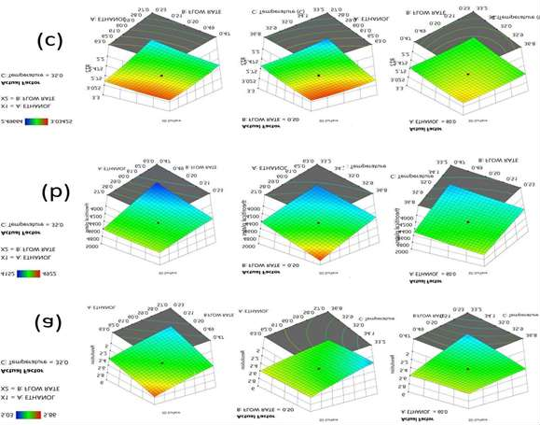
[Table/Fig- 4]: 3D Contour plots for optimized method with interaction of three factors on (a) R 1,
(b) R 2, and (c) R 3.

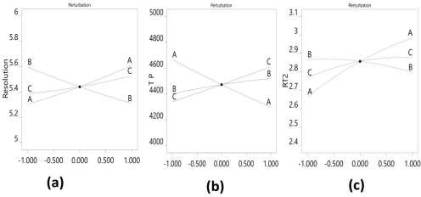
[Table/Fig-5] : Perturbation plots for optimized method with interaction of threefactors on (R 1, (b) R 2, and (c) R 3.
Based on the DoE results, the process model equations were derived and statistically confirmed using ANOVA for each model coefficient. This section's model coefficients were statistically significant (P values 0.0001). Furthermore, the F-ratios illustrate the significance of each coefficient in the model. larger R2 and lower LOF values imply a well-fitting model, whereas larger F-ratios show statistical significance for the analytical model equation. [Table/Fig- 4,5] show the 3D contour and perturbation plots for the A, B, and C interactions.
Table/Fig 6: Constraints and goals selected for the optimized method
A: ETHANOL is target = 57.027 |  | 62.97 | 1 | 1 | 3
B: FLOW RATE is target = 0.47 |  | 0.52 | 1 | 1 | 3
0.50
C: Temperature is in range | 33.21 | 36.78 | 1 | 1 | 3
Resolution is in range | 5.03 | 5.86 | 1 | 1 | 3
Theoretical is in range | 4152 | 4922 | 1 | 1 | 3
RT2 is in range | 2.496 | 3.034 | 1 | 1 | 3

Name Goal Lower Upper Lower Upper Importance 60.0

plates

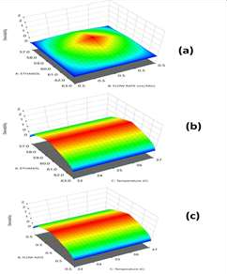

[Table/Fig-7]: 3D desirability plots for the optimized method with interaction of three factors on (a) R 1, (b) R 2, and (c) R
To ensure that the regression models were statistically viable for all three answers, ANOVA findings, LOF non-significance suitable standards of R2, and adjusted and expected R2 were used. These interwoven responses emphasised the importance of a practical strategy. Derringer's statistical model of desirability was used to find the optimal set of conditions based on the relevance and constraints of each response. The desirability technique demonstrated the attainment of specified goals within the limits established, and a specific experimental zone was searched for configurations in which the constraints set were attained to the maximum, i.e., cohesiveness. [Table/ Fig-6,7]

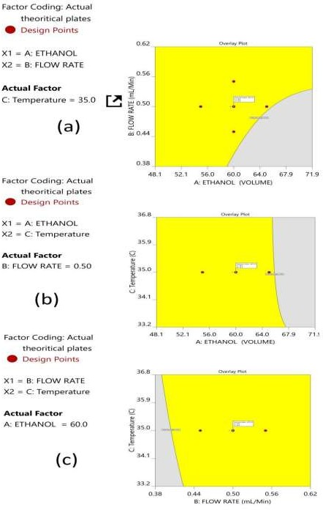

[Table/Fig- 8]: Overlay plots for the variables and responses with interaction of factors on (a) R 1, (b) R 2, and (c) R 3
CMA models and robustness simulations were used in the development of the MODR, also known as the control space. The DoE zone for the optimised technique, also known as a desirability region, is depicted in Fig. 5 as 3D contour plots for various combinations of CMAs. The robustness MODR values are as follows: column temperature is 32–38 °C; flow rate is 0.45–0.55 mL/min. The ideal mobile phase percentage variance is 5%. An ideal operating point within MODR was determined to be 0.5 mL/min flow rate and 34.609 °C column temperature. The expected CMAs for the working period were Rs = 5.425, N = 4442, and RT2 = 2.843. The genuine CMAs at the practically executed were Rs at 5.413, N at 4429, and RT2 at 2.84. The overlay plots for the optimized plots indicating that the yellow region is the range that does not require any revalidation further with each interaction are depicted in [Table/Fig- 8]

Validation according to ICH guidelines Linearity study
Six distinct proportions of standard concentrations were prepared individually to measure the linearity range. The calibration curve was obtained as peak area versus standard solution concentration. The EBS and GZP study solutions were prepared with a concentration ranging from 5 to 30 µg/mL and 10 to 60 µg/mL, respectively. Correlation coefficients (R²) for EBS and GDP 0.9994 and 0.9998 were observed.

A.
70
60
50
40
30
20
10
0
100000
80000
60000
40000
20000
0
y = 2100x + 1272,9
R² = 0,9994
140000
120000
B.

 |  |  |  | y = 9965,3x | - 53,467
 |  |  |  | R² = 0, | 9998

Table/Fig 9: Linearity graphs for (a) EBS and (b) GZP
350000
300000
250000
200000
150000
100000
50000
0
0
5
10
15
20
25
30
35

Accuracy:

Drug | Amoun t | Amoun t found | Amount found Mean | %  Recover y | Avg. | Pooled  %  recover y | SD | % RSD
 | 10 | 37.8 | 37.703 | 100.80 |  |  |  | 1.436
 | 10 | 38.19 | 37.703 | 101.84 | 100.54 |  |  | 1.436
 | 10 | 37.12 | 37.703 | 98.99 |  |  |  | 1.436
 | 20 | 75.66 | 75.393 | 100.88 |  | 100.16 | 1.16  6 | 1.040
 | 20 | 74.51 | 75.393 | 99.35 | 100.52 | 100.16 | 1.16  6 | 1.040
EBS | 20 | 76.01 | 75.393 | 101.35 |  | 100.16 | 1.16  6 | 1.040
EBS | 30 | 112.67 |  | 100.15
EBS | 30 | 112.25 | 111.827 | 99.78 | 99.40 |  |  | 0.998
 | 30 | 110.56 |  | 98.28
 | 20 | 20.32 | 20.17 | 101.60 |  |  |  | 0.893
 | 20 | 19.97 | 20.17 | 99.85 | 100.85 |  |  | 0.893
 | 20 | 20.22 | 20.17 | 101.10 |  |  |  | 0.893
 | 40 | 40.37 | 40.506 | 100.93 | 101.27 | 100.67 | 1.14  6 | 0.501
 | 40 | 40.74 | 40.506 | 101.85
 | 40 | 40.41 | 40.506 | 101.03
GZP | 40 | 40.41 |  | 101.03
GZP | 60 | 60.96 |  | 101.60
 | 60 | 59.84 | 59.933 | 99.73 | 99.89 |  |  | 1.640
 | 60 | 59 |  | 98.33
Table/Fig 10: Accuracy results for the developed method
The consistency of an analytical technique refers to how similar the method's results are to the actual value. As seen in [Table/Fig-10], accuracy results showed a percentage recovery of 98.4–101.9 % at al three levels (80, 100, and 120 %). The percentage recovery findings were within the acceptable level and, ranged from 98.33 % to 101.84 %, respectively, indicating that the procedure should be used for routine drug evaluation.

Precision:

Intra -day

Inter -day

Conc. [μg/mL] | Amount found Mean ± SD  [ n = 3] | [μg/mL]  % RSD | Amount found Mean ± SD  [n = 3] | [μg/mL]  % RSD
5 | 4.94 ± 4.12 | 0.967 | 5.02 ± 2.67 | 1.136
10 | 9.04 ± 4.12 | 1.217 | 9.93 ± 2.21 | 0.300
15 | 15.96 ± 2.12 | 0.790 | 32.02 ± 3.56 | 0.674
10 | 10.08± 1.67 | 1.081 | 10.04 ± 1.78 | 1.278
20 | 19.96 ± 3.01 | 0.708 | 19.98 ± 1.14 | 0.511
30 | 30.98 ± 3.78 | 0.572 | 29.03 ± 1.89 | 0.904
[Table/Fig-11]: Results of Precision Studies (Intra- day and Inter- day)
The intermediate precision results indicated that the method is accurate within reasonable limits for both solutions. [Table/Fig-11] shows that the acceptable precision RSD was less than 2.0 %.

System suitability:

S. No | Parameter | EBS | GZP
1 | Retention Time | 1.703 | 2.849
2 | Resolution | 5.14 | 5.24
3 | Tailing Factor | 1.02 | 1.11
4 | Theoretical Plates | 7435 | 44654
[Table/Fig-12] : System suitability parameters for the developed method
After six repeated injections, the system suitability results showed a lack of significant difference in the CAAs like Kʹ, RT2, and Rs of EBS and GZP. The % RSD values were less than 2%, indicating that the chromatographic instrument has high accuracy [Table/Fig-12].

Solution Stability

Time
RT Number of
theoretical plates

 | EBS | GZP | GZP | EBS
0 min | 1.696 | 2.849 | 44924 | 7521
Sample 24 h | 1.694 | 2.856 | 44857 | 7555
72 h | 1.695 | 2.852 | 44752 | 7455
% RSD | 0.059 | 0.12312 | 0.19333 | 0.67702
0 min | 1.703 | 2.765 | 44721 | 7420
Standard 24 h | 1.714 | 2.745 | 44825 | 7506
72 h | 1.711 | 2.742 | 44924 | 7521
% RSD | 0.33266 | 0.45456 | 0.22647 | 0.72839
[Table/Fig-13]: Solution stability of the developed HPLC method
EBS and GZP standard sample solutions were checked for stability over three days at 35 ±2 °C. The percentage assay value for the analyzed standard samples was compared to freshly prepared samples shows within limits with an acceptable % RSD of < 2. The overall results are depicted in [Table/Fig- 13]

Specificity
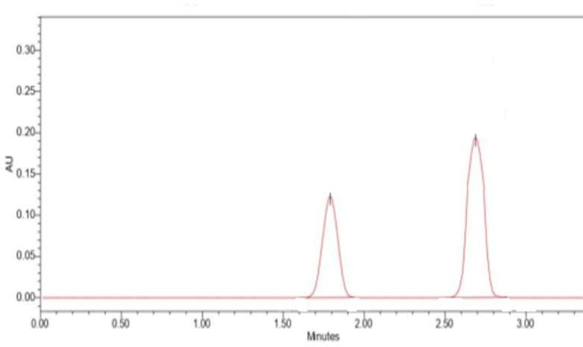

Table/Fig 14: Chromatogram of EBS and GZP
Specificity refers to the substance's ability to be measured precisely in the presence of the matrix effect and any additives used to ensure the identification of the analyte(s) of interest. The blank, standard, and assay test solutions were analyzed, and each solution's EBS and GZP peaks were calculated. The PDA detector was used to determine the peak purity under specified chromatographic conditions. Both compounds were separated, and there was no evidence of analyte retention time drift.as shown in [Table/Fig -14].

Robustness

Chromatographic Conditions | EBS  tR | GZP  tR
Flow Rate (mL/min)
0.90 | 1.78 | 2.83
1.00 | 1.80 | 2.84
1.10 | 1.82 | 2.76
Mean ± SD | 1.8± 0.35 | 2.8± 0.42
Mobile phase composition (v/v)
45:55 | 1.76 | 2.77
40:60 | 1.82 | 2.83
35:65 | 1.86 | 2.79
Mean ± SD | 1.81± 0.19 | 2.79± 0.157
Change in Column Temperature  25 ⁰C | 1.78 | 2.78
b) 30 ⁰C | 1.81 | 2.83
Mean ± SD | 1.79±0.45 | 2.80±0.78
[Table/Fig -15]: Robustness Studies
The standard deviation of peak areas was calculated for each parameter and %R.S.D. was found to be less than 2%. The low %R.S.D. values indicated method is robust. Results are shown in [Table/Fig - 15]

Ruggedness
The proposed method was evaluated by two different analysts in the ruggedness study. The results for EBS were found to be 99.89 %, 99.91 % and for GZP 100.23, 99.97 %, respectively.

Limit of Detection (LOD) and Limit of quantitation (LOQ)
LOD of EBS and GZP were found to be 13.45 and 45.86. LOQ of EBS and GZP were found to be
124.23 and 144.14 respectively

Forced degradation studies
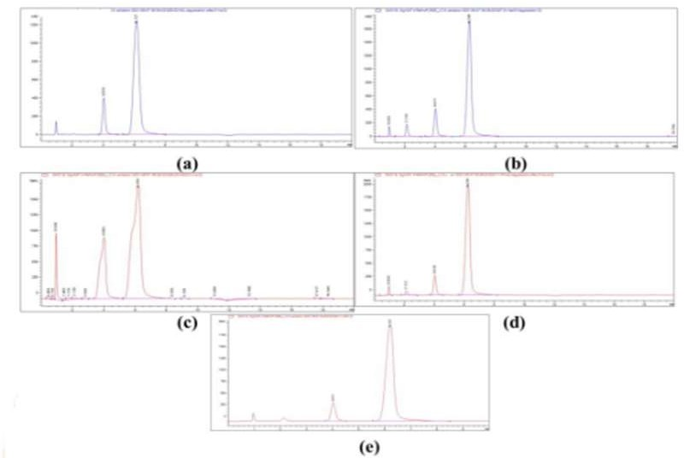
[Table/Fig -16]: Forced degradation of EBS and GZP a) Acidic condition b) Basic Condition c)
Oxidation d) Dry heat e) Photo light condition

Drug Condition | Time | % Assay | % Degradation
Acid | 6 h | 87.478 | 12.522
Base | 6 h | 89.438 | 10.56
EBS Oxidation | 6 h | 82.245 | 17.755
Dry heat | 6 h | 97.77 | 2.43
Photolight | 6 h | No degradation | No degradation
Acid | 6 h | 87.633 | 12.367
Base | 6 h | 97.485 | 2.51
GZP Oxidation | 6 h | 92.97 | 7.03
Dryheat | 6 h | 91.55 | 8.45
Photolight | 6 h | No degradation | No degradation
[Table/Fig -17]: Forced degradation studies for EBS and GZP.
Forced degradation tests were undertaken on the EBS and GZP drug combinations. The 0.1 M HCl,0.1 M NaOH, 3 % H2O2, dry heat and UV light was picked as primary stress condition. This gave reliable information regarding the stability of EBS and GZP. No drug was degraded instantly after adding the acid, base, or peroxide, allowing it to stand for 1, 3, and 6 h. The study report of 1 and 3 h has not shown a noticeable degradation, further allowed to stand for 6 h and found the drugs tend to degrade at this time, and the results and the degradation peaks were portrayed in [Table/Fig -16,17]

Assay of marketed formulation
This demonstrates the selectivity of the technique for determining EBS and GZP in tablets, where resulting as good and were achieved without any detected interference from the excipients. The suggested approach is successfully used to determine the presence of EBS and GZP in tablets.

Green assessment of developed and reported method
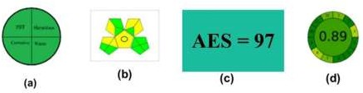

[Table/Fig -18]: Green Assessment results a) NEMI b) GAPI c) AES d) AGREE
The developed method was assessed using green assessment tools, and the results were depicted in [Table/Fig -18], The results show that the new method is completely eco-friendly and can be used as a long-term method. It has a score of nine green pictograms out of fifteen for GAPI, four green parts for NEMI, a score of 97 for AES, and a score of 0.89 for AGREE.
Stability- indicating HPLC method was developed for the simultaneous estimation of EBS and GZP in its tablet dosage form. Quantification was achieved with ultraviolet detection at 253 nm. Green analytical chemistry (GAC) has mainly focused on developing analytical methods that are safe for the environment. Therefore, it is imperative that the GAC principles be applied in pharmacological analysis. A rotatable central composite design was employed, and the optimized conditions for chromatographic separation were made with a run time of 5 minutes using Zorbax C18 column (4.6× 150 mm, 5 µm) with 0.1% Trifluoroacetic acid and ethanol (40:60 v/v) as components of a mobile phase, flowing at a rate of 1.0 ml/minute. The retention time obtained for EBS was at 1.8 min and for GZP was at 2.84 min. The result obtained with the detector response was found to be linear in the concentration range of 5- 30 μg/ml for EBS and 10-60 μg/ml for GZP. The value of correlation coefficients greater than 0.999 indicate good linearity response in the above-mentioned range. The sensitivity of the method was assessed by determining LOD and LOQ. For EBS, LOD and LOQ was found to be, 13.45 and 124.23 respectively. For GZP, LOD and LOQ was found to be 45.86 and 144.14 respectively. The proposed method was applied for pharmaceutical formulation and % label claim for EBS and GZP was found to be 99.70. and 99.91, respectively. The amount of drugs estimated by proposed method was in good agreement with the label claim. The recovery studies were carried out at 80, 100, 120 % level. % RSD values less than 2 indicative of accuracy of the method. The method was found to be precise as indicated by the inter-day, intra-day and repeatability analysis; % RSD less than 2. In robustness study, different parameters (mobile phase composition, change in flow rate, column temperature) were studied and the effects on the results were examined. Low values of % RSD proved method to be robust.
Stability of EBS and GZP was carried out by forced degradation study. [32-33] The chromatograms of samples degraded with acid, base, hydrogen peroxide and light showed well separated spots of pure EBS and GZP as well as some additional peaks at different Rt values. The method is successively applied to pharmaceutical formulation; No chromatographic interferences from the tablet excipients were found. The suitability of this HPLC method for quantitative determination of the compounds is proved by validation in accordance with the requirements of ICH guidelines. 3 randomized response surface designs with a full fraction design were used with 20 trial runs to study the impact of three factors on the three key response variables. In this design 3 factors were evaluated, each at 3 levels, and experimental trials were performed at 3 possible combinations. The resulting data were fitted into Design Expert 10 Software and analyzed statistically using analysis of variance (ANOVA) and F-Test. The data were also subjected to 3-D response surface methodology to determine the influence of flow rate, temperature and mobile phase composition on dependent variables. [34-35]
Four greenness assessment methods were applied in the presented study. In NEMI, circle symbol with four quarters was designed as a pictogram; each quarter signified a component of the method that could potentially negatively influence the environment.[36] GAPI is good semi quantitative tool for laboratory practice and educational purposes. It evaluates and quantities the environmental impact involved in each step of an analytical method. It has many advantages of being simple method has a pictogram with three levels (red, yellow, and green), assess the green character of an entire analytical methodology. The greenness of the current method was assessed by utilizing the analytical eco-score tool, calculating the penalty points. The eco-score value of 97 is in the range of excellent

greenness. AGREE is a modern tool that evaluates all 12 green principles using appropriate software. The AGREE circle is divided into 12 parts; each part describes one green principle, and the estimated AGREE value of the current method is 0.89.[37].

Conclusion
The developed method showed green analytical procedure regarding GAC principles. This study demonstrates the innovative incorporation of AQbD and green analytical chemistry (GAC) through the analytical method development for the determination of EBS and GZP in bulk and its dosage forms. The eco-friendly methods provide better method performances, being an additional motivation for implementation of the GAC concept in the R&D departments and quality control labs in the pharma industry. Green Analytical Performances by the QbD technique for evaluating stability of the drug was found to be environment friendly. The implementation of the green strategies in the pharma analysis will provide benefits for the analysts healthier working environment, this technique will also help commercial and industrial lab research and testing departments adopt and evaluate the various combination in bulk and dosage forms.

References:
- Turner. Sustainable analytical chemistry - more than just being green. Pure Appl. Chem. 2013; 85(12): 2217– 2229 .https://doi.org/10.1351/pac-con-13-02-05
- Gałuszka A, Migaszewski Z, Namiesnik J. The 12 principles of green analytical chemistry and the significance mnemonic of green analytical practices. Trends in Analytical Chemistry. 2013;50:78-84. DOI: 10.1016/j.trac.2013.04.010
- Bagaglio S, Uberti FC, Morsica G.Resistance Mechanisms in Hepatitis C Virus: implications for Direct-Acting Antiviral Use. Drugs. 2017;77(10);1043-1055 doi: 10.1007/s40265-017-0753-x
- https://www.drugbank.ca/drugs/DB11574
- https://en.wikipedia.org/wiki/ Grazoprevir
- Zepatier (elbasvir/grazoprevir) [prescribing information] Whitehouse Station, NJ: Merck & Co Inc; January 2016.
- Zeuzem S, Ghalib R, Reddy KR . Grazoprevir-elbasvir combination therapy for treatment-naive cirrhotic and noncirrhotic patients with chronic hepatitis C virus genotype 1, 4, or 6 infection: A randomized trial. Ann Intern Med. 2015;163(1):1–13.
- Attia AAM, Nasr MEA , Ahmed EO ,Ahmed HA.Simultaneous Spectrophotometric Determination of Elbasvir and Grazoprevir in a Pharmaceutical Preparation.J AOAC 2018;101(2):394-400.doi: 10.5740/ jaoacint. 17-0037
- Zeid AM, Ahmed HA , Mohammed S.Simultaneous spectrophotometric quantitative analysis of elbasvir and grazoprevir using assisted chemometric models.Spectrochimica Acta Part A: Molecular and Biomolecular Spectroscopy.. 2021;251. 119505 https://doi.org/ 10.1016/j.saa. 2021.119505
- Attia KAM, El-Olemy A, Ramzy S, Abdelazim AH, Hasan MA, Abdel-Kareem RF.Simultaneous determination of elbasvir and grazoprevir in their pharmaceutical formulation by synchronous fluorescence spectroscopy coupled to dual wavelength method.Spectrochim Acta A Mol Biomol Spectrosc. 2021 ;248:119157. doi: 10.1016/j.saa.2020.119157. Epub 2020 Nov 4.
- Attia KAM, El-Olemy A, Ramzy S, Abdelazim AH.Application of different spectrophotometric methods for Simultaneous determination of Elbasvir and Grazoprevir in pharmaceutical preparation, Spectrochimica Acta Part A: Molecular and Biomolecular spectroscopy.2018;189(15): 154- 160.10.1016/ j.saa.2017.08.026
- Attia KAM, Abasawi NME , Olemy AE ,Abdelazim AH, Dosoky A.Simultaneous Determination of Elbasvir and Grazoprevir in Their Pharmaceutical Preparation Using High-Performance Liquid Chromatographic Method Journal of ChromatographicScience.2018;56(8):731– 737.https://doi.org/10.1093/ chromsci / bmy049
- Akram N,Umamahesh M, Ramachari T. A new validated RP-HPLC method for the determination of elbasvir and grazoprevir in its bulk and pharmaceutical dosage forms. International Journal of Chemical & Pharmaceutical Analysis. 2017; 4:1-11

- Rao V, Rao AM , Prasad SVU M. A Novel Stability Indicating RP-HPLC Method for Simultaneous Estimation of Anti-Viral Class of Elbasvir And Grazoprevir In Bulk And Pharmaceutical Dosage Form, International Journal of Pharmaceutical Sciences and Research. IJPSR. 2019; .10(2): 655-660.
- Nallagundla,Reddy HS, Vemula V, Kumar B, Nallagundla S.Analytical Method Development and Validation of Elbasvir and Grazoprevir in Bulk and Tablet Formulations by Rp- HPLC . International Journal of Pharmaceutical Science Invention.2017 ;6(8): 01-05
- Raju GE, Shiny S, Rao N , Raghava R .Method development and validation for simultaneous estimation of elbasvir and grazoprevir by RP-HPLC world journal of pharmaceutical and life science.2022; 8(10):124-134
- Kumar VP , Kumar AV , Sivagami B , Sireesha R , Kumar RC , Babu MN.Stability indicating RP-HPLC method development and validation for the simultaneous estimation of Grazoprevir and Elbasvir in bulk and pharmaceutical dosage form.International Journal of Research In Pharmaceutical Chemistry and Analysis.2018;1(1): 1-7
- Kumar DV , Rao JVLNS. A new validated stability indicating RP-HPLC method for simultaneous estimation of grazoprevir and elbasvir in tablet dosage forms. Int J Pharm Sci & Res .2020; 11(4): 1653-59. doi: 10.13040/IJPSR.0975-8232.11(4).1653-1659.
- Labidi A, Jebali S, Safta M. .. RP-HPLC Stability Indicating Method Development and Validation for Simultaneous Determination of Grazoprevir and Elbasvir. Chemistry Africa.2021; 4, 607–619 https://doi. org/10.1007 /s42250-021-00253-9
- Thoddi P, GautamGK , NarasimhaCH, Raju BH. Stability indicating validated RP-HPLC method for Simultaneous estimation of Elbasvir and Grazopravir in Bulk and Pharmaceutical Dosage form. Research J. Pharm. and Tech. 2020; 13(2):950-955. doi: 10.5958/0974-360X.2020.00179.1
- Girija D , Reddy BV.Development and validation of new stability indicating RP-HPLC method for simultaneous estimation of elbasvir and grazoprevir in bulk and pharmaceutical dosage form.Indian drug. 2020; 57(9): 53-59.https: //doi.org/10.53879/id.57.09.11644
- Vancha AR, Naresh D, Sowjanya1 P, Kumar GV. Analytical method development and validation for elbasvir and grazoprevir in combine pharmaceutical dosage forms by RP-HPLC. Int J Res Dev Pharm Life Sci 2016;4:94-101
- Kavitha V, Usha Kondla U, Kumar PV, Swapna G. A Rapid Novel Analytical Method For Simultaneous Estimation Of Grazoprevir And Elbasvir By Using RP-HPLCEPRA International Journal of Research and Development. 2022; 7(9):108-114.DOI: 10.36713/epra2016
- Haritha P, Rao BS, Sunandamma Y. Picogram level quantification of grazoprevir and elbasvir with deuterated internal standards in human plasma samples by LC–ESI-MS/MS. Indian J Pharm Educ. 2016; 50 (4): 612-619.
- Saibaba SV, Ashok H, PravalikaG , Nikitha M, Pavithra M, Lavanya P.Method Development and Validation for Simultaneous Estimation of Grazoprevir and Elbasvir in Bulk Drug and Formulation by Using RP- HPLCInternational Journal of Scientific Research and Engineering Development.2022; 5(3) :1048- 1054
- Madhavi S ,Prameela Rani ,Simultaneous Reverse-Phase Ultra Performance Liquid Chromatography Method Development and Validation For Estimation Of Grazoprevir and Elbasvir.2018;11(4):100-104. DOI: https:// doi.org/ 10.22159 /ajpcr.2018. v11i4.21721.
- Pena-pereira F, Wand W, Tobiszewski M. AGREE—analytical greenness metric approach and software. Anal. Chem.2020; 92: 10076–10082 . https:// doi.org/ 10.1021/ acs. analchem.0c01887
- Wasylka, J.P.(2018) A new tool for the evaluation of the analytical procedure: Green Analytical Procedure Index.Talanta.2018; 181: 204–209. https:// doi.org/ 10.1016/ j.talanta. 2018.01.013
- Int. Conf. on Harmonization (ICH) of Technical Requirements for the Registration of Pharmaceuticals for Human Use, Validation of Analytical Procedures: Methodology, ICH Q2B, Geneva 1996.
- Int. Conf. on Harmonization (ICH) of Technical Requirements for the Registration of Pharmaceuticals for Human Use, Validation of Analytical Procedures, ICH-Q2A, Geneva 1995.
- ICH Guideline Q2(R1), Validation of analytical procedures: text and methodology, 2005, http://www.ich.org/LOB/media/MEDIA417.pdf
- Blessy M, Patel RD, Prajapati PN, Agrawal YK. Development of forced degradation and stability indicating studies of drugs—A review,Journal of Pharmaceutical Analysis. 2014; 4(3): 159-165.https://doi.org/ 10.1016/ j.jpha.2013.09.003
- Sutar SV, Yeligar VC and Patil SS. A Review: Stability Indicating Forced Degradation Studies. Research Journal of Pharmacy and Technology, 2019;12(2):885-890
- Fares MY, Hegazy MA, El-Sayed GM, Abdelrahman MM, Abdelwahab NS. Quality by design approach for green HPLC method development for simultaneous analysis of two thalassemia drugs in biological fluid with pharmacokinetic study. RSC Adv. 2022 May 9;12(22):13896-13916. doi: 10.1039/d2ra00966h. PMID: 35548387; PMCID: PMC9084420.
- Rathinam S, Santhana LK. Analytical quality by design approach for estimating rosuvastatin calcium in pharmaceutical formulation by green HPLC method: Ecologically evaluated and stability- indicating.Journal of Applied Pharmaceutical Science.2021 ; 11(11): 150-160.DOI: 10.7324/JAPS.2021.1101119

- Guardia S.A.M.dela ,A green evaluation of existing analytical methods, in, Green Anal. Chem., ed.M.D.La Guardia and S.B.T.-C.A.C. Armenta,no.11,2011,ch.3, vol.57,pp.39–57.
- Gałuszka A,Migaszewski Z M, Konieczka P, Namieśnik J. Analytical Eco-Scale for assessing the greenness of analytical procedures. Trends Analyt. Chem. 2012, 37, 61–72. 10.1016/j.trac.2012.03.013

