BORANA VERBAL ART, QOOSA

A Literary and Cultural Analysis of Oral Texts of a Nomadic Community of Northern Kenya and Southern Ethiopia

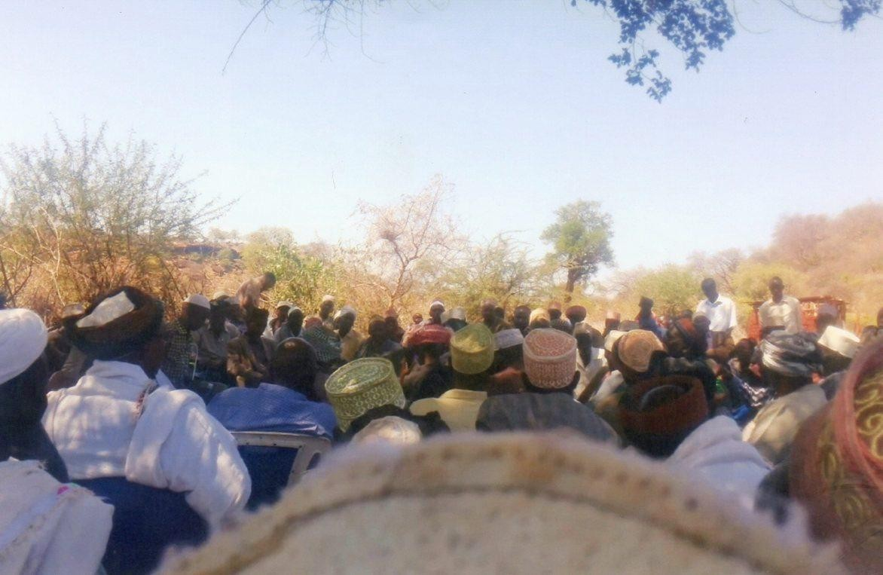

This book is an insightful analysis of a pervasive jocular genre among the Borana of northern Kenya and southern Ethiopia, namely, qoosa. Drawing on various anthropological and folkloric theories as well as Bakhtin’s notions of carnivalesque and the ambiguity of folk humour, qoosa is shown as affirming, yet at the same time questioning central cultural ideals of the Borana. The oral genre operates as an instrument of social and personal criticism that binds friendship while forcing home difficult truths. Extremely interesting is the gender component in the book where the voice of the marginalized women contesting their marginality as defined by the dominant patriarchal voice of the Borana society is captured. The book is a good account of the vital role orality plays in the production of culture on the African continent and a useful contribution to the field of contemporary oral and cultural studies.

Illustrations
page
Plate 1: A typical clan meeting among the Sololo Borana 24
Plate 1b: Mr. Jarso Jillo popularly known as Councilor Yoyaa, formerly councilor of Sololo Ward 1992-2007… 24
Plate 2: Some of the Karayyu clan elites who attended the 2001 meeting in Sololo… 26
Plate 3: Hon. Philip Galma Godana MP Moyale (1988-1992) 26
Plate 4: Hon.Guracha Galgallo MP Moyale (1997-2006) 26
Plate 5: Hon.Mohamud Ali MP Moyale (2007-2013)… 27
Plate 6a: Guyo Goba Abbagada (2008-2016) 42
plate 6b: Guyo Goba Abbagada (2008-2016) 43
Plate 6c: Kura Jarso Dido Abbagada incoming (2017-2025) 44
Plate 7: Aabo Mountain on which the Kenya-Ethiopia boundary passes 44
Plate 8: A typical Borana homestead 45
Plate 9: One of the streets of Sololo town 45
Plate 10: A closer view of Aabo Mountain 46
Plate 11. Author's parents performing gadamojji ritual… 46
Plate 12: Dima Jillo Jirma performing age-set qoosa 66
Plate 13: Roba Halake performing age-set qoosa 64
Plate 14: Mr Boru Guyo Oda perfoming clan qoosa 89
Plate 15: Mr Koroma Wario Bante performing clan qoosa 89
Plate 16: Retired hayyu Qanchora Liban 890
Plate 17: Borana women in Mado Adi village 109
Plate 18: Qabale Kosi, a woman performer 109
Plate 19: Jatani Ali Tandhu Governor Borana Region of Ethiopia in the 1980s… 124
Plate 20: This author in the ayyana shrine 127
Plate 21: Women performing the hadara dance 127
Plate 22: Women performimg cattle song 144
Plate 23: Shuke Wario, mother of a child being named 145
Plate 24: Men performing qoosa mocking women 145
Plate 1a: Qallu and Qaliti of Karayyu with several political and other leaders 165
Plate 1b: Prof Guyo with his 2017 campaign poster 166
Plate 1c: Hon. Roba Duba MP Moyale (2013-2017) 166
Plate 1d: Prof. Guyo with Qallu and Qaliti of Karayyu 167

CHAPTER ONE INTRODUCTION

Genre conventions could be seen as the interface between performer/writer and audience, the shared templates which enable composers to generate a text and audiences to grasp what kind of text it is and therefore how it should be taken (Karin Barber 1999a: 28)

On December 30, 2001, in a remote rural town of Sololo in northern Kenya near the border with Ethiopia, something spectacular that is of prime interest to this book occurred. There, a Karayyu clan among the Borana was meeting on an issue that had been highly politicized. Top on the agenda was that the then area Member of Parliament Dr. Guracha Galgallo had been accused of neglecting clan members at home (Sololo) and in the country’s capital, Nairobi. The matter was brought to the attention of the elders by the Karayyu clan members working in Nairobi and other Kenyan towns. The small dusty town was abuzz with discussion made louder by new faces arriving from the city for the meeting. The political temperature was high. The MP had in effect to defend his job that was due to be contested in a year’s time. As the matter was being deliberated, the area councilor, a Mr. Jarso Jillo, who was also from a Digallu clan with institutionalized joking relationship with the Karayyu clan came to the meeting and performed a poem rich in political implication and cast within the convention of a jocular genre called qoosa¹. The interesting thing is that this was the first time the genre has been used as a direct intervention in modern parliamentary politics.
Immediately he was within earshot of the seated two hundred-plus Karayyu clan members with its mixture of the young and the old, the educated and the illiterate, the high and mighty, and the ordinary, the jovial councillor popularly known as Councillor Yooyaa (nicknamed after his idiosyncratic greeting formula, yooyaa, I embrace you) greeted them with a formulaic call, Karayyu dhinte dhinna? Karayyu dhinte dhinna? The import of this cannot be adequately captured but it is close to something like, “are you ready for me, you members of Karayyu clan?” The gathering answered in unison, oobai, “come out with it”, indicating their readiness to play along with him. Having been granted his request, he performed the following text:
Jaarumaa Guracha Didimtu considered
Didimtun dhibsaate Guracha’s leadership a problem
Garuule iyaane They did not go far Dhanqan Didimtuti irkaate Dhanqa allied with Didimtu Ammenaale inqabdi They are also discontented
Beeree Tiiseleen chiqileet jibsate Beere and Tiseele leaned on their elbows Ammeena qortee hinbamne They did not solve the case
Sibaaf Ittuleen Sibaa and Ittu
Ak dhadha hibsate Smeared it like oil

1

A word that denotes literally joke-play, that describes a field of meaning that are associated with humour. Ton Leus in his Borana Dictionary (1995) translate qoosa as, to joke, make fun of, mock, having a joking relation. In this book I translate the word qoosa as joke but the reader should not lose sight of its richness as intended by the Borana in its original version.

Ajeejin hawecaa Ajeeji the talkative ones
Oroo mii jifate Are like a camel whose load has come off
Eenti itidebisa? Who will reload it?
This was followed by raucous laughter and an invitation for the man to repeat his poem, which he did a few more times. From then on, the poem was on everyone’s lips. Verbal forms lend themselves to verbal exegesis—are intended and expected to be talked about, to be explained, expounded, and opened up so that the multiple meanings enclosed in them are revealed (Barber 1991:3). Thus people memorized the poem, interpreted it and retold it to others, corrected one another, quoted and generally used it as an entry point in the discussions of the prevailing political alignments. The speaker was invited for lunch and congratulated for his creative joke.
What, then, is this discourse about and what is its significance and place in the Borana society? Every text, like every utterance, bears the marks of its orientation towards an addressee, revealing an expectation of being interpreted (Barber 1999b:27). In terms of immediate context, an elected councillor was making an attempt to rescue his beleaguered political colleague whose job was on the line by negotiating a softer option for him all couched in traditional conventions, what Radcliffe-Brown (1940) called joking relationships. The speaker underscores the political dissents of the larger sections of the Karayyu clan lead by Didimtu, and followed by others notably Dhanqa, Beeree, and Tiseele; while others like Siiba and Ittu, unable to mediate between the dissenting sub clans and the MP, assumed an attitude of resigned indifference. In this type of scenario, the speaker concludes that the Ajeeji subclan from which the MP hailed, can only be likened to a camel whose load has loosened and threatens to fall, and is therefore badly in need of a loader. The rhetorical question is put in such a way that the Karayyu clan rises up to the occasion and asserts itself as the loader who will saddle the metaphorical camel, meaning campaign and vote for the MP.
At a more covert level, if one applies Clifford Geertz’s notion (1975), culture is an ensemble of texts that can be read off. The entire discourse is rich with its fluidity and integration of the often polarized and differentiated matrixes of rural/urban, modern/tradition, and humour/serious whose boundaries are crossed and transgressed at different junctures of the social event. Paradoxically, the youngsters from the urban centers called to service the expertise of the tradition and its institution of conflict resolution. Even more important is the unspoken but shared knowledge between the speaker and his audience that is so crucial to the interpretation of this text, one of the essential features of all joke exchanges. What is pertinent is that the speaker had engaged himself in the performance of a traditional art form by composing a text that spoke to the moment at hand. As Madison and Hamera tell us performance has evolved into ways of comprehending how human beings fundamentally make culture, affect power, and reinvent their ways of being in the world (2006). The text alludes to the political history of the constituency and by invoking the Didimtu discontent from the onset, the speaker reminds us of the fact that the subclan mentioned had had a MP a decade or so before who was dislodged by the man the MP who was the subject of the joke beat in the 1997 Kenyan general elections. That year, a large section of the Karayyu clan led by Didimtu wanted Philip Godana, the former MP from Didimtu subclan to be fielded as a candidate but the faction allied to Dr. Guracha carried the day in a climate of political acrimony, for which they have not forgiven him ever since. The notable thing is that the text depended so much on things that are outside it for effective interpretation. The nature of qoosa as with that of oriki, noted by Karin Barber is compact, allusive, and fragmented, and hence needs to be supplemented by the hearer from narrative resources outside the text itself (1991: 27).

Another question to consider is why people laughed, or put another way, what kind of laughter did the poem elicit and why? Firstly, the convention of joke framed and marked by the formulaic utterance and the audience’s prior knowledge of the performer’s clan, made the audience anticipate a performance (Bauman 1975:298) that is essentially humorous. Secondly, as my informants put it, the poem in terms of its content was a depiction of truth, and in the Borana proverbial lore, truth brings about laughter (dugaan hinkofalchifti). Wilson (2006) construes joke as a pretence in which the speaker makes as if to perform a certain speech act, expecting her audience to see through the pretence and recognize the mocking or critical attitude behind it. Thirdly, the beauty of the poem lay in the language repertoire that was used and people laughed for the sheer entertainment it provided. Through his poem the councillor provided an interlude that served to relieve tension and from then on people chatted freely, for he had indeed humourously hinted at the problem the MP faced, and in the same breathe asked for reconciliation and pardon for the man. What this shows, is that there are different ways of using and configuring humour, a subject this book investigates. Qoosa as a genre is an expressive form with which people can mediate diverse and sometimes conflicting pasts of their experience and their identities as Gunner & Gwala (1991:29), suggest in connection with Zulu izibongo which comment on individuals’ experiences of interpersonal relationships.
The above verbal utterance of clan joke represents only one of the four ways in which qoosa genre is made manifest in the Borana society. The other three categories are enacted between men and women, women and men, and amongst an age-set. It is also worth observing that these categories naturally overlap as the members belong to more than one category. Even though the four categories use joke differently and in keeping with the social dynamics that mark the particular category, they are wooven together by the joke conventions, the shared templates cited in Barber’s quotation at the beginning of this chapter. In addition, qoosa is composed in response to local events and thus embodies the criticism of immorality, greed, rivalry, injustice, power struggle and a host of other vices that preoccupy humans in social life.
Outside social events like the meeting quoted at the beginning of this chapter, qoosa is performed in situational contexts of two ritually significant occasions. The first is the rite of korma-korbesa² (bull/he-goat) and the second is the child naming ceremony (jilla). These ritual sites at which qoosa is given voice can be said to be a carnival-like activity which in its widest embraced:
Ritual spectacles such as fairs, popular feasts, wakes, processions, and competition; comic verbal composition (oral and written) such as parodies, travesties and vulgar farce; and various genres which Bakhtin designated curses, oaths, slang, humour, popular tricks, jokes, scatological forms—where all is mixed hybrid, ritually degraded and defiled (Stallybrass & White 1986:8).
2
People of the same age-set normally conduct a ritual of this kind mainly to strengthen their group
solidarity through companionship, and to resolve some common problems. The animal slaughtered must be a male, thus symbolizing the importance of male norms for which the ritual stands.

The thread uniting these motley genres is the spirit of festive laughter that Stallybrass & White describe as ambivalent, for it is at once gay and triumphant, and at the same time mocking and deriding. According to an informant, Dima Jillo, the performances during jilla (naming ceremony) are neither praise nor insult but are considered a play meant to make people laugh and bring happiness to the occasion. In Borana as in other cultures, these events have been regarded as a form of licentious behaviour at which everyday conventions are subverted.

The ludic space within which qoosa operates is primarily a site for uninhibited projections; a freedom ordinarily denied members under the disguise of social propriety. As Gillooly (1999: 27-28) suggests, it is a transitional space, an area of creative play liminal to both psychic and external reality where law is suspended and desire is safely mediated. This space is entered into with express formulas that seek permission from the co-performers to play along and the audience to interpret the performance within the frame of joke.
The study of jocular oral forms in oral communities is scanty³ even when the genre itself is prevalent particularly in Africa. In general oral literary scholars have devoted their attention and energy to the more conventional folktale, legend, riddle, myth and proverb genres⁴, a practice that seems to have taken root since the inception of the discipline. From as early as 1815⁵, the brothers Grimm, arguably the founders of modern folklore, regarded these genres as the mainstay of the oral literature/folklore. The marginalization of humour in oral literature has been observed in most unequivocal terms:
Laughter and its forms represent, as we have said, the least scrutinized sphere of people’s creation. The element of laughter was accorded the least place in the vast literature devoted to myth, to folk lyrics, and to epics. Even more unfortunate was the fact that the peculiar nature of the people’s laughter was completely distorted; entirely alien notions and concepts of humor, formed within the framework of bourgeois modern culture and aesthetics, were applied to this interpretation (Bakhtin 1968:4).

This tendency to peripheralize certain forms of oral literature is hence not new. As Hofmeyer has argued, "much of oral literary scholarship had been attracted to forms with stable generic boundaries like praise poetry and oral stories" (1993:4). Moreover, and in line with Bakhtin’s argument cited above to the effect that the people’s laughter has been ignored; there is the exclusion of the story behind each jocular text that is an integral part of why people laugh.

3
See for example Finnegan's influential Oral Literature in Africa (1970) where no mention is made of
joke as an integral part of the genres she treats.
4
Like Finnegan, authoritative scholars of African oral literature such Okpewho (1983), Scheub (1975), Herskovits (1956), Yankah (1989) have for example concentrated on the epic, the proverb and the narrative.
5
For this see the emphasis on Marchen and also the notion of folktale as a relic, something that belonged to the past and not the continuing present.

When this unspoken but latently implied story known to the audience is omitted, the value of the text as one rich in humour and social meaning is compromised. According to Karin Barber, the way to do justice to the texts in a more inclusive way is to bring the local exegetes forward, out of the footnotes where they are so often confined and into the discussion of the character of the genre itself (1999:45).
Yet the scholarly peripherization of jocular oral forms is unjustified. Ethnographers⁶ working among African communities such as the Dogon, the Padhola, the Abagusii, and the Kaguru to mention but a few have unearthed a rich vein of jocular oral literature. However, jocular discourses like the one cited above as literary art are seldom studied. More often, such scholars following the core questions of their discipline set out to investigate the sociological function of the genre, and to solve anthropological rather than literary queries. Whether one is considering the critical neglect by oral literary scholars or the biases of anthropologically inclined ethnographers, it is clear that the richness of jocular oral forms remains unappreciated.
This book attempts to bridge this gap through a critical examination of qoosa among the Borana. More specifically it aims at interpreting the essence of the genre by investigating how it is constituted, encoded, and inscribed in the Borana oral tradition and culture. The genre has the propensity to traverse what in normal discourse are unbroached subjects such as infidelity, sexual promiscuity, meanness, and a generally indecorous social mien. With satirical undertones, it questions and ridicules the female world, male prowess, and illegitimate clan marriages. This task is realized through the poetic license, which allows it to criticize untoward social norms and deviations from what the performer sees as a sound moral ethos. Beneath the veneer of social criticism, which in its own right is captivating, the textuality of the qoosa genre is manifest. The multiplicity of actors, subjects, contexts, intentions and generic mixture of songs and verbal art marks joke as an intricate and interwoven text that justifies itself as a rich oral form.
In relation to other oral literature genres among the Borana, qoosa occupies a fundamentally central position. This is clearly apparent in view of the fact that other genres like the folktale (duri-duri), and the riddle (impho) are largely in the domain of children’s pastime, a point already underlined by Kidane (1996:23). This is not to downplay the importance of these genres, but the very fact that qoosa is an adult engagement across the age, clan and gender divide bespeaks its importance. In general, with a few exceptions, it is performed at naming ceremonies, at the meeting of age-set, at the gathering of elders, over drinks, when watering animals, and so forth. The performances are repeatedly re-enacted, and it forms part of people’s ways of celebrating life, criticizing persons, making their views known and establishing friendships.
Some of the indices of the genre’s popularity and pervasiveness are manifest in the many forms in which it is disseminated to larger audience beyond the immediate context of performance. In this connection, it is worth noting that one of the texts analysed in this work was a taped material bought from a small music shop in Isiolo by the name, Wan Diqo Dansa (literally ‘some little good thing’), some five hundred miles from the place at which it was originally performed. According to the shop owner, Borana youngsters interested in the preservation and dessimination of the Borana culture brought the tapes to his attention. Wan

6
See such ethnographers as Griaule (1948), Sharman (1967), Mayer (1951) and Beidelman (1966,
1986) who studied various communities largely with the express aim of discovering the ambiguity of friendship and hostility joking relationships exhibit.

Diqo Dansa was particularly instrumental, acting as a conduit by dubbing and selling the cassette to all who wanted, at a paltry Kenya shillings one hundred, about one US dollar. The consumers of the product, the shop owner informed me, were Borana enthusiasts working in other parts of Kenya who are interested in staying in touch with the events in Boranaland, as well as local intellegensia who see themselves as custodians of the Borana culture. This later point needs to be put in context as it relates to the need for survival where culture is used as a means to that end. It must be remembered that the position of Isiolo in Boranaland is a peripheral one, bordering the Meru County to the south and the Wajir County to the east. Over years the relationship with the communities from these two Counties with the Borana have been one of conflict and tension specially over the ownership of land, making the Borana in this County regard themselves as living in diaspora, contending for their survival. In a way then, the shop in question has come to be identified as a center for sharpening Borana consciousness and agitation for rights to land ownership that finds legitimacy through cultural rejuvination.
In this regard, Wan Diqo Dansa stocks tapes on the Borana cattle song, war songs in praise of the Borana heroes, and generally songs that depict the Borana way of life in positive light. More importantly tapes on political songs are stocked that speaks about land alienation by the government and forceful encroachment by other communities with whom the Borana compete for resources. The land question was so topical and thorny and a petition has been presented to the Constitution of Kenya Review Commission at the time of my fieldwork, and my attention was drawn to the latest cassette that contained the text of that presentation. Captured in the form of a song, it articulates the Borana claim to the land in Isiolo district based on historical and cultural considerations by reiterating the known Borana figures associated with the particular locality. The names of prominent Borana persons who long ago lived and died on the disputed lands are used as a rationale for authenticating their claim. The song alluded to their burial sites, the names of hills, waterpans, and trees as landmarks bearing testimony to their claim. Along with these politically charged cassettes, the ones that deal with love, the beauty of cattle and jokes at the expense of the various social segments and persons find their place on the shelves of this shop that has come to signify for many as a kind of ‘Borana cultural center’.
As regards the qoosa texts, they were primarily intended for evaluation and enjoyment, and because of their popularity they are in very high demand as the shop owner told me, from Mega in Ethiopia to Moyale in Kenya. In this scenario, it is interesting to observe that the traditional method of verbal transmission has largely been enhanced by the modern technique where the tape takes the place of an oral performer. This is a clear indication of the fact that oral performers and their products are not enimical to modern technology and instead there is a definite relationship of mutual co-existence between the traditional and the modern, in which the former has benefited from the latter to reach a wider audience than the speaker fathomed. The modern also benefits by drawing on the traditional for legitimate identity in a terrain rife with contestations by providing the much needed identity icons such as burial mounds and names of places.
As Finnegan cautions anthropologists, we say with her that the aim of oral literary interrogation is to understand people’s cultural activities and artistries rather than to build theory (1992:25). This is not to downplay the importance of theory, as she hastens to add. Research after all inevitably depends on some theoretical assumptions. However, I employ this cautious remark because in a work like this that involves fieldwork, neat theoretical formulations may be at variance with the data that one is dealing with precisely because theories after all are generated by the data at a point in time. In other words, even when I employ some of the theories discussed here, I am aware that they do not relate to qoosa in a

one to one kind of relationship. They might have been fashioned out of a qoosa kind of situation but not from qoosa itself. In this sense, I centralize qoosa as a generic text, and I go along with Bakhtin’s (1986:104) assertion that regardless of the goals of the researcher, the only possible point of departure is the text. Again this is not to advocate for the autonomy of the text as a kind of context-free enterprise. On the contrary, as others before me have observed (Skinner 1969, Barber 1999b), I explicate qoosa as a genre that provides its own conventions for generating meaning for its audiences. These local meaning can be further elaborated and understood in the light of classical theoretical postulations on humour, ritual and text in a process of infusion that is mutually enriching the understanding of theory and data within the diversity and vastness of human knowledge.
Since studies in jocular oral form by oral literary scholars are few and far between as earlier stated, I find sufficient justification to make recourse to related disciplines such as psychology, anthropology, history and ethnography to elucidate some of the perception that informs the genre. In addition, as qoosa is not one thing but a nexus of issues that traverses diverse categories of age, sex and clan, and thereby touches on a range of topics such as masculinity, femininity, and moral criticism, it makes academic sense to approach the subject from what has been called methodological hybridity in the domain of cultural studies (Gilmore 1990:5, Archetti 1999:21). This entails drawing on multiple theoretical perspectives that shed light on the work.
A number of scholars have underlined the importance of drawing on multidisciplinary approaches (Barber & Farias 1989, Finnegan 1992). Finnegan for instance speaks of how the knowledgeable use of insights from a number of different schools may increasingly become a mark of the scholarly analysis of oral traditions and verbal arts (1992:49-50). Barber and Farias spell out the nature of this interdiscplinarity by suggesting, “what is required is an approach that acknowledged simultaneously the historicity and textuality of the oral texts that combined sociology with a poetics of oral literature” (1989:1). While the work attempts to follow these recommendations, as already noted, the qoosa data is the primary determinant of how much of these prescriptions can be administered.
The literature on joke takes on one of two broad perspectives. The first is the psychological readings derived from the works of Freud (1916) and Herbert Spencer (1879), which treats joking as the socially accepted articulation of the repressed elements in the individual unconscious. According to this school of thought, the relief/release afforded by humour represented liberation from restraint and became an outlet for tension and stress. Spencer especially saw laughter in terms of the need to expend energy and find relief from strain. In the language of the day, humour was intended as a safety valve for concentrative minds where a sense of the ridiculous, a playful fancy, a capacity of abandon helped lighten the burden of care. For Spencer laughter was the transformation of something large, momentous or important into something small, frivolous and insignificant. Spencer’s theory which was largely embedded in the notion of joke as a physical process by which the body emitted unexpended energy, found validation in most psychologically based studies of humour beginning with Freud (1916), since, in the latter’s perception, joke allowed for the expression of thoughts/feelings that would otherwise be censored.
Freud treats joking as a socially acceptable articulation of the repressed elements in the individual unconscious. He delineates different strands of wit. In his view, wit uses means of connection rejected or carefully avoided in serious thinking (Freud 1916:181). Freud further argues that the pleasure of joke lies in a psychic economy. Noting that at all times we are expending energy in monitoring our subconscious so as to ensure that our conscious perceptions come through a filtering control, he concludes that joke breaks down control,

releasing the unconscious without control, hence creating enjoyment and freedom. In Freud’s opinion, joke determines and maintains group cohesion by distinguishing between mores of one’s own group and that of the out-group.
Modern psycho/social studies (McGhee & Goldstein 1982, Chapman & Foot 1977) are grounded in the understanding that humour is an instrument of social influence, not merely a biological release or cognitive process. Firstly it is a way of self-disclosure as well as social probing since it is assumed that when the target of a joke laughs and starts his joke, an intimate relationship has been struck. Joke also allows for a disclaimer that the communication between the butt and the jester had any serious purpose, and in those subjects that bordered on areas considered a taboo, it is humour that negotiated their introduction. In addition, as an unmasking tactic that uses satire, ridicule, sarcasm, and caricature, humour is used to reject an identity proffered by a person/ego (McGhee 1979).
Although Freud’s attempt to study humour, wit and joke has been successful, he has been guilty of the unitary approach that saw humour, wit and joke to be studied solely as a field of therapy rather than that of social creativity and enjoyment. The influence and tendency towards humour as a theraupatic device was so great that today any mention of humour and joke has to put up with the psychotherapy syndrome as if society is incapable of enjoyment or of doing things with humour rather than as tension relief.

The second strand of joke/play theory understands joking as an important expressive means for channeling and managing potentially hostile points of social interaction. This set of ideas conceives of joking as a social art form that strengthens and promotes social solidarity by safely venting aggressive feeling. The British anthropologist, Radcliffe-Brown has been the most influential in pioneering a range of functionalist approaches, which with various emphases insist that joking is a privileged site of speech that defuses various orders of social tension, and allows for a degree of catharsis and so affirms existing social order. Radcliffe-Brown defined the joking relationship as “a relation between two persons in which one is permitted by custom and in some instances required to tease or make fun of the other, who in turn is required to take no offence” (1940:195). Fascinated particularly by institutionalized joking conventions, Radcliffe-Brown concentrated on joking between kin groups and explains the phenomenon as the opposite of extreme avoidance. He rightly observes that jokes in African communities were couched in insults and obscenities, making it a peculiar combination of friendliness and antagonism. Representing what he calls mutual disrespect licensed by the society, he suggests that the playful antagonism of teasing prevents serious hostility. He theorized that joking relationships are modes of organizing a definite and stable system of social behaviour in which conjunctive and disjunctive components are maintained and combined (1940:209). He contends that by means of sham conflict people avoid real ones (1949:134).
His contemporaries and acolytes (Griaule 1948, Mayer 1951, Beidelman 1966) sought to establish the place of joke in African societies following his lead with increasing gusto. Their principal point was largely the same: a major function joke serves was to relieve tension between societies or the various segments within societies. For them, joking relationships created and sustained an alliance between different societies through mock insult that replaced real tribal war (Griaule 1948:20), or represented a sign of real friendship and cordiality (Mayer 1951:243).

Others were even more explicit in their conviction that joke maintained equilibrium in society through tension relief. The notion of equilibrium and catharsis that joke serves is expounded and echoed by Hammond (1964), and Freedman (1977). Hammond for instance has an interesting suggestion where he maintains that joking relationships are “adjustive mechanisms” that revolve around what he calls communication, control, and catharsis. It is worth citing his him at length:
As a means of communication, joking provides a permissive and flexible context in which grievances can be expressed, thus allowing for its rectification and restoration of amity. As a means of control, the public nature of most joking serves to shame the object of the jocular offensive, to invoke social pressure for his conformity. As a means of catharsis, the joking expression of aggressive feelings reduces frustration and thus serves indirectly to perpetuate the amicable aspect of the relationship in which it occurs (1964:264).

To a great extent this formulation echoes the issues that underlie some aspects of joke. Yet such an argument, convincing though it is, also has its weaknesses, chiefly the one with which functionalism as a theoretical perspective is charged. In what is quite clearly a departure from those who pay debt to Radcliffe-Brown’s all-encompassing theory, Stevens (1978:49) maintains that the institutionalized joking can be a manifestation of an exclusive relationship formed between persons or groups who have been in prolonged and mutually beneficial association with each other. For Stevens, the privileged familiarity becomes a badge on which the degree of license for joke sharing is based.
Rather than concentrate on joke per se and drawing conclusion about its function in society, a more resourceful and yielding method would be to interrogate the institutions within which joke is produced and enacted. As Rigby argues, a whole range of concepts, values, categories, and cosmological ideas, to institutionalized joking, must be taken into account (1968:133). This method will unearth local histories, etiological myths and meaning for joke performance far more than the analytically worked out functionalist mould in vogue at the time. As Rigby has found in the case of the Gogo, mythological explanations are attached to the prevailing joking relationship among the clans. In what appears as a case of one genre narrating the other, Rigby cites his informant:
Nyomi were named “stranglers” because they used to kill goats and hens by strangling them. They in turn gave Itega the name Hilu after an animal that steals honey because of their expertise in honey gathering (1968:145).

Conversely, Rigby attributes joking relationships between age-mates with strong feeling of equality and intimacy to potential competition and hostility over women, prestige, power, and property.

Some scholars have faulted Radcliffe-Brown’s functionalist approach to the study of joke, since the ‘primitive’ society he was describing in their estimation, no longer exists (Davis 1993:292). On the contrary I find Radcliffe-Brown’s theoretical postulates more relevant for precisely this reason. In some of his pronouncements he could be speaking about the Borana especially in his definition of joking relationship. Those who find fault with him are mainly sociologists (Kennedy 1972, Emerson 1969, Davis 1993) who studied joking relationships among industrialized societies with their prevalent sitcoms aired on television for all.

Because the genre with which this book is concerned is largely performed at a rather auspicious social occasion of ceremonies as earlier indicated, I hasten to add another dimension of humour to the above categories. This licentious cultural occasion that gives joke its live performance is that of jilla (festival) which in scholarly circles have been studied in terms equivalent to ritual (Turner 1969) or carnival (Bakhtin 1968, Gilmore 1998). A perusal of this scholarly corpus on the subject shows that the notion of ritual/carnival has been developed in three strands. The various human behaviours relating to celebrations and allied forms that are ritualistic in nature, according to most scholars within cultural studies, are demonstration of consensus, conflictive, or ambivalence features within society. In this book I draw on some of these propositions since they illuminate the various facets of joke.

An ardent proponent of the consensus trajectory that sought to explain the forms of ritual and play thought to be a deviation from normalcy is Victor Turner. Turner (1969) argued that all societies have pressure points, nodes of stress where individuals’ alienation from their fellows collect. According to Turner’s theory, because societies impose authority and hierarchy on members, the regimentation generates psychological tension, which requires periodic remedy. The most creative spaces for the outlet of this tension are at the margins of social life, in play and joking, moments when the artist makes a claim about the interpretation of cultural events (Turner 1969). Ritual then can be construed as one such moment of release, as it reconciles the individual with collective needs of the society. This leads to the creation of what Turner calls communitas, a model of society as an unstructured, of equal individuals

encapsulated in prevailing social relations in ceremonies/carnival/marketplace where hierarchies are leveled, distinctions dissolved.

The notion of inner tension that individuals suffer as a result of communal authority has also been espoused by Gluckman (1963:112), who argued that rites of rebellion act like a thermostatic device in tribal African societies by re-establishing the dynamic equilibrium of social order threatened by inner tension. For him, rituals are an institutionalized protest and in complex ways renew the unity of the system; a point Stanley Brandes (1980) further develops. According to this school of thought, the main social effect of such rituals, even the most conflictive or violent, is paradoxically to reaffirm the existing order. Ritualism provides a safe outlet for the expression of potential conflict as well as restrictive frame within which the potential anomie or entropy is under control. Brandes (1980:208) suggests that carnival-like celebrations that are ordinarily perceived as highlighting social differentiation may be viewed equally well as bringing distinctive and opposing segments of a community together, thus serving as a latent mechanism for letting off steam and stabilizing the status quo. In this sense they become unquestionably the agents of social control.

Yet, the consensus ritual theorists have not been without their critical opponents as a growing number of scholars embraced the conflict rather than the consensus model in which ritual is seen as a weapon of social and political struggle. For those who operate within the tenets of this latter model, popular festivals, rather than being a political prop for the status quo or a means of dissipating individual energies or animosities, are a major source of ideological defense against dominant groups. Carnival-like events may therefore be seen from this point of view as an exercise in resistance against hegemony where through modes of symbolic dissent, people acquire the power to create momentarily an alternative popular social order (Gilmore 1998: 206).

A case in point is that of Jerome Mintz (1997) who has shown the revolutionary potential of carnival songs as rallying cries for the lower classes in oppressive regimes. While this suggestion is valid to some extent, the projection and application of such a theory needs to take note of the kind of society it is analyzing. The Borana, with whom this study is concerned, for instance, can be considered as falling under what might be regarded as a simple egalitarian society where class struggle has never been a characteristic social feature. This is not to argue that there is no dissent and contestation of certain forms of inequalities. On the contrary, people want a society with less suppressive hierarchical structures, even when inequalities are unresented by agitation. The most ardent defender of this theory is Mikhail Bakhtin. For Bakhtin (1968), the carnival celebration was marked by suspension of all hierarchical precedence and temporary liberation from the prevailing truth, a kind of overthrow of prevailing social structure. It is a moral and social inversion, where folly as the negative element of debasement and destruction and a positive element of renewal and truth converge.
Babcock (1974:14) has defined the notion of symbolic inversion as an act of behaviour, which inverts, contradicts, abrogates, or presents an alternative to commonly held cultural codes, values, and norms. She applied this formulation to the study of tricksters and concluded that the trickster embodies the fundamental contradictions between the individual and society, between freedom and constraint. The ambivalences and contradictions with which tricksters abound are not proof of incapacity to differentiate true/false, good/evil, and beneficence/malevolence dichotomies, rather, they express, as Babcock would have it, the generative situation of ambivalence and contradictions that the very basis of culture engenders (1974:16). By effecting an inversion of our assumed values, it exposes the arbitrary quality of social rank and enables people to see that things need not always be as they are.
Carnival can also be seen as a ritual means of controlling social tensions while providing an illusory sense of freedom for the oppressed (Eco 1984:2). According to Eco, carnival can only exist as authorized transgression and an attempt of subordinated groups to create an inversion of polar opposites by restructuring relations and hierarchies. A very similar approach is that of Mary Douglas who sees humour as undermining social order, suspending or subverting forms of authority (1968, 1975). Contrasting it with what she calls ritual rite that imposes order and harmony in society, she suggests that joke disorganizes because “it attacks sense and hierarchy” (1975:102). Douglas maintains that jokes represent a temporary suspension of social structure through denigration and devaluation of ordained patterns. While this position holds true for some type of jokes, the fact is that in some cases, joke questions dubious cultural conventions as well as indicting individual deviance and nonconformity to culturally perceived morality. The ambivalence exhibited by joke must be acknowledged, something Douglas tended to overlook. Jocular form through tacit criticisms imposes its own ideal order on society, a postulation Douglas sees the joke incapable of fulfilling, as after all, it is only a joke.
Contrary to the notion held by Douglas of joke as frivolous, other researchers have suggested that jokes serve as agents of change (Basso 1979, Limon 1982, Abrahams 1983, Briggs 1988). In this regard, Limon has argued that joking is an expressive means for promoting cleavage in the wider social system even when affirming intra-ethnic solidarity (1982:158). Joke is thus perceived as a critical ideological tool with which the minority attacks and dupes institutional authority figures by dramatizing conceptions of what is wrong (Basso 1979:76). One way through which joke questions central cultural ideals is that it creates a zone at the

boundaries of communities in which rules and conceptual schemata are dissected, reorganized, and negotiated (Abrahams 1983:23). Women’s humour, for instance, has been shown to engender critical examination of gender roles that bear the potential for producing real and lasting changes (Briggs 1988:196). Joke essentially makes fun of tradition by calling it into question through a fictionalized mode. The artist “locates herself within the social matrix using the ludic space of the joke to cope creatively with conflicting loyalties” (Briggs 1988:202). This is because as Basso (1979) has found, serious behaviour furnishes raw material from which joking performances are fashioned. In a society stratified along age, gender and clan lines, as the Borana are, inherent biases are not only reflected but also contested. The disparate contesting social groups critiquing their alternate double in the different joke sites are ways of constructing and imprinting their own social identity within the larger Borana society.
A third shade of opinion claims that the experiences in carnival and other ceremonies are marked by ambivalences that subvert normal order as well as confirming it. In this connection Roberto DaMatta’s (1991:43-4) contention that joking both challenges and supports the established order; both subverts and reinforces existing boundaries, hierarchies and sexual moralities is representative. Similarly, Gilmore (1998:35) suggests, as a form of ritual play and moral commentary, carnival can subvert the normal order while at the same time reinforcing normalcy. Rituals of rebellion like carnival and joke can therefore paradoxically enhance the existing social order or subvert it by promoting horizontal solidarity among oppressed groups.
Joke as a licensed act of public criticism through humorous poetry, lends itself to evaluation within the paradigm of the carnival spirit described by various scholars (Brandes 1980, Gilmore 1998, Eco 1990, Bakhtin 1968). The perception of such ritual events as carnival-like is not original to those I am examining. Deborah Kaspin (1999: 85) for instance insists that Chewa life-cycle rites are carnivalistic occasions when people from wide community assemble to eat, drink, and carouse, and to enjoy the often-hilarious dances in the village courtyard. It has also been suggested (Turner 1969:80) that rites emphasize opposition between sexes. Although it is not the intention of this book to indulge in the somewhat dated debate of the role of ritual (Gluckman 1965, Turner 1967, 1969, Douglas 1966), I find Gilmore’s (1998:35) postulation of ritual as a form of play and moral commentary that subverts the normal order while at the same time reinforcing normalcy useful in this study. The notions of carnival revised by Stallybrass & White (1986), to encompass not simply a ritual of European culture but an epistemological category that can be used to understand festival events is congenial for my purpose in this book. I have in mind the notion of carnival as “one instance of economy of transgression and of the recoding of high/low relations across the social structure, --- structured in relation to its negation, its inverse” (Stallybrass & White 1986:19). As Victor Turner (1969) succinctly puts it, the ceremony is a moment when those being moved in accordance with a cultural script were liberated from a normative demand. Parker (1991:120) reinforces this line of thought with the argument that it is in the very nature of celebrations to superimpose opposites and by so doing achieve new and more powerful ways of interpreting the world and its possibilities. For the spoken or sung verbal art being analyzed in this book, the ritual process imparts to it what Linda Hutcheon (1995:144) has called enunciative situation, which includes an institutional site, a physical environment, and a set of expectations.
This book is oriented towards the perception of joke as a social process of textual formation rather than a frozen genre whose features can be compiled. A working definition of a text has been provided (Hanks 1989:75) as coherently interpretable signs by a community of users. This view enables me to examine the variety of performers, the different social categories, the

communally sanctioned sites where qoosa is normally located, and what it is that people are saying to one another both at the communal and individual levels. Thus viewed, qoosa is a panoramic critical social discourse that upholds all to scrutiny, and as Karin Barber (1991:2) maintains, confirms the assertion that literature tells us more about the society than we can get from any other source.
The theoretical orientation adopted in this book is particularly informed by Barber's (1991) penetrating and incisive exposition of the text/context interdependence elaborated in her study of an oral literary discourse in Yoruba, the oriki. Describing oriki as a multifaceted oral poetry and a master discourse pervading Yoruba social life, she contends the genre is able to tell us about society through its textuality, by which is meant its property as a piece of verbal art (1991:2). Citing the diverse ways in which the text functions in many discourses, she urges the centralization of literary texts in anthropological exegesis, as it is in her words "a thread leading into the inner aspects of a society's imaginative life"(1991:4). Suggesting that literary texts pervade social life and function as nodal points in the flow of speech, she asserts that it is in literary texts that commentary on all spheres of experience is inscribed and various other branches of knowledge encoded. The striking illumination this bears on qoosa is far-reaching. Perceived in this way, qoosa unifies literary and cultural boundaries using the literary medium to interrogate age-set, gender, and the clan relationships, discourses that are ordinarily in the domain of anthropology or ethnography from which literature is often excluded. The rivalries, hostilities, and friendships that mark the social relationships of people are elaborately expressed and articulated through qoosa, itself a creative verbal art. Qoosa thus becomes an arena for performers' enactment of self-promotion, reliving and recording of social events. Furthermore, I am fascinated by her notion of ‘deriddling’ of the text and the challenges posed for the direction the study of Africa oral genres might take. Her pioneering suggestion on the way forward proposes the investigation of the conventions of exegesis by bringing out the local exegetes forward out of the footnotes where they are so often confined into the discussion of the character of the genre itself (Barber 1999a).
This theoretical inclination is informed by an assumption that text and context are two sides of the same coin, the blend of which is inseparable. The study also assumes that joke lends itself to be comprehensively evaluated within the unified frame that pays equal attention to text and context. Yet, even as I orient my study thus, I am well aware of the huge but unnecessary divide that dogs the study of oral literature on the basis of this concept. Much erudite, if circumscribed, scholarship has grown around performance⁷, the ethnography of speaking⁸ and text-centered⁹ theoretical orientations. I have no argument with this scholarship and one cannot dismiss in a modest book like this one the fruits of those labours. Mine is simply to negotiate a more unified approach as earlier urged and demonstrated by Karin Barber, that of putting the text and context back together¹⁰. Such a middle ground is not new

7
See Richard Bauman's Verbal Art as Performance (1977) and Kenneth Goldstein and Dan Ben-Amos
(eds.) Breakthrough into Performance, (1976). The overall tone is one of triumph where performance is perceived as a panacea to methodological and theoretical problems of oral literature.
8
Dell Hymes (1981) and Joel Sherzer (1983) have through their study of Native American societies advocated quite influentially for speech act theory based on the categorization by the people being studied.
9
Richard Dorson's famous statement that "a text in the parlance of the folklorist represents the basic source, the pure stream, the inviolable document of oral tradition" (1964:1) is perhaps typical of the underpinnings of the import attached to texts.
10
Recent scholarship in oral literature typified by the edited works of Barber & Farias (1989) convincingly urges for return to the text-centered approach.

either. Foley (1995:29) in his book with a rather telling title, The Singer of Tales in Performance, explicitly expressed his intention to integrate the two approaches into a composite theory. Implied in the title are the two equally influential approaches of Parry-Lord oral-formulaic theory and performance-centered theory closely associated with Richard Bauman. For the latter and those who have embraced the tenets of the theory, verbal art is seen as entirely dependent on the role and status of the performer, the performance situation, the audience and their involvement. Kenneth Goldstein and Dan Ben-Amos (1975), two influential architects of this approach, for example, perceive and articulate their orientation as a conceptualization of folklore in which communication and verbal art are key terms. However, critics of this position point to the danger of losing sight entirely of the literary text that scholars like Parry have painstakingly gathered and analyzed.
In this book the theoretical standpoint advocated by Barber (1991, 1999) and Hanks (1989) namely that texts have a way of implying other text as pre-, extra-, sub-, contexts will be heavily drawn upon. This is because the nature of qoosa is such that it cannot be fully explained by reliance on only the uttered poems. Each line is a compressed unit that merely mentions an event that lies outside the text uttered but crucial to the understanding of that text. Barber speaks of this situation in terms of a journey, going back and forth between texts and generic conventions to interpret the oral texts. Like oriki (Barber 1991:29), qoosa texts have stories that lie behind them and there may even be layers of explanation some of which are so private that their existence could not even be guessed from the text itself. In speaking of oriki as a text that supplies half the message where only a knowledgeable hearer will know how to supply the other half, Barber (1991:19), could have been talking of qoosa among the Borana because the text left out begins with the relationships of the interlocutors, and relates to their past histories and experiences that they had shared. Because the overall nature of qoosa texts can only be summed up in ambivalent terms, the book follows the paths mapped out by scholars who argue that jokes are ambivalent in nature, confirming normalcy as well as undermining it. As some will aver laughter is not just a reaction to a prior turn, it is an action in itself that appreciates the prior, treats it as laugh-relevant and contributes to a particular action sequence inherent within the prior turn such as moving towards topic closure (Holt 2011).
The fieldwork that forms the basis of this study was carried out mainly in Sololo and partly in Nairobi, between June 2000 and June 2015 with intermittent breaks. During this period data was collected and analyzed for the meaning of qoosa texts in diverse contexts. At times previous informants were sought out for clarifications and insights, and new performances were recorded to enrich the data. The recourse to the various informants at different periods of the work brought together multiple voices with diverse perspectives that shed new light on the data. By leaving room for new performances within this period, the work was able to benefit from social events such as the meeting cited at the beginning of this book.
Qoosa texts were tape-recorded on different occasions as various functionaries performed their jocular texts with their particularity of time and place. The presence in the text of an individual performer who brings his stock style to the tradition has also been an object of interest to this study. At the same time the texts are interdependent, in fact some of them are variants of the same texts up to a point, but later assume an identity of their own. I was interested in verbal artistry and the use to which they are put such as in the creation of hilarity and display of ambivalence. Along with the recording of specific textual performances, I noted keenly the ways in which qoosa texts are situated in the specific performance and the larger social contexts. The recording of the data was done by the use of an audio tape recorder augmented by note-taking. In some cases performances were spontaneous and gathered in situ. Where spontaneity was not forthcoming, I solicited performances, noting

that this method is also useful in obtaining the textual data. Of course I am acutely aware of Jackson's (1987:78) observation that this method yields certain type of data that is different from one obtained had people performed for themselves. Although this is partly true, I have encountered performers who are not shy about recording their performances in a rather interesting way. For one, the tape-recorder makes a performance something that is being captured and immediately subjected to evaluation. People comment, laugh and enjoy when their own or other people’s voices are played back to them. In the process, they sometimes find that something has been left out and that they want it included. They are thrilled by their voices on the tape, sometimes amplified better than they imagined possible, and then encouraged by it, ask to record more.
The other attitude displayed at performance in relation to tape recording is that of using the tape as a device that gives them the edge over their joking partners. Hence there are performers who use the tape to spring surprises on their opponents by ‘telling the tape’ the misdeeds of their competitors/compatriots. The intention is to take advantage of the technology to which the opponent has no access and win over him, since as Tedlock (1983:292) remarks, the speaker is mindful of the larger audience that might lie somewhere on the other side of that tape recorder. However, Jackson’s remarks about self-censorship with regard to arranged performances and the performer’s consciousness of being tape-recorded is taken care of by the data I had collected in ‘natural’ contexts in the rural areas where people engage in celebrations and abundant performance of qoosa.
As already indicated, an important qoosa site is the ceremonies that provide an occasion for people to gather in recognition of births, naming, and marriage in their social lives, and formal meetings. These comprises as Goldstein (1964) notes, natural folklore contexts. On these occasions people perform joke in stratified groups based on age, clan and gender. The qoosa composers, raconteurs, and recipients are engaged in discussions too. What qoosa means to them, how they compose, and the function of qoosa in the larger society and the language resources drawn upon for composition, are used as a guide to engage the informants in interpretive discussion. More often, the composer is a historian, a singer, a raconteur, and a performer of praise poetry in the community. I keenly noted how he draws on these other genres as he weaves his texts. Pertinent to the study is also the question of how qoosa is marked as a genre and its unique features that enable one to recognize it as a genre that has to be interpreted within the jocular conventions.
The other important site for qoosa performance is the more spontaneous one that marks the encounter of age-mates, or antagonistic clans who are joking partners. The salient characteristics of the occasion and how it sanctions the performance was closely observed and analyzed for their meaning. Renowned qoosa players across the gender, clan and age divides form significant primary informants in this study. I collected qoosa texts from Boru Guyo, Abdub Galgallo, Dima Jillo Jirma, Koroma Wario Bante, Roba Halake, Kusi Diba, Kanna Boru, Ajaa Gufu, Guyo Qampicha, Councillor Jarso Jillo, Qabale Kosi, Shane Roba, and Darmi Dida. They are regarded in the local parlance as "waar afaan amaa” (people of sharp tongue), for they not only play qoosa but also participate in creative oral performances in many other instances. Some of these informants are joking partners of longstanding. For example, Boru and Abduba, Dima and Roba each have built a repertoire of excellent poetic joke about their friends, some of which are known and recited by other members of the community. Others are renowned for their outstanding verbal artistry about clan, men and women’s qoosa.
One most remarkable experience for me in the course of the fieldwork was the fact of the translocation of the genre from its indigenous rural setting to the slums of the suburban

Nairobi and other Kenyan towns. This was the consequence of frequent drought that has ravaged and decimated cattle, the bedrock of Borana economy, causing able men to migrate to towns to fend for themselves and their families. It is notable that these men and women carried their qoosa with them and even added new ones to their repertoires in the context of their new experiences. As James (1999:78) discovered, in what she calls the social constituency of kiba, the boundary of the rural and the urban is porous and fluid, for people are physically in and conceptually outside town. In this study I encountered the fascinating experience of performers who have "Boranized" the Kiswahili language in the light of their new environment. I was also amazed by the facility with which they comment on their daily interaction with heterogeneous urban communities such as their Asian employers.
I transcribed the various qoosa texts using the cassette recorder operating in a start-stop-rewind process. The taped material was put on paper in this way. However I have not in any way made attempts to transcribe what Tedlock has called the narrator’s shifting voice in amplitude, tone, pace and pauses (1983:61). While in this ommision one stands charged with what again Tedlock has called pervasive deafness to oral qualities (1983:62), I find such an endeavour too mechanical to exert much influence in any practical way on the appreciation of oral literature. This is not to demean his admirable labours, but the point is that in my view, Tedlock’s effort is premised upon the need to create performable text as events to be re-experienced through representation in a new language (1983:62). In this book my intention is not to create another text for English speakers, for however much one attends to the mechanical presentation of an oral text in a target language, the effort is unrewarding because others will not understand. This is because however fully and meticulously transcribed and translated, the text cannot in reality be heard but rather can only be seen.
The second issue is the question of the visual representation of qoosa texts either as prose or poetry. However as qoosa does not conform to the conventions of neither of these genres, I have had to formulate my own methods of presentation. In the main body of the text, I have arranged the speech in lines where each line represents a unit of speech separated by breath, as qoosa texts are fast paced utterances like recitation and songs. I have therefore chosen to have them put on paper as lines separated by breath but otherwise continuous utterances verbally rendered without full stop.
Since the Borana language has not had a tradition of writing, the attempt to present in writing some of its sounds are still intricate linguistic problems, which I lack the competence to address. Initial texts by scholars such as Baxter (1954), and Andrzejewski (1957) were not quite successful in that they adopted the Latin alphabet without making any concession for the different Borana sounds that cannot adequately be represented by those letters. Lately though, quite commendable attempts have been made towards solving the problem as the translation of the Bible into Borana would exemplify. This literacy project was conducted with the help of local scholars and translation experts among them Prof. Gufu Oba an environmental scientist of Borana stock, but one most proficient in the Borana language and culture, H.E. Ambassador Dr. Huqa Wario, himself a Borana with a doctoral training in linguistics, and Mr. Diid Yattani, a man long associated with Borana literacy project involving church literature within the Marsabit County. This is what they say in Kitaaba Waaqa (1994), a translated version of the Bible in Borana:
Afaani Borana keesa dubbini gari qonqo lama qabdi, fakeenna, d, d’, t, t’, ch, ch’. Ammalle dubbini afaani Borana guddooni waan akana kanaani buufati, a, e, i, o, u,. Fulla heddu wonti kunin aka waan qonqo hinqamne jirti fulla muumme dubbii ch’ufati. Ammo hataatuti dubbi gari keesa qonqo inuma qabdi, fulla akasi suni ch’ufa waan kana toko maro lama t’aafani, fakeenna aa, ee, ii, oo, uu

In Borana language some sounds have two letters for example, d, d’, t, t’, ch, ch’. Again most Borana words end in vowels, a, e, i, o, u. In many instances these are silent and are considered unvoiced syllables. However in some other cases the vowels are highly pronounced, and where this occurs, they are represented by long vowels, for example, aa, ee, ii, oo, uu (translation mine).

The Biblical orthography however is not without problems. The words afaani, wonti, and aka, can still be written afaan, waanti, ak. The question of transcription brings one to face the contentious issue of standardization in orthography where the lacuna still exists. This lack of an agreed upon way of writing the language is apparent even from the way the word Borana is spelt. To date there are over five spelling for the word in operation, each reflecting the period of the study, the preference of the author, and the influence of other Oromo groups and the locations of one's fieldwork. These are Boran, Borana, Booran, Boorana, and Booranaa. The first two were used mostly by those researchers whose work falls in the early part of the last century or were based in Kenya. The others are apparently an attempt to synchronize the spelling with the larger Oromo community.

This problem of spelling conventions has been observed and raised in different situation of Oromo scholarship and has been found controversial. Aguilar (1997: 278) underlines one such instance of controversy in the different spelling conventions in Kenya where the Latin alphabet was used and those of the Oromo in Ethiopia where Qube Afaan Oromo consisting of an adaptation of Latin alphabet of 34 characters was employed. Aguilar reports that the editors of Being and Becoming Oromo (1996), a book that brought scholars of Oromo studies together with all their divergent views including the spelling of Oromo words, agreed to use both conventions concurrently as the case of the American or British spelling of the English language. I shall adapt the spelling conventions agreed above, with a proviso that I depart from it where for poetic purposes the performer shortens the words, as in my opinion they are closer to the way words are pronounced in Borana. In this book I have borrowed from Qube Afaan Oromo conveniently to avoid tonal marks and diacritics by representing d’, p’, ch’, t’ sounds with dh, ph, c, and x. hence words like d’adu becomes dhadu, hap’i becomes haphi, c’alla becomes calla and hawat’u becomes hawaxxu.
The translation is largely literal to retain the Borana poetics. This is because qoosa does not translate well into the foreign language that English is. I am aware of the ideal translation prescribed by Tedlock (1983:13) where it is recommended one translate into plausible English, in order to demonstrate that the original storyteller sounded perfectly smooth, while at the same time opening the ear to the possibility of new economies of means in English. While agreeing with the main argument advanced here, I prefer to retain the phraseology of the original speaker in the way they were constructed in Borana, even at the risk of sounding broken in the English sense. For me, in order to keep the texture of the expressions in Borana, a measure of literalness is desirable. Where a word is culturally potent with meaning that direct translation cannot convey, I leave it in its original form and explain it in a footnote. On the whole the production of the written text is largely the work of the author and admittedly far from a perfect representation of the original. I therefore maintain that the original is the primary data for analyzing textual meaning.
While this book is an examination of qoosa as already indicated I have taken the liberty to focus only on four broad categories. This is by no means to imply that these are the only qoosa that exists within the Borana community. Two ready examples come to mind immediately, namely the category the Borana call araaba ilmaan dhiirraa (insult of the male

youths), and xunee, a licentiously abusive song sung by youths during the nyachisa ceremonies. Nyachisa is a feast related to the passage of generation within the gada system, at which the elders of the previous gada as part of their retirement ceremony called gadamoji hold feasts for their sons for months. During this period, the youths come together and in a kind of combative gesture insult their predecessors and praise their fathers. Xunee is largely abusive with vulgar references to people’s mothers and a host of references to sexual penetration without any economy of words. I chose to exclude this because they are the kind of performances the Borana term laalee (obscenities) which are commonly avoided within the home environment. In addition, they are more confrontational and contentious in the case of the former, and ritualistic and context-oriented in the case of the latter. Since the context of nyachisa comes around once every eight years, and informants who had performed it years before find it awkward to perform it now, I found sufficient justification to omit them. Even with the categories on which I have chosen to focus, namely the age-set, men, women and clan, some peripheral qoosa and songs are not treated for reason of space and their often-repetitive nature. The latter case is best exemplified by an age-set qoosa sung at naming ceremonies that generally dwelt on revealing the weaknesses of an age-set member regarding his mistress and his general disposition towards women. Although this subgenre provides the hilarious moment at the ceremony, it is an abbreviated version of the much elaborate face-to-face age-set qoosa to shed more light on the nature of age-set qoosa.

Divided into eight chapters, the book defines the problem to be investigated, the theoretical underpinnings that inform the interpretative frame of the work, and the methodological procedures employed in the fieldwork for data collection and its subsequent analysis in its chapter one. Chapter two centers on the ethnographic details and contextual issues by explaining the socio-cultural world of the Borana within which qoosa genres are performed

and the place of the qoosa genre in the wider society, both as literature and as social engagement that weaves art and culture together.
Chapter three examines the qoosa of intimate friends who are age mates. These groups of people compose for one another jocular poetry based on their shared experiences and the chapter brings out the thematic and stylistic concerns of this type of age-set qoosa among men.
Chapter four is concerned primarily with qoosa among the Borana clans. The topic is particularly rich with veins of inherent mock antagonism and moral indictment of the members of joking partner clans. In the main, most of the clan qoosa performances discussed here criticize the indulgence in socially disapproved ventures and thus serve as a means to assert moral superiority over the butts. In fact, in view of clan qoosa’s perpetual call for and enforcement of a collective norm, they could be regarded as social satire aimed at correcting the social deviants by subjecting them to biting humour. In so far as this humour is institutionalized within the mainstream Borana culture, they serve as a mirror for the individual clan to discover what is laughable about themselves.
Chapter five interrogates the ways in which the Borana women critique and challenge the men’s hegemonic powers using the humorous genre qoosa. Conceived and enacted within a critical paradigm, women’s qoosa serves as a verbal weapon for those who have been relegated to subservient position by a male dominated culture. It inverts the male oriented paradigms by mocking the disproportions and incongruities within masculinized norms. Thus perceived, feminine humour is subversive and functions as a tactic of cultural resistance and a gendered protest. By focusing on men whose appetite for food is perceived as ignoble for example, women’s qoosa shocks the male world to re-examine and rid itself of moral degeneracy for the benefit of society, which it purports to lead.

Chapter six examines the ways in which a dominant group engages humour to entrench itself by exaggerating the assumed foibles of the group it subjugates. Turned into a site for heightening and strengthening the dominant group’s privileged position, male humour undermines the weaker party. Men’s qoosa then is a verbal manifestation of a spirited critique of women who have fallen short of the male notion of ideal woman.

Chapter seven analyses men’s qoosa performed at naming ceremonies. Through an examination of the metaphors employed in jikko, and konsoo koore that are all men’s songs critical of women, the chapter underlines the male assumption that women are wild creatures to be tamed into submission through speech. Towards this end, it focuses on the ways in which men tend to control the woman’s sexuality, property and body by pointing to verbally articulated real and imagined promiscuity.

Chapter eight weaves together the argument of each chapter into a concrete conceptual whole that defines the genric charasteric of qoosa. As a genre, qoosa exhibits facets of constancy and contemporaneity where new experiences are recorded and old ones reiterated. Even outside the traditional Boranaland the genre grafts itself within the expansive worlds where necessity has taken its repositories. It reflects their diverse social categories as actors and as targets of ribald comments. In addition it articulates and mediates through a sufficiently distinct generic paradigm the tensions, conflicts, fears and anxieties from within and without the group.

Plate 1: A typical clan meeting among the Sololo Borana

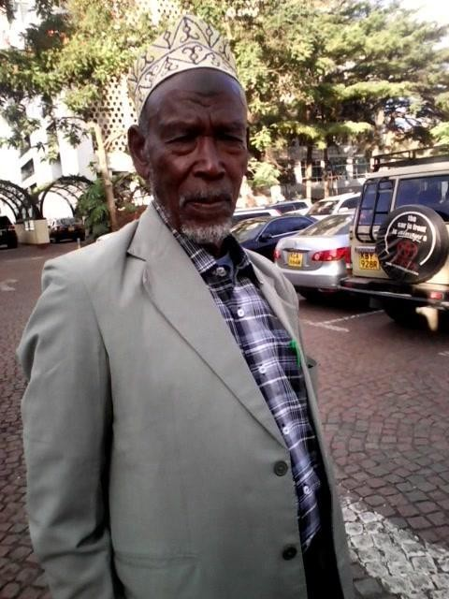
Plate 1b:Mr. Jarso Jillo popularly known as Councillor Yoyaa, formerly councilor of Sololo Ward 1992-2007.

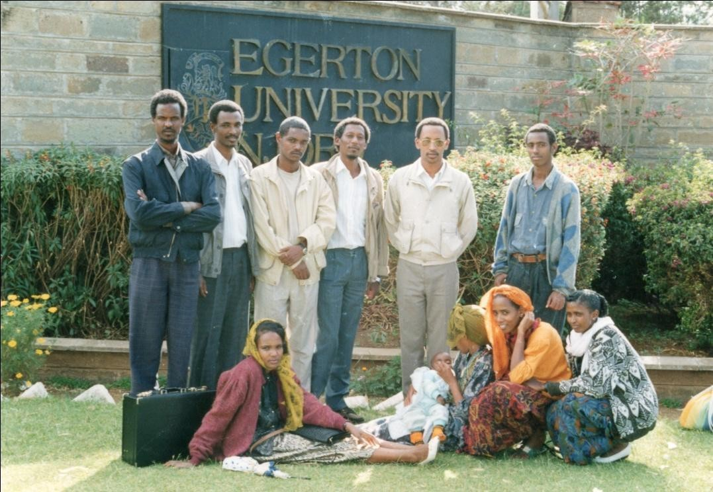

Plate 2: Some of the Karayyu clan elites who attended the 2001 meeting in Sololo. Some of them like Dr. Guracha (standing second left) and Mohamud Ali (standing last from left) joined active politics and became MP for Moyale (See plates 4 & 5).

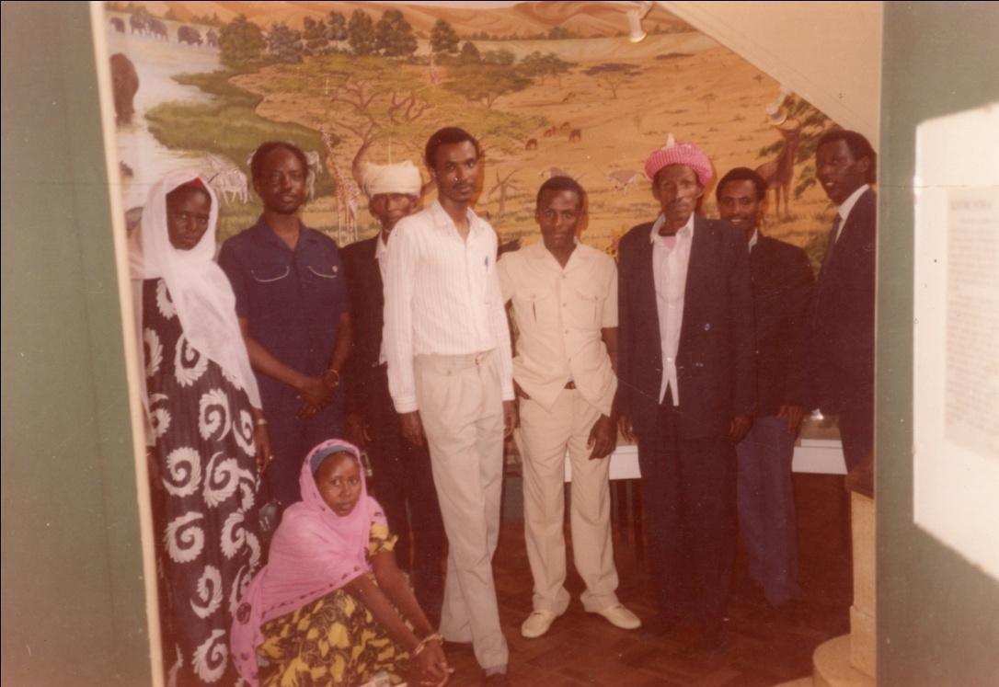
Plate 3: Hon. Philip Galma Godana (in blue Kaunda suit) MP Moyale 1988-1993 with Guracha Boru Galgallo (in white shirt sleeve) and others in a 1990 photograph taken at Parliament building.




Plate 4. Hon. Dr. Guracha Boru Galgalo, Moyale MP 1997-2006.

Plate 5. Hon. Mohamud M. Ali, MP Moyale 2007-2013.



Plate 6: Prof. Guyo with his campaign poster for 2017 general election spelling out the seat he will be vying for.

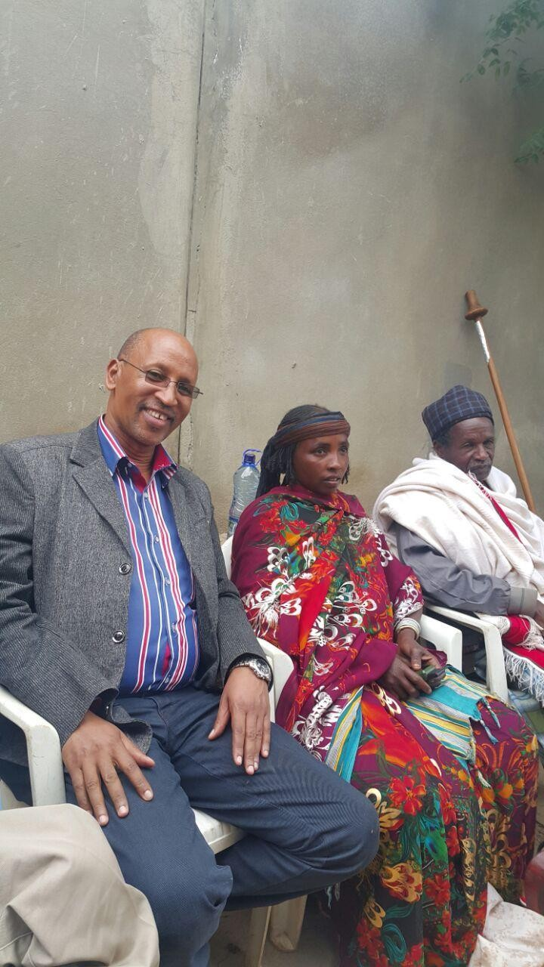

Plate 7: Prof. Guyo posing for a photograph with Qallu and Qaliti of Karayyu in May 2016. He won the Moyale MP seat in 2022.

CHAPTER TWO
THE BORANA CULTURE AND THE PERRFORMANCE OF QOOSA
This chapter traces, albeit briefly, the ethnographic profiles of the Borana community, and in so doing, sheds light on the contextual backdrop on which qoosa draws. As Cosentino (1982:12) remarks of the Mende oral tradition, qoosa is not merely a genre but a way of life that is embedded in the broader culture. The chapter addresses pertinent questions on the Borana social organization that impinges on the genre and brings to the reader’s perception the web of cultural intricacies whose understanding gives meaning to the qoosa texts.
Given the nature of the ethnographic data in question, an attempt of this kind is fraught with pitfalls. Not least among them is the problem of data management in view of its size and the limited space a study of this kind permits. The practical way of surmounting the problem of space is of course to selectively highlight only those features that are crucial for the understanding of the genre under study. But even this selectivity solves only half the problem, for the simple reason that the performers themselves do not limit the content of their performances, which essentially come with a wealth of cultural information, and metaphors that call to service adept knowledge of the culture. As Andrzejewski and Innes (1975) observe, the problem needs the harnessing of multiple disciplines for the creative artist draws on all areas of knowledge, which are now kept separate as compartmentalized disciplines. To express the latitude of his emotions, the oral poet draws on rich cultural repertoires, but they are esoteric. A fuller appreciation of the imagery needs recourse to the fine ingredients of that culture.
The second significant limitation is that of separating a cultural web into strands for the sake of easier understanding, which might result in the tendency of oversimplification to the extent that a wrong impression is created. This is in light of the complexity of, for instance, African lineage and clan systems whose study has been a great challenge to Africanist anthropologists and ethnographers. The field, to which this work belongs only marginally, has equally generated its own constellation of kinship terminologies, often an obstacle to understanding. These disclaimers notwithstanding, the section is a significantly integral part of the book and in no way has it gone out of its scope to focus on the heavy ethnographic details considered in some quarters as quaint and exotic, therefore irrelevant to the study of literature. It situates social performances like those Gluckman refers to as rituals of rebellion where:
Women have to assert license and dominance as against formal subordination to men, princes have to behave to the king as if they covet the throne, and subjects openly state their resentment to authority (1963:112).

One is dealing here with instances of institutionalized ambivalences depicted in a series of variant literary and ritual devices whose unraveling calls to service an array of culture-bound knowledge. The section then, though located outside the mainstream social anthropological discourse, draws on the same discourse to provide a basis for the understanding of what is basically an oral literature performance. It, however, makes no pretence at mapping out a complete Borana ethnography but rather reorients itself along the axis of social experiences that give qoosa its legitimacy and platform for comprehending its performance and meaning.
A predominantly pastoral people, the Borana live in southern Ethiopia and northern Kenya. Kassam (1985) distinguishes them by cattle herding activity in opposition to their neighbours, the Gabra, who specialize in camel husbandry. Pankhurst (1988) supports this position by the claim that cattle were not only the basis of their livelihood but also the object of emotional and ritual concern. Linguistically they are classified as speakers of eastern Cushitic

(Stroomer 1982, Andrzejeweski 1957, Hayward 1998) where the Borana dialect of Oromifa¹¹ is spoken. The Borana refer to themselves as the people of rabba-gada¹², a self-descriptive compound term that intimates the way in which the society is ordered functionally in its daily life. The system, as it is instituted and practiced, is all encompassing in that all Borana subscribe to its tenets in principle if not in practice, and consequently has been singly instrumental for producing a sense of Borananess.
The exact population of the Borana is not known but various sources put the figure from anything between 180,000 to 260,000 in combined total from Ethiopia and Kenya. Based on his 1952 research, Paul Baxter contends the number in Kenya could be 30,000 (1954: 45), and Asmarom Legesse (1973) estimates the population of Ethiopian Borana in the area of 150,000. Following Legesse, Kidane (1996:5) worked out an estimated population of 177,000 for the ones residing in Ethiopia. The much maligned, error-prone Kenyan population census of 1989 puts the Borana population in Kenya at 80,000, while the 2009 one gives a disputed figure of 161,000. These figures, apparently, are based on not very accurate information, and on the whole remain conjectural. However, what the demographic information conveys is that the Borana community is fairly small, with overt discernable features of homogeneity. The qoosa genre clearly displays this characteristic as the performers traverse the entire Boranaland from one end to another, thereby collapsing artistically the international boundary drawn by the colonialists that divided them into two. This adherence to a sense of oneness is symbolized by the wholesale recognition of their traditional leader, abba gada, (the leader of the particular gada system) far beyond his domicile in Liiban in southern Ethiopia.
The region the Borana occupy today is an expansive one that stretches from the Ganale River in the interior of Ethiopia, all the way into the vast northern Kenya districts whose southern most point is marked by Uaso Nyiro River. This region displays diverse geographical and climatic characteristics. In the north, the land is largely savannah grassland with the undulating plains of Diirre, which on average receive relatively ample rainfall. As one descends into Kenya, one is met by harsh climatic conditions. The average annual rainfall is 350mm and even that is unpredictable and erratic in nature (Oba 2001). The importance of the rainfall pattern is so pervasive in people’s lives that they are used as markers of events and calendar years. Expressions like oolla aduun dote (the drought of the eclipse of the sun) or agaya gabbo (the year of abundant short rain) are not uncommon in the historical time reckoning calendar of the Borana. The Borana themselves say that they reside in Diirre-Golbo (the plateau in Ethiopia and the lowlands of northern Kenya) and Saaku-Waaso (Marsabit and Isiolo Counties).
The place of origin of the Borana is still a subject of debate among historians and anthropologists (Goto 1972, Haberland 1963, Lewis 1962, Huntingford 1955). While some like Goto subscribe to the legend-supported contention that the Borana originated from a place called Tullu nam duri (the hill of ancient man), others like Huntingford suggest southern Somaliland as the probable place of origin. Haberland maintains the original home of the Borana was in northern Liiban where according to him they were driven by the Guji¹³

11
This is a recent reconstruction that succeeds the pejorative term Gallinna from the term Galla that has
been in usage in the literature on Borana and related peoples. See Legesse (1973), Cerruli (1922) Huntingford (1955). The term denotes the language spoken by Oromo.
12
This is a system dividing the community into hierarchical classes that wield power alternately after eight years. The system is peculiarly Borana although other Oromo groups practice some variant of it.
13

into Diirre region. Recent reconstruction that seem to have been influenced more by Oromo nationalism¹⁴ than empirical research postulates the view that Bale Goba was their likely cradle land. Oral sources that cite Borbor Bule, a renowned Borana oral historian and genealogist (Wako 1993:23) contend that led by a legendary figure call Abbai Babbo¹⁵, they conquered nine tribes (sidi saalaan) living in the area. Abbai Babbo conquered the people known as Daawe Goobo the original inhabitants of Diirre and incorporated them into the sodoom Boro (thirty Borana); the proto-Borana so called because of the ritualistic uses of the number thirty (Oba 1996). According to Oba (2000), the Borana or their ancestors known by the name Heero Abba Biyya were residents in their present territory earlier than the 13th century. Those clans that are direct descendants of the Heero Abba Biyya were the owners of wells and ritual lands. This has also been corroborated by Mohamed Hassen's historical treatise (1990) on Oromo migration, where he suggests through what he calls adoption (mogaasa), the Borana were able to successfully co-opt former enemies into its clan system. The proto-Borana could trace over 14 lineages before they could come to Oro, the presumed eponymous figure for the larger Oromo before the split into smaller autonomous groups. Oro appears to represent, what Kratz (1994) in connection with the Okiek refer to as the “Then” of the Borana community, a time nostalgically recounted when they had common ancestry and tended their cattle in an atmosphere of tranquility and peace. Oral sources seem to suggest not one monolithic people called the Borana but a people who conquered and absorbed the political foes defeated in warfare as evinced in the names of some of their earlier leaders. The eminent Oromo historian, Mohamed Hassen, is even more categorical as he emphasizes the point with historical hindsight:
There is no such thing as pure Oromo tribe derived from a single founding father. The history of the Oromo people is a story of fusion and interaction by which all tribes and groups had altered and been transformed constantly (1990:4).

Baxter illustrates the truth of this claim by ethnographic observation uniting the many Oromo societies:
Arssi (Arussi) is the overall name taken by the several million-strong Oromo group whose territories extend from the Rift Valley to the Bale-Ogaden boundary. Among the Borana, the Arssi are one of the clans of the Gona exogamous moiety. Among the neighboring Gabra, they are a subclan of the Algana phratry. Karaiyu is the name of the largest clan of the Sabho moiety of the Borana. It is also the name of the camel-herding tribe living along the Awash, and of a Guji subclan (1994:177).

The majority of the Borana do not subscribe to Islam and Christianity, two religions that sought to evangelize them in the 20th century. However a few people in the urban and peri-urban centers became converts, more in response to the exigencies of the modern world than the appeals of the faith. Those who attended missionary-run schools succumbed to the conditionality of their new benefactors and were christened accordingly. Islam entrenched

This is a tall dark Oromo-speaking people to the north of the Borana. They have been arch-enemies of the Borana for a long time. Sometimes referred to in the literature as Janjamtu or Gugi, see Baxter (1954), they are notorious for raiding Borana settlements in their proximity. One such raid was reported by Legesse (1973) where the Qaalu (spiritual leader) of Oditu clan, Tuto Anna, was slain and his official regalia taken as war bounty. According to Baxter (1954) the raid took place in 1946.
14
See for example Schlee and Shongolo (1998) “The Poetics of Jarso Waqo” where oral poems and songs promoting Oromo nationalism are discussed in full.
15
The Abbai Babbo myth has also been collected and analyzed by Andrzejewski in a monograph, “Some Dialects of Galla and Borana” (1962). Through the use of occult science (tolcha) Abbai Baabo defeated the Borana nemesis in war and reclaimed their land, Diirre, for the Borana. Such displaced peoples are the Warday, now residing in the Tana River district of Kenya, and other defunct communities like the Hamaresa and Daawe Goobo.

itself in a similar way, especially in Waaso and Moyale. However it is worth noting that the line between conversion and conformity to the indigenous religious practices, like everything else, remain rather porous and permeable. For example, reporting on the state of affairs about Islam among the Waaso Borana fifty years ago, Baxter underscored what to him was the tendency of the Borana to abandon their tradition of gada and be “Somalianised” by adopting an Islamic religion that is a poor version of Somali culture. But the reasons that made Islam attractive to them have undergone tremendous change. Then, the young and well to do were attracted because the religion appeared to have elements of modernity through dress styles and generally exhibited features of cleanliness. The faithful are forbidden to consume unclean food like the meat of animals not slaughtered by them. The edict of praying five times a day required one to be neat too. The wealthy senior chief Galma Dido even traveled to Mecca and acquired the title Hajj before he was slain together with the first Borana District Commissioner in colonial history, Mr. David Dabasso Wabera in 1963 over their opposition to the Somali demands that the northern Kenya secede to the Somali Republic at the onset of Kenya’s independence. This event angered the Borana for what they saw as duplicity and trickery on the part of the Somali who are seen to preach Islamic brotherhood on the one hand, while executing the murder of their leaders, on the other. Many people backtracked; citing this and other reasons such as Islam’s derogation of the status of their gada system, which has been at the center of their social and moral universe.
Even stranger is the situation as it is today when the Borana, tired of the Somali encroachment in their land and lives, decided to practice their own form of Islam, which is a syncretism of gada and orthodox Islam. Today, the Borana not only go to Mecca in relatively large numbers but also participate in gada rituals as well, which they perceive, help in enhancing their victory over the Somali in warfare. It is in this same respect that in 1999 the youth and learned Borana working in government and plum nongovernmental organizations sponsored the introduction of Gumi Waaso¹⁶, to all intent and purposes an exercise in cultural revival.
In general the more remote areas especially in Ethiopia managed to hold on to their indigenous form of worship, but even there the practice slipped away as soon as they moved to town particularly in times of disastrous drought and famine. It is to waaqa¹⁷ the practical rituals and supplications are directed. This again is not unaffected by external sources, namely the ayyana cult. Andrzejewski (1972) has recorded and analyzed the texts of this cult and concludes that the movement was a splinter of the Sufi Muslim which, led by sheikh Hussein of Bale came amidst the Borana during the 1880s. Although the cult leaders were men, it commanded large following from women who were probably attracted because of its extensive use of the song medium. According to an informant, Jillo Waqo, who himself practices ayyana healing, the participants have interests that surpass the spiritual needs such as sexual gratification and entertainment in the form of emotional release.
As a healing cult ayyana drew its followers mainly from people who are either afflicted or whose kin are in need of the healing powers of its priests. The popularity it enjoys among the women is matched equally by strong resentment from most men who are often skeptical

16
Fashioned along an existing gada institution called Gumi Gayo, the purpose was to draw on the latter
and bring the Waaso people together under a cultural umbrella in which shall be vested powers to decide on behalf of the community in matters of grazing, water and security concerns. For more information on Gumi Gayo, see Shongollo (1994).
17
The name by which god is known in Borana. Conceptually waaqa is enormous, endless and omnipresent and is symbolized in the sky.

about the purported efficacy of the cult and this antipathy has often been a source of friction in conjugal relations. In qoosa it has been one of most articulated themes used to ridicule women and their phony worlds in the perception of the performers. Creatively waaqa and the abstract idea it stands for is mediated by ayyana and it is not infrequent that the two operate in the minds of people as synonymous. The former is embodied and symbolized in the sky, a practice that has led the likes of Andrzejewski (1957) to infer that the Borana regard the sky as a god. Myth has it that in the past god was near to the people although poised above them. This close proximity was interrupted by women who hit him with pestles as they pound maize, and by the notorious kicks from the mule. God decided to move up out of reach of the nuisances of the two but not before he curses them, reminiscent of the biblical tradition; the woman to feel pain in birth and the mule never to give birth at all. The value of this myth lies in its etiological mould, which offers reasons for the predicaments of the mule and the woman in sterility or birth.
The Borana maintain their social order and lead their political life by a system known as gada, a topic that has attracted much attention from anthropologists. Pioneers in this enterprise are Baxter (1954, 1978), Haberland (1963), Legesse (1973), and Bassi (1999). An indigenous system that defies direct translation, gada involves strict observances of elaborate rituals that essentially locate individuals and the society at large within its structural paradigm of lubba (class), gogesa (patriclass), and hariya (age-set). Clearly, Legesse's book by the title, Gada, makes a profound claim for gada as a system of classes that succeeds one another every eight years in assuming military, economic, political and ritual responsibilities (1973:8). But his contemporary, Paul Baxter, refutes this grand claim. Baxter is rather skeptical, perceiving gada as “a clever philosophical working model, but a folk model, representing what ought to be rather than what is” (1978:153-4). Reputed as having been initiated by a man called Gadayo Galgallo, gada at least in myth, was created to restore order in a situation rife with social chaos. In fact, at a literal level, gada loosely implies reign. This is because the Borana use it as a time reckoning device and as Legesse reports they mark the passage of time ritualistically rather than arithmetically (1973:129).
All events are associated with the gada of the leader in power at the particular period when the event took place, and the holder of the office is referred to as abba gada (father of the reign). The system is such that it has five strands called gogesa lubba into which all members of the community are divided. This cuts across clan and age and is normally ascribed at birth following automatically from the father's lubba. In short, the father and the son are in the same gogesa but different lubba. In lay language gogesa denotes a single line and lubba is a successive point on the line. People of the same lubba are said to be friends (jaal) and call each other so even when they are not actually friends.
The members of the same lubba come together at some stages of their ritual life especially during kuusa (youth reconstituting in readiness for initiation) and gadamoji (elders performing the ritual of retirement). It is during this reconstituting stage that youths visit the huts of their fathers for feast (nyaachisa). As a group, they engage in aesthetically rich songs of praise to the ‘fathers’ who hosted them well, and condemn via the same medium the stinginess of some of the ‘fathers’ whose generosity was found to be below their economic means. The ‘fathers’ are socially designated as such by dint of the lubba social class where it is the principle of fatherhood rather than the practice that primarily informs the relationships, so that in some cases the so-called fathers have sons only at a symbolic level.
During this period, like the members of the age-set, they live and act together exclusively, treating non-members to mischievous bullying. The gadamoji village, essentially a settlement designed for the purposes of ritual, stands in a privileged stead in the community. Not least

among these privileges is the convention of joking at the expense of non-members of the village especially by their haughty women who are only too willing to put the men to shame. Stories are related, as evidence of their truancy, of men who are tied to poles and made to consume inordinate quantities of food, water or milk. So engrossed are they in their expensive jokes that at times they even rape or attempt to rape such men for sheer amusement as they are licensed by the solemnity of the ritual. The men, for their part engage in creating vituperative insults to the alternate kuusa, directing them to their mothers and implicating them in incestuous relationships.
An important facet of gada is its positional relation vis-à-vis the immediately preceding gada. They compete for recognition in a fairly overt way and distinctly regard each other as rivals. The gada leader endeavors to surpass his predecessors in achieving prosperous life such as peace, victory in war, plenty of rain and absence of strife for the community under his charge. As his son’s ascendance to the gada leadership is entirely dependant on his performance during his tenure as abba gada, in these matters, he attempts to ameliorate Borana social and political condition beyond the dreams of his predecessors. It is in this regard that as long ago as 1589, Bahrey¹⁸ attributed the success of Oromo expansionism to the gada system where lubba warriors extended the frontiers of Borana territory at the expense of their neighbors. Members of the lubba were the standing army of the particular gada in power then, and they were often called upon to strengthen their leader’s position. This element of contest in gada is played out at all levels as evinced by the leaders who during the gada power transition, engage in mock fights that entail the chasing of an ostrich on horseback to obtain its feathers as symbolic insignia of power.
The Borana are organized around a distinct age-set system, hariya. The system, which is pivoted on the ethos of equality, shares a number of features with the age-set systems of East African pastoral communities (Oba 2017). Spencer (1965) writing on the Samburu observes that members of an age-set are not merely equals, but are also expected to maintain certain norms of behaviour, which derive from and express joint membership. The same theme of equality is underscored by Evans-Pritchard (1940) regarding the Nuer where he states that the system is marked by the notions of seniority, equality, and juniority. Members of the same age-set relate to one another on equal terms, while respect is accorded to the senior members. Bernadi’s (1952) comment on the Turkana echoes much the same observation, but goes a step further to emphasize the unity and brotherhood of all members. Almagor’s (1978) study on the Dasnatch of Southwestern Ethiopia reveals that a man is accompanied by his age-peers at all the major rites of his life and the age-set becomes for him a pillar on which he draws social and political support. Some scholars like Huntingford (1950) argue that the age-system of the Nilo-Hamitic peoples derives directly from gada system of the Galla, best represented by the Borana, but whether this contention is correct is a point of conjecture. As Aguilar (1998:14) suggests, the Borana age-set is a group of cohorts who have been perceived as joining the same group, exercising obligations towards each other under a particular age-set name usually associated with a leader. In all, the motif of equality with and obligation to members is underscored, but a significant feature where age-set becomes an arena for competitive interaction, which forms in the case of the Borana, reasons for qoosa amongst them, is treated with levity.
For the Borana age-set, naming is an elaborate rite of passage known as chiina, literally end, marking the end of adolescent years. In this ritual, age mates who for the most part of four

18
A priest who recorded the Oromo invasion of Christian Ahmara kingdom, quoted from Some Records
of Ethiopia, translated by Huntingford, 1957.

years have been together, gather under a chosen tree on a propitious day. While here, they await the pronouncement that shall make one of them a leader or a sacrificial figure. The unfortunate member is converted through a series of acts of sorcery into a demented figure, bearing henceforth the possible ill fortunes of the age-set for life. The pronouncement of the latter is fraught with contest and danger since the person so named is required to shed blood to subvert the full implications of his newly acquired status. To be thus pronounced as saa gaara, “the cow of luck”, in contrast to hayyu gaara, “the leader with luck”, emasculates and feminizes the man. He is henceforth, automatically excluded from hunting and raiding, two indices of manhood in the Borana community.
For our purposes, the key thing to note is the implication of the ritual for the individual and how it affects his life. The whole process is tension filled, and to diffuse the tension members resort to play, culminating in qoosa among them. However the practice has recently been rescinded for its repugnance to good order, although the language still lingers on. Even for the position of hayyu hariya (leader of age-set), Tagawa (1997:627) observes that people do not want the responsibility because the Borana believe that the hayyu might be met with serious misfortune. All age-sets are named either Dambala or Wakora, followed by the name of the chosen leader. Thus Wakora Sora, Dambala Duba, Wakora Guyo, Dambala Dida are the last four age-sets in the last thirty two years, where each is constituted and named in the eight year period of gada cycle. Adult males belong to an age-set named after one of their members. Married women, who as a rule do not have an age-set of their own, automatically subsume that of their husbands irrespective of their actual age (Legesse 1973).

It is within this age system that life's daily discourses are carried out and made manifest. One is immediately struck by how interpersonal interactions, hunting, cattle raiding, challenges, contests and marriages are organized around the conventions of age-set. When boys attain the ages of 16-20, they come together in what is called cooqorsa gudunfa (the tying of a cooqorsa [a species of grass] knot), from thence they become a corporate group. The ijjoole kuuchuu (youth's gathering) as the group is generally known, has its own conventions, some of which are wantonly permissive regarding their behaviour towards women. As young adolescents, the stage marks for them their first opportunity to flirt with married women, and perhaps acquire sexual exposure. They are in some way venerated, referred to with the idiom that implies their unity, like a swarm of bees (tuuta), and caution is exercised in matters that might slight them. They take advantage of this social complacence and with adolescent desires engage in ever more liberal ventures.
More significantly, their preoccupation with women is apparent in songs, whose predominant themes are praise of women, interspersed with an occasional chiding of those who insulted the age-set. This is exacerbated even more when the immediate hariya before them bully and tease them into praising an unwieldy number of women of their age-set. Apart from the song tradition, they also perform games and contests that are physical and verbal. As they engage in wrestling, racing, spear-throwing and verbal dueling, in what is called arraaba ilmaan dhiira (insult of male youths), a culture of contests begins to emerge and take root. Not only are they companions with an aura of comradeship around them, but they are also contestants who must answer to the challenges of their peers at personal levels.
One such culture of play and joking is that of nicknaming. The age-set has remarkably creative names for their peers which are either descriptive epithets referring to the physical attributes of the person so named, or reflective of biographical facts in the life of such a person. While some of the names are rarely used beyond the circle of close friends of a person, others gain a wider currency and even eclipse the given proper names. During the fieldwork, I observed elders whose personal names are in fact effaced and have come to be

known by their nicknames, although social decorum discourages the use of these names by younger members of the society. In Sololo, names like Guyo Boku (Guyo the club), Bonne Baala (Bonaya the blind), and Jibicho (The bullock) are freely used by people who are much younger, since these nicknames have commonly replaced the proper names of their owners.
The age-set is an important site for inculcating the social ethos, particularly those relating to sex and marriage. The youngsters hang out together for company and comfort and frequently solicit the company of women for sexual gratification. In this connection, Legesse (1973) observes that the Borana make it easy for married couples to maintain legitimate extramarital sexual relationships and that it is very common for married women to have fairly well advertised lovers. He suggests that husbands acquiesce to these apparent anomalous liaisons because they are involved with a similar relationship with other women. He further argues that marriage among the Borana is more out of the desire to have children and acquire social prestige than for love. In his view, the mistress relationship is the society’s way of filling the void created by the lackluster marriage.
While Legesse’s observation may in a certain respect be true, it ignores the majority of the cases where husbands dissent from such practices. The literature seems to cheapen the practice as a norm rather than an anomaly, which is what it is. In the first place, most of the relationships are discrete, and if they come into the open, the involved parties are subjected to sharp reprimand. An informant, Koroma Wario Bante, maintains the Borana lessen the effect of adulterous relationship by converting the offence into a fine paid in the form of cattle. According to him, there is no seera (customary law) that permits people to engage in extramarital sex but once it occurs, the community in its wisdom devises rhetoric that downplays the effect of an otherwise serious matter by making the offended party accept a fine for the offence. That the society forestalls the gravity of the practice without resorting to severe measures like divorce or even death for the persons involved does not legitimize the extramarital affair. It just falls within the general disposition that the Borana have a fairly well organized diplomatic way of going about the problems that beset them. This is through speech; for they have a philosophy that nothing may surpass negotiation by elders who sit together to right a wrong. The latter consider themselves the repository of social mores and experienced handlers of cases that might appear nasty and difficult to resolve. Qoosa amongst the age-set, in addition to other themes, largely take the shape of ridiculing the ugliness of one’s woman friend, the inability of the man to observe discreteness when it is called for, and the breach of rules of social relations such as clan affiliations.
Because the fieldwork is largely based in Sololo and the surrounding areas, it is important that some of the characteristics of the people and the place as a window through which the texts and performances may be viewed are outlined. What is today known as Sololo District took its name from the root word solool, a word that indicates the nature of settlement where continous chains of houses in an unbroken manner are clustered together. Sometimes the place is referred to as Ramata, this latter name describing the loose soil texture. Although these were localized places, the name Sololo has now come to stand for the entire District engulfing Uran, Golole, Anona, Mado Adi, Dambaala Fachana, and the surrounding areas

lying south of them stretching towards Saaku and Waaso. This whole area was previously known as Obbu, and the people called Obbitu. The name Obbu derives from the word obb that means bush, scrubland, and an expressly geographical phenomenon that contrasts the place with wetlands or mountainous areas. According to informants, the well-known Obbitu were primarily the Dhanqa subclan of the larger Karayyu clan led by Diido Duba. Legendary stories supportive of Dhanqa’s occupation of Obbu are told that confirm Diido’s power and influence over the residences of Obbu. The wielding of power at regional levels was not confined to Diido alone, for in Borana certain regions were known to have been ruled over by certain powerful clans and families. For example, the Warjidda clan was the most influential in the Diirre and Tuuqa regions, while the Nonitu clan was known for their influence in the region called Waayama, in the vicinity of today’s Wajir, Buna and Batalu areas which has since come under heavy invasion from the Somali. Other well known families that can be regarded as Obbitu are that of Nyencoo Jatani, the sons of Sanqe Roobale, Qaalla Jillo Ajaa, Guyo Katello, Huqa Kandhoo, the sons of Quyyu whose progenies are Kontoma Roba, the sons of Jatani Jalla, and Halake Galgallo. The renowned leaders of the Obbu Borana in the precolonial days were Dido Duba and Jaldesa Jarso. During the colonial times they were Chief Galgallo Mudaale and Chief Galgallo Matoye and in the postcolonial era they were Chief Huqa Guleid, Chief Jatani Kotote, and Councillors Galgalo Wario, Waqo Gedo and Jaldesa Boru Elema.

During the colonial days there were a number of world events that had destabilized the Obbu Borana that deserve mention here because of the way they have shaped the destiny of people. One of these is the First World War where the Borana were caught between the British in Kenya and the Italians in Ethiopia. Most of the Obbu people fled the war prone border of Kenya and Ethiopia where Obbu was located. As Oba (2000) tells us, under the guidance of Galgallo Mudaale, a section of the Obbu Borana fled to Saaku. However, some of the Obbu

residents migrated to the sheltered hilly regions, which were in close proximity, such as Googe and Bubbe. Although they returned to their original residence after the defeat of the Italians, the region was never without small-scale wars and raids occasioned by defeated heavily-armed Italian soldiers who had turned themselves into armed bandits (Oba, 2013).

Another international event that affected the Obbu Borana was the Somali clamour for secession to become the Republic of Somalia about the time of Kenya’s independence in 1963. In their bid to garner support for their secessionist agenda, Somali tribes backed by the government in Mogadisho waged war against those opposed to them. Of the then six Northern Frontier Districts popularly known as NFD, only the districts predominantly occupied by the Borana opposed the seccession (Whittaker 2014). Between 1965 and 1967 therefore, the Obbu area reeled under the fighting instigated by the Somali armed groups. For purposes of security, the Kenya government confined the Obbu Borana into one major settlement area at a place call Dhadach Korma in Sololo. This was the birth of present Sololo Town and henceforth people began to build semi-permanent structures and sent their children to school in large numbers.

Situated some five kilometers from the boundary of Kenya and Ethiopia at the foot of Aabo escarpment over which the border passes (see plate 7), Sololo District perhaps appears to be a kind of conduit between Ethiopia and Kenya. It is able to benefit from whatever little that seeps from the Kenyan side in the form of modernity, while drinking from the fountain of tradition owing to its relative proximity to Diirre and Liiban Borana in Ethiopia. The latter two are quintessential in cultural matters, being the faithful upholder of the tenets of gada earlier described. On this account, the Borana believe that as long as some Borana people perform the ritual on behalf of the larger community, those who are far away would benefit even if they could not carry out the rituals themselves. Sololo is also equidistant between the

Waaso Borana (less keen on the cultural rituals partly because of the distance and partly because of the Islamic influence), and the Diirre and Liiban people whose lives are enormously dependent on the performance of these rituals.

Regarding modern amenities and infrastructure, Sololo boasts a number of primary schools, a secondary school, a missionary-run hospital, a police post, a post office, a District Commissioner’s office and more recently a five kilometer tarmac road diversion from the Nairobi Addis Ababa International highway. The schools, the earliest of which were started in the 1960s, have been instrumental in changing the lifestyles of the pastoral community. Encouraged by the government policy of basic education for all and coerced by local leaders on the ground, Sololo people took formal education seriously and sent their children to school in relatively large numbers. The children were drawn from all the locations in the District as well as from the Ethiopian side. Some of them resided with their clansmen, relatives and if lucky enough secured the few boarding places in the schools, thanks to Sololo Catholic Mission and the government of Kenya. These amenities in the form of school and hospital, in addition to the changing pastoral lifestyle in Sololo, have largely been responsible for the constant interactions between the Borana on both sides of the border.
Coupled with the foregoing, the daily routines of survival where petty trade and animal husbandry bring people together in never-ending chores perpetuated a fairly uniform cultural intercourse. Thus a pattern of migration following the availability of rain in a normally dry region develops that does not respect the boundary either way. In this way, the tradition of creativity in oral literary genres is shared, to a great extent across the length and breath of Boranaland. This pattern of migration not only brings the Borana from across the borders together, but also makes encounters with other neighbouring communities with the Borana where cultural practices were exchanged, possible. An obvious example of such an exchange was the borrowing of sarki from the Garri¹⁹ and rendilich from the Rendille²⁰ by Borana youths who tend cattle in close proximity to these communities. Sarki is marked by intense hand clapping, jumping and stamping with one’s foot to create a rhythm, while the rendilich entails an aesthetic neck dance common amongst the Samburu and the Maasai of East Africa. Other kinds of unanticipated encounters with communities far removed were to develop later with the onset of Kenyan independence and in response to the exigencies of the unsuitability of pastoralism owing to the vagaries of weather patterns. This took the form of exploring other avenues in the wider country as an alternative to the tradition of cattle herding and the confinement to Boranaland.

Cattle-keeping is the economic mainstay of the Borana of Sololo as elsewhere, although in recent times, there are fairly remarkable attempts at diversification. This is in view of the frequent droughts, which have decimated cattle en masse, making the once proud pastoralists fend for themselves, hiring their labour in casual jobs in urban centers. Richard Hogg (1988) Gudrun Dahl (1978) and Andre Hjort (1978) have written superbly on this aspect of Borana lives taking Isiolo district as a case study. The predominant theme in the studies is that of

19
A group related to the Somali but speaking a dialect of Borana language. They keep camels, have
wholly embraced Islam and frequently engage in warfare with the Borana.
20
According Schlee (1986), they are a Somali-loid people who have been influenced by their Samburu neighbours. For the nature of this influence see Paul Spencer, Nomads in Alliance, (1978).

adaptation to a new economic engagement in the face of new realities. Small scale arable farming on the Uaso Nyiro River, to a people who have traditionally perceived the tilling of land as taboo, is reported as a coping strategy. The sporadic farming to subsidize pastoralism among the Borana is no longer unique to Isiolo and has in fact taken root as dependence on cattle become more and more unreliable. This is true for Sololo where subsistence on pure pastoralism has been found insufficient hence people have resorted to tilling small farms and engaging in wage labour for survival.
Since the 1970s, then, the Borana of Sololo has been displaced and quite a sizeable number are living in small colonies in the slums of Nairobi. The urban Borana are referred to as Borana Dirra, which literally means ‘the Borana of the townships’ (Arero 2007:294). Nairobi and other urban centers have somewhat been transformed into havens for the Sololo people who, ravaged by the successive droughts of 1973, 1984, and 1991, fled their homes in search of menial jobs to salvage their dependents. There has consequently been constant human traffic between the Nairobi slums and the Borana indigenous homelands of Isiolo, Marsabit, Moyale, and Sololo and even far into Ethiopia, of people who come and go either on leave or for good. These are replaced by fresh arrivals that are initially taken into the fold of their kinsmen as they search for jobs in the city with the assistance of old guards, derisively referred to as tenne²¹. The urban situation necessarily brings them closer to other communities and situations hitherto alien to them, which usually forms the basis of jokes among peers, especially the tendency to consort with Bantu communities such as the Kikuyu and their Nilotic counterpart, the Luo. Qoosa genre responds to the new situation by incorporating it into its structural corpus. Humour acts as a double-edged sword being used for collaboration and inclusion, and collusion and exclusion (Rogers-Revell 2007).
The urban influence notwithstanding, the majority of those who leave for Nairobi in search of wage labour do in fact go back temporarily or permanently to perform socially required rituals such as marriage, child naming, circumcision, and participation in gadamoji ceremonies. In short, the Sololo people could still be regarded as practitioners of aada Borana (Borana culture/custom) in spite of the prevailing pressures of social change in the modern world, some inimical to “heathen ritual” practices. Kassam (1999) recorded and analysed a gadamojji ritual that was held in Sololo area, specifically at a place called Wayye Diida in June 1995, where this author’s parents participated (see plate 11). Held in other designated areas among the Borana in Ethiopia too, the ceremony was a celebration of gada at which the elders shave their hair as a symbolic gesture of retirement from active public life.
Along with gada ceremonies mentioned above, the child naming ceremonies and the sacrifice of he-goat ritual by an age-set at some distant village or other where people gather and entertain themselves with assortment of song traditions, serve to add colour to what would otherwise appear an ordinary mundane life. These are occasions of festivity attended by people from far and near to celebrate their lives in songs, dance, and verbal utterances where poetry in a broader sense is rewoven to give expression to their joys, anxieties and experiences. It is a moment where the community creates and reiterates its identity, as Myerhoff (1979) writes, by telling itself a story about itself. As Victor Turner (1986:40) elaborates in another context, the occasion is marked by the group taking stock of their current situation: the nature of their social ties, the power of their symbols, and the effectiveness of their social and moral controls.

21
The term is a corruption of the word ten. It is used as a derogative term for the people of Borana
descent who have stayed more than ten years in Nairobi and other towns without going back to the Boranaland.

Performances of song and dance in Borana like many spheres of their social lives are based largely on age and gender. Thus the men, the women, the adolescent boys and the girls congregate on the occasion at different sites, and as Drew would put it, “ to reflect on their current conditions, define or reinvent themselves in social worlds and either re-enforce, resist or subvert prevailing social order” (1991:2). Here qoosa, along with other artistic mediums, provides the means for these expressions. As a genre with both personal and social characteristics, qoosa’s rendition is not confined to these occasions. The meetings of individuals who normally share jokes at clan, and age categories provide a fortuitous reason for engaging in jocular verbal exchanges as a mark of friendship or opportune moment to comment on some incident at the expense of the other.
As a genre that is primarily concerned with joking among peers, age-set qoosa serves to cement friendship between the performers. Indeed, age-set qoosa exists among friends with commonly shared lived experiences, and who, drawing on these experiences, truthfully speak about a person, although exaggerations and hyperbolic extensions are expected and tolerated.
Let me give an example. Throughout the fieldwork, I witnessed that the composers of age-set qoosa are paired as age mates and as friends. Mr. Dima Jillo is a friend and age-set of co-performer of Mr. Roba Halake, Mr. Jillo Guyo is an age mate and an intimate friend of Mr. Sora Otoba and Mr. Boru Guyo is a performing pair with Mr. Abdub Galgallo as well as an age mate. In the majority of cases, these people grew up together, tended calves and cattle together, wrestled during childhood, as well as exchanged the verbal insult called arraab ilman dhira (insult among the male youths). In their adolescent years, they were circumcised together, hung out together attending kussoma adventures, and later in their adult lives hunted, raided and wooed women together. For some, they worked together as night guards or farmhands in Nairobi, all of which goes to show their cordial relationships. Qoosa that they utter about one another are drawn from these experiences and depicts true histories of their lives. New events in the lives of a performing pair that in the estimation of his peer merits mockery is added to the repertoire of the age mate and creatively used against him. Over years they have rejoiced together, shared sad moments, quarreled, reconciled, exchanged gifts, and shared secrets on many occasions. Through these prolonged years of living together, they have become a kind of double for one another. In a way, one serves as mirror for the other and vice versa, which brings us to the second function of age-set qoosa.
Age-set qoosa draws one’s attention to issues that have escaped one’s knowledge, and in this sense serves as a moment of learning and revelation. In a qoosa exchange, the joke recipient is normally asked to confirm or deny what was said about him. To one such question, Mr. Dima Jillo answered, “I am not aware of this, let me check my facts”, when it was mockingly alleged his wife left him for a much younger man. As a critical discourse, it gives an individual a glimpse of how others view him. Reflexively, the joke recipient is made to re-examine his moral and social standing because members point out through play, some of his weaknesses. Age-set qoosa then is a stinging criticism among other things that men strive to avoid by conforming to the socially accepted codes, and as Bourdieu (1977:161) tells us, this is fundamentally a question of respecting rhythms, not falling out of line. As a critical tool, age-set qoosa is a means of rating individuals because the disparaging epithets are evaluative in nature.
Thirdly age-set qoosa, needless to say, is a means of entertainment both for the society and the performers. At the end of it all, it is laughter that reigns, the ambiguous laughter that Bakhtin (1968) ascribes to folk society. In the most part, it is not so much that a person is laughed at, but rather it is the way in which the joke is packaged that elicits laughter. The

laughter from the audience may not always be interpretable as a shame-on-you-type. On the contrary, such laughter is that which comes with the fact that something aesthetically appealing has been said. This is because it is not news, for instance, that someone has an ugly mistress, or was caught by a jealous husband. These facts the audience knows already. What is news is the way that information has creatively been captured and stylized to become a poetic joke, rather than merely being a shame inducing utterance in the form of gossip.

Lastly the performance and composition of age-set qoosa serves as an avenue for sharpening wit and fostering competence in the artful use of language. As Andrzejewski & Lewis (1964:43-44) contend with regard to the Somali, listening to poetry is not only an artistic pleasure, but provides them with the fascinating intellectual exercise of decoding the veiled speech of the poet’s message. An excellent qoosa performer earns himself the honorific title of naam afaan aamaa. This literally means ‘one with sharp language’, implying the person speaks well and composes poetic texts in extraordinary ways. In evaluative terms such a person is regarded as qaaro, sharp, as opposed to duuda, dumb, blunt or tongue-tied.
In addition to the entertainment and the sharpening of wit, functions that are shared with the age-set qoosa outlined above, qoosa among the clans serves certain other special functions unique to itself. One such function is that of settling cases across the clans, a fact to which the performance by Councillor Jarso cited at the beginning of this book bears testimony. Although in the case of the Councillor, because of his politically vested interest, his intervention was not taken for its words, in most instances known difficult cases are settled by joking partners clan’s intervention. Even in the case cited it must be acknowledged that his utterance diffused the overtly simmering tensions between the different opponents and proponents of the Member of Parliament in question. Jarso was able to do this because the clan qoosa has a special way of appealing to the emotions and intellect of the people addressed, and because of its touching nature the combatants more often soften their stance. If for example, the problem is internal to the clan as was the case the Councillor had come to address, the speaker speaks in such a way that he inflates the egos of the warring parties first by justifying their positions and then deflates them by appealing to their sense of reason and belongingness. In the case of the Member of Parliament who was besieged by his own clan, the speaker prefaces his speech in this way before making the appeal, which in the first place was his intention. He couches his approach in a logic, which says that, if, you the clan members are destroying the political career of one of your own, whom do you expect to build it? He plays the negotiator, the one who arbitrates between the litigants.
Qoosa among the clan is able to do this because the society has granted it this special privilege where truth spoken in this performative act is taken for what it is and in most cases serve to end the matter there and then. In other instances, such as when a father of a girl becomes difficult in refusing to grant the permission to allow for marriage, a renowned clan qoosa specialist will confront him. He would tease him, taunting the father whether he wanted to marry the girl himself. The cardinal thing clan qoosa does is to appeal to the person(s) to rise above pettiness for the sake of good social order. In this way, the clan qoosa serves as an instrument of moral guidance. Even the more atavistic direct mockery between clans prevalent during naming ceremonies, commonly serves didactic purposes. When joking partner clans are chided for the waywardness of their members by indulgent behaviour considered socially immoral, the publicizing of their act is generally meant to set them back on course and deter others from the folly of such actions.
For the members, the clan qoosa serves to unify them as one group who are united in defending themselves against ill-intentioned allegations from external sources. In some cases the singer/jester of clan qoosa directly takes on a joking partner as one who touched our

people (waar keena geete). The clan qoosa thus from the point of view of the members, serves to protect, defend, the members from the verbal attack of other joking partner clans. In the performances of it at jilla, there is therefore a clear distinction where sides are taken, allegation made and refuted, and people stand up in the service of their clans. Yet even as there are contest and competition amongst the clans, the interaction in its ambivalence fosters friendship. As Clifford Geertz (1975:416) says in another context, to be teased is to be accepted.
Since both men and women qoosa are performed in the majority of cases at jilla,(ceremony) the sub-genre takes away the formal atmosphere that usually informs their relationships and creates an atmosphere of equality where jokes can be shared. Moreover, qoosa among the men and women is a way of looking beyond the male-female barrier and seeing one another as people with shortcomings. These shortcomings are shared in a public arena, dramatized, and exaggerated in order that they become repulsive and are avoided.

Qoosa between these two categories generally involve comments on the behaviours of men and women and what each finds wrong with the other. The men are called upon to be proper men, which in the perception of the women performers is clear. Effeminate, quarrelsome, greedy, mean, and stingy men are detested, as masculine, lazy, scruffy, and greedy women are demeaned. By creating acceptable/unacceptable limits for each other, men and women are living by a social code to which they conform. Qoosa then invites members to reassess their actions and behaviours and it is through this reassessment that social cohesion and morality are cultivated and upheld. Being a critical discourse, the genre is used to probe the various segments of society. For the women, it is the much-needed voice of speaking with their own tongue in public outside the confinement to the privacy of their own homes. Although it does not in reality overthrow men, it serves to shame them by disdainfully publicizing their behaviours within the domestic sphere.

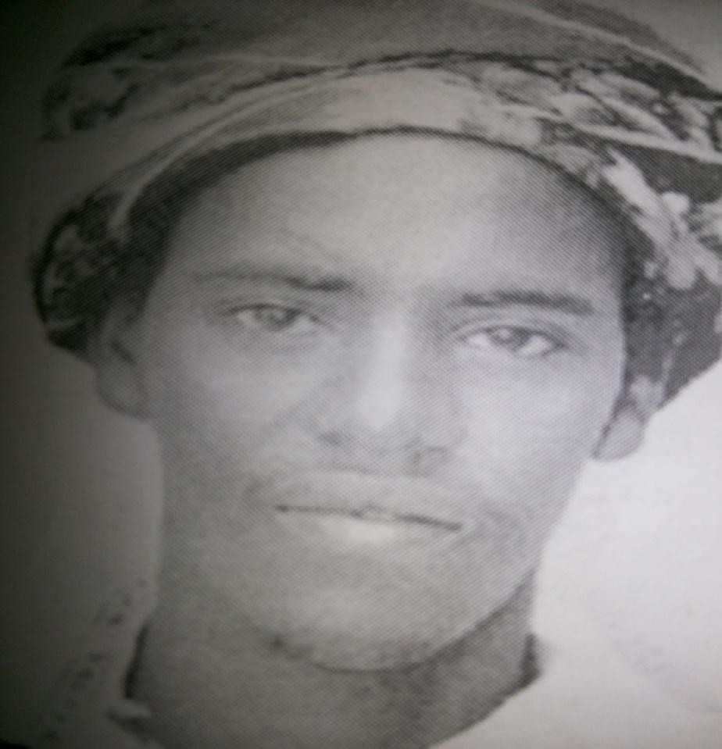

Plate 8. Guyo Goba Borana Abba Gada 2008-2016, when he was assuming office.

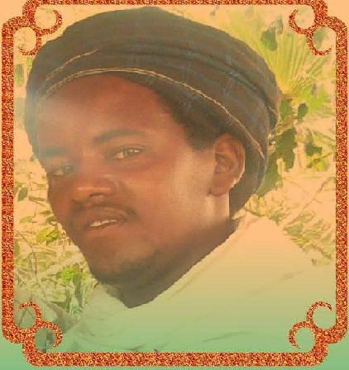

Plate 9. Guyo Goba Borana Abba Gada 2008-2016, when was handing over office.
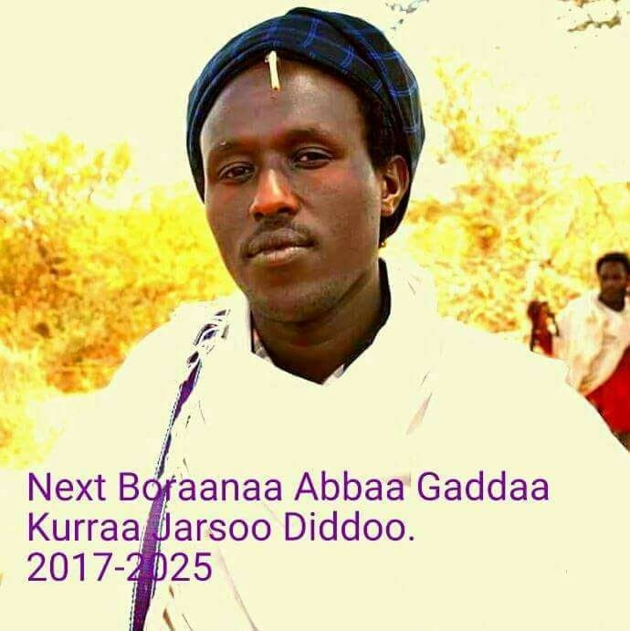

Plate 10. Kura Jarso Dido Borana Abba Gada 2017-2025 when he was assuming office.

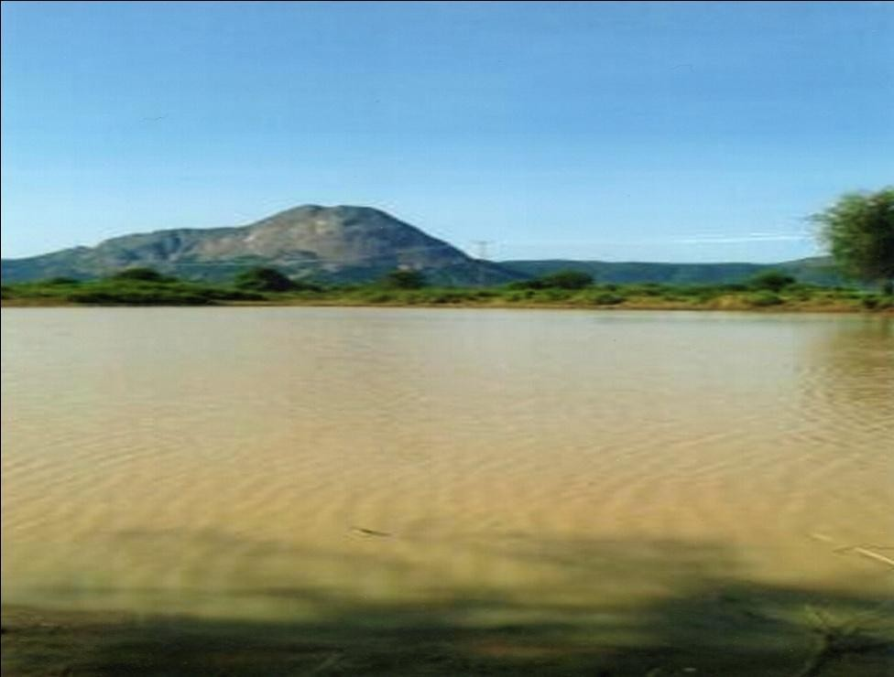
Plate 11: Aabo Mountain on which the Kenya-Ethiopia boundary passes marking the northern part of Sololo.

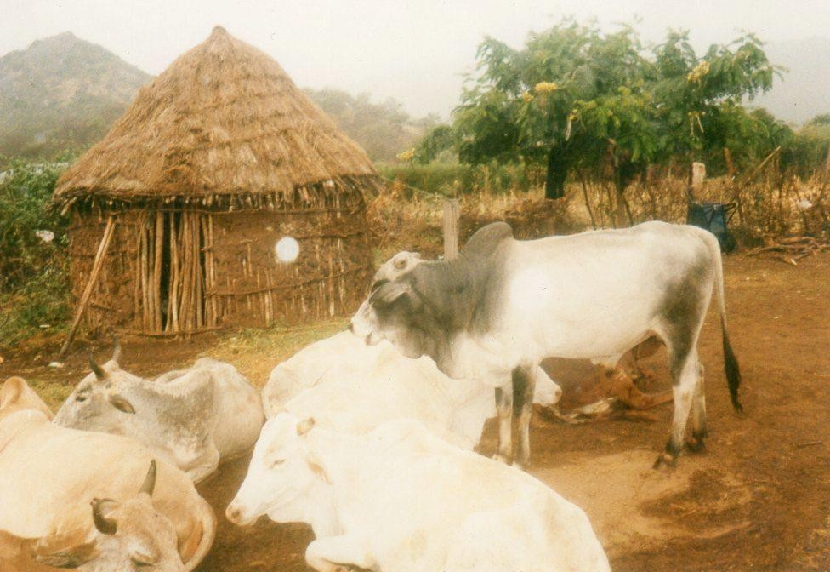

Plate 12: A typical Borana homestead with cattle at the centre of life.

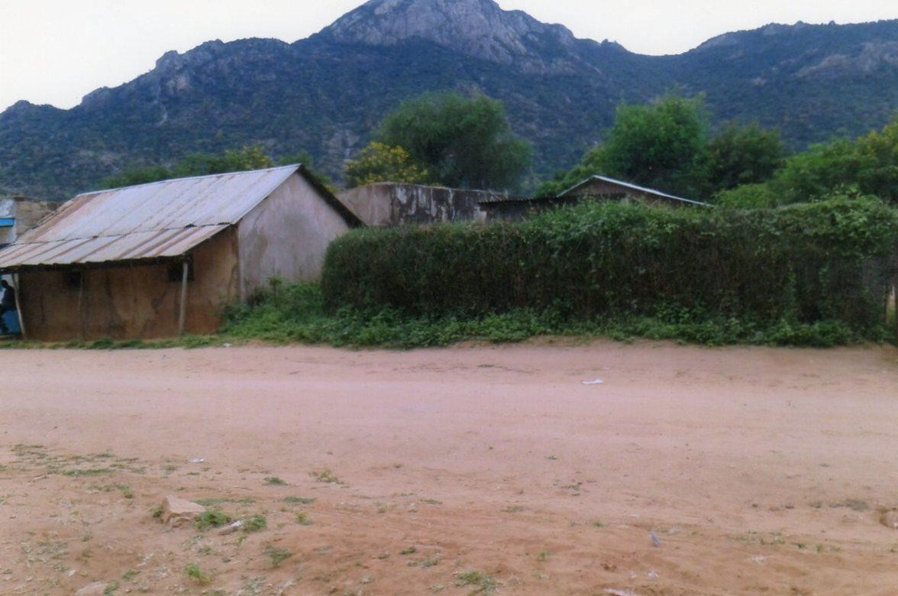

Plate 13: One of the streets of Sololo town with a magnificent view of Borole Mountain.

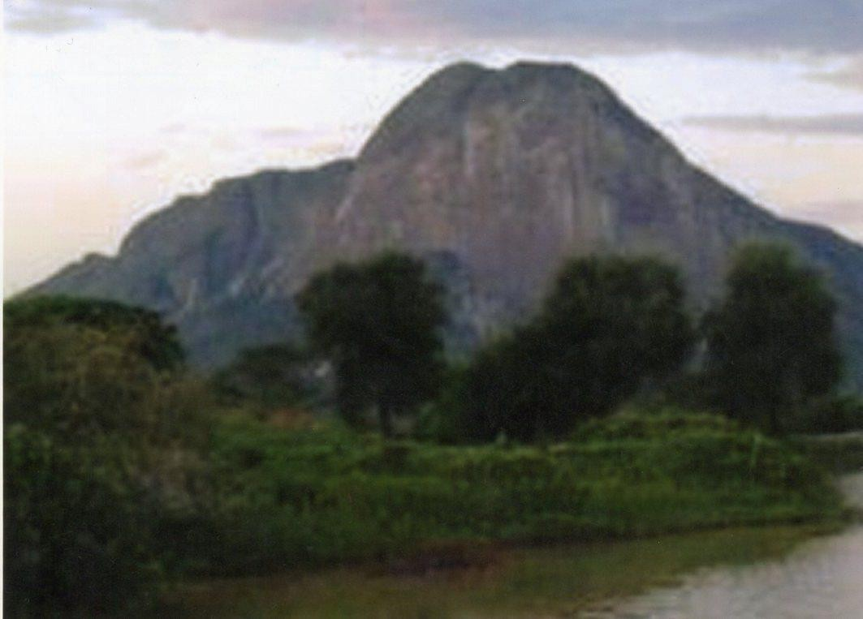

Plate 14: A closer view of Aabo Mountain.


Plate 15: This author’s parents performing one of the gada rituals of gaddamojji c.a 1995.

CHAPTER THREE

STYLES AND THEMES IN AGE-SET QOOSA
The age-set qoosa with which this chapter is concerned entails direct face-to-face interaction between two persons who take turns to exchange some witticism and topical comments composed for the purposes of teasing an age-mate who also doubles up as a friend. In these performances men take turns and joke about their peers often alluding to the foibles of their age-mates regarding their conduct in situation of mistress courting. Age-set qoosa recounts people’s deeds as a way of entertaining the audience by recounting the misadventures of the men and bringing them out for laughter. The men are ridiculed for not being clever enough, wily or for making daring attempts where they were not called for. In terms of these perceptions, wooing is like hunting where a man cannot just come out empty-handed. The wooing of women is coded in hunting terminologies and hence the jokes often delineate the character of the butts concerned based generally on their relationship with mistresses. Humour is derived from the fact of being outwitted, from failure to win in the game of wooing, irresponsible behaviour, inability to sustain relationships and the like. Furthermore, age-mates chastise greed and unconventionality in sexual matters.
It must be noted that the jests here rely on a lot of overstatements that stereotypes the male subculture. An overview of these stereotypes betrays the aesthetic tastes of the male world projected on to the entire community. In another sense, these stories form part of one’s biographical data on which certain decisions of social ratings are based to judge a person. Together with the praise poetry known as dhadu²² that virtually all males worth their status own, joke ascribed to age-set members make up the character of an individual. The criticism engendered in age-set qoosa and the praise epithets in dhadu conjoin to give a balanced picture of the men as humans with strengths and weaknesses, failures and successes. By enumerating and repeating the deviations from the norms, the men are underlining what they consider to be a male code that members must conform to. The attachment of the stigmatic levels on deviants, are particularly meant to delineate the code that binds them as a group. Naivety at getting women is laughed at because a true age-set member should not be naïve as it is considered feminine. The cowards, those who abscond, the lovers of weak, ugly women are denigrated on the basis of their inability to measure up to the masculine expectations. By attributing to each of these men objectionable or disparaging epithets through an examination of their physical and behavioural traits, age-set qoosa urges the members to discard these deprecatory tendencies that portray them in bad light.
Qoosa performers are not professional performers in any sense of the word. They are ordinary members of the community who have the interest and the ability to joke with their friends in a poetic way. There is no formal training institution for the would-be performers to attain and perfect their verbal art, as in the case of, for example, the Yoruba ijala (Babalola 1981:5). People who have the flair for language just learn other people’s qoosa and create their own along the same line. Although most informants agree that it takes quite an effort and a great deal of learning to create their own qoosa texts, they however do not think composition is a kind of inspiration that is sacred, as is the case of Somali poets described by Samatar (1982). According to Samatar, a reluctant poet overwhelmed by passion withdraws

22
This refers to boast poetry where people who have routed enemy males from other communities and
huge games that society finds a menace, boast of their manhood. For a comprehensive analysis of dhadu see Wako (2002).

into himself and spends many sleepless nights and even months, to draft the proper language with which to express his deep feelings (1982:69). In such an instance, poetry is reified and seen as tormenting the poet with an inner struggle. Some people are more skilled in telling jokes and making puns than others (Karl-Heinz 2010: 172). Qoosa poets I have interviewed contend that composition, like the qoosa itself, comes handy when couched in the form of play. To them, being serious actually kills the art because it is meant in the first place, to bring lightness to the heart.
The composition of age-set qoosa is primarily based on events that have taken place with regard to the composer and his age-mate friend. It may be that the composer’s friend was exposed in a situation of having an illicit affair, or had failed in accomplishing some goal. This incident in the life of the age-mate will prompt the composer to create jocular poetry about him, which in some playful way urges him to take action and right the wrong. He will in doing so, draw on other facts such as toponyms, the formulaic phrases which have come to be established in the tradition of qoosa performances such as kophele fanaan yake, fano farada irati yake, (he spoils shoes with his feet, he spoils saddle on the horse). Whichever the case, there must be a history that acts as a prompt and the traditional stock formulas and the particular details of the person forming the flesh of qoosa.

Take the case of two friends Boru Guyo and Abduba Galgallo, both of who belong to the age-set of Dambala Diida, who were born around 1952. I shall examine some of the stories that lie behind the text and how the lines are brought together to form the entire unified text. This is what Abduba said to Boru:

Galaani uuban dhoowa Laagi jiigeesan dhoowa Qalaamu diiman dhae Ablikeeshin kanke
Kaar Torbi Chief Huqaan Bau dhoowa
Moona sii huqiise
Saa kanke ka mateta dalach jedhan Dhacisan miil dhoowa
Aat naami waan diqoo
Barcumaa kaanat hinejaatini Beeni ufuma nyaate
Guma gutuu sii dhoowa
Lake is difficult to cross for debris River is difficult for logs
He crosses with red pen Your application
Chief Huqa
Made difficult to pass Torbi gap It diminished your herd
Your cow called Why-Rest-Brown Disease denied it leg
You who is poor
Do no vie for this post
People will merely eat your money
And deny you the cow of the tuft of hair

The story behind this qoosa is that in 1981, Boru, a resident of Sololo town had put in an application for the advertised post of an Assistant Chief for the area. The then area Chief Huqa Guleid was a power broker and had his preferred candidate in the person of one D’engee Okootu, from his immediate sub clan, and who eventually got the post. Boru had wanted to sell a cow to pursue the matter but his friend Abduba, dissuades him against the pursuance of a futile endeavour since in Abduba’s reasoning the matter has been conducted and concluded behind the scenes. Qoosa text is Abduba’s speech uttered to awaken the butt to see sense and abandon the ambition.
How then is the text crafted from that story? The first line is a stock phrase that is common in the way poems are begun with some general philosophical statement. The important thing is the speaker’s use of the word dhoowa, for the entire poem is built on it. Just as the river and

lake obstructs or make things difficult with various objects, the entire text uses dhoowa as a motif that has great import for the speaker. Dhoowa as word has a wide semantic field and it is this field of possibilities that is exploited. The entire poem can be divided into four units each ending with the word dhoowa or some form of it, sii dhoowa. The first is about the lake/river difficulties, the second the denial of the application to go beyond the Torbi gap, the third is the infliction that robbed the cow of its leg and finally the fourth segment, is the warning to the butt against people who will eat and deny him the symbolic cow of the tuft of hair. This last is about what makes a Borana a Borana. The Borana often refer to themselves as Borana Guutu, the Borana with tuft of pigtail hair on their head. Oba (2000) has also indicated guuma guutu (the cow of the tuft of hair) is a symbolic cow that separates Borana from non-Borana since cattle ownership is a kind of identity marker.
Leaving aside the first line, the second line is concerned with the issue of the application and how it is blocked by the powers that be from reaching the district headquarter at which the considerations take place. The red pen is the instrument used in this blockage and in the mind of the speaker it is conceived as an instrument of hindrance. In school, for example, where the pen is a central instrument, one always knows that exercises done by the pupils were corrected using the red pen. The crossings done in red pen by authoritative teachers, have meant that the red pen is seen as an instrument that deters upward progress, say to the next class. In addition, the red pen is regarded as portending something dangerous, and can only be used when something is amiss. For example, in 1970s and 1980s when letter writing as a means of communication between the rural and urban Borana was a common phenomenon, the illiterate people who ask literate youths to write letters for them were very particular about the use of a red pen. The red pen was only used when conveying information about the death of a beloved member of the family. By using a red pen according to the speaker, the power broker chief had marked Boru’s application as something to be denied life. The toponym, the gap of Torbi is potent with meaning because Torbi is a landmark dividing the district headquarters in Marsabit and the then Sololo division. By ensuring that the application does not reach the required place, the Chief had made it impossible for Boru to be considered for the post, a fact to which the jester draws his attention.

The third group of lines relate to Boru’s property or his lack of it. The speaker personifies the ailment that inflicted the cow, thus impoverishing his kraal, as conspiring with those who stand in the way of his progress. The cow’s name has its own little story. The cow whose name is Why-Rest-Brown was named so, because it was bought with the money earned through menial labour. In this case, Boru the labourer was often subjected to the admonishing rebuke, why rest? The name bears that piece of history during which Boru was a farmhand at a Kiambu coffee plantation near Nairobi in the late 1970s. The line serves to caution the butt that since the cow he laboured to buy has been rendered useless by the bovine disease, he should not venture to sell others to further aggravate his already dismal condition. The last group of lines links the ambition for the position of Assistant Chief and the poverty of the applicant by suggesting that since the processes is riddled with corruption, nepotism and favouritism, Boru should be prudent and stay away. He is being warned not to incur double loss through paying bribes and also losing the appointment.
It is clear from the foregoing that age-set qoosa arises out of a particular situation and addresses that situation. It is a genre where poetry, play and historical events converge and illumine one another. Abduba had made statements, some of which underscore the stark reality of Boru’s needy state that should not be ameliorated by unbridled ambition in the face of a corrupt system that will disregard fairness and consume even the little he had. But it should be noted that this is done with a light touch, and these groups of lines are meant to be humorous, a kind of play yet telling the truth about the realities as they are.

Consider another example where Boru also advises his friend Abduba in another context. This is what he tells him:

Dumansi gamaa dhufe mukha irra taa Jalto issa Wakanyi
Gaaraan jilbaa irra taa
Booba luku teeti eegataa Risaan mukka irra taa Riisaan fiixe luku tee Reeffi tokochan taa
Agaa atin baraan riifaachifte Abbe arraalee gaaraachi Madaan taa
Ijjoleen isaa lama
Guuda ganni kuudhani lama Waan Borana seeda
Mucaan sun arrale tuseen taa

Clouds come from yonder and settle on the trees His mistress Wakanyi
Her belly rests on her knees Waiting for your chicken
Hawks perch on the trees
Hawks killed them your fowls Their carcasses litter everywhere Since you last startled him
Your father still remains With his unhealed wound His children are two
The elder son is twelve years old What is a taboo to the Borana
He still remains with the childhood hair

The story behind this text is that in 1979 when the two friends were working as labourers in Kiambu, Boru had gone home and found Abduba’s father unhappy about his son’s refusal to come home for the child naming ceremony of his son which could not be carried out without him. The last time he was there two years earlier he had slighted his father by adamantly refusing to undergo the ceremony citing various reasons. In fact, since he had found a mistress for himself he cared little for the naming ceremony. As Boru was going back to work at the end of his leave, Abduba’s father pleaded with him to convince his friend to come home and carry out the ceremonial rite expected of him. The text is composed to prick the prodigal son’s conscience for the neglect of the cultural ceremony.
In terms of composition, the important word that gives shape to the poem is taa, which means settle, sit or a state of being that denotes something stationary. This word that implies stagnation in its many forms is used because the objective of the poem is to show that contrary to the societal expectations, the butt’s son still remains with the childhood hair that should have been shaved in a ceremonial way. The lines are thus constructed from observable facts of life, and fashioned around the key word that shows things are stationary, and in this way also maintain rhyming pattern. The poem draws on Abduba’s social history and relationship with other people, and culminates into a heavily loaded cultural statement, which is meant to shock him into consciousness.
Line 1 which points out the cloud settling on trees, like in the previous poem, is a common way of beginning a poem. The second line is an observation that ridicules the butt on account of his foreign mistress. The woman named Wakaanyi was from the Kikuyu community in Central Kenya and from the description of her belly, Abduba had impregnated her, something that explains his estrangement from his cultural roots and the paternal duties he was to perform. Line 3 and 4 are about Abduba’s fowls that were devoured by hawks and in the manner of age-set qoosa, are used to diminish the image of the butt by small allusions to some negation of his character or things that are associated with him. The fifth line refers to Abduba’s slighting of his parent. The last two lines are meant to draw the butt’s attention to the need for him to carry out the rite de passage for his children, the avoidance of which is found to be a cultural anomaly. The invoking of the Borana culture makes it a grave issue that the butt should not take lightly.

As in the other text by Abduba, the butt is being joked about, teased, his stature diminished, and later advised to take action about something that if neglected will result in social embarrassment for him. The speaker, if he chose, could simply have told him to go home and perform the naming ceremony, as the custom requires. Instead, he resorted to joke because the genre is more convincing, jocular, appealing and truthful. It is a way of communicating with one another, unique to a segment and sanctioned by society. More than that it remains a record of biographical information of the man for whom it is composed.
The major themes that preoccupy the age-set qoosa and the styles in which they are rendered needs close scrutiny. This is important because certain key issues seem to underlie and mark the relationships of the age-mates and these are the things crucially important to their lives and thus joked about. By subjecting to scrutiny the themes and styles of their joke, we learn in a more significant way of their woes and worries, their hopes and aspirations, and their worldview. More importantly we learn the ways in which age-set qoosa are constituted as a genre within the society by its performers, and what ends it serves for them and the larger society. This face-to-face joke is moreover agonistic, and involves the positing of challenges and the answering of them. The aim is to deflate the images of the joking partner by use of a series of negative images from disparate realms of social life that culminate in a climax. These negative epithets are drawn from far ranging issues like one’s gait, eating habits, facial features, relation with one’s mistress, issues of morality and honour, one’s involvement in corruption, weaknesses about controlling libido, in short literally everything can be a subject of age-set qoosa. Here I select the more recurring ones from the data and the discussion I had with some of the performers.
One of the most profound themes in the age-set qoosa is that it recounts in a more sustained way the real or imagined foibles of the butt’s mistress. So central is the mistress theme in the joke circle amongst the age-mates that it appears, she and not the man, bears those defects qoosa critiques. The question then is why does this apparent male genre grant a prominent place to what may easily pass as female aggression? One answer, rooted in theoretical formulations of psychoanalytic persuasions is that, owing to peer competition amongst the age-mates, anxiety is produced by the judgmental attitude where conjectures are made about the beauty of one’s woman-friend²³ (mistress) in relation to others. The fear of being thought inadequate amongst peers on account of an ugly woman-friend would facilitate the age-set to joke about other people’s mistresses. In a sense it is emotionally cathartic to laugh at the mistress of the other with whom one is linked as a best friend. As Eileen Gilooly observes, humour transforms the pain of frustrated aggression into a source of pleasure by offering its practitioners a real, if momentary, triumph over lived experience (1999:37).
Yet whether one perceives the mistress theme psychologically or functionally, the fact is that because of the nature of the engagement as a rather illegitimate enterprise, it is an anxiety-producing venture at several levels. On the one hand, there is the danger of being discovered by the husband with its ensuing social embarrassment, and on the other, the fear

23
I use this term to differentiate it from the traditional term girlfriend that is common in the literature. A
girl in common usage is one who is unmarried and in Borana culture, it is forbidden for a man to have a girl as a friend. Mistress is used interchangeably with woman-friend. Legesse (1973) calls this relationship cisbean.

of being thought weak by peers all of whom risked the lurking danger and acquired for themselves women-friends. According to Baxter (1974:813), if a young man is discovered in a liaison, all he can acquire is perhaps some credit from his age-mates, but otherwise he risks public opprobrium and perhaps a beating and a fine. The mistress theme, it appears, gives vent in a playful construction to the more pressing realities on which it is based. It is the realities and fears of these beatings, fines, and anxieties resulting from these relationships that are dramatized in age-set qoosa.

Even as the relief/release theories explicate some features of qoosa there is no doubt as to the genre’s social nature. This is best explained by Radcliffe-Browns’ functionalist formulation (1940, 1949). According to Radcliffe-Brown, joking occurs at a tension point in the social structure of the society, and it serves, as many other kinds of social behaviours in Radcliffe-Brown’s functional trope, to maintain equilibrium. Competition over favours from women may bring tension amongst the age-mates that needed to be diffused through qoosa. As joke theorists (Davies 1990, Palmer 1994) have found out, in-group jokes are told in the face of internal division as ways of coping with harsh reality by making it temporarily less threatening.

The text below amply illustrates the way in which a jester mocks his co-performer by exposing the intention of the latter’s mistress to buy hair from Yaballo town, an intention that is unusual in the circumscribed and fairly unsophisticated Borana world:
Waaqayo guudan roobe duur bukiyyeen dhufte Gaara Qancaaro irra urriin dhalaatin dhufte
Qancaara sarba kuutu odduun te qaata dhufte
Maata bitaadha jeete niitin garaayyu teeti kiibbi diir Yaballo dhufte
Maata gaatin waranaa tokooch riifeensa hinqabdu boori moyyiitin ak loon Guyo Daada buulte
Before the rain came the heavy fog From Qancaaro hill came the dull fog
You the stunted one of bandy legs your mischief have circulated Wishing to purchase hair your mistress went to Yaballo town

The price of hair is dear, without any she slept bare like the cattle of Guyo Daada

Although mistress relationships are matters of privacy, the fact that the age-set make their mistresses the butt of public joking is telling. It is a pointer to the pressing need to project the anxiety caused by the competition and mocks both the man and his consort about an affair whose revelation portends peril for them if found out by the husband. First by narrating that the mistress in question attempted to purchase hair, the jester is implying her foolishness. The jester plays on the script of surprise that borders on absurdity for it is unusual for women in Borana especially the rural ones where qoosa is set, to do so. The woman becomes an object of male aggression as she is derided for her foolish attempt of purchasing hair as a mercantile commodity. Humour is also made apparent at the exposure of ignorance played on the urban/rural axis. The rural people, to whom the woman in question belongs, are perpetually uninformed, desirous of town things and make fool of themselves by this same ignorance such as the price of the desired object, and thus become easy embodiments of laughter.
The climax (line 5) juxtaposes the bare head of cattle with that of the butt’s mistress. The age-mate is considered as qancaara, the stunted one, one who is older than his looks. The shape of his legs is captured with the metaphorical word, kuutu, a small container fashioned as a tobacco holder. The passage’s humour lies in the descriptive epithets pinned on the joking partner. His mistress is no better either. She is bor moyyiti, which roughly means a blue hornless cow, which applied to the bovine, implies affection but detestable when used to refer to a woman. She craves the things of modernity but she cannot afford them. Having lost her natural beauty of long lush hair, the artificial one eludes her because she does not have the means to acquire it. The aim is to ridicule the butt as a man whose mistress is ugly, old and unwomanly within the trope of masculine culture. The mistress and the little stories that surround her is evidence of the age mates’ adventurous life that can be joked about and laughed at. It is an institution fraught with danger, trickery, like hunting and warfare. In the event of its failure the youngsters are mocked disparagingly.

Vulnerable targets too, for the jest composers are some character traits of mistresses who have suffered misfortune of one kind or another. An examination of the text below concretizes this point:
Halaan yabena doote halatin qencan keete Qenca dhedhera qabda refu qadhabin geete
Endhegeen arma demte kara Mombasa deemte
Ak loni bobate niiti garayyu teeti alat Jaluoon geete

The Somali camel dies, the vulture tears with claws You have long claws, you are ready for scavenging The aeroplane leaves here for Mombasa

She strayed like cattle; a Luo²⁴ raped your mistress

In this text the jester turns the misfortune of his friend’s mistress involving rape by an alien person into a comic scene where the woman is blamed for straying into a domain that is ordinarily out of bounds for her. The man is likened to a scavenging bird, a vulture on account of its long nails. He is said to have come of age to go scavenging. His mistress is eroticised as seeking after sex, and what she gets is an alien man. The text’s use of the words plane, Mombasa (Kenya’s second largest city), and its reference to Luo locates it outside the Borana cultural domain to an urban setting. It is an indicator of qoosa’s ability to transcend its cultural environment by reinvention in a continual way. The humourous effect is realized by playing the trope of conventional/unconventional in which the norms of conventionality have been violated. In fact there is a sense in which the jester makes the rape sound as if the victim desired it. The words “strayed like cattle” imply that as cattle look for pasture the victim looked for her aggressor. The outside/inside domain and alien/own dichotomies heighten the transgression and violation of Borana cultural space that causes anxiety, which must be played out in jocular form. The insinuation of straying with suspicious intent that serves to vilify the woman and the rape by a Luo man imbues the text with its jocular quality. The poem acquires its rhythm from the rhyming words keete/geete/deemte that mark the end of each line. Parallelism and balance is achieved by the repetition of the word qench/claw and its variant qencan/its verb form. Mombasa and bobate are used for purposes of sound pattern.

Poor housing structures that are constructed by women often serve as a ready recipe for jest among peers, perhaps one of whose mistress is implicated as a culprit. In the Borana

24

other.

Refers to an ethnic group of Nilotic stock. In this case they are disparagingly referred to as an alien

community it is the sole responsibility of women to construct houses for their family, while the man is charged with the onus of providing shelter for cattle. This responsibility requires competence and is subject to criticism from the public. Very often house construction and general house keeping becomes a yardstick for gauging the neatness of a woman in a community bent on judging women through a masculine lens.
The text below is illustrative:

Mili waqaa dhabate golbo keesaa mulata
Maan hinqabdu ofoor jalto teeti keesan waaqi mulata Ofori dudee jenan niiti garayyu teeti irra odaan dubata (Injirti, odaan korma)

The rain cloud gathered, and appeared in the plains
She lacks a house, through the shack of your mistress the sky appears After the holes have been blocked, oda²⁵ speaks on your mistress
(It is true, oda is a male ayyana)

In this text two issues are used to chide the man, namely shoddy handiwork of his mistress’s house and the fact that after she had made efforts to somehow mend the gaping holes in her house, spirits possess her. The mistress is seen as prone to problems, suffering one calamity after another. She lives in a shanty that can hardly pass as a house. The word used is ofoor, a makeshift with many gaping holes through which sky is visible. Her handiwork is laughed at as something roughly strewn together. The line underlines her helplessness, her vulnerability, her weakness, a woman unable to take charge of her affairs, and therefore of no use for one as

25
This is the name of one of the ayyana spirits. In this instance the butt confirms the claim but puts it
jocosely by claiming that oda is a male ayyana, implying that even though being inflicted by ayyana is undesirable, its being male mitigates the misfortune of acquiring the spirit.

a lover. The text implies that the woman in question is crude, unsophisticated and susceptible to being a victim of an unpropitious spirit harmful to both the man and herself. Another version of this text contends that sheikh Hussein²⁶ impaired her hearing ability in one case, rendering the woman a candidate for the ayyana cultists to attend to.

Another character trait of the mistress that is mocked stems from the jesters reckoning “her being like men”. In the text below, the targeted woman is said to have sat amongst the men and treated herself to the luxury of the local brew. The jester first censors her walking style where she is said to have “thrown her right arm”, and then subjects her to ridicule for violating dominant social decorum of which he is the privileged overseer:

Koophe faanan yakite You spoil shoes with your feet Faano fardaan yakite You spoil the horse with the feet Kara dirraa deemte Walking on her way to the town
Niitin garayyu teeti The woman who is your mistress
Ark mirgich darbite Threw the right arm
Mirga dhira teete She sat on the right side of a man
Farso xassan darbite And gulped alcohol
Farson kara keesat bufte The drunkenness fell her on the road Luqetu keesat caapsite She broke her hips

The method of qoosa is that it uses small allusions to display the character of the man as questionable, and in this case the reference made in the first line serves these purposes. A man who spoils the shoes with his feet is an epitome of ugliness. As in other qoosa, getting at

26
The name of the person believed to be the founder of the cult. Here it is used as the spirit itself.
According Mohamed Hassen (1992), he was a 13th century standard-bearer of Islam, a Muslim scholar of Arab origin and an accomplished missionary saint in southern Ethiopia.

him through the flaws of his mistress diminishes the joking partner’s stature. The text uses snippets of epithets to hint at the woman as a loose, drunkard and a comic figure whose moral degeneration is symbolized by physical degeneration. Line 3 is a pun on mirgich/mirga for right hand and right side respectively and is used effectively to underscore her apparent daring posture in disregard of a male oriented arrangement that considers her being there, in the first place, illegitimate and subversive. The woman is made to appear even more ridiculous in that, the liquor, which like all tough things, belongs to the male domain, tripped her and broke her hip. Implied in this qoosa is the unspoken message that indulgence in culturally prohibited practices leads to disgrace for the woman and by extension the man who is inextricably associated with her.

Being caught by cuckolded husbands, like the incidents themselves, forms a large portion of thematized areas by age-mates in qoosa. The implicit message is that the butt was not wily enough to exercise caution and hence more than deserved to be caught. The indulgence in extramarital sex is shrouded in secrecy and thus, calls for dexterity, as essentially one is a thief as far as sexual liaison with someone else’s wife is concerned. Those who indulge in it are the ones likely to get caught sooner or later and it is they who normally become butts of the age-set qoosa. The following passage shows the discovery by the cuckold is preceded by the butt’s immodesty:
Ilad ilan dhofte Taari xururan dhofte
Ill gara keesa barisa dhofte
Ill yaabi daadi keesa ilisa dhofte Waa dhude cico sephanin dhofte Waa nyate shana lafan dhofte Olli kaate lafat zimbabi dhofte
Olli deemta kara ka Waro diida dhofte
Dabdich faro hamaa mangul jaroti Dambala Diida ebbo udut sii dhofte
You saw the mouse with your eyes The dikdik you caught in a trap
From the gap in the hill you collected honey
From the eyes of a rinderpest infested calf you ate worms You drink milk and drop the container
You ate something and drop faeces on the ground Going to seduce you wore the showy cloth
Going to seduce you walked the path to Waro plain
You stupid one of ill luck, how is it that the elders of Dambala Diida age-set nearly speared your buttocks?

The poem is based on a factual incident. The text recounts a near-tragic event where the butt of the joke, a village commune leader, during former President Mengistu’s villagisation policy in Ethiopia, takes his lover woman with him to attend a meeting. The husband gets wind of their being together and complains about the matter to the elders who in a diplomatic way try to resolve it by bringing the aggrieved parties together. Unfortunately this effort at reconciliation ends up in chaos as the cuckolded husband lashes out after the accused denies any affair with his wife.
The indulgence in extramarital sex and the superficial manner in which it is handled is dramatized. The incongruity of overconfidence assumed on the road to seduction and the fatality of return with a spear thrust in the back is juxtaposed and mocked. The performer appears unsympathetic to the butt’s predicament and because the event is now in the past, he can construct qoosa around it, even though it was a serious one at the time it occurred. In fact qoosa texts are reflective in nature in that it is a reconstruction on the part of the performer who slants an incident, and interprets it in a way that renders the butt of the joke laughable. In this way, the joke narration is like a story of some dangerous but exciting adventures. Because the entire discourse is slanted towards mockery and play, the victims are not sympathized with, and to win in these contest-like performances, the performers have to be more verbally articulate than their challengers.
In the case of qoosa cited above, the butt overreaches himself by trafficking with the woman in a public gathering whence he parades her in the eyes of all and sundry. This foolhardy undertaking is paid for in the ensuing embarrassment and qoosa is constituted in the careful balance between the initial male bravado and the later cowardly flight as the lines below show:
Gooba kaate kara ka Fulo Qayoftu fuute
Qay naqachu dhorte intal jars kani bool qaya ira fuute Naate idhan udun sibute
Fallum falte ab Jaldesifati affan bolati sifute
Going to seduce you walk the path to Fulo Qayoftu
You removed the wife of that old man out of perfuming hole You developed cold feet your trouser fall from your buttocks
Elders Jaldesa and others negotiated and rescued you from the verge of the grave
The word for seduction in its original usage is derived from one that applied to a bull at the apex of the mating season. To Borana, the image of maleness encapsulated in the idiom of the bull is apt. A virile bull presides and maintains domain over a number of herds. It gores both the ground and bullocks to sharpen its horn and to maintain its territoriality. This metaphor is exploited and transposed on to the man who prepares himself to go out to seduce, a venture which ironically turns abortive. By presenting behaviour of members of the age-set, as Hymes (1987) comments in another context, as something laughable and wrong, the speaker denounces them as deceptive, empty and unworthy of emulation.

There are parallel narratives in the Borana oral tradition on this theme that seems to point to a kind of motif, and chief among them is the story of Baboon that seduces Lion’s wife when the former is away. The woman was mesmerized by what she thought was a man considerably different from her husband and enquired about his peculiarities seen in his lean fingers, bare buttocks and hairy chest. Baboon boasted that his fingers were thin because the rings he wore had worn them out. In Borana, a man who has routed male enemies wear rings on his fingers as a mark of his bravery. As for the bare buttocks Baboon boasted that it was the work of the saddle as he was an erstwhile horse rider, and that his hairy chest is that of a brave warrior. Regarded as an act of valour, horse riding is associated with raiding other communities and hunting of big games. For a man to smooth his buttocks in this way, he must have been at the helm of many military expeditions. When Lion returned, his wife challenged him: although he boasts of bravery she has discovered a greater man than him in the person of Baboon.
The following day they decided to test the veracity of Baboon’s claims. Lion hides himself and his wife asks Baboon the same questions. Unaware of the test, Baboon repeats the same wild claims to the woman whom he has marked as an object of erotic attention. To his utter consternation Lion comes out of hiding and challenges him. Scared and begging for forgiveness, Baboon confesses that his thin fingers were caused by digging the ground for roots and his bare behind was a sign of sliding down rocks, and that his hairy chest is the result of the cold nights to which he is exposed.
This narrative can be read as a metacriticism of the Borana culture. As a text, it critiques the condoning of the practice of seducing wives whose husbands are away. The unscrupulous language of deceit and cajoling is simultaneously depicted and denigrated in the shifting mien of Baboon. Like this story, the unspoken assumption in the text of qoosa is that the butt is rebuked for his duplicitous heroic flirtation that is easily demolished in the presence of the husband who invokes fear in him. Unlike the supposition by Eastman (1936: 31) that laughter was a form of play having no other end than those of play (emphasis added), this story and the jocular features it encampuses are invented to laugh at the offending characters for violation of norms. Qoosa here is also a stage of negotiation about how to introduce taboo subjects into everyday discourse and deal with them in a serious vein by dramatizing what is wrong (Basso 1976). Many age-set qoosa that speak about the theme of being caught by the cuckold are built with the same kind of motifs as the above story. Let us consider qoosa between Jillo Guyo and Sora Otoba, two friends who compose qoosa for each other. This is what Sora said to Jillo:
Gaaf jilla tiyya, kooche nyaate diibe goodu lakifte
Gogosaati sii dhane gaf Kuule boor Galgallo Koote daami siiti lakise Dhuuf namicha garte Jaarman qonqo gaadi lakise
Ufi ya keesa dheete dabdich Kuule enu lakifte?
At my naming ceremony, you ate meat and left the empty container
He caned you thoroughly the husband of brown Kuule left scars on your back Seeing the arrival of the man “German” thundered out a huge bark
You had fled the chaos, at whose mercy did you leave Kuule?
The poem tells the story of a man who was caught red-handed in his mistress’s house by her husband. Each line is a contracted story that reveals the character of the butt. In line 1, the butt is portrayed as one who consumed without contributing anything good to society. In naming ceremonies, mistresses of the jilla owner normally make a special kind of meal for her lover to eat with his friends and age-mates. It is a sort of honour for her to do this and the container from which the special meat is eaten is honoured too by giving money, cattle, cloths and other treasured gifts to the woman who had brought the meal. In this case the butt is

diminished in that he only participated in eating and leaving the container empty. Line 2 shifts to the way the butt was caught in his affairs by a man, Galgallo Koote, who caned him silly. Line 3 talks of the barking of the dog called “German” on sighting the arrival of the husband. The naming of the dog is Sora’s way of capturing the years he had worked for a German employer in Nairobi. The butt’s manly stature is diminished because of his fright that made him escape, leaving his lover in danger and at the mercy of the infuriated husband. The poem reveals the joking partner as a man without honour, a glutton, a coward and one who cannot stand by his lover or friend in times of need. Stylistically the words lakifte and lakise both indicating leave, abandon and its many semantic fields are used to construct the poem. Goodu (empty) in line 1 and googossa (thoroughly) in line 2 serve to underline sound balance necessary for the rhythm of the poem.

A prevalent theme in qoosa among age-set is its focus on physical and moral inadequacies of the person with whom one is exchanging qoosa. Qoosa that are explicitly directed at the butt’s personality abound, even though implicitly all are meant to dent his image. What jesters do is to deliberately attribute every misfortune in the butt’s life to a kind of personal inadequacy. This functions as a strategy to render them failures at various levels. This is illustrated, as Wickberg (1998) rightly observes, by cunningly exaggerating simple foibles into character traits. In some instances the urge to display this theme is so great that jesters violate the rules of discreteness by mentioning the personal names of the butt’s mistress. In one such text, a jester contends that the butt obtained love-inducing sorcery from his friend and applied it to dispossess the latter’s wife:
Qay naqachu dhorte jarti Waaqo Darara bol qaya guba fuute Daab kaan sii keesat argaa qoosan walti nu buute
Tolch jaal kanketi olla rimesan fuute Tolchum sunin niiti jarsa arka fuute
Falum falte jarroti waar ayyana wari rasula rabbi waari sheikhana Hussein Akaku Abilo Guyo fa ab Raach Elema fa ab Boru Konsoo fa
Jarroti waar ayyana tun falte afaan bolati fuute
Atin maanin itdebitef niti suun egi faayyite dhukub dhibi fuute?
Interrupting her perfume smoking, you removed Waaqo Darara’s wife from smoking hole
I see this problem in you; this is why my qoosa clash with yours
You bought the witchcraft of your friend in exchange for an expectant ewe You placed the witchcraft in the bedroom
With that witchcraft you snatched the old man his wife
The ayyana cult elders, the people of god, the people of sheikh Hussein Elders Abilo Guyo, Raach Elema, Boru Konso
These elders of ayyana cult with a struggle rescued her from the verge of death
What did you do to her again; the woman has contracted another disease?
The woman in question who was the object of the contest becomes sick to the point of death but thanks to the elders of ayyana cult, was rescued from the jaws of death. It is fascinating that the jester refers to the cult elders as the people of Sheikh Hussein and rasula rabbi (line 5), words that belong to conventional Islamic diction. The repetition of them in this way serves to re-emphasize and add weight to the claim that superior forces rescued the woman. In this text humour resides in the use of the unexpected where the butt is shown to have acquired a potent love potion to enhance his seductive power. The application of the love potion seems to have exceeded what was bargained for as the woman suffers a recurrent

malady attributed to the butt’s association with her. But even more crucial, the text is a depiction of the absurdity of the preoccupation with wooing and the length to which people are prepared to go.
In other instances age-set qoosa performers emphasize different facets of weakness of a friend such as the inability to obtain justice in situations where it is obviously deserved. In Borana, verbal dexterity is highly valued and lack of it is regarded as an abject weakness on the part of the man. In somewhat similar way regarding Akan oratory Yankah (1989) notes the potency of speech, its ability to make or break those who utter it. Such potency has to be harnessed by those with know-how, a matter that entails eloquent knowledge of tradition and clarity of perception to argue for oneself or others. Indeed, conceding defeat in an argument in the Borana worldview is closely associated with being feminized. It is against the backdrop of such internalized cultural expectations that the text below constitutes a humorous jibe against one man who could not be granted justice even as the offence committed is glaringly obvious:
Aak jaabaa waaqi robe Xiitu galaani yae Gaalani Xiitu yae Tuula Qoochaat gargari bae
Faal maleen gololfate niiti Dambala ira garach bafte
Hallo niiti Dambala Diidi Diqa Kule tee barbare ilat maage
Barbaren daba jeete kora jars Obbu yamtee Jarsi Obbu dubate Diqan qulqulo jedhe Jarsi naadabse jeete iyite gar korte
Hayyu Licho dubate Digallu teesan shanan karat dubate
Shanan gochi sii murte Didi Diqa dabse tokole fudhachu sii dhoowe Shanan suni dubate Diidi Diqa Kule teetu amum mata argu sii dhoowa
It rained heavily rivers flowed in Xiitu
The stream from Xiitu branched at Tuula Qoocha
You engaged in unseemly sex with Dambala woman, you made her miscarry In revenge for Dambala woman Diid Diqa poured pepper in your wife Kule’s eyes
You perceived the incident as injustice and call the Obbu elders for arbitration The elders of Obbu discussed and found Diqa innocent
You viewed foul play in it and took the matter to elders on the uphill
The Hayyu and Licho leaders of your Digallu clan talked and awarded you fine of five
The five the clan sanctioned for you Diid Diqa denied you
As you grumble over the fine, Diid Diqa will soon deny you access to your wife Kule
The text recounts a true incident in which a man, Dima Jillo had the unfortunate experience where a man by the name of Diid Diqa attacked his wife, Kule, by pouring hot pepper in her face for repudiating his sexual advances, back in the 1980s. The text relives Dima’s vain attempts to get justice. Line 3 refers to Dima’s supposed mistress who miscarried due to unorthodox coital position demands. In vengeance, Diid Diqa who happens to be the age-mate of the woman’s husband retaliates by committing the vengeful act of pouring pepper in the face of Dima’s wife. The twist by the performer is deliberate, as he seems to insinuate that the culprit had the ill intention to cause harm to Dima’s wife in vengeance for the miscarriage caused by her husband. But the line is peculiar for another reason: it takes the Kiswahili word “maga” (pour) and superimposes it onto the Borana speech structure, by Boranising the word as ‘maage’.

As Deng (cited in Gunner 1984:45) says, men who have traveled away from home have a tendency of projecting their experience into their verbal performance. This innovative utterance blends perfectly well with the Borana set rhyme and acoustic patterns of words. In line 6 a similar alien element is inserted where Diid Diqa’s surname is used instead of his given name, as is normally the case in Borana. Lines 7-9 underscore the complainant’s appeal to elders of his clan in Ethiopia. The tendency to seek justice in the Borana homelands in Ethiopia gives the jurico-political system in Borana as presided over by the hayyu-licho, an unequivocal legitimacy on which the Kenyan Borana draw. The performer underscores the complainant’s hopeless situation by sarcastically urging him to brace himself for stiffer consequences for he is unlikely to see his wife again on account of Diida’s aggressiveness. He jokes with him, as if to say, you ain’t seen anything yet.
For Dima Jillo and Roba Halake, the two who exchanged qoosa in this instance, this type of qoosa serves to underline the cordiality of their friendship. They are categorical in underscoring their affection for each other as age-mates to which their exchange of highly esteemed gifts like cattle bears testimony. They assert that the more one is close to the other the easier it is to exchange qoosa without reprimand. Furthermore since qoosa is in the realm of play, one plays more easily and freely with someone with whom one is familiar. But despite their candid claim, qoosa appears to be an instrument of negotiation of their friendship where contentiously stressful aspects of their relationships are introduced and discussed.
Through qoosa, truth about the weakness of a friend’s mistress is revealed, a revelation on which he would reflect and renegotiate his position vis-à-vis the narrative. To this extent, qoosa is a mirror that reflects his dented image for remedial attention, whether the weakness exposed is, in his ineloquence or his inelegance for which he is denied justice or favours from women. In turn the joke-teller friend becomes a kind of moral conscience whose claims serve to trigger moral introspection on the part of the butt. It must be remembered that one is dealing with a certain way of looking at the world, a certain kind of morality and code that the age-set espouse. In this world of the amorous young men, it is not immoral to have extramarital sex; it is feminine not to, and it is a weakness to be caught. Like the trickster who lives on the verge of society, (Babcock 1978), the man as a member of the age-set is supposed to be clever, slippery, a winner and an achiever where others have failed.
More often qoosa arises from a factual event that the performers have shared in their daily experiences, as already observed. But the point that should not be missed is the way in which the butt is blamed for misfortunes over which he had no control. The miscarriage of his mistress is blamed on Dima, accidental though the incident was. He is said to have engaged in unorthodox sexual demeanour that appears to be the creation of the jester bent on finding fault with him, a typical feature of qoosa. The fictional attribute of qoosa becomes more apparent with the consideration of the following qoosa uttered by Roba Halake to Dima Jillo. Part of the game is that one has to win it by convincing the audience through hyperbolic exaggeration. He claims that an irate husband speared the latter in an abortive seduction adventure:
Aak jaaba sii jaalate ayyo Siiren maaqa kee Dima bafte Aak jaaba sii jalaate Wakori Guyo maaqa kee Hatuu baase
Maaqa hannaa kaan dide Robi Halake maaqa kee Haraamuu koophu baase Imbadhi kaate niitiin garayyu teeti fanti kara bondhori baate
Fan karat argate Aban Karaa Dukalet adhee Karayyu tana Dhengada waranaan dhaallu gargari sii baase jennaa jirti?

She loved you so much your mother Siire called you Dima They loved you so much Wakor Guyo called you thief
I refuted this thief name and called you incest-committer
In her attempt to flee, the woman who is your mistress her footprint was seen at the boundary
He saw her footprint, the father of Kara he is a Karayyu clan
The other day he speared you and split your buttocks, is it true?
The story behind this qoosa, I learnt, is that Dima’s mistress, after a provocative quarrel with her husband, had decided to run away to her people using the Kenya/Ethiopia boundary as her escape route. Dima and his friend found her and instead of apprehending and returning her to her husband, as is the custom, they abetted her escape bid by accompanying her, for it was getting dark. The husband on discovering that his wife has run away traces her footprints until he catches up with her in the company of Dima, her lover. It was at this juncture that the husband hurls two spears at him that according to the jester missed its target by inches. In explaining the circumstances surrounding the composition, Roba concludes his narrative, “he would be dead but for god’s grace, so you see we do not utter falsehood against each other”.
The performer seems to be speaking about conventional truth rather than literal truth. In the text of qoosa itself the claim is that the husband has speared the butt to death (line 6), when of course he survived. But what we learn is a case of fictive projection on the basis of what nearly happened rather than what actually happened. The jester exploits the permissibility that art in general and qoosa in particular affords him. His contention is true in the sense that it was only as a matter of chance that the butt survived the assailant’s attack. Here qoosa is guided by its own licentious notion of truth where playful extensions of real incidents are projected subjectively. Qoosa draws on real happening but exaggerates the details for a purposive end that in the majority of cases is meant to belittle the addressee.

The notion of qoosa as play is especially reinforcing and illuminating here. Abrahams (1983: 58) in his study of West Indian culture, states that the joke speaker through his antics produces a needed sense of classless liminality, which serves as a creative channel. In turn from the point of view of the people, by empowering him thus the community provides itself with a set of people who bring a sense of liminality upon the entire participating group, permitting them to forget themselves under a special circumstance and to enter into licentious occasion. Within the precept of this license, truth assumes a dimension of its own where exaggeration and hyperbolic assertions are never refuted. In qoosa the formula for engaging in joke clearly marks the rules where taking offence is forbidden a priori. The entering of the ludic space is prefaced with elaborate formulaic utterance whose content ranges from direct avowal to not only desist from uttering falsehoods against a joking partner, but also taking offence in a frank enjoyment of the imperfection of the other. But what is so interesting is the use to which such a freedom is put. According to Freud the most conspicuous factor of the

jest is the gratification it affords the speaker by making possible that which reason forbids (1916:197). For qoosa the crucially essential factor is not just the gratification of doing what reason forbids, but the sheer ridiculing of individuals who have failed to measure up to the age-set ideals. According to Holt the absence of laughter at an appropriate juncture may result from orientation to interactional considerations such as on-going trajectories of talk (2010: 1513).

The notion of belittling a joking partner draws on traditional theory of humour closely associated with Bergson (1911), which espouses the argument that humour is derived from a sensation of superiority over that which is laughed at. Studies of racial and ethnic humour (Burma 1946, Davies 1990) are particularly informative in the notion of superiority, where it is generally held that minority groups bear the brunt of humour that arises from a conception of superiority of the dominant groups. Significant in this direction is the contention that humour lends itself to use as a conflict device because its nature is such that it has well concealed malice. It is the object of qoosa performer to portray the butt as a laughable instrument within the normative conventions of joke genre. The text that follows uttered by Dima Jillo to Roba brings out the theme of diminishing the stature of a joking partner by feminizing him and rendering him a vehicle of mirth:
Liifii gaee Indi ruusa kadhata
Liifaa deema bagi bobat qabata
Dhukub qaba jedhe waari Golole irraa kandho baqata Qors dhuga jedhe kara Biilu qabata
Idha sirraa baase Konso Galgallo Mega udu si qaqabata
His leave is due he asks permission from Indian employer Going on leave he carries his bag on his shoulder Suspecting sickness the Golole people keep away from him Going for medication he takes the path to Biilu
Konso Galgallo Mega removes your trousers and fondles your buttocks

The text describes a typical lifestyle of the Borana watchman who stays in Nairobi working for an Asian family and how he sought permission from his employer to go on leave. The description in line 3 for instance is very accurate in that these migrant workers carry many odds and ends for their families such as 20 litre jerrycan, tea leaves, sugar, shoes and clothes. These are appreciated as signs of modernity and form an increasing part of the household material culture of the people shedding traditional household wares.
The reference to ailment may be construed to refer to the rampant HIV/AIDS cases whose initial history has been assumed to have its genesis in towns, especially Nairobi. It is therefore plausible that any person coming from the slums of Nairobi was regarded as a victim of the scourge. Owing to the paucity of knowledge of the disease’s mode of transmission, the rural populous avoid personal contact with such sojourners. The use of the words kandho (away), ruusa (permission), liiffii (leave), liiffaa (from leave), are Kiswahili loan words that betrays the jester’s versatility in ‘Boranising’ a foreign word reflecting the new circumstances in town. The punch line (line 5) is a mockery over what in normal situation the healers do to their patients: examine them in their nudity. But the qoosa performer tilts it in a way to imply that the examination is turned into fondling of the buttocks as a seductive gesture. Being touched in the buttocks implies he is female, or at any rate the passive victim of a homosexual phallic attacks (Dundes & Falassi 1975:192). Qoosa enunciates the partial emasculation of the joking partner as a strategy to heighten the jesters’ superiority over him.

Lastly, as a way of denting the personality of the butt, indecorous feeding and courting habits are employed as the following text shows.

Ilat ilan dhofte
Tarri xuranan dhofte
Il gara keesa barisa dhofte
Il yaabbi dadhi keesa ilisa dhofte Wadhudee cico sephanin dhofte Wanyate shana lafan dhofte
Olli kaate lafat simbabi dhofte
Olli deemta kara ka Waro dida dhofte
Karan gargari bae faro arka mirgichat dhofte Issi faro tante akan jira
Ka gusite jaroti tola keeti
Mangul ebo uduut sii dhofte? Mouse you saw with your eyes, Deer you caught with trap
In the gap of a mountain you eat larva In the eyes of sick calves you ate mucus
You drunk milk and emptied the container
You ate something and defecated on the ground Ready to woo you dressed in fancy clothes Going to woo you took the path to Waro plain
The path forked you followed the one on the right Is it that your luck is bad that the husband of your lover
Chased and nearly speared your buttocks?

The poem hints at the butt’s laughable engagements by a series of unrelated snippets that help build his character traits. Lines 2-5 state the butt’s breaches of dietary rules beginning with the consumption of deer meat, bee larva for honey, rinderpest-infected calf. The consumption of milk, which ordinarily cannot be considered low quality food, comes in the joke category because of the butt’s lack of tact in the consumption of it. As Davies (1990:282) observes, joke tellers characteristically depict the butt of their jokes as being unable or unwilling to consume prestigious food and as subsisting on inferior foods either from choice or from necessity. Lines 4-5 recount the butt’s indecorous habit that makes him discard the container from which he has taken milk, which is paralleled by the way in which he eats vegetable and defecates on the ground. The vegetable referred to, falls in the category of foods the Borana consider low quality, eaten by Konso and Burji, two non-pastoral communities living on the margins of the Borana community. The reference to scatology is also a feature of qoosa that is exploited for humorous ends. Lines 6-10 are an explicit allusion to the butt’s intention to carry out sexual exploits, which end up in a disastrous way. The butt is regarded as one who carries bad luck as he was close to being speared by an irate cuckold with whose wife he was consorting.
The fear of losing a mistress leads to another theme closely linked to the theme of the man’s weakness. This theme, which in most instances is represented as the combination of the questionable character of the woman and the inadequacy of the man as lover, seems to have been composed by people at risk of being edged out by the younger generation as available lovers in the extramarital relationships:
Godaan Waata Golole raamo qubate
Abuya kanke Diid Waaqo Sabura ira gambuti dimtu fudhate Gara tokolchan sii hinjalane ijooleen siraa jalto fudhate
Isi gurba waaqi akam sii tolche ijooleen tol kanke siraa fudhate? The shifting like that of Waata²⁷, you settled at Golole
27

From your uncle Diid Waaqo Sabura you obtained a red gum boot She did not love you fully the youngsters took your mistress
How is it that your affectionate was grabbed from you by the youth?
The jilting of the butt by a discontented mistress in this text is attributed to the fact the woman after all did not love the butt wholeheartedly. Consequently youngsters won her from him and thus he stands ridiculed. This text has certain variants where the butt is chided because the youngsters conspired against him and confiscated his lover from him, a contention that seems to be critical of the man’s inability to sustain a relationship that demands he competes with other contenders. They are said to have “dug a hole” in a conspiratorial way to win the woman in question, for which he becomes a subject of conventional jibe. The gist of qoosa is the implied inability on the part of the man to ward off shrewd youngsters who have outsmarted him.
The loss of a firm grip on a mistress is made even more humorous by the display of them in absurd ways, where the butt is treated to a surprise ouster by one socially regarded as an eccentric. In the text below, the butt of the joke is shown as being outwitted by a member of ayyana cult who implants his cult’s paraphernalia in the bedroom of the woman and in this respect qoosa becomes doubly hilarious. This is because the ayyana devotee is a rustic religious pundit who goes around with forked sticks, scruffy hair and a drum under his arm as stock-in-trade of his little-known faith. Ayyana cultists are generally deemed as sly persons who take advantage of people’s misfortunes by purporting to have answers to all manner of afflictions and exploit their often-unsuspecting desperate clients. It is this play on the shared knowledge of the cultist’s absurdity between the jester and the listeners that triggers comic reactions:
Kophe fan keeyyate Faanoo fardaa keeyyate
Waar itdhalate éelan gaam keeyyate Éllan gaam qubate tol kara lama keeyyate Kan Kar Bururi adhes kess keeyyate
Kan kara bima Ethiopia keeyyate
Ethiopiat deema biskili duda guba keeyyate Waar ini godaat itdeemu adoo ini ufiin beeku
Namichi waar ayyana hinkase affoo boroo keeyyate
You put shoes on your feet You put feet on the horse
His home where he was born he situated it across the well
He settled on the other side of the well, he had his mistresses in two places One he situated her at Kar Bururi amid the adesa trees
The other he situated her at the border with Ethiopia He goes to Ethiopia he places the bicycle on his back
The home that he frequents in Ethiopia as he still believes he is safe
The man of ayyana cult placed his stuff in the bedroom of his mistress
In conclusion, one can infer that qoosa among the age-set takes cognizance of the ambivalently configured peer relationship, which it embodies. Joking occurs more often between close friends than among people who are distant to one another. A series of character

Waata can be defined as a hunter-gatherer people living on the fringe of Borana community. Because of their nature of fending for themselves they frequently move from place to place, thus becoming proverbial nomads.

traits are attached to people and derogatorily emphasized with intent of subduing their self-esteem. Ironically this rigorous interrogation and negation of friends is the bedrock on which the sense of amity and its strength is founded and fostered. The peers seem to find nurture in the utter exposure of their human frailty as if it expunges them of some of the extant misdeeds for which they stand accused. Although psychological tensions may have contributed to its genesis, most of qoosa are satirical in nature and critique real occurances in the lives of the butts. It is primarily an affront on the joking partner to establish superiority over him through reference to his weak points, especially his relationship with the female other. For the jester/butt, roles that are played interchangeably, the ludic space serve varying purposes, which include self-aggrandizement, enjoyment, and relief from anxiety. For the larger society, age-set qoosa is critical in the deconstructive mould, a terrain that licenses their keen voices in ways that as Bruce Lincoln (1999:149) observes elsewhere reflects their subjective position and advances their interest. To sum up, I shall argue with Dubisch (1995:202), that to perform is to present the socially constructed self before others, to argue for that self, and thus to convince and draw recognition from others of one’s place and one’s satisfactory performance of that role. Age-set qoosa is men’s attempt to perform their role vis-à-vis society and themselves, and their qoosa are meant to portray that performance to the rest of the people. In laughing at certain demeanours of men, they are constructing an ideal behavioural code for their age-set in particular and the men in general, which they must live by or be mocked for falling short of it.

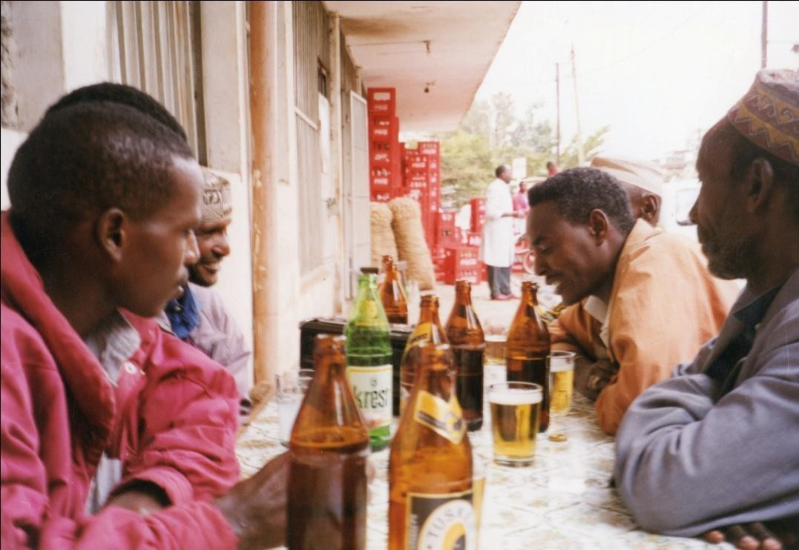

Plate 16: Dima Jillo Jirma (2nd from right), performing age-set qoosa in a Nairobi social place.

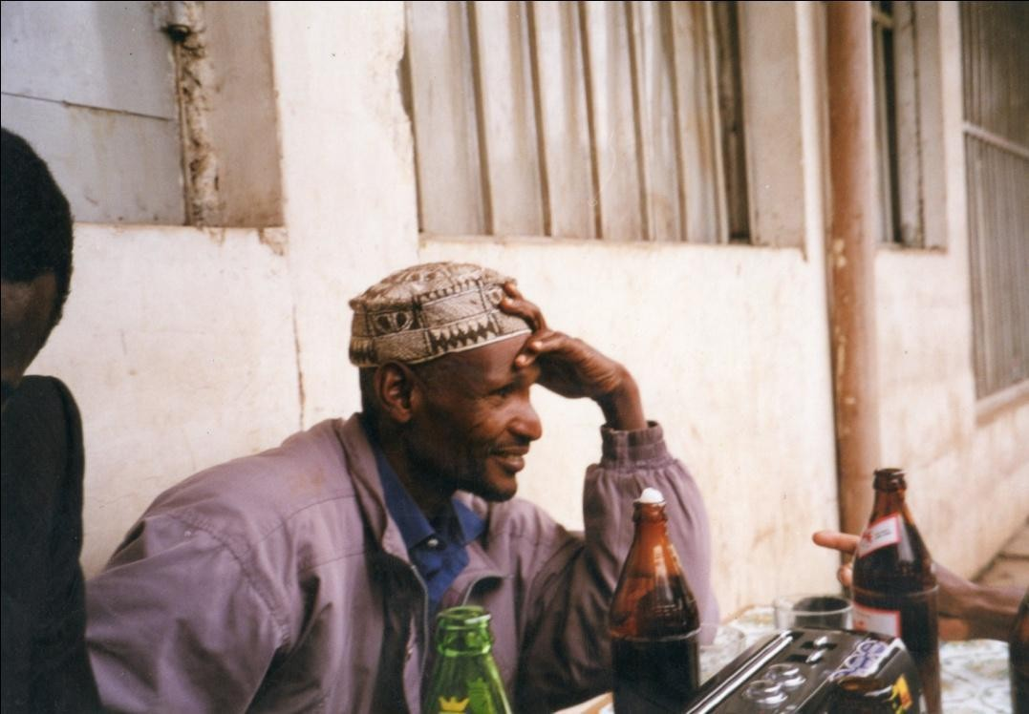
Plate 17. Roba Halake performing age-set qoosa in answer to his ageset peer above.

CHAPTER FOUR
FRIEND OR FOE? : MORAL INDICTMENT OF CLAN IN QOOSA

This chapter investigates the essence of clan qoosa and how it is encoded. The Borana clans have special relationships either of joking or avoidance, a phenomenon common in most African societies (Colson 1962, Gulliver 1957, Moreu 1944, Wilson 1957, Reynolds 1958, Christensen 1963). Christensen for example proposes that joking is an indicator of privileged familiarity. Basing his observation on the joking relationship among the Luguru, he
concludes that the greatest degree of joking is carried on between watani of the same generation, and cross-sexual joking is common with obscene suggestive language and horse play. This is how he puts it:
A man may jokingly grab a woman’s cloth and attempts to disrobe her. A woman may deride a mtani about his lack of sexual prowess, and imply that he is sterile or impotent. He may respond with an invitation to accompany him in order to demonstrate his virility (Christensen 1963:1316).

In the foregoing expose, what is important is that the convention of the genre turns otherwise hostile actions and claims to be construed as a joke about which none should take offense.

Commenting on reciprocal clan relationships among the Bemba of the then Northern Rhodesia, Richards (1937) observes that they teased one another at funerals by making irritating jokes, while at the same time they helped in funeral purification rites. She reports, for instance, that a member of the Crocodile clan will scoff at the one of Fish people and deride him, “you are just my good ration”. Furthermore, she contends that it is common to hear jokes between men and women in the munugwe (joking) relationship to shout to one another, “come here, you are my enemy, you are my wife” (1937:191). Even in this case, the social action of the joking partner clans are mediated by institutionalized relationships that operate to redirect the joke at a solemn time to be understood as a joke rather than an offensive and a callous engagement devised to laugh at the berieved. The generic convention affords the joking partner clan the license to behave inappropriately and get away with it because the speaker enjoys a certain poetic license. The clan relationship entails an ambivalent mixture of hostility and reciprocity.

The agonistic element of joke in general has long been observed as a universal feature (Kanaana 1990). In the case of the Borana clans, the elements of contest, competition, and aggressiveness are manifest in the mode of performance. Clan qoosa is an utterance that addresses a joking partner clan, an action that anticipates and elicits a response. In some of the texts as we shall see below, the responses are direct comments on the abusiveness of the preceding text, such as, ‘you touched [hurt] our clan, I will touch your clan’. The response creates a framing text, one that according to Bakhtin (1986:103) is imbued with the capacity to comment, evaluate and object. This social engagement is more than what Kennedy (1970:52) has called a form of play which provides entertainment that is otherwise deficient. On the contrary, it defines a web of social relationships; and traverses an array of genres in human experience. In the Borana case for instance, joking is a unique art form that combines conventionally disparate genres in oral tradition, such as poetry, narrative, satire, and joke. Although Abrahams (1970:290) recommends the investigation of what limits there are to the license given by the community and by the individuals involved, the generic convention is clear about the extent to which it grants freedom to joking partners. As Stevens (1978:69) comments, the degree of license exhibited is a manifestation of the nature of the relationship, where a man’s jokers are also his moral censors. By the same token, severest clan criticisms are normally from those who share the joking relationships. In addition to its effective role as terse criticisms, clan joke is valued for its aesthetics, what Yankah has called the narrative that pleases the ear, as people are sensitive to discourse animation (1995:107). In the sections that follow, I pay attention to the underpinning genre convention of clan qoosa, and follow it up with an examination of some of the clan qoosa of a teasing nature. Most of the texts have entered the realm of quotable discourse and are re-narrated as new performaqnces, which makes them fresh.

Divided into two moieties, Sabo and Gona, every individual Borana is a member of a certain clan that is ascribed at birth. The moieties are also divided into seventeen clans of which three are Sabo and fourteen are Gona. These are further branched into sub-clans known as maana (house) and balballa (doors). The origin of this division may not be clear, perhaps not even important aside from its organizational value. It nonetheless has far-reaching implications for their social, political, and religious lives. Ideally marriage is exogamous, in that a Sabo can only marry from Gona and vice versa. The clan and gada structures along with lubba (generation) play an important role in the social and cultural life of the people to the point of dictating how an individual should behave towards another individual or group. This culturally mediated behaviour is done through qoosa or wayyu, where the former denotes institutionalized joking, the latter calls for institutionalized reverence. There are clearly defined observances of clan and sub-clan alliances and antagonisms that are played out at various times in the life of the community. A certain reverential bond unites some clans under what is called sunsuma (literally, hearthstone). Members of these clans accord mutual respect and politeness to one another and avoid conflicts by all means. In contradistinction, there are clans whose relationships are marked by mock anguish and who joke at the expense of the other. It is amongst these latter clans that sophisticated, if terse, joke is composed and performed.

Clansmen are obliged to help one another in lean times to redistribute wealth in form of cattle for the afflicted. Social scientists have studied this form of wealth sharing that pervades the Borana community (Oba 1996, Helland 1998). Clan elders who command sufficient moral authority oversee the implementation of this system to strengthen the solidarity and social ties. Although clanship is a social construct, it is religiously executed of which the kinship names they use to refer to each other such as “mother”, “brother”, “father” and “sister” is illustrative. As Legesse writes, a man of Sabo moiety must avoid all forms of sexual intimacy with Sabo woman because they are said to be his "sister", and he must ascertain how he should relate to her immediately by establishing her moiety affiliation (1973). In fact, he not only establishes her clan affiliation but also the lubba (generation-set), since the two are crucial for sexual regulation. In the latter case, if she happens to be in the same gogesa (lineage) with him but ahead of him by one or two lubba, then he avoids sexual commitment to her since she is "mother" and "grandmother" to him. If she is lower than he by one lubba, he also avoids her as his "daughter". Conversely, if she is the same lubba as he, then she is appropriate for intimacy, like everyone in an adjacent lubba who does not fall in his gogesa. This clan and lubba observance of relationships in matters of sex, marriage and sharing of property is important because it is the bedrock of social organization. Deviation from this norm draws sharp criticisms through qoosa and in daily talks, and in some cases the culprits suffer stiff penalties of exclusion from some crucial rituals of social importance. But this neat idealism is flouted from time to time pausing a great challenge to the authority of traditional structures. Cases of members of the same clan marrying are on the increase, as modernity erodes the age-old organizational principle of clan system, and qoosa indicts these apparently rebellious undertakings in the light of its own notions of morality.

The following table shows some of the clan relatiobnship in terms of joking partners (qoosa) and avoidance (sunsuma):

CLAN OR SUBCLAN | JOKING (QOOSA) PARTNER CLAN OR SUBCLAN | AVOIDANCE (SUNSUMA) CLAN OR SUBCLAN
- Karayyu  - Karayyu Suqana  - Digallu | Digallu Digallu Karayyu | Qarcabdu Hawaxxu Wayyitu Warjida

- Digallu Walaji  - Digallu Emaji  - Digallu Titi  - Digallu Udumtu  - Maxxari Gadula  - Maxxari Garjeda  - Nonitu | Karayyu Karayyu Karayyu Karayyu Maxxari Meta Maxxari Dorani Dambitu | Nonitu Oditu Warjida Warjida Dambitu Arusi  Maxxari Meta
- Dambitu  - Hawaxxu  - Warjida | Nonitu Arusi Sirayyu | Maxxari Gadula Karayyu Suqana Digallu Titi/Udumtu

Table 1: Joking and avoidance relationships of some clans and subclans
In the performances of clan qoosa, an element of obscenity comes to the fore. Obscene or dirty jokes as they are generally known have been regarded in the literature as a means for individuals to deal with their own repression (Fine 1976, Legman 1968). In his Rationale For Dirty Jokes, Legman, for instance, argues that under the mask of humour, society allows infinite aggressions where the teller of the joke betrays hidden hostility and signals victory over the butt. He contends “the telling of dirty joke serves in its simplest form as a sort of vocal and inescapable sexual relationship with another person of the desired sex (1968:13). This view assumes that male speakers essentially direct the joke at the female rather than the male butt. This is as one might expect is one-sided, for in the case of qoosa among the Borana, we are dealing with obscene joke aggression at the expense of male joking partners. In the main, most of the clan qoosa performances discussed here criticize the indulgence in socially disapproved ventures and thus serve as a means to assert moral superiority over the butts.
Bryant’s (1991:130) suggestion that obscene joke may be construed as “an aggression in which some persons triumph over others and in which these others are debased, demeaned, disparaged and ridiculed” seems to be a more plausible reason for the joke than the repression of desires as espoused by some theorists. In fact, in view of clan qoosa’s perpetual call for and enforcement of a collective norm, they could be regarded as social satire aimed at correcting the social deviants by subjecting them to biting humour. In so far as this humour is institutionalized within the mainstream Borana culture, they serve as a mirror for the individual clan to discover what is laughable about themselves. However it must be borne in mind that the modus operandi of the clan qoosa is without doubt humour, or to put it in the local expression, “just play”. The play trope is a frame that delineates the communication from serious discourse. Nevertheless, the line between play/serious and fiction/truth is porous and permeable as the textual analysis reveals.

The paired joking partner clans as Radcliffe-Brown (1940) puts it are expected, even obliged, to joke with each other without any offence being taken. For Radcliffe-Brown, institutionalized joking relationship is one special form of alliance as it prevents conflict by keeping the parties conjoined (1949:133). My inquiry into why this institutionalized joking occurred among the Borana clans reveals interesting paradoxical answers couched in locally layered semantics. On the one hand, informants contend that the joking partner is sunsuma to whom one does not utter falsehoods but on the contrary treats with awe, and on the other, he is one with whom one could joke freely. Clan qoosa consequently rests on indeterminately ambivalent ground where awe and free joking are equally prevalent. According to one informant, Koroma Wario, “the joke exchanging clans dare not charge others with false accusation for such a liar would die”. The reason for playing qoosa is that it wards off would-be catastrophe, “abraat baa”. This latter loaded term whose meaning cannot be captured exactly in English, suggests that calamitous events are avoided by mentioning them, by mocking them as if they really had happened. Qoosa plays on the culturally coded but shared knowledge common to the joke-sending clan and the joke-receiving one. In the case of clan qoosa, I presume the mere play on the preexisting socio-cultural information serves to take away the stigma of an event that has already taken place and by the mention of them, debar others of similar kind from recurring.

These joking relationships are configured in a number of ways. One of them is name-calling. In normal daily conversations, ill omen is usually attributed to the joking partner clans. Women are often heard swearing, ‘udu dubr Digallu” (the buttocks of the daughters of Digallu clan), for example, when startled by some unanticipated event. The speaker is from Karayyu clan and the two have mutually accepted joking relationship. The Digallu girls can utter the same about Karayyu and so forth, depending on one’s clan joking partner. These apparent hostilities are based on familiarity and in the opinion of Boru Guyo, an informant, “it is done for purposes of humour because participants love each other, as ordained by god”. Yet the veracity of this love comes into doubt when one considers the foibles of one family or individual projected onto the whole clan by magnifying and generalizing it in pluralistic terms. This kind of projection is a feature of clan qoosa, for the clan is always addressed as a corporate group of people whose acts are generalized, as evinced in the employment of the plural form in reference to them.
What is more, the joking partner clans frequently accuse one another of evil eye (budaa) and the consumption of tabooed animals such as tortoise, porcupine, and warthog. They also refer to one another by the nickname of Waata²⁸, a hunter-gatherer community living on the fringe of Borana community. Invariably, the Waata consume the flesh of the animals mentioned, and thus the consumption and the essential identity are linked directly. In this, we see the attributes of contamination pinned onto the clan with which joking is shared. This pinning of labels implying impurity on rival clans has also been observed in other ethnographic studies

28
For an extensive study of Waata community see Kassam (1992). According to Kassam, in Borana oral
tradition the Waata are regarded with a sense of ambivalence. They are very important for rituals of Qaallu and naming ceremonies but they are also denigrated for their unseemliness.

(Stefaniszn 1950, Rigby 1968, Freedman 1976). Freedman, for example, refers to it as artful insulting and sets out to investigate the element of the interaction that turns a literal insult into a symbolic gesture of friendship. He concludes that the Kiga of Rwanda invest in each clan ritual powers over procreation and activate them with the exchange of services and manipulation of a limited number of sacred symbols of which clan joking is a part (1976:162).

Qoosa in the form of taunts may also be harnessed for the advantage of jesters intent on drawing attention to their immediate needs. In such cases, jokesters couch their material needs in jokes rather than expose themselves to the dishonour of direct begging. Begging couched in artistry is humorous, acceptable and in the main, enters the daily speech as quotable discourses like those proverbial speeches studied by Karin Barber (1999). It is mainly in the form of praise to those who are associated with the person addressed, followed by a coda that begs for whatever one desires. A typical clan qoosa composed primarily for begging but couched in the language of praise can be seen below as retold by Koroma:
Sangan Wario Bante dalach godesa
Koroma Wario waragu wan fora odesa Halake Wario obelesi isa qala gogogesa Ufuma gogesa wan qoru ogesa
Jilti Jarso Haro gaabo jedhe Waaqo Sabura dhufe nat odesa Gabin jil Karayyu lala mee nat hima
(Jenan jars Digallu fudhani mogole dur kani)

The ox of Wario Bante is brown, with curved horns Koroma Wario loves cattle, he talks about foora²⁹ His brother Halake Wario is lean and bony
He is bony but an architect of words who settles disputes
The ceremony of Jarso Haro had plenty, Waaqo Sabura tells me I want to see the plentiness of Karayyu ceremony, please tell me (Then the old man of Digallu clan was given a hind leg of an ox)

29
This is a local term translated in the literature as cattle camp or satellite camp. It denotes a system of
grazing where herds are separated into lactating and non-lactating ones. The latter consists of oxen, bullocks, and heifers and is normally grazed far away from settlements.

The jester begins with the praise of the oxen of Wario Bante that are said to be brown in colour with curved horns. In Borana, this praise is articulated in cattle song where the shape of the horn, colour, and the name of the owner form the main themes (Wako 1993:102). Praised for their outstanding qualities, Wario Bante’s two sons are deemed an adorer of cattle and an architect of words respectively. The climax, however, to which all others have been a preamble is the assertion that the ceremony of Jarso Haro, brother to Wario Bante praised for his huge herds of cattle, he learnt, was conducted amid pomp and bounty in which he wishes to partake. Avoiding the plain language that would compromise his status in the eyes of children, women and ne’er-do-wells who attended the ceremony, the elder negotiates his position by an appropriate code. Resorting to what in the Borana proverbial lore has been summarized as “the beggar of food makes himself a jester”, he performs taunt and wins himself highly prized meat, the hind leg.
Stylistically the words godesa (curved) odesa (tells) gogogesa (lean) ogesa (architect) are crucial to the structure of the poem. Godesa refers to the shape of the horn of the oxen, one of which has just been slaughtered, odesa is used to underscore the narrative about cattle by one of the sons, while gogogesa describes the physique of the son Halake, and ogesa denotes the latter’s wisdom as “an architect of word”. In terms of sound, the words help in the formation of a rhythm on which the poem depends for its forward movement. Describing the cattle, the sons, and the ceremony and by extension the well being of a family on which the jester wants to draw by first of all painting a glorious picture of them, the words are appropriately chosen.

Taunts are also instrumental in solving problems at hand. In the following text Koroma Wario Bante narrates the text of qoosa with which he had confronted a man by the name of Buke Likibo, for an incident in which the latter dislodged his sister from the home of her husband over some domestic quarrel. However, before we indulge in the textual discussion, it will be illuminating to know something about the informant. Born 70 or so years ago (the age is based on his memory of gada system of time reckoning), Koroma lived a good part of his life looking after cattle in the sun-scorched plains of Sololo. Koroma’s family was rich in cattle, a fact attested to by a jocular praise of their family in cattle rearing. In later years when cattle population drastically dwindled owing to successive droughts, he left his family in the rural Golole location and worked as a watchman in Nairobi’s Parkland estate. There are many Borana like him not only in Parkland but also in “the four corners of Nairobi” as they locally call it. As an elder, he plays the traditional role of a Borana man of words, a role he fulfils industriously in spite of the alien environment. He reconciles warring spouses, in-laws, clan members, and generally whenever there is a problem he is the first to be contacted. He arbitrates between Borana youth and their Asian employers, and negotiates amounts to be paid by his “Parkland village” over which he presides, for burials and other myriad problems like accidents, loss of a job and arrests of Borana kinsmen with whom they cooperate on such matters.
I requested the performance of taunts and clan qoosa and he in turn called the people in his “village” that he knows are experts in songs and words. They gathered to discuss mock and play (qoosa), first in general terms and later in an anecdotal style progressing on to specific issues. At times the taunts were narrated as humorous proverbial incidents that have now become part of the social history of the place and people. When Koroma narrates, the others from his village interject with their own knowledge of the story. In connection with the taunt below, such an interjection came from one Roba Halake, “oh I remember the incident, as it was the year when the wife of Boronjo passed away”. Hence the texts of particular qoosa are contextualised by remembrance and retelling. Now for the text:

Koophe fanat lakise Fano fardat lakise Anan diqesa jedhe Sukich Jillo Katelo Burrati idhe bakise Itburese fudhe Dabbo jala fudate Akaku Jillo
Ona tubut lakise Waar Jillo Katelo Galaf harele fudhate Qolle mukhati lakise
He left his shoes on his feet He left footprint on the horse For low milk yield,
The spotted one (cow) of Jillo Katelo He tied on the tree
He snatched
Dabbo (wife) from him, Grandfather Jillo
He left him in an empty homestead From the home of Jillo Katelo
He collected even camel and donkey Leaving them destitutes

In terms of content, Koroma makes fun of his rival clansman by commenting on the latter’s seizure of Jillo Katelo’s wife and livestock, two things that constitute a home in Borana. It captures vividly the implied dissolution and the pain caused to the family by the action of the man who seems to have ignored the traditional mechanisms of settling husband/wife quibbles. The way in which the text is structured is striking. The performer uses common stock phrases such as shoes on feet and footprints on horses, to set the required pace (line 1). The butt’s character is revealed in a series of hints (line 2) that portray him as brutal and unsympathetic to livestock. The text then comments on the butt’s heavy-handedness where he dismantles the home of his brother-in-law by taking away his sister and the livestock that he had given her at the time of her marriage. Qoosa here draws on incongruities that Berger (1972) has called code violation in which strictures of acceptable/unacceptable behaviour was breached regarding in-law relationships. Koroma the jester mocks this apparent non-observance of conventional in-law distance and the breach of customs governing the wife-giver/wife-receiver relationship. The addressee is made to feel ashamed of his antisocial actions evinced in his disturbance of social harmony.

In another text the same jester recounts, how the late chief of Golole location, Buke Liiban³⁰ was scorned for throwing out his senior wife at a time when a clan meeting was due to be convened at his home. Like the text above, this one also benefited from collective retelling. The people present all know the protagonists involved and remember the particular occasion. Koroma accepts and utilizes correction and additional information given by the group in the course of the narration. For instance while Koroma gives the name of the late chief as Buke Liiban, someone adds, Buke Liiban Lakhe in what seems like collective story making where everybody is a narrator, enhancing one another’s memory through correction and interjection. Buke was chided thus:
Buke Liiban dhengada Diqo qabe korat geesa Diqo waara baase, mandhitin ijole
Buke Liiban (a correction by Roba Halake, Buke Liiban Lakhe) Buke Liiban Lakhe kan qaeen kora eesa?

(Ayoonu tana jedhe, atee hinfedhani Diqo galchi jedhanin)

Buke Liiban takes Diqo to the elders meeting He threw Diqo out; the junior wife is a child
This Buke Liiban (a correction by Roba Halake, Buke Liiban Lakhe) This Buke Liiban Lakhe, where is the venue for the clan meeting? (My mother is here he said, he was told to bring his wife Diqo home)
The speaker makes an observation couched in jest to the effect that having sent his senior wife packing at such a crucial time when visitors are expected, the chief is ill prepared to host the important clan meeting. The hosting requires experienced womenfolk and as the jester makes clear, the junior wife is merely a child, inexperienced in handling the reception of such a gathering of clan elders whose needs are diverse. The butt’s plea that his mother was at hand to handle the matter was ignored, with forests of suggestion to bring back the estranged wife, and he had to comply. The clan qoosa here is seen as highly functional, addressing a real problem at hand in a humorous way.

There are many instances where individuals are mocked for poor marital relationships with their wives or in-laws as this text recited by Koroma shows:

30
Ethiopian militiamen on 17th May 1997 murdered Chief Buke. Cynthia Salvadori (2000:128)
documented the murder as a violation of human right and an act of international aggression in a Human Right commissioned book on northern Kenya aptly titled, The Forgotten People Revisited.

Koophele fanan yake Fano farad irat yake Fan cicha barbade
Hadija mira yake Hadija waara baase
Sodoom Maxxari yake
He spoils shoes with his feet He spoils saddle on horse
He searches for footprint He spoils Hadija’s mood He chases Hadija away
He spoils the relationship with his Maxxari in-laws

The poem uses certain key words as building blocks. The repetition of the word fanan/with feet, fano/saddle and fan/foot print plays this role. The first two lines have thus become stock phrases used in both age-set and clan qoosa. It is in line 3 that we get the reason for the constrained conjugal relationship. In Borana there are some husbands who are famed for their jealous feats which makes them look for the footprints of suspected wooers of their wives in their compound. Here the wife called Hadija is annoyed by this suspicious act and she takes off to her people. The butt of the joke is satirized for spoiling what is supposed to be a good relationship extended to him by his Maxxari clan in-laws. In this text the wife is shown as a victim of her husband’s suspicious claims of infidelity. The man, by contrast is portrayed as an aggressor with an unrivalled appetite for quarreling and intolerance. He is unnecessarily suspicious, overtly vicious and stubbornly disrespectful to his wife and in-law, demeanours the performer and his society chide him for.

If constrained relationships between in-laws appear to take center stage in clan qoosa, it is because clans are units for arranging marital aspects of the community’s life. The marriage relationship finds its legitimacy within the imaginative paradigm of clan, itself a social construct. Just as there are certain clans that are socially appropriate to give one another wives, there are also clans that joke with one another about the way those relationships were entered into and handled. They become a kind of moral censor for one another and whatever observation they make is usually given adequate consideration as in most instances they appear to carry elements of truth.

As already indicated above, the salient feature of these taunts is that the Borana use it in certain instances to solve some of the cases that verbal negotiation and wisdom by elders had failed to settle. The case of the chief who had quarreled with his wife cited above is a fine example. Incidents of women caught with their lovers and husbands swearing to kill the culprit also fall within the ambit of situations that taunts of this nature can salvage, as do cases of elopement of girls against the wishes of parents. The case of the clan jest uttered by

the Councillor at the beginning of this book is also a fine example of clan taunts. The poetic finesse with which the joke is rendered and the frankness as well as the supernatural powers that clans are believed to possess, for which they exercise power over one another, ensures the addressee complies with the request.
Besides the taunts treated above, the joking partner clans compose elaborate joke for one another in the form of songs sung at child naming ceremonies (jilla). This group deals with diverse themes ranging from comments on leadership weaknesses, neglect of clan members, to inappropriate sexual liaisons, among others. As Bakhtin tells us, during such ceremonial occasions that he calls the time of carnival, life is subject to its own laws, the laws of its own freedom, and in his words “it is a time of revival and renewal vividly felt as an escape from the official way of life” (1984:7). This escape from officialdom manifests itself in “suspension of all hierarchical ranks, privileges, norms and prohibitions” (1984:10). The clan qoosa on this occasion closely resembles Bakhtin’s category of folk humour that relies on a special type of communication that is gay, triumphant and at the same time, mocking.
Because they employ bawdy and humiliating language on such occasion, the jesters use formulaic language to preface their performances with lengthy apologies and disclaimers for what they were going to say. The formula often employed goes this way:

Waari dhinte dhinna Eeleemmo
Obai maa hinjene Eeleemmo
Waari harma hinjire Eeleemmo
Hawadi fakate Eeleemmo Waari kuno cisaa Eeleemmo Malfano fakate Eeleemmo
Nu malfano hinjene Eeleemmo
Aada jilla jene
The people we are challenging Eeleemmo
Why don’t they say ready Eeleemmo
They are absent Eeleemmo
It (joke performance) appears backbiting Eeleemmo
They are present Eeleemmo
It appears bullying Eeleemmo
We are not uttering this for the sake of bullying
Eeleemmo
It is for the custom of the ceremony

The clan qoosa is thus framed in the terms that clearly spell out what it is and what it is not. It is not a speech that is said to the people who are not present, for the nature of the speech is such that it is too critical of the people it addresses and it is only fair that the allegation is heard, and if possible countered. Neither is it uttered as a speech to bully a people who are defenseless, though the terseness of the criticism makes it appear so. Rather, clan qoosa is rendered as a direct response to the jilla convention, for which none should claim
condemnation and commendation.

The occasion is one where people celebrate their lives by coming together and recounting their past histories and present lives, bringing them within the purview of present reality for observation, evaluation and emulation. The last line above, “as the custom of the ceremony dictates”, alludes to this permissive recounting and reassessment of the community’s life as a whole. The challenged group for its part also replies in a formulaic fashion:

Waari dhinte dhinna Obai nun jedhe Obati fudhane
Aada jilla jene Nuu waran wal jala Waran wal jalana Ola wal godana Wanjenu hinwalalu
Offolen nu nyaati sodana
The people who challenged us Asked us to be ready
We accept the challenge
It is the dictate of the ceremony We are friends with them
We like them dearly
We live in the same village with them We are not in short of what to say
We fear they will eat us

The performers and competitors in the above passage accept the challenge and assert not only their readiness but also their fears. The preface should indeed be perceived as containing some of the most crucial codes of the clan qoosa. First, like all challenges, it contains elements of antagonism that must be answered. Second, the response that comes with the challenge has a way of eroding the friendship between the participants. Hence the speaker, acutely aware of this, finds it imperative to restate and reaffirm the existence of the friendship and neighbourliness that should not be jeopardized by the exigencies of the present antagonizing performance. Third, in answering the challenge posed, it is not that the contestants are short of words, as they make it clear. The truth is that they are cautious of the dangers frankness will bring in a situation where painful revelation of personal or family foibles are brought to the public arena. Startled by such a revelation, the affected individual is feared to cause harm to the utterer in a way that needs some explanation³¹. What the formulaic expression does is to lessen the effect of these dangers by preparing the participants for it psychologically. Thus these formulaic utterances having been exchanged everybody is covered, for whatever is said acquires the legitimacy and license of the jilla ceremony. It

31
The Borana believe that elderly people and certain clans are endowed with supernatural powers. If
such persons were slighted, the offenders would be hurt. The Digallu clan, and the Waar Kurakorme subclans of Karayyu are especially known for their gaar (supernatural powers). One way in which malevolence would befall an individual is that he would lose his speech ability or worse still he could die rather suddenly.

forestalls offence and danger by locating it within the general framework of joke and ceremony, two genres that permit people to engage in extraordinary verbal activities without any reprimand.

The performance of clan qoosa texts that feature prominently on the occasion of child naming ceremony is realized in the festive context that accommodates other genres alongside it. As a matter of custom, the men sit in circles in the hut of the jilla owner and sing the night away, during which, varieties of cattle song, praise and blessing to the children, recounting the history of the child’s lineage, qoosa about women and clan qoosa are sung in a performance marked by longevity and creativity. As Abrahams (1977:79) notes in another context, a celebration that can’t be sustained all night is a disgrace to the performers and the community.

In clan qoosa, a number of themes are treated in a profound way arising from issues that took place, with which the society was generally unhappy. These issues invite comments and people frankly express them through song largely to portray the weakness of the particular clan with whom they joke and in the same vein urge them to mend their ways. In the jilla of Wario Huqa that was recorded during fieldwork, the three outstanding artists were Ajaa Gufu, Guyo Qamphicha and Jirm Dida. Also interviewed at various venues are renowned clan qoosa performers, Koroma Wario, Kana Boru, Kusi Dhiba and Boru Guyo. For purposes of convenience in analysis, I shall talk of their song as texts analyzable for their form and content since the performances are collective, except where personal interviews are given. In any event, the songs have acquired traditional currency and most of the words are generally familiar to the majority of the people. I shall emphasize what the texts actually speak to us and some of the pertinent themes that they raise. Certain concerns are particularly recurrent in clan qoosa that requires special focus seen in the themes discussed below.

Marriages outside the Borana community, for instance, invite adverse comments from critical rival clans who are quick to notice the anomaly as soon as it happens. One jester, Boru Guyo of Warjida clan, creates a joke about a family of Sirayyu clan whose two daughters were married in Tanzania in this way:

Hareen harree dhaltee Gangee fardoon dhaltee
Haricho Karayyu ato Batin dhaltee Haricho sodate jalla Orgeen baadee Halkum Kenyaa dhabdee
Ilman Iya Ganyaa Walum yamatee
Cufti Tanzaniat baadee
Donkey begets donkey Horse begets mule
Mother Bati gave birth to Haricho Karayyu She feared Haricho, Orge his wife ran away They lacked marriage partners in Kenya
The daughters of Iya Ganya Beckoned each other
And disappeared to Tanzania

Two families with different marital problems are made subjects of clan qoosa. In the first case, a man named Haricho had the misfortune of his wife running away because it was said that she feared him. Although the text does not say why the wife fears her husband, the name of the said husband provides a clue. Essentially a nickname, the husband’s name means “male donkey” and such nicknames are normally given to persons who have certain character traits of the objects after which they are named. The fear could be results of insatiable sexual appetite like male donkeys that make the man desire not only his wife but also a harem of other women. The jester is making fun of the butt by employing the imagery of the donkey that in the culture is regarded as stubborn, and an ungrateful beast as the proverb obviously borrowed from Kiswahili language, heshima bundha egeen teqe (the thanks of donkeys are kicks) attests.

The second family is that of Iya Ganya whose daughters are said to have crossed international borders in search of husbands. The joke critiques the tendancy against the backdrop of the society’s perception of girls who are not supposed to give themselves away as willing partners in marriage, let alone search for one. They are represented in a negative light as people who are estranged from the generally accepted social values and conventions. As regards style, this qoosa was constructed from words with similar sounds, harree and the punning word haricho in the first two lines. The ending of most of the lines relies on words that sound alike, dhaltee/baadee/dhabdee. The words are crucial not only at the sound and rhythmic levels but also in terms of content as they carry the import of the main issues raised. Dhaltee denotes beget, baadee means disappear and dhabdee implies missed. The three words aptly capture the birth, disappearance and loss, vital as themes of qoosa. The one born into the community disappears and is alienated not just physically by going to Tanzania but also culturally by getting married to an alien man.

Parenthetically, the daughters referred to in this qoosa are well known to the people of Sololo. Having dropped out of school after a modest education, one of them went to Nairobi to reside with her brother, a shop assistant. It was while here that she met a Tanzanian who married her and they left for Dares Salaam. A year later, the woman came home and went back with her younger sister who incidentally also got a spouse in the same country. Of course, the Borana in their traditional style of being the custodian of social norms did not approve of the arrangement. The joke, emanating from the clan with whom they share joking relations, is given in the spirit of censure and indictment for profaning the institution of marriage by not only marrying outside the community but also outside the country.

Like inappropriate clan marriages, greed is a theme that is common in clan qoosa. In the text below a man of Karayyu clan Diid Huqa Gila is described as greedy because of his incessant day and night roving:

Waaqi dumans guure Wan roobu fakata Fuuli Koote Sora Wan boou fakata Alkani guya deemaa Didi Huqa Gila Sabdi nut fakatee
The cloud gathered, It appears to rain
The face of Koote Sora, Appears to cry
He roves day and night, Diid Huqa Gila
He appears greedy to us

Here, the jester is making fun of two clan members, one for being ugly and the other for being greedy. The speaker describes Koote Sora’s face as being contorted by ugliness and therefore looks like it is about to weep. As for Diid Huqa Gila, his frequency of going to other people’s homes at meal times brings the oddity of his habits to the verge of greed on which the jester comments. The joke is rhythmically balanced with near symmetrical halves divided by the comma. The words roobu (rain) and boou (cry) also aid in creating a sound pattern essential for memory.
Issues of clan leadership are also joked about in clan qoosa. This is especially in the form of comments on the clan hayyu³², particularly his suitability for the post. In the text below, the shrewdness of a councillor is underscored and with it the vulnerability of the clan to being tyrannized by the man’s stewardship. The elections of the councillors are often a contentious issue and are riddled with a lot of conflict that at times threaten to tear the community apart. Jesters critique the choice of hayyu of rival clans and in one such case the jester concludes that the clan in question is about to strangle itself by its own hand:
Alalasa dheete They are afraid of noise
Ala yuyu dheete From the bush they feared hyena
Alalase qore He vociferously arbitrated in cases
Bule qonqo dheete They feared the voice of Bule
Alalan goraa He uses force
Diid Guyo Helo Diid Guyo Helo
Qae gochi dheete The clan deserted his homestead
Bamba hayyu keete And crowned Bamba as hayyu
Offolen baaba bau geete They are on the verge of self-destruction
The jester reveals that the clan rejected Bule’s leadership because they feared his vociferous way of arbitrating in the clan matters. The person refered call Bule Balal, was hayyu during Arero Gedo’s gada, some ninety six years ago. Bule was the only person who ever challenged the authority of Guyo Helo. The story goes that one time Bule Balal chased away Guyo Helo’s cattle from watering at the water well known as Siiba. Having accomplished this task he asked those watering his cattle to sing in mockery of Guyo Helo thus: Afan Siiba yate, Siiba Bullen dhoowate, Abbollen iyya yate (They (cattle) stayed near the well of Siiba, the watering was denied by Bule, Abbole went around crying). Abbolle is the Karayyu subclan to which Guyo Helo the archrival of Bule belonged. When Guyo Helo heard the song, he came and fought him and won, chasing his cattle from watering from the said well. He also asked the people watering his cattle to sing: Angaya gali argate, diman lume gubaa lafuma Siiba argate Camel got browsing plant, the red one of branded neck got Siiba for free. Buude gafi

32
This is a gada councillor representing a clan in the Borana assembly called yaa. A comprehensive discussion of how they are elected is elaborated in Legesse (1973: 126ff). He for example reports a dramatic election in 1969 between Adi Dida and Tuto Anna, which divided the Borana along the clan lines for and against the two candidates.

qorani, guba Bule Balal Siiba dhabde godani the long horned ones like firewood, the blue ones of Bule Balal you must migrate having lost Siiba wells. Guyo Helo’s son Dida was also rejected by the clan as hayyu because of his forceful ways. It was said that he remained unburried for two days when he died because he had no neighbours and people refused to help. A man by the name of Bamba Saake Xururi was elected, and in his election the jester finds the clan’s recipe for disaster. The name Bamba has the same sound with the word baaba (to perish), and it is this likeness of sound that the jester exploits to conclude that the clan, now headed by a man whose name implies perish, is going to be met with just that fate. This satirical criticism reveals that rival clans are a kind of moral custodian of one another. If their direct subjects fear leaders for reasons of politeness and decorum, they are subjected to terse moral probity by a more distant clan over which the leader has no direct influence.
Clan qoosa, for the most part is a vehicle for mirth, drawing on their antagonists’ physical infirmities and habitual misdemeanours. Tallness or shortness as physical attributes are also linked with other social attributes and increasingly elicit comments at the expense of the butt. The following lines uttered by Kusi Dhiba are telling:

Goobo gaala qaba Dheran ak gaala Sarite ka Guraa
Bobbaa daro qaba
Dakko Boru Adi fulli guba qabaa

That with a hump, he owns a camel The tall one like camel
Sarite son of Guraa
Has a gourd under his arm
Dakko Boru Adi, his face has brand

In this text, two people are linked together and made butts of the joke encapsuled in a series of humorous references. The tallness of Sarite Guraa is given in terms that liken him to a camel, an animal whose disproportionate tallness marks it out as an epitome of ugliness. Even the gourd that he is said to have tucked under his arm is from an ugly roughly carved wood usually associated with the camel herders such as the Gaari and Gabra³³. The final line shifts its jocular attention to another man Dakko Boru Adi, who seems to have had facial marks and it is this that forms the basis of the jocular aggression. Facial branding is perceived as a form of infirmity and often become an object of attack by the jesters. These types of marks are normally acquired in childhood as a kind of testimony in remedial antidote to some infliction or other. Common among these inflictions that leave their victims with scars are smallpox, chickenpox, and measles for which the Borana did not have the privilege of vaccines. It was not an uncommon sight for people to have brand marks on their faces as evidence of not only the effect of the disease alone but also a testimonial of man’s attempts to combat the scourge within the limits of his technological know-how.

Deformities such as blindness, like the facial brand, become subjects of clan jests. Chiaro contends that a joke at the expense of physically handicapped appeal to the feeling of repressed sadism (1992:8), and for Bergson, a deformity that may become comic is that which a normally built person could successfully imitate (1911:23). The following texts confirm that jesters can joke about the human body parts that malfunction to render its owner, as Aristotle contends, “ugly without causing pain or disaster” (1927:18). Take, for example, the lines by a performer, Kusi Dhiba:

33
These are Somali-related camel herders. They are notorious for carrying huge gourds that the Borana
derogatorily call darro.

Hadha Kanda Garbiti Mataan lam tahe
Hadha Sanda diqo Ilat bala tahe
Jarti Boru Waaqo Mataan moyye tahe Dibate hinbufane Adate hinagare Matan Boru Waaqo
Manin moyye tahe?
The mother of Kanda Garbiti Her head was paired
The mother of Sanda Her eyes became blind The wife of Boru Waaqo Her hair was sparse
He did not shave in gada ceremony We have not seen him shave normally The head of Boru Waaqo
Why has it become bare?

The first line intimates the seeming double headedness of a protagonist. The shape of the head invites comments even in circumstances outside the jocular arena, and there are consequently people who are even given names in acknowledgement of these various patterns the head invokes. Here the jester is describing one family, displaying a range of their infirmities. The blindness joked about is usually a partial one of a mono-eyed person, so that even as the jesters mix pleasure with pain as Plato (1925) avers, some element of sympathy is reserved for the incapacitated person. Yet there is no denying that the person is a representation of an inferior figure with respect to the jester, and therefore a ready candidate for humour.
In the above qoosa, the last six lines focus on the lack of hair on the head of both the wife and her husband, thus the reason to portray them as objects of aggressive humour. The jester heightens the surprise element by employing a stance in which he wonders aloud how the head of the butt has become bare. To achieve humour and establish the anomaly of the bare head, he calls to service the normative cultural practice that explains the bareness of male head. The first is in the accomplishment of gada rituals at which people in certain stage of gada cycle relinquish their leadership roles in a ceremony where head shaving symbolically marks its closure. The jester makes it starkly explicit that the butt did not undergo this ceremony that would have served an understandable excuse for his bare head. Neither has he been seen shaving in the normal way, the second excusable reason for the barenness of the head. The jester draws pleasure from the infirmities that beset that family, portraying them as symbols of ugliness. As Goldstein (1976:109) points out, laughter at derogatory joke about one’s group may be a means of indicating that the jokes deal with a subclass of the group’s members from whom they want to distance themselves.
Often linked and the person made object of humour in this way, are physical impairment, poverty and being orphaned. The text below describes a man, Sora Otoba, as an orphan who lives in the house of poverty:

Dakko Boru Adi Fuli guba qaba Iyesi waara
Sora ka Otoba Maan iyuma qaba Aban Tanu Buke Jarti bala qaba Nadho balan waara Nadhon isan gartan Maf himama qaba?

Dakko Boru Adi
His face is branded Their orphaned son Sora son of Otoba
He has the house of poverty The father of Tanu Buke
Is married to a blind old woman Their blind elder Nadho
This Nadho you see

Why does he wear decorated turban?
The astonishing thing with the joke at the expense of orphan is that in normal life, being orphaned evokes empathy rather than antipathy. Even in fictional situations that folktale narration typifies, orphaned characters are rarely treated with a knowing sense of antipathy but are given the kind of treatment one normally reserves for one’s own children. The joke at the expense of the orphan, it appears is part of the same trend of anomalous indulgence into which the clan qoosa carries its participants. In addition to the freedom that goes with qoosa performance in general, the need to outdo the other clan with which one is joking makes intensive demands on the jester, thus encouraging him to break the cultural taboos violating the codes of his sympathetic reasoning which would have deterred him from enjoying the pains of members of their community.
The Borana have devised a proverb that underscores the reason why infirmities and misfortunes should not be laughed at. It goes, farr dura baani maale, faf dura hinbani (you could be spared deformities at birth but you cannot escape the shame-inducing humiliation in life). In other words, one may perhaps be born with all the limbs intact and thus be spared the shame that infirmity brings with itself, but in life it is rare that one gets away scot-free from the many social and physical inflictions rife in the world. The proverb thus serves to caution people against laughing at the misfortunes of other as such a misfortune could, by a twist of fate visit the one who gloated at the plight of others. But what qoosa context does is to throw such caution out and enable the jester to freely make reference to the misfortune of other people without bearing the consequences. As Freud avers, joke affords us the means of surmounting restrictions and opens up otherwise inaccessible pleasure source (1916:150).
In another example, although other characteristics are joked about in the text below, the eye is the one targeted here:

Harroo Halakee Sanqee Galcha diid keetee
Galcha har Halakee Kaaruu afaan keetee Afaan Diid Jillo
Gayyaa keesa keetee Jaldesa Molu
Dhibu Waata keetee Maanti achi gaad dhiba Ilti Molu Moyo
Fiite koola teete?
The water pan of Halake Sanqee They placed it in the open
The catchments for the waterpan of Halake They put Kaaruu in charge
The mouth of Diid Jillo They put cigarette in it Jaldesa Molu
They put in the bedroom of Waata What is pushing it from there
The eyes of Molu Moyo Sit on the eyelid?

In this jest we notice the use of the plural ‘they’ as a way of referring to the clan. The actions are all performed by the clan in the perception of the speaker, even when it is the individuals who have done so in their private capacity. This is one of the ways in which clan qoosa is marked that is, the attribution of individual follies to the entire clan and critiquing them as the weaknesses of the many. The first two lines about the water pan shall be explained in the section that follows, but let us focus on the other lines. In simplified terms, the lines make fun of three persons and of course with them the entire clan. These are, Diid Jillo for smoking, Jaldesa Molu for consorting with Waata women and Molu Moyo whose eyes are bulging out in a deformed way. Far removed incidents are brought together through sound pattern, where the ending of one line provides the beginning of another, as in the word afaan/mouth of the water pan provides the beginner for the next line afaan/mouth of a person who smokes. This

kind of linking device where the final element of one line is converted into the initial element of the next line has been observed in other oral compositions in other cultures (Lord 1960, Tedlock 1983, Andrzejewski & Lewis 1964). For the Borana songs, jests and poetry, it remains the most pervasive style used to connect ideas. The repetition of galcha/catchment, afaan/mouth, and Molu in the various lines of the text serves as a connective of the various disparate elements in the text. What makes this jest interesting is the claims by the jester that the clan was engaged in doing things that people do themselves, such as smoking or consorting with women considered from socially impure communities such as the Waata in a sort of deliberate way. It is these deliberate actions that are imputed to the clans that are laughed at. Even the deformed eye becomes the subject of jest because there is causality behind it that the speaker seeks the answer for.

A joke reflects social attitudes and provides a vehicle through which people can voice feelings for which there is no socially acceptable or easily accessible outlet (Winnick 1976:124). Accordingly, one of the most central features of clan qoosa is that it records and critiques sexual inappropriateness among members. Most common of these improprieties are impotence, incest, homosexuality and zoophily, and it would be rewarding to look at each of them in turns. But suffice it to state from the onset that an explicit engagement with these tabooed themes is primarily a manifestation of negotiation of the prohibited and the suppressed, that which social convention has denied entry into the domain of the discursive regime. In the joke that follows, Ajaa Gufu, a jokester captures sexual inadequacy of a man in this way:

Halake isani Barochu odesa Didi mandha wara Falan gogesa
Dhenge cimpee hinqamne Rufot nut odesa
Their Halake
Talks of the bellows of bulls Dida their younger brother
Is lean like a stick
That Dhenge is impotent Rufo narrated to us

The qoosa text underlines the character traits of three brothers. The first is infatuated with cattle and preoccupies himself with talking about the way bulls bellow. The younger brother is negatively portrayed as lean like a stick. But the climax, to which the preceding lines are merely a buildup, is the revelation of the impotency of the one called Dhenge. This is done in a conspiratorial way where Rufo, the wife of the butt is shown as an accomplice in divulging the damaging information. The jester implicates her to authenticate his claim, a strategy that alienates the victim and denies him the public’s sympathy.
Unlike Dhenge in the above text who is charged with impotence, perversion is the subject of criticism below. In the following text, a man, Caacoolle Boru is implicitly referred to as one who engages in copulation with female donkeys:

Qorati sodati Allo jal hinbatu
Aliya sodati
Afaan lagaa hinbatu Caacoolle ka Bore Hareen hinsodati

Moga wara hinbaatu For fear of thorn,
They pass not under allo tree For fear of gorge
They pass not at the river mouth Caacoolle son of Boru
Donkeys fear him
They do not go to his residence

Lines 1 to 4 set the scene which culminates in the last three lines underscoring the man’s tendentious affection for donkeys as a result of which they now dread visiting his residence. The matter, which is in the category of a dirty joke, is curiously surprising for a community that espouses the tenets of gada rule essentially built on principles of sound morality. Certainly such outrageous indulgences in zoophily, by all counts belong to the domain of immorality. But a glance at Borana customary law (seera) has punitive provision for those who copulate with animals. And curiously enough, the law against copulation with the domestic animals such as the donkey, cattle, goats and the like is at variance, with the one on cattle carrying the severest penalty and that of the donkey the lightest. These variable sentences throw light on the local classification of these animals and the place they occupy in the hierarchical category, which is primarily based on whether they and their products are consumed. In this hierarchy, cattle are rated highly and strong regulations against any intention of copulation with them are expressively meant to protect them from desecration. But since the donkey is merely a beast of burden and neither its meat nor milk is consumed, the society is not particularly inclined to protect it against real or imagined sexual contamination.

According to one informant, Boru Guyo, donkeys, like humans, have the dental formula of lower and upper teeth and thus in traditional classification of the Borana are closer to human beings than cattle. Legman (1968) suggests the cow’s paramount motherliness as milk-giver fortifies it against bestiality. He points out that in Europe it is the sheep that is usually the target of zoophilic jokes. In daily Borana discourses the donkey is classified with the horse as the compound term farda-gange (horse-mule) indicates. The horse in particular is treated with close affinity to the human world. One example of such treatment is in the regulation of watering at wells that the Borana have clearly devised. The horse, according to this laid down rule, cannot be denied water because like humans such a denial would interfere with its gestation and cause it to have a miscarriage. Once this happens the person responsible for it would be charged under the Borana customary law as if he had caused a woman to abort. But explicit sexual intercourse with the donkey among the Borana is uncommon unlike their neighbours, the Guji. Boru however, explains that the joke about copulating with the donkey, with which he prods his rival clan, is based on likelihood and is therefore not factual. He narrates an incident in which his rival clan member stumbled over a donkey in the dark at night. The beast, true to its nature kicked him so viciously that he fell with a thud a few meters away. Having learnt of the incident later, he made a joke that the man had in fact intended to copulate with the donkey and was rebuffed with a disastrous kick.
If qoosa arises from incidents like the preceding anecdote, it then begs the question of the place of truth/falsehood regarding the clans that exchange qoosa. As earlier stated the answer is ambivalent, which perhaps is the genre’s way of defying definitive categorization. Such ambivalence has also been observed elsewhere (Oring 1973). In his discussion of chizbat-a body of jokes, anecdotes and tall tales, among the Jews, Oring points out that, informants repeatedly suggest chizbat contained some kind of truth, despite the fact that the word’s literal meaning is “lies”:
It doesn’t have to be all right, but it is not all wrong. It is a story that happened but with a little bit imagination. But the imagination in this case is to make the story a little better, not to change the story. Chizbat is part true, part false and is humorous (360).

Qoosa, like chizbat above, concerns real characters and situations embellished at either the content or formal levels. In general it is safe to assume that clan qoosa contains elements of truth and fiction and that what needs to be answered is the degree of each and to what use they are put.
Like bestiality, homosexuality too, is a common theme in clan qoosa, a phenomenon already underscored elsewhere in the category of sexual jokes (Fine 1976, Chapman & Gadfield 1976). The following text is clear about the occurrence of homosexuality among the Borana and chides the clan from which the person who indulges in the practice hails:

Waari kenna Basso Waani keesan baasa Wan keesan gad baasa Kotobo Qandhoye Janjamo Qaloye Waari Qandho Ruusa Aad lafat ruuse
Gurba Guyo Rero Udu dhira ruuse (Kobla)

Our clans are Basso
Your deeds are strange
I shall reveal your deeds Kotobo Qandhoye Janjamo Qaloye
The family of Qandho Ruusa They bend their forehead
The son of Guyo Rero
Stretches his buttocks to men (Prolonged laughter)

Line 1 underscores the speaker’s identity as coming from the Basso clans. The Basso clans are regarded as being vested with some ritual powers for which they are venerated and held in high esteem. In fact the word basso denotes transcendence of sort and in certain ceremonial rituals he-goat from the Basso clans are slaughtered specifically with the belief that it will aid the Borana to transcend upheavals such as war, drought and disease. For the speaker to assert his people are from the Basso clan, he is underlining their importance within the cultural context of the Borana world. This is heightened when it is contrasted with the butt’s social position, which through the use of words that sound alike (basso, baasa, gad baasa) is denuded and exposed to ridicule. Line 2 thus underscores the oddity of the butt’s clan, and in the line that follows, the jester asserts that he will expose the strangeness to which he has alluded. Lines 4-9 name the personalities in the butt’s clan who engage in homosexuality. The names Kotobo Qandhoye and Janjamo Qaloye are in themselves funny because they describe their owners’ physical oddity. One is peculiarly short, diminutive, while the other is hefty, gigantic. The last two, Qandhoye and Qaloye are funny at the level of sound. Lines 6-9 describe how “the people of Qandho Ruusa place their foreheads on the ground and stretch their buttocks to men”.

The laughter can be construed as a way of distancing oneself from the peculiar act where men stretch their buttocks to other men. In fact Borana people guard against the touching of male buttocks as it is considered an act of castration. The term for a homosexual in Borana is midisa, and it is always invoked in relation to emasculation, failure, weakness, and defeat. For instance, it is commonly used as swearword as in, “if I do not beat you, call me midisa”. Failure to punish a wrongdoer would temporarily make a person a homosexual, or a female because maleness constitutes doing whereas femaleness/homosexuality consist in being done to.

According to an informant, Jillo Waaqo, publicly known midisa are a rarity in the community. He relates that as a child (now he is 65) he had known of a midisa by the name of Kotote. Kotote became a homosexual in a rather unfortunate hunting event. The legend goes that during a hunting expedition, Kotote, who was a famous hunter, killed a female rhino during a mating season. He was asked to sing gerarsa, a heroic song in self-praise normally sung at

such moments. But instead of singing the male oriented heroic song, he sung kaarile, a song sung by women in praise of their lovers. By singing thus, he irreversibly assumed the role of a female rhino on heat. He thus became feminized, and men ran away from him, believing that his state was contagiously feminizing. As he was narrating the story of this homosexual, he kept referring to him in feminine pronoun, thus changing his gender. It seems to me, whether one is creating jokes on the basis of imaginary bestiality or the realities of known homosexuals, qoosa on these subjects are meant to radically take a position regarding sexual perversion. Desiring a donkey, daughter or people of the same sex are morally debasing alternatives of life, which the singers abhor and reject.
The following example is also an explicit case of homosexuality:

Harr Halake Sanqee Kaaru afaan keetee Galcan harr Halake Duuda Dhera geetee Duuda ufit galchitee Gurba Waaqo Fancoo Shondo udu keetee

The water pan of Halake Sanqe They put Kaaru in charge
The catchments for the water pan Extends to Duuda Dhera
They turn his back to themselves The son of Waaqo Fancoo
They insert penis into his buttocks

It is the Karayyu clan who are thus indicted in this rather self-explanatory jest. The first line is about the water pan in Tuqa region in southern Ethiopia named after the person who first dug it, Halake Sanqe. In Borana, water pans are important sources of water and even as they provide water for the whole community, their owners manage them on behalf of the people. In this case Kaaru, a family member, manages the water pan. Line 3 states the fact that the water pan in question has a catchment area that stretches to a place called Duuda Dhera. Although this is stated as a fact, the important thing the performer wishes to utilize is the name of that place whose literal meaning based on its geographical feature translates as “long back”. It is this name that refers to the “long back” that gives impetus to the line that follows describing the way in which homosexuality is carried out. The “long back” as a physical feature that describes a place is transformed to denote human back of an individual allegedly involved in homosexuality.
Incest as a theme is very common in the clan qoosa. It takes the form of the lusts fathers have for their daughters. The clan being a set of imaginary construct of social relations rather than biological ones, the prohibition of incest has both real and metaphorical aspects to it. Not cohabiting with the daughter of the clan is metaphorically synonymous to avoiding incestuous relationship with one’s own daughter. Conversely avoiding older women the age of one’s mother meant the prohibition of incest between mother and son. The following text is illuminating:

Gaalan Waasoo
Godaante quubaatee Gaalaata guudisaa Duubra ira fudhatee Koophe itbafaatee Afaa ityabatee Intaal ufi dhaltee
Fulasa lalatee Gaaraan dhaala baadu Waa jirtaa gaafaatee
To the Uaso Nyiro River They moved and settled The debt of nurturing
They obtain from their daughters They remove their shoes
They climb the bed to them Their own daughters
They search for penetration
The belly of birth being sympathetic They inquire whether they have survived the act

Lines 1-2 underscore the practice of shifting with cattle and here the Uaso Nyiro River is the targeted destination. It is common for people to move within the designated Borana area for the purposes of grazing their livestock. But the importance of these lines are the fact that they herald the word for the third line, gaalaata (thanks) or read within the context of that line, “debt of nurture”, on which the rest of the text is built. We see the subtle use of sarcasm here because the taking of the debt of nurture is sarcastically given as the justification for incest. The same sarcasm is employed in the last line where after a brutal sexual penetration the victimizer is moved by the empathy of parenthood to inquire whether his victim has survived the sexual aggression. The aggression is heightened by the preceding grotesque and vivid description of how the sexual exploit was executed (lines 5-8). It should be noted that the Karayyu clan are the only one among the seventeen Borana clans that enjoy uninhibited sex with women born to their clan. The only restriction that needed to be observed as an exception is that of the lubba and the closer clan segment known as maana (house).
The comment seems to have been generated by the permissive but uneven privilege granted to one clan by the cultural rules. In fact, it seems to echo the sentiments of one envious of the prodigious advantage extended to Karayyu, as other clans too would be tempted to have unrestricted sex with their “daughters”, since the daughterliness is only a social construct. From a psychological point of view, however, qoosa expresses the fear of the possibility of incest and by expressing it in this imaginative genre in a grotesque style, debunks the realization of it. In a word, qoosa is meant to prick the conscience of the fathers and circumvent the very possibility of its fulfillment. At the same time it dramatizes the tension between an ideal moral order and the concessions made to them in what appears favoritism of a clan that makes it operate outside the common codes. This concession seems to be the tension point not only between the clans but also between the idealism of cultural dictates and the practicalities of daily lives.

According to Koroma Wario, an informant of Karayyu clan, the Karayyu were permitted to have sex with their clan women because, as a clan they were beset with problems of population growth and expansion. It was then that the Qaallu blessed the cohabitation with their “daughters” with the stricture that such cohabitation precludes marriage. After this blessing the Karayyu population grew by leaps and bounds and today they are larger than all other clans. The envious feeling harboured by other clans with the Karayyu on this matter manifests itself in other speech mannerisms, where for instance, the latter are referred to as haramu (incestuous people) whose numbers multiply as a result. This comes to the fore especially during local elections where numbers are significant in deciding the outcome.
Incest is also symbolized by sex with one socially regarded as mother or son as evident in the following text as rendered by Kusi Dhiba:

Waar Boru Liibe Ka Liiban Duuba Ka Duub Dedee Budunun isa lama Ta ciiruma tana Ta wayyuma tana Hallo hadha baase Boru Liiban nama
(Kobla. Dhugum baan)

The family of Boru Liiban Who is the son of Liiban Duba Who is the son of Dub Dedee Their professions are two They are healers
They are fortune tellers
He avenged (sexually) his mother Boru Liiban is a man
(Laughter, he speaks the truth)

The qoosa text centers on the family of one Boru Liiban, who on the face of it, is praised by the speaker. But the apparent praise manifest in the recounting of family genealogy and profession is utterly deceptive. In fact, the whole qoosa rests on the irony that turns the praise to undercut the subject as a dubious character. This deserves closer attention as it has a narrative attached to it. According to the speaker (personal communication), Boru Liiban, the man talked about in the joke, had an affair with a woman whose husband had been cohabiting with Boru’s mother. In the Borana culture, a man who has had such a relationship with one’s mother is regarded as one’s junior father (abbera). As a matter of fact, a series of associations that are more social in nature than biological develop between the kin of such people. Under those circumstances, the man’s wife is Boru’s mother’s double. That is to say, having an affair with such a woman is generally taken as cohabiting with one’s own mother. The text under discussion gains jocular credence in the choice of words, particularly in the use of “hallo” (revenge) and nama (man) literally in heroic sense. Hallo normally denotes retribution on behalf of one’s own kin who met their demise at the hands of the enemy. But in this case a son retaliates in vengeance of the mother’s sexual adventures and the speaker presupposes the said mother was assailed sexually. The supposition has an ironical twist to it because the relationship was entered into by mutual consent. Secondly to refer to Boru as a “man” is to laud him for his action. Yet the community knows and believes what he did was wrong. The speaker thus gloats over a wrong and goads the man on by praising him for it. In the eyes of the community, the matter is perceived as an Oedipal complex, since the woman in question is socially regarded as the man’s mother as stated above. Qoosa sarcastically questions the man’s virtues.

Woman as an object of erotic neglect is joked about amongst the clans. The jester’s proposition is that it is upon the clan members to perform the duty of satisfying their women’s sexual needs and that any neglect of that duty becomes a subject of qoosa. Hear a jester, Koroma Wario:

Gaaf godan Gimbe Ororo harkiftte
Godanaa kaate Wati gad lakifte Godaan Dukale Bala waara isani
Qiixoo Caana fale Chamumat lakifte Waluma golite Waluma dhosite
Hadha Boru Qiixoo Dariman lakifte

During the shifting to Gimbe They carried sticks
Ready for shifting
They released the calves free from tethers During the shifting to Dukale
The blind of their homestead Qiixoo Caana
They left him behind in the sun They shielded
And they concealed for one another The mother of Boru Qiixoo
They left her in sexual desire

A descriptive tale of one family whom the jester singles out for criticism, the text details how they conduct their social affairs. Lines 1-4 allude to the shifting from a place called Gimbe, also known by the name Dukale, a common phenomenon among the nomadic Borana in search of grazing land for their herds. But the comments that the performer makes in the text are encapsuled in lines 5-12. Line 6 exposes their irresponsibility evinced in their abandonment of the blind person in the homestead in the course of their movement. The disabled elder named Qiixoo Caana was left basking in the sun, having been regarded a burden by his kin, an utter neglect that caught the eye of the jester for which he chides them. The lines 9-12 underscore the conspiratorial way in which the male members of this family denied sex to a widowed female, referred to as mother of Boru Qiixoo by refusing to inherit her as a wife after the death of their brother. The speaker critiques the anarchic social condition where the infirm are abandoned and widows are left to suffer without the benefit of second marriage.

As I have argued in this chapter, the Borana, organized into clans as units that strengthen social ties, look over their shoulders to monitor the activities of other clans. The community subscribes to certain moral codes, which embody their very notion of a united people. When this underlying sense of a people is threatened, humorous but biting comments are formulated not only for the individual deviant but also for the entire clan. The clan criticism on the whole serves as a crucial platform for fostering the generally accepted traditional codes by subjecting pervasive tendencies of deviation to public ridicule. Moral estrangement and the loss of human dignity are projected as real or imaginary vices that pose a threat to the value system of the community. Such perversions are strongly resisted through suppression of individual desires that tend to gravitate towards deviance. But even as society strives to maintain what it deems a viable order, where clan qoosa serves as its cultural mirror, tension simmers beneath the veneer of the very system. This is partly due to the contradiction within the system and partly to the modern day exigencies that make the community open to ideas and cultures from the wider world.

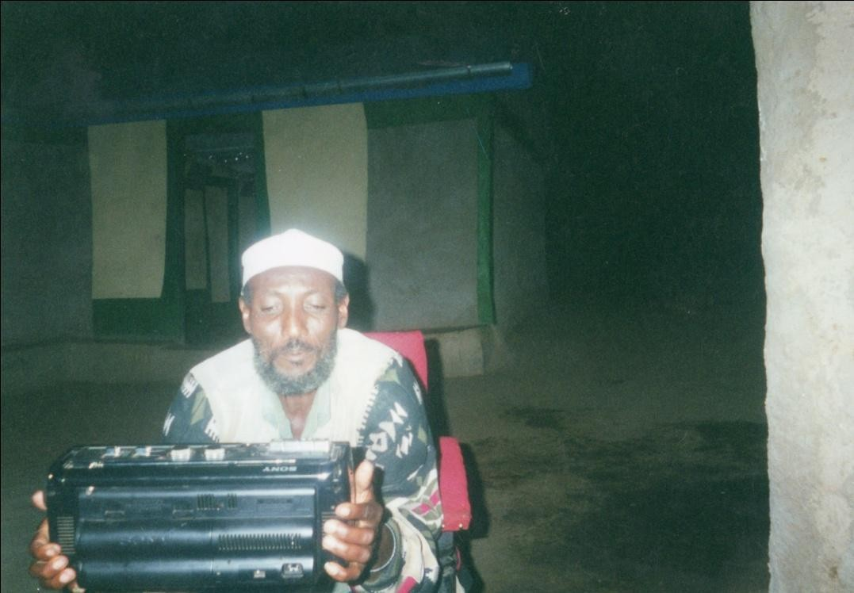

Plate 18: Mr Boru Guyo Oda perfoming clan qoosa.

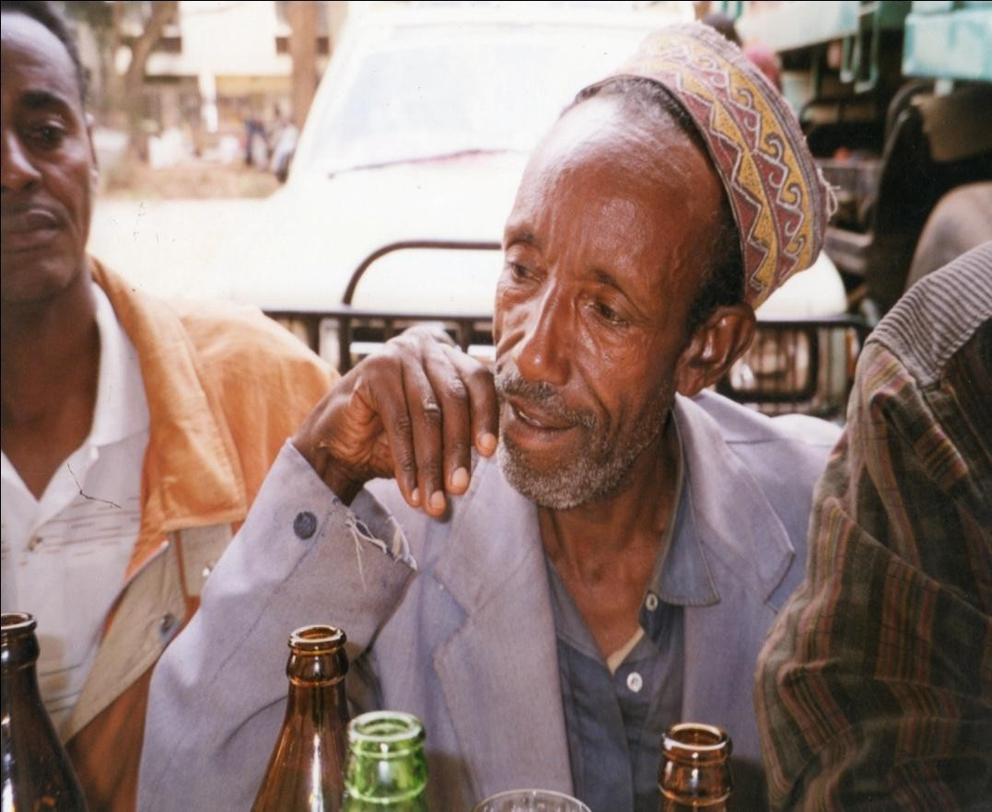

Plate 19: Mr Koroma Wario Bante performing clan qoosa.

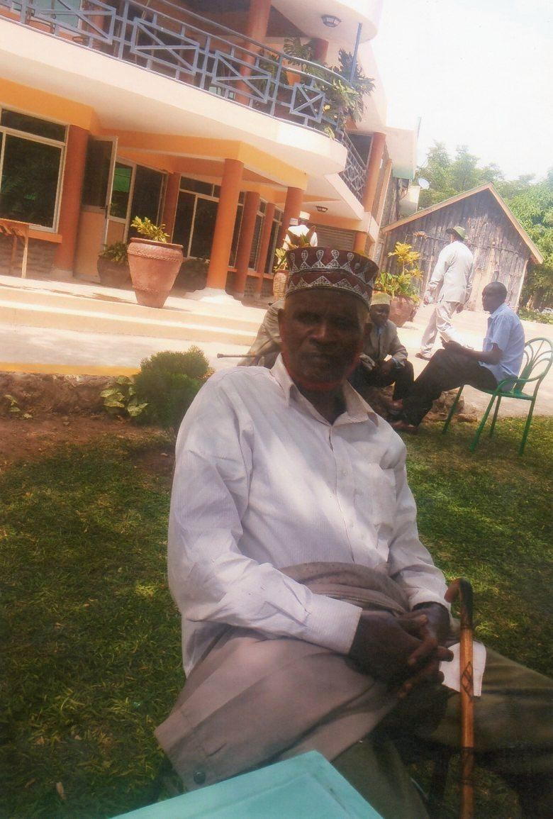

Plate 20: Hayyu Yuubome (retired) Qanchora Liban explains the meaning of clan qoosa.

CHAPTER FIVE
POETIC LICENSE: WOMEN’S QOOSA ON MEN
The critical role joke serves has long been observed, and as Christie Davies (1990:9) argues, jokes are social thermometers that measure, record and indicate what is going on. In this sense, they provide insights into how societies work since “joke does not exist in a vacuum but rather exists in society where it embodies or reflects the concern of that society” (Dundes 1977). Salient to this concern as Douglas indicates is that dominant patterns of social relations are challenged in joke (1968:366). Among the Borana, such a challenge is manifest in women’s qoosa, which to all intent and purposes is a public questioning of men’s posturing of themselves vis-à-vis women. Qoosa by women on men, in a nutshell, is a poetic and humorous rendering of the general discontent women experience. It is a narrative that can easily be categorized as what Morgan (1992:2) has called a critical exposure of ideological mystifications that obscures the inequalities (between male and female) or presents them as natural and immutable. To the extent that they confront the male world and subdue it, if momentarily by subjecting it to shame, women’s qoosa among the Borana is an attempt at representing the culture of the subordination of women by men in a different light.
Performed during the jilla (naming ceremony), that allows oddities to be tolerated, women qoosa humorously assails male crudity. On this occasion, the women constitute themselves into a group that challenges the traditional social order which privileges the men, by recounting the follies of men in their daily experiences. According to Mikhail Bakhtin, such ceremonies are “opposed to dogma and authoritarianism, and they are full of revival and renewal that are sanctioned by the highest aims of human existence and the world of ideals” (1968:8). The present chapter thus interrogates the ways in which the Borana women critique and challenge the men’s hegemonic powers using the playful genre qoosa. Conceived and enacted within a critical paradigm, women’s qoosa serves as a verbal weapon for those who have been relegated to a subservient position by a male oriented culture. From the point of view of the women, as Koljevic (1980) says of Yugoslav epic, it is a way of coming to terms with history and a means of getting out of it by negotiating the power differential between the two genders. Since women’s qoosa is a discourse in power dynamics and the ways in which women negotiate this power, this study draws on the works of Eileen Gillooly (1999), Abu Lughad Lila (1990), and Vail and White (1991), all who have treated the ways in which women negotiate the power differential between themselves and men.
Employing the concept of veiling or masking in her fascinating study of female humour, Gillooly has investigated the indictment of men by women. Feminine humour is conceptualized as a veiled tactic that refrains from pervasive satiric engagement but works inconspicuously to mock the officious (Gillooly 1999:18). Drawing on the 19th century British novel, the author uses copious evidence to demonstrate the ways in which feminine humour undermines socio-cultural values in subtle and nuanced ways. For her, feminine humour inverts the male oriented paradigms by mocking the disproportions and incongruities within the (masculinized) norm. The traditional cultural authority has been internalized and it carries the weight and force of law. Set against this stifling tradition, feminine humour is subversive and functions as a tactic of cultural resistance and a gendered protest.
The kind of resistance motif outlined above has also been located in a Muslim community that seethes under strict Islamic codes. Abu Lughad Lila’s study of women’s veiled resistance to men’s power amongst the women of the Bedouin society in Egypt is a fine example. In her

essay, veiling is used to underscore the women’s invisible aggression towards the men’s perception of themselves, troped in such adjectives as brave, dignified and strong; postures that are resisted through the inversion of the notions of power. Women resist male power by making fun of men and manhood even though officially masculine qualities are lauded. According to this scholar, women seem only too glad when men fail to live up to the ideals of autonomy and manhood, the ideals on which their alleged moral superiority and social precedence are based (Abu Lughad 1990:43). In their own ways women behave irreverently towards the mark of masculinity and privilege by engaging in subversive discourses. Violation of the masculine codes, the study concludes, must be seen as a way of resisting the system and challenging the authority of those who represent and benefit from it (Abu Lughad 1990:47).
The theme of resistance to men’s hegemonic powers takes different forms. Vail & White (1991) through the study of spirit possession (vimbuzi) among the southern Tumbuka people, illustrate how women use the licensed opportunity to articulate their sentiments against male hostilities embedded in the patrilineal systems of marriage. The possessed women, they suggest, present their complaints in the authoritative voice of the spirit, and the “songs invoke not merely an alternative interpretation of history, but also an alternative vision of how life ought to be lived” (1991:247). Through tactics like veiled sentiment or licensed opportunity afforded by spirit possession or concealed tactics to challenge masculinity, a powerless group attempts to find a niche for themselves within a world dominated by men.

Power, Fabian (1990:23) apprises us, is “eaten whole, and once ingested power is internalized, it becomes a person’s weight, a property rather than a function”. In this instance it is the men who are surfeited with power, both literally and figuratively, as a Borana legend will presently show, and it is this powerful monster in the form of men that women must learn to live with one way or the other. Women’s qoosa as an ideological rather than taxonomic discourse, as Bruce Lincoln (1999:149) says of myth, imbues the women with the reflexive capacity to challenge and negotiate the effects of conventional power that essentially subordinates them. Thus the physical might of men is mediated by the verbal articulacy of women that undercuts it by attacking the moral base of the former. Johnson (1973:212) speaks of how women use words effectively to maintain control over the physically stronger men.
In the Borana traditional lore, the fact that men have indeed subjugated women in the power game is best captured by a well-known legend of a woman called Habanoye³⁴. The legend goes that at the height of her reign Habanoye had so subdued the men that, it was they who cared for and tended the children, drew water, collected firewood, and looked after cattle (Kidane 1996:272). Before men toppled her and changed the prevailing power dynamics, she was remembered for demanding impossible tasks to be carried out by men, which included

34

Famed for her tyrannical leadership Habanoye was the last of the most powerful women leaders among the Borana. According to legend, the pit into which she was believed to have fallen is found around the vicinity of Mega in Ethiopia, some 500 miles south of Addis Ababa. A similar legend was reported among the Kikuyu of a woman, Wangu wa Makeri who lorded it over the men but was overthrown in similar circumstances. Although the two legends differ in detail, the authoritarian motif and overthrow of women from the position of leadership is the same.

among others, bringing a sack full of fleas, and hide that has hair on both sides. Finding the tasks impossible, the men instituted their rebellion in stages, presided over by a young clever boy. To dispel the task of carrying children during the many nomadic migrations, the boy advised them to insist that they share the burden by cutting the children in half so that each carries some part of them. But the women, known for their love of their children, would decline and offer to carry them by themselves. As for building houses, the men declined to undertake the task, but insisted on making love in the open. This was meant to induce shame in the women and faced with this abject lack of privacy, they accepted the task of building the houses themselves.
The final onslaught against Habanoye herself came in the form of a meticulously devised conspiracy by the said boy. A hole was dug and covered with grass and her stool was placed on it to cover up any suspicion. People then provoked her by opposing her decrees. Because it was known that she moved with her stool in moments of fury, it was anticipated that she would in the course of this movement fall into the fatal pit. This murderous plan was executed to the letter and the great Habanoye died in this way. As she was dying, the legend claims, she left a legacy and a rallying call to women to disobey their husbands, lie, deceive and fail to respond promptly when called for, edicts according to the Borana, women accomplished with great zeal.
What then is the significance of this legend to the concerns of this chapter? It must be acknowledged that the legend is layered and can be analyzed at several levels, one of which is that by referring to the purported tyrannical rule of women in history, the legend serves to justify the present denigration of women. With the demise of Habanoye, patriarchy supplanted matriarchy. Women lost the power they enjoyed and were thus subjected to servile treatment from men, a state of affairs women’s qoosa in its own ways critique. This line of analysis is supported by the fact that the domestic chores now ritually and stoically borne by women had been previously carried out by men. Following from this and more importantly, the legend can be read as a codification of the politics of representation and how notions of gender are inscribed and naturalized (Kratz 1994). The core meaning of the narrative is that it legitimizes the prevailing gender relations of power and authority by giving currency to male domination over female within the Borana culture. The legend is essentially an explanation and a justification of the dethroning of women from what Nyman (1997) has called the public masculine world to the domestic feminine world. Thus it celebrates the masculine world as clever, virtuous and heroic and by extension posits masculinity as a cultural norm which came to be a viable alternative to the feminine rule whose tyranny was its own undoing. In addition, the knowledge of the legend helps us to locate the women’s qoosa within what White (1989) has termed “concrete social formations and particular historical moments”. Thus situated, the humorous songs that are sung by women about male greed, for example, can be construed as an idiom of power dynamics between the men and women.
But not to be lost sight of is the edict, which was inserted as an etiological parting shot to explain the perceived obstinacy of women. What men perceive as obstinacy constitutes the resistance motif whose artistic expression women’s qoosa verbalizes. Whether it takes the form of direct criticism, ridicule, sarcasm, veiling or masking, these are ways humour is represented in a particular place by a particular artist, oral or otherwise within the tradition in which the artist is operating. Veiling or masking can occur in many ways, some of which are embedded in the culturally licensed performance such as qoosa that diffuses the abusive elements but nevertheless makes its mark. In daily life, women’s resistance to male power is embedded in a refusal to respond fast enough, as well as lying, cajoling and partaking in the

choice portions of foods traditionally reserved for men. Verbal mockery in the form of songs, however, is a refined art where the performers show no apology and disguise for their mockery of the male world even though they have been reeling under its overarching ways. The women’s qoosa and the reading of it in this chapter is an exercise in what Daniel has called “a narrative other than the master narrative that needs to be drawn in a situation that calls for the cultivation of an ear for discourses that are normally drowned out by hegemonic ones” (1996:10).
As a marginalized group, women in the Borana community do not attend public meetings, which are the preserve of the male. Even if they are litigants or witnesses in cases, their pleas are taken as they cover their heads and face away from the gathering, after which they are required to leave immediately. Their marginality has also been captured and expressed in proverbs, an art that (Yankah 1995) neatly summarizes the community’s ethno-philosophy. In a book on Borana proverb the missionary/ethnographer Ton Leus (2000) records four proverbial saying that are directly concerned with the Borana perception of women. Indeed, the four wise sayings portray the women at best in ambivalent terms (Women and tobacco are never completely bad) and at worst as outright liars (A woman will rather cry over something false than over truth). In between this continuum, they are perceived as beasts of burden that are transient and easily replaceable. Andrzejeweski (1957) has also recorded a fairly detailed analysis of a proverb attributed to one Wale Wacuu, a brave military strategist and achiever and according to Legesse (1973:190), an Abba Gada of the Borana from ca. 1722-1730. In the wisdom of Wale Wacuu, women are like a bounty looted in raid, for they belong to the victorious (nadhen harku danaba, naam bakifateti helmata). The adage is premised on an assumption that women like cattle are goods that are owned by men and in this sense it is not uncommon that among the wealth of a man are his wife and children. This latter proverb denies the woman the humane element and commodifies her by equating her to cattle that exchange ownership on the basis of who triumphs in war.
The song jests used in this analysis were performed by women of the Mado Adi village, on the night of 24 June 2001, the occasion being the jilla (naming ceremony) of Wario Huqa’s child. The singers/jesters performed the songs that were normally sung on such occasions, an act that is common in any village in Sololo and amongst the Borana in general. For the most part, three soloists led the jocular songs in revealing the things that the men do or fail to do. These women soloists, Qabale Kosi, Shane Roba, Darmi Dida, articulated in multiple voices the feelings of the group. Qabale was in her mid-fourties, married with four children and is famed for her sharp tongue. She is talkative, fearless and at ease with any genre of oral performance which she can compose at the spur of the moment. Whenever the village engages in verbal performances specific to women, she is called upon to perform, and has consequently acquired the role of a village singer. The other two have also come to be like Qabale in this respect, although the latter stands out by dint of the qualities alluded to. None of them has any education or formal skills from which they earn their living. Neither is their group formal in any sense of the word. They sing primarily because they know how to and enjoy it, and secondarily because the occasion is a communal one where everybody contributes his/her talent in the form of song, and food in accordance with his/her ability towards meeting the expenses and other demands of the occasion. In fact, as far as singing is concerned, women are requested to come and, in local terms, “open mouths (sing) for the people of the jilla”. They gladly oblige because it is a service they render for one another, for potentially if not practically, they will all be in need of such a service.

The jocular songs with which women attack the men in these performances are not directed to any particular person but critique typical situations which no doubt must have arisen from pervasive social realities within the Borana community. Dines-Levy and Smith (1988) suggest that humour that targets sex role stereotypes are about social types rather than identifiable persons. The fact that it is not directed at a known individual not only takes away its sting and lessens potential hostility, but it also has the advantage of speaking to the men folk as a separate gendered category suffering from the weaknesses women list and give echo to. Perhaps this explains Apte’s (1985) contention that women’s humour generally lacks the aggressive and hostile quality of men’s humour.
The original authorship of the songs is seldom remembered, and in that sense the present versions are ascribed to the women who performed them on this particular occasion. In any event, the songs are generally known by almost everybody and there is without doubt a high degree of stability within them. But like any other oral song, addition of new items and omission of lines are commonplace. We can say with Terence Ranger “the structure of the tradition is open-ended enough so that the native who has mastered the tradition may, if he has enough talent, introduce entirely new elements into the common repertoire of ideas, images and expression” (1975:45). Yet, to the extent that the songs are not new, the women cannot claim authorship in the individualistic style of owning them. The songs are a product of a collective endeavour of all the twenty or so women present, who danced, responded and formed a resounding chorus.

Although the jilla is a celebratory site where participants enjoy themselves as they wish, women’s qoosa points towards a kind of tension of rival regimes of truth with the men, who, it must be pointed out, are performing their own equally critical men’s qoosa. Contextually then, women’s qoosa is performed by the women well aware of other critical qoosa being leveled at them by the men, a few metres away in the house of the jilla owner, the latter’s performance venue. The songs are primarily the women’s attempt to demolish the grandiose image of the men through a series of allusions to the tropes of heroism with which men surround themselves. On the surface, they appear simple, but under the apparent simplicity lurks a subtle humour that sarcastically unmasks the men’s pretensions. Indeed in their performances, the jokes become the means of promoting cleavage and a way of staking a claim in the wider social system as “part of a repertoire of redressive symbolic action” (Limon 1982:158).

I will consider for analysis five songs that were performed at the ceremony referred to above. Although they overlap in their concerns in the sense that all reveal a certain aspect of their relationship with men, each nonetheless adds a new dimension to their perception of the gender question. The poems evoke in a general sense issues of greed, ownership of property, honour, identity and mistress relations as the main problem areas that underpin gender interactions. It is to the poems we now turn for exemplars of these features.

In the song known as allisoo, the women singers attack men with arrays of negative associations that are meant to undercut men’s social standing. Such songs generally portray the character traits of men by sarcastically talking about them and undermining their worth. In the song under review, (see below) for example, women sing of how a man slaughters a

bull, prepare and store the meat himself and settles down to its consumption in the course of which he neglects the demanding task of looking after cattle:
Allisoo alliisoo siin jedha, alliisoo Allisoon araba naa qabadha jedha Olla kesoo bae gabaya gafata Gabayan bori jenan saye ufi bafata Beesen arka geete min farso gafata Farso xassa toko si unati toko Beesen sanga toko olma guya toko Ilman niti hingetu wani akana foko Korm bor qale duda lont gale Ufuman naqate ufuman mafate
Duda lonti gale fula fonti gale
Allisoo aliisoo I say to you, allisoo Allisoo is an insult listen to me
He walks in the village and enquires the market day The market is morrow he sells his cattle
When he receives the money he asks for beer hall One litre of alcohol is one sip for you
The price of one bull is one day’s expense for you
The money is not shared with wife and son, this is shame He slaughters the grey bull and turns his back to cattle
He prepares and stores the meat by himself He turns his back to cattle and faces the meat
That he abandons cattle herding on which their livelihood depends for the sake of meat is illustrative of his inordinate greed. The domestic chore of storing meat, is normally carried out by women, and typifies their hard work as opposed to his indolence. In the opinion of the singers, when this man is not slaughtering cattle, he is busy selling them and drinking the proceeds. Alcohol consumption is repeatedly identified as a cause of neglect of responsibility and ensuing domestic quarrel. Tales of men seeking to know the market days, selling their bulls, and spending the proceeds in a day or two are narrated in the song jest. The singer concludes with a moralizing line, “it is not shared with wife and son, this is shame”. The concept of ceera fokko has been defined as respect for moral and spatial distance (Kassam & Megerssa 1994:88). The men who inconsiderately use the family wealth by excluding their dependants are regarded as violating social mores with which the Borana live by. Allisoo not only attacks this selfish sense of not sharing the money or meat with the wife and the children, but the entire power structure that places the control and use of property in the hands of men.
The singers clearly indicate that the men’s indulgences in activities inimical to family unity are characteristics of patriarchal power that affect both the women and the children. The women are not only sidelined from the enjoyment of the wealth they have helped create, but also left out of the decision-making process of how it should be used. Thus wielding this insurmountable power, the man disposes of the family cattle by indiscriminate slaughter and sales and enjoys the largesse by himself. The excesses of indulging in drunkenness are shown by the speaker’s claim that alcohol is taken in quick gulps and that the price of one bull

barely covers the man’s daily expenses. Because of his insensitivity to their moral and material needs, the man becomes an object culpable of female and child neglect. The song is crafted in such a way that the speakers recount the past misdeeds and the present consequences, culminating in a direct address to the man that invariably carries moral indictment. By listing the things foremost in the desires of the man such as market day, sale of cattle and purchase of liquor, the speaker reveals the character of the man to the audience as a sod who lives through the day satisfying his drinking appetites.
The man's triviality in picking a quarrel over small issues is mocked, as is his propensity to be overly selfish. A performer recounts how men even quarrel over the most insignificant item in the house, affare³⁵ (fan) that in any case falls within the domestic domain of the women.
Afarfama dhufe affare dubata Affare arganan wan cuufa dubata Gara mona gahe cuufanaa dubata Gara mana gahe garacha dubata
Aan gabaya daaqa na gololch jedha Wan diqo aan gaaleen naa kokorsi jedha Aan soliti infedhu naa gogos jedha Gogodun naa uuti naa sooles jedha
He comes wobbling and quarrels over affare
After getting affare he quarrels for everything
In the center of cattle kraal he quarrels for closure In the center of the house he quarrels for hunger
I am going to market, give me food, he says What little I brought, prepare it for me he says I do not want it soft, make it hard, he says Hard one is unpalatable; make it soft, he says
The song makes use of two key words, dubata/speak querulously and jedha/say, both of which are in the same semantic fields. In Borana traditional parlance, it is the women who have the penchant to speak querulously. Women’s speech, as Abu Lughad Lila (1990) has also indicated in her study, is classified by men as unsubstantive, noisy and unco-ordinated, while men by contrast speak to negotiate in wisdom and bring harmony within the society. What the song does is to reverse that dogma and portray the men as engaging in talks that border on pettiness and functions as a fuel for disharmonious relations in the home. The words attributed to the man, as Karin Barber (1999a) says in another context are “an encapsulation of his personal quality”. In this case the man is quarrelsome, drunk, petty, gluttonous, selfish and uncaring. The theme of drunkenness is repeated here as evinced in the description of the walking/wobbling gait and the quarrels that come with it.
The speaker underlines the feeding habit of the man, who demands to be fed for he is going to market, presumably an important undertaking deserving special treatment. The irony of this claim of performing an important task is not lost on the listeners viewed against the backdrop of the preceding lines in which the man engages in an orgy of cattle sale and drinking the monies accrued. What is found irritating and yet in character with men in general is the apparent contradiction of their demand. They issue conflicting orders to the chagrin of

35
This is an item made from cowhide to fan fire usually used by women. It is proverbial as an
insignificant household item that falls in the domestic domain.

women. Being drunkards they incessantly talk about the wrong in everything and anything without making any attempt to right them. The constantly irritable naggings are indicated by the enumeration of the man’s demands. The man is also ridiculed for his exaggeration of the food he has entrusted to his wife.
Fitiko qaalate naa karraaba jedha Dulaachi gad tahe naa dhankaka jedha Somba saareen fuute antharafa jedha Andaarafa nyaate naa haraama jedha
He slaughters a calf, he claims it is an ox An old cow dies he says it is a mature heifer
A dog snatches the lung he says, it is breastbone He eats breastbone and swears he hasn’t
These lines depict the man as trivial. The song relies heavily on the knowledge of the listener to the effect that fitiko/calf is not karraaba/ox, a knowledge that would enable him to decipher an exaggeration of ludicrous proportions. As Sherzer (1994:21) notes, humour is intimately dependent on and integrated with knowledge, assumptions, and experiences shared by narrators and audiences. In this poem, the man’s greed is boundless and there seems to be endless scope for invention where calves become oxen and lungs are transformed to breastbones. The joke deconstructs the myth that it is women who are liars, ordinarily echoed in proverbs and other oral genres. The speaker employs a list of contrasts calf/ox, old cow/mature heifer, and lung/breastbone in order to show the ridiculousness of the man’s claim and his limitless envy. As the last line indicates the man is a perpetual liar who swears he has not eaten after consuming the breastbone, considered a choicy meat portion.
In the song that follows, the text is a kind of conspiracy among the women who tell the nasty stories of men to themselves. The first line sets the tone by asking whether the audience and the performers have heard of these stories. The performers then reply in the negative and hence encourage the speaker to reveal the shameful acts of the men. The speaker depicts the man as one who counts, absurd as it may sound, the grains of millet and the entrails of carcasses. Referring to him as the “owner of millet”, he is shown to be mean and particular about the food ration of the family. It is this particularity of meanness that is being ridiculed and laughed at. The theme of meanness and meticulous accounting for food items is furthered by the reference to him with the word qorqorticha, a word that denotes one who looks rather meanly into minute details of food items. Let us examine the song text:
Odu qorqorticha waa dhagete? Hindhagene mee odesi Qorqoro robate waa dhagete?
Jaaji lobbee hiddee waa dhagete? Odu abba misingo waa dhagete? Misinga laakae waa dhagete?
Mii garaa laakae waa dhagete?
Mee maraaton jedhe waa dhagete?
Did you hear the case of the mean one? I haven’t, tell me
He roasted the raw hide did you hear?

He tied together the string meat did you hear? Did you hear the case of the owner of millet? He counted the millet grains did you hear?
He counted the entrails did you hear?
He asked me for the small intestine did you hear?

As the speaker testifies, the man ensures that nobody takes away or wastes anything edible of which the roasting of cowhide is the operative cue (line 3). It is thus in character when the man counts entrails, roasts cowhide and stashes away the dried meat to preserve for some later day. This allusion to eating is similar to Davies’ (1990:271) suggestion that differences of eating habits can give rise to a number of jokes. According to Davies, tabooed and inferior foods in Western Europe for example led to the comic nicknames conferred on the French as “Froggies” and the Germans as “Krauts” (cabbage eaters). To paraphrase Davies’s words, there must be rules that are commonly observed and frequently broken. Because jokes embody shrewd social observation, those who eat inferior foods, as in the case of men here, are comically inferior, coarse and ludicrous. Another example elaborates the point further:
Isa daadu hikuu waa dhagete? Sodan duban bate waa dhagete?
Sooda tun maan jete waa dhagete? Aada bona jedhe waa dhagete?
Isa baare araabu waa dhagete? Arbori rakate waa dhagete?
Arbora hincabsani waa dhagete? Baare hincacabsani waa dhagete? Ark isa hinkutani waa dhagete?
Isa moor baasu waa dhagete? Saren shondo buute waa dhagete?
As he is untying a food container, did you hear? His mother in-law caught him, did you hear?
She asked what was happening, did you hear? It is the norm of drought he said, did you hear? As he licked the container, did you hear?
His ivory bracelet got stuck, did you hear?
The bracelet cannot be broken, did you hear?
The container cannot be smashed, did you hear? His hand cannot be cut, did you hear?
As he melts the fat, did you hear? Dog snatch his member, did you hear?
In this song, women play at narrating to one another some of the misadventures of men. The first line portrays the man as a thief, stealing the food he had initially so meanly preserved. The explanation he gives for the shameful act is that he was merely acting in accordance with norms that prevail during times of scarcity. To survive, he becomes selfish and thus endangers the survival of his wife and children, something which he purports to guard. According to the man, the ways of drought involve self-preservation and privileging of the

self in total disregard of one’s dependents. In that struggle to survive is embedded the element of morbidity of his own honour, an issue women’s qoosa makes its focal point of attack.
In addition to lambasting the man for being greedy, the song criticizes him for trespassing into the secluded terrain of women. The storage of food items fall under the authority of women and for the man to be concerned with it, would be considered anomalous. As Gillooly (1999) points out, humour is caused by the disparity between individual action and the normative social order. What is obvious in this instance is that the butt clearly violates social expectation by transgressing in a world that is liminal to him. In fact, the song dents his assumed superiority by telling his tale of shame among the women folk for whom he wears this superiority. It is a stark revelation of the dismal levels to which he reduces himself in times of scarcity and want. The men are less enduring during drought, discarding their pretentious robe of gentility and indulging in thievery, meanness and scavenging.

The consequences of greed according to the singers are dishonour and in this case nothing captures it more than the mother-in-law seeing the man at his worst. For one, the mother-in-law is revered in Borana and is accorded great respect of which avoidance is its metaphoric representation. Thus to be caught in the act of stealing by the mother in-law is tantamount to social death. The seriousness with which such a breach of honour is treated is attested to by the Borana adage guur duan lubu duanit ir jira (It is better to die than lose honour). Honour is thus a quality that is worth dying for, and the man who is caught by the mother-in-law stealing from a container is deemed “dead”. The importance attached to honour by other communities has been noted and argued by scholars elsewhere, a notable example being Abu Lughod Lila’s treatise on the Bedouin of North Africa. Acknowledging the fact that among the Bedouin, authority derives from moral worthiness, a notion that the Borana also share, she defines honour as a system of symbols and values in terms of which phenomena are conceptualized and interpreted in a specific culture (1986:18). Arising from this definition, she enumerates its primary codes as sincerity, honesty, generosity, fearlessness and loyalty to friend. Also included in the domain of honour are assertiveness and keeping one’s word. All of these can be applied to the Borana notion of honour, a code that underlies moral virtues.
The song relies on the listener’s knowledge and sympathy with these virtues to ridicule the men as a dishonourable lot. A number of cultural metaphors have been drawn on for contrast and effective humour, of which the invocation of arbora, a signifier of heroic accomplishment denoting the killing of male enemies and elephants, is one (lines 5-9). The humorous anecdotal incident of the dilemma where the man’s hand got stuck in the container presented by the speaker has a tragic/comic ring to it. For the women performers, it demolishes the man’s assumed superiority and proves his vulnerability. But viewed from the perspective of the men themselves, it is tragic that a man, who has all the enviable accolades such as the arbora, is caught stealing something as petty as food by none other than a mother-in-law. Licking gourd is invariably associated with the womenfolk, and particularly girls, who usually finish off the remains of milk whose larger share has been consumed by the men. The act of gourd licking has feminized the man.

The importance of arbora as a symbol of manhood among the Oromo in general has long been observed. The narrative by a European traveler in the nineteenth century would suffice:
If the Galla be a man of courage, and successful in destroying his foes, he usually has on his forearm, rings of brass; if an elephant has succumbed to his prowess, he wears on his upper arm, two or three larger and thicker rings of ivory (Plowden 1868:78).

The humour and hence the fatal blow to the man’s honour is derived from the incongruity between the supposed heroism and his entrapment by a container he has no business in licking in the first place. The jester posits the dilemma of the people unwilling to break/cut the arbora, the hand and the container. It is greed that has brought upon him this unfathomable shame making him violate the codes of honour, which he is expected to exemplify. It is such small events occurring in daily existence but hidden from the public view that women use to diminish men’s assumed greatness.
In the same song, it is recounted that as he is treating the hide, a dog snatches at his phallus (lines 10-11). The reference to the phallus completes the emasculation process that has begun with the effeminate tendencies of licking a gourd and being concerned with storing meat, essentially things of the domestic domain. This stirred laughter among the singers and the audience, with some expressing the feeling that the line is rather outlandish. For some, the utterance brought shame not only upon the imaginary men but also on the performers themselves, the reference to phallus having been made amongst the people they respect, in spite of the license enjoyed by the jocular songs, as the words badaa ya bane (we are finished with shame), uttered as a metacommentary on the effect of the offending word, reveal. This reaction is a product of post-performance criticism (Tedlock 1977). The song’s cardinal interest is to attack the man’s honour by revealing what the speakers consider the violations of honour.

Drawing on the observable similarities, the song that follows portray the men in a negative light as evinced by the way they are likened to various objects with negative associations. The song posits a positive picture of them and immediately negates it by introducing a denigrating symbolism that undercuts the apparent laudatory remarks. In so doing the song juxtaposes a false view of the men against their true selves, thus demonstrating that their assumed superiority is no more than a façade merely masking real identities:
Dida gama deeme jirime fakata Udan jirm buse warses fakata Warses ijese bareda fakata
Bari fican fixe hadha dubra fakata Dubra game hade jalata fakata
Jala soda hinqabu iyes fakata Iyuma danani dabes fakata
Dabe moga eje hariko fakata Hare kara dhae dhachitu fakata
Dhane bisan dhowe qoxiftu fakata Dhadacha molmolche iijartu fakata Aredi foloqe falfaltu fakata
Aroresa dabobesa Doti isa adolesa
Walking in the plains he looks like jirime tree Dropping stump-size faeces he looks like a rhino Killing a rhino he looks like a hero
Splashing urine in the morning he looks like mother of a daughter Shaving head for girls he looks like a lover
Lacking friends and in-laws he looks like an orphan Being beaten he looks like a weakling

Standing lonely outside he looks like a donkey
Taking donkey to water he looks like a drawer of water Denying water to donkey he looks like a stingy person Cutting trees he looks like a fence mender
With eroded beard he looks like a witch
Aroresa dabobesa (names of trees) His death is in the cold season
Line 1 describes him as being like a jirime tree, itself a scrub thorny tree rising just above the vast plains, so common in Sololo area. Aside from showing the man’s height as short and diminutive, the word jirime is also significant because of its parallelistic feature with the word jirm (stump) in the next line. Sherzer (1990) in his study of the poetics of Kuna verbal art defines parallelism as a patterned repetition with variation of sounds, forms, and meanings. Most parallelism in the Borana text involves a word in a previous line being replaced by another of different meaning but with similar sound and employed primarily for aesthetic purposes and as a mnemonic aid. The next line, however appears to salvage his situation, as it claims that killing a rhino he appears heroic. Yet this is said in a tongue in cheek kind of way as heroism is only at the level of appearance. The word bareda (hero) is also used as a building block for the next line, resulting in the word bari (morning). In this line, he is anything but positive, as he “splashes urine in the morning like mothers of daughters”. When I asked the performers in an informal interview what it meant, one of them, replied that women normally urinate behind the house in the morning, and that mothers of daughters are known for having large quantities of urine but men are not expected to be like that. This answer, of course, does not explain how and why the mothers of girls have large quantity of urine, even more why the women themselves are instrumental in propagating this stereotype. It is perhaps indicative of the ways in which women are caught between internalized images of denigration and their urge to disabuse themselves of it. Elsewhere men refer to the same urine motif in an exaggeratingly derogatory way (see chapter 7) where it is claimed that the women’s urine is mistaken for a mass of water where cattle were watered. Coming from the men who were in the first place, biased in casting the women in a negative light, the negation is understandable if outrageous. Employed by the women, it is perhaps meant to feminize the man although unwittingly they also cast the same negative light on themselves.
The man’s attempt to perform the chores normally left for women such as attending to the neatness of his daughter’s head is sarcastically spoken of (line 5). Even his gestures of parental love are construed as wantonly superficial. The word jalata (lover), like the words discussed above, provide the speaker with a similar sounding word, jala (friend) on which the next line is built. His lack of friends is used against him and the result of the scarcity of kin relation is seen to expose him to assault and thrashing, thus making him appear a weakling. As a loner, he is equated with a donkey, and the donkey image is further utilized when we are told that he follows the donkey to draw water, a supposedly positive act but one that is normally the preserve of women. But even this is negated in the line that follows, by his refusal to give water to the donkeys supposedly as a custodian of the water well, thus revealing his meanness of character. The singers use disjointed allusions that are knitted together to weave a range of his character traits. These allusions depend for their full understanding on the shared notions the speaker and the listeners have of the images used to describe the man. By focusing on the man’s invariably negative character traits, the women are portraying the kind of life they are doomed to live at the hands of such beastly men. The

men are described in imagery ranging from plants (jirime), to animals (rhino, donkey) to unlikable persons (witch, stingy, orphan, weakling)
In line 11 we are told he is adept at tree cutting something that makes him appear a responsible fence-mender. Fencing of the cattle kraal is the work of men and it is one of those tasks with which the Borana gauge and judge a man’s worthiness alongside his livestock watering abilities. The word molmolche (cutting) presupposes the word molmolle (wearing away), and thus portrayed as one with an eroded beard, the man is likened to a witch. Lines 13 and 14 are linked in that the first is used to set a tone for the second. Aroresa/dabobesa, which are names of trees, are uttered, to rhyme with doti isa adolesa/his death will be in the cold season. The two lines are indeed different from the rest of the song. They serve as a kind of coda, which through their mortifying closure forecasts the end of both the man and the song. This is dramatically portrayed by the way they are markedly rendered in quick succession.
The speaker concentrates on the man’s crudity evident in his ravenous feeding habits to undermine his social standing in the song below. The focus on inordinate food consumption exemplifies the men as insatiable buffoons. This strategy of making the male appear ridiculous is what Johnson (1973) has called female manipulation as opposed to female subordination. The song attempts to map the every day ordinary events into tension-filled encounters between the genders and thus register what the women find wrong with men and the follies they put up with. The singers employ what Sherzer (1990:205) has called play names, used in order to talk about characters and embellish the humorous aspect of the performance. A closer look at the song clarifies the point made:

Ka giratu kiyyon ka giratu Consumer, my consumer
Uji kokoben girata He consumes mugs of porridges
Dima suga qoluman girata He consumes yellow maize³⁶ with coat Burudo qolan girata He consumes fruit³⁷ with their peel
Buri bilan girata He consumes tubers³⁸ with knife
Gadamsa gafan girata He consumes kudu with the horns
Sotowan fanan girata He consumes giraffe with the hooves

In the song the man is nicknamed “consumer” a word with offensive association, which purports that he could eat anything. This assigning of names has also been done in the previous song where the man is referred to as the “one-who-appears” thus underscoring his fake identity. Read together with the “one-who-consumes”, the tags are portraits of the man as an object of mirth, an avaricious, fake individual lacking in qualities that are useful to the self or societal progress. The use of the possessive “my”, (line 1) is ironic with a seeming sentimental affect, but the speaker is feigning non-existent affection. This sarcastic posturing

36
This refers to the maize supplied by the government as a famine relief measure in the 1984 drought. In
fact this drought was appropriately named the “drought of yellow maize”. Here the maize is euphemistically referred to as the “red one that provides life”.
37
The Borana terminology in the original cannot be translated. It is a type of wild fruit whose outer cover must be removed while eating. The fruit is notorious for seeds that are indigestible and becomes a problem in long calls for people who eat a lot of it without much care.
38
This refers to a potato-like tuber that grows wild. It is consumed especially during drought. It is regarded as symptomazing abject poverty

of the speaker is a common feature in the women’s jocular songs. The style, among other things, serves to reduce hostility between the speaker and her subject. This stance suggests that the speaker has no malicious intent and if anything is only too sympathetic with the plight of the man as far as it can be helped. The song exaggerates the container that the butt of the jest uses and hence underpins the inordinate quantity of food ingested, and the lack of propriety on the part of the consumer to discard the inedible parts of what is being consumed, thus painting a negative picture of him.
He is chided for the consumption of porridge, a type of food normally consumed by children. Porridge carries a negative connotation among the Borana of Sololo because of a piece of history of how it came to be among the foods the Borana consume. In the late 1960s and early 1970s, the Catholic mission was beginning to establish its foothold in Sololo as an evangelical center. Schools and health centres were opened and the poor in the society were assisted with among other things food and clothing. Of the foods, a type of cooking oil called “salad” along with porridge was supplied. These foods were largely associated with Italians because the Catholic priests of the day were predominantly of that nationality. But the foods also acquired some negative connotation as it came to be associated with poverty and begging. Prior to the 1973 drought, the Borana were generally proud owners of large herds of cattle and it was only a few people who were the clientele of missionary benevolence, and these, not without some measure of stigma. Although the consumption of porridge is now commonplace, its earlier stigmatization persists in the minds of many. It is essentially a food for scarcity and not leisure. Thus when the singer/jester accuses the man of consuming porridge with a mug, the negation is double-edged. It is a lament about quantity as evinced in the mug imagery, and quality, in that the very consumption of porridge in this communi9ty is degrading to a man.
He is also criticized for consumption of maize, and the manner in which it was done. In fact the yellow maize, in contrast to the white variety, came to be consumed by the Borana during the drought of 1984. It was commonly held by the locals that the maize actually came from America, and that there, the commodity was indeed a staple diet for horses and mules. So the consumption of the yellow maize, like the porridge discussed above, is loaded with negation, worse still when consumed with the outer cover. Lines 3-4 like the preceding lines are a direct attack on the man’s greed. Burudo and buri have similar sound and enhance the jest’s phonoaesthetic quality. Aside from this, the man is exposed as a laughingstock because of his attack on the food item, the one without peeling and the other with a knife. The consumption of the buri is usually attributed to women and by the ravenous consumption of it, the man feminizes himself.

Giraffe and kudu meat although legitimately consumable, attracts attention because of the horn/hoof consumption, indicative of the consumer’s stingy nature that compels him to hold on to the parts that are normally discarded. Structurally the words gafan/horn and fanan/hoof are important in the rhythm they create by their phonological similarity. Cerrulli writing on Galla songs in the early part of the last century speaks of this phenomena as “sound parallelism in the insertion of a line in which the sounds though not the meaning echo a previous line” (1922:109). The lines portray the man as wild not only because he consumes without discrimination but also even those things that are consumed are things of the bush and wilderness. The last two lines presuppose the man is a hunter while the ones immediately preceding them portray him as a gatherer of wild fruits and tubers. The next four lines later in the song allude to the same wild man in a much more domestic and modern environment but who has not disabused himself of crude mannerisms:

Ancha qartassin girata He consumes chewing gum with its wrappings
Miraa sokarin girata He consumes miraa³⁹ with sugar
Farso butolon girata He consumes alcohol with bottles
Gad bae dhufu dibata He comes out and squeezes fart

There is no doubt that the man is uncouth and vulgar, operating outside society. The vulgarity occasions an outburst of laughter from the performers who distance themselves from the crudity. Like the wild fruits before, the gum is chewed with its wrappings, an act that can only be construed as crude. In any case chewing gum is generally considered a pastime of women. This vulgar consumption is repeated for a number of items as miraa, alcohol and so forth for a range of other edibles by different performers throughout the performance. The lines were created by the performer in the spur of the moment to reflect the current situation, seemingly because she is appalled by the unrestrained consumption of these items by men in her village.
The women’s qoosa as Barber (1999a) suggests in connection with oriki among the Yoruba, are words that have been put in circulation by others. In this sense women’s qoosa is a reenactment of and representation of the imaginations of the past and current generations. But one gets the impression that each generation imprints qoosa with its own stamp. For example, the contrast between the consumption of uji/porridge and maize on the one hand, and that of buri/burudo on the other are manifestation of the different generations as evident in the foods prevalent at the time the song was sung. The women of Mado Adi village singing in 2001 about buri/burudo are simply giving in to what Koljavic has called “the inertia of the singer which makes him persist in what is already dead or dying which is as strong as his creative urge to adapt and respond to the burning issues of the actual history” (1980:viii).
But what is the significance of this song that parades the man’s gluttony? Although the answer can by no means be arrived at in a monolithic paradigm, it seems to me our understanding of cultural codes could shed some light on it. For one, the song helps to demystify the superiority complex of men by showing them as gullible characters that like all humans, respond to times of scarcity by becoming subhuman. In fact, the song is an illustration of humanity at its worst, defrocked of its pretentious gentility and reduced to a bestial level. Superiority is only a façade that is worn when things are going well. In times of scarcity, the song contends, men behave like beasts by not only eating up everything at their disposal but also resorting to foodstuff they ordinarily do not eat. The song then, is not only a challenge to the fake superiority of men but it is also a terse criticism of the very codes that comprises this superiority. It questions not just the men but also the idioms with which they barricade themselves. In so far as cuisine rules are concern, the song seems to be pointing out that the inedible is an irrational cultural construct over which men preside. The song thus questions assumptions like the categorization of foods into gender and generation as men have done and bores hole through them. By laughing at men who eat foods that are customarily preserved for women, the song makes a laughingstock not only of them but also of the rules they construct and live by.

39
This is a stimulant herb chewed for purposes of inducing excitement. Sold in bundles, it is a common
phenomenon in Northern Kenya. Valued dearly by men for purposes of entertainment, its social effect could be favourably compared to alcohol. People claim its excessive use leads to impotency and madness.

The fifth song I consider here is rendered in the same mocking spirit as the others above with varying degrees of depth and nuances. It is directed at a category of men the Borana call turquqa. The word, heavily loaded with cultural connotation, can perhaps be translated as a cassanova. Turquqa is generally a man who dedicates his life to a woman as a lover. He subordinates his entire life to her in exchange for sex. Such a man usually chooses a divorcee or a widow as his mistress and neglects his wife and other responsibilities. In the course of this lifelong craving for the woman, he acquires negative attributes and in this song the women ironically mock him for what he is. He displays himself as stupid, gluttonous, crude and ugly. It is these attributes that make him appear something of a caricature that is mocked by the very women he had vowed to love. Remarkably the singer/jester plays the role of the woman whom he had served and from that vantage point of an insider reveals his ways:
Dueelle si dhamada I will leave a word for you in death
Rafule si qabada I will remember you in sleep
O o gutu kuno Oh oh the one whose tuft of hair is cut
Dalichi funan furo The foolish one with mucus in the nostril
O o gaaya jilba Oh oh the one whose knee is like a pipe
Sabdahe garaan iddaa He is a glut with veins on the belly
Agarte beeni jibba People hate to see him
The first two lines read together with the whole stanza, are sarcastically rendered. The jester speaks to the man she claims to remember him in her sleep. In the event of death she will leave a word for him. This appears to be the words of an intimate lover. Yet they are deceptively so, as the intimacy is shattered systematically in the course of the song. Line 3 is a reference to the tuft of hair worn by Borana males who have killed large game such as lion, buffalo, elephant and rhino or human enemies with whom the Borana go to battle. For this man, his tuft of hair essentially shaped like a phallus, which in any case is a metaphor of maleness, is cut. The allusion to the cutting of this overtly expressive symbol of masculinity implies castration, a point the whole song makes. The song essentially castrates the man at the height of what he took to be an assertion of his maleness by sexually subduing the women. He is subjected to a vituperative insult to the effect that his foolishness exudes through the mucus from the nostril. The objective on the part of singer is to show unequivocally that the man, contrary to what he takes himself to be, is foolish, gluttonous, effeminate and castrated, a being that cannot be envied.
The next group of lines (5-7) portrays the man as one who has suffered acute malnourishment. A comparison is drawn between the knee and a pipe, betraying its leanness, and the belly is said to have been invaded by visible veins. These are manifestations of advanced malnutrition, and in that state he becomes an eyesore. The speaker does not mince her words in depicting him as a loathsome character. The verse works in such a way that the seeming sentimental attachment in the song is only an ironic gesture. Being foolish, malnourished and generally in a lethargic state, he is anything but admirable.
The second verse also begins with the same ironic affect but essentially portrays him as a pitiable sight:

Oh oh abba maale Oh oh father of whoever
Ak jaba wali maale We are meant for each other
Jech araba wali gaale We understand each other in speech
Oh oh figa kiyya Oh oh my runner

Duda hinqabu ciisa kiyya He is mine weak-back one Anan hinfoqatu mira kiyya He is mine who takes little food
Eh eh funan gorfa Eh eh he has the nose of a milk container
Adoles furo coobsa He drips mucus in the cold season
Bon agaya fulo gossa He has dry face in the dry season

The first line refers to him as “father of whoever” which is an affectionate name of a child whom one does not quite remember his/her real name or does not want to use it for purposes of expressing intimacy. The ironic intimacy cuts across the entire song as evinced in the repetition of the possessive “my”. The same sarcasm is extended in the next two lines. The one claims that the speaker and the addressee are meant for each other, and the other provides the reason for the supposed affection. The similarity at the sound level with the words maale/gaale helps to create a nuanced sound pattern, which runs throughout the song jest. However, the weaving thread is the technique of sarcasm, which reminds us of what was expressed at the beginning about turquqa. The possessive term kiyya/mine indicates the relationship between the speaker in her role in this parody and the man as one slavishly attracted to her. He is sarcastically referred to as “my runner”, implying that the man is active, athletic and restless. But the line that follows negates this sportsmanship attributed to him by alluding to his chronic back problem as a result of which he always lies down. He is again portrayed as one who does not take much milk, yet, this is explicitly ironic, in view of the previous revelation of his acutely malnourished body. His physical appearance is also a target of invective. The jester describes his nose in figurative terms as gorfa, a spherical milk container locally weaved from certain fibres by women. It conjures the picture of a short and stout object. This is followed by the insulting claim that alludes to the varying afflictions weather patterns leave on his body.
The pathetic picture of the man as he craves for the woman to cook for him is portrayed: Ak dubra ire nyaata He consumes ankle like girls
Inhirate dubro dhanaa He is greedy he canes girls
Amatee qulaa kae He has bad manners he comes out naked
Oh hadho mana Oh mother of the house
Buri suule anaa dhaabi Cook for me buri
Oh abba maale Oh the father of whoever
Buri dhaabu hintau I cannot cook buri
Yabbiye anat galcha I am the one to drive home the calves
Oh hadho mana Oh mother of the house
Yabbi tee anat galcha I will bring your calves for you
Oh abba maale Oh father of whoever
Dhaabu hintau I cannot cook
Qoraan kiyya anat dhaqa I am the one to collect my firewood
Oh hadha maana Oh mother of the house
Qoraan kee anat dhaqa I will collect your firewood Atin buri ana dhaabi You cook buri for me

Drawing on the already mentioned motif of the pipe-like knee and the fact that he cuts a loathsome figure that people wish not to see, he is shown naked, with loose skin belly, and ill-fitting trousers, presumably because of the loss of weight. By this, the speaker insinuates moral deprivation, for the man disregards decorum, exposing his nakedness rather unbecomingly. Before she surrenders her role to other performers, the speaker focuses on the

man’s irritable mood, which he takes out on the girls. The two lines about “consuming the ankle” and “caning girls” are loaded with cultural overtones that need some explanation. Normally the ankle as a portion of meat is preserved for girls, other cuts being ritually assigned to the men, women and boys. The consumption of ankle, like girls, on the part of the man is condescension to a lower status for purposes of attending to his hunger. His caning of the girls further indicates this flouting of the rules, because conventionally it is the mothers who discipline daughters. The man is rebuked for refusing to respect the social space and the privacy due to girls.

The last lines dramatize the argument between the man and his consort. According to the speaker the man had gone in search of this wild tuber called buri already referred to above. The acquisition of it was a hazardous task because the tuber normally lodges itself among deeply penetrating and intertwining roots from which it needed to be dug out. It thus becomes a precious commodity, given the prevailing hunger and the amount of energy the man expended to secure it. It is this commodity that the man asks the woman to cook for him, a request she declines citing her numerous commitment to the household chores such as bringing firewood, calves and livestock to the home. What is interesting is the length to which the man was prepared to acquiesce to role reversal in order to have the commodity cooked, so that he satisfies his cravings. Collecting firewood, bringing calves and donkeys into the home are distinctly female tasks according to culturally accepted arrangement. The assumption of the duties ordinarily performed by women is a feminizing idiom which in turn makes him an object of mirth.
In their entirety, these songs are a parody of the men playing out their daily lives. Their behaviour appears as trifles in contrast to their bloated self-imaging. On the one hand, the men perceive themselves as possessing admirable qualities like bravery, strength, persistence, endurance, and the like, while on the other, these lofty qualities are no more than figments of their fertile imaginations. These positive qualities are particularly portrayed as male qualities and in normal speech any one lacking them is said not to be man enough. The songs question the validity of such male notions by subjecting these invincible men to scrutiny. By broadcasting the gory details of the nasty stories of men who are purportedly conquerors of females, and therefore an epitome of maleness in the public arena, the songs deconstruct the myth of male superiority and lay them bare. By so doing, the women jesters are not necessarily conforming to the conventions of the superiority theory whose object was self-enhancement, but rather see themselves as objective moralists speaking for the common good of the society. Such notions of self-aggrandizement, encapsulated in Hobbes’ classical theory, suggest that humour thrives on the feelings of superiority we derive from the display of inferiority of others. In Hobbes’s terms, “mirth arises out of sudden glory an individual experiences when in comparing himself to others he sees his dominance established or strengthened or the dominance of others destroyed or weakened” (cited in Zillman & Holly 1976:155).
The jesters in women’s qoosa are guided by their words, which are sung as a kind of metacommentary, duban gurat badaa, calimne karrat badaa, (if we speak out, his ear/name/honour will be destroyed, if we keep quiet his property will be destroyed). This line means that it was not their intention to destroy the men’s honour, but the need to save his

property from destruction compels them into critiquing his actions. As a man who indulges in self-destructive activities, he has to be protected from himself and the criticism engendered in women’s qoosa is meant to serve that purpose. By exposing the exploitative structure informing male/female relations in society, women’s qoosa suggests in a subtle way that such a structure of inequalities and oppression also poses a danger to the people who perpetrate it. By focusing on men whose appetite for food is perceived as ignoble, women’s qoosa shocks the male culture to reexamine itself and revive a collective sense of moral integrity built on true honour that is self-denying and serving the greater good. The sense of superiority that emphasizes men’s propensity for consumption rather than production is disparagingly attacked and negated. In this sense, the women see themselves, as Jackson (1982) says of the Kuranko artists, as chroniclers rather than performers. We could say with Rigby (1977) that the public nature of most joking serves to shame the object of the jocular offensive, to invoke social pressure for conformity and elicit support for the complainant.

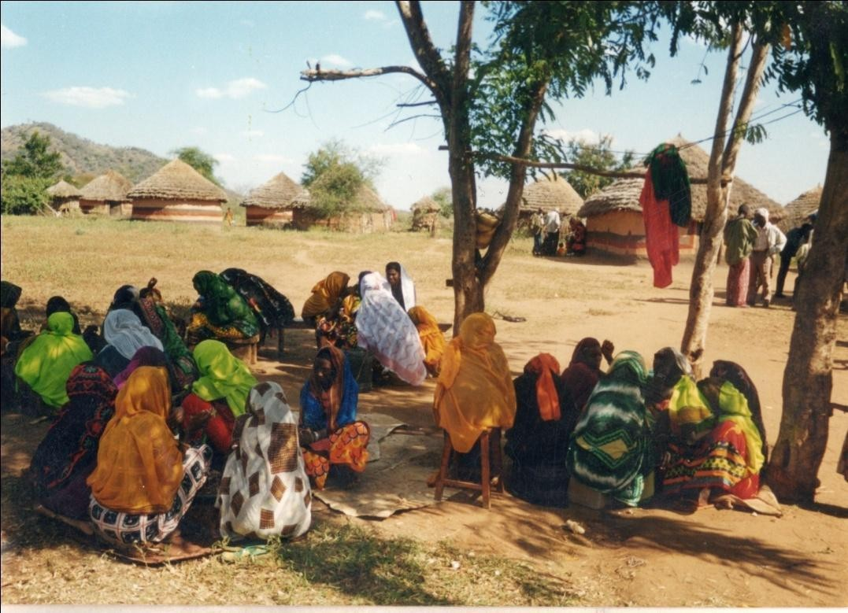

Plate 21: Borana women in Mado Adi village.

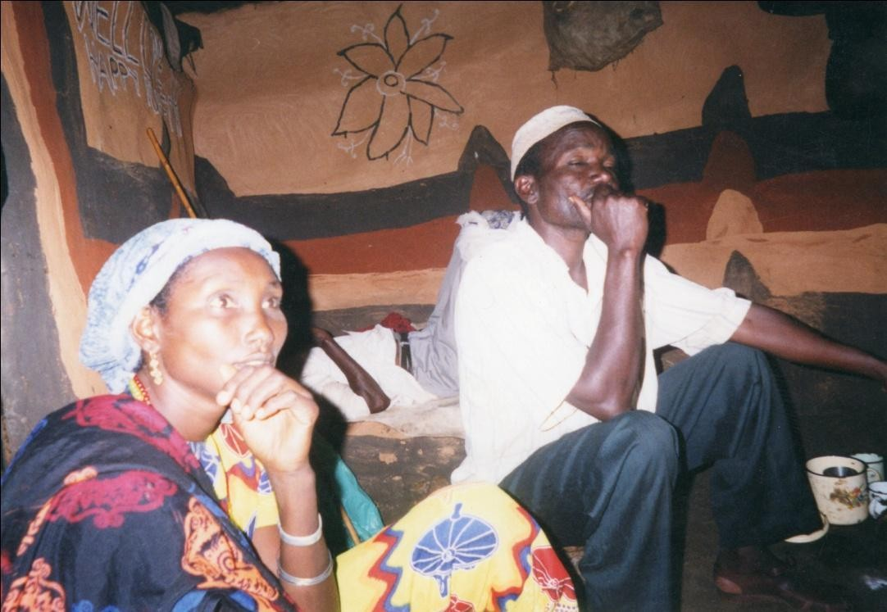

CHAPTER SIX
VERBALISING WOMEN’S FLAWS IN QOOSA
A story is told of a son of a divorcee who decides to get married to a daughter of a woman of the same status as his mother. The bride and the groom separately take advice from their mothers on how to stay on top of the marriage partnership. The young man’s mother was married nine times in her life, while the young woman’s mother was married to a total of eight men in the same period of time. The bride’s mother’s advice to her daughter is that on the day of their marriage as they enter their matrimonial home, she should test him in this way. “When he leads the way, pretend you stumbled and then strike him as if by accident from behind with your siiqe⁴⁰. If he does not respond to the prodding from behind by beating you, then know that he is weak and you can take charge of him, control him”.

The groom’s mother for her part advised, “when you come home leading her, as you pass through the cattle kraal, I shall have let the calves loose. You will then get cross and hurl your spear at me in a pretended fury. She will then think, if he can hurl a spear at his own mother narrowly missing her, he would be ruthless to me, and then fear you”. The young man did as he was told and preempted his bride’s machination. The woman’s mother conceded that her son-in-law’s mother won because she had “lighted one more fire⁴¹” in marriage than herself.

40
This refers to a special wooden stick given to a woman at marriage. In a symbolic way the stick
represents her womanhood, because it is preserved and used on special occasions such as jilla (ceremony). When she dies it is broken and thrown on her grave, thus marking her end.
41
Marriage is considered as the making of fire to indicate a home. There is a proverb among the Borana, which goes, ibida hama ibida dansan eegataan, literally, a bad fire can be lit as one waits for a good one. This teaches that married people should not rush into divorce even when their marriage fails to work, before acquiring a friendly partner. When a man’s wife dies it is said, his fire has been extinguished, thus configuring the wife as fire.

I begin this chapter with an anecdote as a way of interrogating and establishing marriage life as a site of gender contestation. As Broch-Due (1999:159) suggests, one must explore local perspectives on gendering through local narratives and narration. The story belies the struggle for control over power and resources between the newlyweds and how it is being played out in subtle ways. What is particularly interesting is the way in which the story has come to be proverbial, illustrating how one’s degree of experience is a resource for triumph in contests, even when it is clear that the experience drawn on carries a measure of negation. This story has become in effect a quotable genre, to use Barber’s phrase (1999a:x).

The pertinent question to ask is, what kind of covert/overt meanings are being communicated by the proverbial story? First, marriage as an institution that unites men and women entails a contest as to who the principal partner will be. The story therefore relates this scheming behind the scene, where the couple’s mothers are the principal actors. In a paper on domestic power, Gilmore (1990b) argues that the notion of women being reticent, passive and submissive whilst men are active, powerful and assertive is a stereotype that is more imagined than real. From his study of Andalusian society in Spain, he concludes that within the domestic sphere, women are more powerful than men because men voluntarily relinquish domestic control to women to avoid association with femininity (1990b: 954). In addition to their control of food preparation, which creates an oral dependency that makes men subordinate, women’s domestic power resides in their ability to wheel and deal. The domination of women in the domestic realm is evident in the above story in which the mothers take de facto control of socialization and cultural indoctrination of their children. The key issue as Gilmore (1990b: 954) points out and also apparent in this story, is that very often men acquiesce to wife/mother manipulation but maintain a respectable façade of indifference before their peers or in the eyes of society.

In the story above, the contestants who are the mothers of bride and the groom engage in power struggle through their offspring by locating the combat in the husband/wife relationship, while they remain in the background. The more dextrous of them wins the day even though victory is handed to the man. Marriage becomes a field of knowledge where those who have “lighted its many fires”, therefore conventional failures, come out wizened by it. The failure of the mother’s marriage becomes a precipice on which the success of the son’s marriage is built. Conversely, from the point of view of the bride, the relative success of the mother’s marriage becomes the cause of the failure of the daughter’s marriage. In a way, victory is configured in the degree of one’s success to feminize the other through penetration or pinning down. Had the young bride had her way, she would have symbolically emasculated her husband by stroking/entering his buttocks with the eroticized staff (siiqe), an ultimate symbol of womanhood. Inability to rise to the confrontation of emasculation by beating is a sure sign of submission which men dread. Thus wife beating as a male act is a show, put up for fear of being feminized, what in Freudian scholarship has been called castration anxiety. The man won in this contest because he successfully punished his mother’s “wrongdoing” by applying the traditional male symbol of the spear from which his bride has to take her cue and toe the line.

Related to the above, but more generally, is the way qoosa as a form of play is crucial in determining the trajectories human relationships take. The pretended fury and feigned accidents are part of the acting in the story meant to be played on the other party as a way of eliciting their responses, which in turn shapes henceforth the other’s place in the relationship. These are enactments of playful deceit in which one party intentionally manipulates features of a situation in such a way as to induce another person to have a false or misleading sense of

what is going on and so to behave the victim (Bauman 1986:36). As well as the physical enactment, the man’s qoosa was played at a psychological level, to affect his bride’s conception of him. It dawns on her from the joke, which she had interpreted seriously, that no practical joke could be played on such a brutish man. She thus withdraws her less dangerous joke, to perhaps wait for a more opportune time later to stage it in a different version.

To a great extent, men’s qoosa shares this play property with this story. The point being stressed here is that whether one considers men’s qoosa on women or stories of power contestation within marriage, the underpinning discursive realm is hinged on some form of acting. As Abrahams (1970:294) avers, licentious play behaviour brings the group together and allows it to rehearse confusion and embarrassment in a context, which is under control. In the case of men’s qoosa, the play trope is primarily devised to control women, a mechanism by which men subdue women’s character and shape their worldviews based on the ironic readings of the jocular renditions as serious communication. But irony is common to both men and women. In reality, as the above story implies, the woman is not submissive or passive as the man is bound to think, neither is the man brutal or unapproachable, as the woman is wont to infer, for these assumptions are based on “some falsification of some part of the world” (Goffman 1974:83).

The chapter’s focus is on the men’s defense of the masculine ethos of provider, procreator and defender played out within marital relations in particular and gender relations in general. Guided by what Gilmore (1990a: 229) has called manhood ideologies that include a criterion of selfless generosity, men tend to act with a consummate paternalistic posture that assumes service and nurture to women. While amongst the Borana men are generally known to have sentimental attachment to their mothers, they are somewhat distant from their wives, even

reservedly keeping their guard about possible dominance by them. As Ranelagh (1985:201) suggests, men believe that women covet their power and that they will use their charms, purpose-made for this end, to rob men of power as Eve did Adam, or to unman them as Odysseus suspected of Circe, or to destroy them as Bata’s wife did Bata.

Borana folklore is replete with women’s betrayal of their husbands, especially for sexual favours with people from without. An oft-quoted case is that of Diido Gawale, a gigantic man who routed many enemies. He was cuckolded and slain by a man from Arsi community called Obolo who had befriended his wife. As regards women, they too are known to be subtly manipulative, exploiting their sexual charm to that end. Anecdote is told of this same Diido who was a feared great warrior, but succumbed to his wife’s entreaties, exposing himself to ridicule by carrying her on his back and braying like a donkey, unaware that he was being watched by the very men in whom his presence stirred fear and awe. These examples emphasize the several levels at which public and private domains elicit different responses from this male-oriented culture. In a context that thrives on a strong public façade, certain acts like carrying women on one’s back and braying like a donkey are regarded as feminizing and demeaning.

If women’s qoosa is about an underprivileged group cutting a niche for itself in a male dominated society by “rejecting and puncturing a particularly positive identity projected by [its] competitors” (Kane et al. 1977:12), men’s qoosa works differently. Here, a dominant group engages humour to entrench itself by exaggerating the assumed foibles of the group it subjugates. Turned into a site for heightening and strengthening the dominant group’s privileged position, humour undermines the weaker party. As Gilmore (1998:39) writes of the Spanish carnival, qoosa is grounded in serious satire about generic feminine flaws as the men

define them. So pervasive is the subordination that in addition to qoosa, it is expressed in various other oral genres too. One such expressive genre is a legend in currency that claims women are obstinate beings who possess, what has been figuratively termed, three horns right from their birth. A metaphor of haughtiness and self-assertion, the said horns needed to be trimmed to put the woman in her subordinate place, a task that falls on the society. In calculated stages, the society passionately executes this process of dehorning during the lifetime of the woman.

According to this legend, the first horn of the girl-child is demolished by the mother by way of parental disciplinary inculcation that entails among other things caning, admonition and advice geared towards making her a proper woman within the dictates of the culture. The culture is clear in its intent of molding her as an obedient, maternal and dutiful female in relation to her husband and children. In marital life, the husband downsizes the second horn with the same alacrity, even if the method is more severe and brutal. The husband is empowered by the society to take charge of the woman as his property. On the marriage day, for example, the girl’s parents clearly spell out the duty and responsibility of the groom to their daughter in what sounds like handing over. His duties and obligations include among others, beating and insulting his wife for correctional and disciplinary purposes, so long as this is not extended to his in-laws. In other words, safe for impairing her physically, he is at liberty to use all means he deems fit to ‘panel-beat’ her into society’s conception of a good wife.

As for the third horn, the legend contends, the woman lives and dies with it forever, as it cannot be demolished. By this later assertion, society admits that the woman is indeed not quite tamed, as it would have liked. There is thus some essential self of the woman that is not

quite subdued in the course of this dehorning process. Men’s qoosa then is a verbal manifestation of this metaphorical dehorning to which the women are subjected. As Bourdieu (1977:118) points out, speech is a powerful force of naturalizing social reality, where ideological skewing and values accruing to social relations take on the appearance of natural inevitable conditions. I now turn to the ways in which words are used to naturalize the inferior place of women in men’s imaginative world by analyzing men’s qoosa known as dhaawa.

Dhaawa as a subgenre meant to ridicule women is performed during korma-korbeesa ritual. The performance of the korma-korbessa ritual falls squarely on the shoulders of the age-set (hariyya) or the entire male within a locality (dheeda). According to Leus (1990), korbessa hariyya is a goat killed by members of the same age group when they come together to celebrate. On the other hand, korbessa dheeda is the goat killed to ask for kayo (good luck) by the people of a particular area. Whether the age group or the locality performs it, the underpinning function is that the rite of the bull/he-goat is a male activity that primarily serves as a propitious act, seeking blessing of waaqa (god) for the members. The participating group is first separated from the society and acquires its own individuality; its members do not re-enter society until after the performance of rites, which removes that temporary individuality and reintegrates them into the society (Gennep 1960:39). As a male ritual, it excludes females and members are made to aspire to greater achievements of things masculine. As part of this separation, the ritual is held overnight. Male heroic songs are sung, where the deeds of men who have killed trophy games and human enemies are recounted and celebrated.

Male heroes, who are the envy of society, don facial decorations with ochre at this ceremony as a mark of displaying their heroic accomplishments. Thus the ceremony in part, serves to separate the male and female worlds, not just at the levels of biological determinism but also at social levels. The separation is a symbolic emblem highlighting both social differentiations as well as bringing together distinct and opposing segments of the community (Brandes 1980). The ochre decorated man is more masculine than his fellow men who have not been associated with martial heroic acts. Having emasculated others, he is a more complete, fulfilled and irreproachable male, who can be relied upon to carry out masculine tasks of asserting and defending maleness, a notion that dhaawa represents. After nightlong singing, joking and feasting, the participants take the bull/he-goat out into the bush in the morning amid the singing of heroic songs, with some men going into trance. Having performed the necessary rite, the party returns to the village to perform another ritual in the form of verbal assault. It is at this juncture that a hero among the age-set riding on a horse or mule, circles the village to perform dhaawa, an insulting verbal art aimed at miscreant women. It is this verbal art that interests me in this chapter.
By far the stingiest of men’s qoosa directed to women, dhaawa is normally a licensed insult created for women who have denigrated men. It is meant to shame the women by highlighting their dirtiness, ugliness and unattractiveness. In its strictly formal performance, the performer normally rides on a horse and circles the village uttering the invective directed at a woman who had arrogantly defied and insulted men. Vagabond, prostitute, wayward, unruly and immoral are just a few of the terms used to label and stigmatize women whose behavior in some way threatens other people’s expectations of the way things ought to be (Hodgson & McCurdy 2001). Recently the community has proscribed such a licensed performance because of its highly offensive nature. Fortunately during my fieldwork, I came across a recorded version of dhaawa that has undergone a tremendous transformation and I picked it for analysis, since the live performance is virtually unavailable.
The current dhaawa is more generalized, deals with issues affecting the Borana community, and generally views the women as a collective group whose actions can be evaluated and commented upon rather than individuals to be subjected to the insults of offended men. This is instantiated by the way the speaker in the poem below, scolds the women for exploiting their husbands economically under the disguise of ayyana possession. He laments the impact of modernity and the way it has brought equality between the sexes. He blames the government policy on equality, the times in which “we are now living”, and the ayyana cult

as the culprits that have delivered victory to the women in contravention of the Borana traditional way of life.
This jest was performed by a man by the name of Bontora Baraqo, who contextualises his
dhaawa in this way:

Nami bekku najaala haasa an ammo tephiiti haasa Ak isin hinwalale tephiin hasofti
Nu korbeesi nuu qaale ka Taadhii Jatani Baraqo Atu naa beta an Bontora Baraqo
Gangeen an dhaawan bae ta Halake Waaqo Gangee maqan Boora an akaan dhaawa bae

An wakor Waaqo, galach Reero Ijole Karayyu, qaqalo Sabo
Ijole Malbe, oboles Qaabe
Manda Sakalat, gurach Guyatu
Adda Guyot, sodaa Guyo Qancorot Machi wakora
Macholen nam lama, nu machi nam jaa Karayyu machin waar Gedo Jillo
Tertaale machi Tune Dub Jillo
Goges Borana shanan machin nu lubba Jillot Mega machin Gololch Borut
Tertalle machin Godana Borut
Gar Tertalle kesa machin nu ilman abba Borut Wakor machin lama, tok machawa ana
Machawa Jarso Lake Jatanin Naadho taa Jatanin bulcha kena kibi Yabalo taa
Bulti lafa jalate nadheen kori isi baar arra qae mabarra taa Waan bulti tesani hima tanaf korraa Boora abbo Lake taa

People who know can re-narrate after me; I am going to narrate to the tape recorder
The tape will narrate, as it does not forget
Taadhi Jatani Baraqo owned the he-goat we slaughtered You know me, I am Bontora Baraqo
The mule I rode for dhaawa is for Halake Waaqo
The name of the mule is Boora; this is what I performed in dhaawa

I am wakora Waaqo age-set, the hero of galalcha⁴²
I come from Sabo moiety, son of Karayyu clan The son of Malbe, brother to Qabale
Younger brother to Sakala, the black son of Guyatu Elder brother to Guyo, brother-in-law to Guyo Qancoro The hero of the wakora age-set

42
The word is a synonym for Sabo moiety, and is normaly invoked to indicate heroic emblem for the
speaker and identity marker in a situation where competition is implied between the two exogamous Gona and Sabo groups.

Heroes are two, we are six heroes
Among the Karayyu clan the family of Gedo Jillo is a hero In Tertalle Tune Dub Jillo is a hero
In the five Borana generation set our Jillo Aga is a hero In Mega the hero is Gololch Boru
In Tertale the hero is Godana Boru
In the mountain of Tertalle the heroes are we the sons of Boru
There are two heroes in the wakora age-set, one of them is I The heroic son of Jarso Lake Jatani stays in Naadho
Jatani our leader stays in Yaballo
They are happy with the state of governance
Women today their meeting is held at Mabara⁴³ venues
I want to narrate about your life that is why I am sitting on the saddle of the mule of father Halake.
In this speech the jester prefaces the performance by situating it within the immediate context of performance. The occasion is one at which his age-set had slaughtered the he-goat belonging to a man, Taadhi Jatani Baraqo (line 3). The jester speaks of his family, age-set, and military achievements with the overt object of underscoring his own enviable personality within this community. This serves as a kind of preemptive preface, as he is going to say questionable things about women, he would not like his own character to be questioned. The immediacy of the oral performance is replaced by a quasi-oral recording where the tape replaces a human being as a personified narrator, what Walter Ong (1982) calls secondary orality.
The chant itself, a fine example of transition from tradition to modernity, evinced in the mode of transmission, is nostalgically defending “the ways of our fathers”. The speaker tacitly uses the tape recorder as a gadget that is free from faulty memory, and so outlives man. He clearly understands the wider audience the recorded chant can reach and in this sense is addressing the entire Borana. Yet he uses the same product of modernity to chastise women for attempting to benefit from modernity. Before the onset of the tape recorder, the kind of chant with which he lambasts women was more or less a village affair confined to a small locality and known mostly to the age mates and the women to whom he addressed the poem.
The speaker parades the Borana regional and local heroes and centers himself as being one of them (lines 14-19). Each of these heroic allusion are abbreviated, telling their own stories familiar to the general Borana populous in fairly significant ways. For example, the family of Gedo Jillo alluded to in line 14 is a sort of monarchical family from which the Borana qaallu (king) hails from time immemorial, just as Gololch Boru who is alluded to in line 17 was a former paramount chief who was famed for his administrative astuteness. The latter has been captured in many cattle songs by men and women performers, often displaying him as an enemy of cattle on account of his uncompromising tax collection method that led to the sale of cattle in large numbers. They were also wealthy families, owning huge herds of cattle,

43
This is Amharic word for village commune so common in communist Ethiopia in the 1980s.

wielding power and educating their sons to university⁴⁴ level, for which they are respected and envied.
But what is common in all these is that the speaker is drawing on the male world and portraying its heroism which is unmatched by women. By excluding women from the roll of the heroes in the community, the speaker arms himself with a euphemistic way of underscoring the bigness of the men and the smallness of the women without having to directly say this. His lament when he fears that the bigness is under threat from other quarters that appear to support women is evinced thus:
Mabar higiti nuu tolche Qixee bara nuu tolche
Waan bara dhufe dabru nam gara jabat obse Gisen walqixe jenan jirman nut gamtani
Idhanidhe nura Jatanin dhowe Jatanin bulcha kena
Niti tam dhirsa jedha Gudo aada Boranat dhowa
Commune villages we are forced into it Equality is brought by modern times
The times that come to pass is persevered by an enduring man When it was said people are equal
You want to beat us with clubs Jatani held them away from us
Jatani our leader believes wife belongs to husband He follows the Borana culture
Although this jester primarily addresses the relationship between the men and women, he also makes the subject of his concern the unfair government policies that patronize the community by mapping out their social relationships for them. The jester places what he considers the violation of Borana culture that equates the men and women at the doorstep of the government of Ethiopia, and modernity. At the same time he lauds the then provincial governor of Borana province, the late Sebastian (Mebatsion) Jatani Ali⁴⁵ for upholding the tenets of Borana culture amid the threat from the government and modernity.
The speaker uses the historical context of governance in his country to assess what he sees as a turning point of gender equality that threatens men’s power over women. Thus line 1 refers to the village commune system borrowed from the Soviet Union in the 1970s and applied in rural Ethiopia where the speaker resided. From the speaker’s sentiments, it is quite clear that the system was an unpopular one decreed from above by “force”. Along with this forced way

44
Gololch Boru’s son, Boru Gololcha obtained his masters degree from the University of Swansea in UK
in 1988 in Economics with a thesis on Borana pastoral systems.entitled, “Peripherization of a Pastoral Society: The Case of the Borana Oromo of Southern Ethiopia.”
45
A provincial governor in Ethiopia’s Borana province in the 1980s under a regime presided over by the leftist dictator Col. Mengistu Haile Mariam, Jatani Ali Tandhu was regarded as a hero by the general Borana populous. People suspected to have been agents of the government of the then Ethiopian Prime Minister Meles Zenawi assassinated Mr. Ali in 1992 in Nairobi after the fall of Dergue regime. He had taken refuge in Kenya following the spate of anti-Oromo raids around the same period in the border areas of Moyale. A book outlining his career achievement was published in 2015 by Taadhi Liban his former schoolmate and friend.

of living and in fact a necessary adjunct of communism, was the whole gamut of equality [mis]understood and executed by enthusiasts of the regime in return for military assistance from the Kremlin. The resentment of the system and the notions of equality between the sexes it promoted are conjoined as if to say that the system came to the aid of women. But these seemingly defeated men appear to take solace from Jatani Ali, who though a leader in the same system, served as a vanguard of the cultural dictates of “Borana culture”. In Ali’s self-stylized ways, whatever the government stance on gender may be, women belong and are subordinate to their husbands, something that gives life to the dejected male voice bemoaning the loss of power and threat of dominance by women (lines 4-6).
The speaker in qoosa under review harnesses history as a device to locate what to him was the growing tendency of women’s deviance from Borana ways of life through time. Using the gada chronology in summing up the events, the speaker lists some of the ways in which women deviated from the conventional Borana culture:
Gaaf shiftom gada Gooba Egi alat baate lakifte Garayun gobu tahe
Aban bekhu lakise Gada Jillo Aga
Nadhen Borantiti lakifte Yo mangudon hasoftu Nadhen duri tak korate
Gada Bule Dhadacha korate walt baate Gafasile woma hindubane kaate
Gada Guyo Boru nadhen Borana taate Gada Aga Adi garayu banda taate
Gada Jaldes Libani ta maan gutu taate Gaf gada Madha kara afur gargari baate

During the banditry in the gada of Goba Women came out in support but withdrew The lovers became multitude
The one who cares abandons them In the period of Jillo Aga’s gada
Women abandoned Borana ways of life As elders tell us
Women gathered for a meeting once
During the gada of Bule Dhadacha they gathered They did not make any resolution
In the gada of Guyo Boru they became proper women for Borana In the gada of Aga Adi they became mistresses for banda
During the gada of Jaldesa Liban they were devoted to building huts with tufts During Madha’s gada, they split into four paths

Safe for one gada, (Bule Dhadacha, line 9) which was between ca. 1776-1784, the speaker describes a fairly recent and accurate overview of the Borana social history spanning half a century from 1936 to 1984. Although for purposes of poetic convenience he did not follow the chronological order of events, a recollection of the various gada reigns referred to reveals a fairly ordered recounting of the events and their effects on the women as perceived by the

speaker. A re-ordering of these allusions begins with the period of Aga Adi’s gada that falls in 1936-44; a period during which, the speaker contends women became the mistresses of Italian banda⁴⁶ (line 12).
To understand the significance of this criticism, one must put it within the context of the historical event of the time. The criticisms draw on history and are illustrative of the ways in which “one can hear the past in the present” (Lord 1976:1). The Borana who were in both Ethiopia and Kenya were mainly drawn to the Ethiopian side of the border for the purposes of watering their livestock. While an agreement was brokered and a memorandum of understanding put in place with the Ethiopian authorities as long ago as 1904 (Oba 2000: 93), the Italian invaders found themselves under no obligation to respect that arrangement. They therefore employed the ruthless irregulars, banda, from the Borana’s traditional nemesis, the Somali. They created havoc, looted stock and killed without discrimination (Oba 2000:102). These atrocities are so perverse that the then Assistant Police superintendent of NFD visited Sololo on 19th and 20th August 1937 to investigate the report of border violations and molestation of British civilians by Italian banda (Oba 2013:193). Being mistresses to a group that has visited such mayhem on the Borana community is thus regarded as base and contemptible. Women were ridiculed for being the willing victims of a bunch of gangsters (banda) from outside the community. The essence of this criticism is that women in the eyes of Borana have failed to pass the test of “moral beauty construed as selfless devotion to national identity” (Gilmore 1990a: 145).

In the period that follows, glossed as the gada of Guyo Boru (line 11), which falls between 1944-52 in the Gregorian calendar, the speaker records that the women behaved conventionally as wives in the way the society desires and approves. In the period 1952-60, the reign of Madha (line14), however, they are said to have split into four ways of lives, which the speaker elaborates below:
Taan karra ayyana kaate Some went the way of ayyana Taan karra arjalaa kaate Some went the way of goat herding Taan karra nagada kaate Some went into trade
Taan karra Safara kaate Some went the way of Somali

The speaker contends that by choosing to subscribe to these alien ways, women abandoned and betrayed the Borana ways of life. Ayyana is associated with Arsi, goat herding is a specialty of the Rendille people, and commerce and Islam in the Borana worldview are regarded as identity markers of the Somali people.

Line 13 comments on the events of Jaldes Liban’s reign (1960-68). The speaker underscores the fact that women were dedicated to building a certain type of house with a grass tuft on the top, which are more enduring than the simple structures built from grass and sticks. As Prussin (1995: 60) points out regarding the nomadic women of which the Borana ones are a part, much of the woman’s creativity is directed towards setting up the physical requirements for a household, and hence the domicile is the scene of both her creativity and control. Much of the work involved in transforming the natural environment into a built environment is consequently in her hand. The main thrust of such an observation is that the temporality of housing is an indicator of the willingness to migrate at short notice in search of grass and

46

War.

These are Italian irregular army recruited mainly from the Somali tribe in Ethiopia in the Second World

water for the sake of livestock. By insisting on the building of a relatively lasting type of houses, the women are imposing a sedentary kind of life on the Borana, ill-suited for their cattle that depended on pastures availed by the rains. The prioritizing of a lasting type of housing structure defies what Prussin (1995: 44) has called the essence of nomadic architecture whose assemblage of materials and technique derive from the same natural world. More than that, housing structures also define people, and a case in point is that the Borana are called the people of grass (darara), while their Gabra neighbours are called waar daasee, the people of the mat (Tablino 1999), purely on the basis of the material from which their housing structures were constructed. By building the houses with a shaft on top copied from the more sedentary Amhara and Burji, women pose, in the estimation of the speaker, a threat to the Borana identity.
The years 1968-76 fall in the era when Goba Bule was at the helm of Borana gada (line 1). This was also the period when Kenyan Somalis desiring to join their kinsmen in independent Somalia, clamoured for the Northeastern Kenya region to secede after Kenya became independent from British rule. Although they shared the region with Somalis who were ardent proponents of the secession movement, the majority of the Borana did not share the sentiments of the secessionist script. This lack of sympathy on the part of the Borana to the Somali course, led to a protracted ethnic war between the two. According to the report by Hoskyns (1969:33), the Kenya government accused the Somali government of carrying out in Kenya’s Northeastern Province a campaign of terrorism and banditry, armed aggression and military provocation in support of their Somali kinsmen in Kenya.
The ‘Somalition’ project under the slogan, “Somali is our language, Islam is our culture” (Hoskyns 1969:21), necessarily excluded the Borana who neither speak the Somali language nor subscribe to Islam in any significant way. The contention about banditry is an allegation that women, out of some misplaced sympathy for the Somali, tended to participate in it on the Somali side, something the speaker criticizes as treacherous. In view of the atrocities committed by the banda in the 1930s and also the traditional enmity that has persisted between them over grazing rights, it was unthinkable for the Borana, women included, to support the Somali agitation. By contending that women supported the Somali bandits, the speaker imputes to women the perfidy of being an internal enemy that the Diido Gawale legend so vividly captures and charges them with.
In the gada of Jillo Aga, (1976-84) as indicated in line 5, the speaker accuses women of flouting the Borana culture. In Ethiopian history, this was the time when there was massive civil unrest and a peasant revolution culminated in the overthrow of the feudal system presided over by emperor Haile Sellassie (Tareke 1991:123), just two years before Jillo Aga was handed the scepter. During this turbulent period, Ethiopian enthusiasts of the new system sought to overturn all sorts of authority. This applied not just to the feudal lords, but also touched in fundamental ways on other forms of inequalities based on age, sex, lineage and economics. It was a period robust with the rebirth of mass culture and the decline of aristocracy and other forms of authority. In this enthusiasm, university students were deployed in droves to condemn the old feudalists and their beneficiaries and to promote people power along the Marxist-Leninists lines.

Although the authorities embraced the tenets of this leftist ideology, their interpretation and execution were left in the hands of people who did not care to understand and grasp their local applicability. Thus such pronouncements as men and women are equal, were bandied about without any moderation or qualification. It was rumoured that a man with two or more

wives was required to give up all except one, a man with two or more houses would forfeit all except one and a man with many cattle would be required to retain a few and redistribute others. These uncensored utterances in the service of communism, although not executed with the same rigor as they were uttered, reached such intimidating fervor that oral artists recorded them as important events in Borana social history. Embedded in these oral records were dominant themes that tended to imply that “they [the Borana] were tired of being patronized and obliged to adopt foreign ways” (Baxter 1994:171). Echoes and streaks of patronage that induce fear and frustration are apparent throughout this dhaawa, of which the contention in these lines is a fine example:

Ta kara Safara baate Mata filate yaate
Mata Dargiin yakite
Har nadheen dhiraan waal qixe taate
The ones who adopted the Somali ways Combed their hair and went along Their egos were spoilt by the Dergue Today women are equal to men

In the Borana culture, women wear hairstyles that gives them idenntity as married, unmarried, newly wed and mothers of sons. Hairstyles are hence symbolic codes of a woman’s social status in the society that appends ritual significance to them as a way of expressing group norms. In contradiction of this norm, the speaker contends those women who adopted the Somali ways of life wore their hair by simply combing it without braids, something that the Borana regard as socially abominable. In line 3, the jester exploits the polysemous word, maata (hair, head, ego, will) to underline his lament about the alien imposition of equality between men and women. The line claims women’s egos were inflated by the Dergue⁴⁷ regime, which encouraged dissent, not just as a concept of mass culture against the Ethiopian bourgeois, but also among a largely egalitarian Borana community with its own rhythm of life.
From the point of view of the singers, it is those women who followed the ayyana ways that are seen as the major challenge to the privileges bestowed on men by patriarchy. although the government too has played a pivotal role in eroding the powers of men over women, It is here that the speaker brings out what, in his view, is wrong with “women being on top” to use Davis’s (1978) phrase. These reversals of women’s position and fortune in the Borana society are made possible by an invocation of a quasi-religious cult that stirs respect and fear in its followers and detractors. What then is the place of ayyana cult in the men/women relationships? To begin with, men see the cult as women’s way of aligning with a seemingly emancipative force for negotiating and reclaiming of some space of their own from male dominance. Thus the men are wary of the cult on which women draw to cope with the most oppressive aspects of their lives without directly challenging the codes of the mainstream system (Trawick 1999:64).
Elsewhere, the use to which a similar cult has been put was well illustrated by the case study of Tumbuka possession among women in Malawi by Vail and White (1991). They report that women use spirit possession as an escape mechanism of their poor material condition. Such women allude to the cause of their poverty during the trance, prescribing the remedy for them, which usually takes the form of banishing their tormentors and naming their prized animal that they want slaughtered. The role of spirit possession is summarized thus:
Possession is, in sum a form of social therapy that is initiated through the power of poetic license, but it is now especially used by women who, because of their personal insecurity,

47
This is the name by which the military regime that deposed and succeeded Emperor Haile Sellasie is
known.

need to have their message reinforced both by the presence of the supernatural and the supportive participation of sympathetic members of their community. In response the community is not merely to give the woman material gift during the ceremony itself but also take steps to meet her complaints and thereby reintegrate her into the community afterwards (234).

The functional nature of the spirit possession to the dispossessed is quite clearly indicated, and in the Borana case, this seems to be replicated with a variation of details. In the lines below, the speaker bemoans the women’s use of ayyana cult in staking their claims in the social-economic life of the community in a way that turns the tables on the men:

Ta kara ayyana baate Ori dhirsa qoodaate
Chuufti abboti karra taate Suuren maangudo jilla taate Yoo bobbaan gariba dhuftu Dibefi bajjoolen yaate
Korma waranan qaqalte Gaf ayyani jabate Kayon dhir iraa baate

The ones who followed the ayyana ways Divided their husbands’ properties
They became owners of cattle
Their turbans were like elders in ceremony When they see ayyana cult procession They carried drums and sticks
They slaughtered bulls with spear shaft When ayyana becomes entrenched
Grace and good fortune leave men

In the speaker’s estimation, ownership of property is a code of masculinity that effaces women’s femininity. Like men, they wear head turbans and carry sticks normally carried by male elders. They subscribe to the cult, which they host by slaughtering bulls in its honour. By slaughtering bulls with a spear shaft, (line 6), women profane the community’s rituals of bull- and goat-slaughtering (korma-korbesa), which conform to certain specifically laid down procedures. The breaking of these ritual requirements has the effect of destroying the power, grace and fortune of men. The speaker’s complaint about ayyana seems to arise from the fact that it undercuts male power either by taking away their economic powerhouse or by destroying their more ephemeral power and grace through ritual profaning. The cult, like the government system discussed, appears bent on overthrowing men’s hegemonic powers and installing women on top, a reversal the speaker resists through clinging to cultural institution such as Gumi Gayo (Gayo assembly).

It is important to observe that ayyana plays a very important role in the lives of women. They pay a lot of tribute to it and are bent on convincing their husbands to be converts of the cult movement. Women’s glorification of ayyana is observed:

Ayyanan qaallu jeti They say ayyana is a king Afaan qala
dhirsan In the language of ayyana
abba madaba jeti They call their husbands “father of group” Yoo bobban gariba dhuftu When the procession of ayyana comes
Abban biri wakata The husband refuses with money
Ayyan galchite They call ayyana upon themselves
boro abba madaba They claim money is plenty in the house
Dhagon wan gute jeti They want to drink alcohol by deceit
Araqe malan dhudi They demand the purchase of alcohol
Moriso bita jeti They want to slaughter livestock by deceit
Ori malan qaqalti They demand for the slaughter of sheep
Holan fagago jeti They want to apply perfume by deceit

Shito malan dibati They demand for it to be bought
Shigijiri bita jeti Using government order Shigijirin awaje Jatani Ali fan The likes of Jatani Ali
Ayyani hinjiru pass that ayyana is nonexistent
dubin tuun daba jete the demands were unjust

In these lines, the speaker mentions the deceitful ways in which women use the ayyana cult. This entails the employment of strange terminologies and reassigning of names to persons and objects to make them appear mysterious. These changes of names are made apparent in the reference to ayyana as “king”, a term the Borana reserve for their qaallu. The legitimacy of the Borana qaallu depends upon the myth of divine sanction and as Kassam & Mergessa (1989) note, it is believed that he descended from heaven where the Borana received him reverently. By referring to the ayyana with the reverent name qaallu, the cultists are abrogating his divinity to the spirit and thus fronting for an alternative power structure to which they subscribe. From the point of view of the women, such an argument may indeed be true given the fact that the power structure in which qaallu is at the helm, impugned rather than recognized them. In a way, women’s gravitation towards ayyana is an attempt at searching for a new center of power that accommodates them. Interestingly, the ayyana leaders are predominantly men, but women, without doubt, are the dominant followers. Part of the reason why ayyana appeals to women is that being itself dependent on celebration and festivity accompanied by music and dance, it releases the women from the dominance of men and the mundane household chores that dull their lives.

Using their tricks women co-opt men with the affective and fictitious reference given to husbands, abba madaba (father of group, line 3). Other names that have been transformed are those of sheep, goat, alcohol, perfume and money, all of which are material things women desire, but which are out of their reach.because of their close control by men. In these renamings, the speaker reads a wily deceit employed as a way of accessing the prohibited. Goat and sheep are required for meat, while alcohol is used for pleasure and perfume for cosmetic purposes. But as a moderator of the excesses of government policy seen above, Jatani Ali intervenes and saves the community from the confusion the cult has created. Jatani is instrumental in educating them against the nonexistence of ayyana, (line 15). To Jatani and the men folk, ayyana is nothing more than women’s invention to unjustly access the community’s properties presided over by men.

The speaker builds his case by raising doubts about the genuineness of women’s involvement with ayyana cult. This involvement is shown to be pretentious and it serves to access property by deceit and also deny their husbands sexual access:

Ayyana qalan bite Ayyana they celebrate
Qalaa qaqala jete Saying they slaughter for celebration
Maqum ori Borana From all Borana livestock
Kesaa ancaf fixe They finished the male ones
Ayyanan gargarate Under ayyana pretences
Abba dhibu keesa bafate They oust their husbands from the bedroom
Maqum dhibu abba waratu The entire marital bedroom
Maqa gore bafate They name them ayyana consort place
Abba nafan didoftif In avoidance of their husbands
Gaf ayyani jabate When ayyana invades the area

Yo fula dhiira bul qonqot nu gog jete Saying when they sleep with husbands Abba bira yate voices will dry up
Jimman afaa ibida jalat jarati The wayward erect beds near the fireplace
In these lines, the performer intensifies the degree of his suspicion of the cult under whose pretext women finished all Borana male livestock. Yet, it is truly a common practice for women possessed by ayyana to demand the slaughter of animals, a demand that must be met because of the life threatening nature of the spirit possession. Under the disguise of ayyana, women and the men who pretend to control the spirit, exert pressure on livestock populations and threaten the survival of the family herd in the way the speaker underlines. Understandably, tension breeds in the society between the husband who controls the family wealth as a matter of course and the wife who is an immense contributor to its creation.

However, the greatest discomfort on the part of the men as far as ayyana is concerned, is its use to deny them sexual access to their wives. This goes hand in hand with the possible sexual liaison of the women with cult leaders who are usually men. There are telling associations in what the performer says as encapsulated in the ejection of the husband from the matrimonial bed and the conversion of the space into an ayyana consort place. The performer accuses the women of erecting beds near the fireplace in contravention of common practice to preempt their husband's sexual advances. All these are done under the cloak of the ayyana cult, which seems to be beyond the questioning of the men as matters in the spiritual rather than the secular realm. The performer is critical of this romantic liaison with ayyana, for it portends male loss of mastery over women’s bodies, which as husbands they assume they own and control.

Shifting the subject, the speaker in the same vein condemns women who acquiesce to sexual advances for commercial gains as evident in the following lines:
Safarti shain biti Somali entice them with tea
Sidaamti daadhin biti Amhara entice them with alcohol
Yo bobaa Safaraa ciftu When they are under the arms of Somali Nadhen nagaa Borani fuud didi Women refuse to respond to Borana greetings Sidaam nut argate nadhen gaf They had Amhara on their side women during
Jabaan Harsilasse dhira sodachu dide The reign of Haile Sellasie⁴⁸ stopped fearing
men
A major feature of dhaawa is the portrayal of women as flirtatious objects up for grabs by men of means. They are shown as easily transferable instruments of sexual gratification. Gullible and attracted by social trappings like money, drinks, tea, and business proceeds, women are shown as romantically complicit. It is such relationships that are tainted by the cash nexus that is despised, because in the speaker’s view, it is not only a shame to the women concern, but also denigrates the community’s honour. Thus sexual overtures using material enticements by men alien to the community such as the Sidama⁴⁹, the Somali, and

48
Emperor Haile Sellasie was the Ethiopian head of state until he was deposed by a peasant revolution in
1974. The Borana have the knack of naming events after the person in power in the era the particular event occurred. The practice is a spillover from their gada system.
49
The Borana refer to the Amhara and the people of central Oromo who speak Amharic as Sidama.
Since they were in power in Ethiopia, they are represented in a dual way as an ethnicity and the government.

the Burji are recounted and resented as a way of protecting the community’s own social and moral terrain. Women who accept lovers outside the community are sharply criticized for promiscuity and morally compromising themselves as easy recipients of suggestive sexual indulgence. The last two lines allude to the role of the Emperor Haile Sellasie of Ethiopia’s monarchy in giving support to women, something that essentially subverted and weakened men’s authorities over them.
To the Borana man, the imperial Ethiopia’s subjugation of the entire community is regarded as making a woman of him. This is why the government policy on gender equality was construed as an outrageous suggestion implying further loss of manhood. A story is told of an old man by the name Kiyya Waamo⁵⁰, who when told of the gender equality policy of the Dergue regime replied, “O whatever you say, it shall fail at night”. This witty remark summarizes the community’s understanding of gender equality in a sexist sense or as Gilmore puts it “in terms of men’s idealized view of the place of women” (1998:129). The remark has since become proverbial and an offhand dismissal of the gender project by its opponents. In the perspective of the speaker, being on top in the coital position is analogous with being on top in social relations, which are enacted in the individual’s private lives. The government has no way of altering these relations. As Brandes (1980: 206) indicates, the prevalence of dominance and submission as a theme in folklore in part reflects the severely unequal distribution of power among opposing sex and status groups.

In the following lines, women are described as roving opportunists who throw their lot in with all manner of people to satiate themselves:
Dirro Konsoot jirti In Konso they (women) are found around Dirro
Yo Konso misingaan bau When in Konso the millet ripens
Jimaan afan katamaa jirt The flirtatious ones rush to the market
Tertalle Jis jirt In Tertale they are found around Jis
Jisa nyaati yo kinisi lafaat buu Eating honey when the bees are in season Chufti fula sorobdu jirt They all flock to the honey gatherers’ sides
According to the speaker, whether it is the Somali, the Konso⁵¹ or the Sidama, women’s romantic complicity with these people borders on expediency and opportunism. Even within the Borana, women succumb to the dictates of the stomach by aligning themselves opportunistically. So sexually provocative are women, that they could follow honey gatherers, the Konso men, or traders for material gains when conditions are favourable for these groups of men (line 2 & 6). The jest employs what Gilmore (1998:44) has called gastro-sexual imagery where sexual hunger becomes a pretext for hunger for food. In this case the women travel to the market in Konso when the millet ripens to attend to their hunger at the expense of Konso men. The jest thus doubly derides lovesick women who have converted the market into a site for seeking food and consorts.
By way of bringing this chapter to a close, we examine the jester’s closure of his poem, which takes the form of an appeal to the Borana to broadcast his poem further:

50
Kiyya Waamo lived in a place called Yaballo in southern Ethiopia and the remarks were made in 1979
in one of the public meetings in the presence of the government officers.
51
A small community of Oromo stock renowned for their farming activities and intensive labour. They live in close proximity with the Borana to the north at a place call Gaar Konso (Konso Mountain).

Duubi taan amaalle gumin Gayolen Ak kiyya dhugefate akanum dubate Nadhen aada Borana lakifte jete Anin duubi gafas akan dhaawa bae Borani ufi naa dhugefate
Akanan tephii keesa galchine Mee hasaa
(Audience laughter, ori buul jaal kiyya)

In this speech the assembly at Gayo
Agreed with me and discussed in the same terms
They concluded that women have abandoned Borana culture I then performed this dhaawa
Borana agreed with me
Then I played it into the tape recorder So narrate on
(Rejoinder, laughter from the audience, “live long and prosper my friend”).

In this closing gesture, the speaker draws on the authority of Gumi Gayo, an eight-cycle assembly of the Borana that reviews the laws and customs of the community in light of the events that may have occurred in that period of time. One of the most important functions of Gumi among others is to rescind and reinforce customs, and resolve contentious issues that people bring to its attention. To contend that the assembly agreed with him in expressing the tendency of women to deviate from the community’s mores, the speaker strategically legitimizes his claim, purporting it to have the support of the institution that gumi (multitude) represent. In short, he perceives himself as giving voice to a matter that has been of great concern to the entire community. That is why he is confidently urging his audience to “narrate on” as a kind of crusade against women who have “abandoned the ways of our culture”. In this crusade he reinvents dhaawa and uses it to serve the larger project of defending male culture that is also Borana culture. The point that is being made is that in the perception of the speaker, the women are not just antagonistic to the speaker’s age-set, but more importantly to the entire Borana community with its age-old judicial-cultural structures to which their defiance has alienated them. Judging by the way his men folk congratulate him, he has succeeded in implicating women as social offenders, having wrapped them in masculine oratory.

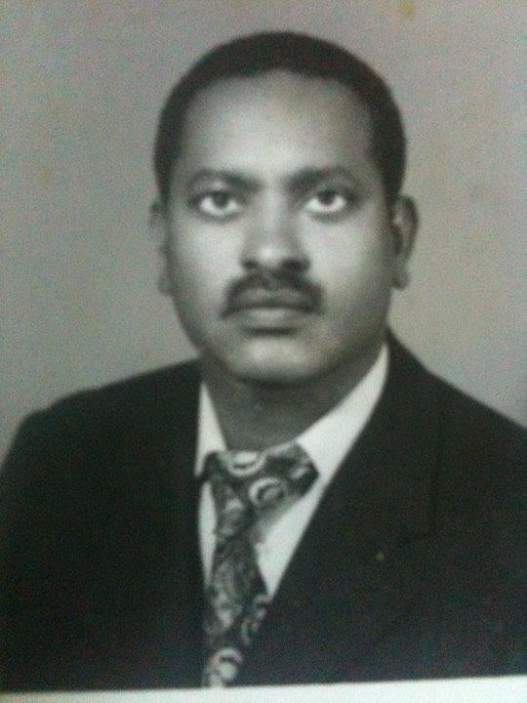

Plate 23. Jatani Ali Tandhu, former Provincial Governor Borana Province of Ethiopia.

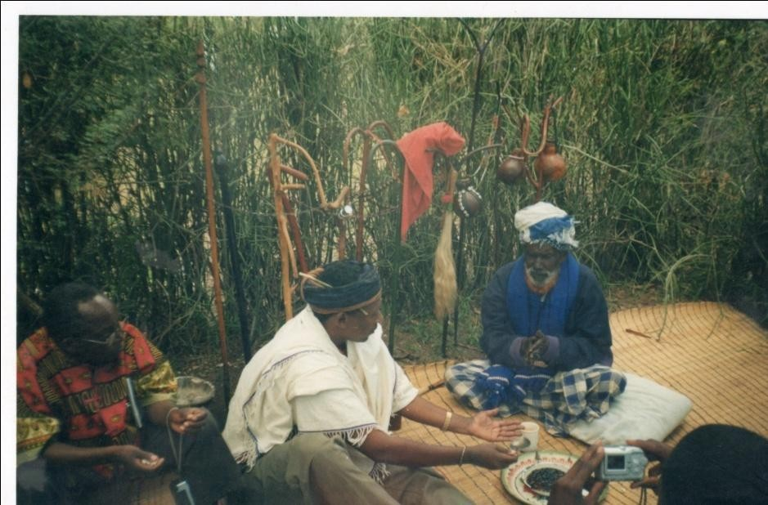

Plate 24: This author in the ayyana shrine with the ayyana priest.

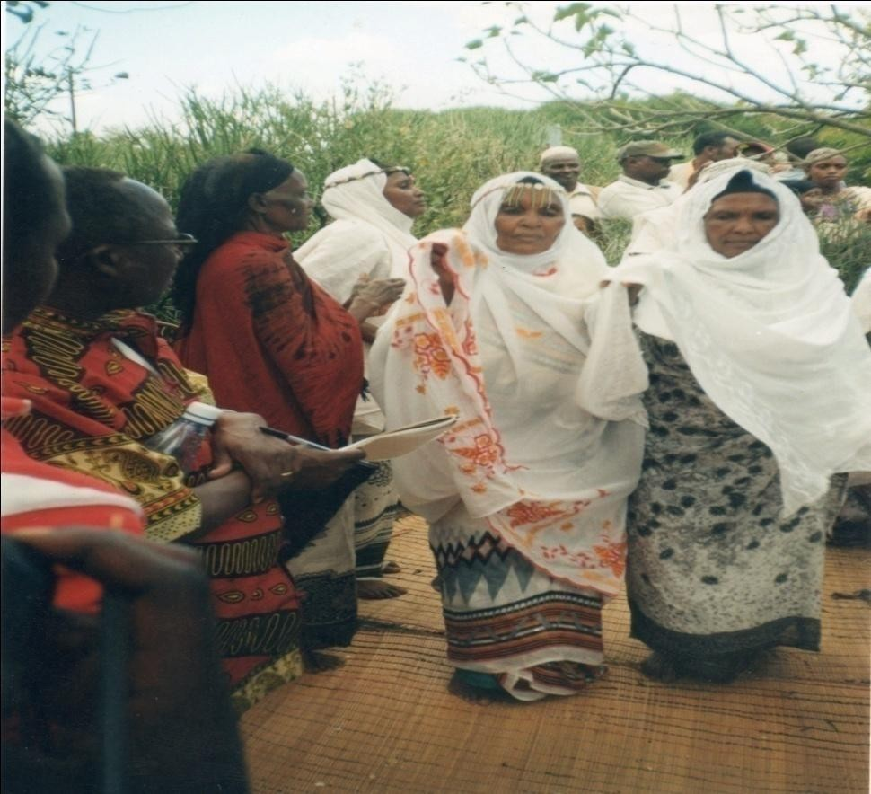
Plate 25: Borana women performing the hadara dance to celebrate ayyana.

CHAPTER SEVEN
PERFORMING QOOSA AT NAMING CEREMONIES
The men’s qoosa that forms the subject of this chapter is performed in the context of child-naming ceremony, an event Heath (1994:94) has termed playful parody of a life-cycle ritual. Child-naming ceremonies in Borana are big social events that bring together relatives, friends, neighbours and festival lovers from far and near. When a child is named he is both individualized and incorporated into society (Gennep 1960:62), something that calls for celebration involving the whole village. For the purposes of elucidating the men’s qoosa, I will focus on the festive part of the ceremony rather than the phenomenological aspect of the rite. Such a selected focus will bring out the licentious contextual backdrop against which the men’s qoosa as a genre operates. For the society, it is a moment of communal unity marked by comradely harmony (Turner 1969:134) and a sudden rendezvous with shocking unity of sexes, a face-to-face encounter with oneness of triumph (Gilmore 1998:207).

The jilla (ceremony) activity is an interesting case of broaching normative gender rules that spell out who does what in the domestic sphere. For instance during jilla, both the men and women cook food in a rare show of unity; thereby erasing the commonly held notion that men do not cook food. Because of the large number of people involved and equally the enormous amount of food to be prepared, women need men’s assistance. At the jilla of Mr. Wario Huqa, performed on the night of 24 June 2001 at Mado Adi village in Sololo District on which much of these observations are based, in keeping with established practice, vibrant young men with torches distribute food to the celebrants and engage in washing cups, plates, and welcome groups and organize them for purposes of eating and drinking.

As observed elsewhere, in jilla, as in the carnival, opposed segments of the community participate together within a unified event productive of enjoyment and a sense of community (Abrahams & Bauman 1978:207). People regroup according to gender and age so that there are distinct women singers, girls who sing songs in praise of their peers, young adolescent boys praising women and elderly men singing in the house of the celebrant. The first three groups gather outside the house in the compound where the celebration is taking place, whereas the last sit inside the house singing various songs, all of which contribute to the

beauty and diversity of the festivity. What people sing changes in content and form, being a nightlong performance, and a celebration that does not last the whole night is commonly judged to be incomplete or poorly performed. Thus the women sing solemnly giving thanks to god for the gift of children at one moment, and then change to songs that ridicule the excesses of men at another. Men too sing praises to cattle and then revert to songs that are extremely critical of women, clans and age-set.
The celebration manifests itself in many ways. People flood the compound and intermingle; old rub shoulders with young, men with women. They become singers and audiences at different points of the night by choice. Most of all, they are celebrants who recognize the occasion by the care they have taken in choosing their attire and their expectation of the occasion. Women’s perfume pervades the air, wafting with rich fragrance of eau de cologne and traditional qaaya smoke. In addition to lavish eating, drinks in the form of tea and alcohol are served. For those who care to drink, no one objects to their drinking. Younger women hide their adventurous indulgence from their hawkish husbands, but they too experiment with amounts that will not betray them as having drunk alcohol. Others chew the less conspicuous, but nevertheless stimulant miraa to enjoy themselves without jeopardizing their relationships with their partners who may not approve of such indulgence.

In addition to this licentious consumption, freedom of expression is granted rather generously, as the case of women allowed the praising of their lovers in a highly sensitive and normally proscribed genre called kaarille indicates. Kaarille is a stark admission of adulterous engagements on the part of the women in a public arena without being reprimanded for it. Ordinarily, the genre is performed in secret among women who have gone to collect firewood in the bush. This was their world, and unless men overheard them by sheer chance and rebuked them, they expressed themselves to their heart’s content. The men

know the existence of the genre, even perhaps some of the lines, their lovers having divulged to them, but discourage its performance in the open. The genre thus stands in the same ambivalent relationship with the affair on which it is based. But on jilla occasions, the community grants these women ambiguously compensatory license to express themselves in public, in what looks like collapsing the sharp line between men and women, the prohibited and the permitted. As Gilmore (1998:138) suggests of the carnival, a point that is also true of the jilla, in erasing the boundaries and superimposing opposites, carnival brings about unification of bodies and provides a polymorphous experience that is deeply pleasurable. The men’s qoosa on jilla occasion, which is the subject of this chapter, enjoys a similar license afforded by the occasion. In the latter part of this chapter, I analyse three men’s qoosa, which are used to mock women on this occasion. They are jikko, konsoo koore, and arraran cancaphalisa; all without what Tedlock has called representative meaning, but well known in the Borana culture. It is to the men’s qoosa known as jikko that I now turn.

In a general sense, the jikko song holds those attributes of women that are considered unfavourable by men to scrutiny and ridicule. As Frolec (1990:66) writes of a play genre in Czechland, the genre criticizes human weaknesses, misbehaviour, and everything that public opinion considered improper and immoral. A host of attributes ranging from physical height and untidiness, to characteristic laziness are listed and attacked. Even the very word jikko from which the song takes its title somewhat insinuates a short, hasty and strong, but crude person. It implies as Gilmore (1990b) writes in another context, diminution of body size, beauty, and social standing as a way of denigrating the subject. Jikko as jocular song is about archetypal women who display the characteristics that allow men to attack them playfully. The speaker appeals to his co-performers for support to perform jikko:

Oyo jikko tiyya Oyo jikko tiyya
Jikko qaaba dhiiro tiyya Isii achiti naara qaaba Ta deemte deebisa
Ta raftuule kaasa Ta teetu indhaageti
Gurraa guurri fuudhi Ilaa compha fuudhi Fican caffefadhi
Jikko waan siin jeedan qalbefadhi

O my short one O my short one
Support me in singing about the short one Restrain her from me
Return the one who has gone home Awake the one who is asleep
The one present hears me
Remove wax from your ears Remove mote from your eyes Wallow in your urine

Understand what is said to you
In the first moment of speech, it is important for speakers to establish their roles vis-à-vis each other and vis-à-vis the audience (Hoffman 2000:93). The singer appeals to his co-performers to lend him support in the rendition of a good performance of the jikko mockery. The men can only competently execute the mockery as a collective entity, for performance as a mode of spoken verbal communication consists in the assumption of responsibility to an audience for a display of communicative competence (Bauman 1975:293). At the same time, he seeks the presence of the women whom he is going to address in the song, thus the appeal for them to be present and alert, so that they understand what is said about them (lines 4-6). Performances as the act of addressing audiences constitute those audiences as a particular form of collectivity (Barber 1997:354). The jester shifts easily from addressing the men while he is performing to a section of the audience namely the women whom he refers to with not very kind words. From the onset he stereotypes women by focusing on one woman’s height to attack women as a category. With the support he has garnered from his men folk he brazens himself for a task of, sarcastically put, praising jikko. The woman is portrayed as a kind of rabid character ready to fight someone and can only be stopped by restraining her. She is depicted as dirty, with a log in the eye and wax in the ear that she is instructed to remove, lest she misses the benefit of the men’s ‘praises’.
The song relies on a number of stylistic features, which need to be pointed out. Prominent among them are repetition and rhyme. In most versions as in this one the first line is repeated in what Sherzer (1990:17) has called place filler that gives the performer the space to remember the next line of the memorized text. Lines 5-7 also uses repeated words as their initial word ta/the one, to underscore and establish the subject of the song as referring to women. The women are mentioned and included in the poem he is performing. Lines 8-9 use repeteition at the end of the lines by way of the word fuudhi/take to emhasise that she needs to pay attention to what is about to unfold. Lines 10-11 employ the rhyming words cafefadhi/qalbefadhi (wallow/understand) both as abusive devices and also a way of enhancing the aesthetic beauty of the poem.
Structurally the song can be divided into three units of analysis. Lines 1-4 are concerned with the song’s right tone, memory, and co-operation for competent performance and constitute the first category. For this to be accomplished co-performers and audiences are appealed to for a stress free performance space, and voices are sharpened in readiness for the rest of the song. He also pleads for the women’s presence that makes demands that they be summoned from their sleep. Although he wants them restrained from engaging in any physical confrontation with him, he nevertheless wants them around and about, for it is them he is addressing. The last category is the one where the women are directly addressed. Lines 8-11 are marked by an array of instructions through which she is subjected to insults.

The woman referred to as jikko exists in some space between femininity and masculinity, an interstitial being, who is neither a man because of biological makeup nor quite a woman because of her socially anomalous ways of not conforming to what has been regarded as female ways of behaviour. As a social icon, femininity involves questions of body ornament, sexual allure, or other cosmetic behaviours that enhance an inherent quality of character (Gilmore 1990b: 11). It is these features that the women ridiculed in jikko lack. Thus women are arbitrarily categorized as beautiful/ugly, tall/short, and feminine/masculine, with long hair/short hair, good housekeeper/poor housekeeper. The second item of the binary set is

regarded as a negation that the men’s joke employs to mock women. Often women are given attributes of men and by these attributes they are fictively unsexed. By gendering her as a man, the poem ‘masculinizes’ the woman as one operating outside the confines of her gender, thus becoming an easy target of the male-oriented jibe. In these lines,

Foon kutachan dhirra Foon arka mirira
Jikko nu waalumaan dhirra

The cutting of meat is like men The muscles of the arm is strong Jikko we are men together

she is said to cut meat like men and her arms have the biceps that betray strength, a quality traditionally celebrated in men. As Gillooly (1999:25) would have it, the speaker employs humour deliberately to de-emphasize the female figure and posture as a means of female assault. Meat eating especially of the choice parts has certain ritual observances that are attached to them. Women in Borana society are relegated to eat the most unpalatable parts of the meat such as the intestines, the head, hooves and ankles, while the men eat the relished parts like the breastbone, the thighbone, the hind leg and the hump.

The stylistic elegance of these lines lie in the rhyme brought about by the use of words dhirra/man and miirira/strong and the repetition of the words foon/meat. Interestingly the speaker uses the fact that in Borana the word foon can stand for meat as in the English language and meat as indicating biceps, literally “meat of the arm”. Dhirra and miirira are interesting at the acoustic level setting the rhyme but at the same time they both indicate some masculine quality of tenacity and hence serve to evoke that the speaker and the subject are men indeed. The shift from reporting on her appearance and demeanour to a conclusion addressed to the woman underlines the addressivity of the poem. It is a speech uttered to someone and the speaker navigates between the audience and the subject.

The theme of masculinization of women is prevalent in men’s qoosa as a code of undermining women’s gender. The cutting of meat and the strength of the biceps are socially constructed codes that are assigned the meaning they carry by the male oriented culture. The

passage below further exemplifies the theme of engendering the woman as what she is not, a man:

Jabdun ako dhirra Walqamnan nuu caate Qurot jala hawarti kaate Utuban qalqalcha Barcuman dhandhansa

The strong one like a man
We held each other and wrestled
Under the short one’s feet dust was raised Her pole is of qalqalcha tree
Her stool is of dhandhansa tree

Here strength is unquestionably put down as a male attribute, and the woman who is strong is chided for the possession of this male quality. She is engaged in wrestling, a game that is played mainly by men in demonstration of their strength. But to “emasculate” them, the women are shown as being no match for the men’s strength and therefore are the ones to fall and raise dust in the wrestling contest. Thus in the speaker’s opinion, they only appear like men but cannot quite measure up to the qualities of men such as strength and hardiness. At the same time, we notice the shift in meanings of metaphors, where for example strength is regarded highly in male circles and celebrated; strong women are reviled because strength as an attribute has crossed the gender boundary where it operates differently. This shift in the meaning of attributes is not unidirectional in that ugliness is ridiculed when it applies to women, but serves as praise epithets in men, as in the case of men who are called seele (missing teeth), bagajja (bandy leg) and waraabees (hyena). This is because the idealism of manliness of procreation, provisioning and protection is fundamentally different from the idealism associated with women that encompass beauty, fidelity, love and care (Gilmore 1990b: 48).

The ridiculing and denial of woman’s strength and hardiness are apparent in other cultural genres and expressions too. A case in point is that of a genre of self-praise called dhaadu, in which people who answer to the community’s notion of heroism boast of their achievement such as the killing of members of enemy communities and big game as lion and elephant. Women are excluded from this heroic undertaking and consigned to a form of boasting in which they are to use their sexuality to attain heroism. Instead of narrating how they routed men and women of enemy societies or wild animals deemed a menace to the society, women are allowed to boast of the livestock such as cattle they have been given by their male friends for sexual favours

An informant Kana Boru (a man) narrated a story that defined the context under which boast poetry is performed by a woman, in this way. A woman had referred to a sixty-year-old woman as “old woman”, jarti to which the addressee objected, insisting that she either be referred to by her proper name or a name denoting her motherhood, such as mother of so and so. The younger woman declined and persisted on calling her old woman. It is at this juncture that the offended woman responded by reciting a boastful poem thus:

Jarruman fuudhe
Gololee biyye tiyyat Golol anaan qenta kiyya
Gaaf nyaachis aakowan tiyya Aan Dirre muumee galche
Itbae Yaai alche Mirgisaan ako gaala
Guya suun fudhaadhe guraan dae
I brought her [cow] in old age At my home in Golole
In exchange for the milk of my cattle with cut ears At the ceremonial feast of my grandchildren
I brought her from the far end of Diiree People of Yaa gathered and admired her The one with abundant milk like camel
That day I brought home and earned honour

The speaker boasts of a cow she was given by her man friend at a place called Golole. This was in exchange of their many years of friendship during which she cared for him evinced by the reference to the provision of milk of the cow named. The friend, who resided in Diire, far into Ethiopia had given such a wonderful gift to the admiration of many people, an event that occurred at the nyaachisa (feast) ceremony of her grandchildren. The speaker considers the feat as a most honourable one, seen in the words of praise showered on the cow received, and the act of reception witnessed by the people. These boasts contain several layers of meanings. First, women’s strength is seen to reside not in things physical but sexual. In this sense, the society allows women to perceive the men as “enemies” to be conquered through sexuality, subdued, defeated and their property taken and boasted over. Directed against the apparent denigration of the offending woman, the speaker is at pains to show what she could accomplish even in old age, a feat that subverts the negative connotation “old woman” carries. As Nuessel has found, many ageist words are particularly pernicious in their deprecatory impact because they imply decadence and decline (1985:17). Dhaadu is always a quick response to a denigrating utterance that is directed at a person, and the response takes its cue from the content of the initial address. In this case the offending word jarti (old woman) is taken and converted into jarruumaan (in old age), thus converting a negative address into a positive action, and there are many examples like that. Likewise, when a man is addressed as “boy” to demean him, he will begin, “I killed a boy of the enemy tribe”, and when he is referred to as “liar”, he will say, “I killed a liar at such and such a place”, with the intent of showing the offender that he is irreproachable, and whatever the other tries to pin on him in a negative way, the dhaadu composer can reverse it and praise himself on the contrary.

In terms of style, the poem relies on the rhyming words, which gives it shape. The first of these words are Golole and golol two different words but that sound alike. Golole is a name of a place while golol indicates the act of serving a meal, making her to speak of geography and cuisine habit at once. The second group of words that catches our attention at the stylistic level are the ones which are indicators of possessive form. In Borana language, as in French for instance, nouns have gender. The words tiya/teena feminine singular and plural or kiya/keena masculine singular and plural are applied respectively. Thus lines 1, 2, and 3, use those possessive words in repeated form to refer to closeness with the soil/land, cattle and grandchildren with the purpose of creating rhythm and imparting to the poem some poetic touch.

The use of sexuality to subdue men is also seen at other levels where women, through conquering men in leadership positions, influence vital social decisions with their sexuality. Legesse (1973:179) documents a social drama in which in 1968, one of the contestants in a hotly contested hayyu election harnessed the power of sexuality by giving his mistress to the qaallu⁵² to influence him to support his candidature. Interestingly, the mistress in question did influence the man, but instead of supporting the candidate, on whose behalf she was dispatched, campaigned for her own son and won. In this drama of intrigue, the woman refused to be used as an object in the furtherance of the men’s political ambitions, and instead used the power of sexuality to brighten the career of her son, and thereby promoted her own rather than empower the offspring of her lover. In this way, the mother achieves a kind of representative masculinity that is otherwise proscribed by the culture, for in this patriarchal system, a powerful incentive for mothers to establish a strong bond of identification between sons and themselves, exists (Gilmore 1998:86). Because the system excludes the woman’s candidature ipso facto, the male child may fulfill the woman’s egoistic masculine needs. This is because when women experience feelings of inadequacy about being female, they often compensate through a male child who becomes their masculine alter ego (Gilmore 1998:85).
Secondly, by restricting women’s heroism to the confines of the domestic domain, the society is reinforcing the separation of the gender space within which men and women can legitimately operate. It is not that women lack the ability to kill enemies of the community, for in any case even those men who boast of routing the Borana enemies are more often slayers of children, the infirm and the aged unable to flee their menace. Women could kill these enemies, but society refuses to accord them the heroic recognition that goes with the act. What it does instead is to permit the woman to assign the honoured trophy to her son or husband, so that the male beneficiary could boast of it as if it indeed was his accomplishment. This denial of recognition is borne of the separate domains where achievement is disdained outside the designated space for the separate male/female domains. While the woman is regarded as heir to the domestic space as a matter of fact, the man’s ability to conquer outside the community’s territory is deemed heroic. The denial of the physical strength of women by men can be read as an acceptance and acknowledgement of their sexual prowess over men. It is this power which men attempt to dismantle, or if it is in their favour, harness.

In addition to criticizing women’s strength, the general disposition of the house invites adverse comments from men’s qoosa. The woman whose hut is built in a shoddy way becomes a subject of sharp satirical criticism and chastisement. The lines, utuban qalqalcha/barcuman dhandhansa/the pole in the house is of qalqalcha tree/the wooden stool is of dhandhansa tree, is an illustration of this criticism. As Prussin (1995:55) suggests of the Gabra, (the Borana’s immediate neighbours), the utuba boro (rear pole) is the first structural component to be put up that defines the orientation of the house. It is the duty of the woman to obtain strong and straight poles for her house, and the ability to get and use these differentiates an industrious architect from a lazy uncaring one. The lines exploit the audiences’ shared knowledge of cultural and botanical uses of these trees to make its qoosa about the lazy woman effective. The names of such trees can be “an abbreviation of a longer history” (Hoffman 2000:5) associated with the nature and history of their usage, the understandings of which the people share. Such a woman, who is locally called adayu, (untidy) does not take good care and maintenance of her body and her house. These trees that

52
This refers to one of royal standing among the Borana whose position is largely ceremonial but one
who is also the ultimate authority in matters that are referred to him in the form of appeal.

the woman uses as seats and to erect her house, are known to be unsuitable for those purposes since being brittle, their durability is in question.
Ugliness is critiqued in these lines:

Achati gaari baatu
Fuulii hama daamu nyaatu Akanaa naa hilalini
Fuulii kanke boyye doote
Ilma sii kenna naa hinyatini
The belly is like a loaded vehicle
The face is ugly like a mongoose eating Do not stare at me like that
Your face is like the dead pig’s
I will give you a son do not eat me

The speaker talks about the ugliness of the woman’s face that is given emphasis by the employment of the two images of mongoose and pig (lines 2 & 4). The mongoose in the Borana tradition is literally called “the ugly one that bores the cow dung” (hama koosi). The word hama is used as a metonymy since it literally means ugly, and can readily be drawn on to describe the ugliness of the woman. The word boyye/pig is also a metaphor of ugliness, and read with the claim that the pig is dead; it competently reinforces the claim of ugliness. In line 5, the speaker suggests that he would bribe the woman with the gift of a son to ward off the possibility of being eaten. A son is an audaciously great gift in a male oriented society particularly if in exchange for being mauled by an ogre-like woman. In Borana, ugliness is often configured in terms of oral ingestion and it is not uncommon for people to proclaim, baadaa naam nyaata (ooh he could eat people) in relation to ugly infants, pictures, cartoons and any such images that they consider ugly. The son as a metaphorical gift becomes an entreaty for being spared by a cannibalistic woman.
An interesting stylistic feature is at work here, where the speaker begins with an observation of the woman’s ugliness (lines 1 and 2), then moves to a direct address to the woman, first asking her to desist from staring at him (line 3) and then saying to her face that he can only compare her to a dead pig (line 4). Line 5 ends with a promise of a son, this having been coerced by the frightful stare. The eye is an instrument of destruction, especially the evil eye. An individual male or female has the power voluntarily or involuntarily, to cause harm to another individual or his property merely by looking at or praising that person or property (Dundes 1980:93). In a similar line the speaker entreats, buuda qaabdu hinbeku, buuditi qonqoo naa hinyatini/I do not know whether you suffer from evil eye, the evil eye one do not eat my voice. Taking himself to be an excellent singer, he asks the woman not to destroy his voice through envy.

It is apparent from these jest songs that jikko as a woman of certain characteristics is very much a male fantasy which is a manifestation of the way men established their masculinity over women. Evidently jikko is a fictitious character and the singer’s testimonies say as much:

Jikko oollaa gaamaa Oollaan keena hinqaabu Oollaan biyya hindaabu
Jikko of the yonder village Our village does not have Other villages do not lack

Here the singers distance the existence of such a woman from themselves by locating artistically in other places far removed. As the lines make clear, although men joke about typical weaknesses of women, they lessen the effect by the disclaimer that the imaginary

woman cannot be found in their residential village and that she is only a problem that is manifest in other villages.
The derision of women through references to their bodies has long been observed (Lesser 1991). In the literature men emphasize the dark side of women’s sexuality with the claim that the feminine is threatening, unpleasant, disloyal and ugly. In the following song jests, the women’s physical dispensation and attitude are made the focus of men’s critical attention and adverse comments are made about them:

Ficifici minni galaan daatuu
Duda cilaaqaa minni olotaa baatuu
Sarbaa rooga aka taafii gooni dhawatuu Dhamna biyye harre badesa baadee Udu ligida sibila ala bulee
Miila badala tadhii Daliti mataa bajji Badala milii goobe Sii biraa jali sokke
Swash like the tapeworm in a river
Bent back like the tapeworm that carries load Crooked ankle like the fleas playing games Soiled cheeks like the donkey at the onset of rain Cold buttocks like metal left out overnight
The legs of weak maize stalk
The foolish one with sideways braids The maize had many stalks
Your men friends desert you

The poem is rich with metaphors that describe the woman in various exaggerated images. These are tapeworm swimming in a river, tapeworm carrying a load, fleas playing games, a donkey going astray, metal left out overnight, weak maize stalk and sideways hair. Although they appear exaggerated in their comparison and description of the woman, they nevertheless are well thought out and are drawn from the speaker’s natural environment.
In its first three lines, the song critiques women’s walking gait as a way of commenting on their character. In line 1, it is suggested the woman walks from side to side like the figurative tapeworm, an image that aptly captures the picture created. Line 2 uses the tapeworm metaphor to show the bent back and the third line comments on the shape of the ankle, comparing it with the exaggerated claim that it resembles fleas playing some racing game. Lines 4-6 focus on the state of the woman’s body. The woman’s cheek is muddy like that of a donkey that had gone astray in the rainy season. The donkey that goes missing implies mischief, insinuating that the woman indulged in romantic misadventures outside the home, precisely in the bush for which the soiled cheek has betrayed her. The rest of the lines are assaults directed at the woman’s buttocks, legs and hair. Clearly the emergent image of the woman is that of a fornicator, unromantic, scruffy and an abandoned being of no use to the men folk. Being unattractive and miserable, she becomes a poor candidate for men’s love, deserted by former consorts.
Bodily emissions have been frequently used as a degrading trait. The natural biological necessity is exaggerated and used against women. This is mostly in the form of fart, urine and excrement. The following example suffices:
Ficaan taamna limaalimi ogahe
Dhufun isii taamna naami himbene mandissu seehe yamate Mataa tikati dhufte sanga bilbilla hijjefte
Ibida jalati dhufte yabbiyyen adaa kuute Moona keesati dhufte elemtu cacapsite

The urine is torrent cattle that has not been watered for long rushed for it

The fart is loud the people who did not know prayed to it as thunder She farted where cattle was grazing and killed an ox with bell
She farted by the fireside and calves break away from their tethers She farted in the kraal and broke the milkmen

What the men have done is make the woman what Bakhtin (1968:309) has called a grotesque character through a focus on the body and bodily functions. A natural biological phenomenon like passing urine or wind is exaggerated to the point that the person is made a laughingstock. In line 1, pleasure derives from the knowledge that cattle which have not been watered for days are so grossly in need of water that whenever there are some showers they will rush to quench their thirst. The jester lays emphasis on the quantity of the woman’s urine as an instrument of negation. Line 2 also uses the technique of exaggeration of the fart by equating it with thunder from far off, which the rain-lacking environment like that of Sololo welcomes with a prayer. Humour accrues from the reality of farting and what the hearer thought it was, thunder preceding life-giving rain. But unlike the rain, the woman’s fart is shown as life consuming as evident in line 3 and 5. In both lines, the fart is said to have killed and broken a leading and important member of the cattle herd and a human being respectively. Even in line 4, the destructiveness and the disruption of normalcy occasioned by the woman’s fart are evident, since calves breaking from their tether meant that they would all disappear unless arrested and confined again. As Bakhtin indicates, the theme of mockery and abuse is almost entirely bodily and grotesque:
The body that figures in all expressions of the unofficial speech of the people is the body that fecundates and is fecundated, that gives birth and is born, devours and is devoured, drinks, defecates, is sick and dying. In all languages there is a great number of expressions related to the genital organs, the anus and the buttocks, the belly, the mouth and the nose (1968:319).

As the above citation shows the men demean the women by referring to the lower parts of the body that are essentially meant to pass body waste. The attack about the torrential urine is an attack on the urinary and birth canal, just as the allusion to the destructive nature of fart is invariably an attack on the buttocks and anal organs.
Other body parts that are targeted are the thigh, and as already indicated the buttocks: Koofaa koofee dullaca koofe buu
Koofaa raduu gogan biyya dugaame Koofaa dhooqee jarsaa fitikoon bufte Kootee qooraa sangan waa biyya baqe Ilaa garangara holaa galaani fudhe Udu ligida sibilaa allaa buule

The thigh with a valley like old cow going down hill
The thigh covered with dry pieces of leather, are people’s cowhide tanned? The thigh covered with mud like the old man tripped by calf
Oily fingers, are people’s oxen fat?
Cross-eyed like the sheep drown in a river
Cold buttocks like the metal that was left out overnight

These insults are couched in metaphorical allusions but are clearly aimed at the woman’s body. The thigh as a sexually loaded woman’s body part is the one mostly attacked. The shape of the thigh is often regarded as a seductive device, but here it is disparaged by the singers as either being sloppy, or covered with mud or pieces of flesh scratched from freshly treated cowhide. All the things with which it is compared are in bad taste. The old cow going

down hill, the old man fallen, the dry leather that covers cowhide, are negative epithets that lack any aesthetic appeal. The fourth line is a sarcastic inquiry instigated by the woman’s fat-smeared fingers. In a way to imply that she begs food from others, she is mockingly asked whether people’s slaughtered oxen are indeed fat. What this line implies is that the woman in question went begging or scavenging for the meat more like a dog that smells meat and follows its scent.

In other instances certain observations are made about the woman and then interpretive inferences are derived from them. For example it is observed in the following song jest that the woman’s excrement has hairy content in it, and from this vulgarity a conclusion that she has therefore eaten all the cowhide is drawn:

Gool fiixen misensa, Udaan fiixen rifensaa Qooli baade bekka lama

The cowhide has a rope at the end, Her excrement has hair in it
The cowhides are finished, beware

The speaker addresses an assumed audience for whom he makes the observations and draws conclusion. The woman is configured as one who drinks blood like a man and engages in the physical activities such as holding the head of an ox, a tough task even for a man:

Qaabdu mataa looni Bultuu gosse looni
Dhigaa dhude mirgo looni Ootuu mucha looni
Holder of the head of cattle Sleeper in the satellite camp Drinker of the ox blood Sucker of cow teat

Apart from the last line, the rest are positive epithets if applied to men. They imply that the person is strong, an adorer of cattle, and being a consumer of blood, healthier than an average person. In Borana these activities are largely confined to bachelors who are wild and are expected to be so because of the hostile environment they inhabit in their career as herdsmen. For a woman to be as wild as the bachelor youths is to say the least, an insult to her femininity. The task of holding the head of an ox, sleeping in the satellite camp in far off places where cattle are taken for grazing are masculine feats of no mean achievement. The claim rids her of her womanhood and transforms her into a wild bachelor. The last line is also insulting because it paints a picture of a woman who snatches at cattle teats, an act locally known as luguu, literally stealing the milk of cows while herding them. As sucker of bovine teats, she is not only a wild creature operating outside society but one who poses a danger to herself. In another instance the grotesque picture of the woman is painted through reference to the food and belly:

Xili xilibiti Sabditi liqimiti Sabdi gaara adaa
Dalaati mormi adaa Daalee dubiin adaa Qarro arabbi adaa
Daalee waan siin jedhu yadaa

The foolish one who becomes infuriated The glut that swallows everything
The glut with long belly as a rope
The brown one with a rope around her neck The foolish one with long talk

The wise one with long tongue as a rope The foolish one I think of what to say to
you
Although the first line is effective more for its acoustic purposes and rhythmic pattern, it still captures the insult of the woman. The word xili is a euphemism for a foolish person, like xile, literally name of a tree but also means a huge foolish person. Xilibiti is onomatopoeic and has something to do with inflatedness like a balloon and is said of people who become angry like a perforated buffoon. The woman is thus configured as foolish and given to anger. In line 2, she is considered as a glutton who swallows everything like a python, with a belly as long as a rope. In line 4, the attack concentrates on physical appearance, namely the skin texture. In Borana, brown as indicating skin pigmentation/texture in contradistinction to ‘red’ or shiny skin denotes scruffiness like the one that has peeled off owing to lack of attention. “The brown one with a rope around her neck” is a belittlement through skin texture and also the necklace that is worn around the neck as ornament. The last line basically alludes to the essence of men’s qoosa as a genre where individuals think of what to say to women. What is being said are insulting epithets such as the brown one, the foolish one, the glut and such like terms that portray women as grotesque figures who preoccupy the men’s creative minds.

Her temperament and relationship with people who have come into contact with her is also commented upon as a way of building her character traits:

Nyaate taambo fixee
Nyaate abba miroo fixee Guuchumaa fiixe dhigaa Fiixa dhigaa boochite
Xalaphi jete fiixe mukkaatin baate Waar issin sente fixan gargari baate

She consumed and finished tobacco She exhausted her husband’s patience
The one with a gourd with bloody top She made relatives cry blood
She climbed and reached the top of tree
The family that she joined relatives disintegrated

In the passage above, the woman is depicted as one with huge appetite and an indulgent behaviour that are shown to be crude. A consumer of tobacco, she disregards the social conventions that require that women observe decorum and moderation in their behaviours. Consuming too much tobacco not only destroys her teeth through discolouring but also gives her bad breath and spoils her reputation. It is common for people to be insulted as, “the foolish one with a tobacco mouth” (daalle afaan tamboo). Just as she is given to chewing excess tobacco, she indulges in consistent nagging of her husband and thus testing his patience and wearing them out. Line 3 refers to the gourd the woman is given at marriage that together with siiqe (a stick) symbolize womanhood, both being symbols of fecundity. The word fixe (top) is used to alliterate with fiixa (kin). By her quarrelsome activities she causes grief to the people associated with her. The last line emphasizes this point further by assigning her the ignominy of one who incites friction between close relatives and thus becomes a destroyer of family ties. This theme of family destroyer is echoed in many of the lines dealing with the woman’s character. She is configured as a manipulator, a cheat, and a slut who searches for bachelors to consort with. This last is well captured by the following lines:

Olla Waaqo Dhibaa Qerro nuu odefaate,
Nuu qerro hingaree jenaan Bordaa gargalfate
Qerro kunoo jenaan
Naagaa teete dhamate
In the village of Waaqo Dhibaa She asked for a bachelor
When we told her there was none

She turned her club on us When we said there was one
She peacefully bade us goodbye
She flirts with young bachelors and is ready to thrash those who stand in her way. The sight of a bachelor is the only thing that appeases her because it promises abundant sex.

I will now consider a mockery of women by men in which they also answer back through the male voice. In a dramatic way, men give voice to their fantastic imagination of what they consider the women’s side of the story regarding marital collapse. Set within the context of marital relations, the speaker outlines why the marriage did not work, and the arbiters are imaginary in-laws to whom the complainants present their case. It is a kind of drama with two sides whereby the men act as if they are women and bring out some of the women’s complaint in the conjugal relationships. This song jest is largely a male fantasy that underlines ways in which men ascribe negative tendencies to women so as to make them appear deviants operating outside the culturally promoted feminine behaviors. At times different singers articulate the two voices, each playing the male and females’ roles respectively. At other times the same singer may play the two roles by switching them after completing one. Since the characters are fictive, the song jest is a generalized narration of gender problems that persist in society. By and large the men’s articulation of the female voice is ironic because the intention is to show the pettiness or absurdity of women who had failed, in the estimation of the men singers, to consolidate their marriage and build a home. This is because the women’s stories told here are nothing more than stereotyped sarcasm revolving around their supposed desire to have sex outside the matrimonial confines, desire to attend the ayyana cultist dance (hadara), and giving excuses for not performing their wifely duties. They were rendered in a way as to give no room for sympathy and understanding but to expose them to ridicule and laughter. The entire enterprise, one could say, is to make them witness to their own shortcoming by verbalizing it:

Abbo kiyya ayyo tiyya O my father and my mother Nam kanalee an hinimadha I am going to accuse this man
Hinimadha naa dhagaya I am going to accuse him listen to me
Abba jedhe naa kadhate Talking to father and mother he begged to marry me Naa kadhate naa argate He begged and got me
Kaara uffitiin naa gaalate He took me to his home
Torbaa bulaan naa lagate After seven days he vowed to keep off me Itile affee dhadhabe I have made the bed for him but to no avail
Ititu naqe dhadhabe I have prepared condensed milk but to no avail Mataa sabeffi dhadhabe I have made pillow for him but to no avail Saboo midhase dhadhabe I have improved the pillow but to no avail
Runde butadhe dhadhabe I have swung my hips but to no avail Duubi duubadhe dhadhabe I have talked talk but to no avail Fuunaan qabate naa diida He holds his nose and refuses me

In this fairly self-evident passage, the woman’s song is a story of her marriage that did not work in spite of the fact that they were properly married in culturally sanctioned way. This is because as she makes it clear, the man stopped performing conjugal duties relating to sexual intercourse after seven days, and in some variants, three days. The story voiced by the men but ascribed to a woman recounts sexual neglect as the basis of their problem, which she makes known to the parents. The woman could not put the short-lived romances back on course try as she could. Her attempts to bring comfort and ease by some seductive tricks such as making bed, a euphemism for readiness for sex, and palatable meal did not help. Neither

did her provocative sexual overtures such as the twisting of the hips. Their marital problem seems to be rooted in her rather than the man’s avowal to have anything to do with her. It is interesting that she confesses to giving in to sexual pleasures with a young man who appears to be an urbane know-all. The reason for the romantic roguery is given as enticement by the goodies of modernity. The man with whom she consorts is described as exuding sophistry. She finds sanctuary in him since he gives her the glamorous things of town and the spiritual nurture of the ayyana by appeasing her ayyana spirit with the necessary provision:

Aga anin waar isa olsene Mucaa tokot naat olsene
Mucaan jabaa biyyan demaa Mucaan afaan diiraa demaa Afaan ka waan cufaa bekka Mucaa kanaafi gubaa demaa

Since I became his wife
Only one young man entered my bedroom The young man is strong he leads people
The young man groves around and about town He knows many languages
I am alive because of this young man

Thus the lines, purportedly uttered by the woman, speak about her infidelity, to her parents as a way of building her case which essentially is intended to draw her people’s sympathy over the husbandly neglect. Line 2 is a euphemism for sexual intercourse, and the rest of the lines describe the man’s attractive qualities. The woman construes the emphasis on a single man as a lover as a measure of innocence and good character. It is this assumption that is used sarcastically by the speaker. Because of his wide knowledge and urbane glamour, he becomes for the woman a godsend figure and emancipator from her repressive life. But far from it, she ends up making herself a laughingstock for being attracted to a man merely because of his superfluous urban characteristics. In the end, this way of life where some townsman takes her in, justifies the husband’s neglectful position. Since it is the men presenting the case even though they artistically ascribe them to the woman, the negation is intended. The following lines are even more explicit in weakening her case:

Qalichon ollaa kana dhufe The ayyana cultist came to this village Borani hadara naa yama People call me for ayyana song and dance
Ini hindaxu naa dhana He denies me attendance and beats me
Naa marite lafaan dhana I was fallen by the ayyana spirit
Mucaan jaban kalen dhufe That strong young man came
Ayyana kiyyo aka bekka He knows my ayyana
Ayyana kiyyo qala bekka He knows the names of my ayyana
Waan Abdalla marsi bite The stuff for Abdalla he bought marsi⁵³
Waan Marite cale bite The stuff for Marite he bought beads
Waan Oda ginjja bite The stuff for Oda he bought perfume Waan dirraa qixaa naa bite The stuff of town he bought me pancake Waan qiixee sibo naa bite The stuff for qiixee⁵⁴ he bought me neck rosary

We have already indicated in chapter six that, men treat ayyana cult with suspicion, while women tend to seek refuge under its purported sanctuary. In this poem we observe a drama and tension between the husband on the one hand, and the wife and her lover on the other hand, playing out their disparate positions regarding the cult. It is obvious that the husband resents his wife’s attendance at the celebration of ayyana because he imagines that it was her

53
A type of chain adorn by ayyana devotees.
54
A word that denotes completeness of the ayyana cult.

way of meeting her consort. By this denial and subsequent beating the husband hopes to discipline his errant wife in the traditional patriarchal way where her public attendance at the dance is regarded as flouting the social norms presided over by men. The mere expression of intent to attend the hadara dance is not condoned and instead it is punished by beating. For the woman, it is more than a love-seeking venture because as she claims the spirit has come upon her and was not giving her peace, until the strong all-knowing young man comes with the remedial measures (lines 4-6). The young man’s hovering over her and providing solutions to her problems indeed justifies the husband’s suspicion that there was more than meets the eye about the spirituality of ayyana. The cult was after all not only her way of flight into the sacred spheres, but also a way of sexual gratification. Although the husband is strict, it is the woman’s vain attempt to free herself from the domestic confines that is being mocked, because it is her manipulative ways that overshadow his sternness. And so rather than sympathize with her, we are being invited to laugh at her, something that vindicates the husband’s position and by extension the patriarchy he represents. By desiring the things the lover provides, she earns the wrath of the male culture that wants to see her as a compliant mother and wife. As the woman’s mouthpiece, the singer/jester misrepresents her by cheekily enumerating the things the lover has done for her, knowing very well that such mentioning of the material things offered by the lover amounted to bribery and can only estrange her from gaining public sympathy rather than being endeared to them. Even with the newfound lover what seems to excite her is what he is purchasing for her, thus commercializing what is supposed to be an emotionally fulfilling venture.

Lines 8-12 concerning the material stuff bought in appeasement of the ayyana needs some explanation. For an understanding of these lines some ayyana social history needs to be constructed regarding its origin and nature among the Borana. According to informants the first Borana person to bring ayyana was a man call Wario Garse Chicho during the gada of Maadha Galma. In the Gregorian calendar this falls between 1952-1960. Oral sources contend that Wario Garse himself brought the spirit from a people they call Waata Wando, according to Webster (1944:5) a kind of gipsy tribe. This first person stumbled on ayyana cult with an encounter of the muuda (anointing) celebration in commemoration of one sheikh Hussein of Baale among the Arsi, which he enthusiastically embraced. The muuda consisted of a pilgrimage of people who were like the Sheikh’s family of believers, praying together and asking for blessing by offering gifts mainly sacrificial lambs to the saint’s successors.
This source is somewhat corroborated by written historical materials namely Mohamed Hasan (1992) who confirms the missionary tendency of Sheikh Hussein. According to him, the muuda ceremony eight-year interval in honour of qaallu is similar to the ceremony in which Muslims go to Sheikh Hussein’s tomb (Hasan 1992:81). Andrzejewski (1972) has also written about Sheik Hussein and the hymns in his praise. In their songs the cultists among the Borana pay a lot of homage to Sheikh Hussein of Baale, thus accentuating the historical claim. The famed Borana seer, Areero Boosaroo in one of his predictions relating to ayyana said:

Madhaki gada Maadha Nami maaratu diide due Nami marate faye
Aari liqimsaa tahe
Maratan yuuba biyyati tahe

In the confusion of Maadha’s reign Those who refused to be mad died
Those who accepted madness were healed Smoke become diet
Mad men became seers for the community

Areero Boosaroo thus saw ayyana in terms of confusion, ailment, and mental derangements. Those who accept and abide by the rules of the spirit, which entailed among other things celebrating it by hosting it lavishly with the material stuff enumerated above, survived its catastrophe, while those who resisted died. Ayyana spirit and by extension those who have it are sustained by fire in its various forms. The spirit is known to lick live coal as part of its therapy, and its foods are mainly those that are cooked on fire. The Borana, being proud owners of cattle who could live on the product of their livestock such as milk and blood, denigrated things that are cooked, as “things of pot and fire”. For the ayyana people, they have to eat meat and smoke those who are inflicted, and in this sense they lived with smoke as a diet. The last line alludes to the ways in which those with ayyana purport to foretell the future when in fact they are mental patients, in contrast with him whose prophesies are plausible to date and in currency.

In the parlance of the ayyana cultists, the ayyana spirits are, like people, named. These names are reflective of the language they speak like Amhara, its origin and whether it is male or female. Each of these characteristics will determine its type and the things it demands from people. According to informants Oda is a male ayyana that came from the Konso, a close neighbour of the Borana to the north. They speak the Borana language but with different accent. Oda is like a Borana man, and one of its foods is milk, which the cultists call xiniqe. Being a male ayyana, Oda is conceived in human terms and even has a wife in the form of a female ayyana called Janno Waale, while another ayyana call Abdalla Nura is believed to have originated from the Muslim Arsi, Borana’s neighbour to the east. Abdalla’s dietary specialty is a he-goat, so that once one is possessed by this ayyana, and the ayyana’s name is known, what it requires is evident and the people provide it in order that the spirit does not harm the person upon whom it has come. Araaba and Asse Faanoo came from Arabia, while Maarite, Gasanya, and Magugeta held from among the Amhara. From the Gaari, a society living sandwiched between the Borana and the Somali, came the ayyana by the name of Hajji Guure, and from the lion another ayyana was believed to have emerged called Jimma Baabo. These in general are the ayyana spirits that are known to afflict people.

Initially ayyana is regarded as an ailment and dangerous to the person upon whom it has come, but with assistance of ayyana experts and the enticements through gifts such as the ones mentioned above, the spirit is pacified and the person lives a normal life. But in general the Borana do not like it, if they could help it. Women claim that god brought about the ayyana, although they add that their husbands think they brought it upon themselves. Often, illness that has nothing to do with ayyana such as tuberculosis and HIV-AIDS are associated with ayyana especially when the person is not responding to the conventional treatment. Because the cultists find the patient an opportune client to exploit for material gains, they do not acknowledge their ignorance of the problem. Instead, they jump at it and prescribe all sorts of outlandish remedies such as the blood of a he-goat of a certain colour, a cockerel, or a lamb. The person is asked to buy beads, rosaries, alcohol, perfume and the like for the ayyana. Since an average Borana finds it problematic to sell his cattle to obtain these materials, they detest ayyana and avoid it completely. Some even go to the Christian clergies to have the spirit exorcised and cursed in the name of Christ. But as I have already indicated, women seem to have a soft spot for it and together with a few men, whom the Borana regards as idlers after easy consumption, make it flourish within the community. Because of the ensuing tension and differing opinion about the ayyana spirit possession or as Radcliffe-Brown puts it, the disjunctive spot, men joke about women’s tendencies to accommodate ayyana at men’s expenses.

The man also has his narrative which he outlines why he has a problem with his wife. He complains about the non-fulfillment of the conjugal duties he expects of his wife. In general the house is depicted as dirty, the woman is scruffy, and everything on the domestic front is in chaos because she is a carefree being with no sense of responsibility. For example:

Qoodaan kiyyon afuurtamaa Afuur bade raasa ciisaa Afuur kaalbaati uduu ciisaa Afuur saareti raasaan ciisaa Akaa jaanaa maaqaa qaabaa Akaa laagaa maalkaa qaabaa Qaabaanao tiite naaxi Qaamaani offee laafaati naaxi
Oowoo waan qaamaanseeti naaxi
Bisaan hindiiqatu jedhe Ittii ceetee iraa ceeti
Qaayuuma hinnaqaatuu jedhe Irraa teetee irraa ceeti
Akaa waan dhirsaa sodatuu Diinqaa aaftee baadaa raafti
My utensils are fourty gourds Four are lost in the bush
Four are spoilt with sour milk Dogs take four to the bush
I have a name like a hero I have a ford like a river
The cold milk she spoils by flies The sour milk she pours it away
The fresh and sour milk she pours together
I say she does not take bath
She touches the water and runs away I say she does not perfume herself
She sits on it and rushes out As if she fears her husband
She makes bed for him in the bedroom and sleeps at the fire place

Domestic disorganization is the main charge the man levels against his wife. It is not that she is short of household wares to use as the forty gourds indicate. The main thing is that she is dirty, careless, and wallows in the bliss of a chaotic house where utensils are strewn all over the place. The milk is unpreserved, the milk gourds are uncured, and the result is that the family food reserves go stale. This lack of care for the food is reflected on her own body. She does not wash nor perfume herself, but darts about. She does not share a bed with her husband as she sleeps at the fireplace, and it is for these reasons that according to the husband their marriage collapsed.

Men’s qoosa can be construed as a spirited critique of women who have fallen short of male notions of ideal womanhood. It is performed against a male assumption that women are wild creatures to be tamed into submission not only by the men, but also by the mores of the Borana society. Premised and performed in this biased social milieu, men’s qoosa as a sub genre may be perceived as a re-enforcer of a male ethos, with the prime function of chastising women who have deviated from this sacrosanct path. Towards this end, it focuses on controlling the woman’s sexuality, property and body. Thus men’s qoosa is often particularly emphatic in pointing out promiscuous tendencies among women, especially those who look beyond the Borana community for love. In such instances women are accused of abandoning the society’s culture and behaving in contempt of moral codes that they ought to uphold. By making adverse comments on their bodies, the male singers are unfairly being judgmental and allowing themselves the very freedom they deny women. Women’s effort to access property within marriage is vehemently contested. Such endeavours are seen as a vain attempt at mounting an exploitative conspiracy to “slaughter all Borana livestock”, which are perceived to be the property of the men. Seen in this way, they are what Hodgson & McCurdy (1996:3) have called those wayward wives, misfit mothers and disobedient daughters who in one way or another individually or collectively push the boundaries of acceptable behaviour to reconfigure gender roles and relations.

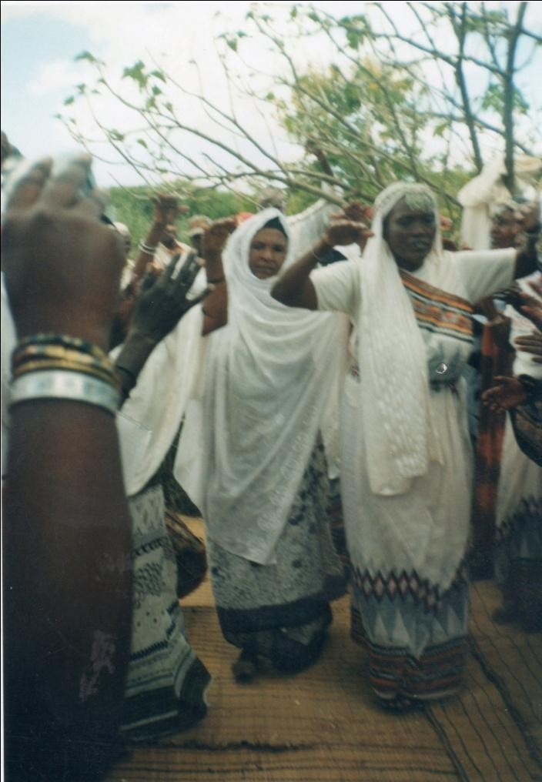
Plate 26: Borana women performimg cattle song.

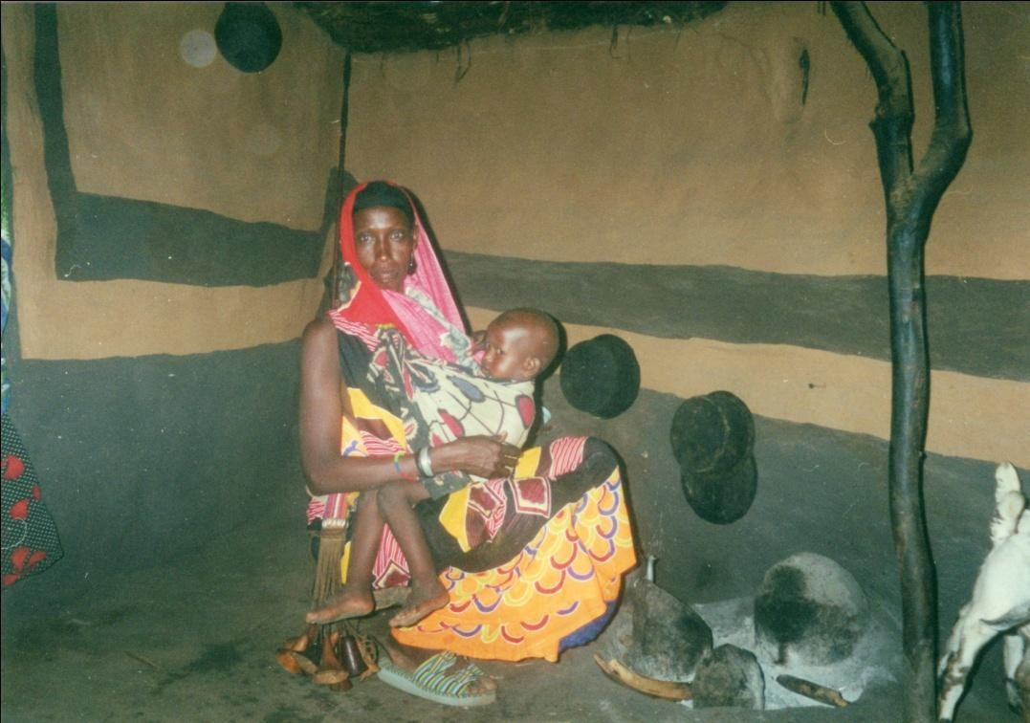

Plate 27: Shuke Wario, mother of a child being named in a celemonial gear at Mado Adi village.

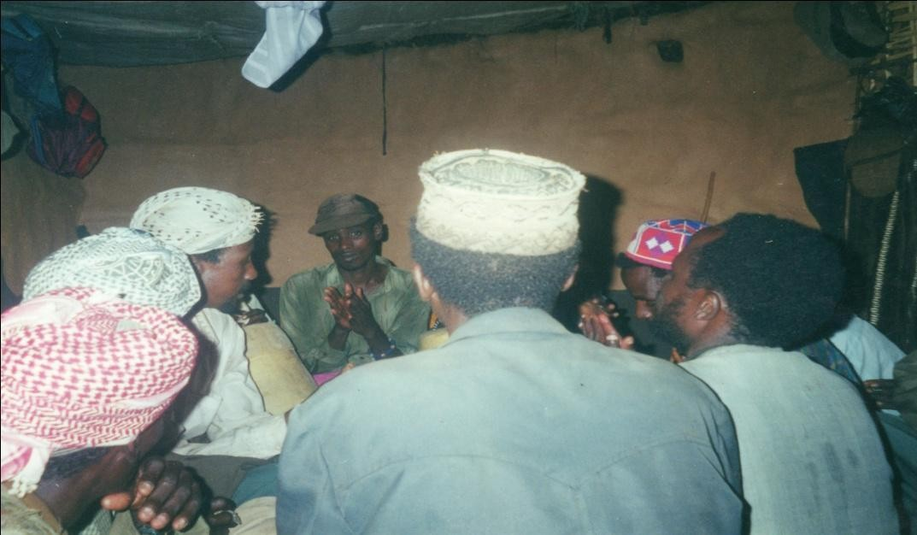

Plate 28: Borana men performing qoosa mocking women during childnaming ceremony in Mado Adi village.

CHAPTER EIGHT
CONCLUSION: DEFINING THE GENRIC FEATURES OF QOOSA
Some one hundred and fifty five years ago, a German missionary, Johan Ludwig Krapf, traveling in what was then Abyssinia, wrote the following in his book of travels and research memoirs:
Like most savage tribes, the Gallas are great talkers and for hours together they can make speeches with expression and play of gestures, which are very amusing to a European (Krapf 1860, reprint 1968:76)

The missionary was being true to the spirit of the time, when Europeans found the encounter with African civilization at best an amusingly primitive spectacle and at worst a repulsively savage engagement. The Galla he was referring to are the present Oromo peoples, of which the Borana are one, occupying Central and Southern Ethiopia, and spilling over into Northern Kenya. Although one wonders what is so amusing about oratory and rhetorical speech reported by the missionary, his work evinces the pervasiveness of oral communication among the Oromo people in general. Mohammed Hassen’s assertion many years later to the effect that Oromo literature is rich in folktales, stories, songs, and poems and is passed on from one generation to another by elders ( 2010: 137) is a more accurate description of the situation. Unlike the missionary, I see the eloquence in speech amongst the Borana Oromo as a lens through which to view their culture and their conception of themselves. As Andrzejewski & Lewis (1964) in connection with the Somali tell us, poetry provides a deeper insight into culture and thought. Karin Barber (1991:2) has made the same point with much clarity, arguing that oral texts can lead into the heart of a community’s own conception of itself.
The current book has been an investigation of one such oral poetic discourse called qoosa among the Borana. It interrogates the range of humorous undertakings that performers engage in and the meaning they derive from it at the personal and social levels. In terms of content, the book has brought the different social actors together and discussed the dynamics of humour that preoccupies them, and how the particular strands of humour reflect performers’ status within the society. In this chapter I discuss emergent issues from the seemingly disparate strands of humour discussed in each chapter by focusing on the weaving thread in a much more holistic way than has hitherto been apparent.

The pertinent question is what then is qoosa? And how is it conceived and configured by the Borana? To answer this fundamental question is to draw on the various facets of the genre, the core of which the preceding chapters have discussed. This chapter is dedicated to the task of synthesizing what the genre stands for and how it attends to some of the fundamental roles and functions it serves in society. Verbal forms of expression attest to the centrality of orature in a multitude of overlapping contexts to help people define their place in rapidly evolving societies (Rosenberg 2011). I am operating within the premise that has already been broached by scholars who assume that the psychology of humour has something to contribute to our understanding of humour, just as functionalism and other anthropological paradigms have. As Palmer (1994:4) infers, anthropologists and film critics use Freud, psychologists refer to historical studies, and literary critics take account of social frameworks when evaluating humour. Following this premise this book has freely drawn on these perspectives and

benefited from them. The multiple theoretical standpoints are enriching to the study of the genre, itself multidimensional in nature.
Neither am I interested in distinguishing wit, satire, comedy, joke, jest and a plethora of terms that riddle the discipline with their etymological roots in the English tradition. The main reason is that to the Borana, the term qoosa contains all of these or at least most of them and in a sense combines the qualities associated with them. But generally speaking qoosa is satirical, being a critical exposure of social and personal ills than merely being funny for the sake of it. As a genre that speaks to the social categories of age-set, men, women and clan, it is embedded in the collective consciousness of the people. It expresses the speaker’s desire to have a reordering of society. My purpose has been to elucidate the moral choice that is articulated by qoosa performers and how this is achieved.

As the preceding chapters have shown qoosa is not one thing but a series of humorous communications that society engages in, largely for criticism and amusement. The degree of seriousness that the Borana society attaches to the various categories of qoosa performed by the distinct functionaries differs. In some cases, here the clan qoosa serves as the best example; it must be acknowledged that joking is paradoxically a serious matter with its own ritual formula that must be harnessed to render it harmless. This potential danger of the genre has parallels in what Stoller (1994:354) in connection with griot performance in Mali, has called the potentially dangerous force of nyamakala, and translated as energy of action. I have witnessed informants who are otherwise articulate jesters but shun qoosa because they fear being “eaten”. The devouring of the performers in the perception of the Borana is thought to occur at two levels. One is that the evil-eyed people can devour a performer with an excellent voice so that he loses his voice. The importance of a good voice to the performer cannot be gainsaid, for he depends on it for a nightlong performance that consumes his energy, and since he has assumed responsibility to the audience for communicative competence (Bauman 1977:300), he is compelled to continue. Thus, in this case, it is the voice that is devoured through envy, using the potency of the evil eye.

The second way in which people are eaten involves a slighted co-performer who through his potent supernatural powers causes the demise of the offending performer when the former has been offended in the verbal exchange. In the Borana world, people know this very well, and fathers generally discourage their sons from engaging in the art. These potential dangers are warded off through gifts that are either concrete in the form of cattle or clothe, or verbal in the case of a promise like gift of a son, or abstract things like the blessing of god. Informants are in agreement that among the Digallu clan, for instance, the Karayyu were invariably afraid engaging such men in qoosa. Whenever they confront them with qoosa utterances, they appease them with a gift not as a way of entreating them to spare them their incisive and scathing criticisms, but more because of their extra verbal powers that were believed to finish the interactant instantly whenever they are vexed. This to them is not merely a belief but constitutes truth, as they have witnessed people die in this circumstances over the years.

In the majority of cases, qoosa in Borana occurs within a socially distinct jilla event of child naming ceremonies that is licentious. It is therefore imperative to understand qoosa within the context of festival of which it is part. As Falassi (1987:3) argues, the festival’s primary function is to renew periodically the life stream of a community by creating new energy, and to give sanction to its institutions. The ways in which this renewal is done are specified in

what he calls festival behaviours marked by reversal, intensifications, trespassing and abstinence.
Among the Borana, humour is dependent on a number of factors. The contravening of cultural norms, the incongruity between cultural expectations and the actual deviation are some of the sources of humour. The sheer unnaturalness, which distorts normalcy, causes laughter. A dangerous past event is also reused as qoosa where emotions such as embarrassment and fear are re-channeled into laughter. In this later case the dangerous event is converted into a hilarious one and the person who survives such an atrocity is given a nickname that reflects the perilous situation. The art resides in its brevity and its allusiveness to the event from which it was derived.

Qoosa may be regarded as a kind of verbal idiom that contributes to Borana unity by mediating the otherwise volatile relationship between individuals. As Leacock (1935:5) states, humour at its highest is a part of the interpretation of life. The qoosa genre is amorphous in that it is jocular without being a joke, humorous without being humour, poetic without being poetry, and narratological without being a narrative. It antagonizes as well as pacifies. It is tendentious, disjunctive, critical, and satirical, and it neither praises nor insults. It is all these at once without being one of them in isolation.
One of the most outstanding cues that signals the onset of qoosa and therefore is an integral part to its making is the formula dhinte dhinna, a sort of phrase without English equivalent. The formula, its translation problem aside, has associational meaning for the Borana who are led to anticipate the performance of qoosa. This anticipation is also preceded by other factors such as the knowledge of the speaker to the listener, a knowledge that already implies that they are joking partners outside the immediate performance context. The formula therefore serves to underline the present performance as a communicational enterprise that must be interpreted as a joke (Bauman 1983).

Confronted with the joke-seeking formula, the addressee is expected to reply oobai (finish, end); a way of lending consent to the anticipated qoosa performance. In qoosa, performers take caution not just with the words dhinte dhinna, which is abbreviated, but also with a lengthy formulaic questioning of the participant. The very elaborate formula actually subjects the participant to a thorough interrogation and obtains his solemn promise that nothing in the other can harm him or make him lose life over things that he was going to perform. Indeed, dhinte dhinna marks the transition from ordinary speech to jocular speech. The acceptance of it is a way of giving accent to the speaker and thus assuming the responsibility for the social intercourse at hand. During the performance certain normalcy of behaviour and speech shall be inversed and inverted. A significant feature of this inversion is the licentious ways in which people embellish their qoosa by adding falsehoods that are events which had not quite occurred. For the performers, and qoosa tradition in general this is acceptable. The addressee is required to deny or confirm the authenticity of the utterance.
What this book has done is to primarily tease out the components of qoosa that are recognized and valued by the people which makes it unique among other genres and other joke situations in other cultures. This task has entailed in part the question of aesthetics and worldview within a paradigm drawn by the Borana themselves. In this connection, the enduring values of qoosa lie in its content and its poetry. When all is said and done qoosa is an oral composition and the style of the verbal utterances makes people enjoy the art. The balance between form and content, the voice, the candor of performance and the ways in

which situations are depicted to bring out the incongruities, amused listeners to greater extent. What makes qoosa unique is that, it is a mode that emphasizes a clever way of saying something with the poetry bringing out the intelligence and witty side of the performers. It is not so much about humour for some of the best utterances can ordinarily not be regarded as funny. Humour in qoosa resides in the nuances that are depicted through historical connotations, cultural associations and local colour.

Furthermore, what is unique about qoosa is the fact that the Borana society has set aside time for it and deferentially perform it with rules, which when violated could in their imagination be fatal. In a word, qoosa genre indicates a time for criticism, play, enjoyment, and display of poetry and moral examination. It is especially valued for its critical realism, what Bakhtin (1968:18) has called grotesque realism, the encapsulation of bitter truth in the beautiful language of poetry. In this sense a good qoosa is that which is long and composed in rhythmic poetic style, grounded in the real everyday events and rendered without faltering or fumbling.
Cast in satirically critical mould without losing its sense of humour, qoosa symbolizes and embodies the community’s indignation at flagrant breaches of socially approved conduct at clan, age, and gender levels. Underlying the criticisms is the need to retain the prestige of the clan and other social categories, which depended on the zealous ways in which members of these categories represent it in the qoosa performance arena. For the individual, qoosa is a way of expressing his/her idiosyncrasies and mapping out an identity of his/her own within the dynamics of the social group to which he/she belongs.

By interrogating the diverse social categories within which qoosa is enacted, the book provides a fresh way of looking at the performance and meaning of joke in an African society, the kind that Radcliffe-Brown based his theory of joke upon some sixty six years ago. It is a society that is structurally different from the urban societies studied by Kennedy (1970), Lundenburg (1969), Davis (1993) and Hadelman & Kapferer (1972). Unlike the urban societies where joke is not a part of the cultural celebration but an individual initiative for interaction, qoosa is embedded in the structures of society. It is part of its celebrations, its joys and its deliberations. Huizinga’s (1970) contention that all antique poetry is at one and the same time ritual, competetion, entertainment, riddle making and artistry is not far from the truth in the case of qoosa. Often the content of these songs comment, defend and conserve societal norms, social behavior and moral values of the community at large (Ryanga 2011: 347).

Because qoosa is a text, which can be evaluated for its poetry as well as humour, it crosses genre boundaries, both at the level of nature and function. The weaknesses of clans are recounted, critiqued, the challenges of age-mates met, the foibles of men and women made public, and in spite of this confrontational performances, or even because of it, society comes out stronger, having celebrated itself through verbalization.

Qoosa then is part of the multiple ways in which various social issues are constituted in a society, where people’s moral ideals and worldview are mapped out. They put on display what is acceptable and unacceptable to them, what they consider immoral and to be avoided, and what is merely a challenge that accosts man and that must be met if one has to maintain one’s honour and intergrity. Qoosa being a commentary on all Borana systems gives us more than we can ask for. It goes beyond the genre boundaries as play and joke to probe the deeper

structures of society by revealing its working at the most basic level of people’s interaction with one another. Qoosa entertains and educates, injures and heals, attacks and defends, creates foes and friendship, and is pervasively present in people’s lives.

As a genre of oral literature, it is creative art that is put on display by individuals or a collective group where society is made to laugh at itself. To the Borana, qoosa is an important discourse that provides entertainment, criticism, and brings people together as part of a celebration. The insistence by informants that qoosa is neither insult nor praise must not be casually dismissed. If nobody was insulted or praised as the performers insist, what then transpired in the length and breath of qoosa? According to the Borana performers interviewed, a fact the poems themselves bring out, the interaction constituted entertainment essentially as an intergral part of the ceremony. In saying so they are aware of its contextual potency and limitation that are set out in form of prefaces to the song or verbal utterances. This means that qoosa is a genre that is called to service whenever and wherever the culture dictates, the latter being at naming ceremonies, at age-set meetings, at bull/he-goat rituals, and at clan gatherings. It forms part of their lives and can be invoked at socially appropriate situations. . In short qoosa is a genre that combines in unique ways criticism, aesthetics, poetry, joke and play by drawing on the rich vitality of Borana oral tradition and thus provides opportunity for a fascinating study.

A fascinating example of such an evocation was revealed to me as part of the way in which the Borana use oral genres, in what appears to be rather unconventional. At an interview I arranged with him, an informant, Jarso Beree told me how the Borana solve judicial cases like the one cited at the beginning of Chapter One by resorting to qoosa. Then he narrated how, many years ago when Beere and Dhanqa, subclans of the Karayyu, were locked in a contentious issue over the ownership of a well, women solved the problem through invocation of a kaarille song they had purposely composed for the occasion. What is so striking is that kaarille is a genre that is primarily sung by women among themselves about their clandestine lovers. As far as the general public is concerned, it is a proscribed genre that is subjected to much censorship from the male dominated culture to rein in women. It is only allowed in a public arena at jilla ceremony, where as previously indicated, licentious performances are put on display. For such a rare genre to be used to solve the problem that high-level elders like the hayyu have been unable to settle, was indeed surprising. This was what they sang:
Waarabane bisan Qarsa Uuba
Dhanqan Obbu hinbaanee booran Diido Duba Dhanqan Beeree baafte ta Qancora Duba
Dhanqa Beeree baafte salamta sii fuuna
We collected the waters of Qarsa Uuba
Dhanqa that resides in Obbu are that of Diido Duba Dhanqa that defeated Beere are that of Qancora Duba Dhanqa who defeated Beere we send you salutations
This was said within earshot of the gathering like the one described at the beginning of the book. According to Jarso Beree the informant, immediately this was uttered the matter was

considered closed and the meeting broke with the understanding that the contested well has been conceded to Dhanqa. When I asked him why the matter was brought to a close, he told me in a matter of fact way that “they spoke the truth, they were not part of the meeting but they came and spoke the truth”. What gave the women’s speech such enormous power and influence is the context in which it was spoken. They were outside the negotiation circles that locked horns in learned rhetorics and counterarguments Borana elders are known for, and in this sense maintained the dignity and impartiality of an observer who merely speaks the truth as s/he sees it. Although the kaarille speech had the traces of praise in the conventional way, it however, addressed itself to the matter at hand and saluted the people they regarded were on the right side of history. Councillor Jarso’s speech at the beginning of the book had this trace of impartiality to it, except that he wasn’t entirely innocent because of his political interest. What I underline here is the evocative quality of qoosa, which like the kaarille cited above transcends the genre convention to mediate social relationships.

Qoosa has four defining characteristics, which are common to all of them. The first is that it must be poetic in nature, unlike the conventional joke in the Western sense. Because of its inherent poetry it needs to be studied as literature. The poetic language brings out its jocular quality. The second is that it is a way of speaking for specific purposes in society, where these purposes are to negotiate a position, to mock, to denigrate, shame or advise. Third, it is a genre that is performed by the entire society, and hence it becomes a social institution celebrated and performed, appreciated and evaluated by the people. Fourth, it is always framed and delineated not only by the occasion but also by the texts themselves since as Hirsch (1967:76) says all understandings of verbal meaning is necessarily genre-bound. Thus the speakers always preface their qoosa texts as already indicated with dhinte dhinna or words like aada jilla, the custom of the festival.
By way of qualification, I must admit I have arrested qoosa as if it is a static phenomenon and talked about it. This is solely for scholarly convinience. The truth is that the genre is evolving in multiple ways since it is a process that involves creativity by many individuals in the Borana society, most of whom I have not talked to. Everybody has his/her creative qoosa about him/her or by him/her, and the repertoire grows as lived experiences expand over years. Essentially then, this is an open field that has no closure. A new study can pick up from this and still unearth new and valid data that can be analysed within a variety of theoretical framework.
Secondly, I have all along tended to assume, although it has some elements of subversion by the way in which it unraffles the status quo that qoosa generally serves to unify the society by negotiating social relationships. A further study can, with all legitimacy, pursue the subversion theme and argue that qoosa indeed overturns the structures of society and thus subverts authority.
As for this study, I have tended to steer the course that is rather definitive, as the book is an attempt to break new ground in an unstudied area and relatively understudied community. One distinctive feature of qoosa among the Borana is its performance by different social categories such as age-set, men, women, clans and generation-set (Wako 2002). I have tried to bring on board the many strands of qoosa in the spirit of achieving a broader understanding of the genre, while a narrower focus on any one of them could have as well yielded a rigorous and viable result. Nonetheless, I see the present study probing the Borana world through its humorous verbal art that qoosa is.

Works Cited
Abrahams, Roger. (1962). “Playing the Dozen”. Journal of America Folklore, 75:209-220
- -. (1970). “Performance-Centred Approach to Gossip”. Man 5: 290-301
----------------.(1983). The Man of Words in West Indies. London & Baltimore. The John Hopkins University Press.
Abrahams, Roger & Richard Bauman. (1978).“Ranges of Festival Behaviour”, pp. 193-208. In Barbara Babcock The Reversal World: Symbolic Inversion in Art and Society. Ithaca and London. Cornell University Press.
Abu-Lughod, Lila. (1986). Veiled Sentiments: Honor and Poetry in A Bedouin Society.
Berkeley. University of California Press.
-----------------------. (1990). “The Romance of Resistance: Tracing the Transformation of Power through Bedouin Women.” American Ethnologist 17:41-55.
Aguilar, Mario. (1999). “Reinventing Gada: Generational Knowledge in Borana”. In Aguilar, Mario. (ed.) The Politics of Age and Gerontocracy in Africa. Trenton. Africa World Press.
Almagor, Uri. (1978). “The Ethos of Equality among Dassanetch Age-peers”, pp. 69-94. In P. Baxter & U. Almagor (eds.), Age, Generation and Time. London. Hurst.
Andrzejeweski, Bogumi. (1957). “Some Preliminary Observations on the Borana Dialects of Galla”. Bulletin of the School of Oriental and African Studies 19: 354-374.
- --. (1962). “Ideas about Warfare in Borana Galla Stories and Fables”. African
Language Studies 3: 116-136.
--------------------. (1972.) “Allusive Diction in Galla Hymns in Praise of Sheikh Hussein of Bale”. African Language Studies 13: 1-31.
Andrezejeski Bogumi & I Lewis. (1964). Somali Poetry: Introduction. Oxford. Clarendon Press.
Apte, Mahadev. (1985). Humour and Laughter: An Anthropological Approach. Ithaca. New York. Cornell University Press.
Archetti, Eduardo. (1999). Masculinities: Football, Polo, and the Tango in Argentina.
Oxford. Berg.
Arero, Hassan Wario. (2007). “Coming to Kenya: Imagining and Perceiving a Nation among the Borana of Kenya”. Journal of Eastern African Studies 1-2: 292-304.
Aristotle (1927). Poetics. London. Heinemann.
Bakhtin, Mikhail. (1968). Rabelais and His World. Bloomington. Indiana University Press

-------------------. (1986). Speech Genres and Other Late Essays. Austin. University of Texas Press.
Barber, Karin. (1991). I Could Speak Until Tomorrow: Oriki, Women, and the Past in A Yoruba Town. London. Edinburgh University Press.
- (1997). “Preliminary Notes on Audience in Africa”. Africa 67 (3): 347-362.
----------------- (1999a). “Obscurity and Exegesis in African Oral Praise Poetry”. In Duncan Brown (ed.) pp 28-43, Oral Literature and Performance in Southern Africa. Cape Town. David Philip.
----------------. (1999b). “Quotation in the Constitution of Yoruba Oral Texts”. Research in African Literature 30(2): 17-41
Barber, Karin. & P, Farias. (eds.) (1989). Discourse and Its Disguises: The Interpretation of African Oral Texts. Birmingham. Center for West African Studies.
Basso, Keith. (1979). The Portraits of “The White Man”: Linguistic Play and Cultural Symbols among the Western Apache. Cambridge. Cambridge University Press.
--------------. (1988). “Speaking with Names: Language and Landscape among the Western Apache”. Cultural Anthropology 3(2): 99-130.
Bauman, Richard. (1975). “Verbal Art as Performance”. American Anthropologist 77: 290-311.
-------------------. (1986). Story, Performance and Event: Contextual Studies of Oral Narrative. Cambridge. Cambridge University Press.
Baxter, Paul. (1954). "The Social Organization of the Galla of Northern Kenya”. Unpublished D.Phil. thesis Oxford.
-----------------. (1974). “Some Preliminary Observations on a Type of Arsi Song, Wellu, which is Popular with Young Men”. V Congresso Internazionale Di Studi Etiopici. Pp.809-820. Roma. Academia Nazionale Dei Lincei.
----------------. (1978). "Borana Age Set and Generation Set: Gada, A Puzzle Or A Maze?"
pp. 151-182. In P. Baxter & U, Almagor. (eds.) Age, Generation And Time. London. Hurst.
--------------. (1986). "Giraffe and Poetry: Some Observation on Giraffe Hunting among the Borana”. Paideuma 32:45-63.
---------------. (1994). “The Creation and Constitution of Oromo Nationality”, pp. 167-186. In Ethnicity and Conflict in the Horn of Africa. (eds.) Fukui Katsuyoshi & John Markakis London. James Currey.
- --. (1998). "Changes and Continuities in Oromo Studies”. Journal of Oromo Studies,
5(1 &2): 35-68

Beidelman, Thomas (1966). "Utani: Some Kaguru Notions of Death, Sexuality, and Affinity”. Southwestern Journal of Anthropology 22: 354-80.
---------------------. (1986). Moral Imagination in Kaguru Modes of Thought. Bloomington.
Indiana University Press.
Ben-Amos, Dan. & Kenneth Goldstein. (1975). (eds.) . Folklore: Performance and Communication. The Hague. Mouton.
Berger, Arthur. (1976). “Anatomy of Jokes”. Journal of Communication 26 (3): 113-115. Bergson, Henri. (1911). Laughter. An Essay on the Meaning of the Comic. London.
Macmillan & Co.
Bourdieu, Pierre. (1977). Outline of A Theory of Practice. Cambridge. Cambridge University Press
Brandes, Stanley. (1980). Metaphors of Masculinity. Philadelphia. University of Philadelphia Press.
Briggs, Charles. (1988). Competence in Performance: The Creativity of Tradition in Mexicano Verbal Art. Philadelphia. University Press of Pennsylvania.
Broch-Due, Vidgis. (1999). “Creation and Multiple Female Body: Turkana Perspective on Gender and Cosmos”. Pp. 153-184. In Those Who Play With Fire: Gender, Fertility and Transformation in East and Southern Africa (eds.) Henrietta Moore, Todd Sanders and Bwire Kaare. London. The Athlone Press
Brown, Duncan. (1998). Voicing the Text: South African Oral Poetry and Performance. Cape Town. Oxford University Press.
Brunkman, J. (1975). “Tongue Play”: Constitutive and Interpretive Properties of Sexual Joking Encounters Among the Koya of South India.” In Sanches, M & B, Blount (eds.) Sociocultural Dimensions of Language. New York. Academic World Press.
Burma, J. (1946). “Humour as A Technique in Race Conflict”. American Sociological Review, Vol. 11: 710-715.
Cerrulli, Enrinco.(1922). "The Folk Literature of the Galla of Southern Abyssinia." Harvard African Studies 3: 9-228.
Chapman, Antony & Nicholas Gadfield. (1976). “Is Sexual Humour Sexist?” Journal of Communication 26 (3): 141-153.
Chapman, Antony & Hugh Foot. (1977). It Is A Funny Thing, Humour. International Conference on Humour and Laughter, Cardiff, Wales, Pergamon.
Chiaro, Delia. (1992). The Language of Jokes: Analyzing Verbal Play. London. Routledge. Christensen, J. (1963). "Utani": Joking, Sexual License, and Social Obligation Among the
Luguru." American Anthropologist 65: 1314-27.

Colson, Elizabeth. (1962). “Clans and Joking Relationship among the Plateau Tonga of Northern Rhodesia”, pp. 66-83. In The Plateau Tonga of Northern Rhodesia: Social and Religious Studies, Colson E, (ed.). Manchester. Manchester University Press.
Cosentino, Donald. (1982). Defiant Maids and Stubborn Farmers: Tradition and Invention in Mende Story Performance. Cambridge. Cambridge University Press
--------------------. (1988). "Image, Parody, and Debate: Levels In Mende Narrative Performance”. Journal of Folkore Research 25(2): 17-34
Dahl, Gudrun. (1979). Suffering Grass, Subsistence and Society of Waso Boran. Stockholm.
Stockholm University Studies in Social Anthropology.
Daniel, Valentine. (1996). “From an Athropologist’s Point of View: The Literary”, pp. 1-13. In Daniel, Valentine & Jeffrey Peck (eds.), Culture/Contexture: Explorations in Athropology and Literary Studies. Berkeley. University of California Press.
Davies, Christie. (1990). Ethnic Humour Around the World: A Comparative Analysis.
Bloomington. Indiana University Press.
Davies, Murray. (1993). What is So Funny: The Comic Conception of Culture. Chicago.
University Press of Chicago.
Davis, Natalie. (1978). “Women On Top: Symbolic Sexual Inversion and Political Disorder in Early Modern Europe”. In Barbara Babcock (ed.) The Reversal World: Symbolic Inversion in Art and Society, pp. 147-192. Ithaca and London. Cornell University Press
Douglas, Mary. (1966). Purity and Danger. London. Routledge and Kegan Paul
-----------------.(1968). "The Social Control of Cognition: Some Factors in Joke Perception”.
Man 3:361-76.
-----------------. (1975). Implicit Meanings: Essays in Anthropology. London & Boston.
Routledge & Kegan Paul.
Drewal, Margaret. (1991). “The State of Research on Performance in Africa”. African Studies Review 34(3): 1-64.
Drew, Paul. (1987). “Po-faced Recepients of Teases”. Linguistics 25: 19-53.
Dundes, Alan. (1977). "Jokes and Covert Language Attitude: The Curious Case of A Wide-Mouth Frog”. Language in Society 6: 141-47.
- --. (1980). Interpreting Folklore. Bloomington. Indiana University Press.
----------------. (1985). "The J.A.P. and The J.A.M. in American Jokelore”. Journal of American Folklore, 98 (390): 456-75.
Eastman, Max. (1936). Enjoyment in Laughter. New York. Simon & Schuster.
Eco, Umberto. (1990). “The Frame of Comic Freedom”. In Carnival!, pp.1-10. (ed.) Thomas Sebeok. Berlin. Mouton Publishers.

Evan-Pritchard, E. (1940). The Nuer. London. Oxford University Press.
Fabian, Johannes. (1990). Power and Performance: Ethnographic Explorations through Proverbial Wisdom and Theater in Shaba, Zaire. Madison. University of Wisconsin Press.
Falassi, Alessandro. (1987). Time Out of Time. Albuquerque. University of Mexico Press. Fine, Gary. (1976). “Obscene Joking Across Cultures”. Journal of Communication 26 (3):
134-140.
Finnegan, Ruth (1970). Oral Literature in Africa. London. Clarendon Press.
------------------.1992. Oral Tradition and the Verbal Arts. London. Routledge.
Foley, John. (1995). The Singer of Tales in Performance. Bloomington. Indiana University Press.
Fowler, Alaister.(1982). Kinds of Literature: Introduction to Theory of Genres and Modes.
Oxford. Clarendon Press.
Freedman, J.(1977). “Joking, Affinity, and the Exchange of Ritual Services Among the Kiga of Northern Rwanda: An Essay on Joking Relationship Theory”. Man 12:259-267.
Freud, Sigmund. (1916). Wit and Its Relation to the Unconscious. London. Fisher & Unwin. Frolec, Vaclav. (1990). “The Ride of Kings and Playing at Kings: Ritual-Play-Festival”
pp.66-74. In International Folklore Review, 7 (ed.) Venetia Newall. London.
Furniss, Graham. (1989). "Typification and Evaluation: A Dynamic Process in Rhetoric." In Barber K. & P, Farias. (eds.) Discourse and Its Disguises: The Interpretation of African Oral Texts.
-------------------. (1996). Poetry, Prose and Popular Culture in Hausa. London. Edinburgh University Press for International African Institute.
Gennep, Arnold Van. (1960). The Rites of Passage. London. Routledge and Kegan Paul. Geertz, Clifford. (1975). The Interpretation of Cultures. London. Hutchinson.
Gillooly, Eileen. (1999). Smile of Discontent: Humour, Gender, and Nineteenth-Century British Fiction. Chicago. University of Chicago Press.
Gilmore, David.(1990a). Manhood in the Making: Cultural Concept of Masculinity. New Haven. Yale University Press.
------------------.(1990b). “Men and Women in Southern Spain: Domestic Power Revisited”.
American Anthropologist 92: 953-70.
- -. (1998). Carnival and Culture: Sex, Symbol and Status in Spain. New Haven
and London. Yale University Press.

Gluckman, Max. (1965). Politics, Law and Ritual in Tribal Society. Chicago. Aldine Publishing Company.
Goldstein, Jeffrey. (1976). “Theoretical Notes on Humour”. Journal of Communication 26
(3): 104-112.
Gollo, Huqa. (1996). The 37th Gumi Gayo Assembly. Addis Ababa. Norwegian Church Aid. Gossen, Gary. (1974.) “Verbal Dueling in Chamula”. In Speech Play. Barbara
Kimblett-Gimblett (ed.). Philadelphia. University of Philadelphia Press.
Goto, Paul. (1972). "The Borana of Northern Kenya". Unpublished BA Dissertation.
University of Nairobi.

Griaule, M. (1948). “L’alliance Carthartique”. Africa 18: 242-258. Gulliver, P. (1957). Joking Relationship in Central Africa. Man 1V11
Gunner, Liz & Mafika Gwala. (1991). Musho! Zulu Popular Praises. East Lansing.
Michigan. Michigan University Press.
Haberland, Eike. (1963). Galla Sud-Athiopiens. Stuttgart. Kohlhammer. Hammond, Peter. (1964). “Mossi Joking”. Ethnologist 3: 259-267.
Handelman, D. & B. Kapferer. (1972). “Forms of Joking Activity: A Comparative Approach”. American Anthropologist 74 (3): 484-517.
Hanks, F. (1989). "Text and Textuality”. Annual Review of Anthropology 18:95-127
Hassen, Mohammed.(1990). The Oromo of Ethiopia: A History 1570-1860. Cambridge.
Cambridge University Press.
Hassen, Mohammed, (2010). “Orature, Resistance, and Nationalism: A Historical Overview of the Development of Written Oromo Literature”. Journal of Oromo Studies, vol 17
(1): 137-78.
Heath, Deborah. (1994). “The Politics of Appropriateness and Appropriation: Recontextualizing Women’s Dance in Urban Senegal”. American Ethnologist 21:88-103
Helland, Johan. (1996). “The Political Viability of Boorana Pastoralism”, pp.132-149. In Baxter, P.T.W et al. (eds.), Being and Becoming Oromo: Historical and Anthropological Enquiries. Uppsala. Nordiska Afrikaininstutet.
Herskovits, Melville. (1958). The Dahomean Narratives. Evaston. Northwestern University Press.
Hjort, Anders. (1979). Savanna Town: Rural Ties and Urban Opportunities in Northern Kenya. Stockholm. University of Stockholm.

Hodgson, Dorothy. & Sheryl McCurdy. (1996). “Wayward Wives, Misfit Mothers, Disobidient Daughters: Wicked Women and the Reconfiguration of Gender in Africa”. Canadian Journal of African Studies 30 (1): 1-9.
- (2001). Wicked Women and the Reconfiguration of Gender in Africa.
Oxford. James Currey.
Hoffman, Barbara. (2000). Griots at War: Conflict, Conciliations and Caste in Mande.
Bloomington and Indianapolis. Indiana University Press.
Hofmeyr, Isabel. (1993). We Spend Our Years As A Tale That Is Told: Oral Historical Narratives In A South African Chiefdom. London & Johannesburg. Heinemann, University of Witwatersrand & James Currey Press.
Hogg, Richard. (1990). “The Politics of Changing Property Rights among Isiolo Boran Pastoralists in Northern Kenya”. In Baxter, P.T.W. & Richard Hogg (eds.)
Holt, Elizabeth (2010). “The Last Laugh: Shared Laughter and Topic Termination”. Journal of Pragmatics 42 (6): 1513-25.
---------------------. (2011). “On the Nature of Laughables: Laughter as a Response to Overdone Figurative Phrases”. Journal of Pragmatics 21 (3): 393-410.
Hoskyns, Catherine. (1969). (ed.) The Ethiopia-Somalia-Kenya Disputes. 1960-67 Documents. Dar es Salaam. Institute of Public Administration.
Huizinga, Johan. (1949). (Reprint 1970). Homo Ludens: A study of Play Element in Culture.
London. Routledge & Paul Kegan.
Hunt, Eva. (1977). “Ceremonies of Confrontation and Submission”. In Secular Ritual. Sally Moore and B. Meyerhoff, (eds,) pp. 124-147. Assen, The Netherlands: Van Gorcum
Huntingford, G.(1955). The Galla of Ethiopia. London. International African Institute. Hutcheon, Linda. (1995). Irony’s Edge: The Theory and Politics of Irony. London and New
York. Routledge.
Hymes, Dell.(1975). "Breakthrough into Performance" In Bauman, R & K Goldstein (eds.)
Folklore: Performance and Communication. The Hague. Mouton.
Jackson, Bruce. (1987). Fieldwork.. Urbana and Chicago. University of Illinois Press. Jackson, Michael. (1982). Allegories of the Wilderness: Ethics and Ambiguity in Kuranko
Narratives. Bloomington. Indiana University Press
James, Deborah. (1999). Songs of the Women Migrants: Performance and Identity in South Africa. London. Edinburgh University Press.
Johnson, David. (1973). “Folklore and Women: A Social Interactional Analysis of Folklore of A Texas Madam”. Journal of American Folklore 86: 211-224.

Kanaana, S. (1990). “Humour of the Palestinian Intifiada”. Journal of Folklore Research,
27(3): 231-40.
Karl-Heinz, R & Heydasch T. (2010). “Performing Humour: On the Relations between Self-presentation Styles, Gelotophobia, Gelotophilia, and Katagelasticism.” Psychological Test and Assessment Modeling 52 (2): 171-90.
Kaspin, Deborah. (1999). “The Lion at the Waterhole: The Secrets of Life and Death in Chewa Rites de Passage”. In Those Who Play With Fire: Gender, Fertility and Transformation in East and Southern Africa. (eds.) Henrietta Moore, Todd Sanders, and Bwire Kaare, pp.83-99. London and New Brunswick. The Athlone Press
Kassam, Aneesa (1999). “Ritual and Classification: A Study of the Borana Oromo Terminal Sacred Grade Rites of Passage.” Bulletin of the School of Oriental and African Studies, Vol. 162(3): 484-503.
Kassam, Aneesa & Gemetchu Megerssa. (1989). “Iron and Beads: Male and Female Symbols of Creation, A Study of Ornaments among the Oromo”, pp.23-31. In I. Hodder (ed.), The Meaning of Things: Material Culture and Symbolic Expression. London. Allen and Unwin.
----------------------------------. (1994). “Aloof Alollaa. The Inside and the Outside; Boran Oromo Environmental Law and Methods of Conservation”, pp. 86-98. In Brokensha, David. (ed.), A River of Blessings. Essays in Honour of Paul Baxter. Syracuse. New York. Maxwell School of Citizenship and Public Affairs.
Kidane, Sehlu. (1996). Borana Oromo Prose Narratives: A Contextual Study. Unpublished MA thesis, Addis Ababa University.
Koljevic, Svetozar. (1980). The Epic in the Making. Oxford. Clarendon.

Krapf, Ludwig. (1860, reprint 1968). Travels, Researches, and Missionary Labours During Eighteen Years in Eastern Africa.
Kratz, Corrine. (1994). Affecting Performance: Meaning, Movement, and Experience in Okiek Women’s Initiation. Washington & London. Smithsonian Institution Press
Leacock, Stephen. (1935). Humour: Its Theory and Technique. London. John Lane the Bodley Head.
Legesse, Asmarom.(1973). Gada: Three Approaches to the Study of African Society. New York. The Free Press.
Legman, Gershen. (1968). The Rationale of Dirty Jokes. New York. Grove.
Lesser, Wendy. (1991). His Other Half: Men Looking At Women through Art. Cambridge.
Mass. Harvard University Press.
Leus, Ton. (1995). Borana Dictionary. (No publication details).

- --. (2000). Mammaassa Booranaa. Dhaddim, Yaaballo.
Levine, J. (1977). Motivation in Humour. New York. Atherton.
Lewis, I. M. (1966). (ed.) Islam in Tropical Africa. London. International African Institute.
Limon, E. (1982). “History, Chicano Joking, and the Varieties of Higher Education: Tradition and Performance as Critical Symbolic Action”. Journal of the Folklore Institute 19: 141-66.
Lincoln, Bruce. (1999). Theorizing Myth: Narrative, Ideology and Scholarship. Chicago.
Chicago University Press.
Lord, Albert. (1960). The Singer of Tales. Cambridge, Ma; Harvard University Press. Lundberg, Craig. (1969). “Person-focused Joking: Pattern and Function”. Human
Organization 28 (1): 22-31.
Madison, D Soyini & Hamera, Judith (2006). The Sage Handbook of Performance Studies.
London.Sage Publication.
Mayer, P. (1951). "The Joking Pals in Gusii Age-Sets”. African Studies 10:27-41
Mcdowell, J. (1981). "Towards A Semiotics of Nicknaming: The Kampsa Example”. Journal of American Folklore 94(371) 1-18
Mcghee, Paul. (1979). Humour. San Francisco. Freeman.
Mcghee, Paul & Jeffrey Goldstein. (1972). The Psychology of Humour: Theoretical Perspectives and Empirical Issues. New York. Academic Press.
Mitchell, W. T. (2000) “Geopoetics: Space, Place, and Landscape”. Critical Inquiry, 26(2): 173-4
Monro, David. (1951). Argument of Laughter. Melbourne. Melbourne University Press. Moreu, R. (1944). “Joking Relationships in Tanganyika”. Africa XIV: 386-400.
Nuessel, Frank. (1985). “Ageist Language”. Maledicta 8:17-23.
Nyman, Jopi (1997). Men Alone: Masculinity, Individualism, and Hard-Boiled Fiction.
Amsterdam, Atlanta. Rodopi.
Oba, Gufu. (1996). “Shifting Identities along Resource Borders: Becoming and Continuing to be Boorana Oromo”, pp. 117-131. In P.T.W. Baxter et al. (eds.) Being And Becoming Oromo: Historical and Anthropological Inquiry. Nordiska Afrikainstitute, Uppsala.
------------------.(2000).”Where the Bulls Fight, It is the Grass that Suffers: Impact of Border Administration on Drought Coping Strategies of the Obbu Booran During the 20th Century”. Journal of Oromo Studies, 7 (1/2): 87-108.
------------------. (2013). Nomads in the Shadows of the Empire: Contests, Conflicts, and Legacies on the Southern Ethiopia-Northern Kenya Frontier. Leiden- Boston. Brill.

-------------------. (2017). Herder Warfare in East Africa: A Social and Spatial History.
Cambridgeshire. UK. The White Horse Press.
Okpewho, Isidore. (1983). Myth in Africa. Cambridge. Cambridge University Press.
Ong, Walter. (1982). Orality and Literacy: The Technologizing of the Word. London.
Routledge.
Opland, Jeff. (1998). Xhosa Poets and Poetry. Cape Town. David Philip Publishers. Palmer, Jerry. (1994). Taking Humour Seriously. London. Routledge.
Parker, Richard. (1991). Bodies, Pleasures and Passions: Sexual Culture in Contemporary Brazil. Boston. Beacon Press
Parkin, David. (1980). "The Creativity of Abuse”. Man 15(1): 45-64
Peek, P. (1981). "The Power of Words in African Verbal Arts”. Journal of American Folklore
94(371): 19-43.
Plowden, Walter. (1868). Travels in Abyssinia and Galla Country. London. Longmans & Greens.
Prussin, Labelle. (1995). African Nomadic Architecture: Space, Place and Gender.
Washington and London. The Smithsonian Institution Press
Radcliffe-Brown, A. R.(1940). "On Joking Relationships”. Africa 3(13): 195-210.
--------------------------. (1949). “A Further Notes On Joking Relationship”. Africa 19(1): 133-140.
Ranelegh, Elaine. (1985). Men on Women. London. Quartet Books.
Ranger, Terence. (1975). Dance and society in Eastern Africa 1890-1970. Beni Ngoma.
London. Heinemann.
Raskin, Victor. (1985). Semantic Mechanisms of Humour. Dordretcht. Reidel. Reynolds, V. (1958). “Joking Relationships in Africa”. Man IVIII
Rigby, Peter. (1968). "Joking Relationships, Kin Categories, and Clanship among the Gogo”.
Africa 38:133-155.
Rogers-Revell, P (2007). “Humour in Business: A Double-edged Sword: A Study of Humour and Style Shifting in Intercultural Business Meetings”. Journal of Pragmatics 39 (1): 4-28.
Rosenberg, Aaron Louis. (2011). Eastern African Popular Songs: Verbal Artistry in the State of Translocation. Trenton. Africa World Press.
Ryanga, Sheila (2011). “Stylistic Analysis of the Digo Women Verbal Art: The Example of Ngodya Dance”. In East African Literature: Essays on Written and Oral Traditions. Makhoka J S, Kabaji E & Dipio D (eds.) pp. 347-68.

Sacks, Harvey. (1974). “An Analysis of the Course of A Joke’s Telling in Conversation”. In. R, Bauman & J, Sherzer. (eds.) Ethnography of Speaking. Cambridge. Cambridge University Press.
Salvadori, Cynthia. (2000). The Forgotten People Revisited. Nairobi. Kenya Human Right Commission.
Samatar, Said. (1982). Oral Poetry and Somali Nationalism: The Case of Sayyid Mahamed Abdille Hasan. Cambridge. Cambridge University Press.
Scheub, Harold. (1975). The Xhosa Ntsomi. Oxford. Clarendon Press.
Schlee, Gunther. (1988). "The Oromo Expansion and Its Impact on Ethnogenesis in Northern Kenya”. In Tadesse Beyene (ed.) Proceedings of the 8th International Conference of Ethiopian Studies, University of Addis Ababa.
- -. (1989). Identities on the Move: Clanship and Pastoralism in Northern Africa.
Manchester. Manchester University Press.
Sharman, A. (1969). "Joking in Padhola: Categorical Relationships, Choice and Social Control”. Man 4:103-117.
Sherzer, Joel. (1990). Verbal Art in San Blas: Kuna Culture through Its Discourse.
Cambridge. Cambridge University Press.
Shongolo, Abdullahi. (1994). “The Gumi Gayo Assembly of the Boran: A Traditional Legislative Organ and Its Relationship to the Ethiopian State and a Modernizing World”. Zeitscrift Fur Ethnologie, 119: 1-33.
----------------. (1996). “The Poetics of Nationalism”, pp.265-290. In Baxter P.T.W. et al. (eds.) Being and Becoming Oromo: Historical and Anthropological Inquiry.
Skinner, Quentin. (1969). “Meaning and Understanding in the History of Ideas”. History and Theory 8 (1): 3-53.
Spencer, Paul. (1973). Nomads in Alliance: Symbiosis and Growth among the Rendille and Samburu of Kenya. London. Oxford University Press.
Stallybrass, Peter & White, Allon. (1986). The Politics and Poetics of Transgression.
London. Methuen
Stefaniszyn, B. (1950). "Funeral Friendship in Central Africa”. Africa 20: 291-306.
Stevens, P. (1978). “Bachama Joking Categories: Toward New Perspectives in the Study of Joking Relationships”. Journal of Anthropological Research 34: 47-71.
Stroomer, Harry. (1987). A Comparative Study of three Southern Oromo Dialects. Leiden. Tablino, Paul. (1999). The Gabra: Camel Nomads of Northern Kenya. Paulines. Paulines
Publication Africa.

Tadhi, Liban. (2015) Jatani Ali Tandhu: Life and Legacy of a Borana Statesman. Fremantle.
Vivid Publishing.
Tagawa, Gen. (1997). “The Rituals of the Gada System of the Borana: With Special Reference to the Latecomers of a Generation Set”, pp. 616-631. In Ethiopia in Broader Perspective. Fukui, Katsuyoshi et al. (eds.) Proceedings of 13th International Conference of Ethiopian Studies Held at Kyoto, Japan.
Tareke, Gebru. (1991). Ethiopia: Power and Protest, Peasant Revolt in the Twentieth Century. Cambridge. Cambridge University Press.
Tedlock, Dennis. (1978). Finding the Center: Narrative Poetry of the Zuni Indians. Lincoln.
University of Nebraska Press.
--------------------. (1983). The Spoken Word and the Work of Interpretation. Philadelphia.
University of Pennsylvania Press.
Tilahun, Gamta. (1993). "Reasons for Choosing the Latin Script for Developing an Oromo Alphabet”. Oromo Commentary 3(1): 17-20.
Trawick, Margaret. (1996). “The Story of the Jackal Hunter Girl”, pp. 58-83. In Daniel, Valentine & Jeffrey Peck (eds.), Culture/Contexture: Explorations in Anthropology and Literary Studies. Berkeley. University of California Press.
Turner, Victor (1967). The Forest of Symbols. Ithaca. Cornell University Press.
- -. (1969). The Ritual Process: Structure and Anti-Structure. London. Rouledge
and Kegan Paul.
Vail, Leroy. & White, Landeg. (1991). Power and Praise Poem: Southern African Voices in History. Charlottesville & London. University Press of Virginia & James Currey.
Wako, Fugich. (1993). “Cattle Song as Performance: The Case of the Borana Weedhu”.
Unpublished MA thesis. University of Nairobi.
---------------. (2002). “Tradition, Memory, Creativity, and the Self in Personal Narratives among the Borana”. Fabula 43 (1/2): 18-34
Whittaker, Hannah (2014). Insurgency and Counterinsurgency in Kenya: A Social History of Shifta Conflict c. 1963-1968. Leiden.Boston. Brill.
Wickberg, Daniel. (1998). The Senses of Humour: Self and Laughter in Modern America.
Ithaca. Cornell University Press.
Wilson, D (2006).”The Pragmatics of Verbal Irony: Echo or Pretence?” Lingua 116: 1722-43.
Winnick, Charles. (1976). “The Social Context of Humour”. Journal of Communication 26
(3): 124-128.
Yankah, Kwesi. (1989). "Proverbs: The Aesthetics of Traditional Communication”. Research in African Literature 20(3): 325-346

-------------------. (1995). Speaking for the Chief: Okyeame and the Politics of Akan Royal Oratory. Bloomington. Indiana University Press.
Zijdevreld, Anton. (1968). “Jokes and Their Relation to Social Reality”. Social Research 35: 286-311.
Zillmann, Dolf & Holly Stocking. (1976). “Putdown Humour”. Journal of Communication 26
(3): 154-163.

