Case Series

MAGNETIC RESONANCE IMAGING IN DIAGNOSIS AND CLASSIFICATION OF MULLERIAN DUCT ANOMALIES: CASE SERIES

ABSTRACT

Background: Mullerian duct anomalies (MDAs) arise from the aberrant development of the uterus, cervix, and vagina, impacting the potential for successful conception and full-term pregnancy. This category encompasses a diverse range of developmental defects, leading to a spectrum of clinical presentations such as amenorrhea, infertility, recurrent miscarriages, intrauterine growth retardation, malposition of the fetus, preterm labor, and retained placenta.
Case(s): In this study, we present 17 cases of MDA with a wide array of clinical manifestations. The varied symptoms included amenorrhea, infertility, repeated miscarriages, intrauterine growth retardation, malposition of the fetus, preterm labor, and retained placenta. Accurate categorization of these cases is crucial for determining the appropriate surgical intervention. While ultrasonography aids in the initial diagnosis of MDA, our focus on accurate classification necessitates the use of magnetic resonance imaging (MRI).
Conclusion: Our findings underscore the significance of MRI in precisely categorizing MDA, and facilitating effective management strategies. The 17 cases presented demonstrate the diverse spectrum of MDA manifestations, emphasizing the need for tailored surgical interventions for successful conception and optimal pregnancy outcomes. The use of MRI proves instrumental in guiding clinical decisions, offering a comprehensive understanding of MDA, and informing targeted interventions to enhance reproductive success.
Keywords: Magnetic resonance imaging, Mullerian duct anomalies, Ultrasonography.

INTRODUCTION
The pair of mullerian ducts in females is responsible for the development of the female reproductive system, namely, fallopian tubes, uterus, cervix, and upper part of the vagina. In cases where there is absence or impaired fusion (partial or complete) of the mullerian ducts, a number of developmental defects may arise [1], known together as mullerian duct anomalies (MDA). Developmental defects of the urinary tract, including renal agenesis, are often associated with MDA [1-3]. Patients with MDA might present with diverse types of symptoms depending on the developmental defect(s), ranging from primary amenorrhea to infertility [1-3]. Infertility and amenorrhea are the two most common symptoms for which patients seek medical attention [4]. Although ultrasonography (USG) can diagnose developmental defects to some extent, for exact identification of the developmental defects magnetic resonance imaging (MRI) is essential, as it would prevent unnecessary laparotomies and surgeries. Besides USG, hysterosalpingography (HSG) can be recommended; however, exposure of the patient to contrast materials and radiation, and poor capacity of HSG to delineate the true extent of the developmental defects has led to limited utility of HSG in the diagnosis of MDA [1-3].

In recent years, MRI has revolutionized the diagnosis of MDA. It has proven its worth as a powerful tool to correctly characterize developmental defects and to delineate the anatomical relationship of the different organs of the female reproductive system with the surrounding other structures (especially the urinary tracts) [1,4,5]. Here, we present 17 cases of MDA with diverse developmental defects.

CASE DISCUSSION

Case 1
A 17-year-old female presented at the gynecology department with complaints of primary amenorrhea with no history of cyclical pain
abdomen. She was advised screening USG which showed absence of uterus with normal bilateral ovaries. Next, MRI was advised. MRI scanning revealed aplastic uterus with partial vaginal agenesis and complete cervical agenesis (European Society of Human Reproduction and Embryology [ESHRE] U5a C4 V4). The patient was advised to undergo vaginoplasty by the gynecologists.

Case 2
A 24-year-old female with repeated history of spontaneous abortions with the normal menstrual history presented at the gynecology department. On USG screening, two separate endometrial cavities with possibility of bicornuate/septate uterus were revealed. Next, on MRI, a scan bicornuate uterus with a common cervical and vaginal canal was made (ESHRE U3bC0V0) (Fig. 1). Patient was advised to undergo septoplasty by the gynecologists.

Case 3
A 23-year-old female with a history of primary infertility for 2 years presented at the gynecology department. USG screening showed two separate endometrial cavities with possibility of bicornuate/septate uterus with a septate vagina. MRI scan revealed complete septate uterus with partial septate cervix with non-obstructive longitudinal vaginal septum (ESHRE U2bC1V1). The patient was advised to undergo septoplasty by the gynecologists. Within 2 months of the procedure, the patient conceived.

Case 4
A 29-year-old female with a history of spontaneous miscarriages for 3 years on USG screening was found to have two separate endometrial cavities with possibility of bicornuate/septate uterus with two separate cervix and vagina. MRI scanning revealed a complete septate uterus with two cervices and two vaginas (ESHRE U2bC2V1). The patient was

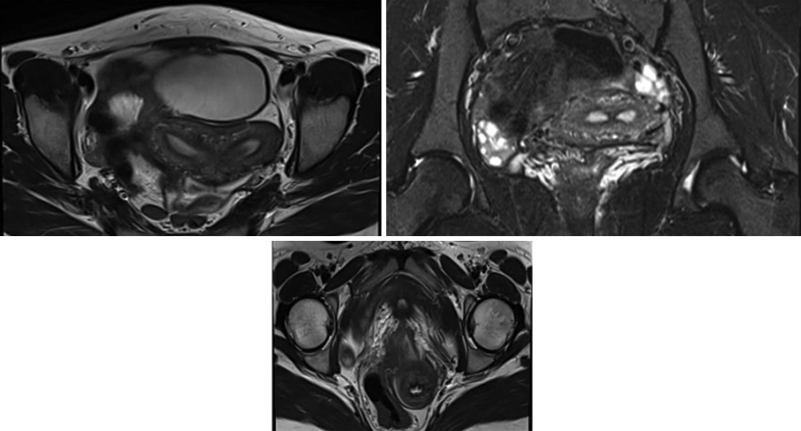
endometrial lining. MRI revealed a left unicornuate uterus with non- communicating right rudimentary horn. (ESHRE U4aC3V0). The patient was advised to undergo metroplasty. She is yet to undergo surgery due to financial constraints.
a
a
b
c

Fig. 1: (a) Axial T2-weighted image showing two separate endometrial cavities with increased inter-cornual distance and obtuse angle between the uterine horns s/o Bicornuate uterus.
- Axial T2-weighted image showing normal bilateral ovaries and separate endometrial cavities as described. (c) Axial T2- weighted image showing a common cervical canal. A common
vaginal canal was also noted European Society of Human Reproduction and Embryology in this patient U3BC0V0

advised to undergo septoplasty, cervicoplasty, and vaginoplasty by the gynecologists. An extensive surgery was done successfully and post- procedure the patient conceived within 6 months.

Case 5
A 22-year-old female with a history of primary amenorrhea with history of cyclical pain abdomen, on USG screening, showed the possibility of two separate endometrial cavities bicornuate/septate uterus. Hematometra and left ovarian hemorrhagic cysts were also diagnosed. MRI scanning revealed a partial septate uterus with a normal cervix and obstructing oblique vaginal septum vaginas with hematometra, hematosalpinx, and left ovarian hemorrhagic cyst. (ESHRE U2aC0 V2/3) The patient was advised to undergo septoplasty. Within 3 months of the procedure, the patient started to have regular menstruation.

Case 6
A 20-year-old female with complaints of primary infertility for 2 years on USG screening showed the possibility of two separate endometrial cavities – bicornuate/septate uterus. Two separate cervixes were also seen. MRI scanning revealed two separate uteri with two cervices and two vaginas (ESHRE U3bC2V1). The patient was advised to undergo metroplasty with vaginoplasty and cervicoplasty. She conceived within 8 months of the surgery procedure.

Case 7
17-year-old female with a history of primary amenorrhea with no history of cyclical pain abdomen on USG screening showed a uterus-like structure which is smaller in size than the cervix and a cystic lesion in the left ovary. MRI revealed unicornuate rudimentary uterus with normal cervix and vagina was made (ESHRE U4aC0V0) with an endometrioma in the left ovary. She was advised to undergo metroplasty. Post-procedure within 8 months patient had an irregular menstrual cycle.

Case 8
A 6-year-old female with a history of urinary incontinence with dribbling, on USG screening, showed two separate endometrial cavities with non-visualization of cervix. MRI revealed bicorporeal bicollis uterus with partially obstructing longitudinal vaginal septum. Urography showed ectopic insertion of the right ureter with hydrocolpos in the left vagina (ESHRE U3bC2V2). She was advised to undergo metroplasty with septoplasty with ureteroplasty. She is yet to undergo surgery as a repeated history of urinary tract infections makes the patient unfit for any surgery.

Case 9
A 30-year-old female with a history of primary infertility for 5 years, on USG screening showed a uterus-like structure with an ill-defined

Case 10
Ultrasound scan was not done i/v/o. A 17-Year-old female presented for MRI imaging for post-traumatic workup of the urethral and vaginal status along with secondary amenorrhea for since trauma (2 years). USG was not done due to altered anatomy following a history of trauma with a history of ureteroplasty. Congenital anomaly of the uterus was picked up on MRI scan. A septum was seen separating the two cervical canals completely along with the septation of the proximal vaginal canals into two halves. A portion of the septa was also seen to extend into the uterine cavity. However, no obvious visualization of the uterine septa was seen. The inter-cornual distance was 3.2 cm and no obvious fundal indentation was seen. She was advised to undergo septoplasty. She is yet to undergo surgery due to financial constraints.

Case 11
A 5-year-old female with a history of S1 hemivertebrae was asked for a screening ultrasound to rule out associated anomalies. USG revealed non-visualization of uterus with normal bilateral ovaries. MRI confirmed uterine and cervical aplasia (ESHRE U5bC4). Urographic sequence revealed ectopic insertion of left ureter into urethra. The diagnosis of Mayer-Rokitansky-Küster-Hauser (MRKH) Syndrome was confirmed. The patient was advised to undergo vaginoplasty and ureteroplasty. She is yet to undergo surgery due to financial constraints.

Case 12
A 17-year-old female with a history of primary amenorrhea on USG showed a normal cervix with absent uterus. MRI revealed uterine hypoplasia with a normal cervix (ESHRE U5aC0V0). The patient was advised to undergo metroplasty. She is yet to undergo surgery due to underlying dilated cardiomyopathy.

Case 13
A 26-year-old female came with complaints of primary amenorrhea and primary infertility. Screening USG revealed absence of uterus with normal bilateral ovaries. MRI confirmed the diagnosis of aplastic uterus with left rudimentary horn with cervical aplasia (ESHRE U5aC4V0) (Fig. 2). A diagnosis of MRKH Syndrome was made. The patient was advised for assisted reproductive technology (ART) or adoption. As she could not afford ART, is waiting for adoption.

Case 14
A 36-year-old female with a history irregular menstruation with oligomenorrhea and repeated miscarriages, on USG revealed two separate uterine cavities and two cervix with hematometra and hematocolpos. Hysteroscopy was done to relieve hematometra and hematocolpos.

MRI confirmed diagnosis of bicorporeal uterus with double cervix and normal vagina with residual hematometra (ESHRE U3C2V0) (Fig. 3). Patient was advised for metroplasty and cervicoplasty; however, she is yet to undergo the procedures due to financial constraints.

Case 15
A 17-year-old female presented with primary amenorrhea. Screening USG revealed the presence of a rudimentary uterus-like structure with ill- defined endometrial lining with normal bilateral ovaries. MRI confirmed uterine hypoplasia with only two rudimentary horns joined through a septum in the midline s/o complex uterine anomaly. A blind-ending distal vaginal pouch was seen (ESHRE U6C4V4). The patient was advised for metroplasty, cervicoplasty, and vaginoplasty. The first trial surgery failed due to infection. At present, she is waiting for a second trial of surgery.

Case 16
A 30-year-old female presented with a history of recurrent abortions. Screening USG revealed the presence of two uterine cavities with

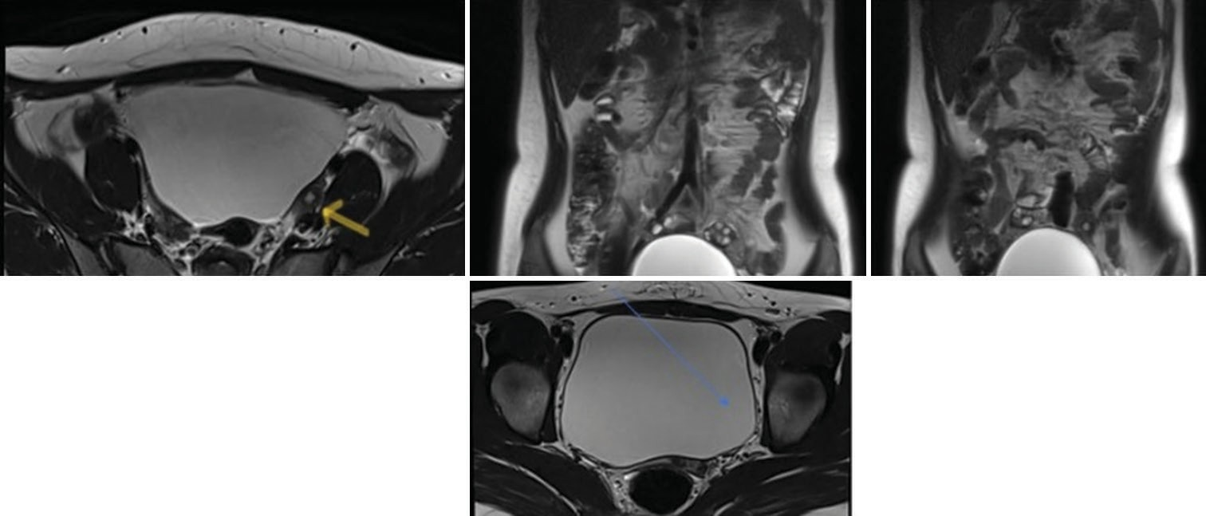
a
b
c
d
Fig. 2: (a) Axial T2-weighted image showing rudimentary left uterine horn (arrow) with uterine aplasia. (b and c) Coronal T2-weighted images showing normal bilateral ovaries with left rudimentary uterine. (d) Axial T2-weighted image showing cervical aplasia; normal vagina was seen. ESHRE-U5aC4V0
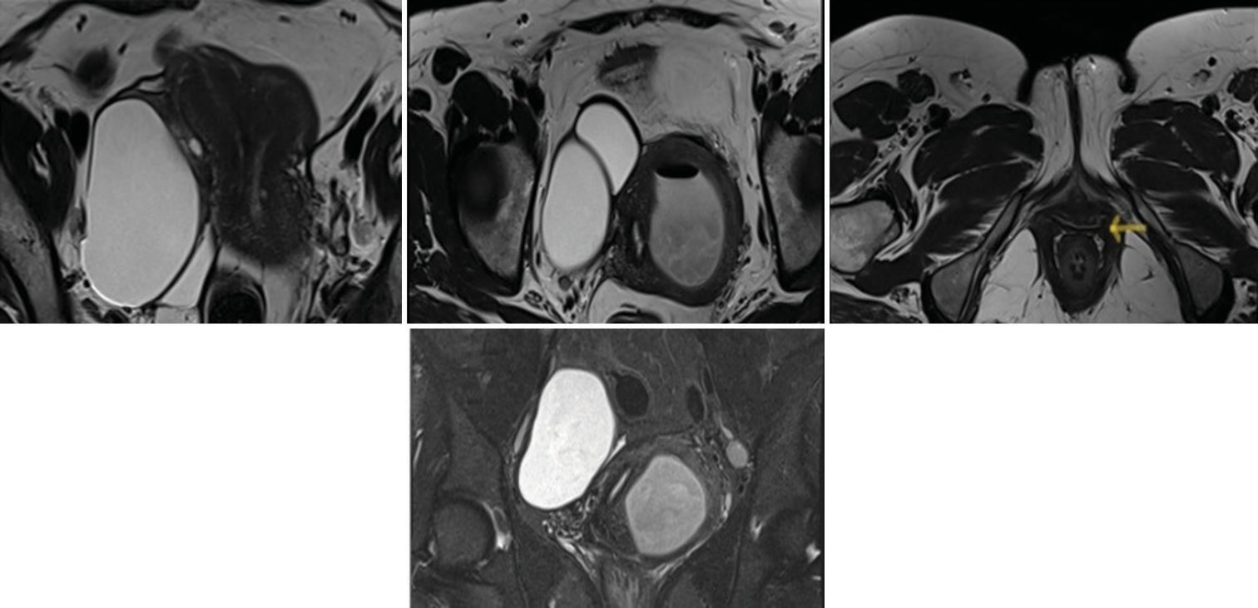
a
b
c
d
Fig. 3: (a) Axial T2-weighted image shows two separate uterine cavities with obtuse angle between uterine horns. (b) Axial T2-weighted image shows two separate cervical cavities with hematotrachelos in the left cervical cavity. Note is made of right endometrioma.
- A single vaginal canal is noted with minimal hematocolpos (arrow). (d) Coronal T2-weighted image showing two separate cervical cavities with bilateral endometriomas ESHRE-U3C2V0

normal bilateral ovaries with possibility of septate and bicornuate uterus. MRI revealed a partial septate uterus with the normal cervix, vagina, and bilateral ovaries (ESHRE U2aC0V0). The patient was advised for septoplasty.

Case 17
A 27-year-old female presented with a history of primary infertility and dysmenorrhea. USG revealed the presence of two uterine cavities with normal ovaries. Cervix was not visualized clearly. MRI revealed a partial septate uterus with a partial septate cervix and bilateral ovaries (ESHRE U2bC1V0). The patient was advised septoplasty. She has recently undergone successful surgery and is planning for pregnancy. The clinical features of all the cases are depicted in Table 1.

DISCUSSION
In this case series, we have prospectively investigated 17 cases with suspicion of MDA with MR imaging. MRI scan has correctly delineated the wide array of developmental defects of MDA in these cases along with accurate identification of any other structural defects in all the patients. It is to be noted that many of the developmental defects of MDA can be picked up by USG and, MRI remains to be the imaging technique of choice as it is the most accurate non-invasive imaging technique available till date. MRI unlike USG and HSG can correctly classify the uterovaginal developmental defects of MDA, besides picking up other developmental defects in surrounding structures like the ureter or
urethra; also, it gives clear idea about the external contour of uterine fundus, shape of the uterine cavity, and can also delineate the character of the septa, if any [6-8].
Although MDA are uncommon, 7% of the general female population and up to 25% of the females presenting with infertility or frequent miscarriages, but it can be treated to some extent [4]. Therefore, to decide the treatment course and the chance of successful conception, accurate classification of MDA is essential. MR imaging has proven to be an essential tool for accurate classification of MDA. The most common classification system used worldwide was developed by the American Society of Reproductive Medicine. As per this classification, the developmental anomalies in MDA can be hypoplasia or agenesis (class I: vaginal, cervical, fundal, tubal, and combined), unicornuate (class II: communicating, non-communicating, no cavity and no horn), didelphus (class III), bicornuate (class IV: complete and partial), septate (class V), arcuate (class VI), and DES-related (class VII) [1,8-10].
Class I cases show typical MRI findings like the presence of fibrous bands joining Müllerian remnants of both sides and meeting at the triangular-shaped soft tissue (continuous with the vagina) and located in the middle just above the bladder. Class II cases typically show on MRI scans the presence of banana shaped uterine horn with one fallopian tube and deviated to on side. On T2-weighted images, non-functioning rudimentary horn shows homogenous low signal intensity; on the

Table 1: Description of the cases
S.  No. | Age (years) | Chief complaint | Ultrasonography findings | Magnetic resonance imaging findings | Other investigations | Advice
1. | 17 | Primary amenorrhea with no history of cyclical pain abdomen | Absence of uterus with normal bilateral ovaries | Aplastic uterus with partial vaginal agenesis and complete cervical agenesis (ESHRE U5a C4 V4) |  | To undergo vaginoplasty
2. | 24 | Repeated history of spontaneous abortions with normal menstrual history | Two separate endometrial cavities with possibility of Bicornuate/  septate uterus | Bicornuate uterus with common cervical and vaginal canal was made (ESHRE  U3bC0V0) |  | Advised to undergo septoplasty
3. | 23 | History of primary infertility for 2 years | Two separate endometrial cavities with possibility of Bicornuate/ septate uterus with  septate vagina | Complete septate uterus with partial septate cervix with non-obstructive longitudinal vaginal septum was made  (ESHRE U2bC1V1) |  | Advised to undergo septoplasty; post- procedure patient conceived within 2  months
4. | 29 | History of spontaneous miscarriages with 3 abortions | Two separate endometrial cavities with possibility of Bicornuate/septate  uterus with two separate cervix and vagina | Complete septate uterus with two cervices and two vaginas was made (ESHRE U2bC2V1) |  | Advised to undergo septoplasty, cervicoplasty, and vaginoplasty.  Post-procedure patient conceived within 6  months
5. | 22 | History of primary amenorrhea with history of cyclical pain abdomen | Showed possibility of two separate endometrial cavities bicornuate/ septateuterus.  Hematometra and left ovarian hemorrhagic cyst | Partial septate uterus with normal cervix and  obstructing oblique vaginal septum; hematometra, hematosalpinx, and left ovarian hemorrhagic cyst.  (ESHRE U2aC0 V2/3) |  | Advised to undergo septoplasty. Patient started to have normal menstrual cycle within 3 months of the procedure.
6. | 20 | Complaints of primary infertility for 2 years | Possibility of two separate endometrial cavities – bicornuate/ septate uterus. Two separate cervix were  also seen. | Two separate uterus with two cervices and two vaginas was made  (ESHRE U3bC2V1) |  | Advised to undergo metroplasty with vaginoplasty and cervicoplasty. Patient conceived within 8  months of procedure
7. | 17 | History of primary amenorrhea with no history of cyclical pain abdomen | Showed a uterus-like structure which is smaller in size than the cervix and a cystic  lesion in the left ovary. | Unicornuate rudimentary uterus with normal cervix and vagina was made  (ESHRE U4aC0V0) with  endometrioma in the left ovary |  | Advised to undergo metroplasty.  Patient had irregular menstrual cycle 8  months post-procedure
8. | 6 | History of urinary incontinence with dribbling | Two separate endometrial cavities with non-visualization of cervix. | Bicorporeal bicollis uterus with partially obstructing longitudinal vaginal septum was made | Urography showed ectopic insertion  of the right ureter with hydrocolpos in the left  vagina (ESHRE U3bC2V2) | Advised to undergo metroplasty with septoplasty with ureteroplasty.  Patient is still waiting for surgery as repeated episodes of urinary tract infections makes the patient unfit for any surgery
9. | 30 | History of primary infertility for 5 years. | Showed a uterus like structure with an ill- defined endometrial lining | Left unicornuate uterus with non-communicating right rudimentary horn(ESHRE U4aC3V0) |  | Advised to undergo metroplasty Patient is still waiting for the  surgery due to financial  constraints
10. | 17 | History of secondary amenorrhea post-trauma (2 years ) | Not Done due to altered anatomy following trauma with ureteroplasty | Congenital anomaly of the uterus was picked up. A septa was seen separating the two cervical canals completely along with septation of the proximal vaginal canals into two halves. A portion of the septa was also seen to extend into the uterine cavity. However, no obvious visualization of the uterine septa was seen. The inter-cornual distance was  3.2 cm and no obvious fundal indentation was seen. |  | Initially planned for vaginoplasty; following MRI findings, was advised to undergo septoplasty. Patient  is still waiting for the surgery due to financial constraints
(Contd...)

Table 1: (Continued)
S.  No. | Age (years) | Chief complaint | Ultrasonography findings | Magnetic resonance imaging findings | Other investigations | Advice
11. | 5 | History of S1 hemivertebrae was asked for a screening ultrasound to rule out associated anomalies | Non visualization of uterus with normal bilateral ovaries | Uterine and cervical aplasia (ESHRE U5bC4)  A diagnosis of Mayer- Rokitansky-Küster-Hauser Syndrome was made | An urographic sequence was also taken and ectopic insertion of  left ureter into urethra was  seen | Advised to undergo vaginoplasty and ureteroplasty.  Patient is still waiting for the surgery due to financial constraints
12. | 17 | History of primary amenorrhea | Showed normal cervix with absent uterus | Uterine hypoplasia with normal cervix was made (ESHRE U5aC0V0) |  | Advised to undergo metroplasty.  Patient is still waiting for the surgery due to underlying dilated  cardiomyopathy.
13. | 26 | Complaints of primary amenorrhea and primary infertility. | Showed absence of uterus with normal bilateral ovaries. | Aplastic uterus with left rudimentary horn with cervical aplasia  (ESHRE U5aC4V0)  A diagnosis of Mayer- Rokitansky-Küster-Hauser Syndrome was made |  | Was advised for ART or adoption.  Patient cannot afford ART and is waiting for adoption.
14. | 36 | History of repeated miscarriages and irregular menstrual history with oligomenorrhea | Two separate uterine cavities and two cervices with hematometra and hematocolpos | Bicorporeal uterus with double cervix and normal vagina with residual hematometra was made. (ESHRE U3C2V0) | Hysteroscopy was done  to relieve hematometra and hematocolpos | Advised for metroplasty and cervicoplasty.  Patient cannot afford the surgery and is currently trying to  gather funds
15. | 17 | Presented with primary amenorrhea | Rudimentary uterus like structure with  ill-defined endometrial lining with normal bilateral ovaries | Uterine hypoplasia with only two rudimentary horns joined through a septum  in the midline s/o complex uterine anomaly  A blind ending distal vaginal pouch was seen (ESHRE U6C4V4) |  | Advised for metroplasty, cervicoplasty and vaginoplasty Patient underwent one trial of failed  surgery due to infective complications and is waiting for a second  trial of surgery
16. | 30 | History of recurrent abortions | Presence of two uterine cavities with normal bilateral ovaries with possibility of septate  and bicornuate uterus | Partial septate uterus with normal cervix, vagina, and bilateral ovaries was made (ESHRE U2aC0V0) |  | Advised for septoplasty Patient is waiting for surgery
17. | 27 | History of primary infertility and dysmenorrhea | Presence of two uterine cavities with normal ovaries. Cervix was not visualized clearly. | Partial septate uterus with partial septate cervix and bilateral ovaries (ESHRE U2bC1V0) |  | Advised for septoplasty Patient has recently undergone successful  surgery and is planning for pregnancy.

other hand, functional rudimentary horn after puberty shows high signal intensity on both T1 and T2 images, suggestive of hematometra.

Class III cases, on MRI, show widely spaced two divergent horns with preserved endometrium; on the outer side deep midline fundal cleft is usually seen complete with two separate cervixes. There is also duplication of the vagina picked up MRI, with the hemovaginal septum blocking on of the horns of uterus usually with high signal intensity on T1 images (due to presence of blood). In Class IV patients cleft of >1 cm in depth on MRI is identified on the outer aspect of the fundus with a gap of more than 4 cm between the cornu. In Class V cases, an MRI scan helps in the delineation of the character of the septum, as based on the nature of the septum, surgical approach is chosen. A fibrous septum with low signal intensity at T2-weighted images requires hysteroscopic resection, whereas a muscular septum with intermediate
signal intensity at T2-weighted images will require transabdominal approach. Class VI cases on MRI scan show a uterus of normal size with normal external appearance, except for smooth-appearing soft tissue at the fundus encroaching within the uterine cavity.

MRI scan for Class VII cases can pick up different types of images, most commonly being T-shaped uterus. Other than the above-mentioned classification, another classification is there, the European classification of MDA. As per this classification, following main classes are there, normal uterus (U0); dysmorphic uterus (U1: t shaped, infantilis, and others); U2, septate uterus (U2; partial and complete); bicorporeal uterus (U3; partial, complete, and bicorporeal septate); hemi-uterus (U4; with rudimentary cavity, and without rudimentary cavity); aplastic uterus (U5; with rudimentary cavity, and without rudimentary cavity); for still unclassified cases (U6) [1,8-10].

Depending on the classes, the treatment modalities are decided. Thus, accurate classification with MRI is essential to ensure the successful management of individual cases. However, it has to be remembered that the classification system is just a framework, not all the cases will fit into it. The majority of the patients in our case series (n=15) presented with complaints of amenorrhea (primary, most commonly) along with infertility; only two cases (n=2), two girls of 6 years and 5 years, respectively, presented with urinary incontinence with dribbling of urine and S1 hemivertebrae, respectively. Seven patients with septate uterus (case nos. 2, 3, 4, 5, 10, 16, and 17) were advised septoplasty following the final diagnosis and categorization of MDA with MR imaging. Of these patients, two patients (case nos. 3 and 4) have successfully conceived after procedure, one patient has started menstruating (case no. 5), three patients (case nos. 2, 10, and 16) are yet to undergo surgery, and one patient (case no. 17) has undergone surgery successfully and planning for pregnancy.
Another seven patients were advised metroplasty (case nos. 6, 7, 8, 9, 12, 14, and 15), along with vaginoplasty (in n=2 patients case nos.6, and 15) and cervicoplasty (n=3, case nos. 6, 14, and 15). Two patients were diagnosed as with MRKH Syndrome; the 26-years-old patient (case no13) (aplastic uterus, left rudimentary horn, and normal bilateral ovaries) was advised for ART or adoption and the second patient aged 5 years (caseno. 11) was advised vaginoplasty and urethroplasty (as left ureter was inserted in urethra). One patient was (case no. 1) was advised only vaginoplasty as she had aplastic uterus with partial vaginal agenesis and complete cervical agenesis. Like our cases, Guo X and her colleagues have reported a case of twin pregnancy in a woman with septate uterus following metroplasty [11]. Again, in another case like ours, Selvaraj and Selvaraj also reported cases of successful term pregnancy in seven women with secondary infertility and six cases of successful pregnancy in primary infertile women [12]. In another systematic review by Carrera et al., the importance of metroplasty has been outlined to reduce miscarriage in partial and complete uterine septum [13].
Thus, all these findings suggest that with appropriate management many of the patients of MDA can conceive; however, it should be stressed that for choosing timely surgical intervention accurate classification of the developmental defect is essential and for that MRI scan is essential. Moreover, correct classification with MRI scan can also avoid unnecessary surgical interventions and patient can be advised accordingly for adoption or ART.

CONCLUSION
MDA comprises of wide variety of developmental anomalies with different presenting features. Although MDA can be initially detected with HSG or USG; these two investigations are incapable of accurately categorize MDA and delineate other structural anomalies, if any. MRI is the imaging technique of choice for MDA, as it can accurately classify developmental anomalies and therefore guide the clinician to choose the best treatment modality for the patient. Female infertility can be attributed to MDA, and in many cases of MDA appropriate surgery can lead to successful conception. Furthermore in some cases, surgery cannot lead to conception. Thus, correct classification of individual cases with MRI is essential for not only successful conception through appropriate surgery but also for avoidance of unnecessary surgical intervention.

PATIENT CONSENT STATEMENT
No personal information has been shared. However, consent was taken verbally for including images and professional information in the paper.

REFERENCES
- Chandler TM, Machan LS, Cooperberg PL, Harris AC, Chang SD. Mullerian duct anomalies: from diagnosis to intervention. Br J Radiol. 2009 Dec;82(984):1034-42. doi: 10.1259/bjr/99354802, PMID 19433480.
- Grover SB, Antil N, Katyan A, Rajani H, Grover H, Mittal P, et al. Niche role of MRI in the evaluation of female infertility. Indian J Radiol Imaging. 2020 Jan-Mar;30(1):32-45. doi: 10.4103/ijri.IJRI_377_19, PMID 32476748.
- Sugi MD, Penna R, Jha P, Pōder L, Behr SC, Courtier J, et al. Müllerian duct anomalies: role in fertility and pregnancy. RadioGraphics. 2021 Oct;41(6):1857-75. doi: 10.1148/rg.2021210022, PMID 34597219.
- Garratt J, Siegelman ES. MR imaging of Müllerian anomalies. Magn Reson Imaging Clin N Am. 2023;31(1):11-28. doi: 10.1016/j. mric.2022.06.002, PMID 36368856.
- Marten K, Vosshenrich R, Funke M, Obenauer S, Baum F, Grabbe E. MRI in the evaluation of Müllerian duct anomalies. Clin Imaging. 2003 Sep-Oct;27(5):346-50. doi: 10.1016/s0899-7071(02)00587-9, PMID 12932688.
- Behr SC, Courtier JL, Qayyum A. Imaging of Müllerian duct anomalies. RadioGraphics. 2012 Oct;32(6):E233-50. doi: 10.1148/rg.326125515, PMID 23065173.
- El Ameen NF, Ebraheem MA, Nour El Dien NM. MR assessment of Müllerian duct anomalies: does it help? Egypt J Radiol Nucl Med. 2014;45(2):561-7. doi: 10.1016/j.ejrnm.2014.02.006.
- Olpin JD, Moeni A, Willmore RJ, Heilbrun ME. MR imaging of Müllerian fusion anomalies. Magn Reson Imaging Clin N Am. 2017 Aug;25(3):563-75. doi: 10.1016/j.mric.2017.03.008, PMID 28668160.
- Jegannathan D, Indiran V. Magnetic resonance imaging of classified and unclassified Müllerian duct anomalies: comparison of the American Society for Reproductive Medicine and the European Society of Human Reproduction and Embryology classifications. SA J Radiol. 2018 Apr 23;22(1):1259. doi: 10.4102/sajr.v22i1.1259, PMID 31754489.
- Robbins JB, Broadwell C, Chow LC, Parry JP, Sadowski EA. Müllerian duct anomalies: embryological development, classification, and MRI assessment. J Magn Reson Imaging. 2015 Jan;41(1):1-12. doi: 10.1002/ jmri.24771, PMID 25288098.
- Guo X, Sun X, Xu H, Si S, Yu B, Liu J. Successful pregnancy in each half uterus cavity of the septate uterus after transferring three embryos in one half-cavity: a case report. J Ovarian Res. 2013;6(1):56. doi: 10.1186/1757-2215-6-56, PMID 23924779.
- Selvaraj P, Selvaraj K. Reproductive outcome of septate uterus following hysteroscopic septum resection. J Hum Reprod Sci. 2010 Sep;3(3):143-5. doi: 10.4103/0974-1208.74157, PMID 21234176.
- Carrera M, Pérez Millan F, Alcázar JL, Alonso L, Caballero M, Carugno J, et al. Effect of hysteroscopic metroplasty on reproductive outcomes in women with septate uterus: systematic review and meta-analysis. J Minim Invasive Gynecol. 2022 Apr;29(4):465-75. doi: 10.1016/j. jmig.2021.10.001, PMID 34648934.

